Quantifying AI data center flexibility as a resource adequacy asset
Chris Dunlap
Abstract
AI data centers are entering resource adequacy planning as inflexible firm load, a treatment that reflects operational convention rather than physical necessity and that is increasingly difficult to sustain at the scale of projected demand. In reality, AI inference workloads are flexible along multiple operational axes including spatial migration across grid regions, temporal deferral of non-interactive workloads, and dynamic voltage-frequency scaling on residual compute. What is missing is not the flexibility itself but a framework for translating composed operational flexibility into the capacity-accreditation terms that resource adequacy planning requires. We develop an eleven-parameter decomposition organized as three composable mechanism mini-cascades, composed additively at the megawatt layer with sequential ordering and explicit overlap correction. Each parameter is graded against available empirical evidence, with grounding categories ranging from direct measurement to scenario construction. We test the framework against four years of day-ahead pricing data across five U.S. grid regions and 49.4 million production inference requests, finding that at least one cross-region destination is unstressed during 99% or more of observed stress hours from each of four source zones tested, and that drain-within-window completion of in-flight inference requests is approximately two orders of magnitude faster than emergency dispatch notice.
We report commitment depth under two scope scenarios reflecting the bi-modal heterogeneity of the projected 2030 data-center fleet. For mixed-use colocation facilities representative of the fleet average (φ_inf = 0.43), single-facility commitment depth is approximately 24.6% of nameplate. For purpose-built inference-dominant facilities (φ_inf = 0.70), single-facility commitment depth is approximately 40.0%. At 10-GW fleet scale, commitment depth declines to 24.1% (mixed-use) and 38.5% (inference-dominant) as destination-pool contention binds spatial migration and post-stress queue saturation begins to bind temporal deferral. The dominant remaining uncertainties — destination compute absorption during stress hours, contractual workload pinning, and fleet-scale recovery-period absorption — are decision-relevant rather than physical: they reflect operator and institutional choices that policy can shape, not physics of compute migration or power management. The gap between physical flexibility potential and realized grid value is governed by institutional mechanism design.
1. Introduction
In PJM Interconnection, the 2027/2028 capacity auction fell 6.6 GW short of the reliability requirement, the first such shortfall in the region's history, while large load adjustments, predominantly for data centers total 33.7 GW by 2030 in PJM's 2026 Long-Term Load Forecast and account for effectively all net peak demand growth. Supply-side responses cannot keep pace: generation and storage projects face median completion timelines exceeding five years, with only 13% reaching commercial operation, and the underlying bottlenecks in permitting and equipment supply chains cannot be compressed by capital investment alone. Policy research has begun to argue that load flexibility should be the primary response. Norris and colleagues at Duke's Nicholas Institute estimated that the 22 largest U.S. balancing authorities could accommodate approximately 98 GW of new flexible load using existing system capacity, with an average annual curtailment rate of 0.5% and an average curtailment duration of approximately two hours. The International Energy Agency's 2025 Energy and AI report reached a similar conclusion through different methodology, finding that data-center flexibility for as little as 0.1% to 1% of annual hours would suffice to integrate all projected 2030 capacity additions into existing U.S., E.U., and Chinese electricity systems, and explicitly notes that the U.S. Department of Energy has called for the development of a flexibility taxonomy and framework to guide implementation.
Resource adequacy planning has responded to data-center load growth by treating it as firm and inelastic at each facility, requiring corresponding procurement of generating capacity plus reserve margin for every additional megawatt and allocating those costs to retail customers through capacity charges. This treatment reflects how data center operators have historically operationalized their service-level contracts to guarantee uninterrupted compute reliant on maintaining locally firm power draw at every facility. The aggregation of these local firmness commitments across a rapidly growing fleet is what produces the system-level capacity requirement now exceeding what the interconnection queue can deliver.
Recent work has begun to challenge the technical premise that this firmness is physically necessary. Field demonstrations and production deployments at major hyperscalers have established intra-facility phase-disaggregated inference, datacenter-wide power management with millisecond control latencies, structured demand response targeting machine-learning workloads, and software-orchestrated peak-power reduction with maintained service quality (Section 2). Parallel work by Zhou et al. quantifies the single-facility cost, and capacity-expansion modeling by Knittel et al. finds that data-center temporal flexibility reduces total system costs across all three regions hosting 82% of projected 2030 data-center demand. Across these analytic approaches, the technical potential is not in dispute; what differs is the unit of analysis and the mechanism set considered.
Here we develop a framework for valuing the composed operational flexibility of AI inference data centers as an accreditable resource adequacy asset. The framework comprises four analytical components: an eleven-parameter decomposition organized as three composable mechanism mini-cascades; an empirical stress-decorrelation analysis using four years of day-ahead locational marginal pricing across five U.S. grid regions; a workload characterization grounded in 49.4 million production inference requests; and a conditional Monte Carlo simulation that conditions on observed per-hour grid states.
We report two scope scenarios in parallel: a mixed-use facility representative of the fleet average and a purpose-built inference-dominant facility representative of the upper envelope reachable by siting choices. The framework's primary function is decomposition rather than point estimation and identifies where the operational, empirical, and institutional uncertainties are concentrated, grades the evidence for each, and bounds the consequences of those uncertainties across a plausible parameter space.
2. Framework: Decomposing composed operational flexibility
The mechanisms underlying composed flexibility are well established in the systems literature and deployed at production scale. Microsoft's Flex system demonstrates software-enforced flexibility substituting for hardware power reserves in datacenter operation, with sub-second action latencies and fewer than 5% stranded power across deployments enabling 33% additional servers. Facebook's Dynamo and Google's Thunderbolt establish DC-wide power management with millisecond control latencies and production-verified fault tolerance. Splitwise, DistServe, and Mooncake demonstrate intra-facility phase-disaggregated LLM inference at production scale, including in Moonshot AI's deployed Kimi serving platform. SageServe's analysis of Microsoft O365 Copilot production traces documents predictable workload tiering with hours-scale deadlines for non-interactive workloads. Colangelo et al. demonstrate 25% sustained cluster-level peak-power reduction for three hours on a mixed AI workload ensemble at Oracle Phoenix, with zero SLA violations across 33 experiments. What this systems literature has not done is translate operational flexibility into capacity-accreditation terms that resource adequacy planning and capacity markets require.
The framework developed here is that translation. It analyzes the fraction of nameplate inference load that is simultaneously flexible, operationally committable, and capacity accreditable during a grid dispatch event, decomposes the conditions that must hold for that load to deliver accreditable resource adequacy values, and composes them into an effective commitment depth (the megawatt-equivalent grid value per megawatt of nameplate inference load). Within each of the three mechanisms identified in Section 1, parameters compose multiplicatively. Across mechanisms, contributions add at the megawatt layer with sequential ordering of spatial first, deferral on the inference residual at source second, and dynamic voltage-frequency scaling on what remains. The sequential ordering implements an explicit overlap correction: within-facility power management at the source partially substitutes for deferral when work returns post-event, so the same megawatt of non-interactive compute cannot be counted both as deferred and as DVFS-reduced.
The framework is reported under two scope scenarios reflecting the bi-modal heterogeneity of the projected 2030 data center fleet. The first, the mixed-use scenario, applies the cascade to the typical hyperscaler colocation facility for which inference is approximately 43% of IT compute by 2030, anchored in McKinsey's December 2025 projection that inference workloads will reach more than 40% of total data-center demand. The second, the inference-dominant scenario, applies the cascade to purpose-built AI campuses for which inference exceeds 70% of IT compute, a class of facilities now emerging in industry and modeled distinctly in the IEA's 2025 Energy and AI report and in Zhou et al.'s 2024 analysis of AI-focused HPC. The two scenarios are reported in parallel rather than as alternatives because the actual 2030 fleet will include both, and the difference between their commitment depths is itself a finding: the marginal flexibility gain from purpose-built siting decisions is decomposable.
The largest residual uncertainties of destination utilization headroom during stress hours where the literature reports estimates spanning 40% to 90%, fleet-scale post-stress queue absorption, and contractual pinning of inference workloads to specific facilities by 2030, are decision-relevant rather than physical. They reflect institutional and contractual choices that policy can shape, not physics of compute migration or power management. The framework's primary function is to locate these institutional choices and bound their consequences across the plausible parameter space.
Commitment depth is computed hourly through a conditional Monte Carlo simulation conditioning on observed per-hour grid states across the five-RTO empirical dataset (Section 5). Scale-dependent structure emerges from the composition. At single-facility scale where destinations are not the binding constraint, mechanism-composed commitment depth reaches approximately 24.6% of facility nameplate in the mixed-use scenario and approximately 40.0% in the inference-dominant scenario. At 10-gigawatt fleet scale where destination-pool contention binds spatial migration and post-stress queue saturation begins to bind deferral, commitment depth declines to approximately 24.1% (mixed-use) and approximately 38.5% (inference-dominant). The spread between scales is the signature of finite destination capacity binding on spatial migration, partially offset by deferral's slower saturation and DVFS's facility-local applicability. Sections 6 and 7 unpack what the scale dependence implies for capacity-market design and where institutional mechanism choices matter most.
Parameter definitions, grounding categories, and composition logic are reported in Methods Table M1.
3. Cross-region stress decorrelation
Spatial compute migration requires that at least one destination grid region is operating under normal conditions when the source region is stressed. We test this condition empirically using 35,060 hours of day-ahead locational marginal pricing (DA LMP) data from January 2022 through December 2025, spanning five U.S. grid regions: PJM, ERCOT, CAISO, MISO, and NYISO. Within each region we identify destination pricing zones co-located with data center facilities using county-level data center capacity data from the U.S. Department of Energy / National Renewable Energy Laboratory Accelerating Speed to Power Data Viewer, which aggregates operational, under-construction, and announced data center capacity from multiple commercial and public sources. Stress hours are defined as hours in which the DA LMP exceeds the 99th percentile of the zone’s own four-year distribution, yielding the 200 highest-priced hours per zone (see Methods for threshold sensitivity).
Using the ComEd zone in Northern Illinois as the primary source region, we compute the fraction of source stress hours in which at least one cross-region destination zone exhibits a DA LMP below its stress threshold. Of the 200 observed ComEd stress hours, at least one cross-region destination was available in 198, corresponding to a dynamic availability of 99.0%. The two failure hours occurred during the January 2024 Arctic Blast. The decorrelation structure reflects the electrical topology of the North American transmission system. ERCOT operates as an electrically isolated interconnection with no synchronous ties to the Eastern grid. CAISO has temporal offset and weather patterns that are largely independent from the Midwest. Capacity-weighted stress overlap between ComEd and cross-interconnection destinations ranges from 3.7% (ERCOT, summer) to 14.0% (CAISO, annual), with CAISO exhibiting zero summer overlap across the four-year study period (Fig. 1). Same-interconnection destinations exhibit substantially higher overlap: MISO zones range from 43% to 66%, and NYISO zones from 29% to 41%, consistent with shared exposure to regional weather systems and partial electrical coupling.
We replicate the analysis from three additional source zones to test generalization beyond the ComEd perspective: PJM-DOM (Northern Virginia, approximately 9,400 MW of installed data center capacity), ERCOT-LZ-NORTH (Dallas-Fort Worth), and CAISO-NP15 (Silicon Valley). Dynamic availability is 99.5% from PJM-DOM (one failure hour, the same 2024 Arctic Blast event) and 100% from both ERCOT-LZ-NORTH and CAISO-NP15.
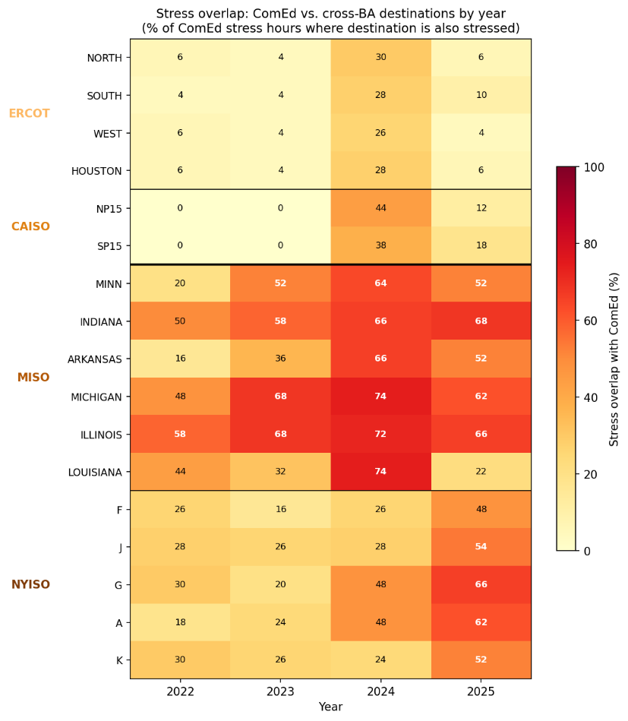
Fig. 1. Stress overlap between ComEd and 17 cross-BA destination zones by year, 2022–2025. Each cell shows the percentage of ComEd's 50 annual stress hours in which the destination zone was simultaneously stressed. Cross-interconnection destinations (ERCOT, CAISO) exhibit overlap below 30% in all years; same-interconnection destinations (MISO, NYISO) range from 16% to 74%, consistent with shared exposure to regional weather systems. The 2024 column reflects elevated co-stress during the January 2024 Arctic Blast. CAISO coverage begins November 2022; earlier periods are treated as available per Methods.
4. Workload characterization
The drain-within-window parameter (DRAIN_ok) captures whether active inference requests at a source facility can complete within the grid operator's emergency dispatch window. We validate drain time using two independent production inference datasets totaling 49.4 million requests over a combined 128 days of observation (see Methods for dataset descriptions). P99 drain times range from 4.5 to 12.12 seconds across model configurations and datasets, approximately two orders of magnitude below PJM's minimum dispatch window of 10 minutes, indicating that DRAIN_ok = 0.95 is a conservative parameterization. The 5% excluded by DRAIN_ok accommodates long-running or batched inference requests, multi-turn conversational sessions with persistent state, and potential future workload types with longer completion times.
5. Conditional Monte Carlo validation
We develop a conditional Monte Carlo simulation that conditions on observed per-hour grid states to capture how commitment depth depends on fleet size, destination contention, and post-stress recovery saturation during specific stress events. The simulation is run separately under each of the two scope scenarios; results are reported in parallel.
For a representative 500 MW inference-dominant facility, the conditional Monte Carlo yields a mean commitment depth of 40.0% under the inference-dominant scope (φ_inf = 0.70), with 5th percentile of 38.5% and conditional expected shortfall below the 5th percentile of 33.1%. Under the mixed-use scope (φ_inf = 0.43), the corresponding values are mean 24.6%, P5 23.7%, and CVaR 20.6%. The framework's conservatism at single-facility scale arises from a ratio effect: aggregate available headroom across unstressed destinations substantially exceeds the demand from a single migrating facility in the large majority of stress hours, and the deferral and DVFS mechanisms operate independently of destination contention.
When the analysis is extended to simultaneous migration by geographically distributed facilities, commitment depth becomes scale-dependent. We first evaluate an empirical fleet defined by the geographic distribution of PJM data center capacity across load zones, with per-hour co-stress identified from the intra-PJM coincidence matrix described in Section 3. Only zones experiencing simultaneous stress contribute migrating load in each hour. Across the 30 ComEd stress hours where at least one other PJM zone is also stressed, the migrating fleet averages 4,729 MW (range 747–14,379 MW), with substantial variation driven by whether the Dominion zone in Northern Virginia (9,431 MW of data center capacity) is co-stressed with ComEd. This empirical fleet yields a mean commitment depth of 33.6% under inference-dominant scope and 21.1% under mixed-use, with conditional expected shortfall below the 5th percentile of 19.8% and 12.3% respectively. A reliability assessment grounded in worst-case performance such as PJM's Loss of Load Probability framework, mapped through PJM's 92% demand-response ELCC, would credit this fleet with approximately 19.4% (inference-dominant) or 12.1% (mixed-use) of accredited capacity per fleet MW. Fleet-level accreditation depends on the mean-versus-tail metric chosen by the capacity market operator, a methodological choice with direct consequences for the economic value quantified in Section 6.
We then evaluate commitment depth as a continuous function of fleet size using a parametric sweep from 0.5 to 15 GW. Under the inference-dominant scope, commitment depth declines from 39.8% at 1 GW to 38.5% at 10 GW. Under the mixed-use scope, commitment depth declines from 24.6% at 1 GW to 24.1% at 10 GW. The decline is driven primarily by destination contention engaging spatial migration: the share of Monte Carlo draws that are destination-constrained rises from 4.9% at 1 GW to 25.7% at 10 GW under the inference-dominant scope, and from 3.0% to 8.5% under the mixed-use scope. Spatial contention does not exceed the 50% threshold within the swept range, with onset projected beyond 15 GW. The decline in mean commitment depth is mild because deferral and DVFS contribute additively across all fleet sizes and do not saturate within the range evaluated; the 5th percentile shows a sharper decline (from 38.1% to 25.2% under inference-dominant; from 23.6% to 16.1% under mixed-use), reflecting that destination contention binds most aggressively in the worst stress hours rather than across the full distribution.
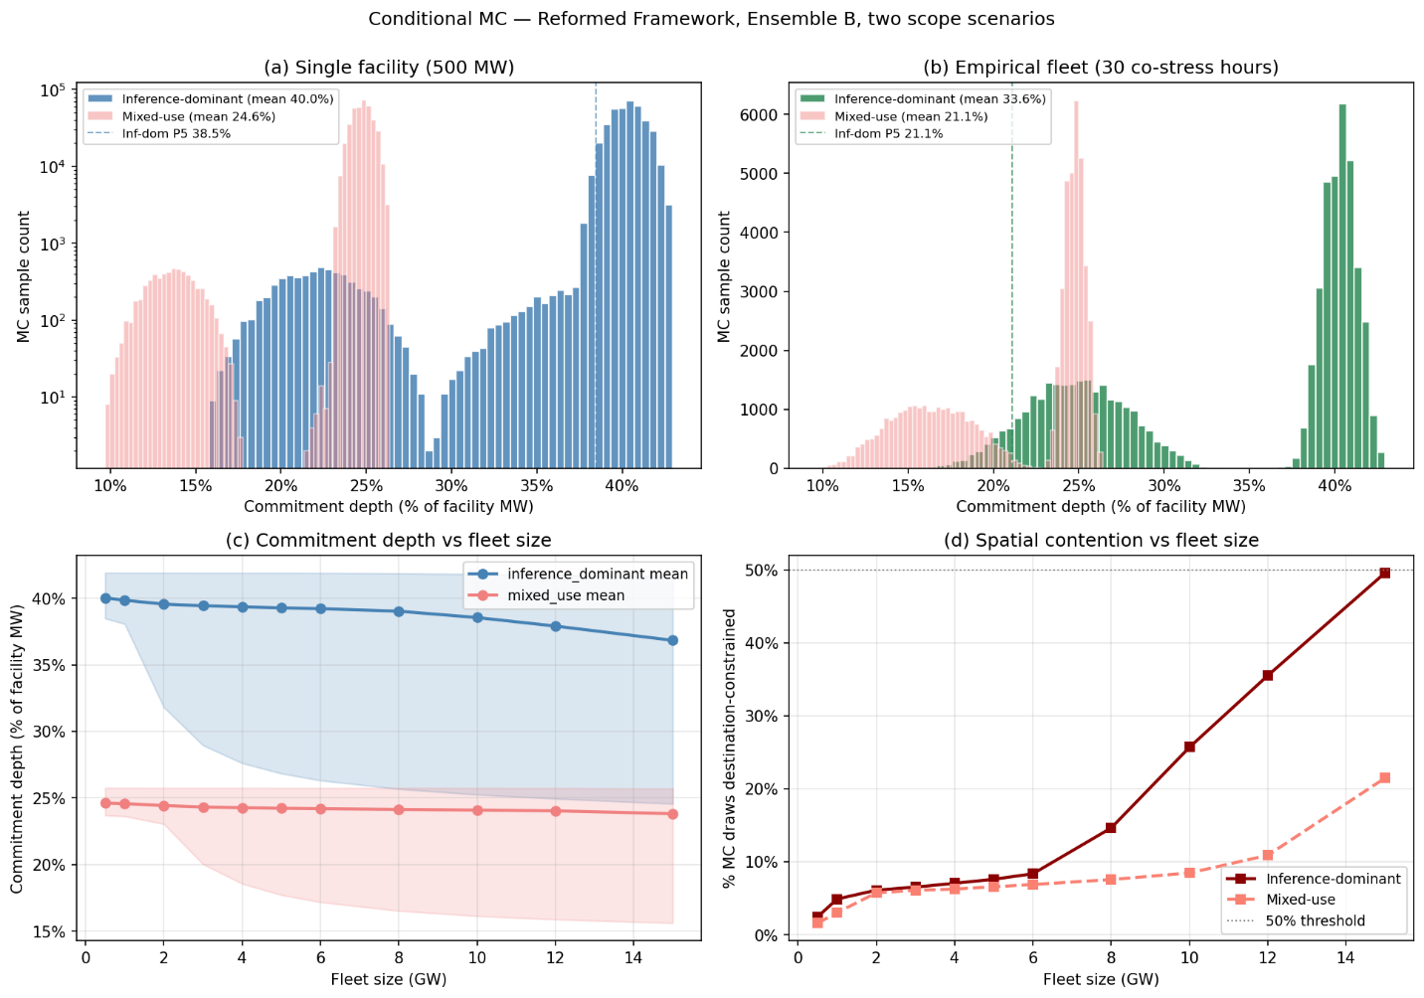
[Figure 2 callout (re-rendered for reformed framework, two scopes): Four-panel figure. Panels (a) and (b) report single-facility (500 MW) and empirical fleet commitment depth distributions, both showing the inference-dominant scope as the primary distribution with a mixed-use scope distribution overlaid in lower opacity. Panel (c) reports the per-GW commitment depth sweep with separate curves for the two scopes, P5–P95 bands, and dotted-line markers at contention onset and QUEUE_OK onset. Panel (d) reports the percentage of draw-hour combinations destination-constrained as a function of fleet size, plus a parallel curve for the percentage QUEUE-constrained.]
The scale dependence has direct implications for how this flexibility should be quantified in capacity market design. A single operator evaluating participation faces a commitment depth distribution sharply concentrated near 40% under inference-dominant scope, with the 5th percentile at 38.5% and the conditional expected shortfall below the 5th percentile at 33.1% — meaningful contribution from all three mechanisms even in the tail, supporting bids based on the mean rather than worst-case performance. Fleet-level accreditation cannot be inferred from single-facility performance: destination contention reduces the spatial contribution as fleet size grows, with the share of Monte Carlo draws destination-constrained rising from 4.9% at 1 GW to 25.7% at 10 GW under the inference-dominant scope. Mean commitment depth declines correspondingly from 39.8% at 1 GW to 38.5% at 10 GW, while the 5th percentile drops more sharply from 38.1% to 25.2%, reflecting that destination contention binds most aggressively in the worst stress hours. Capacity market operators evaluating DR class ratings for data center flexibility must therefore set accreditation at the fleet level rather than extrapolating from facility-scale studies, and must distinguish between the three mechanisms in the accreditation framework because their saturation behaviors differ structurally — DVFS contributes additively across all fleet sizes evaluated, deferral remains nearly constant, and only spatial migration shows scale-dependent decline.
6. System-level implications
The commitment depths estimated by the conditional Monte Carlo translate directly to resource adequacy contributions within existing capacity market frameworks. We evaluate system-level implications at two reference scales (1 GW facility and 10 GW fleet), under each of the two scope scenarios.
For an individual 1 GW inference-dominant facility, the conditional Monte Carlo yields a mean commitment depth of 39.8%, implying approximately 398 MW of curtailable load during system emergencies, or approximately 367 MW when derated to a 92% effective load carrying capability (ELCC) consistent with PJM's treatment of demand response resources. For a 10 GW inference-dominant fleet, the mean commitment depth of 38.5% implies approximately 3,546 MW accredited. Under the mixed-use scope, the corresponding 1 GW and 10 GW figures are 226 MW and 2,216 MW respectively.
These accredited capacity values use mean commitment depth, consistent with PJM's standard UCAP accreditation convention for demand response. An alternative approach using the 5th-percentile commitment depth would yield approximately 350 MW (1 GW inference-dominant), 2,322 MW (10 GW inference-dominant), 217 MW (1 GW mixed-use), and 1,483 MW (10 GW mixed-use). The gap between mean-based and P5-based accreditation is small at single-facility scale (16 MW under the inference-dominant scope) but grows substantially at fleet scale (1,224 MW at 10 GW), reflecting that destination contention binds most aggressively in the worst stress hours rather than across the full distribution.
To estimate the economic value to the grid, we calculate avoided capacity costs using the capacity requirements identified in Energy + Environmental Economics' 2025 Resource Adequacy Study for Illinois and cost estimates from NREL's Annual Technology Baseline. At E3's levelized CT cost of $180,000/MW-yr, the annualized avoided capacity cost is approximately $66M for an individual 1 GW inference-dominant facility and approximately $638M for a 10 GW inference-dominant fleet. Under the mixed-use scope, the corresponding figures are $41M and $399M. The four numbers represent the system planner's perspective: capacity procurement that the composed-flexibility commitments would displace.
From the operator's perspective, a distinct and substantially larger incentive exists through interconnection acceleration. A flexible interconnection framework allows a facility to energize before network upgrades complete; the present value of avoided delay depends on foregone compute revenue during the waiting period. Using prevailing hyperscaler capital expenditure rates and a three-year acceleration window for a 1 GW facility, we estimate a central NPV of approximately $23.1B under the inference-dominant scope. This figure exceeds the present value of avoided capacity payments over a comparable horizon by approximately two orders of magnitude, indicating that operators' primary economic motivation under this framework derives from accelerated energization rather than capacity payments. The dominance ratio is robust across the two scope scenarios because IX NPV scales with foregone compute revenue (a function of facility productivity, not commitment depth), while avoided capacity cost scales with commitment depth directly.
7. Discussion
Several limitations qualify these results. Most importantly, the parameters that dominate model uncertainty — destination compute absorption (DEST_absorb), the unpinned fraction of migration eligibility (MIG_elig Component B), and post-stress queue absorption at fleet scale (QUEUE_OK) — are not directly observable in public data. The literature dispute on destination utilization rates is particularly material: credible estimates span a factor of two, from LBNL's 40% modeling assumption to the IEA's reported 90% for accelerated servers, with Zhou et al.'s empirical traces from seven AI-HPC centers placing the central value at 70–80% with low variance. We do not interpret the framework as providing a precise universal estimate of accreditable flexibility for AI data centers. The contribution of the cascade and conditional Monte Carlo is to show that, after the physical feasibility of cross-region migration and the operational feasibility of dispatch window compliance are established empirically (Sections 3 and 4), the remaining uncertainty is concentrated in a small set of operational and institutional choices. The framework therefore identifies where operator behavior, disclosure, or contractual commitments would have the highest impact on realized resource adequacy value, and bounds the consequences of those choices across a plausible parameter space. We additionally verified that the cascade math is source-invariant at single-facility scale by replicating the analysis with PJM Dominion as the source zone, yielding 40.2% mean commitment depth under inference-dominant scope versus 40.0% with ComEd as the source (see Extended Data).
The flexibility quantified here is a physical property of multi-region, multi-mechanism compute infrastructure: inference workloads can be geographically relocated, temporally deferred, and power-managed during stress events regardless of what drove the underlying capacity shortfall. The relevant counterfactual is not a grid without data centers but a grid with data centers treated as inflexible firm load — the current planning convention. Under that convention, every megawatt of data center load requires a corresponding megawatt of generation or storage procurement. If some fraction of that load is demonstrably flexible, failing to recognize it results in over-procurement of supply-side resources at ratepayer cost.
The nature of the concentrated uncertainty is decision-relevant rather than irreducible. DEST_absorb reflects how much GPU headroom operators choose to maintain at destination facilities, the compatibility of destination hardware with source workloads, and the aggressiveness of model weight pre-staging across geographically diverse facilities. Each of those is an investment or operational decision, not a physical constraint, and the literature dispute on destination utilization rates is itself evidence that the parameter is operationally tunable rather than empirically determined. MIG_elig Component B reflects the prevalence of contractual workload pinning, an entirely commercial and organizational property that standardized DR-participation contract language could measurably tighten. QUEUE_OK reflects whether multiple facilities defer into the same recovery window in coordinated or uncoordinated fashion; aggregator-level visibility into post-stress fleet behavior — analogous to demand response aggregation in existing capacity markets — would directly reduce the saturation behavior at fleet scale. The gap between the physical potential for composed flexibility and realized commitment depth is therefore governed by institutional choices including disclosure requirements, contractual standardization, and coordination mechanisms, rather than by the physics of compute migration, deferral, or power management itself.
Each of the dominant parameters corresponds to a concrete policy or investment lever. The two-dimensional sensitivity surface (Fig. 3a) shows that mean commitment depth at 10 GW under the inference-dominant scope ranges from 32.5% to 40.0% across the plausible ranges of DEST_absorb and QUEUE_OK. The tornado chart (Fig. 3b) confirms that DEST_absorb, QUEUE_OK, and MIG_elig together account for the dominant share of fleet-scale sensitivity, while parameters with tight empirical anchoring (DRAIN_ok, DEST_avail, NET_OK) show near-zero sensitivity. Source-side parameters that vary widely across the framework's ensembles do not change fleet-scale outcomes materially because the fleet is destination-constrained for spatial migration and queue-constrained for deferral. Of the dominant parameters, DEST_absorb is the most directly actionable: it requires no change in hardware or workload composition, only operational investment in destination headroom maintenance, hardware compatibility planning, and model weight pre-staging across geographically diverse facilities. The IEA 2025 Energy and AI report and Knittel et al.'s capacity-expansion modeling each independently identify these institutional levers as the binding constraint on realized data-center flexibility value, arrived at through methodologies entirely distinct from the bottom-up cascade decomposition developed here. The convergence of methodology-independent analyses on the same conclusion strengthens the policy case beyond what any single analytic approach would justify.
The scale dependence identified in Section 5 implies that accreditation frameworks should distinguish between individual facility commitments and fleet-level resource contributions, and between the three mechanisms within the composed-flexibility portfolio. Aggregation of spatial-migration commitments across multiple operators, analogous to demand response aggregation in existing capacity markets, could allocate destination headroom more efficiently than uncoordinated facility-level decisions. Aggregation of deferral commitments could prevent post-stress queue saturation by coordinating recovery-window utilization. DVFS commitments require no inter-facility coordination because they operate within a single facility, and their accreditation can be set at the facility level without regard to fleet composition. Zhang et al.'s virtual-link framework provides a formal basis for incorporating spatially flexible loads into market clearing, though its application to reliability-committed resources under the destination contention conditions identified here remains unexplored. The development of such mechanisms is a precondition for fleet-level composed flexibility to deliver commitment depths in tail scenarios consistent with single-facility scale. The conditional Monte Carlo developed here provides a quantitative basis for evaluating how parameter improvements — driven by coordination, disclosure, or contractual standardization — would translate to accredited capacity.
Top-down capacity-expansion modeling (Knittel et al. 2025) has shown that data-center temporal flexibility reduces system costs across all three regions hosting 82% of projected 2030 data-center demand, with emissions effects conditional on grid mix. Those models parameterize "share of flexible workload" as an exogenous sweep over a 1-to-100% range; the cascade decomposition developed here provides the endogenous bottom-up determination, anchoring which level of flexibility is physically and operationally defensible given empirical production inference workloads. Parallel work by Zhou et al. (2024) quantifies the single-facility cost of providing grid ancillary services from AI-focused HPC data centers at approximately half the cost incurred by CPU-heavy general-purpose HPC, and notes spatial flexibility as a future-work direction. The framework developed here addresses that direction explicitly through the spatial mini-cascade and provides the cross-region empirical backbone (Section 3) that single-facility ancillary-service models cannot.
Production precedent for AI-inference-specific demand response is not hypothetical. Google's 2025 agreements with the Tennessee Valley Authority and Indiana Michigan Power target machine-learning workloads explicitly and follow a demonstration with Omaha Public Power District in which Google reduced the power demand associated with ML workloads during three grid stress events. Google's own published framing of this program acknowledges both the potential — load flexibility as part of the strategy to serve AI-driven load — and the constraint that bounds the framework's commitment depth: high levels of reliability are critical for services like Search and Maps, as well as Cloud customers in essential industries. The framework decomposes those limits into their constituent mechanisms and conditions and expresses the result in capacity-accreditation terms. The IEA's 2025 estimate of approximately USD 700 per megawatt-hour of energy shifted as the cost of overbuilding data-center capacity for flexibility provision is consistent with historical scarcity-pricing events in ERCOT but prohibitive for daily arbitrage. This economic frame clarifies what the cascade's decomposition implies for mechanism design: composed flexibility has capacity-adequacy value at the hours when capacity is scarce, not energy-market value at the hours when energy is cheap, and policy frameworks should target the former.
The system-level calculations apply PJM's 92% ELCC for demand response, but the conditional Monte Carlo tail profile indicates that a full sequential Monte Carlo reliability determination would likely yield a different accreditation value. The workload validation draws from two production datasets totaling 49.4 million requests across 128 days of observation; while the consistency of drain-time results across both datasets provides partial cross-validation, generalization to other providers, model architectures, and deployment configurations remains an open empirical question.
The framework proposed here reallocates reliability risk. Under current practice, the grid operator bears the full obligation to procure capacity to serve data center load at nameplate rating, and procurement costs are allocated to retail ratepayers. Under this framework, the data center operator assumes responsibility for managing a portion of its own power availability during system emergencies through a portfolio of three composable mechanisms. The cross-region decorrelation of grid stress demonstrated in Section 3 is a physical property of the North American transmission system, the within-facility power management precedent is established at three independent hyperscalers, and major data center operators have already constructed the multi-region infrastructure that would activate the spatial mechanism. What remains is institutional mechanism design: flexible interconnection frameworks for facilities in the interconnection queue and accredited demand response participation for operating facilities, mutually exclusive and sequenced by grid position. The U.S. Department of Energy has explicitly called for the development of a flexibility taxonomy and framework to guide implementation; the framework developed here responds to that call. Direct empirical measurement of the parameters that dominate framework uncertainty would sharpen quantitative predictions, but the institutional gap is the binding constraint on realized value.

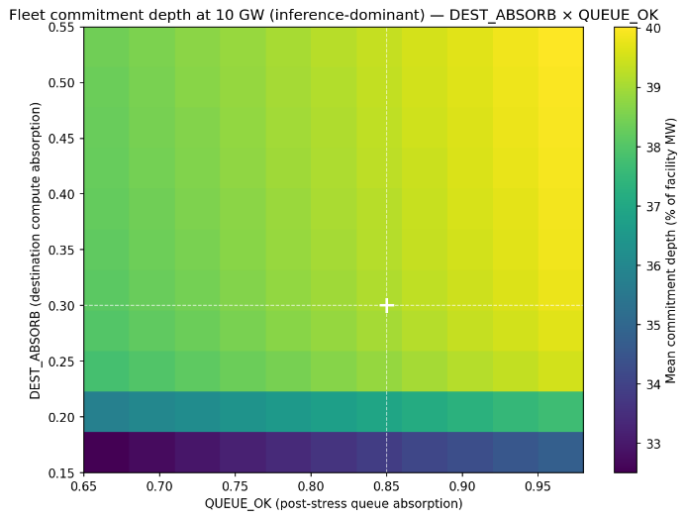  Fig. 3a. Two-dimensional sensitivity surface: mean fleet commitment depth at 10 GW across the D2 (utilization headroom) × D5 (pre-staging readiness) parameter space, with D3 and D4 held at central values. Crosshairs mark central values (D2 = 0.33, D5 = 0.65). Depth ranges from 21.6% to 34.1%. | 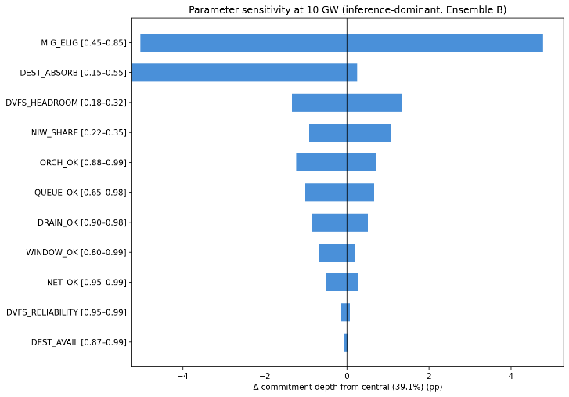  Fig. 3b. Tornado chart: one-at-a-time parameter sensitivity at 10 GW fleet scale. D2, D4, and D5 together account for the full sensitivity range. Source-side parameters (S2, S3) show zero sensitivity at fleet scale because the fleet is entirely destination-constrained.

Methods
Framework structure
The framework decomposes accreditable system slack — the fraction of nameplate inference load that is simultaneously flexible, operationally committable, and capacity-accreditable during a grid dispatch event — into three composable mechanisms operating on distinct operational axes: spatial migration across balancing authorities, temporal deferral of non-interactive workloads, and dynamic voltage-frequency scaling on residual compute. Each mechanism is decomposed into a small mini-cascade of multiplicatively-composed parameters representing the conditions that must hold for one MW of that mechanism's contribution to realize during a dispatch event. The three mini-cascades compose additively at the megawatt layer with sequential ordering — spatial first, deferral on residual after spatial, DVFS on residual after both — and an explicit overlap correction reflecting that DVFS at the source partially substitutes for deferral when work returns post-event.
The framework is reported under two scope scenarios reflecting the bi-modal heterogeneity of the projected 2030 data-center fleet: a mixed-use facility (φ_inf,mixed = 0.43, McKinsey December 2025) and an inference-dominant facility (φ_inf,dominant = 0.70, scenario construction anchored in IEA 2025 and Zhou et al. 2024). The two scopes are reported in parallel rather than as alternatives. Detailed parameter specifications, grounding categories, and composition logic are reported in the Technical Appendix.

Parameter specifications.
Specifications for all eleven framework parameters are reported in Table M1. Parameters are organized into four groups: scope scalar (1 parameter), spatial mini-cascade (6 parameters), deferral mini-cascade (3 parameters), and DVFS mini-cascade (2 parameters).
The framework's eleven parameters are graded by the strength of empirical grounding underlying their central values and ranges. The decomposition makes the framework's logic explicit. Each parameter carries a grounding category. DATA-grounded parameters are directly measured from publicly available production traces, the author's own analyses, or peer-reviewed field demonstrations: the destination decorrelation finding from 35,060 hours of day-ahead pricing across five U.S. grid regions (Section 3), the drain-time finding from 49.4 million production inference requests (Section 4), the peak-power-reduction anchor from Colangelo's field demonstration. ESTIMATED-MODERATE parameters are bounded by convergent evidence from related but non-direct measurements: hyperscaler within-facility orchestration reliability, peak-to-valley headroom for post-stress absorption. ESTIMATED-WEAK parameters are bounded only by operational floors and upper assumptions in the absence of direct measurement: destination compute absorption, contractual workload pinning, fleet-scale deferral saturation.

Table M1. Cascade parameter specifications.
Mechanism | Parameter | Symbol | Central | Distribution | Empirical basis | Key sources
Scope scalar | Mixed-use inference share | φ_inf,mixed | 0.43 | Uniform[0.30,0.50] | McKinsey Dec 2025 base case: 93.3 GW inference / 219 GW total in 2030; "more than 40 percent of data center demand" | McKinsey (2025)
Scope scalar | Inference-dominant scope | φ_inf,dominant | 0.70 | Uniform[0.60, 0.85] | Scenario construction; AI-focused HPC class per IEA and Zhou et al.; threshold below which facility no longer inference-dominant | IEA (2025); Zhou et al. (2024)
Spatial | Migration eligibility | MIG_elig | 0.65 | Uniform[0.45, 0.85] | Architectural portability (McKinsey atomizability) × unpinned (no published measurement; bounded by enterprise contractual restrictions) | McKinsey (2025); Patel et al., ISCA (2024); Zhong et al., OSDI (2024); Qin et al. (2024)
Spatial | Drain within window | DRAIN_ok | 0.95 | Uniform[0.90,0.98] | P99 drain times 4.5–12.1 s vs. 10-minute minimum dispatch window | This paper, Section 4
Spatial | Destination region availability | DEST_avail | Observed | Per-hour from data | 200 ComEd stress hours × unstressed-destination capacities from day-ahead LMP across five RTOs; capacity-weighted any-destination availability 94.5% | This paper, Section 3; IEA (2025)
Spatial | Destination compute absorption | DEST_absorp | 0.30 | Uniform[0.15,0.55] | Headroom × hardware compatibility × pre-staging; literature dispute on utilization (LBNL 40%, IEA 90%, Knittel 80%, Zhou 70-80%, Guidi 75%, Uptime <40%) | Shehabi et al., LBNL (2024); IEA (2025); Zhou et al. (2024); Knittel et al. (2025); NVIDIA CUDA documentation; NVIDIA Run:ai Model Streamer (2025)
Spatial | Network adequacy | NET_ok | 0.98 | Uniform[0.95, 0.995] | Hyperscaler wavelength purchases on a single carrier grew 133% from 18.2 Tb (2020) to 42.4 Tb (2024); Azure inter-region P50 latencies; B4 globally-deployed WAN | Jain et al., ACM SIGCOMM (2013); Zayo (2025)
Spatial | Orchestration reliability | ORCH_ok | 0.95 | Uniform[0.88, 0.99] | Within-facility production precedent at three hyperscalers; cross-facility-grid-dispatch interface novel; load balancer SLAs ≥99.99% | Zhang et al., ISCA (2021); Wu et al., ISCA (2016); Li et al., OSDI (2020); American Public Power Association (2025)
Deferral | NIW compute share | NIW_share | 0.28 (B) | Ensemble-dependent;  A: Uniform[0.10, 0.20]  B: Uniform[0.22, 0.35]  C: Uniform[0.32, 0.50] | SageServe O365 Copilot production traces: IW-F + IW-N = 72% of requests/TPS, NIW = 28% | Jaiswal et al. (2025)
Deferral | Window feasibility | WINDOW_ok | 0.95 | Uniform[0.80, 0.99] (scope-dependent) | 24-hour NIW deadline vs. 6-hour PJM emergency DR profile; production precedent in Google-TVA agreement | Jaiswal et al. (2025); American Public Power Association (2025)
Deferral | Post-stress queue absorption | QUEUE_ok | 0.85 | Uniform[0.65, 0.98] | DynamoLLM peak-to-valley ratios 3.3× to 34.6× at single-facility scale; fleet-scale saturation extrapolation novel | Stojkovic et al., HPCA (2025)
DVFS | Sustained peak-power reduction | DVFS_headroom | 0.25 (B) | Ensemble-dependent ±0.07; A: 0.18  B: 0.25  C: 0.32 | Colangelo et al. 25% sustained cluster-level peak power reduction over 3 hours; corroborated by Patel 21% inference headroom and Dynamo Fig. 13 knee | Colangelo et al. (2026); Patel et al., ASPLOS (2024); Wu et al., ISCA (2016); Kakolyris et al., IEEE CAL (2024)
DVFS | Within-window SLO compliance | DVFS_reliability | 0.98 | Uniform[0.95, 0.995] | Colangelo et al. zero SLA violations across 33 experiments / 212 jobs; corroborated by Thunderbolt and Flex production precedent | Colangelo et al. (2026); Li et al., OSDI (2020); Zhang et al., ISCA (2021)

Composition formulas
The three mini-cascades compose multiplicatively within mechanism and additively across mechanisms with sequential ordering:
Spatial mechanism:
$$M_spatial = (nameplate × (1/PUE) × φ_inf,scope) × (MIG_elig × DRAIN_ok × DEST_avail × DEST_absorb × NET_ok × ORCH_ok)$$
Deferral mechanism (sequential, on residual after spatial):
$$M_{defer}= \left(facility inference MW - M_{spatial}\right)× \left(NIW_{share}× WINDOW_{ok}× QUEUE_{ok}\right)$$
DVFS mechanism (sequential, on residual after spatial + deferral):
$$M_{DVFS}= \left(facility inference MW - M_{spatial}- M_{defer}\right)× \left(DVFS_{headroom}× DVFS_{reliability}\right)$$
Total commitment depth per facility MW:
$$Commitment depth = (M_spatial + M_defer + M_DVFS) / nameplate$$
The sequential ordering implements the overlap correction between DVFS and deferral. Colangelo et al.'s observation that 25% peak-power reduction translates to only 5% energy reduction reflects work returning post-event — that is, DVFS at the source partially substitutes for deferral. By applying DVFS only to inference residual after deferral has removed its NIW slice, the same megawatt of NIW load cannot be counted twice: it is either deferred (work pushed to post-event hours) or DVFS-reduced (work done at lower power within the dispatch window), not both.
The PUE assumption (1.3) is applied at the megawatt-translation layer inside the spatial composition formula above. Translations to facility-metered quantities in Section 6 therefore do not require an additional PUE step; commitment depth is reported as a fraction of facility nameplate directly.
Conditional Monte Carlo simulation
For each of the 200 ComEd stress hours, the conditional Monte Carlo simulation identifies the set of unstressed destination zones from DA LMP flags (the DEST_avail observation) and uses their realized capacities directly. For each unstressed destination, available headroom is computed as destination capacity × DEST_absorb. Migrating demand from the source facility or fleet is allocated across destinations in proportion to available headroom; when aggregate demand exceeds aggregate headroom, destinations fill to their individual capacities and the unallocated demand contributes nothing to the spatial mechanism (but the deferral and DVFS mechanisms still contribute on the residual).
The conditional MC uses the following parameter scheme:
Observed per-hour from empirical data (1 parameter): DEST_avail. The simulation conditions on the empirical realization rather than drawing from a distribution; this is the "conditional" in conditional Monte Carlo.
Drawn independently per iteration from specified distributions (3 parameters): DEST_absorb (Uniform[0.15, 0.55]), QUEUE_ok (Uniform[0.65, 0.98]), and one of NIW_share / DVFS_headroom per ensemble specification. These represent the residual absorption uncertainty the operator cannot observe at commitment time.
Held fixed at central values (7 parameters): φ_inf at the scope-scenario value (run separately for mixed-use and inference-dominant), MIG_elig = 0.65, DRAIN_ok = 0.95, NET_ok = 0.98, ORCH_ok = 0.95, WINDOW_ok = 0.95, DVFS_reliability = 0.98. These are either scope-defining (φ_inf), known by-construction software properties (DRAIN_ok), or high-confidence infrastructure SLAs (NET_ok, ORCH_ok, DVFS_reliability).
We additionally ran the conditional MC with PJM Dominion as the source zone as a robustness check; results are reported in Extended Data Table 3.
Variance decomposition
The unconditional cascade Monte Carlo (N = 50,000) draws all variable parameters independently from their specified distributions, computes the multiplicative-within-mechanism and additive-across-mechanism composition, and applies the commitment depth formula. φ_inf is held at one of the two scope-scenario centrals (run separately for each scope); all eleven non-scope parameters are drawn independently from their specified ranges. Variance attribution uses the η² correlation ratio, computed by digitizing each variable parameter into 20 quantile bins and measuring the between-bin variance of cascade output as a fraction of total variance.
Variance attribution under inference-dominant scope identifies five parameters that together account for over 96% of cascade output variance: DEST_absorb (η² = 0.43, 44% of total), DVFS_headroom (0.22, 22%), MIG_elig (0.13, 13%), NIW_share (0.10, 10%), and QUEUE_ok (0.07, 8%). The remaining six parameters together contribute under 4% of variance, reflecting their tighter empirical anchoring (DRAIN_ok, DEST_avail, NET_ok, DVFS_reliability) or narrower operational ranges (WINDOW_ok, ORCH_ok). Of the dominant contributors, three are ESTIMATED-WEAK or ESTIMATED-MODERATE under the framework's grounding categories (DEST_absorb, MIG_elig Component B, QUEUE_ok), and two reflect ensemble-construction uncertainty rather than measurement (DVFS_headroom, NIW_share). Variance shares for mixed-use scope are computed independently and exported in cascade_parameters.json.
Stress threshold definition
Stress hours are defined as the top 50 hours per year per zone (approximately the 99.4th percentile of each zone's four-year distribution), yielding 200 ComEd stress hours over the January 2022 through December 2025 observation period. Sensitivity analysis at alternative thresholds confirms the headline any-destination availability finding is stable: 99.0% at the baseline, varying by at most 1.25 percentage points at the top 25 and top 100 hours per year specifications. The capacity-weighted overlap declines monotonically with threshold tightness (23.9% at top 100/year, 21.6% at baseline, 15.2% at top 25/year), indicating that cross-region decorrelation strengthens at more extreme stress intensities (Extended Data Fig. 1).
Workload datasets
We analyzed 44.1 million production LLM inference requests across two Azure services (Coding and Conversation) drawn from the DynamoLLM trace release on the Azure Public Dataset repository, spanning seven days in May 2024. The underlying traces were characterized for energy-management purposes by Stojkovic et al. We separately analyzed the BurstGPT dataset (arXiv v3 release), comprising 5.29 million requests from Azure OpenAI regional endpoints over 121 days of continuous observation. Both datasets represent production inference traffic. Drain times are computed as generated tokens divided by a central generation rate of 60 tokens per second, with sensitivity across 30–120 tokens/sec reported in Extended Data Fig. 2.
The two datasets differ in temporal structure: DynamoLLM shows strong diurnal variation (3.3× peak-to-trough for conversational workloads, 34.6× for coding workloads) while BurstGPT exhibits near-continuous 24-hour activity with minimal weekly periodicity. The DynamoLLM peak-to-valley structure provides the empirical anchor for the QUEUE_ok parameter at single-facility scale (the post-stress recovery hours have meaningful absorption headroom because peak-to-valley ratios are wide). This divergence reflects differing user populations and does not affect the DRAIN_ok parameterization, which depends on per-request drain time rather than aggregate traffic volume.
Per-GW parametric sweep
The fleet-level analysis evaluates commitment depth as a continuous function of fleet size from 0.5 to 15 GW under each scope scenario. At each fleet size, the migrating demand in each stress hour is fleet_MW × (1/PUE) × φ_inf,scope × MIG_elig × DRAIN_ok (the source-side spatial-cascade product, evaluated at central values for the fixed parameters). This demand competes for the same per-hour destination headroom computed in the conditional MC. The same DEST_absorb / QUEUE_ok / ensemble draws are reused across all fleet sizes to isolate the scale effect from Monte Carlo variance. The sweep identifies the spatial contention onset — the fleet size at which more than 50% of draw-hour combinations are destination-constrained for spatial migration. Within the swept range, spatial contention does not exceed the 50% threshold under either scope scenario, with onset projected beyond 15 GW. The fleet commitment-depth curve under each scope and the per-fleet-size constraint percentages are reported in Section 5.
Sensitivity analysis
The two-dimensional sensitivity surface evaluates fleet commitment depth at 10 GW across a 10×10 grid of DEST_absorb and QUEUE_ok values, under the inference-dominant scope. Other parameters are held at the conditional MC central values, and DEST_avail is observed per-hour from the empirical pricing data as in the base conditional MC. Each grid point computes deterministic hour-by-hour commitment depth under these fixed parameter choices.
The tornado chart quantifies one-at-a-time sensitivity at 10 GW fleet size across the variable parameters under the inference-dominant scope, sweeping each from its lower to upper bound while holding all others at central values. φ_inf is excluded as a scope-defining parameter (the two-scope reporting itself surfaces this sensitivity). DEST_avail is swept parametrically across its range rather than observed per-hour, which enables direct comparability of DEST_avail's uncertainty envelope against the other parameters.
System-level calculations
System-level calculations evaluate avoided capacity cost and interconnection acceleration value at two reference scales (1 GW facility and 10 GW fleet), under each of the two scope scenarios, using the commitment depths reported in Section 5. The 92% ELCC applied to committed MW follows PJM precedent for demand response resources. Avoided capacity cost is computed using the levelized CT cost of $180,000/MW-yr from the E3 2025 Resource Adequacy Study for Illinois. Full assumptions and scenario values for the interconnection acceleration NPV are reported in Extended Data Table 2.
Data and Code Availability
Day-ahead locational marginal pricing data are publicly available from the respective RTO market portals: PJM Data Miner 2 (https://dataminer2.pjm.com), ERCOT Market Information System (https://www.ercot.com/mp/data-products), CAISO OASIS (http://oasis.caiso.com), MISO Market Reports (https://www.misoenergy.org/markets-and-operations/real-time--market-data), and NYISO Custom Reports (https://www.nyiso.com/custom-reports). The Microsoft Azure LLM Inference Dataset 2024 (DynamoLLM traces) is publicly available at https://github.com/Azure/AzurePublicDataset under AzureLLMInferenceDataset2024. The BurstGPT dataset is publicly available at https://github.com/HPMLL/BurstGPT. Data center location data are from the U.S. Department of Energy / National Renewable Energy Laboratory Accelerating Speed to Power Data Viewer (https://maps.nrel.gov/speed-to-power), accessed via its public backend API. Analysis code and processed datasets are available at https://github.com/ctdunlap32/data-center-flexibility-resource-adequacy.
Acknowledgments
The author thanks Robert Rosner for advisory support. This research was supported by the Bartlett Fellowship at the Energy Policy Institute at Chicago (EPIC). The author used Anthropic's Claude for assistance with structural organization, literature search, computational code development, and prose drafting. All analytical design, empirical methodology, results, interpretation, and final editorial decisions are the author’s own.
References
[1] PJM Interconnection. 2025 Long-Term Load Forecast (2025).
[2] PJM Interconnection. 2027/2028 Base Residual Auction Report (2025).
[3] LBNL. Queued Up: Characteristics of Power Plants Seeking Transmission Interconnection (2024).
[4] Norris, T. H., Profeta, T., Patino-Echeverri, D., & Cowie-Haskell, A. Rethinking Load Growth: Assessing the Potential for Integration of Large Flexible Loads in US Power Systems. NI R 25-01, Nicholas Institute for Energy, Environment & Sustainability, Duke University (March 2025).
[5] Colangelo, P., Coskun, A. K., Megrue, J., Roberts, C., Sengupta, S., Sivaram, V., Tiao, E., Vijaykar, A., Williams, C., Wilson, D. C., Records, B., MacFarland, Z., Dreiling, D., Morey, N., Ratnayake, A., & Vairamohan, B. AI data centres as grid-interactive assets. Nature Energy 11, 254–261 (2026). https://doi.org/10.1038/s41560-025-01927-1.
[6] Zheng, J., Chien, A. A., and Suh, S. Mitigating curtailment and carbon emissions through load migration between data centers. Joule 4, 2208–2222 (2020).
[7] Zhang, W., Roald, L. A., Chien, A. A., Birge, J. R., and Zavala, V. M. Flexibility from networks of data centers: A market clearing formulation with virtual links. Electric Power Systems Research 189, 106723 (2020).
[8] U.S. Department of Energy / National Renewable Energy Laboratory. "Data Center Demand Capacity by County." Accelerating Speed to Power Data Viewer. maps.nrel.gov/speed-to-power (accessed December 2025)
[9] PJM Interconnection. PJM Manual 13: Emergency Operations. Rev. 97, effective November 20, 2025.
[10] Deloitte. Technology, Media and Telecommunications Predictions 2026 (November 2025).
[11] M Arora, C., Sorel, M., Sachdeva, P., Bhan, A., He, J., Shaw, N., Garg, R., & Ravishankar, S. The next big shifts in AI workloads and hyperscaler strategies. McKinsey & Company, Technology, Media & Telecommunications Practice (December 2025).
(11B) Patterson, D., Gonzalez, J., Hölzle, U., Le, Q., Liang, C., Munguia, L.-M., Rothchild, D., So, D. R., Texier, M., & Dean, J. The carbon footprint of machine learning training will plateau, then shrink. IEEE Computer 55(7), 18–28 (2022).

[12] Stojkovic, J., Zhang, C., Goiri, Í., Torrellas, J., & Choukse, E. DynamoLLM: Designing LLM Inference Clusters for Performance and Energy Efficiency. Proc. HPCA 2025, pp. 1348–1362.
[13] Wang, Y., Chen, Y., Li, Z., Kang, X., Zhao, Y., Ma, Z., Bao, H., Mei, X., Liu, Y., Chen, Y., Zhang, Q., Guo, M., Jin, W., Guo, M., & Cui, H. BurstGPT: A Real-World Workload Dataset to Optimize LLM Serving Systems. arXiv:2401.17644v3 (2024). Dataset: github.com/HPMLL/BurstGPT.
[14] Patel, P., Choukse, E., Zhang, C., Goiri, Í., Warrier, B., Mahalingam, N., & Bianchini, R. Characterizing Power Management Opportunities for LLMs in the Cloud. Proc. ASPLOS 2024..
[15] Cortez, E. et al. Resource Central: Understanding and predicting workloads for improved resource management in large cloud platforms. In Proceedings of SOSP (2017).
[16] PJM Interconnection. 2025 Effective Load Carrying Capability and Reserve Requirement Study (2025).
[17] E3 (Energy and Environmental Economics). 2025 Resource Adequacy Study for Illinois (2025).
[18] NREL. 2024 Annual Technology Baseline. atb.nrel.gov/electricity/2024.
[19] Zhang, W. and Zavala, V. M. Remunerating space–time, load-shifting flexibility from data centers in electricity markets. Applied Energy 326, 119930 (2022).
[20] Jain, S. et al. B4: Experience with a globally-deployed software defined WAN. In Proceedings of ACM SIGCOMM (2013).

Extended Data

Extended Data Fig. 1. Stress threshold sensitivity.
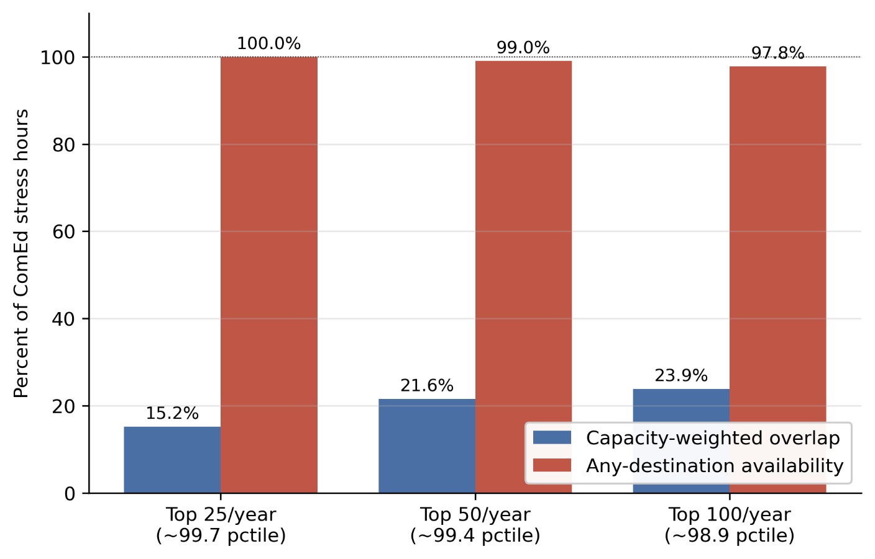
Capacity-weighted destination overlap and any-destination availability at three alternative stress-hour thresholds. Baseline: top 50 hours per year per zone (~99.43 percentile, 200 ComEd stress hours total). Alternatives: top 25 (~99.71st percentile) and top 100 (~98.86th percentile). Any-destination availability varies by at most 1.25 percentage points across thresholds; capacity-weighted overlap declines monotonically with threshold tightne

Extended Data Table 1. Multi-source generalizability.
Source Zone | Source RTO | Source IC | Stress Hours | N Cross RTO Dests | N Cross IC Dests | Dynamic Avail Cross RTO | Dynamic Avail Cross IC | All Stressed Hours | Cap Weighted Overlap | Summer Hours | Summer Avail | Winter Hours | Winter Avail
PJM_COMED | PJM | Eastern | 200 | 17 | 6 | 99 | 94 | 2 | 21.6 | 102 | 100 | 87 | 97.7
PJM_DOM | PJM | Eastern | 200 | 17 | 6 | 99.5 | 99 | 1 | 11.3 | 73 | 100 | 70 | 98.6
ERCOT_LZ_NORTH | ERCOT | ERCOT | 200 | 20 | 20 | 100 | 100 | 0 | 8.2 | 104 | 100 | 39 | 100
CAISO_NP15 | CAISO | Western | 200 | 22 | 22 | 100 | 100 | 0 | 7.8 | 39 | 100 | 137 | 100
Capacity-weighted destination overlap computed with alternative source zones (PJM-DOM, ERCOT-LZ-NORTH, CAISO-NP15, others). Headline decorrelation result holds across all tested source zones.
Extended Data Table 2. Interconnection acceleration NPV assumptions.
Parameter | Value | Description
GPU_PER_MW_GRID | 603 | GPUs per MW of grid capacity (derived: 10.2 kW / 8 GPUs Ã— 1.3 PUE)
GPU_RATE_HR | 2.2 | H100 spot rate, USD/hour (Jan 2026)
WACC | 0.1 | Weighted average cost of capital
ACCELERATION_YEARS_CENTRAL | 3 | Queue acceleration window, central case (years)
FACILITY_SIZE_MW | 1000 | Reference facility size (MW)
DEPTH_1GW_INF_DOM_MEAN | 0.398 | Mean commitment depth at 1 GW (inference-dominant scope) underlying NPV ratio
NPV_CONSERVATIVE_BILLIONS_USD | 16.1 | NPV of accelerated interconnection, conservative (2-year acceleration)
NPV_CENTRAL_BILLIONS_USD | 23.1 | NPV of accelerated interconnection, central (3-year acceleration)
NPV_OPTIMISTIC_BILLIONS_USD | 29.5 | NPV of accelerated interconnection, optimistic (4-year acceleration)
DOMINANCE_RATIO | 518.2 | Ratio of IX NPV (central) to annual total capacity revenue at mean commitment depth
Input parameters and central estimate for the interconnection acceleration NPV calculation reported in Section 6

Extended Data Table 3.Source-zone robustness check.
Source zone | Configuration | Scope | Mean | P5 | CVaR | n hours
PJM ComEd | Single facility (500 MW) | Inference-dominant | 40.0% | 38.5% | 33.1% | 200
PJM ComEd | Single facility (500 MW) | Mixed-use | 24.6% | 23.7% | 20.6% | 200
PJM Dominion | Single facility (500 MW) | Inference-dominant | 40.2% | 38.7% | 36.7% | 200
PJM Dominion | Single facility (500 MW) | Mixed-use | 24.7% | 23.8% | 22.6% | 200
PJM ComEd | Empirical fleet | Inference-dominant | 33.6% | 21.1% | 19.8% | 30 co-stress
PJM ComEd | Empirical fleet | Mixed-use | 21.1% | 13.2% | 12.3% | 30 co-stress
PJM Dominion | Empirical fleet | Inference-dominant | 40.0% | 38.4% | 32.8% | 145 co-stress
PJM Dominion | Empirical fleet | Mixed-use | 24.6% | 23.7% | 20.8% | 145 co-stress
Source-zone robustness check using PJM Dominion as an alternative source. Single-facility commitment depth is essentially identical across the two source zones (40.0% vs 40.2% inference-dominant), confirming that the cascade math is source-invariant at small scale. The empirical fleet result differs more substantially because the migrating fleet definition shifts: with Dominion as source, the fleet outside Dominion excludes the largest data center zone in PJM, leaving a smaller migrating fleet (max 6,678 MW) that experiences less destination contention than the ComEd-source fleet (max 14,379 MW). The 30-vs-145 co-stress hour count reflects geographic differences in stress patterns: ComEd stress events are more locally concentrated, while Dominion stress events more frequently coincide with broader PJM stress.

PJM Interconnection, 2027/2028 Base Residual Auction Report (Valley Forge, PA: PJM Interconnection, December 17, 2025).
PJM Interconnection, 2026 Long-Term Load Forecast Report (Valley Forge, PA: PJM Interconnection, January 14, 2026), Tables B-9 and B-9b.
Lawrence Berkeley National Laboratory, Queued Up: 2025 Edition, Characteristics of Power Plants Seeking Transmission Interconnection As of the End of 2024. (Berkeley, CA: LBNL, 2025).
Norris, T. H., Profeta, T., Patino-Echeverri, D., & Cowie-Haskell, A. Rethinking Load Growth: Assessing the Potential for Integration of Large Flexible Loads in US Power Systems. NI R 25-01, Nicholas Institute for Energy, Environment & Sustainability, Duke University (March 2025).
International Energy Agency. Energy and AI. World Energy Outlook Special Report (2025).
Knittel, C., Senga, M., & Wang, S. Flexible Data Centers and the Grid: Lower Costs, Higher Emissions? NBER Working Paper 34065 (2025).
Zhang, C., et al. Flex: High-availability datacenters with zero reserved power. ISCA (2021).
Stojkovic, J., Zhang, C., Goiri, Í., Torrellas, J., & Choukse, E. DynamoLLM: Designing LLM Inference Clusters for Performance and Energy Efficiency. Proc. HPCA 2025, pp. 1348–1362
Li, L., et al. Thunderbolt: Throughput-optimized, quality-of-service-aware power capping at scale. OSDI (2020)
Patel, P., Choukse, E., Zhang, C., Goiri, Í., Warrier, S., Mahalingam, N., & Bianchini, R. Splitwise: Efficient generative LLM inference using phase splitting. ISCA (2024).
Zhong, Y., Liu, S., Chen, J., Hu, J., Zhu, Y., Liu, X., Jin, X., & Zhang, H. DistServe: Disaggregating prefill and decoding for goodput-optimized large language model serving. OSDI (2024).
Qin, L., et al. Mooncake: Trading more storage for less computation — a KVCache-centric architecture for serving LLM chatbot. (Moonshot AI, 2024).
Jaiswal, S., Jain, K., Simmhan, Y., Parayil, A., Mallick, A., St. Amant, R., et al. SageServe: Optimizing LLM Serving on Cloud Data Centers with Forecast Aware Auto-Scaling. arXiv:2502.14617 (2025).
Colangelo, P., Coskun, A. K., Megrue, J., Roberts, C., Sengupta, S., Sivaram, V., Tiao, E., Vijaykar, A., Williams, C., Wilson, D. C., Records, B., MacFarland, Z., Dreiling, D., Morey, N., Ratnayake, A., & Vairamohan, B. AI data centres as grid-interactive assets. Nature Energy 11, 254–261 (2026). https://doi.org/10.1038/s41560-025-01927-1.
M Arora, C., Sorel, M., Sachdeva, P., Bhan, A., He, J., Shaw, N., Garg, R., & Ravishankar, S. The next big shifts in AI workloads and hyperscaler strategies. McKinsey & Company, Technology, Media & Telecommunications Practice (December 2025).
International Energy Agency. Energy and AI. World Energy Outlook Special Report (2025).
Zhou, X., et al. AI-Focused HPC Data Centers Can Provide More Power Grid Flexibility and at Lower Cost. arXiv:2410.17435 (2024).
U.S. Department of Energy / National Renewable Energy Laboratory. "Data Center Demand Capacity by County." Accelerating Speed to Power Data Viewer. maps.nrel.gov/speed-to-power (accessed December 2025)
PJM Interconnection. PJM Manual 13: Emergency Operations. Rev. 97, effective November 20, 2025.

