Quantifying AI data center flexibility as a resource adequacy asset
Chris Dunlap
Abstract
AI data centers are entering resource adequacy planning as inflexible firm load, a treatment increasingly difficult to sustain at the scale of projected demand. AI inference workloads are flexible along three operational axes: spatial migration across grid regions, temporal deferral of non-interactive workloads, and dynamic voltage-frequency scaling on residual compute. We develop an eleven-parameter framework to quantify this three-mechanism flexibility in the capacity-accreditation terms that resource adequacy planning requires, with parameters graded against available empirical evidence. Tested against four years of day-ahead pricing across five U.S. grid regions and 49.4 million production inference requests, the framework yields single-facility commitment depths of approximately 24.6% (mixed-use scope) and 40.0% (inference-dominant scope), declining to 24.1% and 38.5% at 10-GW fleet scale. The dominant remaining uncertainties are institutional rather than physical, identifying where data center operators and grid planners can target the operational and policy levers that translate physical flexibility into realized grid value.

In PJM Interconnection, the 2027/2028 capacity auction fell 6.6 GW short of the reliability requirement. Large load adjustments, predominantly for data centers, total 33.7 GW by 2030 in PJM's 2026 Long-Term Load Forecast and account for effectively all net peak demand growth. Generation and storage projects have median completion timelines exceeding five years, with only 13% reaching commercial operation, and permitting and equipment supply-chain bottlenecks cannot be compressed by capital alone.
Resource adequacy planning currently treats data-center load as firm at each facility, requiring corresponding procurement of generating capacity and reserve margin for every additional megawatt. This treatment reflects how operators have historically operationalized service-level contracts to guarantee uninterrupted compute, which requires maintaining locally firm power draw at every facility. The aggregation of these local firmness commitments across a rapidly growing fleet is what now produces the system-level capacity requirement exceeding what the interconnection queue can deliver.
Policy research has begun to argue that load flexibility should be a primary response. The IEA’s 2025 Energy and AI report finds that data-center flexibility for as little as 0.1% to 1% of annual hours would suffice to integrate all projected 2030 capacity additions into existing U.S., E.U., and Chinese electricity systems. Recent work has begun to challenge the technical premise that this firmness is physically necessary, with production demonstrations at major hyperscalers establishing three operational mechanisms: spatial migration of inference workloads across grid regions, temporal deferral of non-interactive workloads, and dynamic voltage-frequency scaling on residual compute (Section 2). Across these analyses, the technical potential is not in dispute; what differs is the unit of analysis and the mechanism set considered.
Here we develop a framework for valuing the composed operational flexibility of AI inference data centers as an accreditable resource adequacy asset. The framework comprises four analytical components: an eleven-parameter decomposition organized around the three operational mechanisms identified above; an empirical stress-decorrelation analysis using four years of day-ahead locational marginal pricing across five U.S. grid regions; a workload characterization grounded in 49.4 million production inference requests; and a conditional Monte Carlo simulation that conditions on observed per-hour grid states.
2. Framework: Decomposing composed operational flexibility
The mechanisms underlying composed flexibility are well established in the systems literature and deployed at production scale. Microsoft's Flex, Facebook Dynamo, and Google Thunderbolt establish datacenter-wide power management with millisecond control latencies and production-verified fault tolerance. Splitwise, DistServe, and Mooncake demonstrate intra-facility phase-disaggregated LLM inference at production scale, including in Moonshot AI’s deployed Kimi serving platform. SageServe’s analysis of Microsoft O365 Copilot production traces documents predictable workload tiering with hours-scale deadlines for non-interactive workloads. Colangelo et al. demonstrate 25% sustained cluster-level peak-power reduction for three hours on a mixed AI workload ensemble at Oracle Phoenix, with zero SLA violations across 33 experiments. What this systems literature has not done is translate operational flexibility into capacity-accreditation terms that resource adequacy planning and capacity markets require.
The framework developed here is that translation. It decomposes the conditions under which nameplate inference load delivers accreditable resource adequacy value, composing them into commitment depth (the megawatt-equivalent grid value per megawatt of nameplate inference load). Within each of the three mechanisms identified in Section 1, parameters compose multiplicatively. Across mechanisms, contributions add at the megawatt layer with sequential ordering as defined above. The sequential ordering implements an explicit overlap correction: within-facility power management at the source partially substitutes for deferral when work returns post-event, so the same megawatt of non-interactive compute cannot be counted both as deferred and as DVFS-reduced.
The framework is reported under two scope scenarios reflecting the bi-modal heterogeneity of the projected 2030 data center fleet. The mixed-use scenario applies the cascade to typical hyperscaler colocation facilities for which inference is approximately 43% of IT compute, anchored in McKinsey's December 2025 projection that inference workloads will reach more than 40% of total data-center demand. The inference-dominant scenario, applies the cascade to purpose-built AI campuses for which inference exceeds 70% of IT compute, a class of facilities now emerging in industry and modeled distinctly in the IEA's 2025 Energy and AI report and in Zhou et al.'s 2024 analysis of AI-focused HPC. The two scenarios are reported in parallel because the actual 2030 fleet will include both, and the difference between their commitment depths is itself a finding: the marginal flexibility gain from purpose-built siting is decomposable.
The largest residual uncertainties — destination utilization headroom (where literature estimates span 40-90%), fleet-scale post-stress queue absorption, and contractual workload pinning — are decision-relevant rather than physical. They reflect institutional and contractual choices that policy can shape, not the physics of compute migration or power management. Parameter definitions, grounding categories, and composition logic are reported in Methods Table M1.
3. Cross-region stress decorrelation
Spatial compute migration requires that at least one destination grid region is operating under normal conditions when the source region is stressed. We test this condition empirically using 35,060 hours of day-ahead locational marginal pricing (DA LMP) data from January 2022 through December 2025, spanning five U.S. grid regions: PJM, ERCOT, CAISO, MISO, and NYISO. Within each region we identify destination pricing zones co-located with data center facilities using county-level capacity data from the U.S. Department of Energy / National Renewable Energy Laboratory Accelerating Speed to Power Data Viewer. Stress hours are defined as the top 200 DA LMP hours per zone over the four-year window (the 99.4th percentile; see Methods for threshold sensitivity).
Using the ComEd zone in Northern Illinois as the primary source region, we compute the fraction of source stress hours in which at least one cross-region destination zone exhibits a DA LMP below its stress threshold. Of the 200 observed ComEd stress hours, at least one cross-region destination was available in 198, corresponding to a dynamic availability of 99.0%. The two failure hours occurred during the January 2024 Arctic Blast. The decorrelation reflects the electrical topology of the North American transmission system: ERCOT operates as an electrically isolated interconnection, and CAISO’s temporal offset and weather patterns are largely independent from the Midwest. Capacity-weighted stress overlap between ComEd and cross-interconnection destinations ranges from 3.7% (ERCOT, summer) to 14.0% (CAISO, annual), with CAISO exhibiting zero summer overlap across the four-year study period (Fig. 1). Same-interconnection destinations exhibit substantially higher overlap: MISO zones range from 43% to 66%, NYISO zones from 29% to 41%, consistent with shared exposure to regional weather systems and partial electrical coupling.
We replicate the analysis from three additional source zones to test generalization beyond the ComEd perspective: PJM-DOM (Northern Virginia, approximately 9,400 MW of installed data center capacity), ERCOT-LZ-NORTH (Dallas-Fort Worth), and CAISO-NP15 (Silicon Valley). Dynamic availability is 99.5% from PJM-DOM (one failure hour, the same 2024 Arctic Blast event) and 100% from both ERCOT-LZ-NORTH and CAISO-NP15.
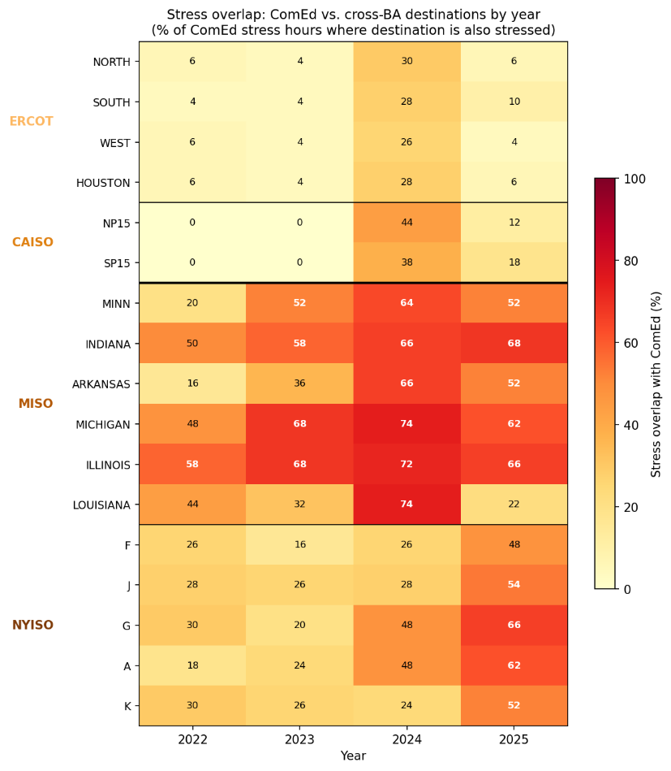
Fig. 1. Stress overlap between ComEd and 17 cross-BA destination zones by year, 2022–2025. Each cell shows the percentage of ComEd's 50 annual stress hours in which the destination zone was simultaneously stressed. Cross-interconnection destinations (ERCOT, CAISO) exhibit overlap below 30% in all years; same-interconnection destinations (MISO, NYISO) range from 16% to 74%, consistent with shared exposure to regional weather systems. The 2024 column reflects elevated co-stress during the January 2024 Arctic Blast. CAISO coverage begins November 2022; earlier periods are treated as available per Methods.
4. Workload characterization
The drain-within-window parameter (DRAIN_ok) captures whether active inference requests at a source facility can complete within the grid operator's emergency dispatch window. We validate drain time using two independent production inference datasets totaling 49.4 million requests over a combined 128 days of observation (see Methods for dataset descriptions). P99 drain times range from 4.5 to 12.12 seconds across model configurations and datasets, approximately two orders of magnitude below PJM's minimum dispatch window of 10 minutes, indicating that DRAIN_ok = 0.95 is a conservative parameterization. The 5% excluded by DRAIN_ok accommodates long-running or batched inference requests, multi-turn conversational sessions with persistent state, and potential future workload types with longer completion times.
5. Conditional Monte Carlo validation
We develop a conditional Monte Carlo simulation that conditions on observed per-hour grid states to capture how commitment depth depends on fleet size, destination contention, and post-stress recovery saturation during specific stress events. The simulation is run separately under each of the two scope scenarios; results are reported in parallel.
For a representative 500 MW inference-dominant facility, the conditional Monte Carlo yields a mean commitment depth of 40.0% under the inference-dominant scope (φ_inf = 0.70), with 5th percentile of 38.5% and conditional expected shortfall below the 5th percentile of 33.1%. Under the mixed-use scope (φ_inf = 0.43), the corresponding values are mean 24.6%, P5 23.7%, and CVaR 20.6%. The framework's conservatism at single-facility scale arises from a ratio effect: aggregate available headroom across unstressed destinations substantially exceeds the demand from a single migrating facility in the large majority of stress hours, and the deferral and DVFS mechanisms operate independently of destination contention.
When extended to simultaneous migration by geographically distributed facilities, commitment depth becomes scale-dependent. We first evaluate an empirical fleet defined by the geographic distribution of PJM data center capacity across load zones, with per-hour co-stress identified from the intra-PJM coincidence matrix described in Section 3. Across the 30 ComEd stress hours where at least one other PJM zone is also stressed, the migrating fleet averages 4,729 MW (range 747–14,379 MW), with substantial variation driven by whether the Dominion zone in Northern Virginia (9,431 MW of data center capacity) is co-stressed with ComEd. This empirical fleet yields a mean commitment depth of 33.6% under inference-dominant scope and 21.1% under mixed-use, with conditional expected shortfall below the 5th percentile of 19.8% and 12.3% respectively. Mapped through PJM's 92% demand-response ELCC, this fleet would be credited with approximately 19.4% (inference-dominant) or 12.1% (mixed-use) of accredited capacity per fleet MW.
We then evaluate commitment depth as a continuous function of fleet size using a parametric sweep from 0.5 to 15 GW. Under the inference-dominant scope, commitment depth declines from 39.8% at 1 GW to 38.5% at 10 GW; under the mixed-use scope, from 24.6% at 1 GW to 24.1% at 10 GW. The decline is driven primarily by destination contention engaging spatial migration: the share of Monte Carlo draws that are destination-constrained rises from 4.9% at 1 GW to 25.7% at 10 GW under the inference-dominant scope, and from 3.0% to 8.5% under the mixed-use scope. Spatial contention does not exceed the 50% threshold within the swept range, with onset projected beyond 15 GW. The decline in mean commitment depth is mild because deferral and DVFS contribute additively across all fleet sizes and do not saturate within the range evaluated. The 5th percentile shows a sharper decline (from 38.1% to 25.2% under inference-dominant; from 23.6% to 16.1% under mixed-use), reflecting that destination contention binds most aggressively in the worst stress hours.
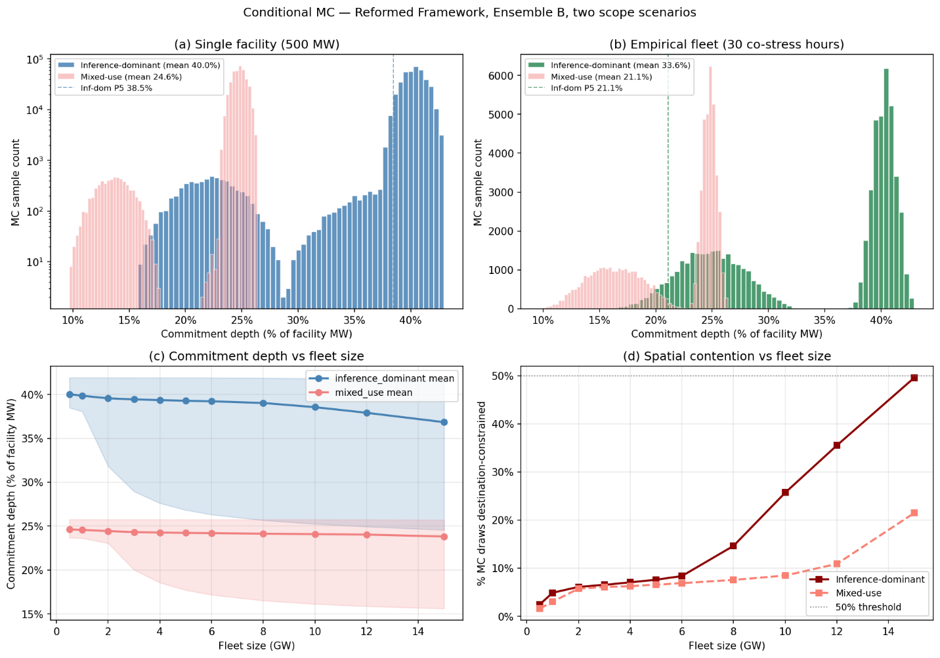
Fig. 2. Conditional Monte Carlo commitment depth distributions and scale dependence, ComEd source zone, 2022–2025. (a) Single-facility (500 MW) commitment depth distribution under inference-dominant scope (φ_inf = 0.70, primary distribution) with mixed-use scope (φ_inf = 0.43) overlaid in lower opacity. Mean 40.0% inference-dominant, 24.6% mixed-use; 5th percentiles 38.5% and 23.7%. (b) Empirical fleet commitment depth distribution across 30 ComEd stress hours where at least one other PJM zone is also stressed; migrating fleet ranges 747–14,379 MW. Mean 33.6% inference-dominant, 21.1% mixed-use. (c) Per-GW commitment depth sweep from 0.5 to 15 GW under both scopes, with mean curves and P5–P95 bands; the secondary axis (right) shows the percentage of Monte Carlo draws destination-constrained, rising from 4.9% at 1 GW to 25.7% at 10 GW under the inference-dominant scope. 2,000 draws per stress hour; full parameter specification in Methods Table M1
6. System-level implications
At PJM's 92% demand-response ELCC, a 1 GW inference-dominant facility's mean commitment depth of 39.8% implies 367 MW accredited; at 10 GW fleet scale, 38.5% mean implies 3,546 MW. Mixed-use scope yields 226 MW and 2,216 MW respectively. P5-based accreditation would yield 350 MW (1 GW inference-dominant), 2,322 MW (10 GW inference-dominant), 217 MW (1 GW mixed-use), and 1,483 MW (10 GW mixed-use); the gap between mean-based and P5-based accreditation is small at single-facility scale (16 MW under the inference-dominant scope) but grows substantially at fleet scale (1,224 MW at 10 GW).
At E3’s levelized CT cost of $180,000/MW-yr (2025 Resource Adequacy Study for Illinois) , avoided capacity cost is approximately $66M/yr for a 1 GW inference-dominant facility, $638M/yr for a 10 GW fleet, and respectively $41M/$399M under mixed-use scope. From the operator’s perspective, interconnection acceleration could provide a far larger incentive: using a three-year acceleration window for a 1 GW facility, central NPV is approximately $23.1B (Methods; Extended Data Table 2), significantly exceeding the present value of avoided capacity payments over a comparable horizon. The dominance ratio is robust across both scopes because IX NPV scales with foregone compute revenue while avoided capacity cost scales with commitment depth directly.
7. Discussion
Several limitations qualify these results. The parameters that dominate model uncertainty — destination compute absorption (DEST_absorb), the unpinned fraction of migration eligibility (MIG_elig Component B), and post-stress queue absorption at fleet scale (QUEUE_OK) — are not directly observable in public data. The literature dispute on destination utilization is particularly material, with credible estimates spanning a factor of two from LBNL's 40% modeling assumption to the IEA's reported 90% for accelerated servers. The cascade and conditional Monte Carlo do not provide a precise universal estimate; rather, they show that once cross-region migration feasibility and dispatch-window compliance are established empirically (Sections 3 and 4), the remaining uncertainty concentrates in a small set of operational and institutional choices. Two further caveats apply: the system-level calculations apply PJM's 92% ELCC for demand response, but the conditional Monte Carlo tail profile suggests a full sequential reliability determination would yield a different value; and while drain-time consistency across the two production datasets provides partial cross-validation, generalization to other providers, model architectures, and deployment configurations remains open. We additionally verified source-invariance at single-facility scale by replicating the analysis with PJM Dominion as the source zone (40.2% mean commitment depth inference-dominant vs 40.0% with ComEd; see Extended Data).
The flexibility quantified here is a physical property of multi-region, multi-mechanism compute infrastructure: inference workloads can be geographically relocated, temporally deferred, and power-managed during stress events. The relevant counterfactual is not a grid without data centers but a grid with data centers treated as inflexible firm load — the current planning convention, under which every megawatt of data center load requires corresponding generation or storage procurement. If some fraction of that load is demonstrably flexible, failing to recognize it results in over-procurement at ratepayer cost.
The concentrated uncertainty is decision-relevant rather than irreducible. DEST_absorb reflects how much GPU headroom operators choose to maintain at destination facilities, the compatibility of destination hardware with source workloads, and the aggressiveness of model weight pre-staging — each an operational decision, not a physical constraint. MIG_elig Component B reflects contractual workload pinning, a commercial property that standardized DR-participation contract language could tighten. QUEUE_OK reflects whether multiple facilities defer into coordinated or uncoordinated recovery windows; aggregator-level visibility would directly reduce the fleet-scale saturation. The gap between physical potential and realized commitment depth is therefore governed by institutional choices — disclosure requirements, contractual standardization, coordination mechanisms — not by the physics of compute itself.
Each dominant parameter corresponds to a concrete policy or investment lever. The two-dimensional sensitivity surface (Fig. 3a) shows mean commitment depth at 10 GW inference-dominant ranges from 32.5% to 40.0% across the plausible ranges of DEST_absorb and QUEUE_OK; the tornado chart (Fig. 3b) confirms that DEST_absorb, QUEUE_OK, and MIG_elig together account for the dominant share of fleet-scale sensitivity, while parameters with tight empirical anchoring show near-zero sensitivity. Source-side parameters do not change fleet-scale outcomes materially because the fleet is destination-constrained for spatial migration and queue-constrained for deferral. DEST_absorb is the most directly actionable, requiring no change in hardware or workload composition. The IEA 2025 Energy and AI report and Knittel et al.'s capacity-expansion modeling each independently identify these institutional levers as the binding constraint, arrived at through methodologies distinct from the bottom-up cascade developed here; the cascade complements both by providing endogenous determination of which flexibility levels are physically defensible and by addressing the spatial direction Zhou et al. identified as future work.
The scale dependence identified in Section 5 implies that accreditation should distinguish between individual facility commitments and fleet-level contributions, and between the three mechanisms. Aggregation of spatial-migration commitments across operators could allocate destination headroom more efficiently than uncoordinated facility-level allocation; aggregation of deferral commitments could prevent post-stress queue saturation through coordinated recovery-window utilization. DVFS commitments require no inter-facility coordination and can be accredited at the facility level. The three mechanisms differ structurally in saturation: DVFS contributes additively across all fleet sizes, deferral remains nearly constant, and only spatial migration shows scale-dependent decline. Operators can credibly bid based on the mean at single-facility scale where the distribution is sharply concentrated near 40% inference-dominant; at fleet scale, the wider mean-vs-tail gap requires explicit accreditation choices between the two metrics.
Production precedent for AI-inference-specific demand response is not hypothetical. Google's 2025 agreements with the Tennessee Valley Authority and Indiana Michigan Power explicitly target machine-learning workloads, following a demonstration with Omaha Public Power District in which Google reduced ML workload power demand during three grid stress events. Google's published framing acknowledges both the potential and the binding constraint on the framework's commitment depth: high reliability requirements for production services. The IEA's 2025 estimate of approximately USD 700 per MWh of energy shifted clarifies what the cascade's decomposition implies for mechanism design: composed flexibility has capacity-adequacy value at the hours when capacity is scarce, not energy-market value at the hours when energy is cheap, and policy frameworks should target the former.
The framework proposed here reallocates reliability risk. Under current practice, the grid operator bears the full obligation to procure capacity at nameplate rating, with procurement costs allocated to retail ratepayers. Under this framework, the data center operator assumes responsibility for managing a portion of its own power availability through three composable mechanisms. The cross-region decorrelation demonstrated in Section 3 is a physical property of the North American transmission system; within-facility power management precedent and multi-region infrastructure are established at major hyperscalers. What remains is institutional mechanism design: flexible interconnection frameworks for facilities in the interconnection queue and accredited demand response participation for operating facilities, mutually exclusive and sequenced by grid position. The U.S. Department of Energy has explicitly called for the development of a flexibility taxonomy and framework to guide implementation; the framework developed here responds to that call. Direct empirical measurement of the dominant parameters would sharpen quantitative predictions, but the institutional gap is the binding constraint on realized value.
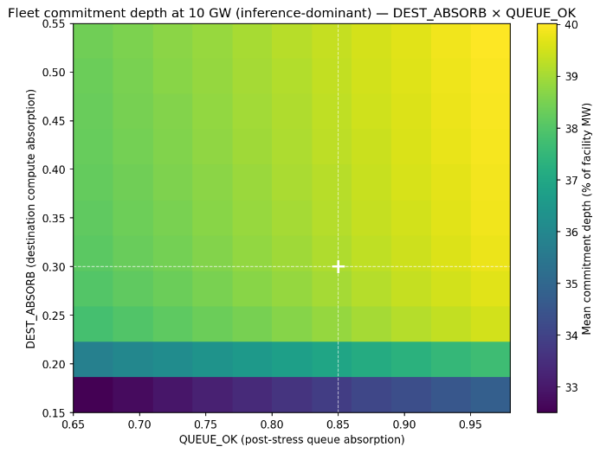  Fig. 3a. Two-dimensional sensitivity surface: mean commitment depth at 10 GW fleet scale under inference-dominant scope, swept across the plausible ranges of DEST_absorb (Uniform[0.15, 0.55]) and QUEUE_OK (Uniform[0.65, 0.98]). Other parameters held at central values; DEST_avail observed per-hour from the empirical pricing data. Commitment depth ranges from 32.5% (joint-pessimistic corner) to 40.0% (joint-optimistic corner). Crosshairs mark central values (DEST_absorb = 0.30, QUEUE_OK = 0.85). | 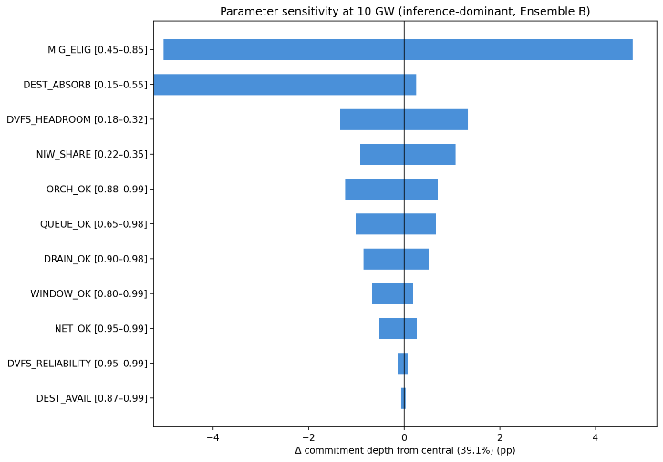  Fig. 3b. Tornado chart of one-at-a-time parameter sensitivity at 10 GW fleet scale under inference-dominant scope. Each bar shows the change in mean commitment depth when the named parameter is swept from its lower to upper bound while all other parameters are held at central values. DEST_absorb, QUEUE_OK, and MIG_elig together account for the dominant share of fleet-scale sensitivity; parameters with tight empirical anchoring (DRAIN_ok, DEST_avail, NET_OK, DVFS_reliability) show near-zero sensitivity. φ_inf is excluded because the two-scope reporting throughout the paper surfaces this sensitivity directly.

Methods
Framework structure
The framework decomposes accreditable system slack — the fraction of nameplate inference load simultaneously flexible, operationally committable, and capacity-accreditable during a grid dispatch event — into three composable mechanisms (spatial migration, temporal deferral of non-interactive workloads, and DVFS on residual compute), each itself a small mini-cascade of multiplicatively-composed parameters representing the conditions that must hold for one MW of that mechanism's contribution to realize. The three mini-cascades compose additively at the megawatt layer with sequential ordering — spatial first, deferral on residual after spatial, DVFS on residual after both — and an explicit overlap correction reflecting that DVFS at the source partially substitutes for deferral when work returns post-event.
The framework is reported under two scope scenarios reflecting the bi-modal heterogeneity of the projected 2030 data-center fleet: a mixed-use facility (φ_inf,mixed = 0.43, McKinsey December 2025) and an inference-dominant facility (φ_inf,dominant = 0.70, anchored in IEA 2025 and Zhou et al. 2024).
Parameter specifications.
Specifications for all eleven framework parameters are reported in Table M1, organized into four groups: scope scalar (1 parameter), spatial mini-cascade (6 parameters), deferral mini-cascade (3 parameters), and DVFS mini-cascade (2 parameters). Each parameter is graded by empirical grounding strength: DATA-grounded parameters are directly measured from publicly available production traces, the author's own analyses, or peer-reviewed field demonstrations (the destination decorrelation finding from 35,060 hours of day-ahead pricing across five U.S. grid regions in Section 3, the drain-time finding from 49.4 million production inference requests in Section 4, the peak-power-reduction anchor from Colangelo's field demonstration); ESTIMATED-MODERATE parameters are bounded by convergent evidence from related but non-direct measurements (hyperscaler within-facility orchestration reliability, peak-to-valley headroom for post-stress absorption); ESTIMATED-WEAK parameters are bounded only by operational floors and upper assumptions in the absence of direct measurement (destination compute absorption, contractual workload pinning, fleet-scale deferral saturation).
Table M1. Cascade parameter specifications.
Mechanism | Parameter | Symbol | Central | Distribution | Empirical basis | Key sources
Scope scalar | Mixed-use inference share | φ_inf,mixed | 0.43 | Uniform[0.30,0.50] | McKinsey Dec 2025 base case: 93.3 GW inference / 219 GW total in 2030; "more than 40 percent of data center demand" | McKinsey (2025)
Scope scalar | Inference-dominant scope | φ_inf,dominant | 0.70 | Uniform[0.60, 0.85] | Scenario construction; AI-focused HPC class per IEA and Zhou et al.; threshold below which facility no longer inference-dominant | IEA (2025); Zhou et al. (2024)
Spatial | Migration eligibility | MIG_elig | 0.65 | Uniform[0.45, 0.85] | Architectural portability (McKinsey atomizability) × unpinned (no published measurement; bounded by enterprise contractual restrictions) | McKinsey (2025); Patel et al., ISCA (2024); Zhong et al., OSDI (2024); Qin et al. (2024)
Spatial | Drain within window | DRAIN_ok | 0.95 | Uniform[0.90,0.98] | P99 drain times 4.5–12.1 s vs. 10-minute minimum dispatch window | This paper, Section 4
Spatial | Destination region availability | DEST_avail | Observed | Per-hour from data | 200 ComEd stress hours × unstressed-destination capacities from day-ahead LMP across five RTOs; capacity-weighted any-destination availability 94.5% | This paper, Section 3; IEA (2025)
Spatial | Destination compute absorption | DEST_absorp | 0.30 | Uniform[0.15,0.55] | Headroom × hardware compatibility × pre-staging; literature dispute on utilization (LBNL 40%, IEA 90%, Knittel 80%, Zhou 70-80%, Guidi 75%, Uptime <40%) | Shehabi et al., LBNL (2024); IEA (2025); Zhou et al. (2024); Knittel et al. (2025); NVIDIA CUDA documentation; NVIDIA Run:ai Model Streamer (2025)
Spatial | Network adequacy | NET_ok | 0.98 | Uniform[0.95, 0.995] | Hyperscaler wavelength purchases on a single carrier grew 133% from 18.2 Tb (2020) to 42.4 Tb (2024); Azure inter-region P50 latencies; B4 globally-deployed WAN | Jain et al., ACM SIGCOMM (2013); Zayo (2025)
Spatial | Orchestration reliability | ORCH_ok | 0.95 | Uniform[0.88, 0.99] | Within-facility production precedent at three hyperscalers; cross-facility-grid-dispatch interface novel; load balancer SLAs ≥99.99% | Zhang et al., ISCA (2021); Wu et al., ISCA (2016); Li et al., OSDI (2020); American Public Power Association (2025)
Deferral | NIW compute share | NIW_share | 0.28 (B) | Ensemble-dependent;  A: Uniform[0.10, 0.20]  B: Uniform[0.22, 0.35]  C: Uniform[0.32, 0.50] | SageServe O365 Copilot production traces: IW-F + IW-N = 72% of requests/TPS, NIW = 28% | Jaiswal et al. (2025)
Deferral | Window feasibility | WINDOW_ok | 0.95 | Uniform[0.80, 0.99] (scope-dependent) | 24-hour NIW deadline vs. 6-hour PJM emergency DR profile; production precedent in Google-TVA agreement | Jaiswal et al. (2025); American Public Power Association (2025)
Deferral | Post-stress queue absorption | QUEUE_ok | 0.85 | Uniform[0.65, 0.98] | DynamoLLM peak-to-valley ratios 3.3× to 34.6× at single-facility scale; fleet-scale saturation extrapolation novel | Stojkovic et al., HPCA (2025)
DVFS | Sustained peak-power reduction | DVFS_headroom | 0.25 (B) | Ensemble-dependent ±0.07; A: 0.18  B: 0.25  C: 0.32 | Colangelo et al. 25% sustained cluster-level peak power reduction over 3 hours; corroborated by Patel 21% inference headroom and Dynamo Fig. 13 knee | Colangelo et al. (2026); Patel et al., ASPLOS (2024); Wu et al., ISCA (2016); Kakolyris et al., IEEE CAL (2024)
DVFS | Within-window SLO compliance | DVFS_reliability | 0.98 | Uniform[0.95, 0.995] | Colangelo et al. zero SLA violations across 33 experiments / 212 jobs; corroborated by Thunderbolt and Flex production precedent | Colangelo et al. (2026); Li et al., OSDI (2020); Zhang et al., ISCA (2021)

Composition formulas
The three mini-cascades compose multiplicatively within mechanism and additively across mechanisms with sequential ordering:
Spatial mechanism:
$$M_spatial = (nameplate × (1/PUE) × φ_inf,scope) × (MIG_elig × DRAIN_ok × DEST_avail × DEST_absorb × NET_ok × ORCH_ok)$$
Deferral mechanism (sequential, on residual after spatial):
$$M_{defer}= \left(facility inference MW - M_{spatial}\right)× \left(NIW_{share}× WINDOW_{ok}× QUEUE_{ok}\right)$$
DVFS mechanism (sequential, on residual after spatial + deferral):
$$M_{DVFS}= \left(facility inference MW - M_{spatial}- M_{defer}\right)× \left(DVFS_{headroom}× DVFS_{reliability}\right)$$
Total commitment depth per facility MW:
$$Commitment depth = (M_spatial + M_defer + M_DVFS) / nameplate$$

The sequential ordering implements the overlap correction between DVFS and deferral. Colangelo et al.'s observation that 25% peak-power reduction translates to only 5% energy reduction confirms that DVFS at the source partially substitutes for deferral; the sequential ordering ensures the same megawatt of NIW load is either deferred or DVFS-reduced, not both.The PUE assumption (1.3) is applied at the megawatt-translation layer inside the spatial composition formula above. Translations to facility-metered quantities in Section 6 therefore do not require an additional PUE step; commitment depth is reported as a fraction of facility nameplate directly.
Conditional Monte Carlo simulation
For each of the 200 ComEd stress hours, the conditional Monte Carlo simulation identifies the set of unstressed destination zones from DA LMP flags (the DEST_avail observation) and uses their realized capacities directly. For each unstressed destination, available headroom is computed as destination capacity × DEST_absorb. Migrating demand from the source facility or fleet is allocated across destinations in proportion to available headroom; when aggregate demand exceeds aggregate headroom, destinations fill to their individual capacities and the unallocated demand contributes nothing to the spatial mechanism (but the deferral and DVFS mechanisms still contribute on the residual).
The conditional MC uses the following parameter scheme:
Observed per-hour from empirical data (1 parameter): DEST_avail. The simulation conditions on the empirical realization rather than drawing from a distribution; this is the "conditional" in conditional Monte Carlo.
Drawn independently per iteration from specified distributions (3 parameters): DEST_absorb (Uniform[0.15, 0.55]), QUEUE_ok (Uniform[0.65, 0.98]), and one of NIW_share / DVFS_headroom per ensemble specification. These represent the residual absorption uncertainty the operator cannot observe at commitment time.
Held fixed at central values (7 parameters): φ_inf at the scope-scenario value (run separately for mixed-use and inference-dominant), MIG_elig = 0.65, DRAIN_ok = 0.95, NET_ok = 0.98, ORCH_ok = 0.95, WINDOW_ok = 0.95, DVFS_reliability = 0.98. These are either scope-defining (φ_inf), known by-construction software properties (DRAIN_ok), or high-confidence infrastructure SLAs (NET_ok, ORCH_ok, DVFS_reliability).
We additionally ran the conditional MC with PJM Dominion as the source zone as a robustness check; results are reported in Extended Data Table 3.
Variance decomposition
The unconditional cascade Monte Carlo (N = 50,000) draws all variable parameters independently from their specified distributions, computes the multiplicative-within-mechanism and additive-across-mechanism composition, and applies the commitment depth formula. φ_inf is held at one of the two scope-scenario centrals (run separately for each scope); all eleven non-scope parameters are drawn independently from their specified ranges. Variance attribution uses the η² correlation ratio, computed by digitizing each variable parameter into 20 quantile bins and measuring the between-bin variance of cascade output as a fraction of total variance.
Variance attribution under inference-dominant scope identifies five parameters that together account for over 96% of cascade output variance: DEST_absorb (η² = 0.43, 44% of total), DVFS_headroom (0.22, 22%), MIG_elig (0.13, 13%), NIW_share (0.10, 10%), and QUEUE_ok (0.07, 8%). The remaining six parameters together contribute under 4% of variance, reflecting their tighter empirical anchoring (DRAIN_ok, DEST_avail, NET_ok, DVFS_reliability) or narrower operational ranges (WINDOW_ok, ORCH_ok). Of the dominant contributors, three are ESTIMATED-WEAK or ESTIMATED-MODERATE under the framework's grounding categories (DEST_absorb, MIG_elig Component B, QUEUE_ok), and two reflect ensemble-construction uncertainty rather than measurement (DVFS_headroom, NIW_share).
Stress threshold definition
Stress hours are defined as the top 50 hours per year per zone (approximately the 99.4th percentile of each zone's four-year distribution), yielding 200 ComEd stress hours over the January 2022 through December 2025 observation period. Sensitivity analysis at alternative thresholds confirms the headline any-destination availability finding is stable: 99.0% at the baseline, varying by at most 1.25 percentage points at the top 25 and top 100 hours per year specifications. The capacity-weighted overlap declines monotonically with threshold tightness (23.9% at top 100/year, 21.6% at baseline, 15.2% at top 25/year), indicating that cross-region decorrelation strengthens at more extreme stress intensities (Extended Data Fig. 1).
Workload datasets
We analyzed 44.1 million production LLM inference requests across two Azure services (Coding and Conversation) drawn from the DynamoLLM trace release on the Azure Public Dataset repository, spanning seven days in May 2024. The underlying traces were characterized for energy-management purposes by Stojkovic et al. We separately analyzed the BurstGPT dataset (arXiv v3 release), comprising 5.29 million requests from Azure OpenAI regional endpoints over 121 days of continuous observation. Both datasets represent production inference traffic. Drain times are computed as generated tokens divided by a central generation rate of 60 tokens per second, with sensitivity across 30–120 tokens/sec reported in Extended Data Fig. 2.
The two datasets differ in temporal structure: DynamoLLM shows strong diurnal variation (3.3× peak-to-trough for conversational workloads, 34.6× for coding workloads) while BurstGPT exhibits near-continuous 24-hour activity with minimal weekly periodicity. The DynamoLLM peak-to-valley structure provides the empirical anchor for the QUEUE_ok parameter at single-facility scale (the post-stress recovery hours have meaningful absorption headroom because peak-to-valley ratios are wide). This divergence reflects differing user populations and does not affect the DRAIN_ok parameterization, which depends on per-request drain time rather than aggregate traffic volume.
Per-GW parametric sweep
The fleet-level analysis evaluates commitment depth as a continuous function of fleet size from 0.5 to 15 GW under each scope scenario. At each fleet size, the migrating demand in each stress hour is fleet_MW × (1/PUE) × φ_inf,scope × MIG_elig × DRAIN_ok (the source-side spatial-cascade product, evaluated at central values for the fixed parameters). This demand competes for the same per-hour destination headroom computed in the conditional MC. The same DEST_absorb / QUEUE_ok / ensemble draws are reused across all fleet sizes to isolate the scale effect from Monte Carlo variance. The sweep identifies the spatial contention onset — the fleet size at which more than 50% of draw-hour combinations are destination-constrained for spatial migration. Within the swept range, spatial contention does not exceed the 50% threshold under either scope scenario, with onset projected beyond 15 GW.
Sensitivity analysis
The two-dimensional sensitivity surface evaluates fleet commitment depth at 10 GW across a 10×10 grid of DEST_absorb and QUEUE_ok values, under the inference-dominant scope. Other parameters are held at the conditional MC central values, and DEST_avail is observed per-hour from the empirical pricing data as in the base conditional MC. Each grid point computes deterministic hour-by-hour commitment depth under these fixed parameter choices.
The tornado chart quantifies one-at-a-time sensitivity at 10 GW fleet size across the variable parameters under the inference-dominant scope, sweeping each from its lower to upper bound while holding all others at central values. φ_inf is excluded; the two-scope reporting captures its sensitivity. DEST_avail is swept parametrically rather than observed per-hour for direct comparability with other parameters.
System-level calculations
The 92% ELCC applied to committed MW follows PJM precedent for demand response resources. Avoided capacity cost is computed using the levelized CT cost of $180,000/MW-yr from the E3 2025 Resource Adequacy Study for Illinois. Interconnection acceleration NPV is computed using H100 GPU spot rates of $2.20/GPU-hour (Silicon Data GPU Rental Index, January 2026), 603 H100s per MW grid capacity (derived from 10.2 kW × 8 GPUs × 1.3 PUE), 80% utilization, and a 10% weighted average cost of capital. The central case applies a three-year acceleration window; conservative (two-year) and optimistic (four-year) values are reported in Extended Data Table 2.
Data and Code Availability
Day-ahead locational marginal pricing data are publicly available from the respective RTO market portals: PJM Data Miner 2 (https://dataminer2.pjm.com), ERCOT Market Information System (https://www.ercot.com/mp/data-products), CAISO OASIS (http://oasis.caiso.com), MISO Market Reports (https://www.misoenergy.org/markets-and-operations/real-time--market-data), and NYISO Custom Reports (https://www.nyiso.com/custom-reports). The Microsoft Azure LLM Inference Dataset 2024 (DynamoLLM traces) is publicly available at https://github.com/Azure/AzurePublicDataset under AzureLLMInferenceDataset2024. The BurstGPT dataset is publicly available at https://github.com/HPMLL/BurstGPT. Data center location data are from the U.S. Department of Energy / National Renewable Energy Laboratory Accelerating Speed to Power Data Viewer (https://maps.nrel.gov/speed-to-power), accessed via its public backend API. Analysis code and processed datasets are available at https://github.com/ctdunlap32/data-center-flexibility-resource-adequacy.
Acknowledgments
The author thanks Robert Rosner for advisory support. This research was supported by the Bartlett Fellowship at the Energy Policy Institute at Chicago (EPIC). The author used Anthropic's Claude for assistance with structural organization, literature search, computational code development, and prose drafting. All analytical design, empirical methodology, results, interpretation, and final editorial decisions are the author’s own.

References
[1] PJM Interconnection, 2027/2028 Base Residual Auction Report (Valley Forge, PA: PJM Interconnection, December 17, 2025).
[2] PJM Interconnection, 2026 Long-Term Load Forecast Report (Valley Forge, PA: PJM Interconnection, January 14, 2026), Tables B-9 and B-9b.
[3] Lawrence Berkeley National Laboratory, Queued Up: 2025 Edition, Characteristics of Power Plants Seeking Transmission Interconnection As of the End of 2024. (Berkeley, CA: LBNL, 2025).
[4] International Energy Agency. Energy and AI. World Energy Outlook Special Report (2025).
[5] Zhang, C., et al. Flex: High-availability datacenters with zero reserved power. ISCA (2021).
[6] Stojkovic, J., Zhang, C., Goiri, Í., Torrellas, J., & Choukse, E. DynamoLLM: Designing LLM Inference Clusters for Performance and Energy Efficiency. Proc. HPCA 2025, pp. 1348–1362
[7] Li, L., et al. Thunderbolt: Throughput-optimized, quality-of-service-aware power capping at scale. OSDI (2020)
[8] Patel, P., Choukse, E., Zhang, C., Goiri, Í., Warrier, S., Mahalingam, N., & Bianchini, R. Splitwise: Efficient generative LLM inference using phase splitting. ISCA (2024).
[9] Zhong, Y., Liu, S., Chen, J., Hu, J., Zhu, Y., Liu, X., Jin, X., & Zhang, H. DistServe: Disaggregating prefill and decoding for goodput-optimized large language model serving. OSDI (2024).
[10 Qin, L., et al. Mooncake: Trading more storage for less computation — a KVCache-centric architecture for serving LLM chatbot. (Moonshot AI, 2024).
[11] Jaiswal, S., Jain, K., Simmhan, Y., Parayil, A., Mallick, A., St. Amant, R., et al. SageServe: Optimizing LLM Serving on Cloud Data Centers with Forecast Aware Auto-Scaling. arXiv:2502.14617 (2025).
[12] Colangelo, P., Coskun, A. K., Megrue, J., Roberts, C., Sengupta, S., Sivaram, V., Tiao, E., Vijaykar, A., Williams, C., Wilson, D. C., Records, B., MacFarland, Z., Dreiling, D., Morey, N., Ratnayake, A., & Vairamohan, B. AI data centres as grid-interactive assets. Nature Energy 11, 254–261 (2026). https://doi.org/10.1038/s41560-025-01927-1.
[13] M Arora, C., Sorel, M., Sachdeva, P., Bhan, A., He, J., Shaw, N., Garg, R., & Ravishankar, S. The next big shifts in AI workloads and hyperscaler strategies. McKinsey & Company, Technology, Media & Telecommunications Practice (December 2025).
[14] Zhou, X., et al. AI-Focused HPC Data Centers Can Provide More Power Grid Flexibility and at Lower Cost. arXiv:2410.17435 (2024).
[15] U.S. Department of Energy / National Renewable Energy Laboratory. "Data Center Demand Capacity by County." Accelerating Speed to Power Data Viewer. maps.nrel.gov/speed-to-power (accessed December 2025)
[16] PJM Interconnection. PJM Manual 13: Emergency Operations. Rev. 97, effective November 20, 2025.
[17] E3 (Energy and Environmental Economics). 2025 Resource Adequacy Study for Illinois (2025).

Extended Data
Extended Data Fig. 1. Stress threshold sensitivity.
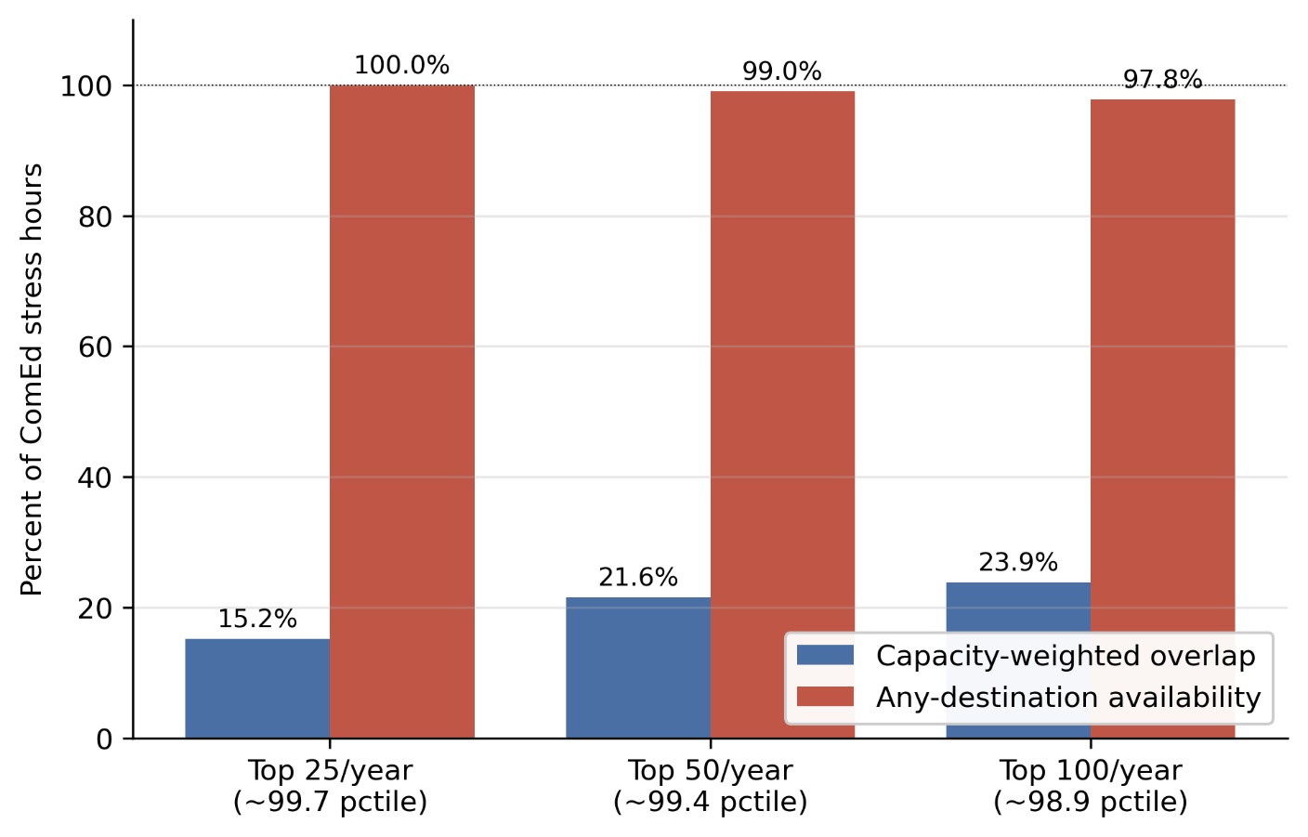
Capacity-weighted destination overlap and any-destination availability at three alternative stress-hour thresholds. Baseline: top 50 hours per year per zone (~99.43 percentile, 200 ComEd stress hours total). Alternatives: top 25 (~99.71st percentile) and top 100 (~98.86th percentile). Any-destination availability varies by at most 1.25 percentage points across thresholds; capacity-weighted overlap declines monotonically with threshold tightne

Extended Data Table 1. Multi-source generalizability.
Source Zone | Source RTO | Source IC | Stress Hours | N Cross RTO Dests | N Cross IC Dests | Dynamic Avail Cross RTO | Dynamic Avail Cross IC | All Stressed Hours | Cap Weighted Overlap | Summer Hours | Summer Avail | Winter Hours | Winter Avail
PJM_COMED | PJM | Eastern | 200 | 17 | 6 | 99 | 94 | 2 | 21.6 | 102 | 100 | 87 | 97.7
PJM_DOM | PJM | Eastern | 200 | 17 | 6 | 99.5 | 99 | 1 | 11.3 | 73 | 100 | 70 | 98.6
ERCOT_LZ_NORTH | ERCOT | ERCOT | 200 | 20 | 20 | 100 | 100 | 0 | 8.2 | 104 | 100 | 39 | 100
CAISO_NP15 | CAISO | Western | 200 | 22 | 22 | 100 | 100 | 0 | 7.8 | 39 | 100 | 137 | 100
Capacity-weighted destination overlap computed with alternative source zones (PJM-DOM, ERCOT-LZ-NORTH, CAISO-NP15, others). Headline decorrelation result holds across all tested source zones.
Extended Data Table 2. Interconnection acceleration NPV assumptions.
Parameter | Value | Description
GPU_PER_MW_GRID | 603 | GPUs per MW of grid capacity (derived: 10.2 kW / 8 GPUs Ã— 1.3 PUE)
GPU_RATE_HR | 2.2 | H100 spot rate, USD/hour (Jan 2026)
WACC | 0.1 | Weighted average cost of capital
ACCELERATION_YEARS_CENTRAL | 3 | Queue acceleration window, central case (years)
FACILITY_SIZE_MW | 1000 | Reference facility size (MW)
DEPTH_1GW_INF_DOM_MEAN | 0.398 | Mean commitment depth at 1 GW (inference-dominant scope) underlying NPV ratio
NPV_CONSERVATIVE_BILLIONS_USD | 16.1 | NPV of accelerated interconnection, conservative (2-year acceleration)
NPV_CENTRAL_BILLIONS_USD | 23.1 | NPV of accelerated interconnection, central (3-year acceleration)
NPV_OPTIMISTIC_BILLIONS_USD | 29.5 | NPV of accelerated interconnection, optimistic (4-year acceleration)
DOMINANCE_RATIO | 518.2 | Ratio of IX NPV (central) to annual total capacity revenue at mean commitment depth
Input parameters and central estimate for the interconnection acceleration NPV calculation reported in Section 6

Extended Data Table 3.Source-zone robustness check.
Source zone | Configuration | Scope | Mean | P5 | CVaR | n hours
PJM ComEd | Single facility (500 MW) | Inference-dominant | 40.0% | 38.5% | 33.1% | 200
PJM ComEd | Single facility (500 MW) | Mixed-use | 24.6% | 23.7% | 20.6% | 200
PJM Dominion | Single facility (500 MW) | Inference-dominant | 40.2% | 38.7% | 36.7% | 200
PJM Dominion | Single facility (500 MW) | Mixed-use | 24.7% | 23.8% | 22.6% | 200
PJM ComEd | Empirical fleet | Inference-dominant | 33.6% | 21.1% | 19.8% | 30 co-stress
PJM ComEd | Empirical fleet | Mixed-use | 21.1% | 13.2% | 12.3% | 30 co-stress
PJM Dominion | Empirical fleet | Inference-dominant | 40.0% | 38.4% | 32.8% | 145 co-stress
PJM Dominion | Empirical fleet | Mixed-use | 24.6% | 23.7% | 20.8% | 145 co-stress
Source-zone robustness check using PJM Dominion as an alternative source. Single-facility commitment depth is essentially identical across the two source zones (40.0% vs 40.2% inference-dominant), confirming that the cascade math is source-invariant at small scale. The empirical fleet result differs more substantially because the migrating fleet definition shifts: with Dominion as source, the fleet outside Dominion excludes the largest data center zone in PJM, leaving a smaller migrating fleet (max 6,678 MW) that experiences less destination contention than the ComEd-source fleet (max 14,379 MW). The 30-vs-145 co-stress hour count reflects geographic differences in stress patterns: ComEd stress events are more locally concentrated, while Dominion stress events more frequently coincide with broader PJM stress.

PJM Interconnection, 2027/2028 Base Residual Auction Report (Valley Forge, PA: PJM Interconnection, December 17, 2025).
PJM Interconnection, 2026 Long-Term Load Forecast Report (Valley Forge, PA: PJM Interconnection, January 14, 2026), Tables B-9 and B-9b.
Lawrence Berkeley National Laboratory, Queued Up: 2025 Edition, Characteristics of Power Plants Seeking Transmission Interconnection As of the End of 2024. (Berkeley, CA: LBNL, 2025).
International Energy Agency. Energy and AI. World Energy Outlook Special Report (2025).
Zhang, C., et al. Flex: High-availability datacenters with zero reserved power. ISCA (2021).
Stojkovic, J., Zhang, C., Goiri, Í., Torrellas, J., & Choukse, E. DynamoLLM: Designing LLM Inference Clusters for Performance and Energy Efficiency. Proc. HPCA 2025, pp. 1348–1362
Li, L., et al. Thunderbolt: Throughput-optimized, quality-of-service-aware power capping at scale. OSDI (2020)
Patel, P., Choukse, E., Zhang, C., Goiri, Í., Warrier, S., Mahalingam, N., & Bianchini, R. Splitwise: Efficient generative LLM inference using phase splitting. ISCA (2024).
Zhong, Y., Liu, S., Chen, J., Hu, J., Zhu, Y., Liu, X., Jin, X., & Zhang, H. DistServe: Disaggregating prefill and decoding for goodput-optimized large language model serving. OSDI (2024).
Qin, L., et al. Mooncake: Trading more storage for less computation — a KVCache-centric architecture for serving LLM chatbot. (Moonshot AI, 2024).
Jaiswal, S., Jain, K., Simmhan, Y., Parayil, A., Mallick, A., St. Amant, R., et al. SageServe: Optimizing LLM Serving on Cloud Data Centers with Forecast Aware Auto-Scaling. arXiv:2502.14617 (2025).
Colangelo, P., Coskun, A. K., Megrue, J., Roberts, C., Sengupta, S., Sivaram, V., Tiao, E., Vijaykar, A., Williams, C., Wilson, D. C., Records, B., MacFarland, Z., Dreiling, D., Morey, N., Ratnayake, A., & Vairamohan, B. AI data centres as grid-interactive assets. Nature Energy 11, 254–261 (2026). https://doi.org/10.1038/s41560-025-01927-1.
M Arora, C., Sorel, M., Sachdeva, P., Bhan, A., He, J., Shaw, N., Garg, R., & Ravishankar, S. The next big shifts in AI workloads and hyperscaler strategies. McKinsey & Company, Technology, Media & Telecommunications Practice (December 2025).
International Energy Agency. Energy and AI. World Energy Outlook Special Report (2025).
Zhou, X., et al. AI-Focused HPC Data Centers Can Provide More Power Grid Flexibility and at Lower Cost. arXiv:2410.17435 (2024).
U.S. Department of Energy / National Renewable Energy Laboratory. "Data Center Demand Capacity by County." Accelerating Speed to Power Data Viewer. maps.nrel.gov/speed-to-power (accessed December 2025)
PJM Interconnection. PJM Manual 13: Emergency Operations. Rev. 97, effective November 20, 2025.
E3 (Energy and Environmental Economics). 2025 Resource Adequacy Study for Illinois (2025).

