Data Centers Can Help Solve the Grid Crisis They’re Creating
How AI Workload Flexibility Could Deliver Thousands of Megawatts of Grid Reliability Value
Chris Dunlap

Abstract
U.S. electricity demand is growing at its fastest pace in decades, driven overwhelmingly by data centers. Grid operators cannot build generation, transmission, and interconnection infrastructure fast enough to keep up, and the bottleneck is not capital. Permitting, network upgrades, and supply chains impose physical timelines that no amount of spending can compress. This paper identifies a way around that constraint: data centers can actively manage their own power availability across a fleet through a combination of geographic workload migration, power scaling, and on-site generation. This paper proposes two policy mechanisms to capture that flexibility: flexible interconnection agreements that allow data centers to energize faster in exchange for binding curtailment commitments during grid emergencies, and capacity market participation through existing demand response frameworks. The result is a bridge that allows the grid to catch up with the pace of data center deployment in a way that is cost-effective, reliable, and mutually beneficial for grid operators, ratepayers, and the data center industry itself.

The Problem: A Grid Running Out of Room
Recently, PJM Interconnection, which manages the power grid across 13 states and the District of Columbia, failed to procure sufficient capacity to meet its reliability requirement for the first time in its history. The 2027/2028 Base Residual Auction fell 6,623 MW short of the target installed reserve margin, and data centers are the primary driver. PJM's 2026 Long-Term Load Forecast includes 33.7 GW in large load adjustments by 2030, predominantly for data center growth, which account for effectively all net peak demand growth across the RTO. The supply side cannot respond fast enough. Generation and storage projects face median interconnection timelines exceeding five years, and only about 13% of projects that enter the queue reach commercial operation. Meanwhile, four of the largest US hyperscalers' combined capex is projected at ~$298 billion in 2025, up from $217 billion in 2024, with Bain estimating that annual AI data center capex will need to reach ~$500 billion by 2030 to meet projected demand. Enormous investment is being made, but the physical timelines imposed by permitting, transmission studies, network upgrades, and equipment supply chains cannot be compressed by spending alone.
The consequences fall disproportionately on ratepayers. The 2027/2028 capacity auction cleared at its price cap of $333.44/MW-day which was the second consecutive auction to clear at the cap and a roughly 7.5× increase in cleared capacity value over three delivery years (from $2.2B in 2024/2025 to $16.4B in 2027/2028). If the load materializes, the grid faces a reliability crisis. If it does not, ratepayers finance stranded assets. Either way, the current trajectory concentrates risk on the parties least equipped to manage it. Policymakers have begun responding, though almost entirely on the supply side. Illinois enacted the Clean and Reliable Grid Affordability Act to support storage procurement and existing generation retention, FERC opened new interconnection pathways for data centers with co-located generation. and PJM is reforming its interconnection queue process. These interventions are necessary but remain subject to the same physical timelines that created the problem.
What has received less attention is the demand side. Recent work by Norris and colleagues at Duke's Nicholas Institute estimated that the 22 largest U.S. balancing authorities could accommodate approximately 98 GW of new flexible load using existing system capacity, with an average annual curtailment rate of 0.5% and an average curtailment duration of approximately two hours. The possibility that the load driving the deficit possesses flexibility that, if captured, could materially reduce the reliability gap while supply-side solutions are built deserves equal attention.
Recent work has begun to establish the empirical case. In early 2026, Colangelo et al. demonstrated in Nature Energy that a 256-GPU cluster in a Phoenix data center could reduce its power consumption by 25% during peak demand periods through software-based workload orchestration, while maintaining service quality. The same month, FERC directed PJM to create new transmission service options for data centers with co-located generation, signaling regulatory openness to novel interconnection structures tied to flexibility commitments. What remains unanswered is whether geographic workload migration, the capability Colangelo et al. explicitly identified as future work, can be quantified well enough to serve as an accreditable grid resource.
What the Analysis Shows
Geographic migration works only if, when one grid is stressed, another is not. We tested this directly using four years of day-ahead electricity pricing data across 19 destination zones in five U.S. grid regions, each mapped to verified data center locations. The ComEd territory in Northern Illinois was used as the source region because it faces among the most acute capacity pressures in the country and hosts a major concentration of existing and planned data center capacity.
In 198 out of 200 observed stress hours in Northern Illinois, at least one cross-region destination was operating normally. The two exceptions occurred during a the January 2024 Arctic Blast, the only period in the four-year dataset (2022–2025) in which all five destination regions were stressed concurrently with ComEd.

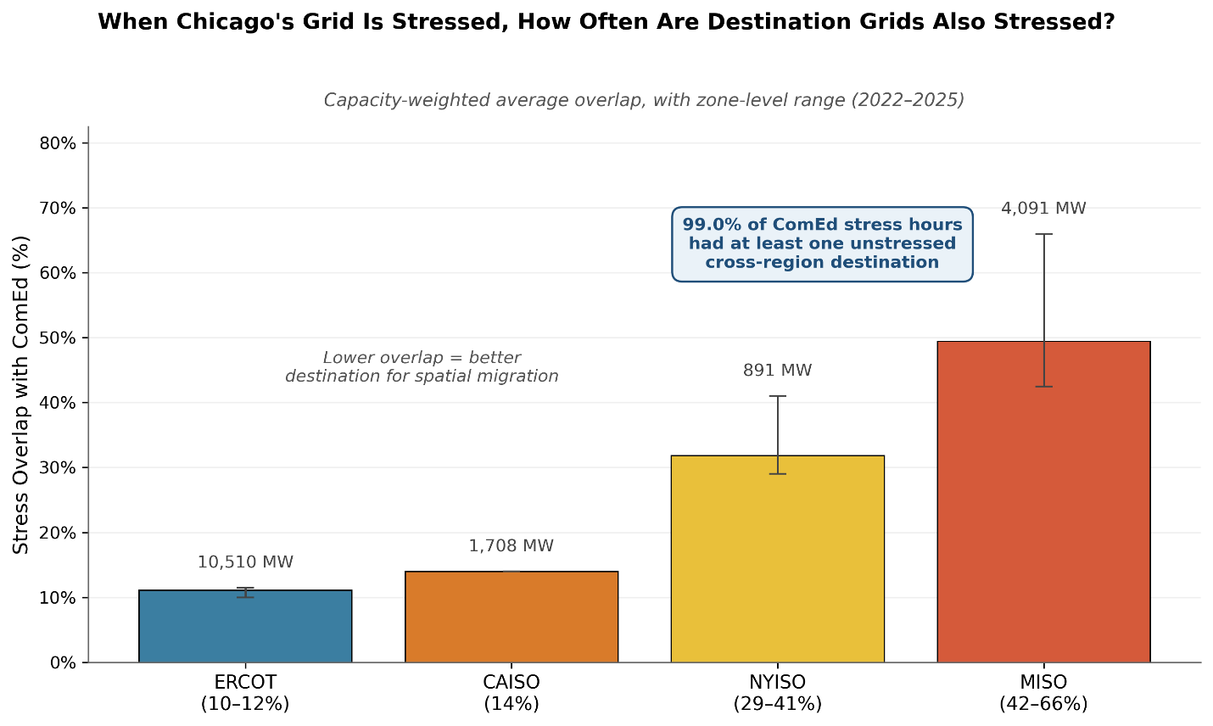
Figure 1. Stress overlap between ComEd and destination grid regions, 2022–2025. Each bar shows the capacity-weighted average percentage of ComEd stress hours in which the destination region was also stressed. Lower overlap means the region is more reliably available as a migration destination.
The pattern reflects the physical structure of the North American grid. Three sources of decorrelation are at work. ERCOT is electrically isolated from the Eastern Interconnection, so no synchronous coupling transmits stress. CAISO operates under a different weather regime, so heat domes and cold fronts that stress the Midwest rarely hit the West Coast at the same time. And afternoon peak hours occur at different clock times across time zones, so when Chicago hits emergency pricing on a hot afternoon, Texas and California are often still climbing toward their own peaks. Winter events are the harder case, because continental cold excursions can stress broad geography simultaneously, but even then cross-region destinations remained available in 99% of observed ComEd stress hours.
How much load can reliably relocate during a grid emergency depends on a chain of real-world source, destination, and execution constraints such as workload type, geographic pinning, destination capacity, and technical execution. Modeling these constraints, we estimate that an individual inference-dominant data center can credibly commit roughly half its electricity demand as dispatchable flexibility when spatial migration is combined with local power scaling. This headline result is scale-dependent: as multiple co-stressed facilities migrate simultaneously and compete for finite destination capacity, fleet-level commitment depth declines, falling to approximately a quarter of total load at 10 GW of aggregate inference-dominant capacity. The implication is that individual operators can credibly commit substantial flexibility today, while system-level contributions at scale will require coordination mechanisms that allocate destination capacity across competing facilities.
A Policy Framework: From Flexibility to Grid Resource
Data centers already manage load across regions for commercial purposes. But without a mechanism to make that flexibility visible to the grid and compensate operators for committing it as a binding obligation, the grid plans around them as if they are inflexible. Generation gets built to serve their full nameplate load, and ratepayers pay for it. Two mechanisms can change this, one for data centers currently seeking to energize and another for those already operating. For new facilities, the mechanisms can operate sequentially: flexible interconnection during the queue period, converting to capacity market participation once they successfully connect to the grid. For existing facilities, the second mechanism is available today.
Phase 1: Flexible interconnection (pre-queue)
Under current practice, a data center may wait years for network upgrade studies and construction to complete before it can energize. Under a flexible interconnection agreement, the facility could energize sooner, at or near its full nameplate capacity, with a binding commitment to curtail to a specified level during grid emergencies. The required network upgrades still proceed, but the data center is not waiting for them to finish before it can operate. The curtailment commitment makes early energizing tolerable for the grid operator. ERCOT already operates a connect-and-manage framework for generators along these lines. Over the past five years, PJM has brought on less new capacity relative to its peak demand than either ERCOT or CAISO. In 2021–2022 alone, ERCOT interconnected 14.2 GW of new generation compared to 5.6 GW in PJM. FERC’s December 2025 co-location order is a step in this direction, but co-located generation still needs to be permitted, sited, and built. Flexible interconnection works today because it commits demand-side flexibility rather than requiring new supply-side infrastructure.
Critically, this mechanism operates on the demand side of the reliability equation. A 500 MW facility with a binding commitment to curtail half its load during emergencies enters the grid operator’s planning models as 250 MW of firm load. The Reliability Requirement is sized to the lower number. Every megawatt of load removed from the planning process avoids building not just that megawatt of generation, but the additional reserve margin capacity required to back it. The data center operator averts the years-long interconnection delays and captures potentially billions in otherwise foregone compute revenue.
Phase 2: Demand response into the capacity market (post-interconnection)
The second mechanism is participation in PJM’s capacity auction as accredited demand response, bidding curtailment capability as supply rather than counting it as reduced load. This pathway is available to two populations. The first is facilities that entered through Phase 1 and have since completed their network upgrades, making conversion to full firm service feasible. The second is data centers that are already operational. For this population, Phase 2 is available today, and the constraint has been incentive rather than pathway. For operators whose primary economic concern is compute availability and whose interconnection is already complete, the marginal value of capacity market revenue has not been sufficient to justify the operational burden of binding commitments. As capacity prices rise and flexibility becomes a standard component of data center operations, Phase 2 becomes attractive for this population as well.
The same megawatt of flexibility cannot be counted twice, once as reduced demand and once as DR supply, so Phase 1 and Phase 2 are mutually exclusive for any individual facility. Whether conversion from Phase 1 or direct entry into Phase 2 makes economic sense depends on whether the capacity revenue exceeds the planning value of the reduced demand treatment at that specific facility’s grid position. For the near term, Phase 1 is likely the dominant mechanism. Phase 2 becomes more relevant as behind-the-meter generation matures and data centers develop the capability to offer surplus power back to the grid.
The central feature of this framework is a transfer of reliability risk. Under the status quo, the grid bears the full obligation to ensure sufficient resources exist to serve data center load, and ratepayers bear the cost when it falls short. Under this framework, the data center takes on responsibility for managing a portion of its own power availability during emergencies. That is a real operational burden. The natural decorrelation of grid stress across interconnection boundaries is a physical property of the North American grid, but exploiting it requires multi-region infrastructure, operational migration capability, and monitoring systems. These operators have already built that infrastructure for commercial reasons.
Conclusion
The conversation about data center flexibility is underway. What has been missing is evidence that the flexibility is real, reliable, and large enough to matter, along with a specific regulatory framework to capture it. This paper offers an initial case for both, with a full analytical framework forthcoming. The result, if realized, is a bridge that allows the grid to catch up with the pace of data center deployment in a way that is cost-effective, reliable, and mutually beneficial for grid operators, ratepayers, and the data center industry itself.

Acknowledgments
The author thanks Robert Rosner for advisory support and substantive feedback on this work. This research was supported by the Bartlett Fellowship in Energy Policy at the Energy Policy Institute at Chicago.

PJM Interconnection, 2027/2028 Base Residual Auction Report (Valley Forge, PA: PJM Interconnection, December 17, 2025)
PJM Interconnection, 2026 Long-Term Load Forecast Report (Valley Forge, PA: PJM Interconnection, January 14, 2026), Tables B-9 and B-9b.
Lawrence Berkeley National Laboratory, Queued Up: 2025 Edition, Characteristics of Power Plants Seeking Transmission Interconnection As of the End of 2024. (Berkeley, CA: LBNL, 2025).
Bain & Company, Technology Report 2025 (September 2025).
PJM Interconnection, 2027/2028 Base Residual Auction Report (December 17, 2025).
Clean and Reliable Grid Affordability Act, Public Act 104-0458, 104th Illinois General Assembly (signed January 8, 2026).
Federal Energy Regulatory Commission, Order Directing PJM to Revise Tariff for Co-Located Load Arrangements, 193 FERC ¶ 61,217, Docket Nos. EL25-49-000 et al. (December 18, 2025).
PJM Interconnection, "Interconnection Process Reform: Status Update" (November 2025); PJM Interconnection, "PJM Generation Interconnection Reforms Continue to Produce Results," PJM Inside Lines (June 4, 2025).
Tyler H. Norris, Tim Profeta, Dalia Patino-Echeverri, and Adam Cowie-Haskell, Rethinking Load Growth: Assessing the Potential for Integration of Large Flexible Loads in US Power Systems (Durham, NC: Nicholas Institute for Energy, Environment & Sustainability, Duke University, March 2025).
Colangelo, P., et al., “AI Data Centres as Grid-Interactive Assets,” Nature Energy 11, 254–261 (2026), https://doi.org/10.1038/s41560-025-01927-1. Earlier work established that data center workloads can be shifted geographically for renewable energy absorption: Jiajia Zheng, Andrew A. Chien, and Sangwon Suh, "Mitigating Curtailment and Carbon Emissions through Load Migration between Data Centers," Joule 4, no. 10 (October 2020): 2208–2222.
Federal Energy Regulatory Commission, Order Directing PJM to Revise Tariff for Co-Located Load Arrangements, 193 FERC ¶ 61,217, Docket Nos. EL25-49-000 et al. (December 18, 2025).
Analysis uses 35,060 hours of day-ahead locational marginal pricing data (January 2022–December 2025) from PJM, ERCOT, CAISO, MISO, and NYISO, covering 19 destination pricing zones mapped to data center locations using U.S. Department of Energy / National Renewable Energy Laboratory Accelerating Speed to Power Data Viewer (accessed via its public backend API). Day-ahead LMP price spikes are used as a proxy for grid stress.
Estimates derive from a ten-parameter multiplicative cascade modeling source-side, destination-side, and execution constraints on spatial migration, validated against observed grid stress events using a conditional Monte Carlo simulation. For an individual inference-dominant facility, mean commitment depth is approximately 47% when spatial migration is combined with local power scaling. The result is scale-dependent: as multiple co-stressed facilities migrate simultaneously and compete for finite destination capacity, fleet-level commitment depth declines to approximately 27% at 10 GW of aggregate inference-dominant capacity. Three destination-side parameters dominate model uncertainty: utilization headroom at receiving facilities, the share of destination workloads running compatible inference, and operational readiness of model weight pre-staging across geographically diverse facilities.
RMI, "PJM's Speed to Power Problem and How to Fix It," November 4, 2025 (updated November 11, 2025), https://rmi.org/pjms-speed-to-power-problem-and-how-to-fix-it/.
Ethan Howland, "Can ERCOT Show the Way to Faster and Cheaper Grid Interconnection?," Utility Dive, November 27, 2023, https://www.utilitydive.com/news/connect-and-manage-grid-interconnection-ferc-ercot-transmission-planning/698949/.
Federal Energy Regulatory Commission, Order Directing PJM to Revise Tariff for Co-Located Load Arrangements, 193 FERC ¶ 61,217, Docket Nos. EL25-49-000 et al. (December 18, 2025).
For a 1 GW facility, the present value of accelerated interconnection is on the order of billions of dollars over a three-year acceleration window, computed from foregone compute revenue at prevailing hyperscaler capital expenditure rates. The estimate is highly sensitive to assumptions about revenue per MW and acceleration duration, but even under conservative assumptions substantially exceeds plausible capacity market revenue.
PJM Manual 18: PJM Capacity Market, Rev. 60 (Valley Forge, PA: PJM Interconnection, 2025). Demand response currently receives a 92% Effective Load Carrying Capability (ELCC) class rating.
A forthcoming analysis in Nature Energy format details the ten-parameter cascade model, the cross-region stress decorrelation methodology, and the conditional Monte Carlo simulation used to test the cascade's independence assumption against observed per-hour grid states.

