Quantifying AI data center flexibility as a resource adequacy asset
Chris Dunlap
University of Chicago Booth School of Business / Harris School of Public Policy
Energy Policy Institute at Chicago (EPIC), Bartlett Fellowship
Abstract
AI data centers are increasingly being treated as inflexible, firm loads in U.S. electricity grid resource adequacy planning, leading to capacity procurement requirements that surpass what the interconnection queue can actually provide. To address this, I present an eleven-parameter framework organized along three operational axes: spatial migration across grid regions, temporal deferral of non-interactive workloads, and dynamic voltage-frequency scaling (DVFS). This framework quantifies the flexibility of AI inference in terms relevant to capacity-accreditation for resource adequacy planning. Using data from four years of day-ahead pricing across five U.S. grid regions and 49.4 million production inference requests, I find that commitment depths reach 24.6% for mixed-use facilities and 40.0% for inference-dominant facilities at the single-facility level. These values decrease only slightly to 24.1% and 38.5% at the 10-GW fleet scale, since deferral and DVFS mechanisms contribute additively as they saturate. Finally, most remaining uncertainties such as destination utilization, contractual workload pinning, and post-stress recovery coordination are found to be institutional challenges, not physical limitations.

Introduction
In PJM Interconnection the 2027/2028 capacity auction fell 6.6 GW short of the reliability requirement[1]. PJM’s 2026 Long-Term Load Forecast projects large load increases — primarily from data centers — totaling 33.7 GW by 2030, which accounts for nearly all net peak demand growth in the region[2]. At the same time, new generation and storage projects face median completion timelines of over five years, with only 13% of projects reaching commercial operation[3]. Permitting and supply-chain bottlenecks remain major hurdles that cannot be resolved simply by investing more capital.
Current resource adequacy planning treats data-center loads as firm at each facility, meaning every additional megawatt requires corresponding procurement of generating capacity and reserve margin. This practice stems from service-level contracts that guarantee uninterrupted compute, demanding a consistent local power supply at each site. Aggregating these local firmness requirements across an expanding data center fleet is now driving system-level capacity needs far beyond what the interconnection queue can supply.
Policy research increasingly suggests that load flexibility should be a key response. For instance, the IEA’s 2025 Energy and AI report finds that enabling data-center flexibility for just 0.1% to 1% of annual hours would be enough to integrate all projected 2030 capacity additions into major electricity systems across the U.S., E.U., and China[4]. Recent studies are challenging the technical necessity of local firmness, with production demonstrations at major hyperscalers highlighting three operational mechanisms: spatial migration of inference workloads across grid regions, temporal deferral of non-interactive workloads, and dynamic voltage-frequency scaling on residual compute (DVFS) on residual compute. The technical potential for these mechanisms is widely recognized, though studies differ in their analysis units and operational mechanisms considered.
In this work, I develop a framework for assessing the combined operational flexibility of AI inference data centers as resources eligible for capacity accreditation. The framework has four main components: (1) an eleven-parameter decomposition structured around the three identified operational mechanisms; (2) empirical analysis of stress-decorrelation using four years of day-ahead locational marginal pricing data across five U.S. grid regions; (3) workload characterization based on 49.4 million production inference requests; and (4) a conditional Monte Carlo simulation leveraging observed per-hour grid states. My results show that commitment depth varies from 24% to 40% depending on facility scale, declines only slightly with increased fleet size, and that the most significant constraints on grid value are driven by institutional decisions, not physical limitations.
Framework: Decomposing Combined Operational Flexibility
Production demonstrations at Microsoft[5], Meta[6], Google[7], and Oracle[8] have validated all three flexibility mechanisms at hyperscaler scale. These include datacenter-wide power management with millisecond-level control, phase-disaggregated LLM inference within facilities, and a 25% sustained reduction in cluster-level peak power over multi-hour periods without violating service level agreements (SLAs). However, while the systems literature established operational flexibility, it has not yet translated this flexibility into the capacity-accreditation metrics required by resource adequacy planning and capacity markets.
My framework addresses the gap by decomposing the conditions under which nameplate inference load can deliver accreditable resource adequacy value, and assembling these into a metric called commitment depth — the megawatt-equivalent grid value per megawatt of nameplate inference load. Within each of the three identified mechanisms, parameters combine multiplicatively, while contributions from different mechanisms sum at the megawatt layer, following a specified sequential ordering. This ordering corrects for overlap: power management at the facility can partially substitute for deferral when work resumes after an event, so a given megawatt of non-interactive compute cannot be double-counted as both deferred and DVFS-reduced.
The framework is applied to two scenarios that reflect the bimodal heterogeneity of the projected 2030 data center fleet. The mixed-use scenario applies the model to typical hyperscaler colocation facilities, where inference makes up about 43% of IT compute — based on McKinsey's December 2025 estimate that inference workloads will account for over 40% of total datacenter demand[9]. The inference-dominant scenario applies the model to purpose-built AI campuses, where inference exceeds 70% of IT compute — a facility type that is becoming more prominent and is analyzed in both the IEA's 2025 Energy and AI report[4] and Zhou et al.'s 2024 study of AI-focused high-performance computing (HPC)[10]. I report results for both scenarios in parallel, since the actual 2030 datacenter fleet will include both types. The distinction in commitment depth between the two is significant: the marginal flexibility benefit from purpose-built siting can be quantified.
Cross-region Stress Decorrelation
Spatial compute migration requires that at least one destination grid region is operating under normal conditions when the source region is stressed. I test this condition empirically using 35,060 hours of day-ahead locational marginal pricing (DA LMP) data from January 2022 through December 2025, spanning five U.S. Regional Transmission Organizations (RTOs): PJM, ERCOT, CAISO, MISO, and NYISO — covering the mid-Atlantic, Texas, California, Midwest, and New York respectively, which together coordinate roughly two-thirds of U.S. electricity demand. Within each region I identify destination pricing zones co-located with data center facilities using county-level capacity data from the U.S. Department of Energy / National Renewable Energy Laboratory Accelerating Speed to Power Data Viewer[11]. Stress hours are defined as the top 200 DA LMP hours per zone over the four-year window (the 99.4th percentile; see Methods for threshold sensitivity).
Using the ComEd zone in Northern Illinois as the primary source region, I compute the fraction of source stress hours in which at least one cross-region destination zone exhibits a DA LMP below its stress threshold. Of the 200 observed ComEd stress hours, at least one cross-region destination was available in 198, corresponding to a dynamic availability of 99.0%. The two failure hours occurred during the January 2024 Arctic Blast. The decorrelation reflects the electrical topology of the North American transmission system: ERCOT operates as an electrically isolated interconnection, and CAISO’s temporal offset and weather patterns are largely independent from the Midwest. Capacity-weighted stress overlap between ComEd and cross-interconnection destinations ranges from 3.7% (ERCOT, summer) to 14.0% (CAISO, annual), with CAISO exhibiting zero summer overlap across the four-year study period (Fig. 1). Same-interconnection destinations exhibit substantially higher overlap: MISO zones range from 43% to 66%, NYISO zones from 29% to 41%, consistent with shared exposure to regional weather systems and partial electrical coupling. The decorrelation finding generalizes across source zones: dynamic availability is 99.5% from PJM-DOM (Northern Virginia), 100% from ERCOT-LZ-NORTH (Dallas-Fort Worth), and 100% from CAISO-NP15 (Northern California).
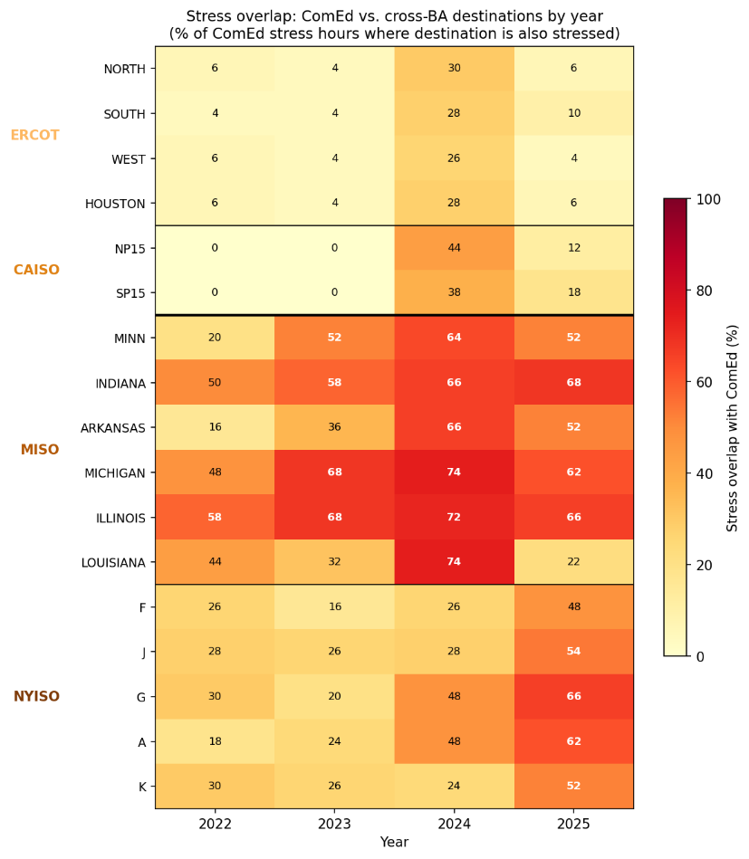
Fig. 1. Stress overlap between ComEd and 17 cross-BA destination zones by year, 2022–2025. Each cell shows the percentage of ComEd's 50 annual stress hours in which the destination zone was simultaneously stressed. Cross-interconnection destinations (ERCOT, CAISO) exhibit overlap below 30% in all years; same-interconnection destinations (MISO, NYISO) range from 16% to 74%, consistent with shared exposure to regional weather systems. The 2024 column reflects elevated co-stress during the January 2024 Arctic Blast. CAISO coverage begins November 2022; earlier periods are treated as available per Methods.
Workload Characterization
The drain-within-window parameter (DRAIN_{ok}) measures whether active inference requests at a facility can finish within the grid operator's emergency dispatch window. I validated drain time using two independent production datasets, totaling 49.4 million inference requests across 128 days (see Methods for dataset details). Across all model configurations and datasets, the 99th-percentile (P99) drain times range from 4.5 to 12.12 seconds — nearly two orders of magnitude faster than PJM's minimum dispatch window of 10 minutes[12]. This supports setting DRAIN_{ok} = 0.95 as a conservative estimate. The remaining 5% not included in DRAIN_{ok} accounts for long-running or batch inference requests, multi-turn conversational sessions with persistent state, and potential future workloads that may require longer completion times.
Conditional Monte Carlo Validation
I designed a conditional Monte Carlo simulation that uses observed per-hour grid states to analyze how commitment depth is affected by fleet size, destination contention, and post-stress recovery saturation during specific stress events. The simulation is conducted separately for each of the two scope scenarios, and results are reported side by side.
For a typical 500 MW inference-dominant facility, the simulation produces a mean commitment depth of 40.0% under the inference-dominant scenario (φ_{inf} = 0.70), with a 5th percentile value of 38.5% and a conditional expected shortfall below the 5th percentile of 33.1%. In the mixed-use scenario (φ_{inf} = 0.43), the mean commitment depth is 24.6%, the 5th percentile is 23.7%, and the conditional expected shortfall is 20.6%.
The framework's conservatism at the single-facility level comes from a ratio effect: during most stress hours, the combined available headroom across unstressed destinations greatly exceeds the demand from a single migrating facility. Additionally, the deferral and DVFS mechanisms function independently of destination contention.
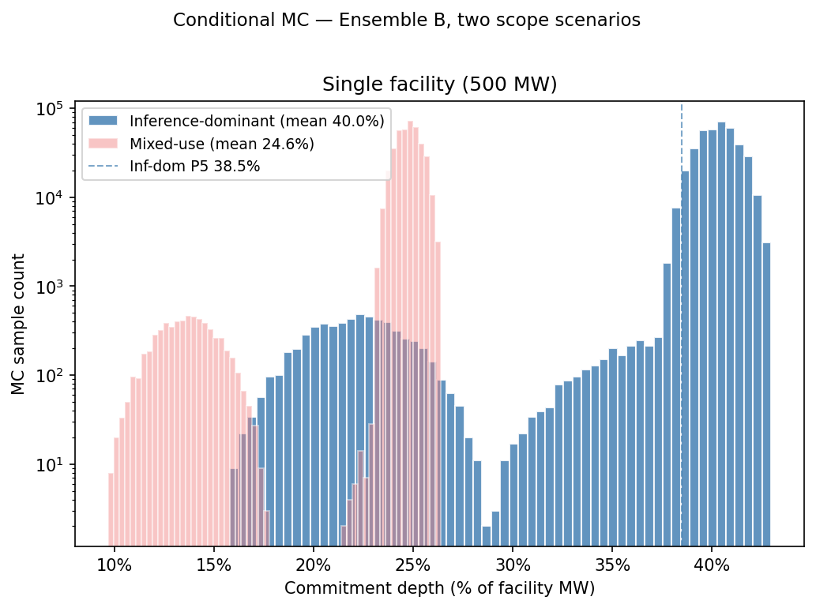
Fig. 2. Conditional Monte Carlo commitment depth distributions and scale dependence, ComEd source zone, 2022–2025. (a) Single-facility (500 MW) commitment depth distribution under inference-dominant scenario (φ_{inf} = 0.70, primary distribution) with mixed-use scenario (φ_{inf} = 0.43) overlaid in lower opacity. Mean 40.0% inference-dominant, 24.6% mixed-use; 5th percentiles 38.5% and 23.7%.
When expanded to include simultaneous migration by geographically distributed facilities, commitment depth becomes dependent on scale. I first analyze an empirical fleet based on the geographic distribution of PJM data center capacity across load zones, identifying per-hour co-stress using the intra-PJM coincidence matrix described in Section 3. During the 30 ComEd stress hours when at least one other PJM zone is also stressed, the migrating fleet averages 4,729 MW (ranging from 747 MW to 14,379 MW), with substantial variability driven by whether the Dominion zone in Northern Virginia (which has 9,431 MW of data center capacity)[13] experiences co-stress with ComEd.
For this empirical fleet, the mean commitment depth is 33.6% under the inference-dominant scenario and 21.1% under the mixed-use scenario. The conditional expected shortfall below the 5th percentile is 19.8% and 12.3%, respectively. Applying PJM’s 92% Effective Load Carrying Capability (ELCC) for demand-response, this fleet would receive accredited capacity of roughly 19.4% (inference-dominant) or 12.1% (mixed-use) per megawatt of fleet capacity.
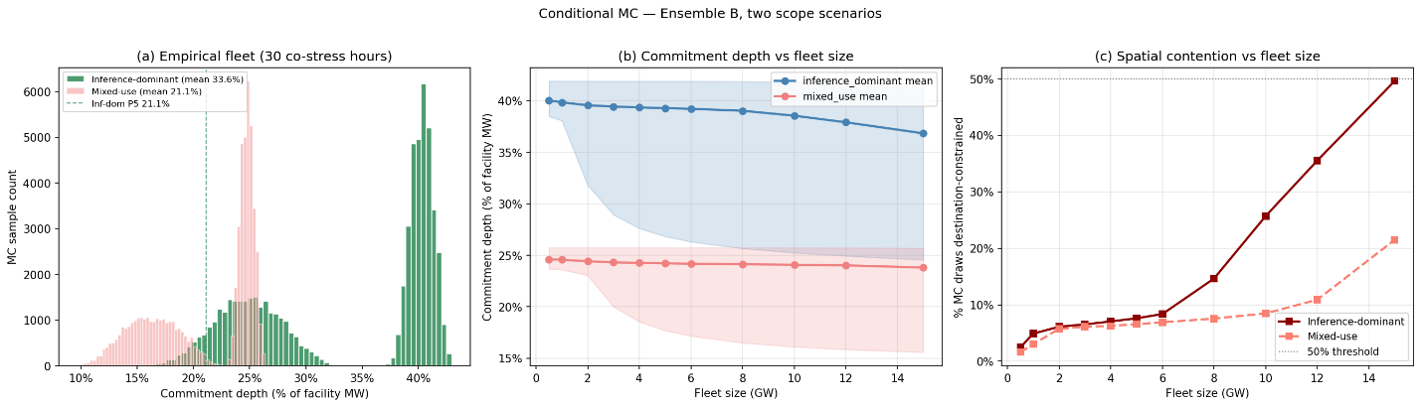
Figure 3: (a)Empirical fleet commitment depth distribution across 30 ComEd stress hours where at least one other PJM zone is also stressed; migrating fleet ranges 747–14,379 MW. Mean 33.6% inference-dominant, 21.1% mixed-use. (b) Per-GW commitment depth sweep from 0.5 to 15 GW under both scenarios, with mean curves and P5–P95 bands; (c) shows the percentage of Monte Carlo draws destination-constrained, rising from 4.9% at 1 GW to 25.7% at 10 GW under the inference-dominant scenario. 2,000 draws per stress hour; full parameter specification in Methods Table M1.
Next, I assess commitment depth as a continuous function of fleet size, conducting a parametric sweep from 0.5 GW to 15 GW. In the inference-dominant scenario, commitment depth decreases from 39.8% at 1 GW to 38.5% at 10 GW; in the mixed-use scenario, it declines from 24.6% at 1 GW to 24.1% at 10 GW. The reduction is mainly due to increased destination contention affecting spatial migration: the proportion of Monte Carlo draws constrained by destination rises from 4.9% at 1 GW to 25.7% at 10 GW (inference-dominant), and from 3.0% to 8.5% (mixed-use). Spatial contention remains below 50% throughout the sweep, with greater contention projected past 15 GW.
The decrease in average commitment depth is modest because deferral and DVFS mechanisms contribute additively across all fleet sizes and do not saturate within the evaluated range. However, the 5th percentile drops more sharply — from 38.1% to 25.2% (inference-dominant) and from 23.6% to 16.1% (mixed-use) — indicating that destination contention strongly constrains performance during the worst stress hours.
System Level Implications
At PJM's 92% demand-response ELCC, a 1 GW inference-dominant facility with a mean commitment depth of 39.8% would be accredited at 367 MW. For a 10 GW fleet, the mean commitment depth of 38.5% implies 3,546 MW. Facilities used for both inference and other workloads (“mixed-use”) would yield 226 MW (1 GW) and 2,216 MW (10 GW) respectively. Using a P5-based accreditation method — anchored on the 5th-percentile outcome rather than the mean, the level achieved during the worst 5% of stress hours — the same facilities would be accredited at:
- 350 MW (1 GW inference-dominant)
- 2,322 MW (10 GW inference-dominant)
- 217 MW (1 GW mixed-use)
- 1,483 MW (10 GW mixed-use).

The difference between mean-based and P5-based accreditation is minor at the single-facility scale (16 MW gap for inference-dominant) but becomes significant for a large fleet (1,224 MW gap at 10 GW).
At E3's levelized combustion turbine (CT) cost of $180,000/MW-yr (2025 Resource Adequacy Study for Illinois)[14], the avoided capacity cost is approximately:
- $66M/year for a 1 GW inference-dominant facility
- $638M/year for a 10 GW fleet
- $41M/$399M pre year for mixed-use facilities (1 GW/10 GW).
From the operator's perspective, accelerating interconnection offers a much larger incentive. For a 1 GW facility, a three-year acceleration yields a central NPV of about $23.1B, far exceeding the present value of avoided capacity payments over a comparable horizon. The dominance ratio is robust across both scenarios because interconnection acceleration NPV scales with foregone compute revenue while avoided capacity cost scales with commitment depth directly.
Discussion
This framework produces commitment depths ranging from 24% to 40% per MW of inference capacity, with only modest decline as fleet size increases. This is because the three flexibility mechanisms saturate differently. The relevant comparison is not a grid without data centers but a grid where data centers are treated as inflexible load, requiring procurement of matching generation and reserves for every MW of inference capacity. When loads are flexible, current practice leads to over-procurement beyond actual reliability needs.
The main sources of uncertainty are operational decisions:
- (DEST_{absorb}): How much GPU headroom operators maintain, hardware compatibility, and pre-staging — all operational choices.
- (MIG_{elig} Component B): Fraction of workloads eligible for migration, largely determined by contracts, which could be standardized for demand-response participation.
- (QUEUE_{ok}): Post-stress queue absorption at fleet scale, determined by whether facilities coordinate recovery windows; aggregator-level visibility can reduce fleet saturation.
Sensitivity analysis shows these three institutional parameters drive most of the framework’s residual uncertainty. At 10 GW inference-dominant scale, mean commitment depth varies from 32.5% to 40.0% across plausible DEST_{absorb} and QUEUE_{ok} values. Tornado charts confirm these three parameters dominate fleet-scale sensitivity, while empirically anchored parameters have minimal impact. Source-side parameters are negligible because the fleet is destination- and queue-constrained.
DEST_{absorb} is most actionable, requiring no hardware or workload changes. The IEA’s 2025 Energy and AI report highlights the need to understand economic, operational, and contractual limits to realize flexibility potential[4]. Knittel et al. model flexible workload shares exogenously across a wide range to evaluate system-level importance of endogenous determination of flexibility levels [15]. The bottom-up model here provides that determination and addresses spatial direction identified for future work[10].
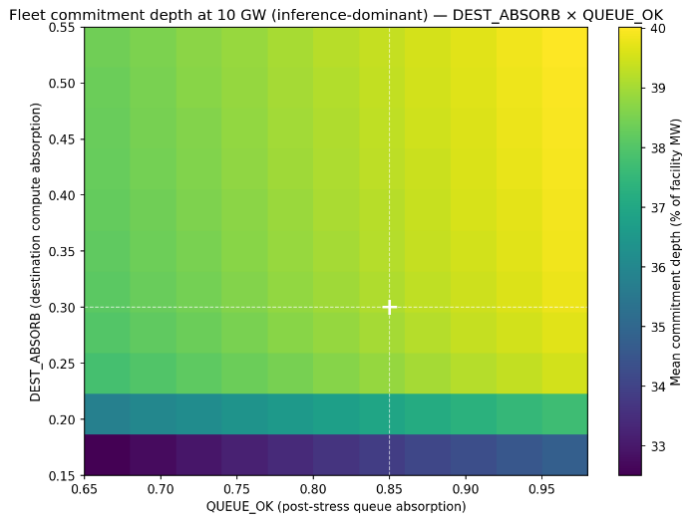  Fig. 4a. Two-dimensional sensitivity surface: mean commitment depth at 10 GW fleet scale under inference-dominant scenario, swept across the plausible ranges of DEST_{absorb} (Uniform[0.15, 0.55]) and QUEUE_{ok} (Uniform[0.65, 0.98]). Other parameters held at central values; DEST_{avail} observed per-hour from the empirical pricing data. Commitment depth ranges from 32.5% (joint-pessimistic corner) to 40.0% (joint-optimistic corner). Crosshairs mark central values (DEST_{absorb} = 0.30, QUEUE_{ok} = 0.85). | 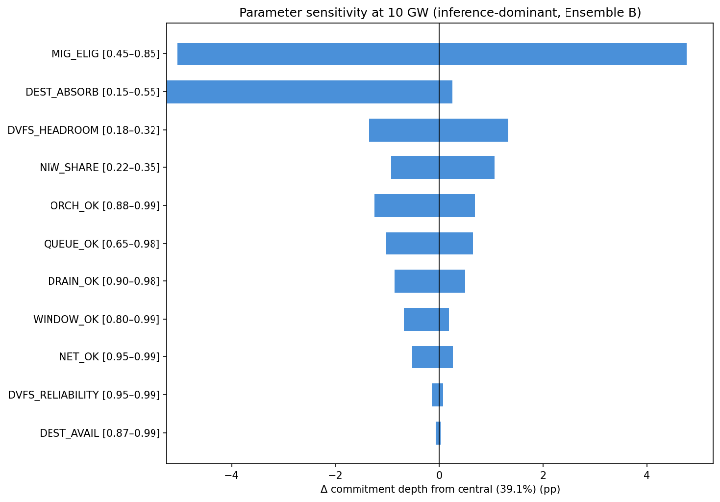  Fig. 4b. Tornado chart of one-at-a-time parameter sensitivity at 10 GW fleet scale under inference-dominant scope. Each bar shows the change in mean commitment depth when the named parameter is swept from its lower to upper bound while all other parameters are held at central values. MIG_{elig} , DEST_{absorb}, and QUEUE_{ok}, together account for the dominant share of fleet-scale sensitivity; parameters with tight empirical anchoring (DRAIN_ok, DEST_{avail}, NET_{ok}, DVFS_{reliability}) show near-zero sensitivity. φ_{inf} is excluded because the two-scope reporting throughout the paper surfaces this sensitivity directly.
The scale dependence implies that accreditation should distinguish between facility-level and fleet-level contributions as well as across mechanisms. Aggregating spatial-migration commitments across operators could allocate destination headroom more efficiently than uncoordinated allocation. Aggregating deferral commitments could prevent queue saturation through coordinated recovery windows. DVFS commitments require no coordination and can be accredited at the facility level. The three mechanisms differ structurally in saturation: DVFS contributes additively across all fleet sizes, deferral remains nearly constant, and only spatial migration shows scale-dependent decline. Operators can credibly bid based on the mean at single-facility scale, but at fleet scale the mean-vs-tail gap requires explicit accreditation choices.
Production precedent for AI inference demand response already exists. Google’s 2025 agreements with the Tennessee Valley Authority and Indiana Michigan Power specifically target machine-learning workloads, backed by demonstration with Omaha Public Power District during grid stress events[16]. Google recognizes both the potential and the limits: high reliability requirements constrain commitment depth. IEA’s 2025 estimate of $700 per MWh shifted highlights that combined flexibility has capacity-adequacy value during scarcity, not energy-market value during low prices; policy should target capacity value.
The proposed framework reallocates reliability risk. Under current practice, the grid operator must procure capacity at full facility rating, with procurement costs passed through to ratepayers. Under the proposed framework, data center operators manage part of their own power via three mechanisms.
Cross-region decorrelation is a physical property of North America’s electricity grid. Facility-level power management and multi-region infrastructure are established at major hyperscalers. What is needed is institutional mechanism design sequenced based on grid position:
- Flexible interconnection for queued facilities
- Accredited demand response for operating facilities

The U.S. Department of Energy has called for a flexibility taxonomy and framework —the framework here addresses that gap. Direct measurement of dominant parameters would improve quantitative accuracy, but institutional design is the main constraint on realized value.
Several limitations qualify these results:
- DEST_{absorb}, MIG_{elig} Component B, and QUEUE_{ok} dominate model uncertainty but are not publicly observable.
- There is a literature dispute on destination utilization: LBNL assumes 40%, IEA reports up to 90% for accelerated servers.
- The model and Monte Carlo method do not provide universal estimates but show that with empirical validation of migration feasibility and dispatch compliance, most uncertainty is concentrated in a few operational/institutional choices.
- PJM's 92% ELCC for demand response is used, but full sequential reliability determination may differ.
- While production dataset consistency partially validates drain-times, generalization to other providers and configurations remains uncertain.

Methods
Framework structure
The framework decomposes accreditable system slack — the fraction of nameplate inference load simultaneously flexible, operationally committable, and capacity-accreditable during a grid dispatch event — into three composable mechanisms (spatial migration, temporal deferral of non-interactive workloads, and DVFS on residual compute), each itself a small sub-model of multiplicatively-composed parameters representing the conditions that must hold for one MW of that mechanism's contribution to realize. The three sub-models combine additively at the megawatt layer with sequential ordering of spatial first, deferral on residual after spatial, DVFS on residual after both and an explicit overlap correction reflecting that DVFS at the source partially substitutes for deferral when work returns post-event.
The framework is reported under two scope scenarios reflecting the bi-modal heterogeneity of the projected 2030 data-center fleet: a mixed-use facility (φ_{inf,mixed} = 0.43, McKinsey December 2025[9]) and an inference-dominant facility (φ_{inf,dominant} = 0.70, anchored in IEA 2025[4] and Zhou et al. 2024[10]).
Parameter specifications.
Specifications for all eleven framework parameters are reported in Table M1, organized into four groups: scenario scalar (1 parameter), spatial sub-model (6 parameters), deferral sub-model(3 parameters), and DVFS sub-model(2 parameters).
Table M1. Model parameter specifications.
Mechanism | Parameter | Symbol | Central | Distribution | Empirical basis | Key sources
Scenario scalar | Mixed-use inference share | φ_{inf,mixed} | 0.43 | Uniform[0.30,0.50] | McKinsey Dec 2025 base case: 93.3 GW inference / 219 GW total in 2030; "more than 40 percent of data center demand" | McKinsey (2025)[9]
Scenario scalar | Inference-dominant scenario | φ_{inf,dominant} | 0.70 | Uniform[0.60, 0.85] | Scenario construction; AI-focused HPC class per IEA and Zhou et al.; threshold below which facility no longer inference-dominant | IEA (2025)[4]; Zhou et al. (2024)[10]
Spatial | Migration eligibility | MIG_{elig} | 0.65 | Uniform[0.45, 0.85] | Architectural portability (McKinsey atomizability) × unpinned (no published measurement; bounded by enterprise contractual restrictions) | McKinsey (2025)[9]; Patel et al.[17], ISCA (2024); Zhong et al., OSDI (2024)[18]; Qin et al. (2024)[19]
Spatial | Drain within window | DRAIN_{ok} | 0.95 | Uniform[0.90,0.98] | P99 drain times 4.5–12.1 s vs. 10-minute minimum dispatch window | This paper, Section 4
Spatial | Destination region availability | DEST_{avail} | Observed | Per-hour from data | 200 ComEd stress hours × unstressed-destination capacities from day-ahead LMP across five RTOs; capacity-weighted any-destination availability 94.5% | This paper, Section 3; IEA (2025)[4]
Spatial | Destination compute absorption | DEST_{absorp} | 0.30 | Uniform[0.15,0.55] | Headroom × hardware compatibility × pre-staging; literature dispute on utilization (LBNL 40%, IEA 90%, Knittel 80%, Zhou 81%, Guidi 75%, Uptime <40%) | Shehabi et al., LBNL (2024)[3]; IEA (2025)[4]; Zhou et al. (2024)[10]; Knittel et al. (2025)[15]; NVIDIA CUDA documentation[20]; NVIDIA Run:ai Model Streamer (2025)[21]
Spatial | Network adequacy | NET_{ok} | 0.98 | Uniform[0.95, 0.995] | Hyperscaler wavelength purchases on a single carrier grew 133% from 18.2 Tb (2020) to 42.4 Tb (2024); Azure inter-region P50 latencies; B4 globally-deployed Wide Area Network (WAN) | Jain et al., ACM SIGCOMM (2013)[22]; Zayo (2025)[23]
Spatial | Orchestration reliability | ORCH_{ok} | 0.95 | Uniform[0.88, 0.99] | Within-facility production precedent at three hyperscalers; cross-facility-grid-dispatch interface novel; load balancer SLAs ≥99.99% | Zhang et al., ISCA (2021)[5]; Wu et al., ISCA (2016)[24]; Li et al., OSDI (2020)[7]; American Public Power Association (2025)[25]
Deferral | NIW compute share | NIW_{share} | 0.28 (B) | Ensemble-dependent;  A: Uniform[0.10, 0.20]  B: Uniform[0.22, 0.35]  C: Uniform[0.32, 0.50] | SageServe O365 Copilot production traces: IW-F + IW-N = 72% of requests/Transactions per Second (TPS), NIW = 28% | Jaiswal et al. (2025)[26]
Deferral | Window feasibility | WINDOW_{ok} | 0.95 | Uniform[0.80, 0.99] (sceanrio-dependent) | 24-hour NIW deadline vs. 6-hour PJM emergency DR profile; production precedent in Google-TVA agreement | Jaiswal et al. (2025)[26]; American Public Power Association (2025)[25]
Deferral | Post-stress queue absorption | QUEUE_{ok} | 0.85 | Uniform[0.65, 0.98] | DynamoLLM peak-to-valley ratios 3.3× to 34.6× at single-facility scale; fleet-scale saturation extrapolation novel | Stojkovic et al., HPCA (2025)[6]
DVFS | Sustained peak-power reduction | DVFS_{headroom} | 0.25 (B) | Ensemble-dependent ±0.07; A: 0.18  B: 0.25  C: 0.32 | Colangelo et al. 25% sustained cluster-level peak power reduction over 3 hours; corroborated by Patel 21% inference headroom and Dynamo Fig. 13 knee | Colangelo et al. (2026)[8]; Patel et al., ASPLOS (2024)[27]; Wu et al., ISCA (2016)[24]; Kakolyris et al., IEEE CAL (2024)[28]
DVFS | Within-window Service Level Objective compliance | DVFS_{reliability} | 0.98 | Uniform[0.95, 0.995] | Colangelo et al. zero SLA violations across 33 experiments / 212 jobs; corroborated by Thunderbolt and Flex production precedent | Colangelo et al. (2026)[8]; Li et al., OSDI (2020)[7]; Zhang et al., ISCA (2021)[5]

Composition formulas
The three sub-models combine multiplicatively within mechanism and additively across mechanisms with sequential ordering:
Spatial mechanism:
$$M_{spatial} = (nameplate × (1/PUE) × φ_inf,scenario) × ({MIG}_{elig} × {Drain}_{ok} × {DEST}_{avail} × {DEST}_{absorb} × {NET}_{ok} × {ORCH}_{ok})$$
Deferral mechanism (sequential, on residual after spatial):
$$M_{defer}= \left(facility inference MW - M_{spatial}\right)× \left(NIW_{share}× WINDOW_{ok}× QUEUE_{ok}\right)$$
DVFS mechanism (sequential, on residual after spatial + deferral):
$$M_{DVFS}= \left(facility inference MW - M_{spatial}- M_{defer}\right)× \left(DVFS_{headroom}× DVFS_{reliability}\right)$$
Total commitment depth per facility MW:
$$Commitment depth = (M_{spatial} + M_{defer} + M_{DVFS}) / nameplate$$

The sequential ordering implements the overlap correction between DVFS and deferral. Colangelo et al.'s observation that 25% peak-power reduction translates to only 5% energy reduction confirms that DVFS at the source partially substitutes for deferral[8]; the sequential ordering ensures the same megawatt of non-interactive workload (NIW) is either deferred or DVFS-reduced, not both. The Power Usage Effectiveness (PUE) assumption of 1.3, the ratio of total facility power to IT-equipment power, is applied at the megawatt-translation layer inside the spatial composition formula above. Translations to facility-metered quantities in Section 6 therefore do not require an additional PUE step; commitment depth is reported as a fraction of facility nameplate directly.
Conditional Monte Carlo simulation
For each of the 200 ComEd stress hours, the conditional Monte Carlo simulation identifies the set of unstressed destination zones from DA LMP flags (the DEST_{avail} observation) and uses their realized capacities directly. For each unstressed destination, available headroom is computed as destination capacity × DEST_{absorb}. Migrating demand from the source facility or fleet is allocated across destinations in proportion to available headroom; when aggregate demand exceeds aggregate headroom, destinations fill to their individual capacities and the unallocated demand contributes nothing to the spatial mechanism (but the deferral and DVFS mechanisms still contribute on the residual).
The conditional MC uses the following parameter scheme:
Observed per-hour from empirical data (1 parameter): DEST_{avail}. The simulation conditions on the empirical realization rather than drawing from a distribution; this is the "conditional" in conditional Monte Carlo.
Drawn independently per iteration from specified distributions (3 parameters): DEST_{absorb} (Uniform[0.15, 0.55]), QUEUE_{ok} (Uniform[0.65, 0.98]), and one of NIW_share / DVFS_{headroom} per ensemble specification. These represent the residual absorption uncertainty the operator cannot observe at commitment time.
Held fixed at central values (7 parameters): φ_inf at the scope-scenario value (run separately for mixed-use and inference-dominant), MIG_{elig} = 0.65, DRAIN_{ok} = 0.95, NET_{ok} = 0.98, ORCH_{ok} = 0.95, WINDOW_{ok} = 0.95, DVFS_{reliability} = 0.98. These are either scenario-defining (φ_{inf}), known by-construction software properties (DRAIN_{ok}), or high-confidence infrastructure SLAs (NET_{ok}, ORCH_{ok}, DVFS_{reliability}).
I additionally ran the conditional MC with PJM Dominion as the source zone as a robustness check; results are reported in Extended Data Table 3.
Variance decomposition
The unconditional Monte Carlo model (N = 50,000) draws all variable parameters independently from their specified distributions, computes the multiplicative-within-mechanism and additive-across-mechanism composition, and applies the commitment depth formula. φ_{inf} is held at one of the two scope-scenario centrals (run separately for each scenario); all eleven non-scenario parameters are drawn independently from their specified ranges. Variance attribution uses the η² correlation ratio, computed by digitizing each variable parameter into 20 quantile bins and measuring the between-bin variance of model output as a fraction of total variance.
Variance attribution under inference-dominant scenario identifies five parameters that together account for over 96% of model output variance: DEST_{absorb} (η² = 0.43, 44% of total), DVFS_{headroom} (0.22, 22%), MIG_{elig} (0.13, 13%), NIW_{share} (0.10, 10%), and QUEUE_{ok} (0.07, 8%). The remaining six parameters together contribute under 4% of variance, reflecting their tighter empirical anchoring (DRAIN_{ok}, DEST_{avail}, NET_{ok}, DVFS_{reliability}) or narrower operational ranges (WINDOW_{ok}, ORCH_{ok}). Of the dominant contributors, three are weak or moderate grounding estimates (DEST_{absorb}, MIG_{elig} Component B, QUEUE_{ok}), and two reflect ensemble-construction uncertainty rather than measurement (DVFS_{headroom}, NIW_{share}).
Stress threshold definition
Stress hours are defined as the top 50 hours per year per zone (approximately the 99.4th percentile of each zone's four-year distribution), yielding 200 ComEd stress hours over the January 2022 through December 2025 observation period. Sensitivity analysis at alternative thresholds confirms the headline any-destination availability finding is stable: 99.0% at the baseline, varying by at most 1.25 percentage points at the top 25 and top 100 hours per year specifications. The capacity-weighted overlap declines monotonically with threshold tightness (23.9% at top 100/year, 21.6% at baseline, 15.2% at top 25/year), indicating that cross-region decorrelation strengthens at more extreme stress intensities (Extended Data Fig. 1).
Workload datasets
I analyzed 44.1 million production LLM inference requests across two Azure services (Coding and Conversation) drawn from the DynamoLLM trace release on the Azure Public Dataset repository, spanning seven days in May 2024. The underlying traces were characterized for energy-management purposes by Stojkovic et al.[6]. I separately analyzed the BurstGPT dataset (arXiv v3 release)[28], comprising 5.29 million requests from Azure OpenAI regional endpoints over 121 days of continuous observation. Both datasets represent production inference traffic. Drain times are computed as generated tokens divided by a central generation rate of 60 tokens per second, with sensitivity across 30–120 tokens/sec reported in Extended Data Fig. 2.
The two datasets differ in temporal structure. DynamoLLM shows strong diurnal variation (3.3× peak-to-trough for conversational workloads, 34.6× for coding workloads) while BurstGPT exhibits near-continuous 24-hour activity with minimal weekly periodicity. The DynamoLLM peak-to-valley structure provides the empirical anchor for the QUEUE_{ok} parameter at single-facility scale (the post-stress recovery hours have meaningful absorption headroom because peak-to-valley ratios are wide). This divergence reflects differing user populations and does not affect the DRAIN_{ok} parameterization, which depends on per-request drain time rather than aggregate traffic volume.
Per-GW parametric sweep
The fleet-level analysis evaluates commitment depth as a continuous function of fleet size from 0.5 to 15 GW under each scope scenario. At each fleet size, the migrating demand in each stress hour is fleet_{MW} × (1/PUE) × φ_{inf,scenario} × MIG_{elig} × DRAIN_{ok} (the source-side spatial-model product, evaluated at central values for the fixed parameters). This demand competes for the same per-hour destination headroom computed in the conditional MC. The same DEST_{absorb} / QUEUE_{ok} ensemble draws are reused across all fleet sizes to isolate the scale effect from Monte Carlo variance. The sweep identifies the spatial contention onset — the fleet size at which more than 50% of draw-hour combinations are destination-constrained for spatial migration. Within the swept range, spatial contention does not exceed the 50% threshold under either scope scenario, with onset projected beyond 15 GW.
Sensitivity analysis
The two-dimensional sensitivity surface evaluates fleet commitment depth at 10 GW across a 10×10 grid of DEST_{absorb} and QUEUE_{ok} values, under the inference-dominant scenario. Other parameters are held at the conditional MC central values, and DEST_{avail} is observed per-hour from the empirical pricing data as in the base conditional MC. Each grid point computes deterministic hour-by-hour commitment depth under these fixed parameter choices.
The tornado chart quantifies one-at-a-time sensitivity at 10 GW fleet size across the variable parameters under the inference-dominant scenario, sweeping each from its lower to upper bound while holding all others at central values. φ_{inf} is excluded; the two-scenario reporting captures its sensitivity. DEST_{avail} is swept parametrically rather than observed per-hour for direct comparability with other parameters.
System-level calculations
The 92% ELCC applied to committed MW follows PJM precedent for demand response resources[12]. Avoided capacity cost is computed using the levelized CT cost of $180,000/MW-yr from the E3 2025 Resource Adequacy Study for Illinois[14]. Interconnection acceleration NPV is computed using H100 GPU spot rates of $2.20/GPU-hour (Silicon Data GPU Rental Index, January 2026)[30], 603 H100s per MW grid capacity (derived from 10.2 kW × 8 GPUs × 1.3 PUE), 80% utilization, and a 10% weighted average cost of capital. The central case applies a three-year acceleration window; conservative (two-year) and optimistic (four-year) values are reported in Extended Data Table 2.
Data and Code Availability
Day-ahead locational marginal pricing data are publicly available from the respective RTO market portals: PJM Data Miner 2 (https://dataminer2.pjm.com), ERCOT Market Information System (https://www.ercot.com/mp/data-products), CAISO OASIS (http://oasis.caiso.com), MISO Market Reports (https://www.misoenergy.org/markets-and-operations/real-time--market-data), and NYISO Custom Reports (https://www.nyiso.com/custom-reports). The Microsoft Azure LLM Inference Dataset 2024 (DynamoLLM traces) is publicly available at https://github.com/Azure/AzurePublicDataset under AzureLLMInferenceDataset2024. The BurstGPT dataset is publicly available at https://github.com/HPMLL/BurstGPT. Data center location data are from the U.S. Department of Energy / National Renewable Energy Laboratory Accelerating Speed to Power Data Viewer (https://maps.nrel.gov/speed-to-power)[13], accessed via its public backend API. Analysis code and processed datasets are available at https://github.com/ctdunlap32/data-center-flexibility-resource-adequacy.
Acknowledgments
The author thanks Robert Rosner for advisory support. This research was supported by the Bartlett Fellowship at the Energy Policy Institute at Chicago (EPIC). The author used Anthropic's Claude for assistance with structural organization, literature search, computational code development, and prose drafting. All analytical design, empirical methodology, results, interpretation, and final editorial decisions are the author’s own.

References
[1] PJM Interconnection, 2027/2028 Base Residual Auction Report (Valley Forge, PA: PJM Interconnection, December 17, 2025).
[2] PJM Interconnection, 2026 Long-Term Load Forecast Report (Valley Forge, PA: PJM Interconnection, January 14, 2026), Tables B-9 and B-9b.
[3] Lawrence Berkeley National Laboratory, Queued Up: 2025 Edition, Characteristics of Power Plants Seeking Transmission Interconnection As of the End of 2024. (Berkeley, CA: LBNL, 2025).
[4] International Energy Agency. Energy and AI. World Energy Outlook Special Report (2025).
[5] Zhang, C., et al. Flex: High-availability datacenters with zero reserved power. ISCA (2021).
[6] Stojkovic, J., Zhang, C., Goiri, Í., Torrellas, J., & Choukse, E. DynamoLLM: Designing LLM Inference Clusters for Performance and Energy Efficiency. Proc. HPCA 2025, pp. 1348–1362
[7] Li, L., et al. Thunderbolt: Throughput-optimized, quality-of-service-aware power capping at scale. OSDI (2020)
[8] Colangelo, P., Coskun, A. K., Megrue, J., Roberts, C., Sengupta, S., Sivaram, V., Tiao, E., Vijaykar, A., Williams, C., Wilson, D. C., Records, B., MacFarland, Z., Dreiling, D., Morey, N., Ratnayake, A., & Vairamohan, B. AI data centres as grid-interactive assets. Nature Energy 11, 254–261 (2026). https://doi.org/10.1038/s41560-025-01927-1.
[9] M Arora, C., Sorel, M., Sachdeva, P., Bhan, A., He, J., Shaw, N., Garg, R., & Ravishankar, S. The next big shifts in AI workloads and hyperscaler strategies. McKinsey & Company, Technology, Media & Telecommunications Practice (December 2025).
[10] Zhou, X., et al. AI-Focused HPC Data Centers Can Provide More Power Grid Flexibility and at Lower Cost. arXiv:2410.17435 (2024).
[11] U.S. Department of Energy / National Renewable Energy Laboratory. "Data Center Demand Capacity by County." Accelerating Speed to Power Data Viewer. maps.nrel.gov/speed-to-power (accessed December 2025)
[12] PJM Interconnection. PJM Manual 13: Emergency Operations. Rev. 97, effective November 20, 2025.
[13] U.S. Department of Energy / National Renewable Energy Laboratory. "Data Center Demand Capacity by County." Accelerating Speed to Power Data Viewer. maps.nrel.gov/speed-to-power (accessed December 2025)
[14] E3 (Energy and Environmental Economics). 2025 Resource Adequacy Study for Illinois (2025).

[15] Knittel, C. R., Senga, J. R. L., & Wang, S. Flexible Data Centers and the Grid: Lower Costs, Higher Emissions? NBER Working Paper No. 34065, National Bureau of Economic Research, July 2025. http://www.nber.org/papers/w34065.
[16] Terrell, M. How we're making data centers more flexible to benefit power grids. The Keyword (Google) https://blog.google/innovation-and-ai/infrastructure-and-cloud/global-network/how-were-making-data-centers-more-flexible-to-benefit-power-grids/ (4 August 2025).
[17] Patel, P., Choukse, E., Zhang, C., Goiri, Í., Warrier, S., Mahalingam, N., & Bianchini, R. Splitwise: Efficient generative LLM inference using phase splitting. ISCA (2024).
[18] Zhong, Y., Liu, S., Chen, J., Hu, J., Zhu, Y., Liu, X., Jin, X., & Zhang, H. DistServe: Disaggregating prefill and decoding for goodput-optimized large language model serving. OSDI (2024).
[19] Qin, L., et al. Mooncake: Trading more storage for less computation — a KVCache-centric architecture for serving LLM chatbot. (Moonshot AI, 2024).
[20] NVIDIA Corporation. CUDA Compatibility, Release r595 (NVIDIA Corporation, March 31, 2026). https://docs.nvidia.com/deploy/cuda-compatibility/.
[21] Dayan, O., Neria, N., & Karabulut, E. Reducing Cold Start Latency for LLM Inference with NVIDIA Run:ai Model Streamer. NVIDIA Technical Blog (September 16, 2025). https://developer.nvidia.com/blog/reducing-cold-start-latency-for-llm-inference-with-nvidia-runai-model-streamer/.
[22] Jain, S., Kumar, A., Mandal, S., Ong, J., Poutievski, L., Singh, A., Venkata, S., Wanderer, J., Zhou, J., Zhu, M., Zolla, J., Hölzle, U., Stuart, S., & Vahdat, A. B4: Experience with a Globally-Deployed Software Defined WAN. Proceedings of the ACM SIGCOMM 2013 Conference (Hong Kong, China, August 2013), pp. 3–14.
[23] Zayo Group. The Bandwidth Report: Insights & Trends Driving the Bandwidth Boom (Zayo, 2025).
[24] Wu, Q., Deng, Q., Ganesh, L., Hsu, C.-H., Jin, Y., Kumar, S., Li, B., Meza, J., & Song, Y. J. Dynamo: Facebook's Data Center-Wide Power Management System. Proceedings of the 43rd ACM/IEEE International Symposium on Computer Architecture (ISCA) (Seoul, Korea, June 2016), pp. 469–480. DOI: 10.1109/ISCA.2016.48.
[25] Ciampoli, P. Google, TVA Enter Agreement Tied to Data Center Demand Response. American Public Power Association (August 4, 2025). https://www.publicpower.org/periodical/article/google-tva-enter-agreement-tied-data-center-demand-response.
[26] Jaiswal, S., Jain, K., Simmhan, Y., Parayil, A., Mallick, A., St. Amant, R., et al. SageServe: Optimizing LLM Serving on Cloud Data Centers with Forecast Aware Auto-Scaling. arXiv:2502.14617 (2025).
[27] Patel, P., Choukse, E., Zhang, C., Goiri, Í., Warrier, B., Mahalingam, N., & Bianchini, R. Characterizing Power Management Opportunities for LLMs in the Cloud. Proceedings of the 29th ACM International Conference on Architectural Support for Programming Languages and Operating Systems (ASPLOS '24), Volume 3 (San Diego, CA, April–May 2024), pp. 207–222.
[28] Kakolyris, A. K., Masouros, D., Xydis, S., & Soudris, D. SLO-Aware GPU DVFS for Energy-Efficient LLM Inference Serving. IEEE Computer Architecture Letters 23, no. 2 (July–December 2024): 150–153.
[29] Wang, Y., Chen, Y., Li, Z., Kang, X., Tang, Z., He, X., Guo, R., Wang, X., Wang, Q., Zhou, A. C., & Chu, X. BurstGPT: A Real-World Workload Dataset to Optimize LLM Serving Systems. arXiv:2401.17644v3 (June 17, 2024). https://arxiv.org/abs/2401.17644v3.
[30] Li, C. H100 Price Spike: Understanding the 10% Surge in GPU Rental Costs. Silicon Data (January 9, 2026). https://www.silicondata.com/blog/h100-price-spike.

Extended Data
Extended Data Fig. 1. Stress threshold sensitivity.
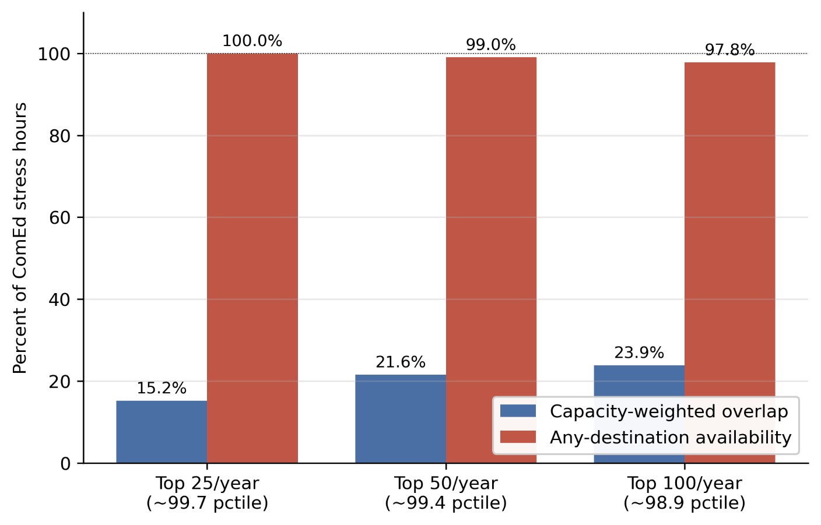
Capacity-weighted destination overlap and any-destination availability at three alternative stress-hour thresholds. Baseline: top 50 hours per year per zone (~99.43 percentile, 200 ComEd stress hours total). Alternatives: top 25 (~99.71st percentile) and top 100 (~98.86th percentile). Any-destination availability varies by at most 1.25 percentage points across thresholds; capacity-weighted overlap declines monotonically with threshold tightening.
Extended Data Table 1. Multi-source generalizability.
Source Zone | Source RTO | Source IC | Stress Hours | N Cross RTO Dests | N Cross IC Dests | Dynamic Avail Cross RTO | Dynamic Avail Cross IC | All Stressed Hours | Cap Weighted Overlap | Summer Hours | Summer Avail | Winter Hours | Winter Avail
PJM_COMED | PJM | Eastern | 200 | 17 | 6 | 99 | 94 | 2 | 21.6 | 102 | 100 | 87 | 97.7
PJM_DOM | PJM | Eastern | 200 | 17 | 6 | 99.5 | 99 | 1 | 11.3 | 73 | 100 | 70 | 98.6
ERCOT_LZ_NORTH | ERCOT | ERCOT | 200 | 20 | 20 | 100 | 100 | 0 | 8.2 | 104 | 100 | 39 | 100
CAISO_NP15 | CAISO | Western | 200 | 22 | 22 | 100 | 100 | 0 | 7.8 | 39 | 100 | 137 | 100
Capacity-weighted destination overlap computed with alternative source zones (PJM-DOM, ERCOT-LZ-NORTH, CAISO-NP15, others). Headline decorrelation result holds across all tested source zones.
Extended Data Table 2. Interconnection acceleration NPV assumptions.
Parameter | Value | Description
GPU_PER_MW_GRID | 603 | GPUs per MW of grid capacity (derived: 10.2 kW / 8 GPUs Ã— 1.3 PUE)
GPU_RATE_HR | 2.2 | H100 spot rate, USD/hour (Jan 2026)
WACC | 0.1 | Weighted average cost of capital
ACCELERATION_YEARS_CENTRAL | 3 | Queue acceleration window, central case (years)
FACILITY_SIZE_MW | 1000 | Reference facility size (MW)
DEPTH_1GW_INF_DOM_MEAN | 0.398 | Mean commitment depth at 1 GW (inference-dominant scenario) underlying NPV ratio
NPV_CONSERVATIVE_BILLIONS_USD | 16.1 | NPV of accelerated interconnection, conservative (2-year acceleration)
NPV_CENTRAL_BILLIONS_USD | 23.1 | NPV of accelerated interconnection, central (3-year acceleration)
NPV_OPTIMISTIC_BILLIONS_USD | 29.5 | NPV of accelerated interconnection, optimistic (4-year acceleration)
DOMINANCE_RATIO | 518.2 | Ratio of IX NPV (central) to annual total capacity revenue at mean commitment depth
Input parameters and central estimate for the interconnection acceleration NPV calculation reported in Section 6

Extended Data Table 3.Source-zone robustness check.
Source zone | Configuration | Scenario | Mean | P5 | Cond. Shortfall (CVAR | n hours
PJM ComEd | Single facility (500 MW) | Inference-dominant | 40.0% | 38.5% | 33.1% | 200
PJM ComEd | Single facility (500 MW) | Mixed-use | 24.6% | 23.7% | 20.6% | 200
PJM Dominion | Single facility (500 MW) | Inference-dominant | 40.2% | 38.7% | 36.7% | 200
PJM Dominion | Single facility (500 MW) | Mixed-use | 24.7% | 23.8% | 22.6% | 200
PJM ComEd | Empirical fleet | Inference-dominant | 33.6% | 21.1% | 19.8% | 30 co-stress
PJM ComEd | Empirical fleet | Mixed-use | 21.1% | 13.2% | 12.3% | 30 co-stress
PJM Dominion | Empirical fleet | Inference-dominant | 40.0% | 38.4% | 32.8% | 145 co-stress
PJM Dominion | Empirical fleet | Mixed-use | 24.6% | 23.7% | 20.8% | 145 co-stress
Source-zone robustness check using PJM Dominion as an alternative source. Single-facility commitment depth is essentially identical across the two source zones (40.0% vs 40.2% inference-dominant), confirming that the model math is source-invariant at small scale. The empirical fleet result differs more substantially because the migrating fleet definition shifts: with Dominion as source, the fleet outside Dominion excludes the largest data center zone in PJM, leaving a smaller migrating fleet (max 6,678 MW) that experiences less destination contention than the ComEd-source fleet (max 14,379 MW). The 30-vs-145 co-stress hour count reflects geographic differences in stress patterns: ComEd stress events are more locally concentrated, while Dominion stress events more frequently coincide with broader PJM stress.

PJM is the largest of seven U.S. Regional Transmission Organizations (RTOs), independent operators that coordinate transmission and run wholesale electricity markets across defined geographic footprints. PJM serves 13 mid-Atlantic states and the District of Columbia. Capacity auctions procure generation three years forward to ensure adequate supply during peak demand.
The discrete decomposition presented here is the form relevant to capacity-accreditation frameworks, which require a single commitment number per facility per dispatch window. The underlying operator decision is a continuous coupled optimization across compute mechanisms, behind-the-meter assets, and grid market signals; the framework is the projection of that optimization onto the accreditation question. A joint-optimization treatment, including substitutability between mechanisms and BTM assets, is a subject of ongoing work.
Day-ahead locational marginal pricing reflects the clearing price of electricity at each location node on the grid, set the day before delivery, with prices rising where transmission constraints or local scarcity prevent cheap generation from reaching demand. High LMP at a given location therefore signals local system stress.
The January 2024 Arctic Blast was a multi-day cold weather event in mid-January 2024 that produced simultaneous extreme cold across the eastern two-thirds of the United States, driving record electricity demand and forced generation outages across PJM, MISO, ERCOT, and other interconnections. PJM experienced its highest winter peak load on record during the event, and ERCOT issued conservation alerts despite operating in a different interconnection.
ELCC quantifies the fraction of a resource's nameplate capacity that counts toward meeting reliability requirements, after accounting for the probability that the resource is available during stress hours. A resource that can be relied upon during every stress hour would receive 100% ELCC; resources with limited or uncertain availability receive less. PJM applies a 92% ELCC to demand response, meaning that one MW of committed demand response counts as 0.92 MW toward the reliability requirement.

