Katrina Voll-Taylor
Module 8, Programming Assignment: Console Apps
12 November 2019

Problem 1:

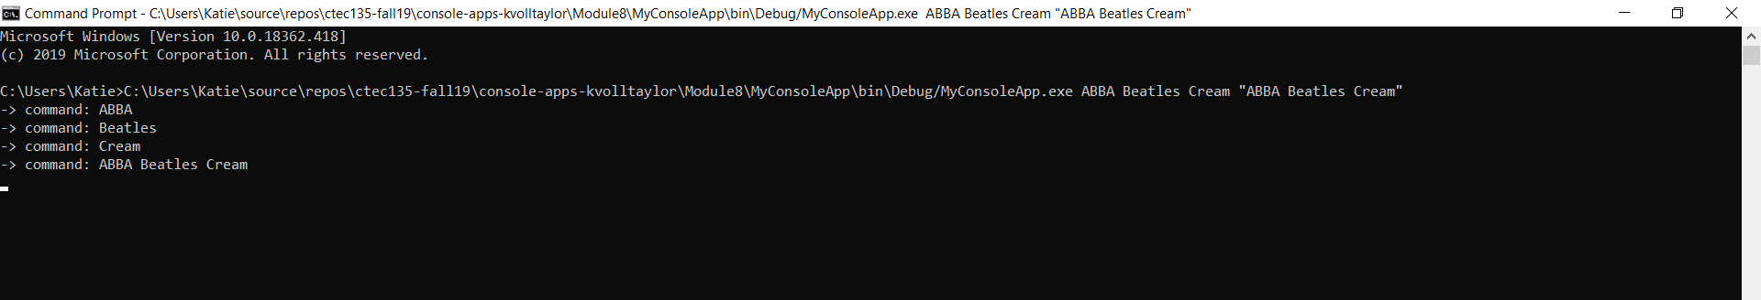

Problem 2:
