Windows Forms App By Hand Screenshot

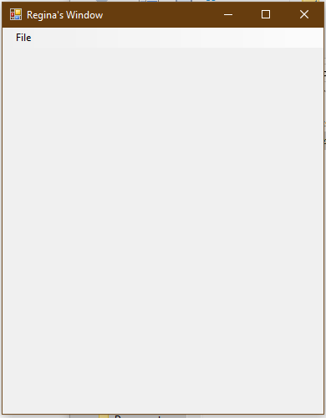

Doesn’t show exit here, but it’s there.