Windows Service

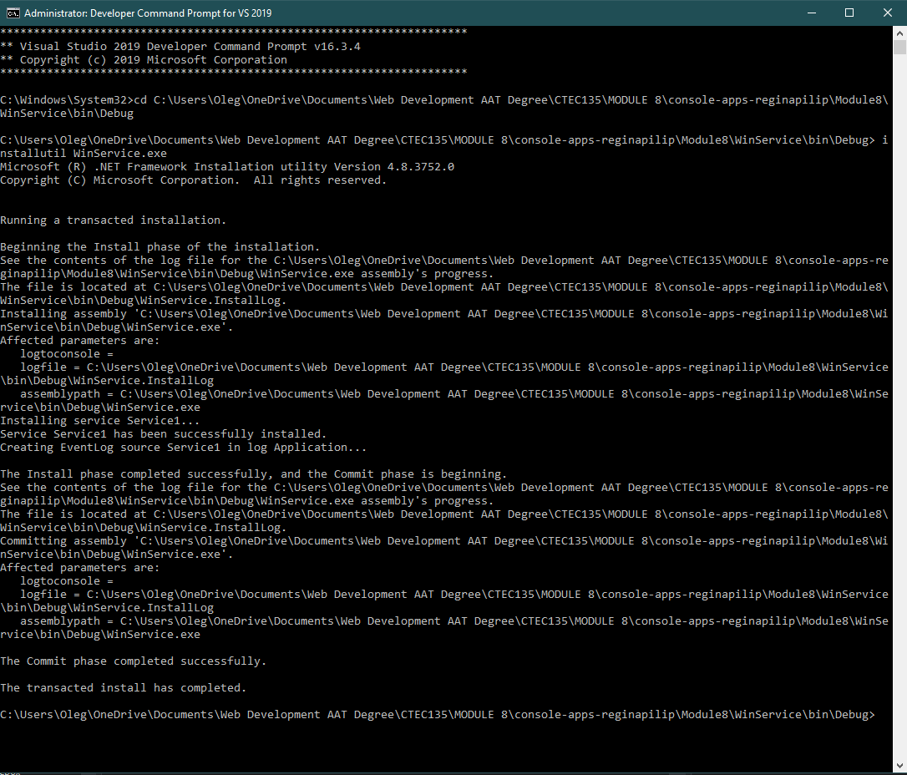

Service started successfully

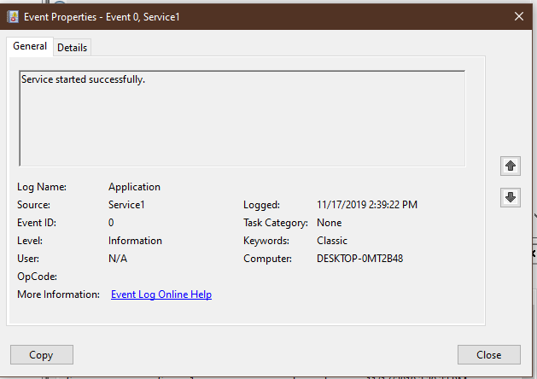

\*\* for some reason it didn’t show up as WinService here. For the first event, it did show up as WinService:



Starting, Pausing, Resuming, Restarting, and Stopping Service Events

