Torin Tashima

**Windows Form App By Hand**

*Screenshot*

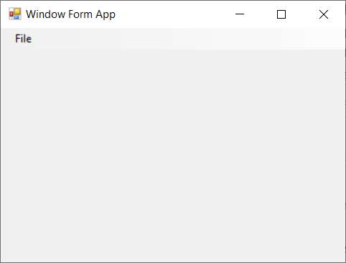

Note: The Exit option is under File, I swear.