TASK: Working with CSS and Javascipt

Prob 1: CSS

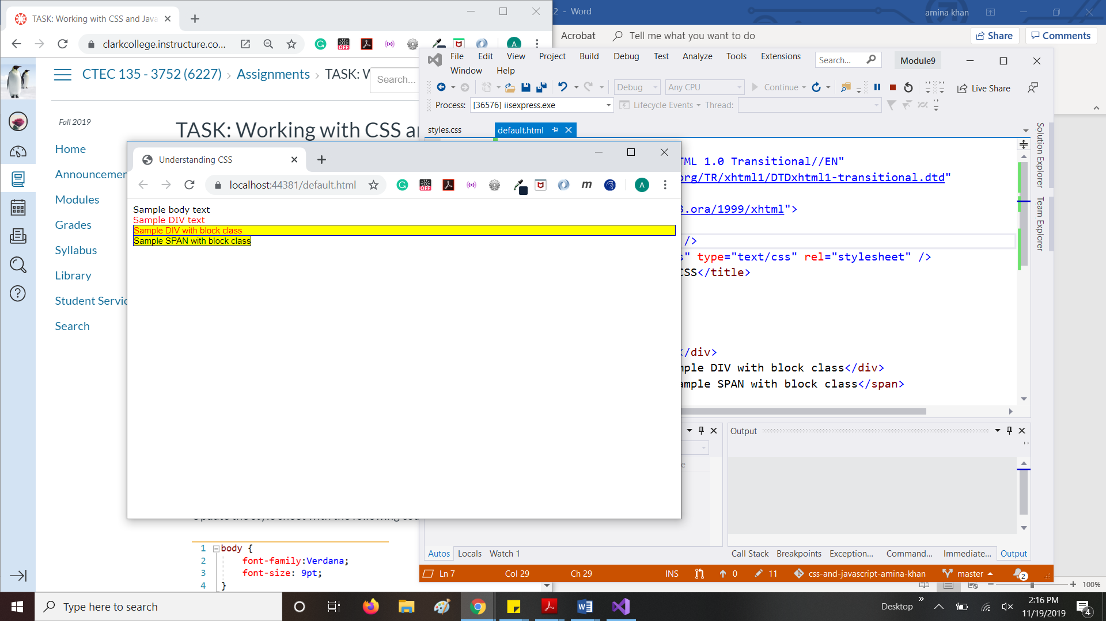

Prob 2: JavaScript

Before filling out the form

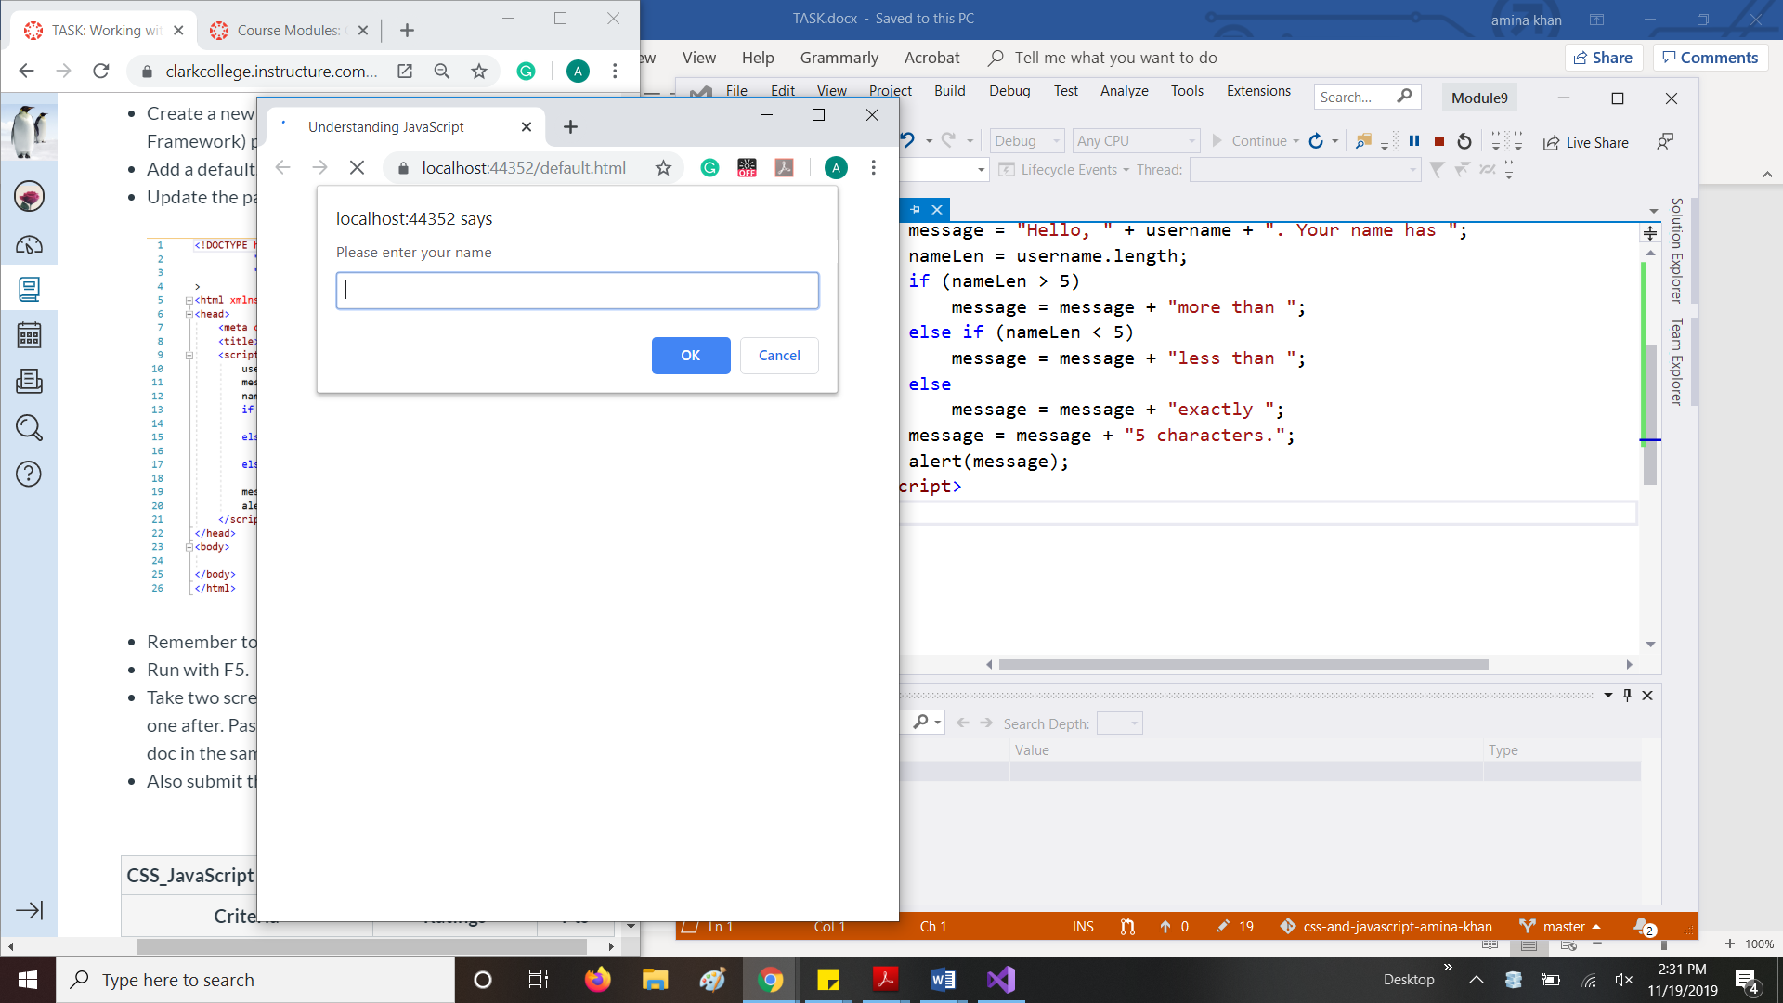

After filling out the form:

