Torin Tashima

TASK: Working with CSS and JavaScript

Prob: 2 – JavaScript

Screenshot: Before Entering Input

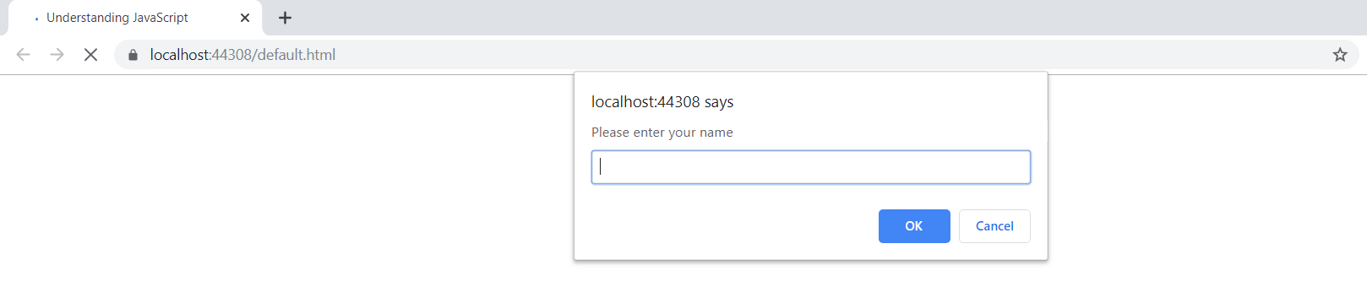

Screenshot: After Entering Input

