# Prob 3 Write-up

Here, the Car class has a field reference to the Attributes class. This makes it possible to aggregate data and behavior by calling methods from the Car class that are from the Attributes class.

**Define Aggregation in your own words:**

* Essentially, aggregation is a class creating a field reference of another class. This enables classes to have access to each other.

**Define Composition in your own words:**

* Composition means the class owns the variable. The variable’s existence depends on the class. For example, a variable being created solely by one class, and not depending on references to other classes to be created.

**Internet examples of how other people define these terms:** 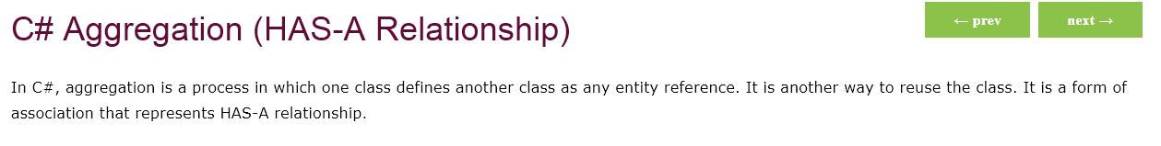

<https://www.javatpoint.com/c-sharp-aggregation>

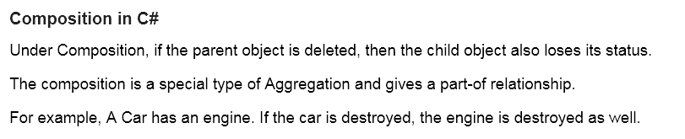

<https://www.tutorialspoint.com/Association-Composition-and-Aggregation-in-Chash>

**How does your definition compare to other definitions? (w/ sources)**

* The internet example of composition above describes it as a special type of aggregation and also describes it as a Has-a relationship.
* The Internet example of aggregation above also calls it a HAS-A relationship, but is very similar to my definition.

**What is the difference between these two relationships?**

* The difference is, in aggregation, the reference variable refers to something completely independent from the class it is referred to in. It exists independently. The opposite is the case in composition.