Author: Allison Drake

Lab: Create and Test a Webs Service

CTEC 135: C# Programming

11/21/2019

CREATE THE SERVICE

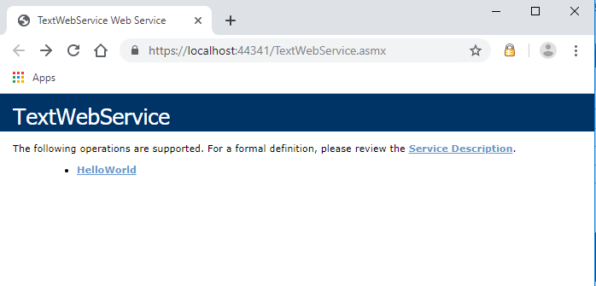

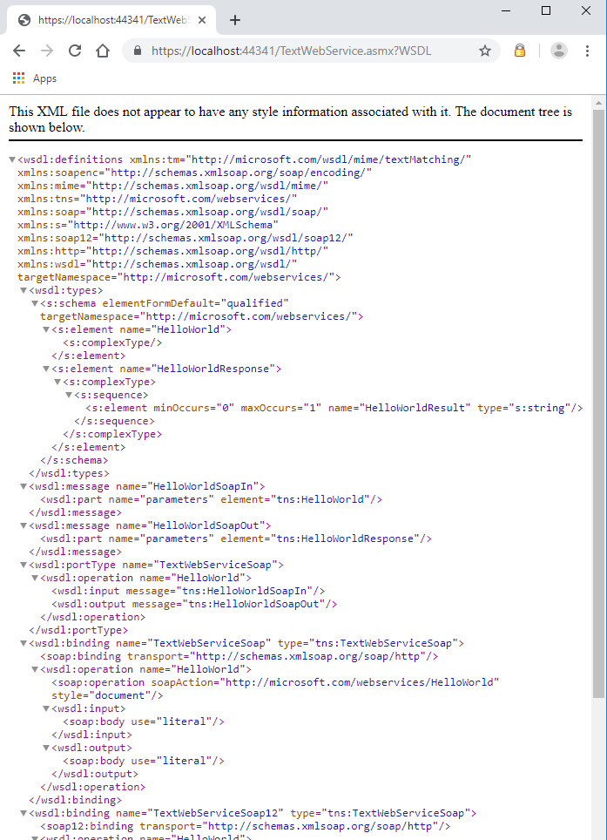

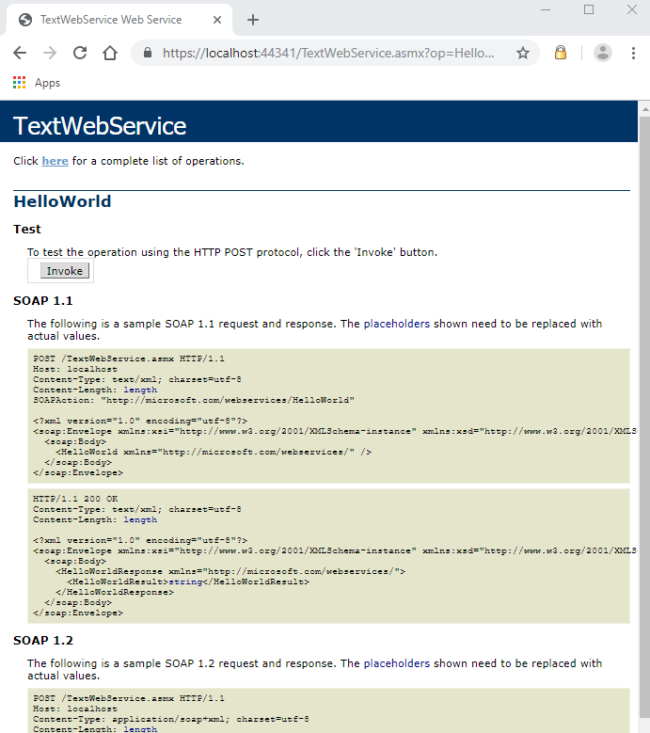

TESTING:

