Torin Tashima

Lab: Create and Test a Web Service

Screenshot – Description

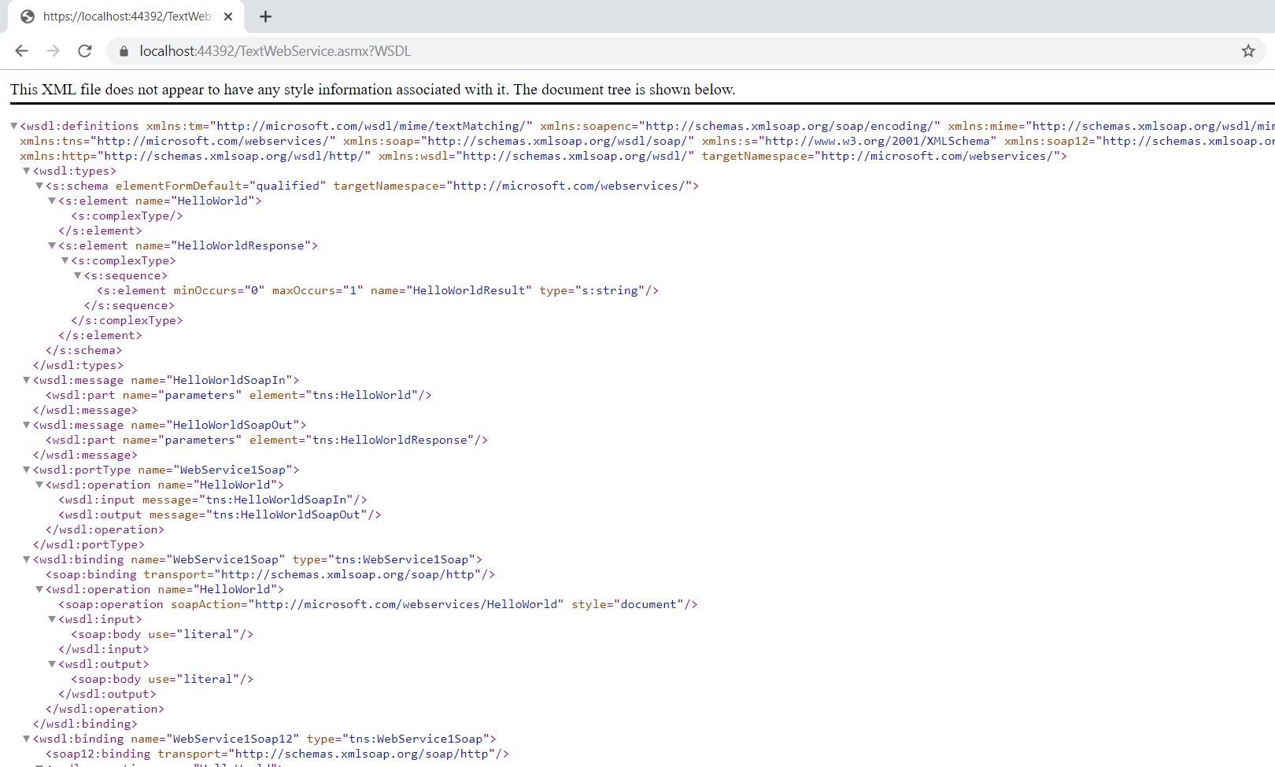

Screenshot – Hello World

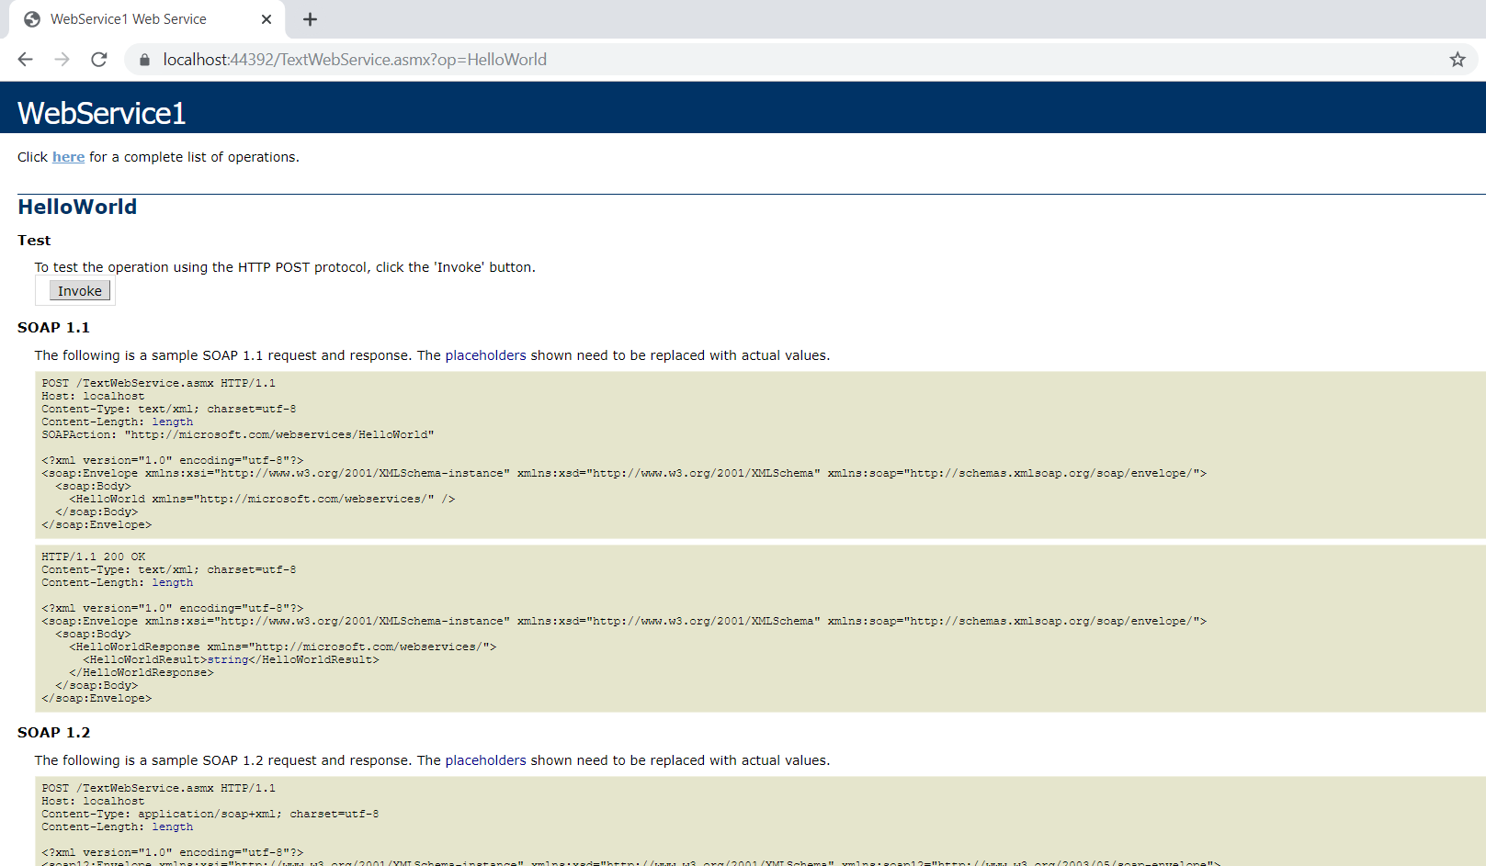

Screenshot – Invoke Link

