Torin Tashima

Lab: Create a Web Service Client

Screenshot – Before Invoke

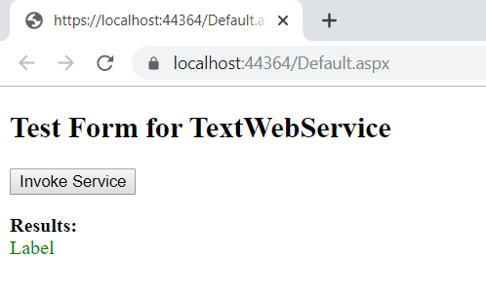

Screenshot – After Invoke

