**OpenGrab Electro Permanent Magnet NicaDrone.com**

EPM688-V2.5x

**General Description**

The EPM688-V2.5X is an Electro Permanent Magnet, combining the advantages of electro and permanent magnets.

The magnetic domains in the Alico magnets are aligned in a particular orientation as to form a magnetic circuit with a ferrous target plate. A short, 20us pulse current of 300A is generated by discharging the main capacitor through a Thyristor full bridge into the copper winding generating a field of 70kAm. This field is used to align Alico domains.

The key advantage is a very strong electromagnet that does not consume energy during steady state operation only during cycling

This Device comes with integrated electronics that can be operated with a 50Hz 5V PWM signal common on RC electronics. The device is designed to hold 5kg of cargo with a holding force of over 80N or 8kg.

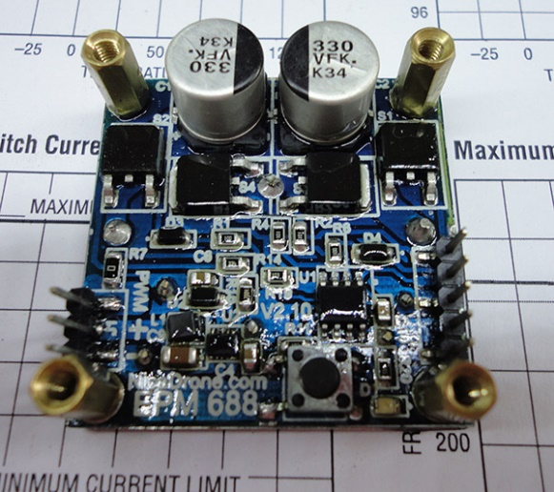**Applications**

* Cargo lifting in UAVs
* Robot work holidng
* Education demonstration of magnetic properties

**Features**

* 5-6V Vcc
* PWM signal
* Minimal steady state power <1mW
* Water resistant conformal coating
* Short cycle time
* On board Pic12F with source code and in-circuit programming header

**Recommended Operational Conditions**

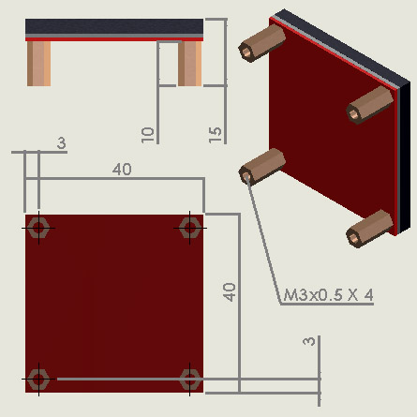

Figure 1 Drawing

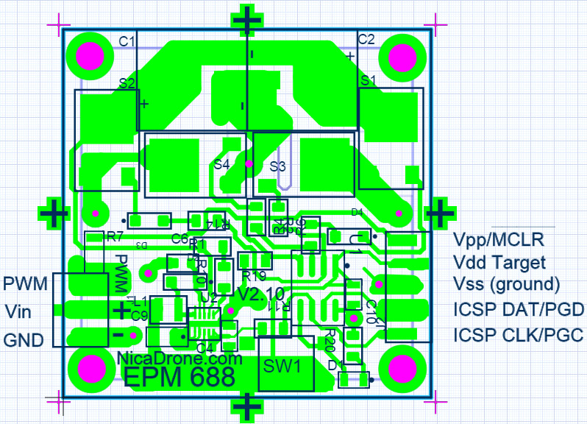

**Pin Functions**

**GND**

Ground pin

**Vin**

5V supply

**PWM**

RC PWM signal input

**ICSP CLK / Data**

The Data pin puts out the current state of the EPM,TTL high for On and TTL low for Off.

**Vpp, Vdd, Vss, ICSP Dat, ICSP CLK**

These pins are broken out to provide the user with the ability to reprogram the on board PIC12F. Further information can be found in the documentation provided by Microchip

**Operation**

After connection VCC and GND the device will charge the capacitor.

When a on command is given either by the toggling push button or by a PWM signal the device will discharge the capacitor 6 times into the coil. This takes 1750ms

When a off command is given the device will alternately magnetize the alnico magnets repeadly while decreasing the amplitude of the voltage thereby demagnetizing the Alnico magnet. This takes 1250ms

**Push Button Mode**

Pressing the Push button will toggle between an on and off command

**PWM Mode**

A RC Pulse Width Modulated signal can also be used. High times between 0.75 and 1.25ms are consider an Off command. 1.75-2.25ms is considered On command. Moving the signal on time from neutral, 1.25-1.75ms to either On or Off range will command the EPM to go into the respected state.

**Error**

The LED will blink about once per second when the PWM signal is not present. An error is either a missing or out time range PWM signal.

**LED**

Led goes on when the button is pressed. The Led will blink rapidly 4 times after a command has been executed, either going On or Off.

**Principle of operation**

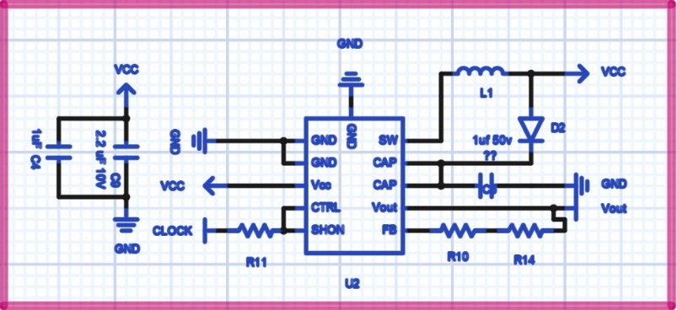U2 a boost converter creates 40V and charges the main capacitors, C1 and C2 storing 550mJ.

Figure 2 Boost Converter

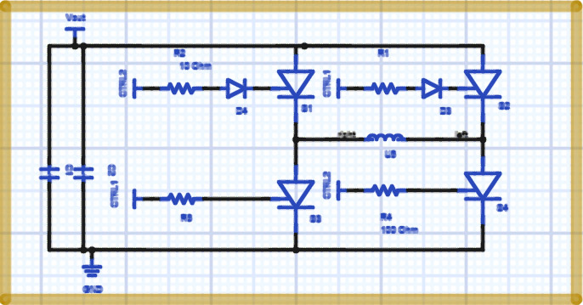The full bridge Thyristor discharges this energy into a copper coil making up the magnetic assembly. This creates a 300A current

Figure 3 Full bridge Thyristor