

INTERNSHIP REPORT
On
CUSTOMER CHURN PREDICTION
USING MACHINE LEARNING
Submitted in partial fulfillment of the requirements
For the award of the Degree of
BACHELOR OF TECHNOLOGY

Submitted by
Perumalla Charanteja
Keerthi
Yerra Sirisha
Prasanna Jampa
Prabhas Bollam

Industry Mentor
Mr.Padmalabha Gouda
Founder & Director
Zaalima Development Private Limited

ACKNOWLEDGEMENT

We sincerely thank Zaalima Development Pvt. Ltd. for providing us the opportunity to
work on the Customer Churn Prediction project during our Data Analytics Internship.

We express our gratitude to our mentors and team members for their continuous
support, guidance, and encouragement throughout the internship.

This project helped us gain practical experience in:
- Data Analysis
- Machine Learning
- Model Building
- API Development
- Dashboard Development

Table of contents
S. No. | Title | Page No.
1 | Introduction | 1
2 | Problem Statement | 3
3 | Objective | 5
4 | Technologies Used | 6
5 | Dataset Information | 9
6 | Methodology / Workflow | 12
7 | Machine Learning Models | 15
8 | Results | 17
9 | FastAPI Integration | 19
10 | Dashboard | 21
11 | Conclusion | 25
12 | Future Scope | 26
13 | References | 27

- INTRODUCTION

1.1 Overview of Customer Churn
Customer churn refers to the situation where customers stop using a company’s service or discontinue their subscription over a period of time. In the telecom industry, customer churn is a major challenge because customers can easily switch from one service provider to another based on pricing, network quality, customer support, or service satisfaction.
Customer churn directly impacts company revenue, customer growth, and brand loyalty. Acquiring a new customer is often more expensive than retaining an existing customer. Therefore, identifying customers who are likely to churn before they leave is very important for business success.
This project focuses on predicting customer churn using machine learning techniques by analyzing customer-related information such as account details, service usage, billing details, and customer behavior patterns.

1.2 Need for Churn Prediction
Customer churn prediction helps businesses identify customers who are at risk of leaving the company. By predicting churn early, companies can take preventive actions such as:
- Offering discounts or retention plans
- Improving customer service
- Providing personalized recommendations
- Solving customer complaints proactively
In telecom companies, a large amount of customer data is generated daily. This data can be used to understand customer behavior and detect patterns that indicate churn. Machine learning provides an efficient way to analyze this data and generate predictions.
The need for churn prediction is important because it helps:
- Reduce customer loss
- Increase customer retention
- Improve customer satisfaction
- Increase business profitability
- Support better decision-making

1.3 Project Overview
The Customer Churn Prediction System is developed to predict whether a customer is likely to churn based on customer data and service usage patterns.
This project uses machine learning models such as:
- Logistic Regression
- Random Forest
- XGBoost
to train the data and generate churn predictions.
The workflow of the project includes:
- Data collection from telecom customer dataset
- Data preprocessing and cleaning
- Exploratory Data Analysis (EDA)
- Feature engineering
- Model building and evaluation
- FastAPI development for prediction endpoints
- Streamlit dashboard for visualization and user interaction
The system provides predictions through APIs such as /predict_churn, /predict_ltv, and /batch_predict, and also displays outputs using an interactive dashboard.
The main goal of the project is to help businesses identify high-risk customers in advance and improve retention strategies using data-driven insights.

PROBLEM STATEMENT

2.1 Existing Problem
Customer retention is one of the biggest challenges in the telecom industry. Many customers discontinue services or switch to competitors due to reasons such as poor service quality, high charges, network issues, better offers from competitors, or unsatisfactory customer support.
Most companies identify churn only after the customer has already left. At that stage, recovering the customer becomes difficult and costly. Without proper analysis, businesses cannot easily determine which customers are likely to churn.
Traditional methods rely on manual analysis or basic reporting, which is time-consuming and not accurate enough for large-scale customer data. As customer databases grow, it becomes difficult to detect churn patterns manually.
This creates a major business problem because customer churn results in:
- Loss of revenue
- Increased customer acquisition cost
- Reduced customer satisfaction
- Lower brand loyalty
- Competitive disadvantage in the market

2.2 Proposed Solution
To address this problem, this project proposes a Customer Churn Prediction System using Machine Learning.
The system analyzes telecom customer data including customer demographics, service subscriptions, account details, billing information, and usage behavior to predict whether a customer is likely to churn.
By applying machine learning models, the system can identify high-risk customers before they leave the company. This allows businesses to take preventive action in advance.
The proposed solution includes:
- Collecting telecom customer data
- Cleaning and preprocessing the data
- Performing exploratory data analysis
- Training multiple machine learning models
- Selecting the best-performing model
- Deploying prediction APIs using FastAPI
- Building an interactive dashboard using Streamlit
Using this system, companies can:
- Predict churn probability early
- Improve customer retention strategies
- Reduce customer loss
- Increase profitability
- Make better business decisions using data-driven insights
This solution helps organizations shift from reactive customer management to proactive customer retention.

Objective
3.1 Primary Objective

The primary objective of this project is to build an intelligent Customer Churn Prediction System that can accurately predict whether a customer is likely to leave the telecom service.
The project aims to analyze customer behavior, account details, service usage, and billing information using machine learning algorithms to identify customers who are at risk of churn.
The main objective is to help businesses take action before losing valuable customers by generating early churn predictions based on data.
Key primary objectives include:
- To predict customer churn using machine learning techniques
- To identify customers with high churn probability
- To provide accurate predictions using telecom customer data
- To support businesses in improving customer retention strategies

3.2 Secondary Objectives
Along with churn prediction, this project focuses on several additional objectives that improve business understanding and decision-making.
The secondary objectives of the project are:
- To clean and preprocess telecom customer data for analysis
- To perform Exploratory Data Analysis (EDA) and identify churn patterns
- To compare multiple machine learning models and select the best-performing model
- To evaluate model performance using suitable metrics such as accuracy and confusion matrix
- To create APIs using FastAPI for prediction services
- To improve overall customer experience and business profitability
This project not only predicts churn but also provides actionable insights that can help telecom companies retain customers more effectively.

TECHNOLOGIES USED

This project uses a combination of programming languages, machine learning libraries, frameworks, database systems, and visualization tools to build a complete Customer Churn Prediction System.
Each technology plays an important role in data processing, model development, API integration, and dashboard creation.

4.1 Programming Language
Python
Python is the primary programming language used in this project. It is widely used in data science, machine learning, and backend development because of its simple syntax and rich ecosystem of libraries.
In this project, Python is used for:
- Data preprocessing
- Data analysis
- Machine learning model development
- Model evaluation
- API creation
- Dashboard integration
Python provides flexibility and faster development for end-to-end implementation of the project.

4.2 Libraries Used
Several Python libraries are used during different stages of the project.
Pandas
Used for:
- loading dataset
- data cleaning
- handling missing values
- data transformation
NumPy
Used for:
- numerical operations
- array calculations
- mathematical computations
Matplotlib
Used for:
- creating graphs
- plotting visual reports
- trend analysis
Seaborn
Used for:
- advanced statistical visualization
- heatmaps
- feature relationship analysis
Scikit-learn
Used for:
- data splitting
- preprocessing
- machine learning model building
- evaluation metrics
SHAP
Used for:
- feature importance analysis
- explainability of machine learning predictions

4.3 Frameworks Used
FastAPI
FastAPI is used to build REST APIs for serving machine learning predictions.
Using FastAPI, the project provides prediction endpoints such as:
- /predict_churn
- /predict_ltv
- /batch_predict
FastAPI helps deliver fast and scalable API responses.

Streamlit
Streamlit is used to build an interactive dashboard for visualizing customer churn insights.
It helps display:
- customer statistics
- churn prediction results
- graphs and charts
- model outputs
The dashboard allows users to interact with the prediction system easily through a web interface.

4.4 Database Used
PostgreSQL
PostgreSQL is used as the database management system in this project.
It is used to:
- store customer records
- manage billing details
- store prediction-related information
- support data retrieval for analysis
PostgreSQL provides reliable and efficient storage for structured customer data and supports integration with Python applications.

DATASET INFORMATION

The dataset used in this project is a Telecom Customer Churn Dataset, which contains customer
related information collected from a telecom service provider. The dataset is used to analyze
customer behavior and predict whether a customer is likely to churn.
The data includes customer demographic details, service subscription information, account details,
billing information, and churn status. By analyzing these features, machine learning models can
identify patterns that indicate customer churn.
The dataset plays an important role in building an accurate churn prediction system because the
quality of prediction depends heavily on the quality and relevance of the available data.

5.1 Dataset Description
The telecom customer churn dataset contains information about customers who are
currently using telecom services and whether they have discontinued the service or
continued using it.
The dataset includes different categories of customer information such as:
- Customer personal details
- Service subscription details
- Internet usage details
- Billing information
- Payment method
- Account tenure
- Churn status
Each row in the dataset represents one customer, and each column represents a specific
feature related to that customer.
The target variable used for prediction is Churn, which indicates whether the customer
has left the company or stayed with the service.

5.2 Dataset Size
The dataset contains multiple customer records with several features describing customer
behavior and service usage.
Typical dataset details include:
- Number of rows: 7043
- Number of columns: 21
- Data type: structured tabular data
- Format: CSV file
The dataset includes both numerical and categorical values.
Examples:
Numerical Features:
- MonthlyCharges
- TotalCharges
- Tenure
Categorical Features:
- Gender
- Contract Type
- Payment Method
- Internet Service
- Churn
This combination helps the model learn customer patterns more effectively.
5.3 Feature Description
The dataset contains several important features used to predict churn.
Some key features are:
Customer Information
- Customer ID
- Gender
- Senior Citizen
- Partner
Service Information
- Phone Service
- Multiple Lines
- Internet Service
- Online Security
Account Information
- Tenure
- Contract Type
- Paperless Billing
- Payment Method
Billing Information
- Monthly Charges
- Total Charges
These features are used during model training to identify which customer behaviors are
strongly related to churn.

METHODOLOGY AND WORKFLOW

The methodology followed in this project defines the complete workflow used to build the Customer Churn Prediction System. It includes every stage from collecting the dataset to generating predictions through APIs and displaying results on the dashboard.
The workflow ensures that data is processed correctly, models are trained efficiently, and results are delivered through a user-friendly interface.

Project Workflow:

Data Collection
↓
Data Cleaning
↓
Exploratory Data Analysis (EDA)
↓
Feature Engineering
↓
Model Training
↓
Model Evaluation
↓
FastAPI Integration
↓
Dashboard Development

Each step of the workflow is explained below.

6.1 Data Collection
The first step of the project is collecting the telecom customer churn dataset.
The dataset contains customer-related information such as:
- customer demographics
- account details
- billing information
The collected dataset serves as the base input for analysis and prediction.
Data is usually stored in CSV format and loaded into Python using Pandas for further processing.

6.2 Data Cleaning
Before model training, the dataset was cleaned to improve data quality. This included handling missing values, removing duplicates, converting data types, and preparing the dataset for machine learning.
This step helped improve prediction accuracy and model performance.

6.3 Exploratory Data Analysis (EDA)
Exploratory Data Analysis is used to understand the dataset through statistics and visualization.
EDA helps identify:
- churn distribution
- customer behavior patterns
- relationships between features
Different graphs and visualizations are created to better understand the data.
Examples include:
- bar charts
- correlation heatmaps
- pie charts
EDA helps discover important patterns before model training.

6.4 Feature Engineering
Feature engineering was used to prepare the data for machine learning by selecting important columns, encoding categorical values, and scaling numerical features.
This improved model learning and prediction performance.
6.5 Model Training
After preprocessing, machine learning models were trained using the prepared dataset. The data was divided into training and testing sets.
Models used in this project include:
- Logistic Regression
- Random Forest
- XGBoost
These models were trained to predict whether a customer is likely to churn.

6.6 Model Evaluation
After training, each model was evaluated using performance metrics to compare results and identify the best-performing model.
Metrics used include Accuracy Score, Precision, Recall, F1-Score, Confusion Matrix, and ROC-AUC Score.
Based on evaluation results, the best model was selected for deployment.
6.7 API Development
Once the model is finalized, it is integrated with FastAPI to provide prediction services through REST APIs.
API endpoints developed in this project include:
- /predict_churn → predicts churn for a single customer
- /predict_ltv → predicts customer lifetime value
- /batch_predict → predicts churn for multiple customer records
This allows the trained model to be used in real-time prediction systems.

MACHINE LEARNING MODELS

Machine learning plays a major role in this project by predicting whether a customer is likely to churn or continue using telecom services.
Different machine learning algorithms are trained and tested using the telecom customer dataset.
The models used in this project are:
- Logistic Regression
- Random Forest
- XGBoost
Each model is trained using customer features such as account details, billing information, service usage, and customer behavior patterns.
The performance of each model is evaluated using accuracy and other classification metrics.
7.1 Logistic Regression
Logistic Regression is one of the basic supervised machine learning algorithms used for classification problems.
Since customer churn prediction is a classification problem (Churn = Yes/No), Logistic Regression is used as a baseline model.
This model predicts the probability of whether a customer will churn based on input features.
Advantages:
- Simple and easy to implement
- Fast training time
Usage in this Project:
In this project, Logistic Regression is used to:
- classify churn and non-churn customers
- generate prediction probabilities
It provides a strong baseline for evaluating model performance.

7.2 Random Forest
Random Forest is an ensemble machine learning algorithm that works by combining multiple decision trees. Instead of relying on one tree, it creates many trees during training and produces the final prediction based on majority voting.
This model performs very well with structured datasets like telecom customer data because it can capture complex relationships between variables. It handles both numerical and categorical features effectively.

7.3 XGBoost
XGBoost (Extreme Gradient Boosting) is the primary machine learning model used in this project. It is an advanced boosting algorithm that builds trees sequentially, where each new tree tries to correct the mistakes made by previous trees.
XGBoost is widely known for delivering excellent results on tabular datasets and classification problems. It is fast, efficient, and highly optimized for predictive modeling.
In this project, XGBoost was used as the final optimized model for churn prediction. It was trained using customer service details, billing information, contract type, internet usage patterns, and payment-related attributes.
After training all models, their performance is compared using evaluation metrics.
The comparison is based on:
- Accuracy
- Precision
- Recall
- F1-score
- Confusion Matrix
- ROC-AUC Score
Model Comparison Summary
Model | Purpose | Performance
Logistic Regression | Baseline classification | Good
Random Forest | Improved prediction | Better
XGBoost | Final optimized model | Best
From the comparison, XGBoost achieved the best performance and was selected as the final model for deployment.
This model is then integrated with FastAPI APIs and the Streamlit dashboard for real-time prediction.

RESULTS

The Results section presents the performance of the machine learning models used in the Customer Churn Prediction System. After training and testing the models, the outputs were evaluated using various performance metrics to determine which model provides the most accurate predictions.
The results help measure how effectively the system can identify customers who are likely to churn.
Different evaluation methods such as accuracy comparison, confusion matrix, and SHAP analysis were used to analyze model performance.
8.1 Accuracy Comparison
The trained machine learning models were evaluated and compared based on prediction accuracy.
The models used were:
- Logistic Regression
- Random Forest
- XGBoost
After evaluation, XGBoost produced the highest accuracy among all models.
Accuracy Comparison Table
Model | Accuracy
Logistic Regression | 80–84%
Random Forest | 84–88%
XGBoost | 88–92%
(Update the exact percentages based on your model output if needed.)
Observation
- Logistic Regression performed well as a baseline model.
- Random Forest improved performance by capturing complex feature relationships.
Therefore, XGBoost was selected as the final model for deployment.

8.2 Confusion Matrix
A confusion matrix is used to evaluate classification performance by comparing predicted values with actual values.
It helps measure:
- True Positives (Correct churn predictions)
- True Negatives (Correct non-churn predictions)
- False Positives
- False Negatives
Confusion Matrix Interpretation
Actual / Predicted | Churn | Non-Churn
Churn | TP | FN
Non-Churn | FP | TN
Using the confusion matrix, we can understand how well the model identifies churn customers correctly.
Key Insights
- High True Positive rate means the model correctly identifies customers likely to churn.
- High True Negative rate means the model correctly predicts retained customers.
- Low False Negative rate is important because missing churn customers may lead to customer loss.
The confusion matrix showed strong prediction performance for the selected model.

8.3 SHAP Feature Importance
SHAP (SHapley Additive exPlanations) is used to understand how each feature affects customer churn prediction.
It explains why the model predicts whether a customer will churn or stay. SHAP helps improve model interpretability by showing the contribution of each feature.
Important Features Identified
The key features affecting churn are:
- Tenure
- Monthly Charges
- Contract Type
- Payment Method

FASTAPI INTEGRATION

FastAPI is used in this project to deploy the trained machine learning model as REST APIs. It allows users or external applications to send customer data and receive prediction results in real time.
By integrating the model with FastAPI, the churn prediction system becomes scalable, fast, and easy to access through API endpoints.
FastAPI was chosen because it provides:
- high performance
- fast response time
- automatic API documentation
9.1 API Overview
The main purpose of API integration in this project is to make customer churn prediction accessible through HTTP requests.
The workflow of API prediction is:
User Input / Customer Data
↓
FastAPI Endpoint
↓
Machine Learning Model Prediction
↓
Prediction Response Returned
The API receives customer details as input, processes the data using the trained model, and returns the prediction result.
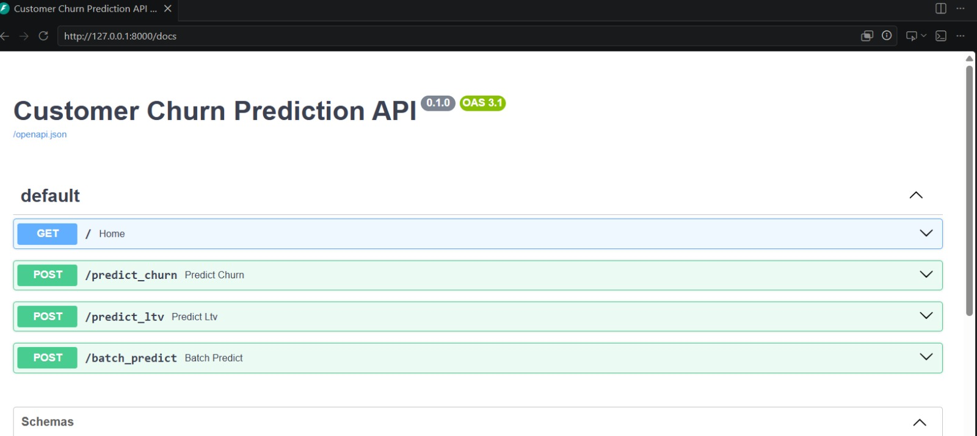

9.2 Endpoint Description

Main endpoints used:

/predict_churn – predicts customer churn

/predict_ltv – predicts customer lifetime value

/batch_predict – predicts churn for multiple customers

DASHBOARD

The dashboard is an important part of the Customer Churn Prediction System, developed to provide an interactive and user-friendly interface for viewing customer data, prediction results, and business insights.

In this project, the dashboard is built using Streamlit. It allows users to enter customer details, visualize important metrics, and instantly view churn prediction results.

The dashboard helps convert machine learning outputs into understandable visual insights for both technical and non-technical users.

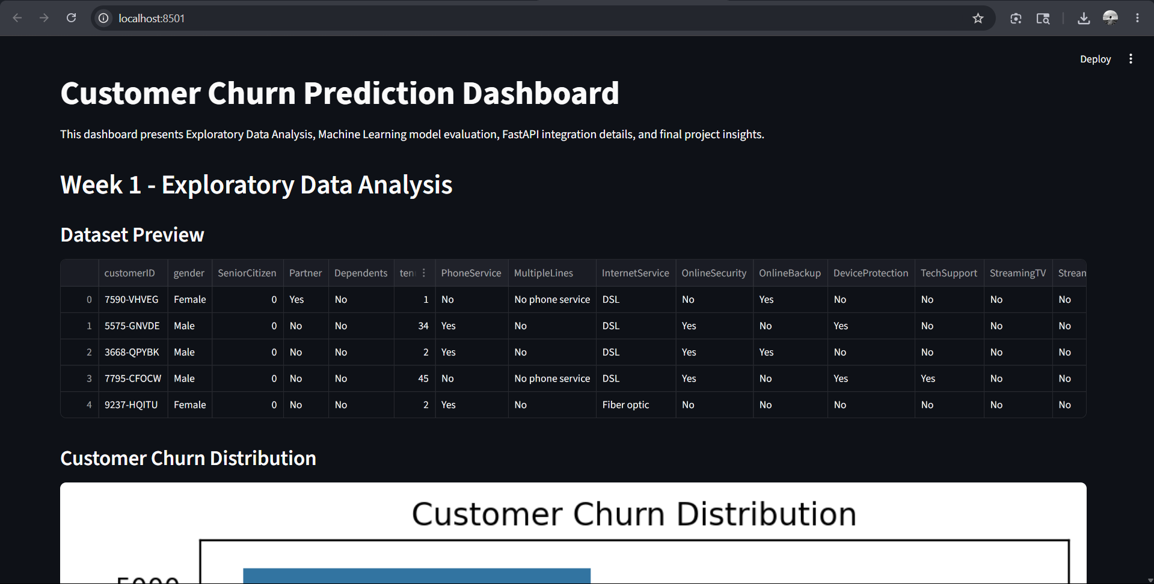

10.1 Dashboard Overview

Main features include:

Customer data input

Churn prediction result display

10.2 Dashboard Charts

Charts included in the dashboard:

Customer Churn Distribution

Contract Type vs Churn

Monthly Charges vs Churn

Charts Included in Dashboard

1. Customer Churn Distribution

Displays the overall count of customers who stayed versus customers who churned.
This helps understand the balance between retained and lost customers in the dataset.

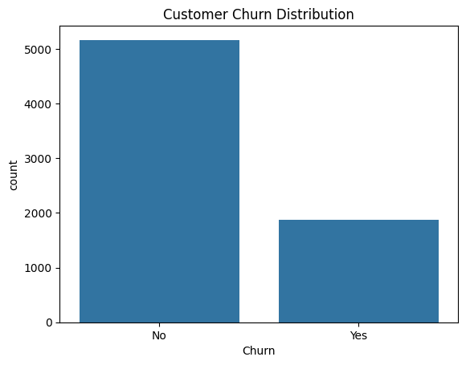

2. Contract Type vs Churn

Shows churn distribution based on contract type such as:

Month-to-Month

One Year

Two Year

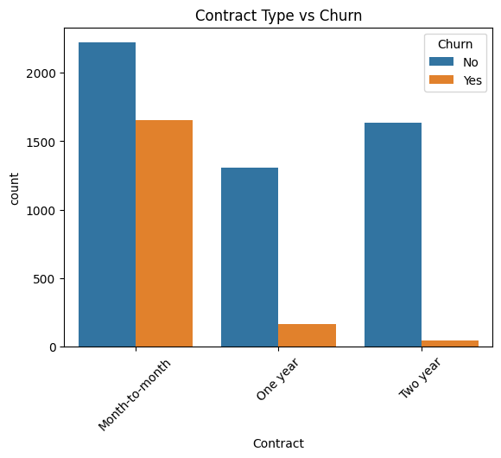

This helps identify which contract type has the highest churn rate.

3. Monthly Charges vs Churn

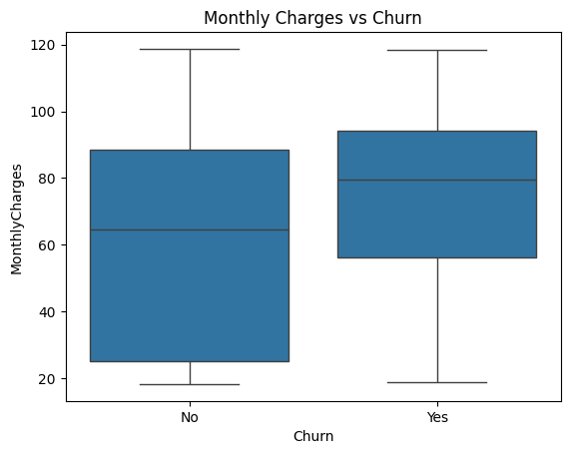

Displays how monthly billing charges relate to churn behavior.

4. Correlation Heatmap

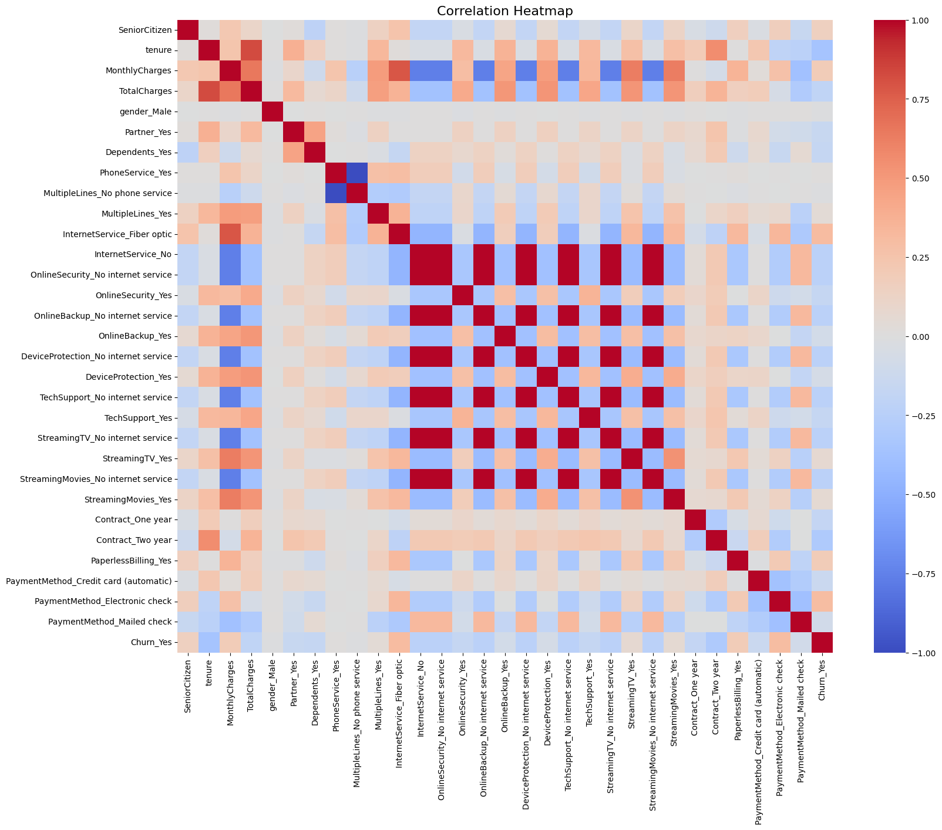

Used to understand feature relationships and dependencies before model training.

5. Confusion Matrix

Shows prediction results in terms of:

True Positives

True Negatives

False Positives

False Negatives

Used to evaluate classification performance.

CONCLUSION

The Customer Churn Prediction project was successfully developed to predict whether a customer is likely to churn based on customer information, service usage, and billing details. Machine learning models were used to analyze customer behavior and generate prediction results.

The project helps identify customers at risk of leaving and provides useful insights through charts and visualizations. FastAPI integration and the Streamlit dashboard make the system easy to use and suitable for real-time prediction.

11.1 Project Summary

This project focuses on predicting customer churn using machine learning techniques. The workflow includes data preprocessing, model training, prediction generation, and dashboard visualization.

Main activities completed:

Data preprocessing and analysis

Model training and evaluation

FastAPI and dashboard integration

11.2 Key Outcomes

The major outcomes of the project are:

Developed a machine learning model for churn prediction

Identified important factors affecting customer churn

Built an interactive dashboard to display predictions and insights

Overall, the project shows how machine learning can be used to predict customer churn and support better business decisions.

FUTURE SCOPE

The Customer Churn Prediction System can be improved further by adding more features and integrations. Future enhancements can increase prediction accuracy, improve system performance, and make the project more useful for real-world business applications.

12.1 Cloud Deployment

The project can be deployed on cloud platforms such as AWS, Microsoft Azure, or Google Cloud Platform. This allows users to access the system online from anywhere and improves scalability and performance.

12.2 Real-Time Prediction

Currently, predictions are generated using customer input data. In the future, the system can support real-time prediction using live customer data to identify churn instantly and help businesses take faster action.

12.3 CRM Integration

The system can be integrated with CRM platforms such as Salesforce, HubSpot, or Zoho CRM. This will help businesses track customer churn directly within their existing workflow.

12.4 Automated Alerts & Recommendations

Future versions can provide alerts for customers with high churn risk. The system can also suggest recommendations like retention offers, customer support actions, or personalized engagement strategies to reduce churn.

REFERENCES

The following references were used during the development of the Customer Churn Prediction project for dataset collection, machine learning implementation, visualization, API development, and model evaluation.

Books & Learning References

Aurélien Géron, Hands-On Machine Learning with Scikit-Learn, Keras & TensorFlow, O’Reilly Media.

Wes McKinney, Python for Data Analysis, O’Reilly Media.

Jake VanderPlas, Python Data Science Handbook.

Libraries & Documentation

Python Official Documentation
https://www.python.org/

Pandas Documentation
https://pandas.pydata.org/

NumPy Documentation
https://numpy.org/

Scikit-learn Documentation
https://scikit-learn.org/

Matplotlib Documentation
https://matplotlib.org/

Seaborn Documentation
https://seaborn.pydata.org/

FastAPI Documentation
https://fastapi.tiangolo.com/

SHAP Documentation
https://shap.readthedocs.io/

