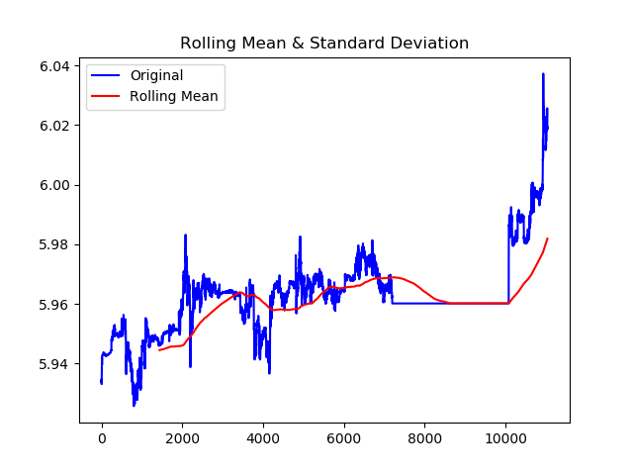

Figure 1. Question 1a

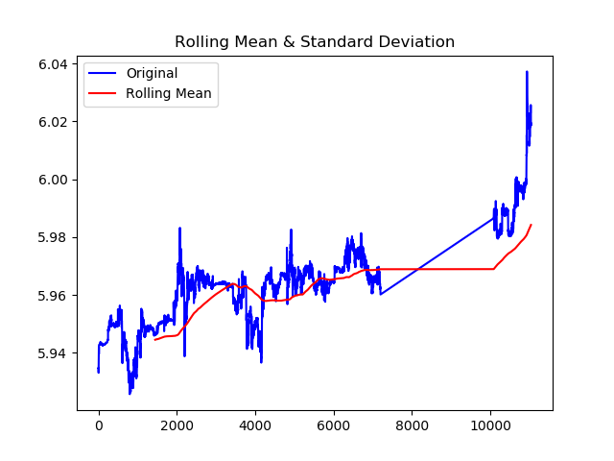

Figure 2. Question 1c

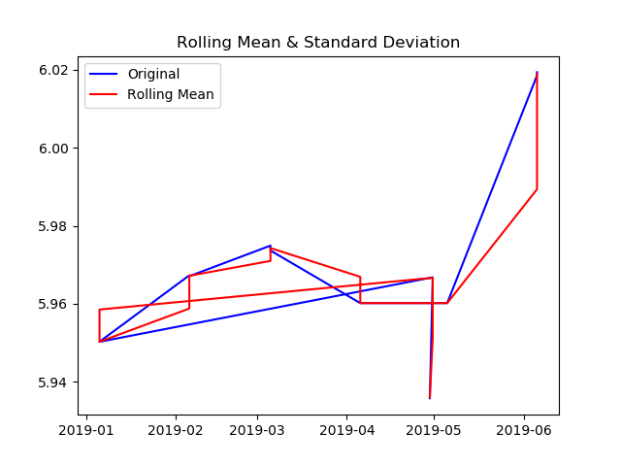

Figure 3. Question 2a

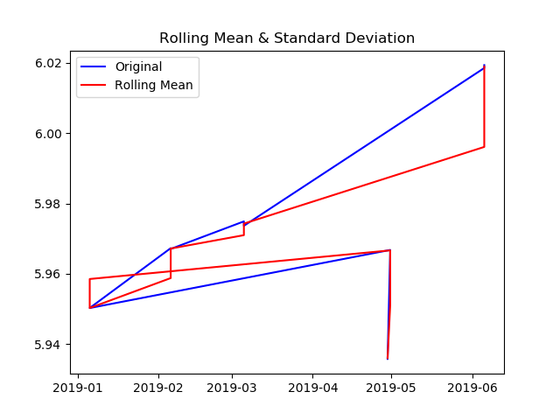

Figure 4. Question 2c

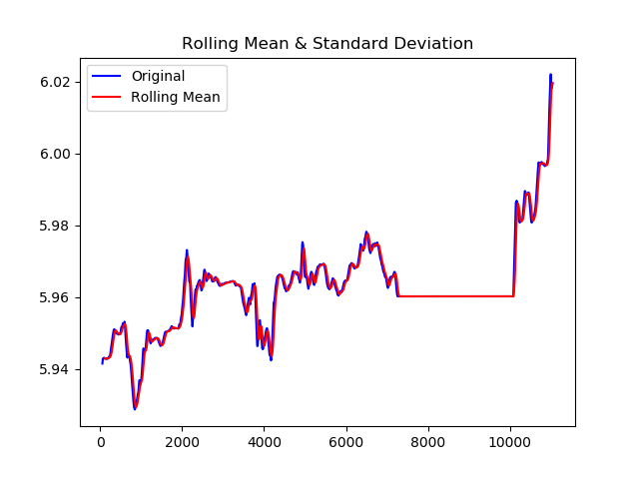

Figure 5. Question 3a

1. When we look at the RMSE values, the best method seems to be simple moving average method with exponential smoothing estimation.
2. Smoothing decreased the RMSE values significantly.