|  |  |
| --- | --- |
| Description: Description: Description: Description: Picture1 | ***Department Of Computer Engineering*** |

Experiment No. 4

|  |  |
| --- | --- |
| Semester | B.E. Semester VIII – Department of Computer Engineering |
| Subject | Human Machine Interaction |
| Subject Professor In-charge | Prof. Swapnil Sonawne |
| Assisting Teachers | Prof. Divya Racha |
| Laboratory | M-314 B |

|  |  |  |
| --- | --- | --- |
| Student Name | Chinmay Terse | |
| Roll Number | 13106B0004 | |
| Grade and Subject Teacher’s Signature |  |  |

**Title:** Create an user interface for car manufacturing company which shows the information about various car models.

**Objective:** **CO1** Student will able to design user centric interfaces

**CO2 –** Student will able to design innovative and user friendly interfaces

**Pre Lab/ Prior Concepts:** Thorough knowledge about HTML, CSS and Javascript.

**New Concepts to be learned:** GUI and Web User Interface

**Requirements:** Computer, Internet connectivity, Text editors, Web browsers.

**Explanation:**

The **user interface** (**UI**), in the industrial design field of human–computer interaction, is the space where interactions between humans and machines occur. The goal of this interaction is to allow effective operation and control of the machine from the human end, whilst the machine simultaneously feeds back information that aids the operators' decision-making process. Examples of this broad concept of user interfaces include the interactive aspects of computer operating systems, hand tools, heavy machinery operator controls, and process controls. The design considerations applicable when creating user interfaces are related to or involve such disciplines as ergonomics and psychology.

The interaction between a user and software running on a Web server. The user interface is the Web browser and the Web page it downloaded and rendered. See Web application and Web server.

Six simple design principles underpin 70+ patterns and best practices for creating rich internet applications.

1. Make it Direct
2. Keep It Lightweight
3. Stay on the Page
4. Provide an Invitation
5. Use Transitions
6. React Immediately

The developed web site directly enters the car section without redirecting the user to other webpages or showing ads to the user. The page is made lightweight as possible by using CDN instead of using Bootstrap off the server. Transitions are provided on the homepage that are attractive and inviting to the users and present an entry point to the buying portal. Due to the site being fast, it reacts immediately to user actions.

**Program Code:**

**Home.php:**

<!DOCTYPE html>

<html lang="en">

<head>

<meta name="viewport" content="width=device-width, initial-scale=1">

<title>Welcome To Tesla</title>

<link href="https://maxcdn.bootstrapcdn.com/font-awesome/4.7.0/css/font-awesome.min.css" rel="stylesheet">

<link href="https://fonts.googleapis.com/css?family=Open+Sans:400,700" rel="stylesheet">

<link rel="stylesheet" href="https://maxcdn.bootstrapcdn.com/bootstrap/3.3.7/css/bootstrap.min.css">

<script src="https://ajax.googleapis.com/ajax/libs/jquery/3.1.1/jquery.min.js"></script>

<script src="https://maxcdn.bootstrapcdn.com/bootstrap/3.3.7/js/bootstrap.min.js"></script>

<link rel="stylesheet" type="text/css" href="home.css">

</head>

<body>

<div class="container-fluid">

<div class="row text-center">

<h1 style="color:white;font-family:verdana;">Welcome To Tesla<br><h3 style="color:white;font-family:verdana;">The future is here</h3></h1>

</div>

<div class="row">

<div class="cover-card col-sm-4" style="background: url(https://www.tesla.com/configurator/compositor/?model=mx&view=STUD_SIDE&size=1920&bkba_opt=2&file_type=jpg&options=MDLX,RENA,AD15,AF00,AH00,AU00,BC0R,BP01,BS00,BTX6,CC02,CDM0,CH00,COL2-PPSB,COUS,CW00,DA02,DRLH,DSH5,DV4W,FG00,FR01,GLFR,HP00,IDCF,IX00,LP00,LT1B,ME02,MI00,MX01,PA00,PF01,PI00,PK00,PS01,PX6D,QPMB,RFPX,S02B,SC01,SP00,SR04,ST01,SU01,TIM7,TM00,TP00,TR01,TRA1,TW00,UM01,USSB,UTPB,WTHX,X001,X003,X008,X011,X014,X019,X024,X026,X028,X031,X037,X040,X041,YFFC) no-repeat center top;background-size:cover;">

<p>

Text Caption

</p>

</div>

<div class="cover-card col-sm-8" style="background: url(tesla_cars.png) no-repeat center top;background-size:cover;">

<p>

Text Caption

</p>

</div>

<div class="cover-card col-sm-3" style="background: url(https://www.tesla.com/sites/all/themes/custom/tesla_theme/assets/img/preowned/header-inventory-ms.jpg?20160803) no-repeat center top;background-size:cover;">

<p>

Text Caption

</p>

</div>

<div class="cover-card col-sm-3" style="background: url(https://www.tesla.com/configurator/compositor/?model=ms&view=STUD_3QTR&size=1200&bkba_opt=3&file_type=jpg&options=MS01,RENA,AF00,APF1,APH2,APPB,AU00,BCMB,BP00,BR03,BS00,BX60,CDM0,CH05,COL3-PPSW,CW02,DCF0,DRLH,DSH5,DV2W,FG00,FR04,HP00,IDBA,IX00,LP00,ME02,MI01,PF00,PI00,PK00,PS01,PX00,QTSB,RFP2,SC04,SP00,SR01,SU00,TM00,TP00,TR00,UTAB,WTTB,X002,X003,X008,X011,X014,X021,X025,X026,X028,X031,X037,X040,X044,YFFC) no-repeat center top;background-size:cover;">

<p>

Text Caption

</p>

</div>

<div class="cover-card col-sm-3" style="background: url(https://www.tesla.com/configurator/compositor/?model=ms&view=STUD_SIDE&size=1920&bkba_opt=2&file_type=jpg&options=MS01,RENA,AF00,APF1,APH2,APPB,AU00,BCMB,BP00,BR03,BS00,BX60,CDM0,CH05,COL3-PPSW,CW02,DCF0,DRLH,DSH5,DV2W,FG00,FR04,HP00,IDBA,IX00,LP00,ME02,MI01,PF00,PI00,PK00,PS01,PX00,QTSB,RFP2,SC04,SP00,SR01,SU00,TM00,TP00,TR00,UTAB,WTTB,X002,X003,X008,X011,X014,X021,X025,X026,X028,X031,X037,X040,X044,YFFC) no-repeat center top;background-size:cover;">

<p>

Text Caption

</p>

</div>

<div class="cover-card col-sm-3" style="background: url(http://i2.cdn.turner.com/money/galleries/2011/autos/1111/gallery.tesla_model_s_electric/images/tesla-s.09.jpg) no-repeat center top;background-size:cover;">

<p>

Text Caption

</p>

</div>

<div class="cover-card col-sm-4" style="background: url(https://www.tesla.com/configurator/compositor/?model=mx&view=STUD_SEAT&size=640&bkba_opt=2&file_type=jpg&options=MDLX,RENA,AD15,AF00,AH00,AU00,BC0R,BP01,BS00,BTX6,CC02,CDM0,CH00,COL2-PPSB,COUS,CW00,DA02,DRLH,DSH5,DV4W,FG00,FR01,GLFR,HP00,IDCF,IX00,LP00,LT1B,ME02,MI00,MX01,PA00,PF01,PI00,PK00,PS01,PX6D,QPMB,RFPX,S02B,SC01,SP00,SR04,ST01,SU01,TIM7,TM00,TP00,TR01,TRA1,TW00,UM01,USSB,UTPB,WTHX,X001,X003,X008,X011,X014,X019,X024,X026,X028,X031,X037,X040,X041,YFFC) no-repeat center top;background-size:cover;">

<p>

Text Caption

</p>

</div>

<div class="cover-card col-sm-4" style="background: url(https://cars.usnews.com/static/images/Auto/izmo/i5300/2015_tesla_model_s_dashboard.jpg) no-repeat center top;background-size:cover;">

<p>

Text Caption

</p>

</div>

<div class="cover-card col-sm-4" style="background: url(http://www.torquenews.com/sites/default/files/image-1/tesla_model_s_cloth_seats.jpg) no-repeat center top;background-size:cover;">

<p>

Text Caption

</p>

</div>

<div class="cover-card col-sm-6" style="background: url(https://s-media-cache-ak0.pinimg.com/originals/65/ad/45/65ad450dbfbd4d3ec1009cb3c4ce8421.jpg) no-repeat center top;background-size:cover;">

<p>

Text Caption

</p>

</div>

<div class="cover-card col-sm-6" style="background: url(https://www.tesla.com/sites/default/files/presskit-85d-large.jpg?201501121530) no-repeat center top;background-size:cover;">

<p>

Text Caption

</p>

</div>

</div>

</div>

</a>

</small>

</h3>

</div>

</div>

</body>

</html>

**CarSpecs.php:**

<!DOCTYPE html>

<html lang="en">

<head>

<meta name="viewport" content="width=device-width, initial-scale=1">

<title>Car Details</title>

<link href="https://maxcdn.bootstrapcdn.com/font-awesome/4.7.0/css/font-awesome.min.css" rel="stylesheet">

<link href="https://fonts.googleapis.com/css?family=Open+Sans:400,700" rel="stylesheet">

<link rel="stylesheet" href="https://maxcdn.bootstrapcdn.com/bootstrap/3.3.7/css/bootstrap.min.css">

<script src="https://ajax.googleapis.com/ajax/libs/jquery/3.1.1/jquery.min.js"></script>

<script src="https://maxcdn.bootstrapcdn.com/bootstrap/3.3.7/js/bootstrap.min.js"></script>

<link rel="stylesheet" type="text/css" href="CarSpecs.css">

</head>

<body>

<div class="container">

<!-- Topper w/ logo -->

<div class="row hidden-xs topper">

<div class="col-xs-7 col-sm-7">

<a href="//convertify.io"><img am-TopLogo alt="SECUREVIEW" src="https://rctom.hbs.org/wp-content/uploads/sites/4/2015/12/tesla-logo-new-800x200.png" class="img-responsive"></a>

</div>

<div class="col-xs-5 col-xs-offset-1 col-sm-5 col-sm-offset-0 text-right ">

<p am-CallNow>1 (888) CALL - NOW</p>

</div>

</div> <!-- End Topper -->

<!-- Navigation -->

<div class="row">

<nav class="navbar navbar-inverse" role="navigation">

<div class="container">

<!-- Brand and toggle get grouped for better mobile display -->

<div class="navbar-header">

<button type="button" class="navbar-toggle" data-toggle="collapse" data-target=".navbar-ex1-collapse">

<span class="sr-only">Toggle navigation</span>

<span class="icon-bar"></span>

<span class="icon-bar"></span>

<span class="icon-bar"></span>

</button>

<a class="navbar-brand visible-xs-inline-block nav-logo" href="/"><img src="/images/logo-dark-inset.png" class="img-responsive" alt=""></a>

</div>

<!-- Collect the nav links, forms, and other content for toggling -->

<div class="collapse navbar-collapse navbar-ex1-collapse">

<ul class="nav navbar-nav js-nav-add-active-class">

<li><a href="/index.html">Model S</a></li>

<li class="active"><a href="/markets.html">Model X</a></li>

<li><a href="/buy.html">Model 3</a></li>

<li><a href="/svstrike.html">Energy</a></li>

</ul>

<ul class="nav navbar-nav navbar-right hidden-xs">

<a type="button" class="navbar-btn btn btn-gradient-blue" am-latosans="bold" href="https://susteen7.zendesk.com/hc/en-us">Support</a>

</ul>

</div><!-- /.navbar-collapse -->

</div>

</nav>

</div>

</div>

<div class="container">

<div class="card">

<div class="container-fliud">

<div class="wrapper row">

<div class="preview col-md-6">

<div class="preview-pic tab-content">

<div class="tab-pane active" id="pic-1"><img src="https://www.tesla.com/configurator/compositor/?model=ms&view=STUD_SIDE&size=1920&bkba_opt=2&file_type=jpg&options=MS01,RENA,AF00,APF2,APH2,APPB,AU01,BC0B,BP00,BR03,BS00,BX60,CDM0,CH05,COL2-PMSS,CW02,DCF0,DRLH,DSH5,DV4W,FG00,FR03,HP00,IDBA,IX00,LP00,ME02,MI01,PF00,PI00,PK00,PS01,PX00,QPBT,RFP2,SC01,SP00,SR01,SU00,TM00,TP00,TR00,UTAB,WTSG,X002,X003,X008,X011,X013,X021,X025,X026,X028,X031,X037,X040,X044,YFFC" /></div>

<div class="tab-pane" id="pic-2"><img src="" /></div>

<div class="tab-pane" id="pic-3"><img src="http://placekitten.com/400/252" /></div>

<div class="tab-pane" id="pic-4"><img src="http://placekitten.com/400/252" /></div>

<div class="tab-pane" id="pic-5"><img src="http://placekitten.com/400/252" /></div>

</div>

<ul class="preview-thumbnail nav nav-tabs">

<li class="active"><a data-target="#pic-1" data-toggle="tab"><img src="https://www.tesla.com/configurator/compositor/?model=ms&view=STUD_3QTR&size=1200&bkba_opt=3&file_type=jpg&options=MS01,RENA,AF00,APF2,APH2,APPB,AU01,BC0B,BP00,BR03,BS00,BX60,CDM0,CH05,COL2-PMSS,CW02,DCF0,DRLH,DSH5,DV4W,FG00,FR03,HP00,IDBA,IX00,LP00,ME02,MI01,PF00,PI00,PK00,PS01,PX00,QPBT,RFP2,SC01,SP00,SR01,SU00,TM00,TP00,TR00,UTAB,WTSG,X002,X003,X008,X011,X013,X021,X025,X026,X028,X031,X037,X040,X044,YFFC" /></a></li>

<li><a data-target="#pic-2" data-toggle="tab"><img src="https://www.tesla.com/configurator/compositor/?model=ms&view=STUD_REAR&size=900&bkba_opt=3&file_type=jpg&options=MS01,RENA,AF00,APF2,APH2,APPB,AU01,BC0B,BP00,BR03,BS00,BX60,CDM0,CH05,COL2-PMSS,CW02,DCF0,DRLH,DSH5,DV4W,FG00,FR03,HP00,IDBA,IX00,LP00,ME02,MI01,PF00,PI00,PK00,PS01,PX00,QPBT,RFP2,SC01,SP00,SR01,SU00,TM00,TP00,TR00,UTAB,WTSG,X002,X003,X008,X011,X013,X021,X025,X026,X028,X031,X037,X040,X044,YFFC" /></a></li>

<li><a data-target="#pic-3" data-toggle="tab"><img src="https://www.tesla.com/configurator/compositor/?model=ms&view=STUD_SIDE&size=1860&file_type=jpg&options=MS01,RENA,AF00,APF2,APH2,APPB,AU01,BC0B,BP00,BR03,BS00,BX60,CDM0,CH05,COL2-PMSS,CW02,DCF0,DRLH,DSH5,DV4W,FG00,FR03,HP00,IDBA,IX00,LP00,ME02,MI01,PF00,PI00,PK00,PS01,PX00,QPBT,RFP2,SC01,SP00,SR01,SU00,TM00,TP00,TR00,UTAB,WTSG,X002,X003,X008,X011,X013,X021,X025,X026,X028,X031,X037,X040,X044,YFFC" /></a></li>

<li><a data-target="#pic-4" data-toggle="tab"><img src="https://www.tesla.com/configurator/compositor/?model=ms&view=STUD_SEAT_ALTA&size=1100&bkba_opt=3&file_type=jpg&options=MS01,RENA,AF00,APF2,APH2,APPB,AU01,BC0B,BP00,BR03,BS00,BX60,CDM0,CH05,COL2-PMSS,CW02,DCF0,DRLH,DSH5,DV4W,FG00,FR03,HP00,IDBA,IX00,LP00,ME02,MI01,PF00,PI00,PK00,PS01,PX00,QPBT,RFP2,SC01,SP00,SR01,SU00,TM00,TP00,TR00,UTAB,WTSG,X002,X003,X008,X011,X013,X021,X025,X026,X028,X031,X037,X040,X044,YFFC" /></a></li>

<li><a data-target="#pic-5" data-toggle="tab"><img src="https://www.tesla.com/configurator/compositor/?model=mx&view=STUD_SIDE&size=1920&bkba_opt=2&file_type=jpg&options=MDLX,RENA,AD15,AF02,AH01,AU01,BC0R,BP01,BR00,BS00,BTX6,CC03,CDM0,CH05,COL2-PPSB,COUS,CW02,DA02,DRLH,DSH7,DV4W,FG02,FR02,GLFR,HP00,IDCF,IX01,LP01,LT3W,ME02,MI00,MX01,PA00,PF01,PI01,PK00,PS01,PX6D,QLEW,RFPX,S06W,SC01,SP00,SR01,ST02,SU01,TIP0,TM00,TP03,TR01,TRA1,TW00,UM01,USSW,UTAB,WT22,X001,X003,X007,X011,X013,X019,X024,X026,X028,X031,X037,X040,X042,YFFC" /></a></li>

</ul>

</div>

<div class="details col-md-6">

<h3 class="product-title">Tesla Model X P100D</h3>

<div class="rating">

<div class="stars">

<span class="fa fa-star checked"></span>

<span class="fa fa-star checked"></span>

<span class="fa fa-star checked"></span>

<span class="fa fa-star checked"></span>

<span class="fa fa-star"></span>

</div>

<span class="review-no">4k reviews</span>

</div>

<p class="product-description">Every Model X receives a full inspection, remaining battery and drive warranty and a four year, 50,000 miles new vehicle limited warranty with 24 hour roadside assistance.

The calculation above provides information about the price of the car if you pay in cash and the estimated monthly payment if you participate in Tesla Leasing. The calculation does not include taxes or fees, which vary from state to state and in some cases, town to town.</p>

<h4 class="price">current price: <span>Rs. 80,54,557.28</span></h4>

<p class="vote"><strong>91%</strong> of buyers enjoyed this car! <strong>(4k votes)</strong></p>

<h5 class="colors">colors:

<span class="color orange not-available" data-toggle="tooltip" title="Not In store"></span>

<span class="color green"></span>

<span class="color blue"></span>

</h5>

<div class="action">

<button class="add-to-cart btn btn-default" type="button">add to cart</button>

<button class="like btn btn-default" type="button"><span class="fa fa-heart"></span></button>

</div>

</div>

</div>

</div>

</div>

</div>

</body>

</html>

**Output:**

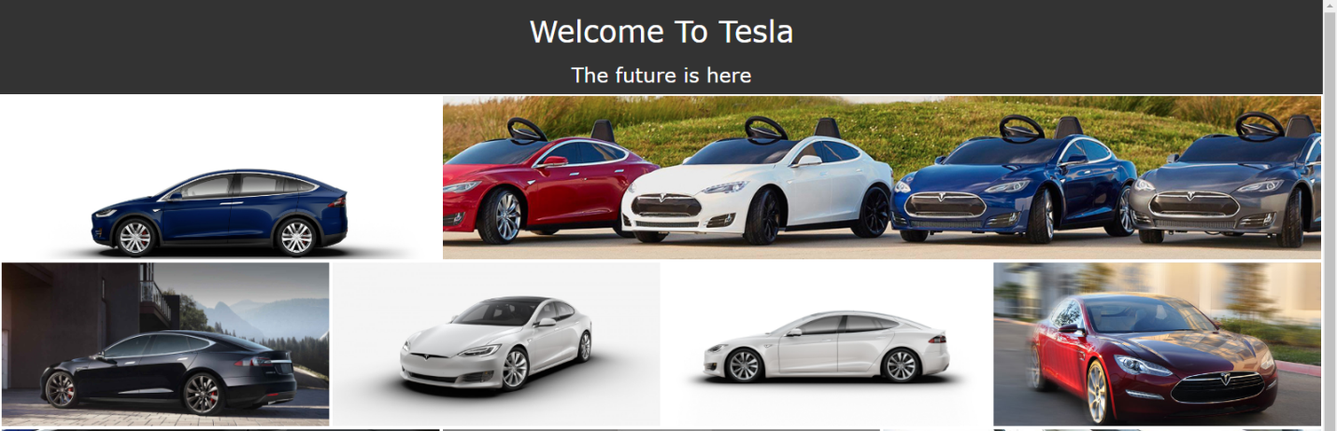

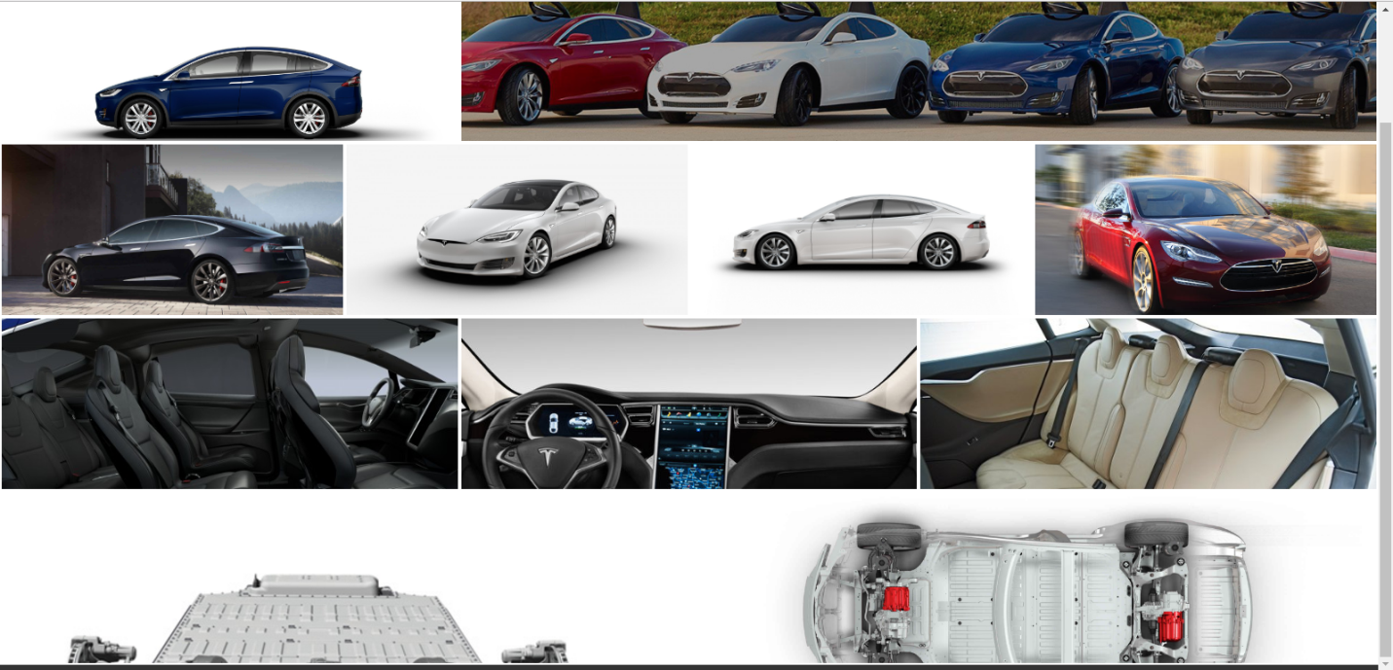

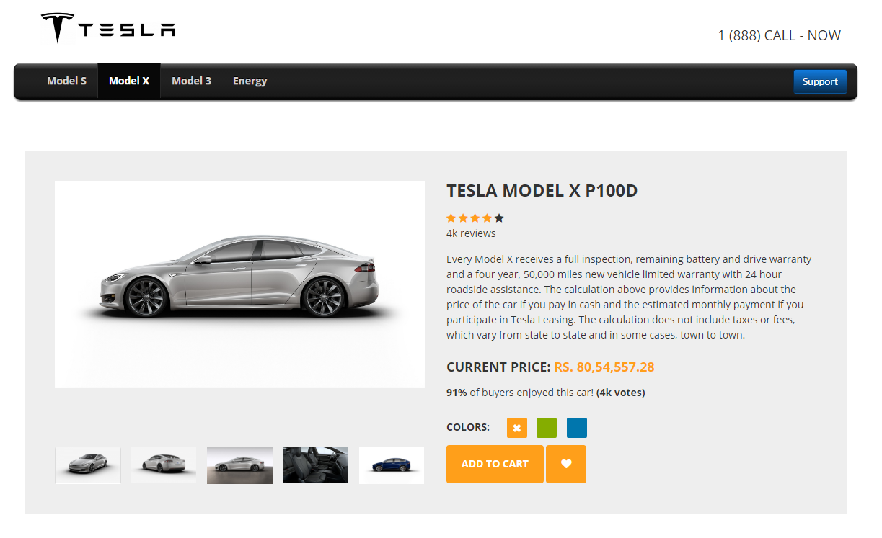

**Conclusion:** Thus, we have successfully created a web interface for a car manufacturing company.