|  |  |
| --- | --- |
| Description: Description: Description: Description: Description: Picture1 | ***Department Of Computer Engineering*** |

Experiment No. 6

|  |  |
| --- | --- |
| Semester | B.E. Semester VIII – Department of Computer Engineering |
| Subject | Human Machine Interaction |
| Subject Professor In-charge | Prof. Swapnil Sonawne |
| Assisting Teachers | Prof. Divya Racha |
| Laboratory | M-314 B |

|  |  |  |
| --- | --- | --- |
| Student Name | Chinmay Terse | |
| Roll Number | 13106B0004 | |
| Grade and Subject Teacher’s Signature |  |  |

**Title:** Use of multimedia tools in interface

**Objective:** To create user interface with several media tools such as video, images, gifs etc.

**Pre Lab/ Prior Concepts:** Thorough knowledge about HTML, CSS and Javascript.

**Requirements:** Computer, Internet connectivity, Text editors, Web browsers.

**Explanation:**

**Multimedia** is [content](https://en.wikipedia.org/wiki/Content_(media)) that uses a combination of different [content forms](https://en.wikipedia.org/wiki/Content_format) such as text, audio, images, animations, video and [interactive](https://en.wikipedia.org/wiki/Interactive) content. Multimedia contrasts with [media](https://en.wikipedia.org/wiki/Media_(communication)) that use only rudimentary computer displays such as text-only or traditional forms of printed or hand-produced material.

Multimedia can be recorded and played, displayed, interacted with or accessed by [information](https://en.wikipedia.org/wiki/Information) content processing devices, such as computerized and electronic devices, but can also be part of a live performance. Multimedia devices are [electronic media](https://en.wikipedia.org/wiki/Electronic_media) devices used to store and experience multimedia content. Multimedia is distinguished from [mixed media](https://en.wikipedia.org/wiki/Mixed_media) in [fine art](https://en.wikipedia.org/wiki/Fine_art); for example, by including audio it has a broader scope. The term "rich media" is synonymous with [interactive multimedia](https://en.wikipedia.org/wiki/Interactive_media).

Multimedia is gaining popularity on the Web with several technologies to support use of animation, video, and audio to supplement the traditional media of text and images. These new media provide more design options but also require design discipline. Unconstrained use of multimedia results in user interfaces that confuse users and make it *harder*for them to understand the information.

1. Animation:
2. Showing continuity in transitions.
3. Indicating dimensionality in transitions.
4. Illustrating change over time.
5. Multiplexing the display.
6. Enriching graphical representations.
7. Visualizing three-dimensional structures.
8. Attracting attention.
9. Video:

Due to bandwidth constraints, use of video should currently be minimized on the web. Eventually, video will be used more widely, but for the next few years most videos will be short and will use very small viewing areas. Under these constraints, video has to serve as a supplement to text and images more often than it will provide the main content of a website.

1. Audio:

The main benefit of audio is that it provides a channel that is separate from that of the display. Speech can be used to offer commentary or help without obscuring information on the screen. Audio can also be used to provide a sense of place or mood as done to perfection in the game Myst. Mood-setting audio should employ very quiet background sounds in order not to compete with the main information for the user's attention.

**Program Code:**

<!DOCTYPE html>

<html lang="en">

<head>

<title>Best Of Coke Studio</title>

<meta charset="utf-8">

<meta name="viewport" content="width=device-width, initial-scale=1">

<link rel="stylesheet" href="https://maxcdn.bootstrapcdn.com/bootstrap/3.3.7/css/bootstrap.min.css">

<script src="https://ajax.googleapis.com/ajax/libs/jquery/3.1.1/jquery.min.js"></script>

<script src="https://maxcdn.bootstrapcdn.com/bootstrap/3.3.7/js/bootstrap.min.js"></script>

<link rel="stylesheet" type="text/css" href="home.css">

</head>

<body>

<header>

<div class="container header inner">

<nav class="navbar">

<div class="container">

<div class="navbar-header">

<button type="button" class="navbar-toggle" data-toggle="collapse" data-target="#myNavbar">

<span class="icon-bar"></span>

<span class="icon-bar"></span>

<span class="icon-bar"></span>

</button>

<a class="navbar-brand" href="#">Best of Coke Studio</a>

</div>

<div class="collapse navbar-collapse" id="myNavbar">

<ul class="nav navbar-nav navbar-right masthead-nav">

<li><a href="#"> Season 1</a></li>

<li><a href="#"> Season 2</a></li>

<li><a href="#"> Season 3</a></li>

<li><a href="#"> Season 4</a></li>

</ul>

</div>

</div>

</nav>

</div>

</header>

<div class="container" style="margin-top: 20px;margin-bottom: 20px;">

<div class="row">

<div class="col-sm-8">

<h3 style="color:;">Afreen Afreen, Rahat Fateh Ali Khan & Momina Mustehsan:</h3>

<video src="E:\Chinmay\HMI\HMIPrac06-Multimedia\afreen.mp4" controls autoplay="true"></video>

<div>

<h3 style="color: ;">Audio Only:</h3>

<div class="btn-group" style="">

<button type="button" class="btn btn-primary"><span class="glyphicon glyphicon-fast-backward"></span></button>

<button type="button" class="btn btn-primary"><span class="glyphicon glyphicon-backward"></span></button>

<button type="button" class="btn btn-primary"><span class="glyphicon glyphicon-play"></span></button>

<button type="button" class="btn btn-primary"><span class="glyphicon glyphicon-pause"></span></button>

<button type="button" class="btn btn-primary"><span class="glyphicon glyphicon-stop"></span></button>

<button type="button" class="btn btn-primary"><span class="glyphicon glyphicon-forward"></span></button>

<button type="button" class="btn btn-primary"><span class="glyphicon glyphicon-fast-forward"></span></button>

</div>

</div>

</div>

<div class="col-sm-4">

<h3 class="text-center" style="color: ">Video Info</h3>

<p class="text-center" style="color: ">Published on Aug 19, 2016

Nusrat Fateh Ali Khan was one of the shining lights of Pakistan, a Qawwali Shahehshah whose talent was heralded both locally and globally. To celebrate the legend that still lives 19 years on, Coke Studio presents

Afreen Afreen, Rahat Fateh Ali Khan and Momina Mustehsan, Episode 2, Coke Studio 9

Music Directed by Faakhir Mehmood

Produced by Strings

The beautifully crafted ‘Afreen Afreen’ sung two decades ago by the legendry, Nusrat Fateh Ali Khan still …

</p>

</div>

</div>

</div>

</body>

</html>

**Output:**

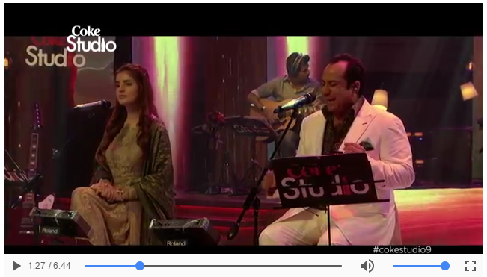

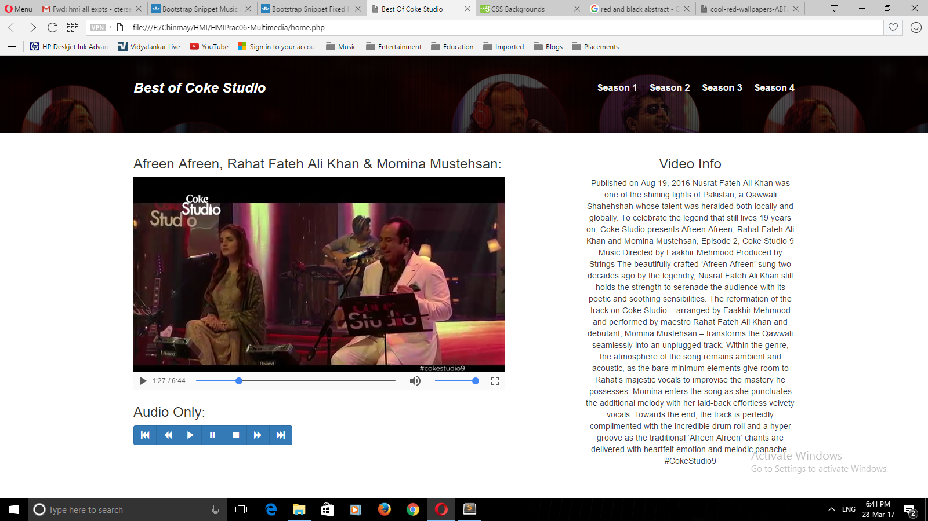

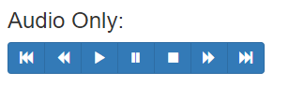

**Conclusion:** Multimedia tools are used to display relevant data in the other file formats such as videos, images or gifs. Such representation improves the appearance and content delivery of the webpages. We created a webpage with the information about GRE exam and also added a video outlining the test sections and scoring system.