Design Document

The purpose this app is to allow mobile users to check their printing quota and printing history, check which printers are working, check the print queue, and report any problems.

How V1.0 will function:

Upon clicking the app, the user will be sent to the dashboard, shown by figure 1. In the top left, it will have a menu icon. When clicked, it will open a menu on the left (figure 2). It show if there are computers and printing available in the three labs. It will also display the user’s name, quota remaining, last printed job, and, if any, the jobs that are queued to be printed (not shown in the mock-up).

Figure 2 shows the menu which appears on the left of the screen. The buttons are: Dashboard, Labs, Your Account, Report Problems, and Settings, which bring the user to their respective pages, and the logout button.

Figure 3 shows the lab info page. It shows if computers and printing are available, as well as the queue for the printer in that room. The user can change which room is shown by sliding the screen. By clicking the room map button, a popup will appear, as seen in figure 4. The popup shows a picture of the positions of the computers inside the lab, as well as the printer, colored depending on their availability. Each computer is labelled.

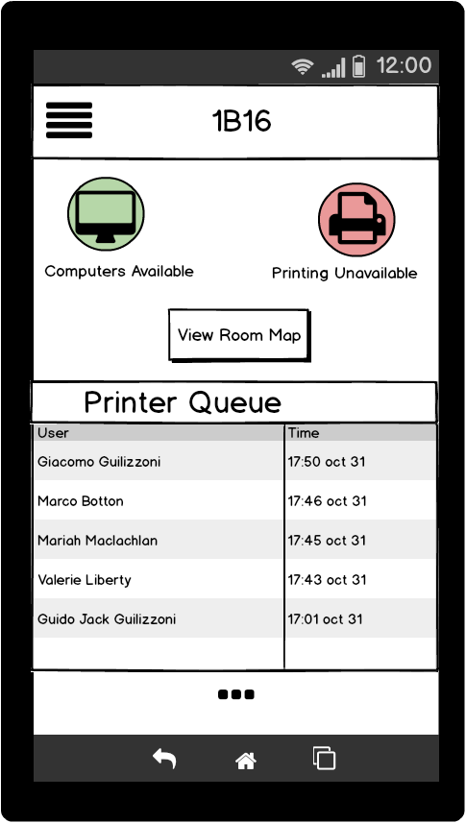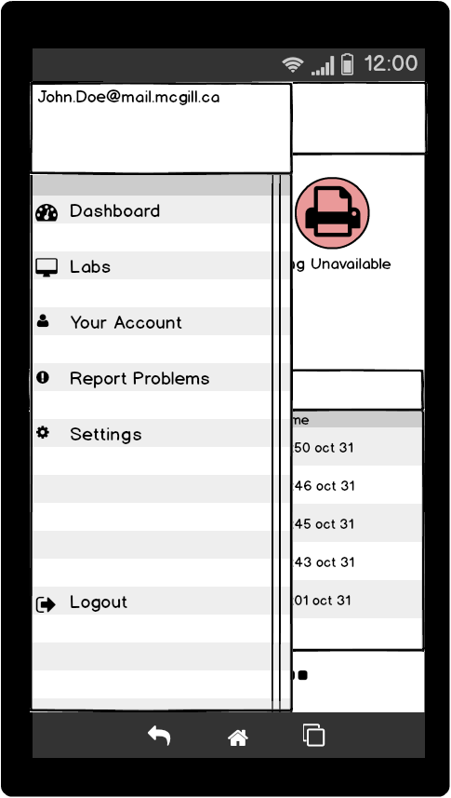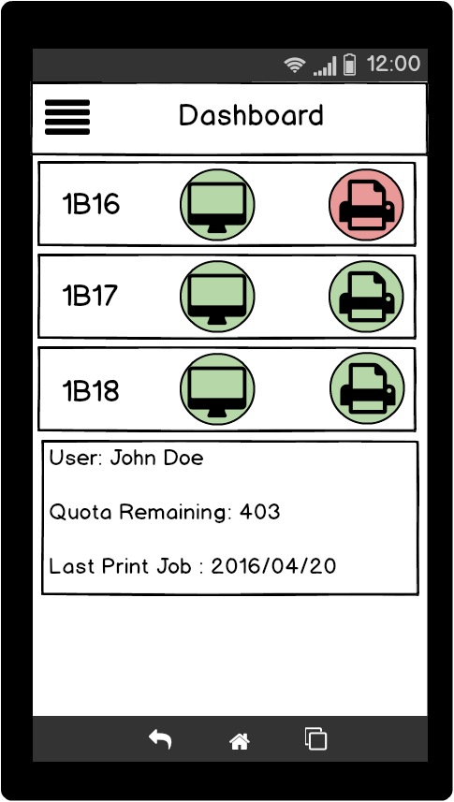

Figure 1

Figure 2

Figure 3

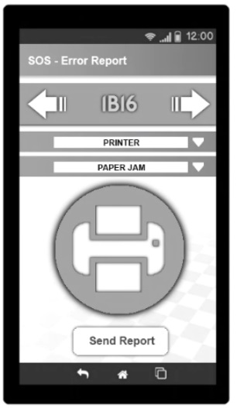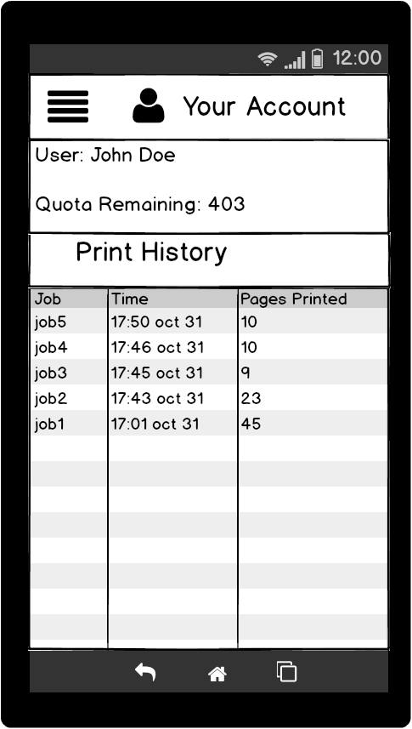The accounts page shows the user’s name, quota remaining, and printing history. The report problems page uses dropdown menus, where the options that appear are dependent of the user’s previous selection. The settings page allows the user to toggle notifications and other miscellaneous items.

Figure 6

Figure 5

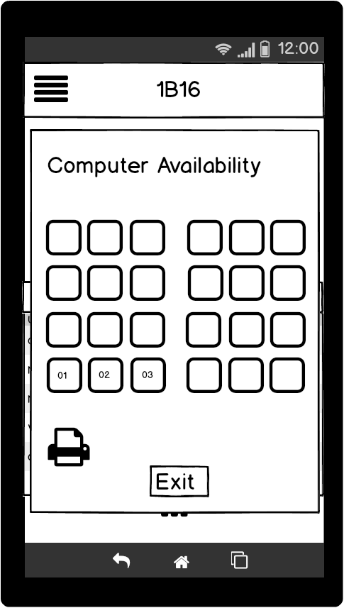

Figure 4

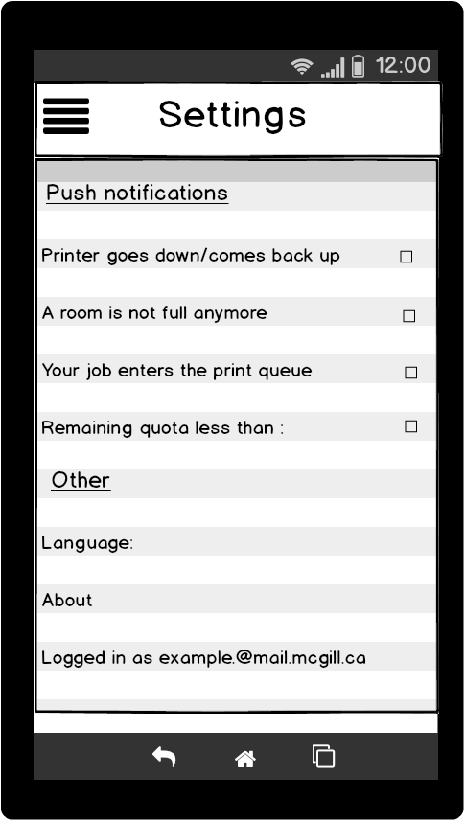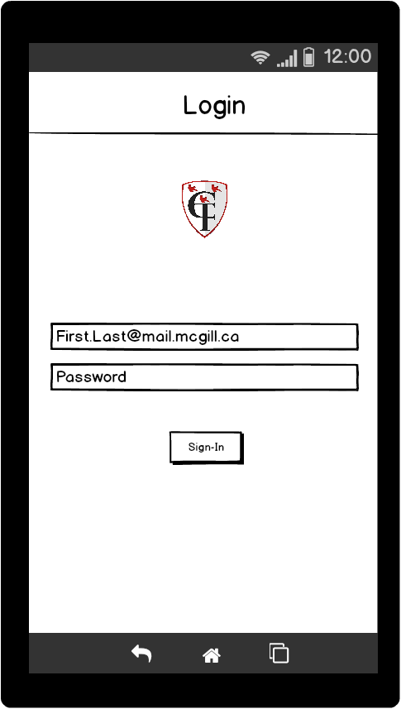

Figure 8

Figure 7