Name: Thai, Chris SDEV 300/6381 Date: (08/30/2022)

Pylint Results:
************* Module lab_2
lab_2.py:61:0: C0116: Missing function or method docstring (missing-function-docstring)
lab_2.py:81:58: E1121: Too many positional arguments for function call (too-many-function-args)
lab_2.py:61:0: R0912: Too many branches (17/16) (too-many-branches)

------------------------------------------------------------------
Your code has been rated at 9.35/10
lab_2.py:61:0: C0116: Added Docstring comment

************* Module lab_2
Lab_2.py:82:58: E1121: Too many positional arguments for function call (too-many-function-args)
Lab_2.py:61:0: R0912: Too many branches (17/16) (too-many-branches)

------------------------------------------------------------------
Your code has been rated at 9.44/10 (previous run: 9.35/10, +0.09)
Lab_2.py:61:0: R0912: Reduced by taking out an elif statement

************* Module lab_2
Lab_2.py:82:58: E1121: Too many positional arguments for function call (too-many-function-args)

------------------------------------------------------------------
Your code has been rated at 9.53/10 (previous run: 9.44/10, +0.09)

Lab_2.py:82:58: E1121:
Changed:
From: print("Your new password is: {}\t".format(get_password(pass_length)))
To:
password = format(get_password(pass_length))
print("Your new password is:\t" + password)

-------------------------------------------------------------------
Your code has been rated at 10.00/10 (previous run: 9.53/10, +0.47)
-------------------------------------------------------------------

Test Case 1:

Execution Output (Case 1):
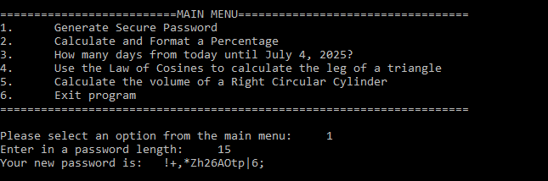

Test Case 2:

Execution Output (Case 2):
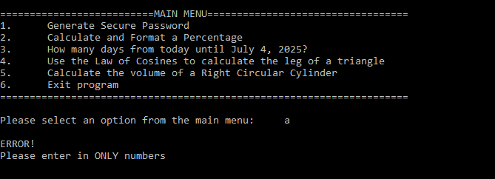

Test Case 3:

Execution Output (Case 3):
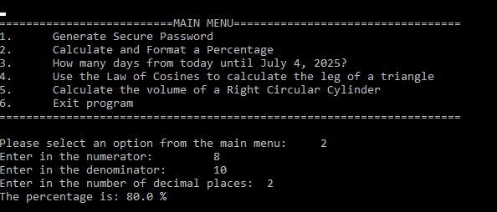
Test Case 4:

Execution Output (Case 4):
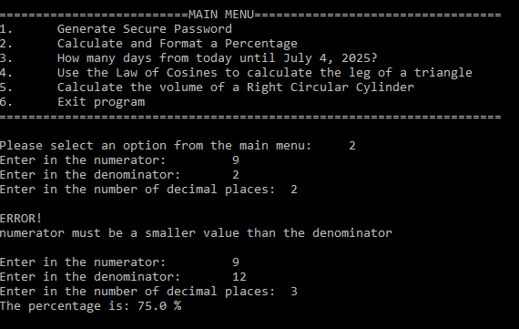

Test Case 5:

Execution Output (Case 5):
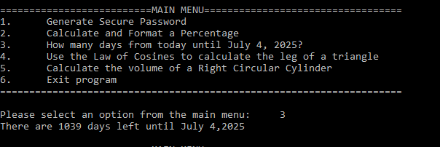

Test Case 6:

Execution Output (Case 6):
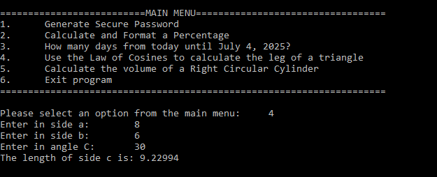
Test Case 7:

Execution Output (Case 7):
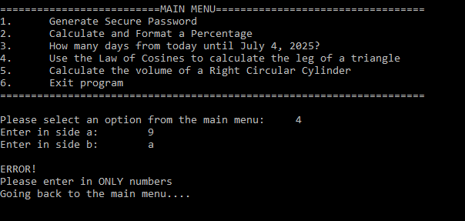

Test Case 8:

Execution Output (Case 8):
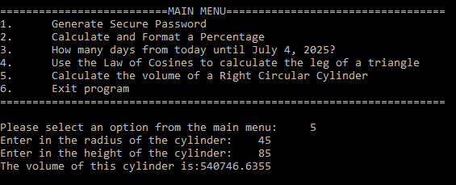

Test Case 9:

Execution Output (Case 9):
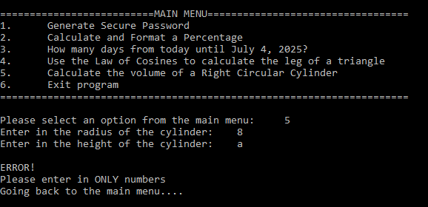

Test Case 10:

Execution Output (Case 10):
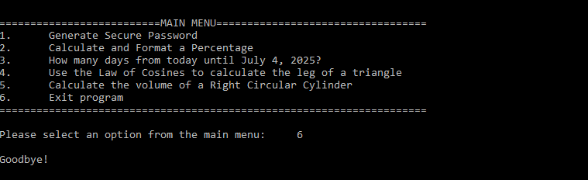

Screenshot of Code:
