Name: Thai, Chris SDEV 300/6381 Date: (10/11/2022)
LAB 8
Test Case 1:
Input: Login: Incorrect Password
Output: Logger – Create a log to log all failed login attempts, includes date, time, and IP address
Pass Test?
Yes
Execution Output (Case 1):
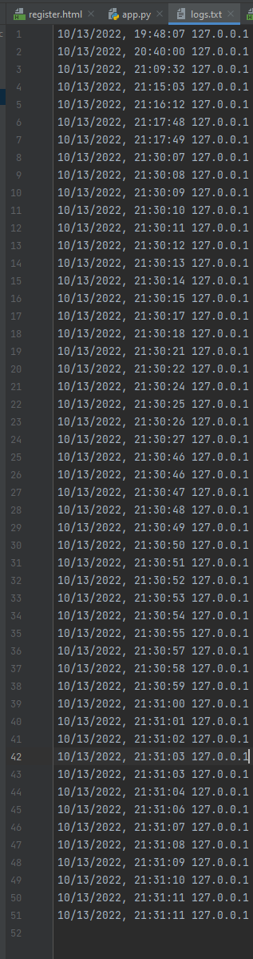
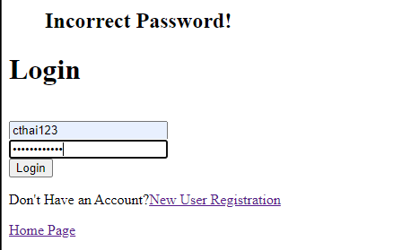

Test Case 2:
Input: Login: correct Password
Output: The website opens
Pass Test?
Yes
Execution Output (Case 2):

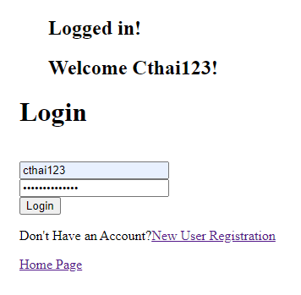



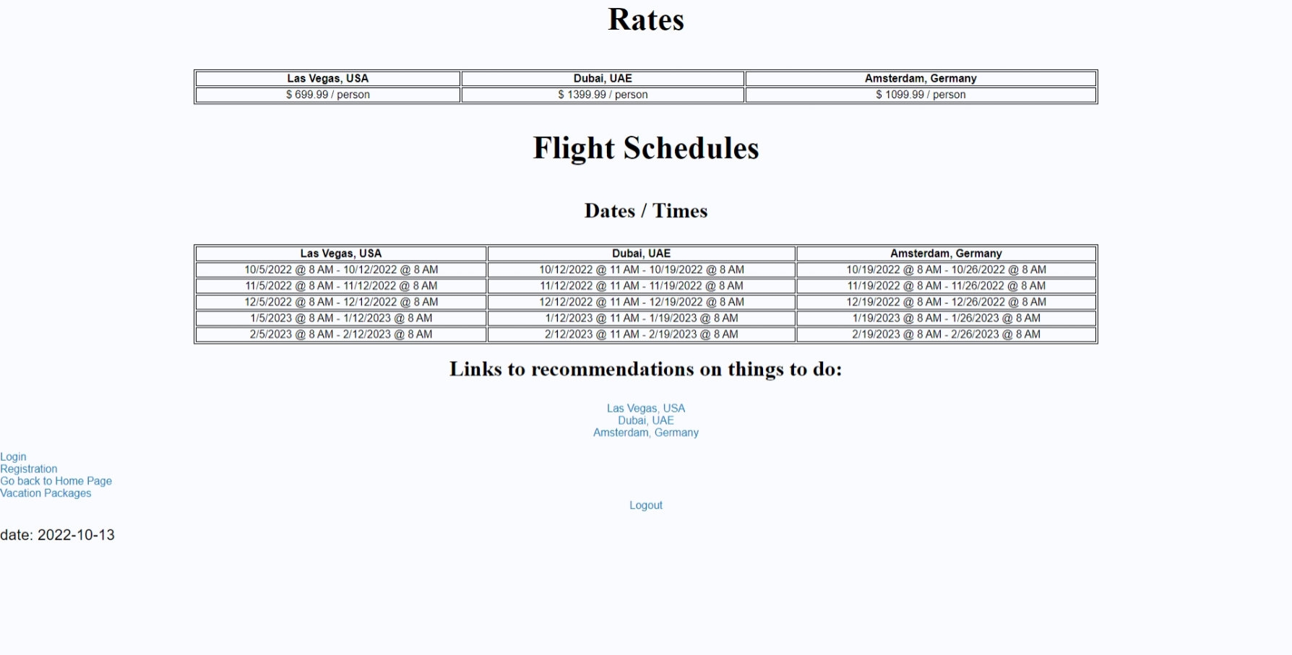


Test Case 3:
Input: Change Password, Enter in unregistered user and email address
Output: Username or email does not exist
Pass Test?
Yes
Execution Output (Case 3):
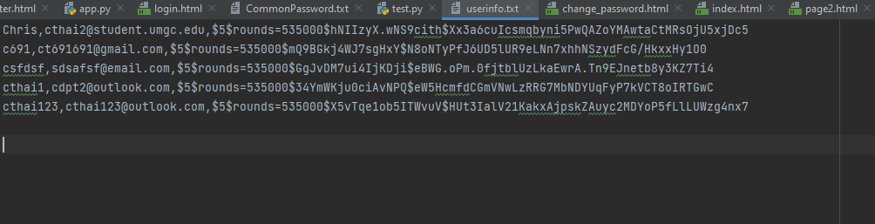
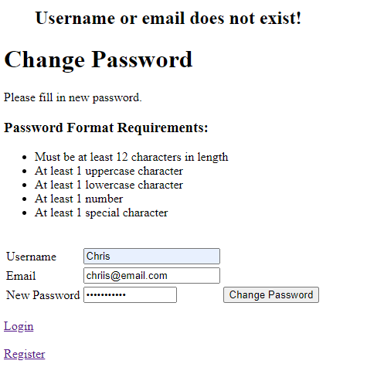
Test Case 4:
Input: Change password to “qwerty”
Output: Compares to common Password list, The password you entered is a weak password!
Pass Test?
Yes
Execution Output (Case 4):
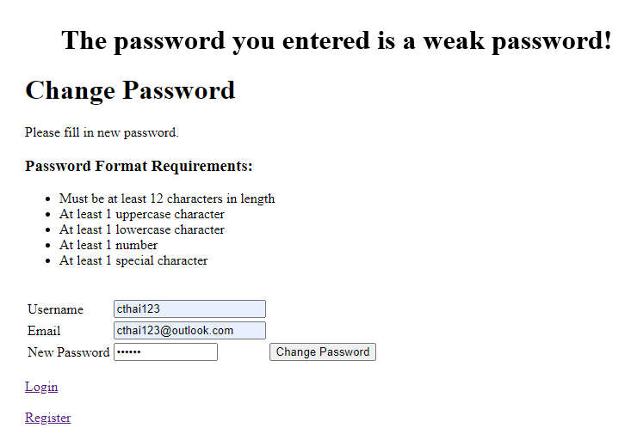

Test Case 5:
Input: Change password to “chris1” checks the following NIST SP 800-63B criteria are met upon password update: Uses the previous criteria for password length and complexity.
Output: please match the request format
Pass Test?
Yes
Execution Output (Case 5):
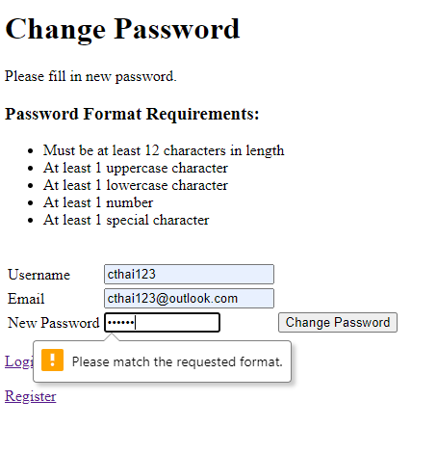

Test Case 6:
Input: Change password to “Aa1!1234567890”
Output: You have successfully changed your password!
Pass Test?
Yes
Execution Output (Case 6):
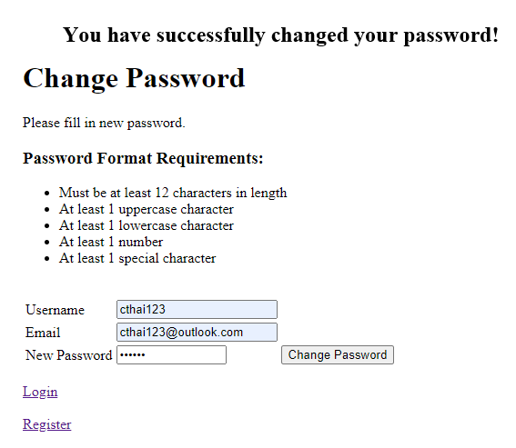

Part 2

Using the Decrypting Secret Messages sites found in this week’s readings, decrypt the following messages.
- - .... .. ... / ... -.. . ...- / ...-- ----- ----- / -.-. .-.. .- ... ... / .... .- ... / ... --- -- . / ... - .-. .- -. --. . / .-. . --.- ..- . ... - ... .-.-.-
Cipher: Morse
Decoded Message: THIS SDEV 300 CLASS HAS SOME STRANGE REQUESTS.
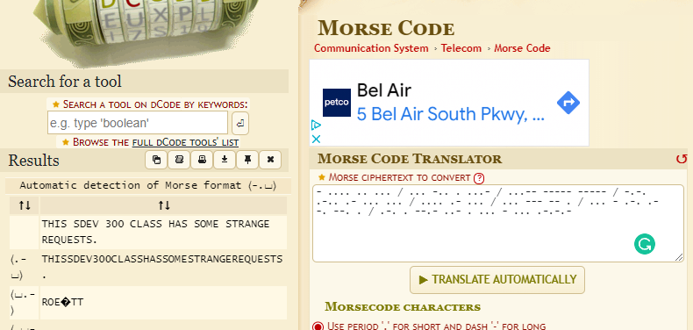

- U28gdGhpcyBpcyBiYXNlNjQuIE5vdyBJIGtub3cu
Cipher: Base64
Decoded Message: So this is base64. Now I know.

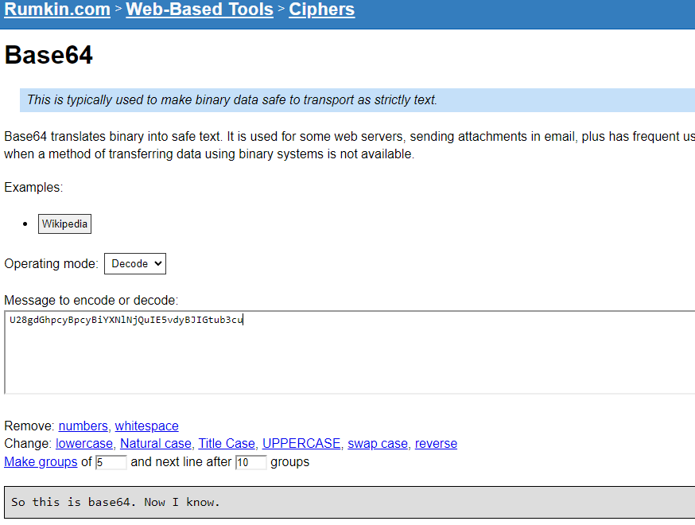

- --- Psuwb Ysm ---- W oa gc qzsjsf. Bc cbs qcizr dcggwpzm twuifs hvwg cih. --- Sbr Ysm ---
Cipher: Caesar , Shift/ Key (number) = 12
Decoded Message:
--- Begin Key ----
I am so clever. No one could possibly figure this out.
--- End Key ---

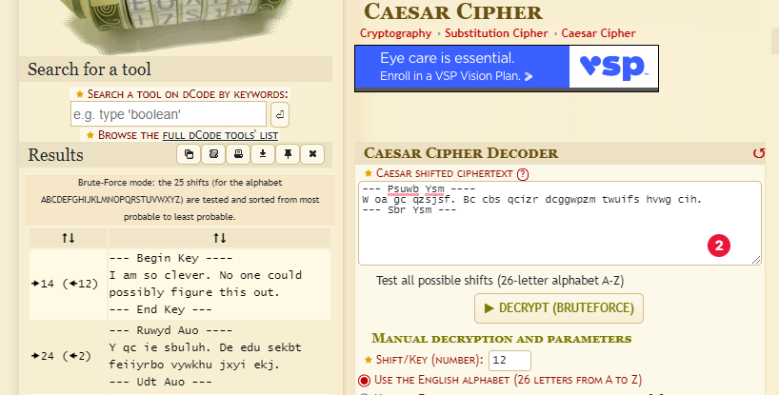

Part 3
Pylint Results:
app.py:61:0: C0116: Missing function or method docstring (missing-function-docstring)
app.py:81:58: E1121: Too many positional arguments for function call (too-many-function-args)
app.py:61:0: R0912: Too many branches (17/16) (too-many-branches)
app.py:61:0: R0912: Too many branches (17/16) (too-many-branches)
app.py:23:58: C0303: Trailing whitespace (trailing-whitespace)
app.py:3:0: W0611: Unused url_for imported from flask (unused-import)
app.py:3:0: W0611: Unused redirect imported from flask (unused import)
------------------------------------------------------------------
Your code has been rated at 5.38/10
Added Docstring comment
Delete some spaces and unused imported from flask
app.py:82:58: E1121: Too many positional arguments for function call (too-many-function-args)
app.py:61:0: R0912: Too many branches (17/16) (too-many-branches)

------------------------------------------------------------------
Your code has been rated at 9.44/10 (previous run: 5.38/10, +4.06)
app.py:61:0: R0912: Reduced by taking out an elif statement
app.py:82:58: E1121: Too many positional arguments for function call (too-many-function-args)

------------------------------------------------------------------
Your code has been rated at 10.00/10 (previous run: 9.44/10, +0.47)
All users leave traces of their activity in logs, whether they are trusted or malicious. Logs can be used to detect and investigate insider attacks and assist in the discovery and investigation of insider-related incidents. Logs can be very useful evidence of network connectivity for systems under the control of malicious insiders by tracking successful/failed logins, account creation, account deletion, account settings, and password changes help. Analyzing log data is essential not only for tracking insider activity, but also for investigating, detecting, or predicting and preventing insider attacks. Centralized log collection and subsequent analysis (via pattern matching, correlation, or anomaly detection) of all logs and audit trails is critical. This data is an important piece of the puzzle for investigating insider attacks.
Authentication in functions python checks for the following NIST SP 800-63B criteria are met upon password update by using the previous criteria for password length and complexity. A password complexity is enforced to include at least 12 characters in length, and include at least 1 uppercase character, 1 lowercase character, 1 number and 1 special character. Passwords are safely stored and verified if the password a user enters matches the stored password. To store the password a hashing technique is used to protect the data at rest in the file, which also gives the ability to compare the hashed version of the password in SHA256 with a user entry to authenticate the user, using a hashing module called passlib. With the provided CommonPasswords.txt, we can compare the prospective secrets against a list that contains values known to be commonly used, expected, or compromised. A secret key is also used to prevent hackers from stealing and modifying your cookies to login as you, the session is encrypted to prevent this. If the chosen secret is found in the list, the application will advise the subscriber that they need to select a different secret.

