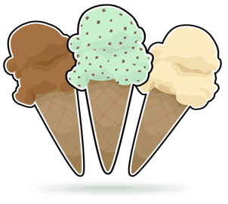

**The C l Spot**





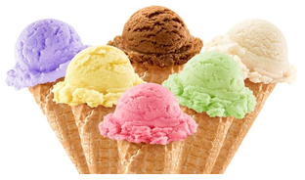

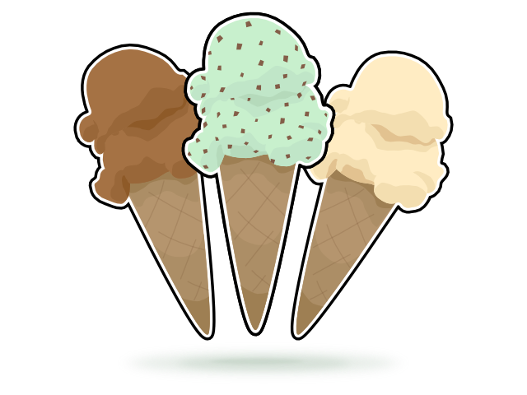

[This Photo](http://masonmouse.deviantart.com/art/ice-cream-cones-62777251) by Unknown Author is licensed under [CC BY-SA-NC](https://creativecommons.org/licenses/by-nc-sa/3.0/)