

EPI5143 Epidemiological Research Using Large Databases

Camilia Thieba

University of Ottawa

March 28, 2022**Epi5143 Winter 2022 Quiz 4**

You have been provided with an abstracts table for the quiz:

1. a) What proportion of the encounters in the abstract table had an admission date on a weekend (using hraAdmDayofWeek)? 5.97 %

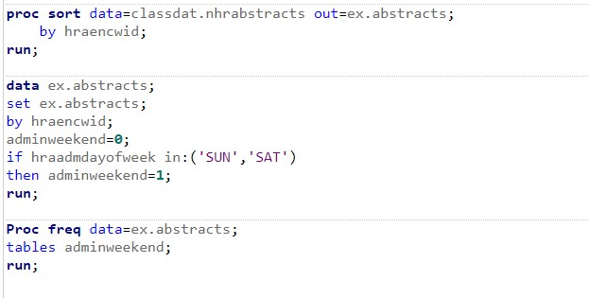

**The FREQ Procedure**

| **adminweekend** | **Frequency** | **Percent** | **Cumulative Frequency** | **Cumulative Percent** |
| --- | --- | --- | --- | --- |
| **0** | 23067 | 94.03 | 23067 | 94.03 |
| **1** | 1464 | 5.97 | 24531 | 100.00 |

b) Derive your own new variable that reports the admission day of the week from the admission datetime and compare the proportion of weekend admissions between your calculated variable and hraAdmDayofWeek.

Adminweekend = 5.97 %

Newadminweekend = 7.78%

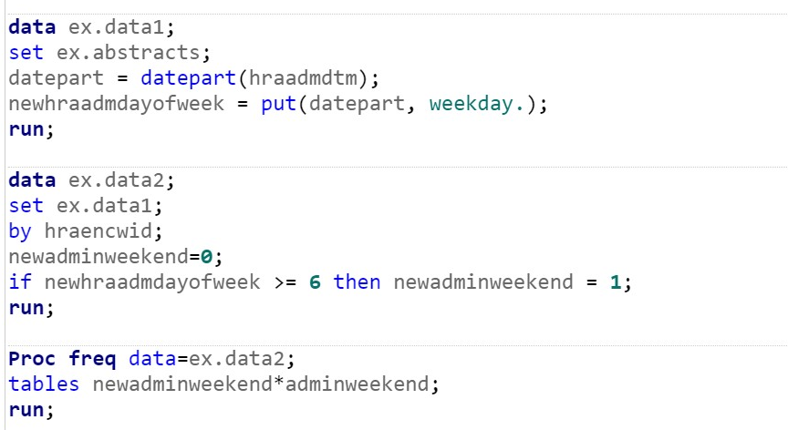

**The FREQ Procedure**

|  |  |  |  |  |  |  |  |  |  |  |  |  |  |  |  |  |  |  |  |  |  |  |  |  |  |
| --- | --- | --- | --- | --- | --- | --- | --- | --- | --- | --- | --- | --- | --- | --- | --- | --- | --- | --- | --- | --- | --- | --- | --- | --- | --- |
| |  | | --- | | **Frequency**  **Percent**  **Row Pct**  **Col Pct** | | | **Table of newadminweekend by adminweekend** | | | | | --- | --- | --- | --- | | **newadminweekend** | **adminweekend** | | | | **0** | **1** | **Total** | | **0** | 21871  89.16  96.68  94.82 | 752  3.07  3.32  51.37 | 22623  92.22 | | **1** | 1196  4.88  62.68  5.18 | 712  2.90  37.32  48.63 | 1908  7.78 | | **Total** | 23067  94.03 | 1464  5.97 | 24531  100.00 | |

1. Create a new dataset that only includes weekend admissions (according to hraAdmDayofWeek). This is your spine dataset for the rest of the questions.

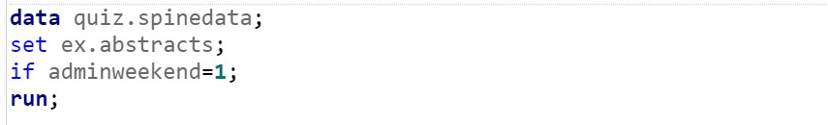

* 1. Which lab test code is the most frequent for weekend admissions (from your class nService dataset)? Lab tests are rows in the nService dataset in which SvcTableCd = "Lb". Lab test codes are recorded in SvcStmWID.

The most frequent code is 4706

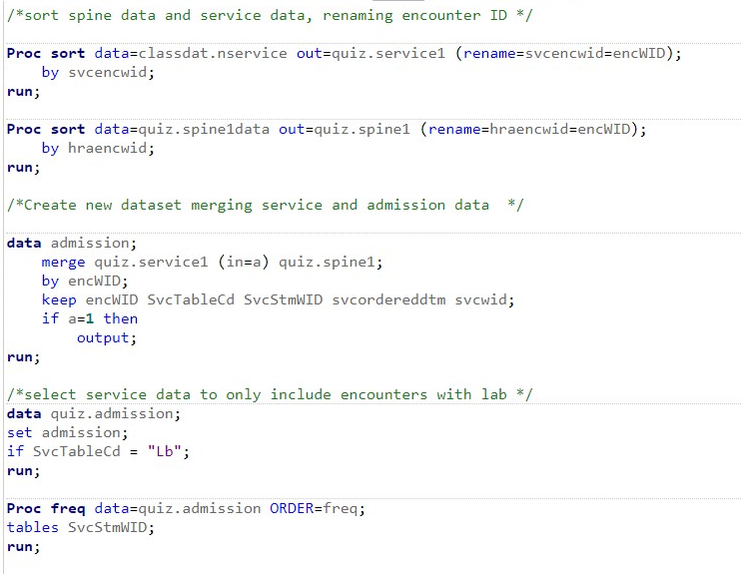

* 1. What percentage of weekend admissions had this lab test code recorded at least once during the admission? 3.04%

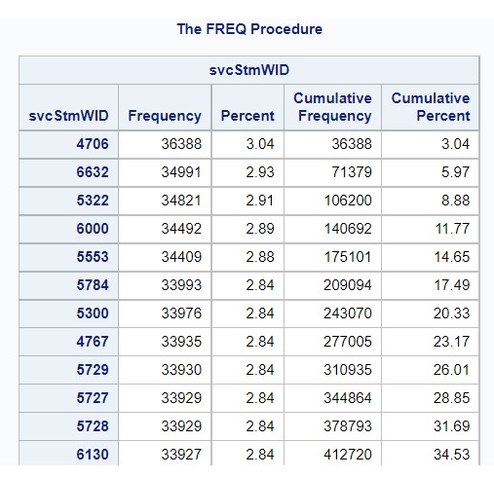

1. a) For weekend admissions, what percentage had a blood typing test done? Blood typing test codes are identified by SvcStmWID= 10564 or 5360 in the nService table.

0.11%

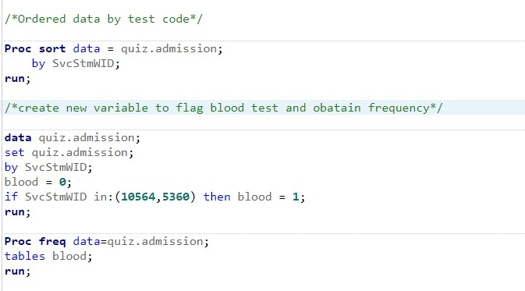

**The FREQ Procedure**

| **blood** | **Frequency** | **Percent** | **Cumulative Frequency** | **Cumulative Percent** |
| --- | --- | --- | --- | --- |
| **0** | 1194038 | 99.89 | 1194038 | 99.89 |
| **1** | 1302 | 0.11 | 1195340 | 100.00 |

1. For weekend admissions where blood typing was done, generate a frequency table of blood types. Blood type results are found in the nLabService table column LabSingleResult (again use the class dataset). You will need to link to the nLabService table using the svcWID from your nservice table for blood tests and the labSvcWid from the nLabService table.

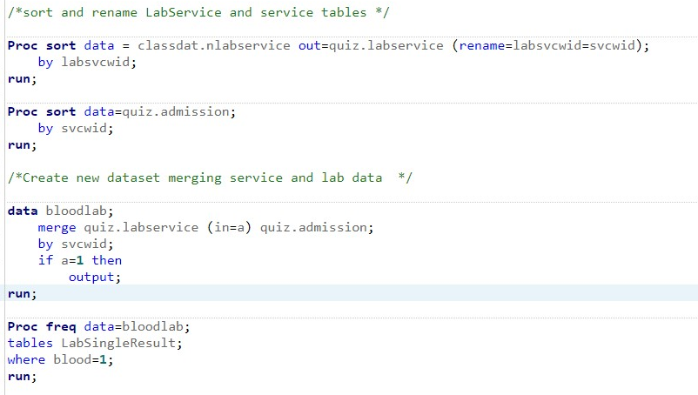

**The FREQ Procedure**

| **labSingleResult** | | | | |
| --- | --- | --- | --- | --- |
| **labSingleResult** | **Frequency** | **Percent** | **Cumulative Frequency** | **Cumulative Percent** |
| **A NEG** | 86 | 6.61 | 86 | 6.61 |
| **A POS** | 421 | 32.33 | 507 | 38.94 |
| **ABNEG** | 3 | 0.23 | 510 | 39.17 |
| **ABPOS** | 53 | 4.07 | 563 | 43.24 |
| **B NEG** | 28 | 2.15 | 591 | 45.39 |
| **B POS** | 134 | 10.29 | 725 | 55.68 |
| **INTERP:** | 2 | 0.15 | 727 | 55.84 |
| **O NEG** | 123 | 9.45 | 850 | 65.28 |
| **O POS** | 452 | 34.72 | 1302 | 100.00 |

Please provide your final SAS code, PROC FREQ frequency table output, and answers to the questions asked. Use inline comments to explain the purpose of each step in your program (which may earn you part marks if your code doesn’t actually do what it is supposed to).