Lesson 3

Vũ Công Chí Thiện

1. Corrected Dependency Array  
   - Remove unnecessary ‘prices’ dependency form ‘useMemo’ since it’s not used in the memorized computation
2. Multiple mapping over balances  
   - The balances are mapped twice: once for formatting and once for creating rows. This results in redundant computations.
3. Redundant data in ‘formattedBalances’  
   - The ‘formattedBalances’ is created but not used directly, leading to unnecessary processing

Old code   
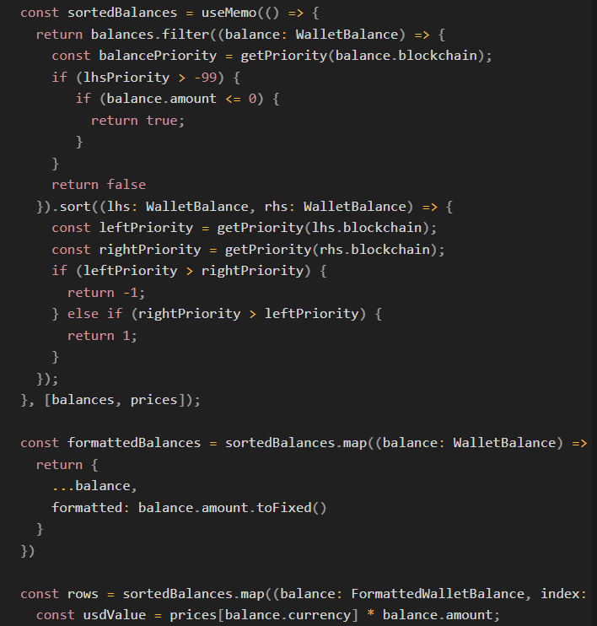

New code

