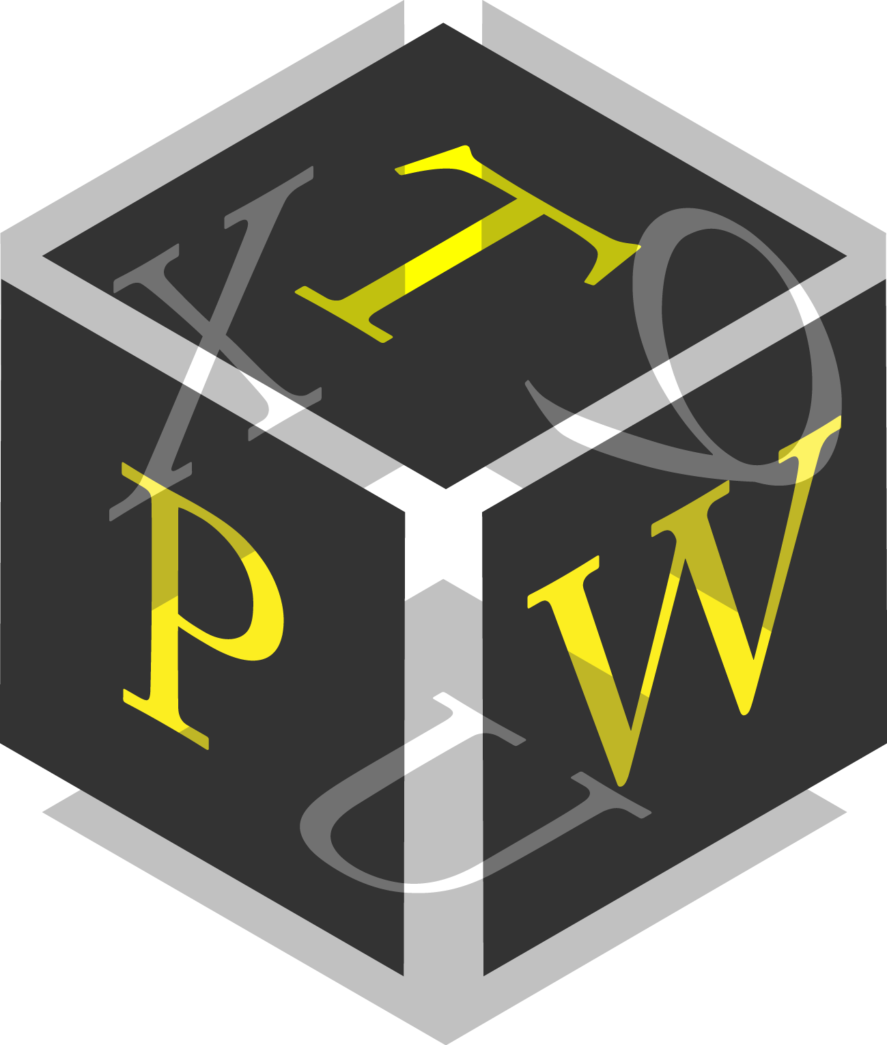
PASSWORDTECH
OPEN-SOURCE PASSWORD GENERATOR & MANAGER

SCRIPTING MANUAL

Version 3.2.0

Copyright Information
Copyright © 2020 by Christian Thöing <c.thoeing@web.de>
See User Manual (manual.pdf) and License (license.txt) for more details on the Password Tech software.
Contents
Introduction 3
Lua Notes 3
Data Types 3
Function Syntax 4
Bit fields 4
Structure of a Lua Script 5
Script Properties 5
Function init() 5
Function generate() 6
PwTech Lua API Functions 7
Function pwtech_random() 7
Function pwtech_password() 8
Function pwtech_phonetic() 8
Function pwtech_passphrase() 9
Function pwtech_word() 10
Function pwtech_numwords() 10
Function pwtech_format() 10
Example Scripts 11

Introduction
As of version 3.0.0, Password Tech (PwTech) allows running custom Lua scripts to generate passwords, passphrases, and generally any kind of random sequences. Lua is a high-level, dynamically typed programming language, providing basic mathematical functions, string operations, and list/array functionalities. For an introduction to Lua programming see, for example, the online version of the book Programming in Lua by R. Ierusalimschy.
For creating and editing Lua scripts, you can use any text editor such as Notepad++ or a code editor such as Lua Development Tools.
Input of user parameters (PwTech → script), output of passwords (script → PwTech), and generating random data (including passwords, passphrases, …) within a script is accomplished through a dedicated application programming interface (API). This API as well as the general structure of Lua scripts for PwTech are explained in the following.

Lua Notes

Data Types
The PwTech Lua API uses the following data types for transferring input and output arguments between the main application and the scripting level:

Integer
Signed integer number, the value range of which corresponds to the processor architecture (32-bit or 64-bit) version of PwTech. In the 32-bit and 64-bit version of the program, the value range is -2,147,483,648 to 2,147,483,647 and -9,223,372,036,854,775,808 to 9,223,372,036,854,775,807, respectively. (The processor architecture for which the executable was built is displayed in the Help | About dialog of PwTech.)
Note: Return values of type integer that are returned by Lua functions and received by PwTech (such as the generate() function) are converted into signed 32-bit integers in all versions of PwTech.

Float
64-bit floating point number (double precision, corresponding to double type in C/C++), ranging from 10⁻³⁰⁸ to 10³⁰⁸ with a precision of 15-17 decimal digits.

String
String of 8-bit integers (each ranging from 0 to 255), also called octets, with UTF-8 encoding. In UTF-8, a single Unicode character is encoded as up to four octets. Thus, a string of length len (number of octets) may actually consist of less than len Unicode characters. If the password generated by the main application contains Unicode characters outside the 7-bit ASCII character set, you have to treat the UTF-8 octet representations of these characters as units that must not be separated.
To determine the UTF-8 octet length of a Unicode character in a Lua string, you can use the following rule: If the first octet o of the UTF-8 unit is <192, 192 ≤ o < 224, 224 ≤ o < 240, or ≥240, the octet length of the Unicode character is 1, 2, 3, or 4, respectively.

Function Syntax
A Lua function may look like this:
function fun(param1, param2, param3)
--do something...
return ret1, ret2
end

In this manual, the input arguments param1, param2, param3 are called parameters, and the output arguments ret1, ret2 are called return values. The following syntax is used to illustrate the usage of a function:
fun(param1 [, param2 [, param3]]) -> ret1, ret2
Input and output arguments are set in italic. Parameters without brackets are mandatory, those enclosed with square brackets [] are optional. In the above example, only param1 is mandatory, whereas both param2 and param3 are optional. Thus, the function can be called as fun(1), fun(1, 2), and fun(1, 2, 3). Return values are specified after a stylized arrow “->” for better visibility. Note that the caller is not obliged to catch all return values but may decide to catch only the first n values or none of them, e.g., via r = fun(42).

Bit fields
PwTech uses bit fields to encode binary options, i.e., options that can be either enabled or disabled, in 32-bit integer numbers. Each option or bit flag occupies one bit position in the number and sets the bit to 0 (false) or 1 (true) if the option is disabled or enabled, respectively. To set a bit to 1 in the bit field integer and thus enable the corresponding option, the integer is combined by bitwise “or” with the number corresponding to the bit position. The i-th bit corresponds to the number 2^{i−1} (first bit = 1, second bit = 2, third bit = 4, etc.). For example, to set the 2nd, 3rd, and 5th bit, the values 2, 4, and 16 are combined by bitwise “or” to yield the bit field integer 22 (in binary notation: 10110).
Conversely, to check whether a bit flag at a specified position in the integer is set, the bit field is combined by bitwise “and” with the number corresponding to the bit position. If the result of this operation is nonzero or zero, the bit flag is set (enabled) or not set (disabled), respectively. For example, to check whether the 3rd bit is set in the bit field 22 (10110), calculate 22 and 4 = 4 (nonzero), hence the flag at this position is set.
You can use the Lua operators | and & for the bitwise “or” and “and” operations, respectively. For example, to set the 4th and 6th bit (values of 8 and 32) in a bit field integer, you can use the statement:
flags = flags | 8 | 32
To check whether the 4th bit (value of 8) is set, you can use the following if statement:
if flags & 8 ~= 0 then
--do something...
end

Structure of a Lua Script
When generating passwords from a script, PwTech calls two functions, init() and generate(). init() is optional and only called once, namely when generating the first password. It can be used to transfer the user parameters related to password generation to the scripting level. generate() is mandatory—scripts without this function will not be loaded—and called whenever a new password is requested. It passes the password that has been generated by PwTech before (using the other Include … options, if applicable) to the script via input arguments, which may then be manipulated by the script. However, the script may also generate a completely new password. The generated password is then returned to PwTech via output arguments (return values).
The script may also expose specific properties to PwTech, which can be used to optimize the password generation. The specification of properties is optional, but they must be defined as global variables in the form script_property=setting (all variables have global scope unless explicitly declared local via the local keyword) in order to be recognized by PwTech.

Script Properties
The following properties are currently supported:
script_flags | Integer | Bit field (bit flags combined by bitwise “or”) that encodes binary (on/off) properties of the script. Default is 0 (if variable is not specified).  1 – The script generates passwords completely on its own (stand-alone) and does not use previously generated passwords (via Include … options in PwTech). If specified, PwTech will not generate any passwords, passphrases, or formatted passwords before executing the script, and always pass an empty password to the generate() function.

Function init()
The specification of this function is optional. It is used to pass user parameters related to password generation to the script. These parameters can then be evaluated in the script to further customize the password generation.

Function definition
init(num_passw, dest, gen_flags, advanced_flags, num_chars, num_words,
format_str)

Parameters
num_passw | Integer | Number of passwords to be generated (≥1).
dest | Integer | Destination of the generated password(s):  0 – Single password in password box (main window)  1 – Multiple passwords in password list window  2 – Write password(s) to file  3 – Copy password to clipboard  4 – Show password in message box  5 – Display password(s) on the console  6 – Autotype password
gen_flags | Integer | Bit field (bit flags combined by bitwise “or”) that encodes the types of password to be generated:  1 – Include characters  2 – Include words  4 – Format password  Example: 5 = Include characters + Format password.
advanced_flags | Integer | Bit field that encodes the “Advanced password options” flags (list of checkboxes). The options in the list correspond to the flags 1, 2, 4, …, 2^{N-1} (from 1st to N-th list entry) with N being the number of options.
num_chars | Integer | Number of characters for option Include characters.
num_words | Integer | Number of words for option Include words.
format_str | String | Format sequence for option Format password – may be nil (empty).

Return values
None.

Function generate()
This function must be specified in the script. PwTech calls it whenever a new password is requested and passes the password that has been generated so far as an input parameter. This password can be manipulated on the scripting level. Also, a new random password can be generated by calling dedicated API functions. The function should return the new password and the corresponding entropy value.

Function definition
generate(passw_num, in_passw, in_entropy) -> out_passw, out_entropy

Parameters
passw_num | Integer | Password number: Always 1 if a single password is generated, ≥1 if multiple passwords are generated (1 for 1st, 2 for 2nd password, …).  Note that passw_num is not necessarily incremented with every call: If the “Exclude duplicates” option is enabled and the previously generated password was a duplicate, the password number does not change.
in_passw | String | Password that has been generated before executing the script. This may be a password, passphrase, formatted password, or a combination thereof. The password may be nil (empty).
in_entropy | Float | Entropy value associated with in_passw. 0 if password is empty or does not contain any random characters.

Return values
out_passw | String | Password to be transferred to the main application. Make sure that the password is properly UTF-8 encoded!
out_entropy | Float | Entropy value associated with out_passw.

PwTech Lua API Functions
The PwTech Lua API provides functions for generating random numbers, passwords, passphrases, formatted passwords, and more. All functions can be called from the init() and generate() function within the script.

Function pwtech_random()
Returns a random floating point number between 0 and 1, or an integer number in a specified range. It is functionally equivalent to math.random() from the Lua standard library. There are three versions of this function.

Function definition
(1) pwtech_random() -> rnd_f
(2) pwtech_random(n) -> rnd_n
(3) pwtech_random(n1, n2) -> rnd_n

Parameters
(1) – | – | Generates floating point number between 0 and 1 (0 inclusive, 1 exclusive).
(2) n | Integer | Generates random integer in the range 1 to n (both inclusive).
(3) n1, n2 | Integer | Generates random integer in the range n1 to n2 (both inclusive).

Return values
(1) rnd_f | Float | Floating point number between 0 and 1.
(2) rnd_n  (3) rnd_n | Integer | Integer in the specified range.

Function pwtech_password()
Generates a random password of a specified length, using the character set that is currently loaded in PwTech.

Function definition
pwtech_password(len [, flags]) -> passw, entropy

Parameters
len | Integer | Desired password length (number of Unicode characters). Note that the returned string may be longer than len due to the UTF-8 encoding.
flags | Integer | (optional) Bit field that encodes various options to customize the password generation:  1 – First character must not be a lower-case letter  2 – Exclude repeating consecutive characters  4 – Only include additional characters if custom character set contains appropriate subset  8 – Include at least one upper-case letter  16 – Include at least one lower-case letter  32 – Include at least one digit  64 – Include at least one special symbol  512 – Each character must occur only once

Return values
passw | String | Resulting password, UTF-8 encoded.
entropy | Float | Entropy of the password.

Function pwtech_phonetic()
Generates a random phonetic password of a specified length, using the phonetic trigrams that are currently loaded in PwTech. Letters are lower-case by default.

Function definition
pwtech_phonetic(len [, flags]) -> passw, entropy

Parameters
len | Integer | Desired password length (number of Unicode characters). Note that the returned string may be longer than len due to the UTF-8 encoding.
flags | Integer | (optional) Bit field that encodes various options to customize the password generation:  8 – Include at least one upper-case letter  16 – Include at least one lower-case letter  32 – Include at least one digit  64 – Include at least one special symbol  128 – Upper-case letters  256 – Lower-case and upper-case (mixed-case) letters, selected randomly for each letter; increases entropy by 1 bit per letter

Return values
passw | String | Resulting password, UTF-8 encoded.
entropy | Float | Entropy of the password.

Function pwtech_passphrase()
Generates a passphrase composed of random words from the currently loaded word list.

Function definition
pwtech_passphrase(num [, chars [, flags]]) -> passphr, entropy

Parameters
num | Integer | Desired number of words (max. 100).
chars | String | (optional) Characters to be combined with the words (equivalent to the option “Combine words with characters” in PwTech’s main window) if corresponding flag is set (see next parameter). May be nil if the combination with characters is not desired.
flags | Integer | (optional) Bit field that encodes various options to customize the passphrase generation:  1 – Combine words with characters (if chars is a valid string)  2 – Do not separate words by a “-” character  4 – Do not separate words and characters by a “-” character  8 – Reverse order of words and characters (i.e., characters first)

Return values
passphr | String | Resulting passphrase, UTF-8 encoded.
entropy | Float | Entropy of the passphrase (without considering characters given in chars parameter).

Function pwtech_word()
Returns a word from the currently loaded word list.

Function definition
(1) pwtech_word() -> word
(2) pwtech_word(idx) -> word

Parameters
(1) – | – | Returns a random word from the word list.
(2) idx | Integer | Returns the word at position idx in the word list. Consistent with Lua conventions, the first word has index 1 and the last word has index N. To get the number of words N in the list, call pwtech_numwords().

Return values
word | String | Word from the word list, UTF-8 encoded.

Function pwtech_numwords()
Returns the size (number of words) of the currently loaded word list.

Function definition
pwtech_numwords() -> num

Parameters
None.

Return values
num | Integer | Size of the word list.

Function pwtech_format()
Generates a formatted password using the specified format string.

Function definition
pwtech_format(format [, flags]) -> passw

Parameters
(1) format | String | Format sequence for generating the password. Refer to the PwTech User Manual for more details on the syntax of format sequences.
(2) flags | Integer | (optional) Bit field that encodes various options to customize the password generation:  1 – Exclude repeating consecutive characters

Return values
passw | String | Resulting password, UTF-8 encoded.

Example Scripts
Example Lua scripts are contained in the folder script_examples within the folder where Password Tech resides.
Happy scripting!

