Embedded Wireless Multi-Channel Audio Mixer

Christopher Thomas
ECE 554 – Embedded Systems
University of Michigan – Dearborn
Summer 2011

Abstract
An embedded wireless multi-channel audio mixer was designed and developed. The mixer was capable of allow WiFi connections from clients and accept audio data streams. The system then mixes the client streams into a single output stream and outputs it via a speaker. An ARM-based development board in conjunction with embedded Linux were used for the implementation, and a successful and viable end product was achieved.

1. Introduction

A wireless audio mixer was developed which allows for clients to connect via WiFi and stream an audio file to the mixer. The mixer is then able to take the multiple streams from audio clients and output a single mixed channel of audio to a speaker.

The rationale behind developing a project such as this is two-fold. There currently is no consumer product available that allows multiple clients to stream audio to a single mixing point that does not use proprietary wireless transmission protocols. The design of this system lends itself well to being usable in all types of environments from client PC’s running Linux, Windows, or Mac OS. The only specialized portion of the system is the mixing server which runs on an embedded ARM-based device. The second reason for developing this project was to gain experience in developing an embedded system based around audio. I have a high level of interest in audio applications and working on a project such as this was a great learning experience.

The project was implemented utilizing an OMAP4-based pandaboard and embedded Linux. [3][2] The mixing system was composed of a multi-threaded mixing server application on the pandaboard and an audio client application running on a PC where both systems are connected hosts on a WiFi network. The client application was able to connect to the mixer server running on the pandaboard and stream audio data to the server. The server would then mix the audio data streamed from all connected clients into a single audio channel and output the mixed audio via a connected speaker.
This project was successfully implemented and tested as shown in the demo video. The system was able to successfully mix multiple client streams and provide a mixed output signal. There were some limitations to the system that were found during testing such as clipping of the output audio signal and buffering delays which are discussed in the validation and testing section of this report.

2. Project Design

2.1. Requirements
The requirements for this system were the basis upon which the design was formed. The main functional requirements for system are as follows:
- The system shall allow for client connections that can stream audio data to the system.
- The system shall actively mix the content provided by the client streams into a single output channel that provides a nearly perfect audio mix down of the audio data.
- The system shall have a way to wirelessly transfer the data between client and server.

Other non-functional requirements for this system were formulated in order to provide a basis upon which to build the system:
- The system shall use WiFi for wireless communications.
- The system shall use a pandaboard for the development board due to availability.
- The system shall utilize an embedded Linux distribution suitable for use with the pandaboard in order to facilitate using standard threading and synchronization constructs available in the Linux kernel and take advantage of other applications which are available in a standard Linux installation.

2.1. High-level System Architecture
As shown in Figure 2.1, the high-level architecture of the system was designed given the set of functional and non-functional requirements. The proposed system would utilize standard operating system facilities available from the Linux kernel and utilize Wifi in order to allow for both the server and client applications to communicate wirelessly using standardized protocols.

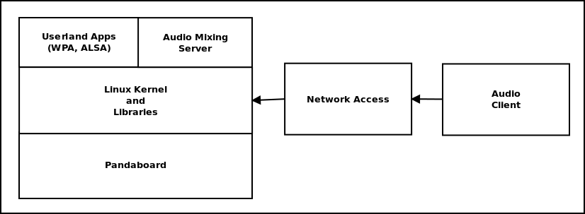
Figure 2.1. High-level System Architecture

2.2. Mixing Server Design
Figure 2.2 depicts a functional data flow diagram of the mixing server application.

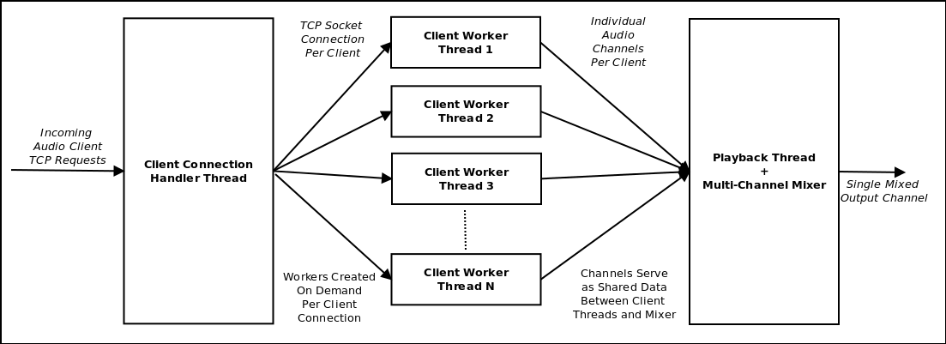
Figure 2.2. Data-flow Diagram of Mixing Server

As shown, the main interface to the mixer application is via the Client Connection Handler Thread. This thread listens for client connections on a Transmission Control Protocol(TCP) port and will spawn Client Worker Threads as needed to handle the connections coming in from audio clients. The Client Connection Handler interfaces with the outside world via TCP sockets.

The next block in the diagram of interest are the Client Worker Threads. Each worker thread is responsible for handling the stream of audio data from a single audio client. The worker threads are constituted of a TCP socket and a mutex-protected shared data area which holds the audio data transmitted from the clients in queue to be mixed. When the worker thread adds the client’s stream data to its audio channel, the mixing and playback thread can then use that data for audio output.

The mixing and playback thread block is responsible for mixing down the multiple channels of audio client data into a single channel of output audio data. As necessary, the thread will get exclusive access to each audio channel’s data and then mix all of the client streams into a single output channel. The playback thread is also responsible for outputting the final mixed stream. It feeds the audio output data on a regular basis in order to not starve the audio driver of data.

2.3. Audio Client Design
Figure 2.3 shows a finite state automata for the audio client application. The audio client is a single threaded application that, given a valid input WAV file, will read the audio samples from it and stream them to the mixing server via a TCP socket. This application allows the user to initiate and cancel playback at will and can be run on Windows, Mac OS, and Linux environments.

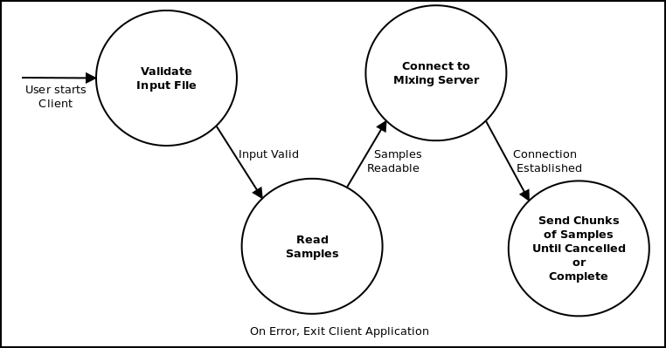
Figure 2.3. Audio Client FSA

3. Implementation Details

3.1. Pandaboard
The development board that was chosen for this project was the pandaboard. [3] It has an OMAP-4400 based dual-core ARM processor with a TI DSP co-processor. The board has one gigabyte of DDR2 RAM and has many peripherals built-in such as WiFi, UART, SD/MMC, and an Audio Codec. This board was chosen for this project for multiple reasons. The main reason it was chosen is the availability of both the board itself, operating system software, and build tool-chain that has been ported to the platform. At the time of this writing, Ubuntu Linux, Debian Linux, and and Android have all been ported to run on this development board. Due to this fact, development of an application such as the audio mixing server can be performed on a Linux-based desktop PC and then built natively on the target system when ready for target testing.

3.2 Ubuntu Linux
The operating system that was chosen for this project to run on the pandaboard was Ubuntu Linux. [2] The kernel and root file-system for this board were developed as open source implementations and were customized by the OMAP Ubuntu project to run on the pandaboard. In fact, Ubuntu support for pre-built binaries that are compatible with ARM-based systems are based around the pandaboard. This level of community support for Ubuntu running on the pandaboard allowed for a high level of compatibility with the majority of Ubuntu applications and the Linux kernel itself when performing the bring-up of the pandaboard for this project.

3.3 Libraries
The main libraries utilized for this project were the POSIX thread(pthread) library and the Advanced Linux Sound Architecture (ALSA) library. The pthread library provides a high-level way to spawn multiple threads within a process space and provide synchronization among these threads using various constructs such as mutexes and conditions. Using the pthread library for multi-threading for this application allowed for shared memory among the threads and thus sharing of data such as client audio streams to the mixing and playback threads. In conjunction with the pthread library, the Linux real-time library(librt) was used to provide for real-time thread management and context switching capabilities with pthreads. The ALSA library was used as the main interface to the audio device on the pandaboard. ALSA provides an API that allows for setting parameters such as sample rate and bit depth of the audio stream and a way to play audio by writing samples to a file descriptor. This highly standard library interfaces with the Linux kernel in order to provide audio data for playback to the audio device and provides a level of synchronization in terms of providing the correct amount of data to the device per unit time.

3.4 Operating System / Library Customization
There were a few customizations that needed to take place in order for this project to function properly. The main customization that took place were some modifications made to the ALSA library. The ALSA implementation that was available from the OMAP Ubuntu project at the time of this project’s implementation was incomplete and mis-configured. In order to be able to use the ALSA library for audio playback, customizations were made to the library to use the correct device enumerations for the audio device and customizations were made to the library configuration to be able to correctly configure the audio device for playback. Also, run-time customizations were made to the operating system root file-system to ensure functionality of the mixing server. Scripts were developed and used to start the WiFi connectivity on startup of the system, the mixing application once operating system initialization was complete, and initialize the audio playback device.

3.5 Mixing Server Threading and Synchronization
The threading in general of the mixing application and synchronization of these threads with their shared data areas was a very sensitive portion of the implementation of this project. Due to the fact that audio playback was the main facet of the project, any sort of delay in the provisioning of audio samples for the playback thread would be readily apparent. In order to mitigate the possibility of starving the playback thread of audio data while obtaining data from clients and performing mixing operations, shared data areas and mutexes were used to provide synchronization and prevent data races. In addition to these constructs, conditions were used in order to allow the threads to communicate between each other regarding the availability of new data. Figure’s 3.5.1 and 3.5.2 below are finite state automata depicting the behavior of each client audio channel and the way signaling the mixing and playback thread takes place.

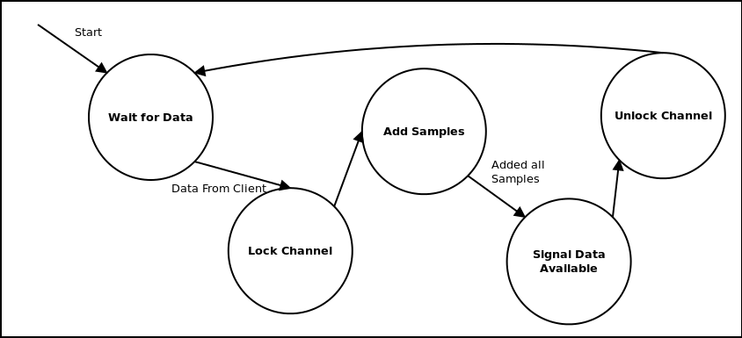
Figure 3.5.1. FSA of Client Worker Thread Data Handling

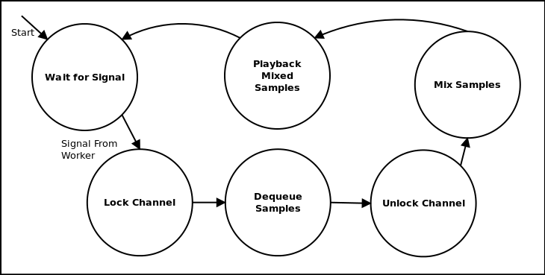
Figure 3.5.2 FSA of Mixing/Playback Thread Data Handling

As can be observed from Figures 3.5.1 and 3.5.2, the audio channels serve as a commonly accessible data area between the client threads and the mixer and playback thread. In order to provide exclusive access to the channel’s storage, a mutex lock is performed during read and write operations. Also, if there is no data available when the mixing and playback thread are ready to process data, the playback thread will wait on a condition and release the lock on the channel storage. When a channel has data added to it, the condition is signaled effectively unlocking any thread that is waiting on data to be available. These thread synchronization constructs, mutexes and conditions, made it possible to share data among the producers of audio data and the consumers of audio data within the channel itself and prevent data races.

3.6 Audio Client Sample Blobbing
The client application utilized a blobbing technique when sending data in order to throttle the amount of communication and processing that needed to take place per unit time. For example, when a client is ready to send the contents of a WAV file to the mixing server, the client application would divide the contents of the audio stream into finite size audio blobs no greater than a given number of samples. The client application then sends the sample set to the mixing server and idles for a specified period of time. The number of samples per blob and the amount of time to idle on the client side was tuned to coincide with the number of samples processed and outputted on the mixing server. This technique proved to be quite successful in preventing overwhelming the mixing server with data while preventing under-run in the playback of audio data. Also, this technique minimized the processing and communication resources per unit time by the embedded mixing system and the wireless network respectively.

4. Validation and Testing

4.1 System Startup Timing
In order to develop a responsive system, the startup time was characterized and minimized as necessary. The startup time was characterized as the amount of time in seconds until the mixing system was able to be utilized by the client application to stream data. Table 4.1 below shows some samples of the startup time from the beginning of startup time analysis to the final product.

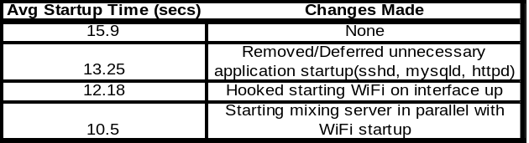Table 4.1. System Startup Timing

As shown, significant improvement was made over time in minimizing the startup time of the system. These improvements included removing unnecessary applications from the Ubuntu startup such as daemon applications that provide secure shell access to the system, and starting the mixing application and WiFi connection scripts in parallel to the major system-level applications necessary for the system to function.

4.2 Client Connection Response Time
The amount of time necessary for a client to connect to the system and its audio data to be included in the output signal was analyzed in order to verify the system’s viability in terms of practical usage. Below in Table 4.2, average connection time is shown to be on the order of hundreds of milliseconds.

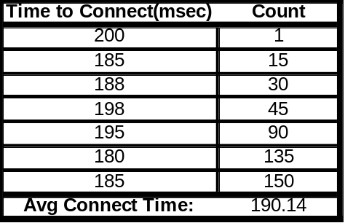Table 4.2. Average Client Connection Time

Given this set of data, no other optimization was found to be necessary in order to allow for faster client connection time.

4.3 System Resource Utilization
Resource utilization of the system during no, medium and heavy loading was analyzed in order to ascertain whether the chose hardware was a proper choice for the proposed solution. Statistics from this analysis are summarized below in Table 4.3.

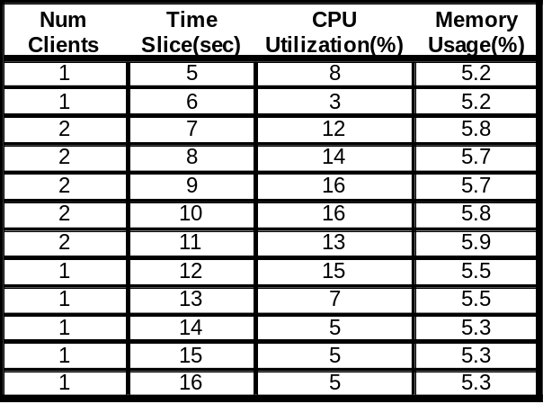Table 4.3. System Resource Utilization

As shown, the system was never utilizing a high percentage of the board’s resources. This can be attributed to a few reasons. One reason for low resource utilization is that the pandaboard is a highly powerful system. It is based on a dual 1-GHz ARM processor and fast I/O buses. In order for the system to highly utilize these resources, many computationally intensive applications would need to be running at high load at the same time. Moreover, measures were taken in the implementation of the mixing application to minimize resource utilization such as throttling of the data transfer to the system wirelessly and minimizing mixing of audio data until the playback thread was nearly starved for data.

4.4 Subjective Sound Quality Perception
The main way to test this type of implementation other than time-based measurements is based on subjective perception of sound quality. As can be shown from multiple resources, the human ear is highly sensitive to imperfections in audio, especially when the audio is being converted from digital representations to analog. [5] In the testing of this project, various scenarios were employed to judge the final outputted sound quality. It was found that as more audio clients were added, the quality of the mixed audio stream would go down in terms of amplitude clipping and intelligibility of the mixed stream. Audio clipping was an expected issue when the output stream is using the same bit-depth as the input streams. This occurs when the combined amplitude of the client streams is greater than the amplitude of signal that can be represented by the output stream. A simple solution to this problem would be to double the bit-depth of the output signal when compared to the input signals. The mixed client streams would then more accurately be represented due to the higher level of representation capable of the system at a higher output bit-depth. The intelligibility of the mixed stream, or the ability of the listener to be able to perceive each client stream in the combined output stream, was another issue. This problem is inherent in the implementation and usage of this type of system and is subject to the content of the audio data that is being used. If multiple similar streams are used as an input signal, the output signal would be an accurate representation of the input signals but would also be saturated. A high level of signal power per unit time would be the final result of mixing many similar signals and would result in subjectively garbled output to the listener.

5. Comparison of Similar Products

Comparing this implementation of the embedded wireless audio mixer with other wireless audio devices, there are not many options that meet the same requirements as this implementation. For example, the Apple AirPlay system is capable of streaming audio from a client machine to an AirPlay-enabled device such as an Airport Express or the AppleTV. While similar to the implementation of this project, the AirPlay devices have some distinct limitations. One obvious limitation is that only a single client can stream data to the AirPlay device at a time. AirPlay devices do not have the capability to mix audio from multiple clients into a single output stream. [1]

Another set of devices that have a similar set of features as the embedded audio mixer in this project are developed by Sonos. Sonos systems allow for wireless transmission of audio to remote speaker systems. A significant distinction to be made about Sonos systems compared to the system in this report is that Sonos system utilize a proprietary wireless communication system. This limitation requires only Sonos products and software to be able to stream audio. Another limitation, similar to that of AirPlay devices, is that only a single stream can be used with Sonos devices at a time. [4]

There are a multitude of wireless audio devices on the market, however research has shown none that utilize both standard wireless technologies, such as WiFi with TCP sockets, and are able to mix multiple streams of audio for a single channel output. The use of standardized communication protocols, and the ability to mix multiple streams of audio make this system unique among its peers.

6. Conclusions

The design and implementation of the embedded audio mixer was a large undertaking that required a high level of effort to complete. The choice of using a platform such as the pandaboard couple with community support for the operating system proved to be invaluable in meeting the aggressive timeline involved in completing the project during the Summer session. If another platform was considered, such as a PIC or AVR based system, more low-level work would have been required in order to implement the system and would have proven to be time prohibitive. Over the course if this project’s implementation, exposure and experience was gained in the areas of board bring-up, operating system customization, and project management in order to achieve a viable system. This experience will prove to be invaluable in future embedded system implementations. The quality of the final product was greater than expected given the time constraints of the implementation and a viable embedded wireless audio mixing system was developed.

7. References

Reference and utilized open source software/code are referenced in the source code submitted with the project and the README file included with the source code.

All figures and tables are original and full size version are included with the report submission.

[1] Apple Airplay Feature Specification, [http://www.apple.com/itunes/airplay/].
[2] OMAP Ubuntu Documentation, [http://www.omappedia.org/wiki/OMAP_Ubuntu_Main].
[3] Pandaboard Documentation, [http://pandaboard.org/content/resources/home].
[4] Sonos Feature Specification, [http://www.sonos.com/system/].
[5] Wikipedia article, Psychoacoustics, [http://en.wikipedia.org/wiki/Psychoacoustics].

