INF2003 Database Systems, Final Report
GigTrack, a live-music discovery, ticketing & memory companion
Group G12 · Macarius Dai (lead) 2500581 · Chin Yu Xuan 2502811 · Heng Ann Ya 2502737 · Wesley Chandra 2500823 · Lennon Lim Le Rong 2503438 · Kent Lo Wei Jun 2500343

1. Introduction
GigTrack is a Ticketmaster-style web application for discovering live music, booking tickets, and reliving shows through fan-sourced setlists, reviews, and photos. Today a concert-goer juggles separate platforms for ticket purchase, lineup information, and post-show discussion; GigTrack unifies the whole journey, discover, book, and remember, into one product with two roles. Customers browse and filter concerts, book up to six tickets per show, follow artists, and post photo reviews; administrators manage the catalogue (concerts, ticket tiers, venues, artists), bookings, and user accounts through a dedicated dashboard.
The domain is a deliberate fit for this module because its data is genuinely heterogeneous, which lets us contrast relational and non-relational modelling on one dataset. Ticket inventory and financial transactions require ACID transactions and strict integrity handled by a relational store, whereas setlists and reviews are variable-shaped and primary append-only, ideal for a document store. Hot listing pages and session tokens are managed via an in-memory cache and image bytes are offloaded to object storage to prevent database bloat. GigTrack therefore runs a polyglot back-end, MySQL, MongoDB, Redis, and MinIO, each used for what it does best.
Why we chose each datastore for different types data is explained in greater detail below:
MySQL was chosen for handling large volumes of transactional, relational data such as: users, artists, venues, concerts, tickets, bookings, and follows. As a relational database management system (RDBMS), it organises correlated data into one or more data tables, helping to maintain its structure and integrity while keeping the data storage scalable and flexible. Data integrity is enforced through the utilisation of constraints such as foreign keys, CHECK and triggers. These functionalities are crucial in keeping vital system information such as seat inventory and pricings correct and reliable. Furthermore, it addresses the limitations of other datastores used, such as MongoDB’s limited ACID transactions, which is better suited with a relational store.
MongoDB was chosen for its ability to handle unstructured and semi-structured data effectively. It is optimised for read and write-applications through efficient indexing and in-memory storage, allowing for fast and high performance. This makes it effective at managing variable-shape variables such as setlists, reviews with tags/photos and artist bios, all of which require intensive data submitting and retrieval operations which would be difficult to normalise.
Redis was chosen for its in-memory cache functionality as it stores data in the RAM, making it very fast at storing data temporarily and suitable as a cache for the application. Frequently requested data such as concert listings, distinct city/genre lists, and temporary data such as live view counters and session tokens can be expensive to fetch and would hence benefit from the access speed of Redis.
Finally, MinIO was chosen for its S3-compatible object storage for images blobs, which would be effective in storing data such as artist photos and review photos or any sort of media file. The database stores only the URL pointer; while the bytes stay in a bucket. Swapping the endpoint for AWS S3 / Cloudflare R2 requires no code change, making it easy to scale and maintain.

Project Objectives
To successfully accomplishing this architecture, this project satisfies four core technical objectives:
- Relational Design: Design a normalised relational schema with real referential integrity, constraints, triggers, and advanced queries.
- NoSQL Modeling: Design a justified NoSQL document model and demonstrate data aggregation.
- Polyglot Integration: Integrate the two stores with a cache and object storage within one unified application backend.
- Performance Evaluation: Evaluate the design with a reproducible performance benchmark.

2. Data and Datasets
We use a deterministic synthetic dataset produced by scripts/generate_seed.py with a fixed RNG seed, so every team member and marker reseeds an identical, consistent state. This ensures the dataset resembles real ticketing data and adheres to all application business rules – including seat availability, VIP-pricing rule, and the six-ticket quota – ensuring that the seed matches what the application itself would produce. The MySQL and MongoDB seeds share entity counts so integer IDs act as logical foreign keys across the two stores. Artist portraits are real images fetched once at boot and stored as blobs in object storage, not in a database.
Store | Entities (volumes)
MySQL | 21 users, 30 artists, 15 real venues across 8 cities, 50 concerts, 116 ticket tiers, ~176 confirmed bookings, 220 artist follows
MongoDB | ~25 setlists, 220 reviews (with tags/photos), 30 artist bios
MinIO | Artist portraits + review photo blobs (URL pointer kept in the DBs)
Utilizing a synthetic dataset allowed us to accelerate schema design, trigger implementation, and application development, avoiding early-stage bottlenecks with data cleaning.
3. Database Design

3.1 Conceptual model and translation to relations
The ER model has eight relational entities and exercises multiple relationship kind:
- One-to-many: A venue hosts many concerts, an artist headlines many concerts, a concert offers many ticket tiers, and a ticket tier appears in many bookings.
- Many-to-many: Realized via two junction tables: concert_artists (tracks festival / support lineups, slot order, and roles) and follows (maps the user-artist follow graph).
- The complete entity-relationship diagram, showing all eight entities with their attributes and the three relationship types described above, is provided in Appendix A (Figure 3).
The physical schema enforces strict data integrity by mapping each conceptual entity to an individual table using optimized data types: VARCHAR, INT, DATETIME, ENUM for statuses, TINYINT for boolean flags, and DECIMAL for monetary values. To resolve many-to-many relationships, the two junction tables utilize composite primary keys: (concert_id, artist_id), and (user_id, artist_id). Furthermore, the schema is normalized to Third Normal Form (3NF); every non-key attribute depends strictly on the whole key, eliminating repeating groups and transitive dependencies.

3.2 NoSQL document model and justification
MongoDB holds three collections whose shape varies per document, the canonical case for the document model. setlistsembed an ordered song array consisting of 10–40 songs, each with duration and optional cover-of / encore / notes, reviewscarry a rating, free-form tags, an array of photo pointers, and a liked_by set of user IDs; artist_bios embed nested tour history and social handles. Normalising these into MySQL would require five-plus sparse tables and a join on every read for what the app always consumes as a single unit. Storing likes as a liked_by set (not a counter) makes the helpful-count derived (len(liked_by)) and guarantees a user can never be double-counted.

3.3 The SQL–NoSQL boundary
Mongo documents reference MySQL rows by integer concert_id / user_id / artist_id, a logical foreign key that Mongo does not enforce and the application layer does. The two designs are independent but reconciled at the app tier, which is the realistic enterprise pattern and the discussion point for project task 5.
- Pros of independence: each store optimises for its own access pattern and Mongo schema evolution needs no MySQL migration.
- Cons: dangling references are possible, so the application implements the cross-store cascade itself (Section 6 and the Appendix).

3.4 Cache and object-storage layers (Redis 7, MinIO)
Two supplementary data stores complete the architecture. Redis serves as an in-memory caching layer managing four distinct key families, each configured with a Time-To-Live (TTL). Implemented via a unified redis-py client, the application utilizes SETEX, GET, and EXPIRE commands for session tokens, an atomic GETDEL and INCR pattern for real-time view counters, and JSON.SET and JSON.GET operation for caching concert listings.
Redis key pattern | Type | Purpose | TTL
session:{token} | string | auth session (user_id); slid on each request | 30 min
browse:{when}:{city}:{genre} | JSON | cached concert listing per filter | 5 min
cities:list / genres:list | JSON | filter dropdowns & category tiles | 1 hr
concert:{id}:views | counter | pending view delta, GETDEL-drained to MySQL | none
MinIO provides S3-compatible object storage for image blobs in the gigtrack-media bucket,accessed through a thin boto3 helper (app/storage.py: ensure_bucket, upload_fileobj, public_url, presigned_url, delete). The databases never hold image bytes, a review document keeps only {url, key} and MySQL keeps the artist's image_url, so the same code runs unchanged against AWS S3 or Cloudflare R2 by swapping the endpoint and credentials. The demo bucket is public-read so <img src> works directly; presigned_url() shows the time-limited signed-URL pattern for a private production bucket.

4. Relational Implementation (MySQL 8)
Full CRUD is implemented over all eight tables through parameterised statements with integrity enforced well beyond foreign keys.
· Constraints: FK + CHECK constraints back every rule: CHECK (available_seats >= 0 AND available_seats <= total_seats); concert delete cascades to tickets and concert_artists but is RESTRICTed while bookings exist.
· Four triggers enforce rules that constraints alone cannot handle:
Command | On | Purpose
BEFORE INSERT | bookings | Decrements seat inventory and raises SQLSTATE 45000 (rollback) if booking would oversell ticket
AFTER UPDATE | bookings | Restores seats when confirmed booking moves to cancelled or refunded
BEFORE INSERT / UPDATE | tickets | Enforces a VIP tier is never cheaper than other tiers of same concert
The full BEFORE INSERT seat-inventory trigger source (abridged) is provided in Appendix A; it locks the ticket row, checks availability, decrements inventory, and raises SQLSTATE 45000 to roll back an oversell.

Advanced queries (sql/queries.sql) go beyond CRUD. Nested and correlated subqueries support relational-division "for every" logic, while window functions compute revenue RANK() per city and a running cumulative total. The script also includes a multi-step CTE, an explict multi-statement transaction, and a reusable view. EXPLAIN output confirms that the composite index serves the trending query. The booking quota of maximum six tickets per user for each concert is enforced inside a single locking transaction using SELECT ... FOR UPDATE on the concert's ticket rows, so concurrent requests cannot race past the limit.
SELECT v.city, c.title, COALESCE(SUM(b.total_price),0) AS rev,
RANK() OVER (PARTITION BY v.city
ORDER BY COALESCE(SUM(b.total_price),0) DESC) AS rk
FROM concerts c JOIN venues v ON v.venue_id = c.venue_id
LEFT JOIN tickets t ON t.concert_id = c.concert_id
LEFT JOIN bookings b ON b.ticket_id = t.ticket_id AND b.status='confirmed'
GROUP BY v.city, c.concert_id; -- window function: revenue leaderboard per city
sql/queries.sql, window-function example
These advanced queries are not only demonstrated but used live: three of them power the admin dashboard. A window-function leaderboard ranks the top-earning concert per city, a GROUP BY with HAVING flags concerts with under 20% of their inventory left, and a two-step CTE lists artists earning above the average. The admin concert list is itself served from a reusable SQL view, v_concert_summary, which joins concerts, venues and artists and exposes computed from-price and seats-left columns, keeping the route logic simple.
Indexes beyond the primary keys support the application's main access patterns: concerts carry a composite index on (status, concert_date) that serves the date-ordered trending lists; venues are indexed on city to drive the browse filter; and artists are indexed on name and genre. An EXPLAIN on the trending query confirms the optimiser uses this composite index (a ref access on status, with the index supplying the concert_date ordering) instead of a full table scan, avoiding a filesort. The booking path through the locking transaction and the seat trigger is shown in Appendix A (Figure 7).

5. Non-relational Implementation (MongoDB 7 + Redis Cache + MinIO object storage)
CRUD on all three collections runs through PyMongo (mongo/queries.py). Indexes include a compound (concert_id, posted_at) for review listing, a unique artist_id, and a text index powering full-text review search. Aggregation pipelines use $group and $unwind, plus two showcase operators: $facet computes the whole rating dashboard (rating distribution + top tags) in a single pass, and $lookup performs a document-side join of reviews to setlists.
db.reviews.aggregate([{ $facet: {
byRating: [{ $group: { _id: '$rating', n: { $sum: 1 } } }, { $sort: { _id: -1 } }],
topTags: [{ $unwind: '$tags' }, { $group: { _id: '$tags', n: { $sum: 1 } } },
{ $sort: { n: -1 } }, { $limit: 5 }]
}}]) // one-pass multi-metric rating dashboard
mongo/queries.py, $facet aggregation
Likes are toggled with $addToSet / $pull on the per-user liked_by set, this is a single atomic update with no join table, so a double-click never double-counts. Object storage follows a strict pointer-vs-blob pattern: review and artist images live as bytes in a MinIO S3-compatible bucket (app/storage.py), while the databases keep only a URL pointer and structured metadata (caption, order).
Documents have a 16 MB cap and putting image bytes in a database bloats the working set and backups. Object storage is purpose-built for large immutable blobs and migrating to AWS S3 or Cloudflare R2 would require changing only the endpoint and credentials. The demo uses a public-read bucket so <img src> works directly; storage.presigned_url() shows the time-limited signed-URL alternative for production. The pointer-vs-blob write path is shown in Appendix A (Figure 8).
Beyond MongoDB, the non-relational layer also includes Redis 7, the in-memory key-value store, reached through a single redis-py client created once in app/db.py from REDIS_URL (with decode_responses enabled so values return as strings). The application uses it for three jobs, each with its own key family and TTL. Authentication sessions are stored as session:{token} holding the user id: on login the app writes the key with SETEX and a 30-minute expiry, and every authenticated request refreshes it with EXPIRE, giving a sliding idle timeout rather than a fixed one.
Listing pages use a cache-aside pattern, where the browse route first issues a GET on a per-filter key (browse:{when}:{city}:{genre}); on a miss it runs the MySQL query and stores the JSON result with a 5-minute SETEX, and the distinct city and genre lists are cached the same way for an hour. Whenever an administrator creates, edits, or deletes a concert, the affected browse, cities, and genres keys are deleted so the cache never serves stale listings.
Finally, concert view counts are held as concert:{id}:views counters incremented with INCR on each detail view and drained into the MySQL view_count column by an atomic GETDEL before any view-ordered list renders, a write-behind pattern that keeps the hot path off the database without losing counts[1] . Because every cache and session key carries a TTL, the store is self-cleaning, and serving a cached listing or a session lookup from memory is roughly an order of magnitude faster than recomputing it from MySQL (Section 7).
Cache, not the source of truth: Redis is deliberately a thin acceleration layer rather than the system of record. Because it keeps everything in RAM, capacity is small and costly compared with disk, and every key is volatile: entries carry a TTL and can be evicted under memory pressure, so data may disappear at any time. Redis also has no joins, schema constraints, or multi-entity transactions, so it cannot enforce rules such as the no-oversell guarantee that MySQL provides. The full catalogue and all history therefore live durably in MySQL and MongoDB, while Redis holds only a small, hot working set (cached listings, sessions, and counters) that can always be rebuilt from those stores on a miss.

6. Application and System
The Flask application coordinates all four stores. A single user action often touches several: MySQL is the source of truth (identity, inventory, bookings, follows), MongoDB holds rich content (setlists, reviews, bios), Redis provides speed (cache, sessions, view counters), and MinIO holds media bytes. Figure 4 in the appendix traces the core journey across all four datastores.
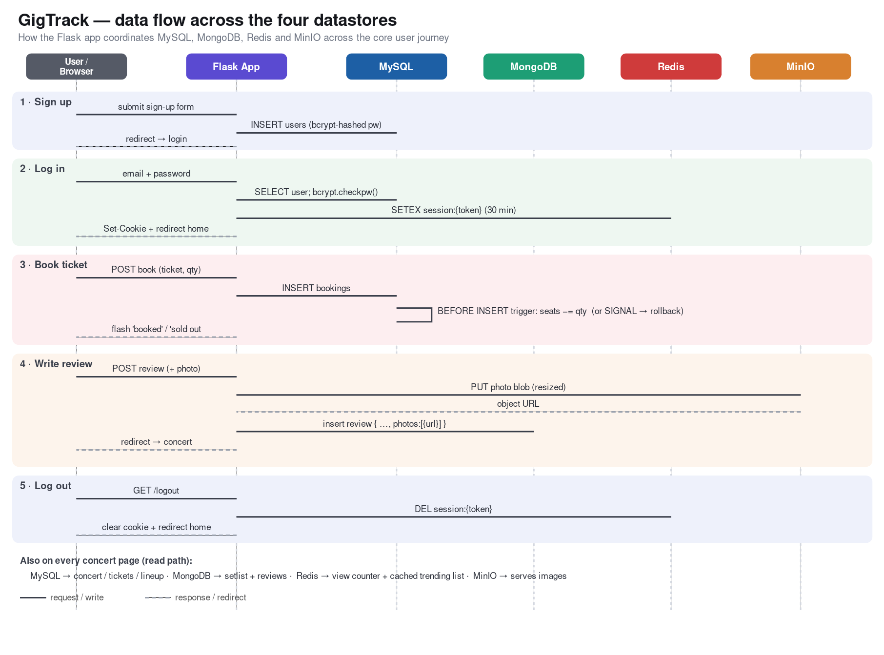
Figure 1. GigTrack data flow across the four datastores.
Caching strategy: Building on the Redis key design in Section 3.4, listing pages are served cache-aside (a hit skips the three-table join entirely), view counts use a write-behind GETDEL that drains into MySQL only before a view-ordered render so counting stays lossless yet off the hot path, and any admin create/edit/delete immediately busts the affected browse, cities, and genres caches.
Key features: Booking enforces a six-per-concert quota inside one locking transaction (race-safe); the admin dashboard does full concert/ticket/user CRUD, can add a brand-new artist and venue inline in the same transaction, and on delete performs an application-level cascade across the SQL–NoSQL boundary (removing the concert’s Mongo setlists/reviews and their MinIO photo blobs) so no orphans remain.
Security is enforced at the application tier across several layers. All SQL is parameterised, so user input cannot change query structure (injection-safe); passwords are stored only as bcrypt hashes, never as plaintext; every state-changing form carries a CSRF synchroniser token that is verified server-side; session cookies are HttpOnly and SameSite=Lax with a sliding 30-minute Redis-backed expiry; uploaded review images are type-checked, size-capped and downscaled before storage; administrator accounts cannot purchase tickets; and booking is blocked server-side for any concert whose date has already passed, so past events cannot be booked even through a crafted request.
Connection management: every MySQL access borrows a live connection from a pool (DBUtils PooledDB wrapping PyMySQL, configured in app/db.py) and returns it on close, instead of opening a fresh TCP-plus-authentication connection on each request. This keeps a small set of connections warm and removes most of the per-call connection latency quantified in Section 7.

7. Performance Evaluation
scripts/benchmark.py measures seven scenario groups, cached vs uncached reads, indexed vs full-scan, a connection-pool comparison, a per-store point-lookup ladder, server-side compute, write latency including trigger cost, commit batching, and concurrent throughput, each over 300 iterations, reporting latency percentiles, client CPU per call, throughput, and peak memory (about 70 MB for the run). Figure 2 summarises the main groups across MySQL, MongoDB, and Redis; the table below lists the headline scenarios, including the connection-pool comparison.
Scenario (store) | avg ms | p95 ms | ops/s
Redis cached read | 1.14 | 1.49 | 881
MySQL trending read (pooled) | 3.99 | 5.21 | 250
MySQL read, new connection per call | 17.24 | 20.72 | 58
MySQL read, pooled connection | 5.00 | 8.01 | 200
Redis GET (point lookup) | 1.16 | 2.70 | 866
MySQL PRIMARY-KEY lookup | 4.64 | 7.90 | 216
MySQL INSERT (plain) | 4.45 | 7.08 | 225
MySQL INSERT + seat trigger | 4.98 | 6.80 | 201
MySQL, 1 commit / 50 rows | 67.26 | 78.55 | 15
MySQL, 50 commits / 50 rows | 231.35 | 275.59 | 4
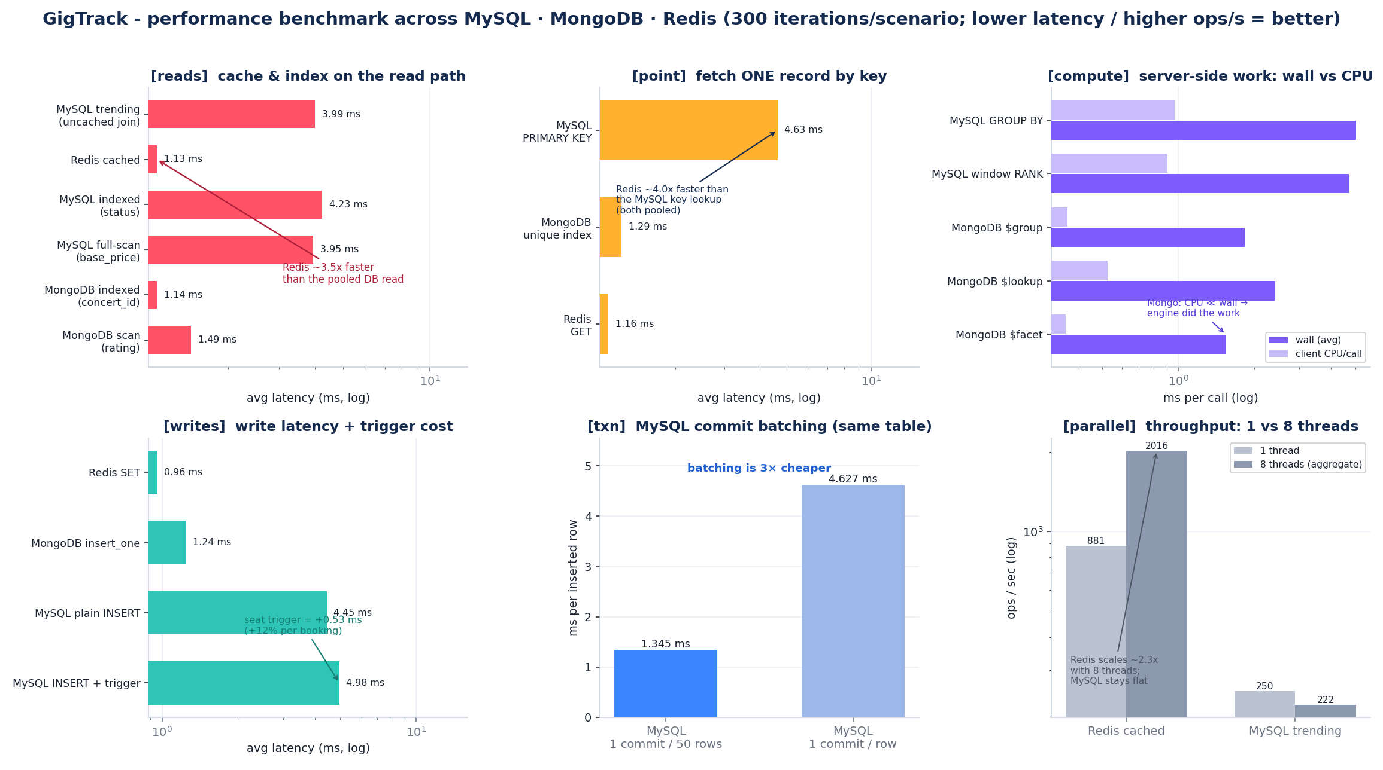
Figure 2. Six-group benchmark across MySQL, MongoDB and Redis (last two table rows are the same MySQL table, comparing commit strategy).
Analysis. With connection pooling now enabled (Section 6), the relational reads are far quicker than in our earlier, unpooled runs. A warm Redis read serves the trending payload in 1.14 ms against 3.99 ms for the uncached three-table MySQL join, about 3.5x lower latency (881 vs 250 ops/s). The point-lookup ladder is similar: a Redis GET (1.16 ms) and a MongoDB unique-index find_one (1.29 ms) versus 4.64 ms for a MySQL primary-key lookup, so the cache is still roughly 4x faster on a single key. The largest single win, however, came from the connection layer itself. The [pool] group isolates it by running the same read with a fresh connection on every call versus a connection borrowed from the pool: 17.24 ms drops to 5.00 ms, about 3.4x faster and roughly 12 ms saved per call (Figure 9, Appendix A). That 12 ms was almost entirely TCP and authentication handshake, which pooling removes by keeping a small set of connections open and handing them out on demand.
Indexing showed no measurable benefit at seed volume on either store (MySQL indexed 4.23 ms vs full-scan 3.95 ms; MongoDB roughly 1.1 to 1.5 ms either way): at 50 concerts the planner scans regardless, so index value is better shown via EXPLAIN or at larger scale. The seat-inventory trigger is cheap, 4.98 ms with the trigger vs 4.45 ms plain, a +0.53 ms (+12%) price for guaranteed inventory integrity. Commit batching, compared on the same MySQL table, is about 3.4x cheaper per row (one commit per 50 rows is 1.35 ms per row vs 4.63 ms per row for one commit each, roughly 3.3 ms per extra fsync), which is why the seed loader emits multi-row INSERTs. Under concurrency (8 threads) Redis throughput scaled about 2.3x (881 to 2,016 ops/s aggregate) while pooled MySQL stayed essentially flat (250 to 222 ops/s): the pool caps the number of concurrent connections and Python's GIL serialises client-side parsing, so Redis stays far faster per call but neither store scales linearly with threads. Correctness is verified separately by a pytest suite: 22 unit tests pass, and 19 integration tests run against a live stack and skip automatically when it is offline.

8. GenAI Reflection
We used GenAI assistants for scaffolding (route stubs, the seed generator skeleton, Docker/compose boilerplate), for drafting and proofreading prose, and as a faster reference for SQL window-function and MongoDB aggregation syntax. The clear pros were speed on boilerplate and a lower barrier to trying unfamiliar operators such as $facet and RANK(). The cons were real: assistants occasionally produced plausible-but-wrong SQL, invented PyMongo options, or suggested non-atomic like-counting that we had to correct. Our takeaway for future projects is to treat GenAI as a junior pair-programmer, great for first drafts and explanations, but every generated query, trigger, and security control must be verified against the official docs and our own tests, and core design decisions (the schema, the SQL–NoSQL boundary, the trigger logic) should stay human-owned.

9. Conclusion and Future Work
GigTrack delivers a working polyglot application that demonstrates the full range of module skills: a normalised relational core with foreign keys, CHECK constraints, four business-rule triggers, and advanced queries; a justified MongoDB document model with text search and $facet / $lookup aggregation; a Redis cache/session/counter layer; and S3-compatible object storage, all integrated behind a secure Flask UI and validated by a reproducible benchmark and an automated test suite. Future work: import a real public dataset through the existing pipeline, add a payment gateway, build a recommendation feed from the follow graph and review tags, and move to managed/replicated datastores for horizontal scale.

Appendix

A. Additional flow diagrams
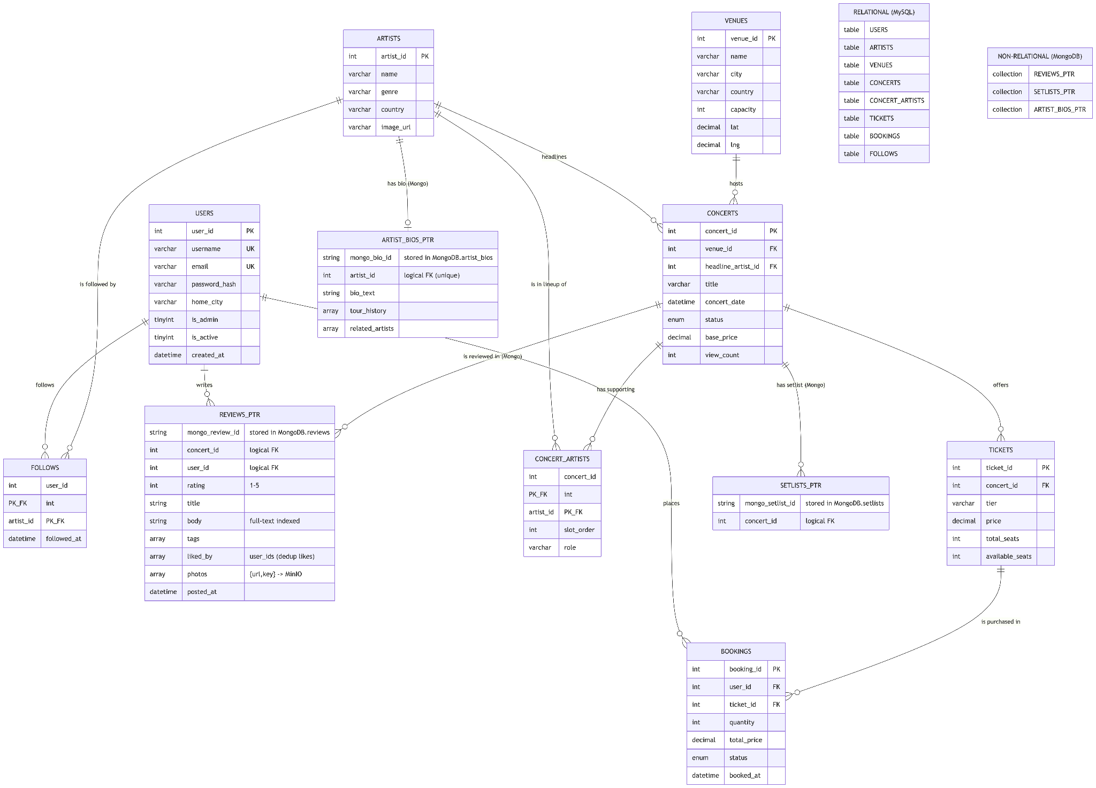
Figure 3. ER diagram (8 relational entities + 3 logical-FK Mongo collections)
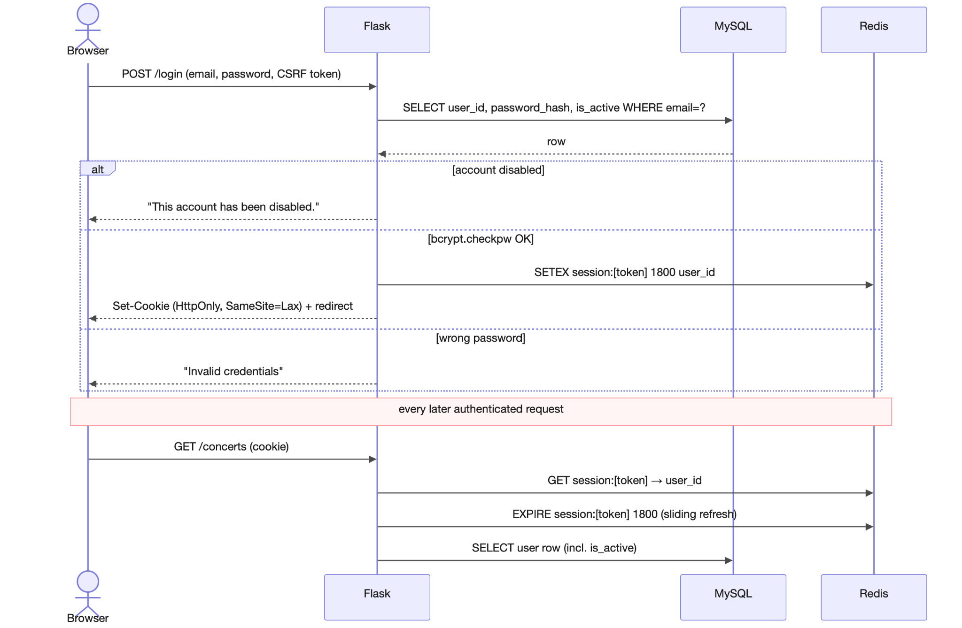
Figure 4. Login & session, bcrypt verify + sliding Redis session

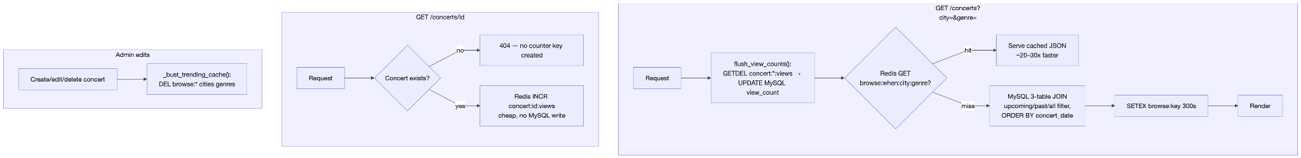
Figure 5. Browse caching & view counters (cache-aside + write-behind)
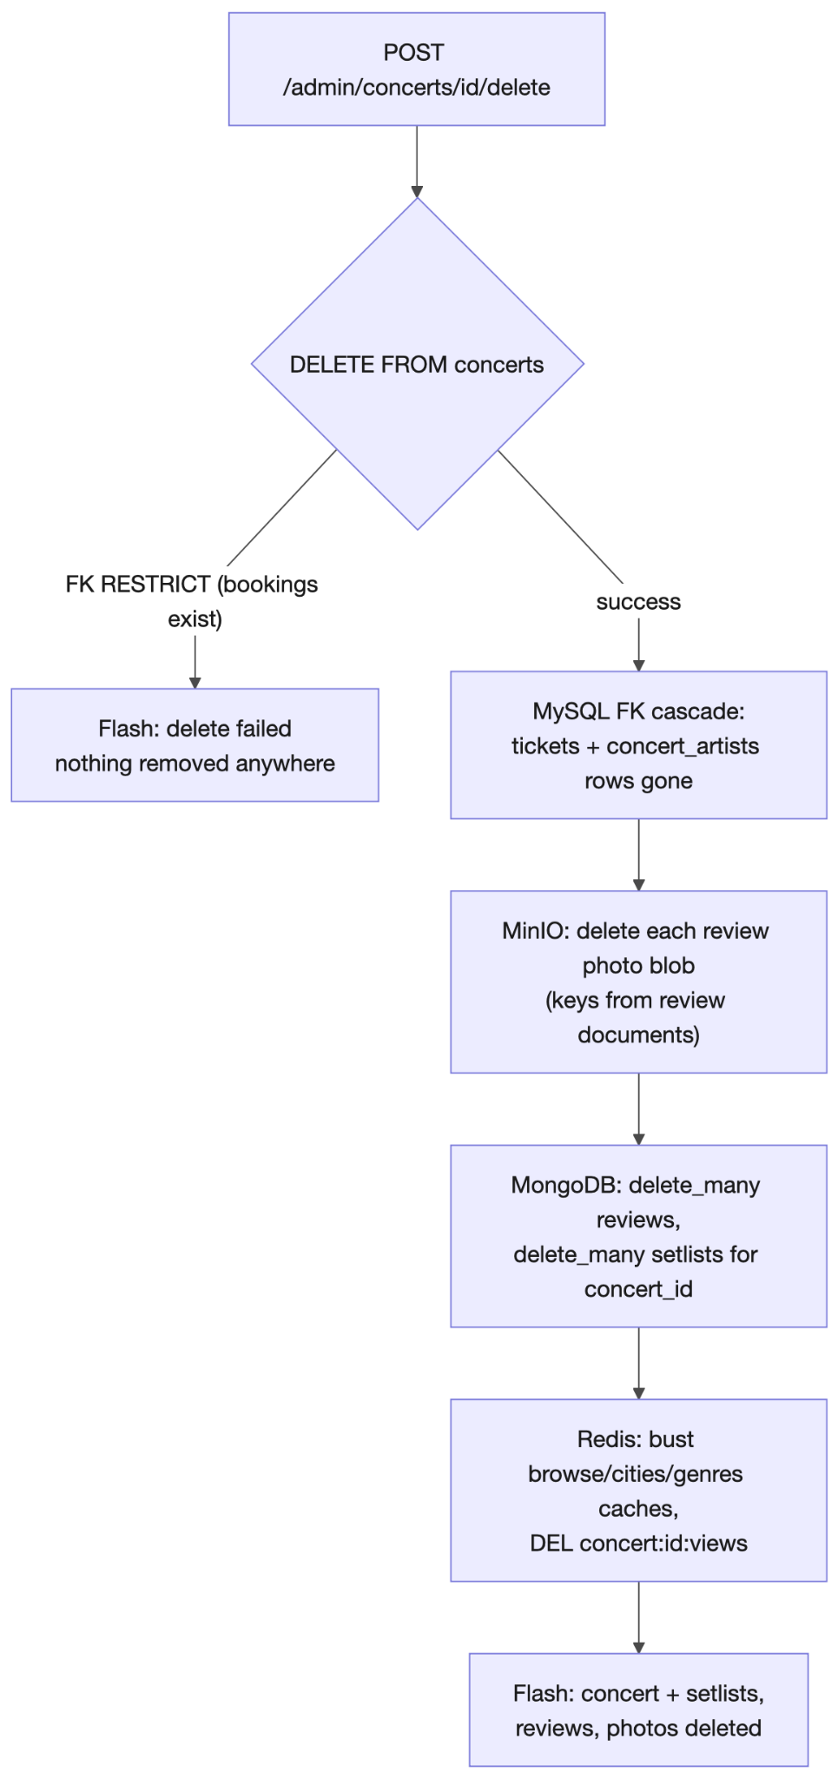
Figure 6. Concert delete, cross-store cascade (MySQL → MinIO → Mongo → Redis)
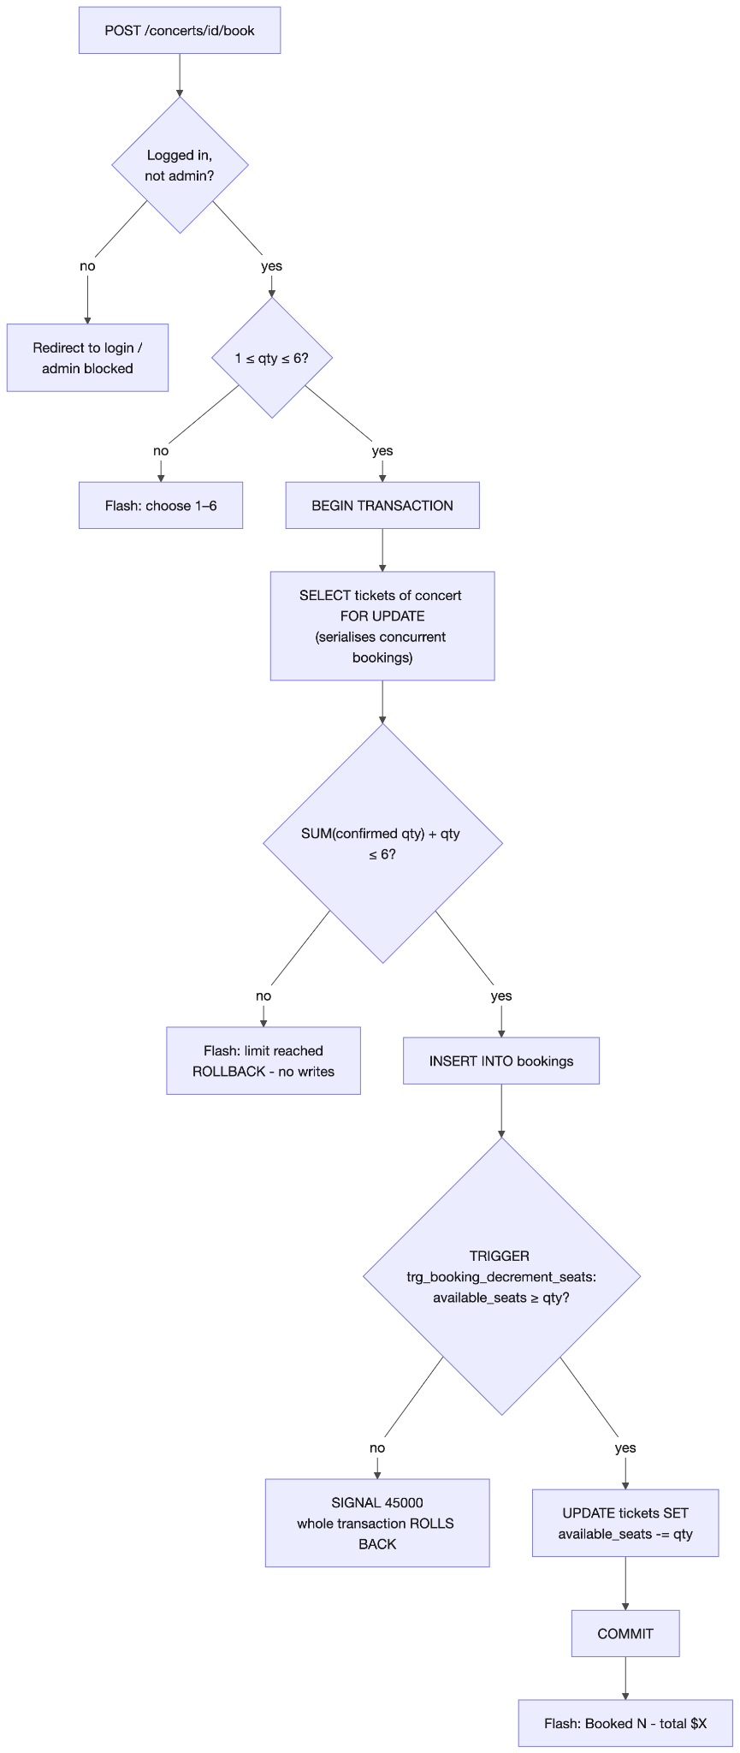
Figure 7. Ticket booking, quota check + seat trigger in one transaction
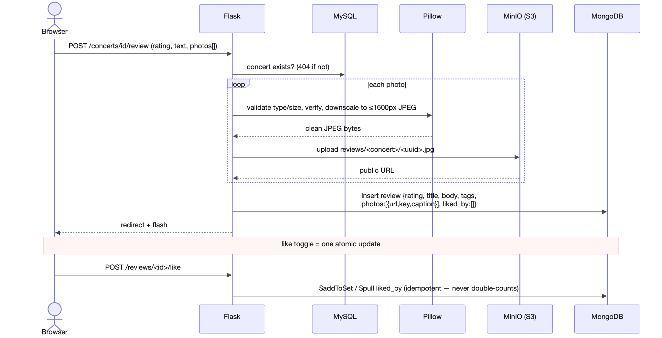
Figure 8. Review with photo, bytes to object storage, pointer to the DBs
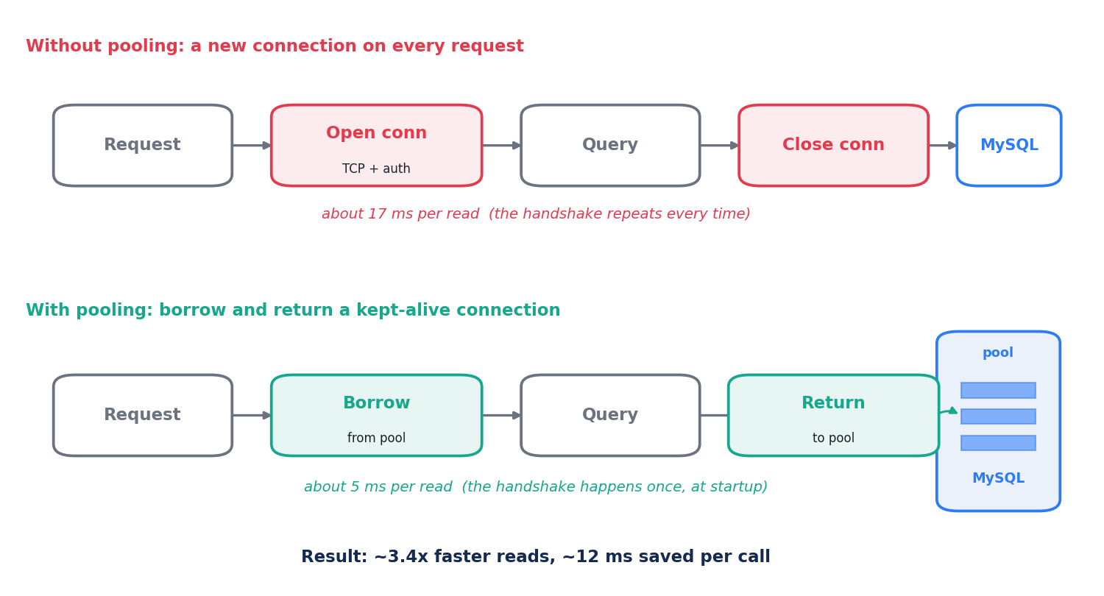
Figure 9. Connection pooling: a fresh connection per call (about 17 ms) versus a pooled connection (about 5 ms), about 3.4x faster (scripts/benchmark.py, [pool] group).

Seat-inventory trigger (abridged), referenced from Section 4:
CREATE TRIGGER trg_booking_decrement_seats BEFORE INSERT ON bookings
FOR EACH ROW BEGIN
DECLARE avail INT;
SELECT available_seats INTO avail FROM tickets WHERE ticket_id = NEW.ticket_id FOR UPDATE;
IF avail < NEW.quantity THEN
SIGNAL SQLSTATE '45000' SET MESSAGE_TEXT = 'Not enough seats';
END IF;
UPDATE tickets SET available_seats = available_seats - NEW.quantity
WHERE ticket_id = NEW.ticket_id;
END;[1]
sql/schema.sql, seat-inventory trigger (abridged)

B. Relational schema summary
Table | Key design points
users | UNIQUE username/email, bcrypt hash, is_admin / is_active flags
artists | name + genre indexes; image_url points at object storage
venues | city/country/capacity; city index drives the browse filter
concerts | FKs to venue + headline artist; ENUM status; (status, concert_date) index
concert_artists | M:N junction, lineup slots (order, role); cascade on concert delete
tickets | tiers per concert; CHECK (available_seats >= 0 AND <= total_seats)
bookings | quantity, total price, ENUM status; FKs to user and ticket; RESTRICT delete
follows | M:N junction, composite PK (user_id, artist_id), cascade delete

C. Redis key patterns
Key pattern | Purpose | TTL
concert:{id}:views | pending view delta drained into MySQL (GETDEL) | none
browse:{when}:{city}:{genre} | cached listing per filter combination | 5 min
cities:list / genres:list | distinct cities / genres for filters & tiles | 1 hr
session:{token} | auth session (sliding) | 30 min

D. Source-code submission screenshots
The source-code zip may include up to ten screenshots of advanced features for the marker. Suggested set (replace each bracket with an actual screenshot): [admin concert form with inline artist/venue creation], [oversell attempt blocked by the trigger], [six-ticket quota error], [review with photo + MinIO object], [redis-cli MONITOR showing a cache hit], [pytest run all green].

E. Production considerations (real-world deployment)
GigTrack runs locally via Docker Compose, but each store maps cleanly onto a managed, horizontally scalable production deployment. The application code does not change; only configuration (endpoints, credentials, pool sizes) does.
Store | How it runs in production
MySQL | Primary with read replicas (reads scale out, writes stay consistent); a connection pool removes the per-request connect cost measured in Section 7; row-level locking and transactions preserve correctness under concurrency; automated backups + point-in-time recovery.
MongoDB | Deployed as a replica set for high availability and automatic failover; sharding spreads large collections across nodes for horizontal scale; server-side aggregation and flexible schema evolution need no migrations.
Redis | Redis Cluster / Sentinel for high availability and key sharding; AOF/RDB persistence so sessions and counters survive restarts; LRU eviction + TTLs cap memory; acts as a shared session store across many app servers.
MinIO / S3 | S3-compatible object storage scales effectively without limit and is served via a CDN; lifecycle rules, versioning and presigned URLs for private access; swap MinIO for AWS S3 / Cloudflare R2 by changing only the endpoint and credentials.
This is the standard polyglot-persistence pattern: each store is operated and scaled independently, and the application reconciles the logical-FK boundary between MySQL and MongoDB (Section 3.3). The single highest-impact change identified by the benchmark, a MySQL connection pool, is a configuration-level addition with no schema or code change.
Note: body sections target the 8-page limit; dashed placeholder boxes collapse to the image height once replaced, and the Appendix is the trim buffer if you run long.

