ros_gluon 开发环境配置手册

# 1.Ubuntu install of ROS Melodic

Ref: <http://wiki.ros.org/melodic/Installation/Ubuntu>

## 1.1 Configure your Ubuntu repositories

Configure your Ubuntu repositories to allow "restricted," "universe," and "multiverse." You can [follow the Ubuntu guide](https://help.ubuntu.com/community/Repositories/Ubuntu) for instructions on doing this.

## 1.2 Setup your sources.list

Setup your computer to accept software from packages.ros.org.

* sudo sh -c 'echo "deb http://packages.ros.org/ros/ubuntu $(lsb_release -sc) main" > /etc/apt/sources.list.d/ros-latest.list'

|  |  |
| --- | --- |
| [Mirrors](http://wiki.ros.org/ROS/Installation/UbuntuMirrors) | [Source Debs](http://wiki.ros.org/DebianPackageSources) are also available |

## 1.3 Set up your keys

* sudo apt-key adv --keyserver 'hkp://keyserver.ubuntu.com:80' --recv-key C1CF6E31E6BADE8868B172B4F42ED6FBAB17C654

If you experience issues connecting to the keyserver, you can try substituting hkp://pgp.mit.edu:80 or hkp://keyserver.ubuntu.com:80 in the previous command.

Alternatively, you can use curl instead of the apt-key command, which can be helpful if you are behind a proxy server:

* curl -sSL 'http://keyserver.ubuntu.com/pks/lookup?op=get&search=0xC1CF6E31E6BADE8868B172B4F42ED6FBAB17C654' | sudo apt-key add -

## 1.4 Installation

First, make sure your Debian package index is up-to-date:

* sudo apt update

There are many different libraries and tools in ROS. We provided four default configurations to get you started. You can also install ROS packages individually.

In case of problems with the next step, you can use following repositories instead of the ones mentioned above [ros-shadow-fixed](http://wiki.ros.org/ShadowRepository)

* **Desktop-Full Install: (Recommended)** : ROS, [rqt](http://wiki.ros.org/rqt), [rviz](http://wiki.ros.org/rviz), robot-generic libraries, 2D/3D simulators and 2D/3D perception
  + sudo apt install ros-melodic-desktop-full

or [click here](apt:ros-melodic-desktop-full?refresh=yes)

* **Desktop Install:**ROS, [rqt](http://wiki.ros.org/rqt), [rviz](http://wiki.ros.org/rviz), and robot-generic libraries
  + sudo apt install ros-melodic-desktop

or [click here](apt:ros-melodic-desktop?refresh=yes)

* **ROS-Base: (Bare Bones)** ROS package, build, and communication libraries. No GUI tools.
  + sudo apt install ros-melodic-ros-base

or [click here](apt:ros-melodic-ros-base?refresh=yes)

* **Individual Package:** You can also install a specific ROS package (replace underscores with dashes of the package name):
  + sudo apt install ros-melodic-PACKAGE

e.g.

sudo apt install ros-melodic-slam-gmapping

To find available packages, use:

apt search ros-melodic

## 1.5 Environment setup

It's convenient if the ROS environment variables are automatically added to your bash session every time a new shell is launched:

echo "source /opt/ros/melodic/setup.bash" >> ~/.bashrc

source ~/.bashrc

If you have more than one ROS distribution installed, *~/.bashrc* must only source the *setup.bash* for the version you are currently using.

If you just want to change the environment of your current shell, instead of the above you can type:

source /opt/ros/melodic/setup.bash

## 1.6 Dependencies for building packages

Up to now you have installed what you need to run the core ROS packages. To create and manage your own ROS workspaces, there are various tools and requirements that are distributed separately. For example, [rosinstall](http://wiki.ros.org/rosinstall) is a frequently used command-line tool that enables you to easily download many source trees for ROS packages with one command.

To install this tool and other dependencies for building ROS packages, run:

sudo apt install python-rosdep python-rosinstall python-rosinstall-generator python-wstool build-essential

#### 1.6.1 Initialize rosdep

Before you can use many ROS tools, you will need to initialize rosdep. rosdep enables you to easily install system dependencies for source you want to compile and is required to run some core components in ROS. If you have not yet installed rosdep, do so as follows.

sudo apt install python-rosdep

With the following, you can initialize rosdep.

sudo rosdep init

rosdep update

# 2. ros_gluon 编译

## 2.1 源码下载

Ref: <https://github.com/innfos/ros_gluon>

mkdir -p catkin_ws/src

cd catkin_ws/src

git clone <https://github.com/innfos/ros_gluon.git> 或者 下载zip压缩包

cd ..

git clone <https://github.com/innfos/innfos-cpp-sdk.git>

cp –r innfos-cpp-sdk/sdk src/gluon/ActuatorController_SDK

cp –r innfos-cpp-sdk/sdk src/gluon_control/ActuatorController_SDK

## 2.2 安装依赖包

sudo apt-get install ros-melodic-ros-control-boilerplate

sudo apt-get install ros-melodic-moveit-visual-tools

sudo apt-get install ros-melodic-moveit

sudo apt-get install ros-melodic-joint-state-publisher-gui

sudo apt-get install ros-melodic-ros-controllers

## 2.3 源码编译

cd catkin_ws

catkin_make

## 2.4 运行环境

echo "source /opt/ros/melodic/setup.bash" >> ~/.bashrc

echo "source ~/catkin_ws/devel/setup.bash" >> ~/.bashrc

echo "expo" >> ~/.bashrc

echo "" >> ~/.bashrc

source ~/.bashrc

**Tips:** 上述操作只需一次操作，重新开启Terminal 终端窗口时自动设置

## 2.5 运行demo

#### 2.5.1 运行环境配置

EZB 默认IP 地址是192.168.1.30, PC 的IP 地址需要配置为同网段的192.168.1.1xx；运行demo前，需要确保机械臂在正确的零位位置

#### 2.5.2 Rviz 控制模式

roslaunch gluon display.launch

正确运行后，在rviz界面（图-1）中可以看到gluon 机械臂urdf模型，拖拉joint_state_publisher窗口的滑动条即可控制机械臂运动，界面中的模型和真实机械臂联动

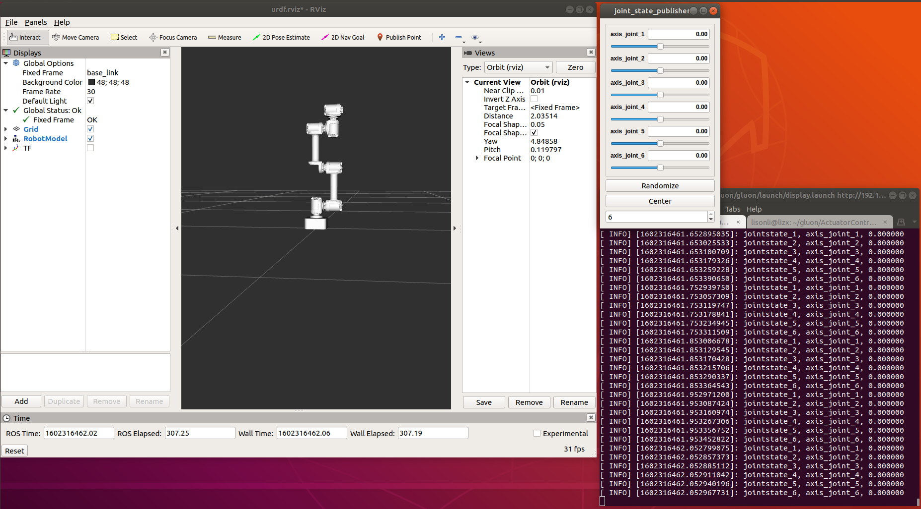

图-1

#### 2.5.3 Moveit+Rviz 控制模式

roslaunch gluon_moveit_config cm_demo.launch

这个demo 在rviz展示gluon 模型，在界面中拖拽至目标点或设置Goal State（预设值），点击按钮Plan -> Execute或 Plan and Execute, 我们可以看到gluon 模型运动到目标位置的运动轨迹（真机同步联动）

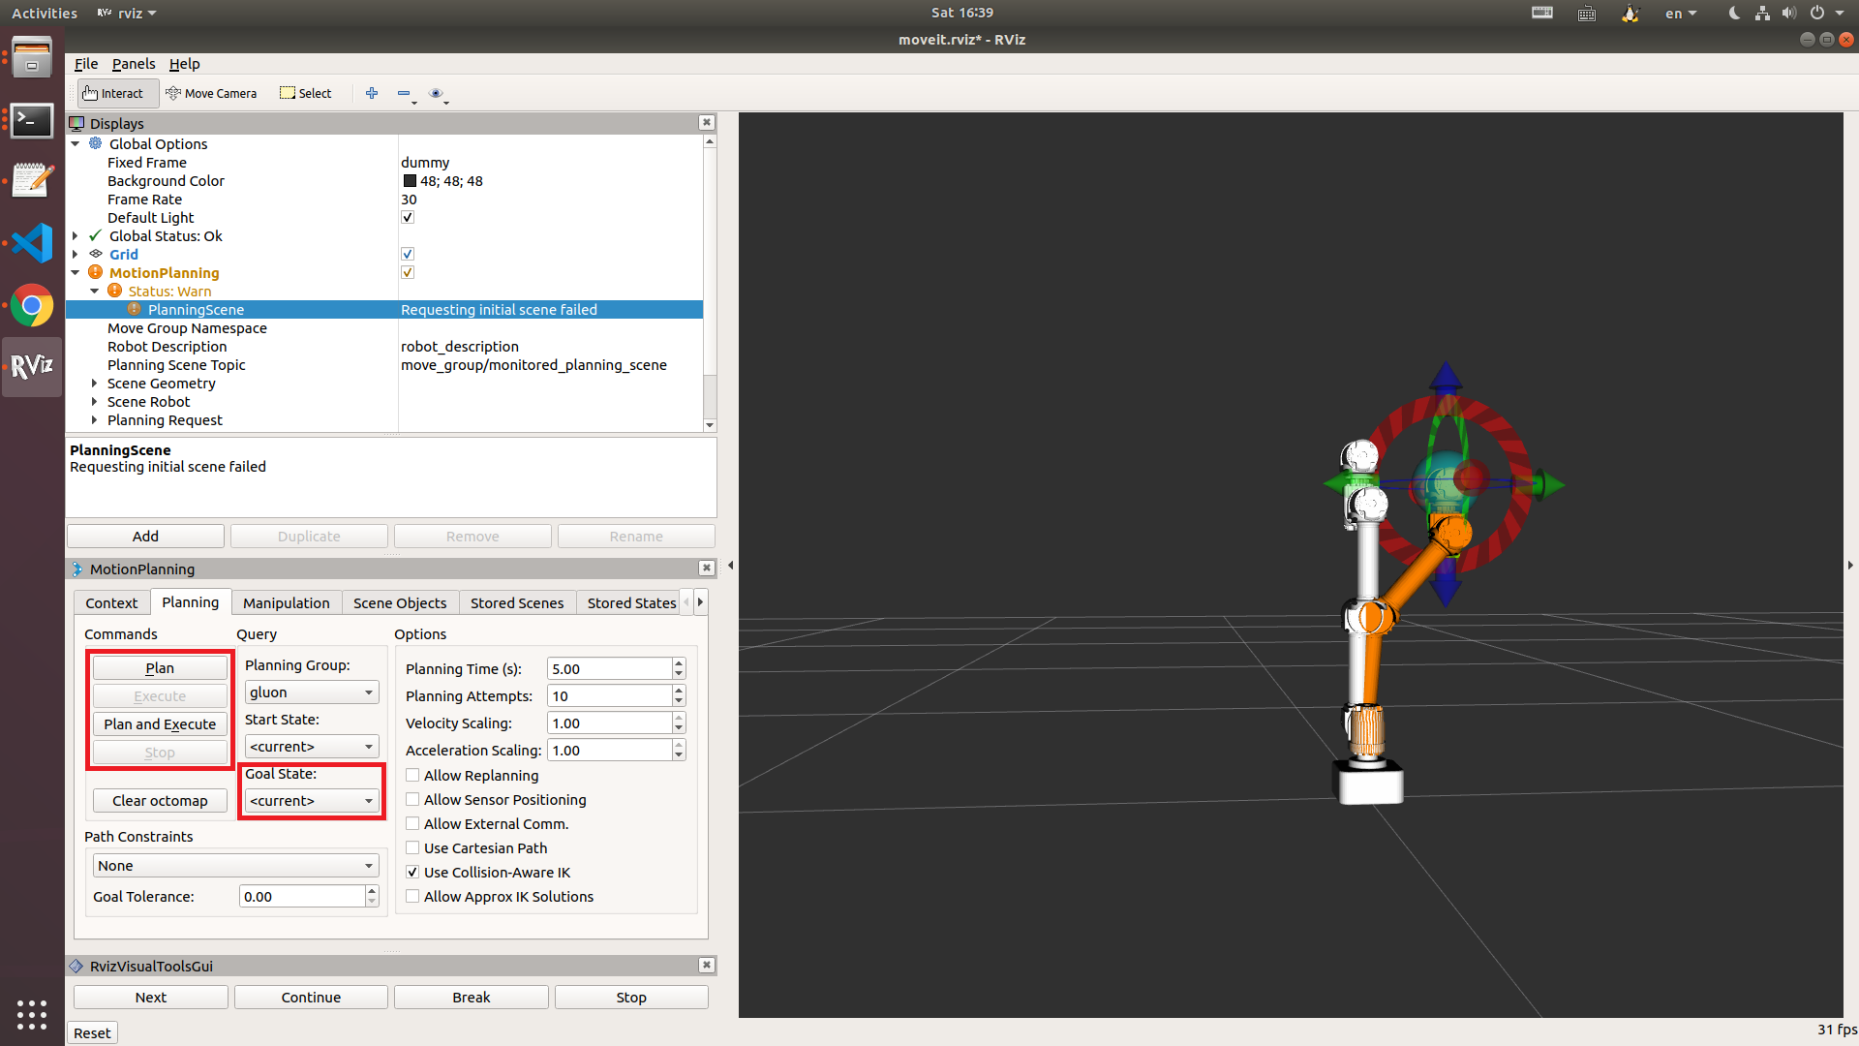

图-2

#### 2.5.4 Moveit 教程实例

roslaunch moveit_tutorials move_group_interface_tutorial.launch

需要在cm_demo的基础上运行，提供了joint_state space 和 Cartesian 笛卡尔空间路径规划例子

# 3. 常见问题

## 3.1 curl not found



解决方案：

sudo apt install curl



## 3.2 catkin_make 找不到

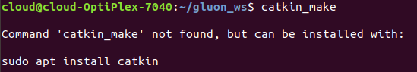

解决方案：

首先检查是否正确安装ros melodic，其次检查是否正确配置source 环境变量至.bashrc 或执行了相关source操作，如果前两步已经操作请尝试重启Terminal 终端窗口

## 3.3 编译时常见错误

#### 3.3.1 Could NOT find ros-control-boilerplate

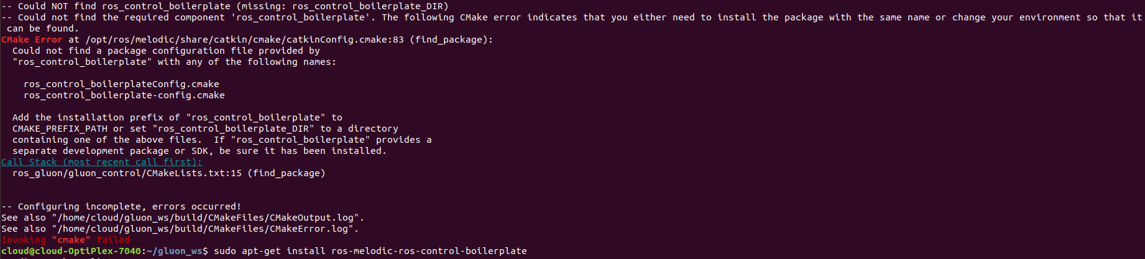

解决方案：

sudo apt-get install ros-melodic-ros-control-boilerplate

#### 3.3.2 Could NOT find moveit_core

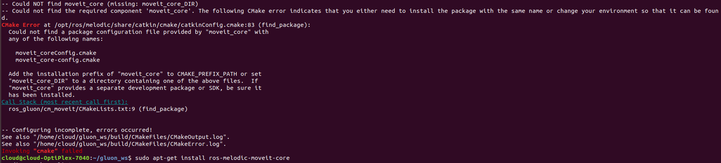

解决方案：

sudo apt-get install ros-melodic-moveit-core

#### 3.3.3 Could NOT find moveit_visual_tools

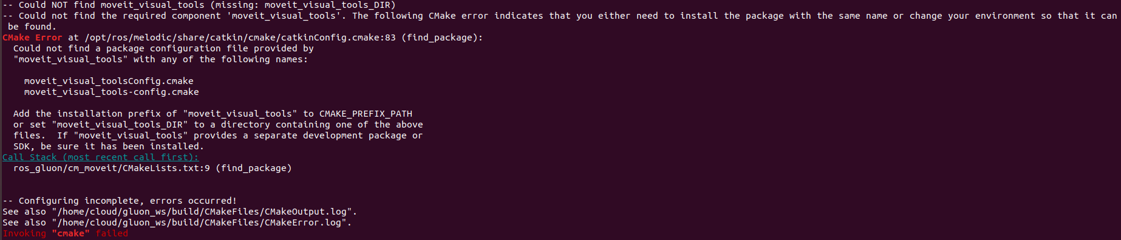

解决方案：

sudo apt-get install ros-melodic-moveit-visual-tools

#### 3.3.4 Could NOT find moveit_ros_planning_interface

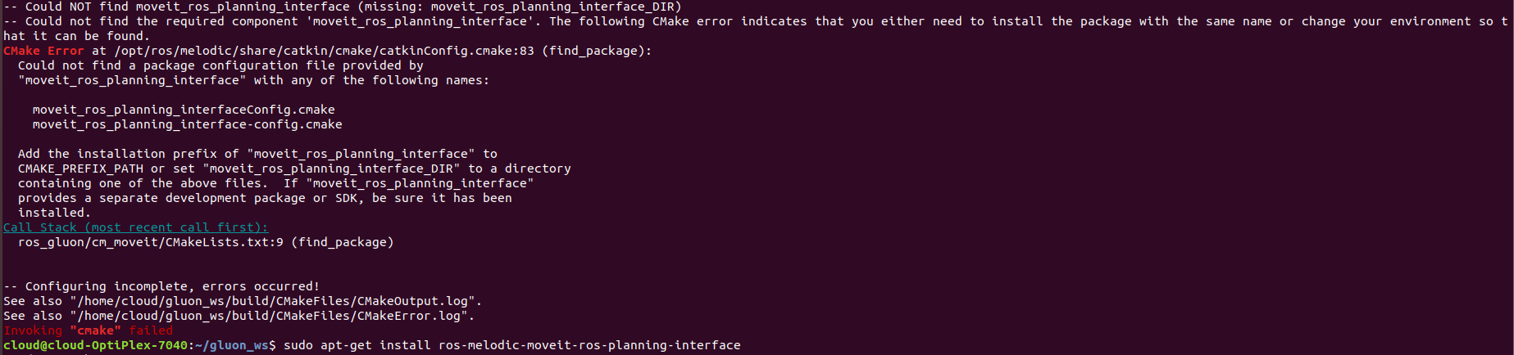

解决方案：

sudo apt-get install ros-melodic-moveit-ros-planning-interface

#### 3.3.5 Could NOT find moveit_ros_perception

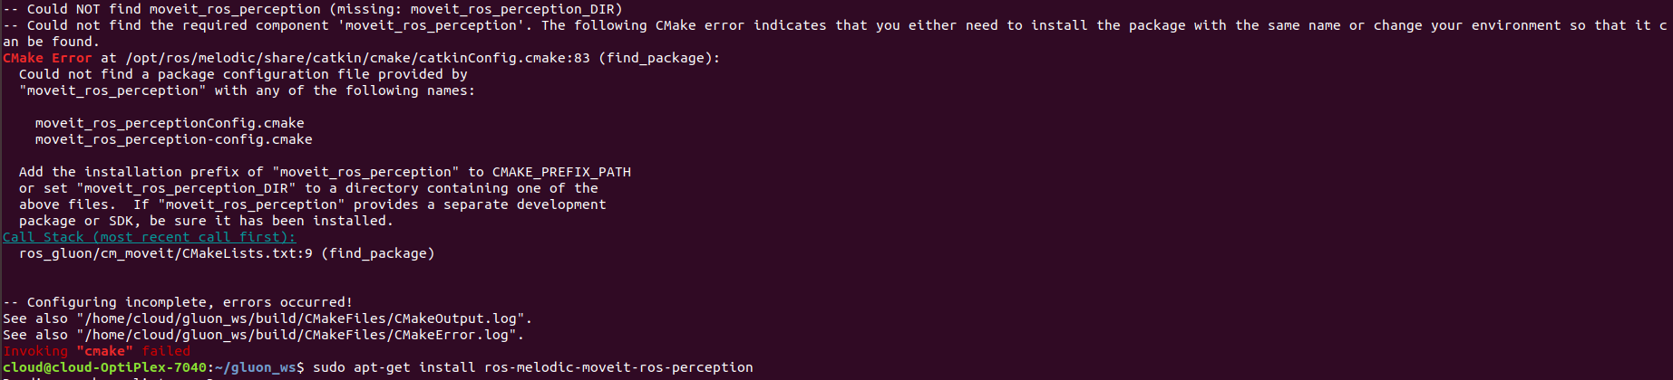

解决方案：

sudo apt-get install ros-melodic-moveit-ros-perception

#### 3.3.6 fatal error: actuatorcontroller.h

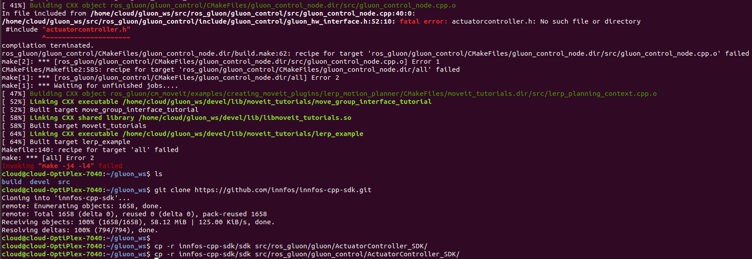

## 3.4 运行时常见错误

#### 3.4.1 Could not find the GUI, install the ‘joint_state_publisher_gui’ package

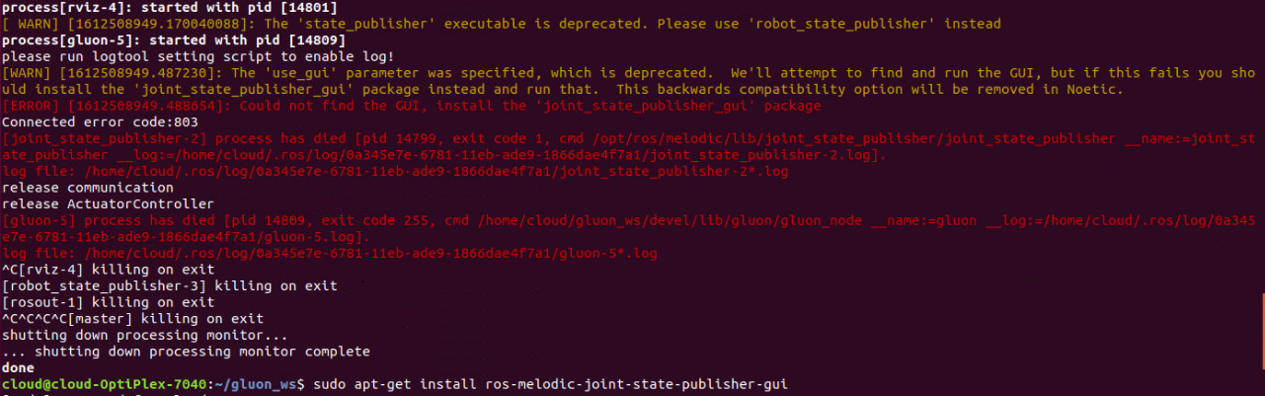

解决方案：

sudo apt-get install ros-melodic-joint-state-publisher-gui

#### 3.4.2 Exception while loading controller manager ‘moveit_simple_controller/MoveItSimpleControllerManager’



解决方案：

sudo apt-get install ros-melodic-moveit-simple-controller-manager

#### 3.4.3 Exception while loading planner ‘ompl_interface/OMPLPlanner’



解决方案：

sudo apt-get install ros-melodic-moveit-planners-ompl

#### 3.4.4 PluginlibFactory: The plugin for class ‘moveit_rviz_plugin/MotionPlanning’ failed to load



解决方案：

sudo apt-get install ros-melodic-moveit-ros-visualization

#### 3.4.5 Connected error code: 803



解决方案：

这个错误是未检测到EZB，请检查是否正确连接机械臂及EZB至PC