**Usecase Diagram for Online Shopping System**

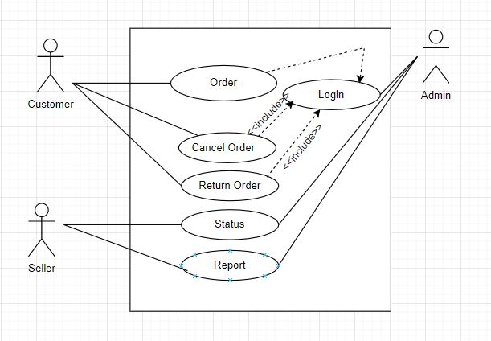

**Sequence Diagram for Online Shopping System**

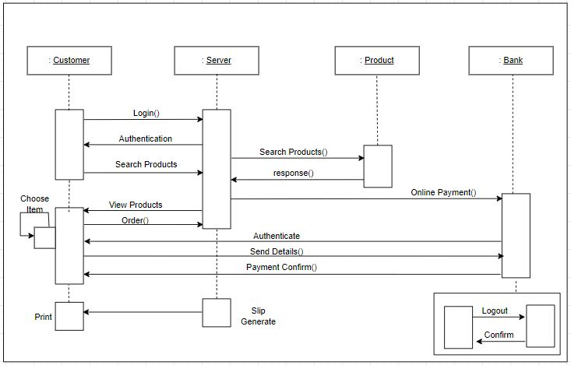

**Activity Diagram for Online Shopping System**

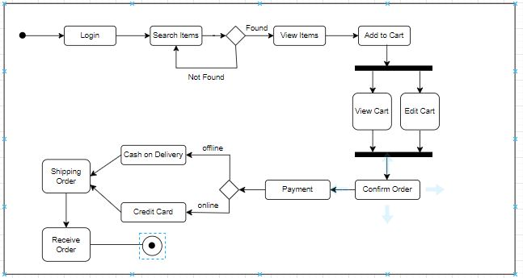

**Class Diagram for Online Shopping System**

