Flu Forecasting Project DRAFT
Each year, influenza epidemics result in significant morbidity, mortality, and cause adverse effects to the economy. Predicting annual influenza outbreaks can prepare jurisdictions to reduce detrimental outcomes through targeted vaccinations, health care preparations, and other programs to reduce exposure. Since probability of exposure among individuals is enhanced through increased human density, we used incidence data from the Southern hemisphere during the winter to predict future influenza rates in the Northern hemisphere. The model predicted a 30\% increase in the winter of 2025 in North America which closely tracked actual incidence. We maintain models populated with data from other jurisdictions can be useful to predict relative incidence and be used to more effectively allocate resources from which to protect public health.

Introduction
Annual influenza outbreaks cause considerable morbidity, mortality, and economic effects. There is also widespread concern amongst public health professionals regarding the deadly potential of a future influenza pandemic (Doshi 2008). Pathogenic airborne viruses increase transmission proportionally within higher areas of human density. Such increases occur annually during winter in temperate regions when people spend greater time indoors (Simonsen 1999). Tempo-spatial patterns can be useful in predicting influenza outbreaks (Onozuka and Akihito 2008, Shaman and Karspeck 2012) and can be used in modeling approaches to better prepare certain jurisdictions to focus public health resources.
Long range influenza forecasts are scarce due to the high variability of the influenza season year-to-year. The current state-of-the-art models provided by the CDC (FluSight 2025) are done using an ensemble that predict 1-4 weeks influenza hospitalization rates. Their work is mostly motivated to aid hospitals in preparation for potentially overwhelming flux of patients. (Blurb about long range and machine learning) There have been some work to explore machine learning as a method of determining influenza rates (Li, Jiang, & Huang 2021, Huang et al 2025) utilizing deep learning techniques, but generally are not focused on the U.S. and although show promise, leave significant room for improvement. We explore deep learning further in this paper with an emphasis on longer horizon forecasts than typically seen in the literature. Longer forecasts can be beneficial for the pharmaceutical manufacturers who need to scale production months in advance and can be hesitant to make a surplus of products that will go unsold.
The strength of an influenza outbreak can be dependent on a variety of factors such as the dominant strain(s) of the virus H(i)N(j), vaccination efficacy and adherence, timing of close human activity etc. Vaccine efficacy relies on the CDC's ability to predict the dominant viral strains likely to infect humans. Vaccines are created by analyzing the current dominant strains effecting humans around the globe to select “candidate vaccine viruses” (CVVs) to include in the new vaccine formulation where the mutation behaviors are studied. Vaccine efficacy varies year-to-year but has had a relatively small variance in the past 10 years with a 36(9)% estimated reduction in infection (CDC Seasonal Flu Vaccine Effectiveness Studies 2025). Rather than studying the viral mutations, which has already shown to be very challenging as evident by vaccine efficacy never exceeding 50%, we propose countries in the southern hemisphere can act as confounding variables where the necessary viral properties and human behavior are hidden and manifest themselves in each country's respective severity rate.
This work aims to push the flu modeling forecasting range to approximately half of year while naturally sacrificing some week-to-week accuracy. We first present a subset of countries whose influenza rates may be heavily related to the U.S. Following a proper “candidate" determination and preprocessing of the data, we propose model architectures built from Recurrent Neural Networks (RNNs), that can learn complex temporal and cross relationships of the data to forecast the U.S. season. Following model declaration, we explain the model tuning process, how we aggregate and filter the results, and ultimately compare influenza forecasts for the 23-24 and 24-25 seasons.
Southern Hemisphere Countries (Input Data)
It is well known that the southern and northern hemispheres experience winters approximately half a year apart. This half year phase difference can provide insight into how severe we expect the following season to be in the U.S., provided the virus has not mutated in a significant way. Given the ease people travel the globe, and the popularity the U.S. is as a travel destination, we assume the viral strains dominating the infections in the southern hemisphere will be related to the strains dominating the northern hemisphere and are not isolated in a way that would cause significant deviations in strains. Using multiple countries also offers the opportunity to capture potential variation from strain divergence through the antigenic drift.
A country's size and latitude will generally dictate the significance of season change making some countries more sensitive to flu-seasons than others. It is also necessary to include locations that sample different latitudinal regions to effectively increase our sample size and potentially capture as many sub-strains as possible. We select a list of relevant “candidates” by borrowing influenza records from the W.H.O. (cite) and compute their lagged correlations with the U.S. hospitalizations records given by the CDC (specifically this is the Flu-Surv dataset which represents ~10% of the population). Specifically, we compute
$$C_{α}\left(δt\right)=\frac{\sum_{t}{\left(x_{t}^{US}-\overline{x^{US}}\right)\left(x_{t-δt}^{α}-\overline{x^{α}}\right)}}{\sqrt{\sum_{t}{\left(x_{t}^{US}-\overline{x^{US}}\right)\sum_{t}{\left(x_{t-δt}^{α}-\overline{x^{α}}\right)}}}}$$
where $x_{t}^{α}$ represents the number of positive documented cases for country $α$ on week t and $\overline{x}$ denotes the mean. A peak in the correlation function signals that corresponding country has a prominent flu season like the U.S. The height of the peak corresponds to how similar the flu seasons have been in the corresponding time-window and how potentially predictive it can be of the U.S. season. We find Australia, Chile, Paraguay, Argentina, and Uraguay have the clearest peaks in the period 2013-2022, and we show their correlations in Figure CORRS. These countries have clear peaks for $δt∈\left[20,35\right]$ making them suitable for our half-year horizon goal.
It is evident in Figure CASES that there exists no single candidate or obvious linear combination of the candidates that could represent the U.S. hospitalizations, however we do observe some general relative scaling of peak heights and the target. We will explore potential non-linear relationships as solutions via tuning a neural network for each consecutive season.
Models
- Architecture
RNNs (Recurrent Neural Networks) were once the state of the art for sequence learning, commonly applied in time-series forecasting and text sequence generation (find some citations). In recent years, they have lost popularity with the emergence of transformer models (citation), due to transformers superiority in learning long-range sequences. They can do so via the attention mechanism which generally requires many parameters and significant amount of data to train to be effective. RNNs can still be preferable for smaller datasets where they are inexpensive to train, and temporal dependencies are shorter.
We employ RNNs not only due to their computational efficiency, but to utilize their feedback connections that enable them to learn sequences of data where ordering is important. These have the advantage of not needing a parametric description to capture the seasonality, which can be challenging for weekly inputs where the week start date and month start date do not coincide. Using weekly data has an advantage over monthly by increasing the sample size, and it is a more natural stratum of influenza records given the rapid change in the season, and the data provided. The input features the 5 southern countries in batches of 26-week sequences shifted by 21 weeks making the input tensor of shape ${[T}_{window},26,5]$ where $T_{window}$ is the total weeks included in the fitting procedure. The influenza rates $i_{α}\left(t\right)$
are all normalized such that $\min\left(i_{α}\left(t\right)\right)=0$ and $\max\left(i_{α}\left(t\right)\right)=1$ in the training set to normalize all countries to the same scale as well as improving convergence of the loss function minimization as RNNs, which are well known to suffer from vanishing gradients.
The model architecture can be separated into a recurrent block and a sequential portion visually depicted in Figure ARCH. The recurrent piece features a single or two RNNs with a linear layer acting as a feature transformation in between. This general architecture has been used in original encoder-decoder text sequence generation techniques where the first RNN acts to capture the semantic meaning of the sentence, the linear layer transforms this semantic representation, and the second RNN is used to predict the next word. We borrow this technique to apply to weekly influenza rates where the first RNN captures the behavior the Southern Hemisphere flu behavior, linear layer transforms into a new representation where the second RNN can than apply to predict the United States flu behavior. We make use of three flavors of RNNs by including Gated Rectangular Units (GRUs) and Long Short Term Models (LSTMs) to add additional variability to our model construction in an effort to not bias our forecast via a single model prediction, and gauge the importance of long-range temporal dependencies. The sequential layers are used in dimensionality reduction with the hope they capture the remaining inter-country relationships via linear layers, RELUs and drop out layers when multiple linear layers are used. The various layer archetypes are illustrated in Figure \ref{loop}.
We omit seasons 20-21 and 21-22 due to the damaging effect Covid-19 had on the seasonality. The input during that period were masked to zero to not damage the continuity of the dataset, but we acknowledge we could have just as easily removed that period entirely from training.
We attempt to predict an entire season from historical data, so we find it natural to use a full season as validation when training the model to minimize the inevitable overfitting that neural networks are guilty of. The utility of having a full season as validation will be evident in the following section where we utilize select observables in our modified loss function.
- Training
We used a mean squared error as the loss function for back-propagation, however invented a slight hybrid to the conventional mean squared error function to evaluate the validation set for terminating the minimization. Our validation metric is the following
$$MSE^{adj}={\left(y_{val}^{max}-y_{val}^{pred,max}\right)}^{2}+α^{2}\left({\left(t_{val}^{max}-t_{val}^{pred,max}\right)}^{2}+MSE_{train}\right)$$
where $y^{max}$ is the peak height, $t^{max}$ is the peak location, and the $MSE_{train}$ is the conventional mean squared error of the training set. This metric ensures the loss function is not totally penalized for not capturing the exact week-to-week behavior but can still capture maximum weekly rate and location. The training mean squared error is included to ensure the model sufficiently represents the training set, but is suppressed by a factor of $α=0.1$ so that the peak height is still the dominant feature when searching for a minima or plateau in the training curve. We suppress the peak location difference as well to keep it on the same relative scale as the peak height.
We found $MSE^{adj}∼0.2$ adequately described the validation peaks while simultaneously allowing the model to describe the training set. The accepted model variations with $\min\left(MSE^{adj}\right)≤0.2$ are displayed in Figure \ref{fig:full}. These models capture the peak height and location but possess spurious movement outside of the flu season and we remove these from the final forecasts.
- Aggregation
A naive weekly average of the model variation will produce a poor description of the data due to the seasonality. Any small phase difference of two, otherwise completely equivalent descriptions, would wash away the peak behavior. One must first capture the phase differences and shift accordingly, or alternatively find a parametric description to describe the season. A parametric solution for describing U.S. flu seasons is the following sum of renormalized hybrid Lorentzian distribution
$$L\left(t\right)=\sum_{i}^{2}{L_{i}\left(t\right)=\sum_{i}^{2}{A_{i}\frac{{\left(\frac{Γ_{i}}{2}\right)}^{2}}{{\left(t-t_{i}\right)}^{2}+{\left(\frac{Γ_{i}}{2}\right)}^{2}}}}$$
where $A_{i}$is the peak height, $t_{i}$ peak location, and $Γ_{i}$ is the half width. A typical Lorentzian has a defined normalization that we have removed to control the height. All three of the parameters can be computed for each model and their averages and standard deviations can be used to estimate the parameterization variance.
Each season appears to have one or two-pronounced peaks meaning we can reduce the -~30-week flu severity rates to three or six parameters. We demonstrate this relationship in Figure \ref{fig:peakfits} where we have used two peak models to fit each season in the past 10 years with mean absolute percentage error varying from 1.6% to 4.0%. Given that a bimodal Lorentzian can describe a general U.S. flu season, we aim to fix the parameters from the results of the neural networks.
Utilizing the results of our model ensemble, we can transform the forecasts into single-peaked Lorentzian by taking their height, location, and widths. We approximate the flu season as monomodal given that our training algorithm only allowed for sensitivity to a single peak height. Although many seasons have two distinct peaks, in practice we find a single peak can still describe the overall number of cases, as well as the maximum case rate and location, which are arguably the three most important observables. Using the models to gather the three parameters required for a Lorentzian distribution, we can compute the parameter uncertainties given the model variabilities and produce a single mean forecast with an uncertainty band.
Upon examination of the raw model outputs, it appears the validation curves consistently produce widths significantly larger than the target. To compensate for the larger widths, we use the validation season to scale the width of our forecasted season via the following weighted sum
$$Γ_{model}/Γ_{adj}=\frac{μ_{1}Γ_{1}}{μ_{1}+μ_{2}}+\frac{μ_{2}Γ_{2}}{μ_{1}+μ_{2}}$$
where $μ_{i}=\sum_{t}{L_{i}\left(t\right)}$ refers to the partial sum of the i^{th} peak. The weighted sum is used because we are scaling a single peak via two peaks’ widths. We can capture the contribution of both peaks’ widths into a weighted average and then rescale the validation width accordingly.
Results
After repeating the process outlined in the previous section for both seasons ’23-’24 and ’24-’25 we produce two distinct forecasts. For the ’23-’24 season, we forecasted a total case count of 314.7K(742) with a maximum case rate of 44.1K(48) compared to the Flu-Surv documented total case count 378.7K and maximum case rate 42.2K. For the ’24-’25 season, we forecasted a total case count of 480.6K(1153) with a maximum case rate of 65.7K(104) compared to the Flu-Surv documented total case count 611.8K and maximum case rate 64.7K. When limiting our model choices to only those with multiple linear layers in the sequential piece, we find no significant change in the ’23-’24 with total case count 292.0K(761) and max case rate 42.2K(42), but a significant narrowing in uncertainty for the ’24-’25 season with a total case count of 535.0K(773) and maximum case rate 67.7K(30). It may be the case that a single linear layer is not sufficient in capturing the correct height of the output, but at this stage we show the results together due to the fact there is no reason a priori to reject the other architectures, and we are limited to only a two-season test set.
We have displayed these results in Figure SUM, where both seasons had compatible peak height predictions as well as total case counts although perhaps slightly underpredicting the latter. A shallow estimation of the total case count is not necessarily surprising, given that we have largely ignored the second peak dependance on the total season outside our reweighting factor.
We were unsuccessful in reliably forecasting the maximum rate week as seen in Figure RESULTS for season ’24-’25. This is not terribly unsurprising because there exists no obvious relationship, quantitative or anecdotal, between the timing of maximum influenza rates between the southern hemisphere and the U.S. There can be many differences including the timing of Thanksgiving and winter holidays which provide opportunities for viral transfer unique to the U.S. Given our model training algorithm, it appears the maximum rate week is generally determined via the previous year’s validation season. This would explain why season ’23-’24 had the correct peak location because the ’22-’23 season had a similar peak location, as compared to the ’24-’25 season where the maximum rate weeks were ~7 weeks apart.
Conclusion
This work describes a promising algorithm for long-range estimation of influenza hospitalizations that reliably estimated the total case count as well as the maximum case rate for both test seasons. Specifically, we have demonstrated a procedure for extracting relevant country influenza rate data as input into a forecasting model. We have proposed multiple neural network architectures and a tuning/training process for producing raw forecasts. We have also demonstrated how to reduce the U.S. influenza season dimensionality to three or six parameters, and how to transform the model forecasts into a single-peak approximation of the season where we can predict the total case count, maximum case rate, and (in principle) maximum case rate location.
Future work will require finding sensitivity to the second peak of the flu season to produce a comprehensive prediction, as well as exploring how to determine the peak locations and separation length. As vaccine skepticism increases in the U.S. combined with current administration’s changes to vaccine creation, we will need to explore building in vaccine efficacy and adherence into our model.
We would like to thank W.H.O for providing publicly available respitaory illness data
We would like to thank CDC and the Flu-Surv project blahblahbla

Centers for Disease Control and Prevention. (2025). Forecasts of Hospital Admissions - FluSight: https://www.cdc.gov/flu-forecasting/data-vis/current-week.html
Centers for Disease Control and Prevention. (2025). Laboratory-confirmed influenza-associated hospitalizations among children and adults—FluSurv-NET, United States, 2010–2025. MMWR Surveillance Summaries, 73(6).
Centers for Disease Control and Prevention. (2025). CDC Seasonal Flu Vaccine Effectiveness Studies: https://www.cdc.gov/flu-vaccines-work/php/effectiveness-studies/index.html

Li, L., Jiang, Y., & Huang, B. (2021). Long-term prediction for temporal propagation of seasonal influenza using Transformer-based model. Journal of Biomedical Informatics, 122, 103894. doi:10.1016/j.jbi.2021.103894.
Huang et al (2025). "ChatGPT-Assisted Deep Learning Models for Influenza-Like Illness Prediction in Mainland China: Time Series Analysis Using Transformer-based model", Journal of Medical Internet Research, 2025, vol. 27, article e74423, with the DOI: 10.2196/74423.
James Turtle, Michal Ben-Nun, Pete Riley (2024). “Enhancing seasonal influenza projections: A mechanistic metapopulation model for long-term scenario planning
“. DOI: https://doi.org/10.1016/j.epidem.2024.100758

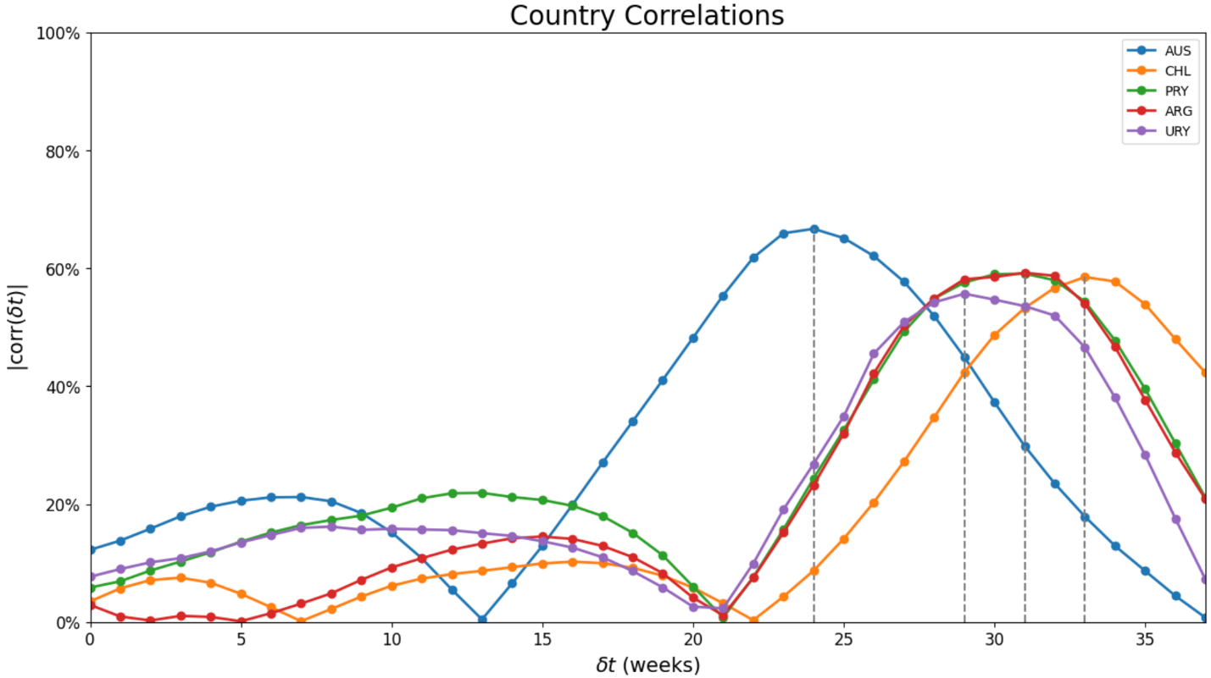
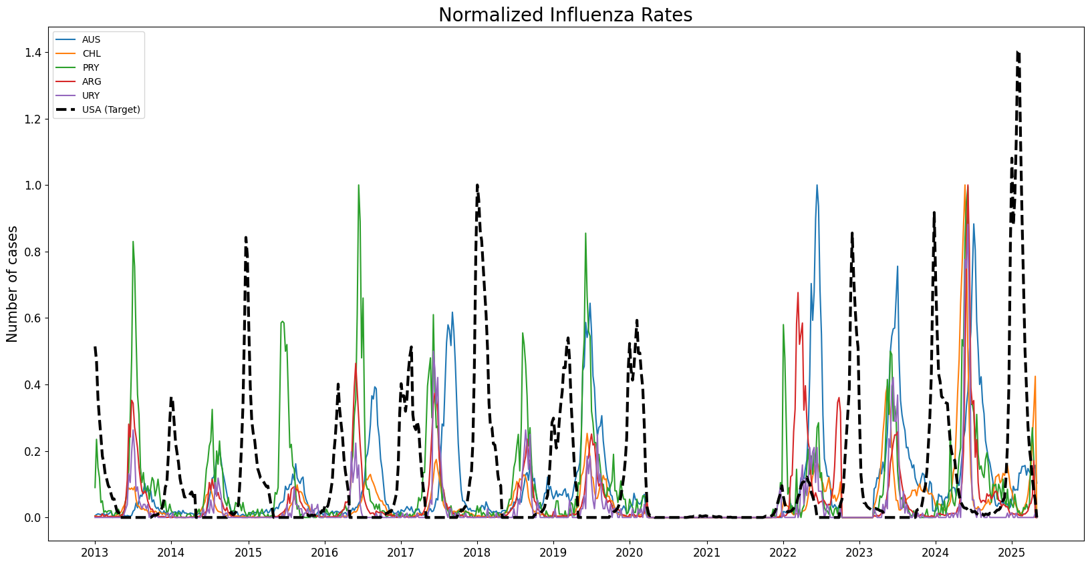
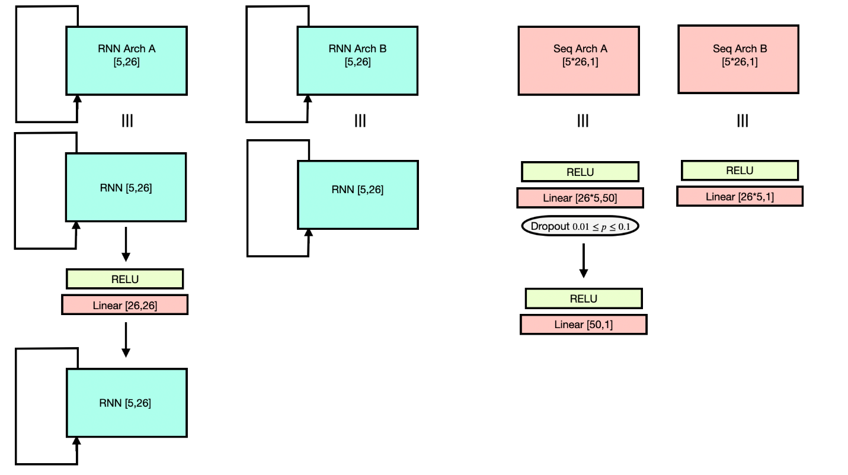

We could just as well have used WHO data as the target as well, but CDC hospitalizations were chosen to avoid bias from having the entire project built on a single data source

