*Journal of Wildlife Management* 26 January 2023

Dear Dr. Paul R. Krausman

On behalf of my co-authors, I am pleased to resubmit the manuscript *Unsecured attractants, collisions, and high mortality strain coexistence between grizzly bears and people in the Elk Valley, southeast British Columbia* (previously JWM-22-0315) for your consideration for publication as a Research Article in the Journal of Wildlife Management.

Thank you for the time that you and the two reviewers invested in our work. We were pleased to see that the manuscript was well received by reviewer 1, and we believe that we have been successful in addressing the suggestions and concerns raised by both reviewers.

We provide detailed responses to each reviewer comment below which generally fall into the following categories:

1. Novelty and utility of current paper compared to past work
2. Analytical approaches, especially relating to grouping of ages, open vs closed spatial capture recapture models, timing of cub surveys, and unreported mortality.
3. Minor phrasing/typological edits.

We believe the comments and suggestions from the reviewers helped us refine the manuscript and provide clearer and better evidenced arguments. The manuscript has improved because of the helpful comments from editors and reviewers, thank you.

Sincerely,

Clayton T. Lamb, PhD

Wildlife Science Center—Biodiversity Pathways

University of British Columbia

We respond to the helpful comments from reviewers below in the following format:

Reviewer comment

* Our response

**Associate Editor**

Comments to the Author:  
(There are no comments.)  
  
------  
**Reviewer: 1**  
  
Comments to the Author  
My comments are attached in the pdf file as comment bubbles.

*Comments pasted in from comment bubbles:*

L65: Could use something more timely for an estimate

* Agreed, we have now added a 2021 citation and updated the population estimate from >750 to >1000 to reflect the information in this updated citation

L239: Does this include bears killed by COs as part of conflict management? It seems that all of these would be reported and represent a bias in this approach. If so, then you may want to drop these known management removals from the calculation.

* Yes, to account for this we broke out the conflict-COS mortalities from the non-COS mortalities in table 1. The COS kills are legitimate sources of mortality, are always reported, and thus to influence to overall reporting rate. Keeping COS mortalities in the overall estimate was important to get a population-level estimate, but we separated out COS kills (as well as others such as road/rail or hunter) to provide estimates by source, which confirms the reviewers thoughts the COS have high reporting rates.

L396: It seems odd to me that if you remove two bears that apparently reproduced as 9 year olds and then the mean went up?

* Those two were captured at 9 without cubs. So their addition means two more bears in each age class that don’t produce cubs before 9 due to imputing past years as per (Garshelis et al. 2005) method. But we are not confident that they had not already had cubs, say between 6-8, and then we caught them at 9 once their cubs had dispersed. The rest of the bears we monitored before 9 and were more confident that they either had not already had cubs, or at least had not taken a litter cubs through multiple years (they could have had cubs that were killed before we caught them).

L417: Ages of these bears? Subdults or adults. Subadults might represent dispersal, but if adults, they represent some other phenomena.

* Added subadult into the sentence. Two were <3 and one was not know but was dead here before he reached adulthood.

L504: How does a train hitting a bear result in a loss to the railroad except possibly in their image?

* Good point, rephrased to be specifically about passenger vehicles.

L522: Are resident adult females actually successful at teaching their young? The mortality data for young bears would not suggest they are successful.

* This is part of the unknown to us. Given the high survival of adult females it seems to make sense that local mothers should produce better offspring than offsite mothers less adept to teach skills for this area. We aren’t often able to track the dead subadults back to whether their mother was local or not, or if they dispersed in.

L555: While the population may not be self-sustaining, your evidence suggests it is stable. If you reduce these mortality sources, the population should approach self sustaining but then begin to increase because of continued immigration. Is there a desire for more bears in the area from either the public or as a management goal??? Emphasize the reduction to human injury risk and reduced property damage? Possibly some estimates of the dollar values associated with property damage and human injury particularly with auto crashes on highways. Structures to get bears across highways will also reduce ungulate collisions which probably are the major source of damage and injury.

* Good point, we have added a piece on reducing human injury and property damage,
* I think immigration would reduce as the population becomes self sustaining. Assuming some level of density-dependent immigration, as the population is left with fewer availabilities from mortality, immigration should decrease.
* There is not a desire for more bears, just better levels of coexistence which is where the attractant management and collision reduction should come in. As well as keeping “better” bears around might help.
* Unfortunately we don’t have any data on the dollar values associated with conflicts like other jurisdictions (Karamanlidis et al. 2011, Morehouse et al. 2018) have. This is partly due to a lack of government compensation for damages, which are instead covered by the landowners, meaning no formal database of costs exist. There would be a moderate cost to collide with a few bears a year on the highway but the cost would be low <100K/yr.
* Also, part of the injury is just people getting attacked.

L556: Might it be more thoughtful to put people ahead of bears in this sentence if you want people to change their ways? It could be construed as bears are more important than people and that is not the way to engage people that live in bear country.

"safety of people and bears".......

* Great point, switched this around. Thanks.

------

**Reviewer: 2**

Comments to the Author  
This manuscript describes characteristics and dynamics of a subpopulation of grizzly bears in the Elk Valley, British Columbia.  The study centers on a human-dominated valley bottom and involves documenting human-caused mortality and source-sink dynamics.  I find the manuscript to be a bit unfocused and I am not completely sure of its overall goal or importance.  
  
Scientifically, the manuscript is highly repetitive of subject matter previously reported in two previous studies: Lamb et al. 2017 and Lamb et al. 2020.  Lamb et al. (2020) conducted analyses on intrinsic growth versus immigration on a much larger spatial scale, and the current study replicates that same general approach, but in a more confined area.  The Lamb et al. (2020) study included the Elk Valley and made use of many of the same data used in this current manuscript (according to the supplementary materials). Major finding from Lamb et al. (2020) included the following:  
-In human-dominated landscapes, “bear persistence was reliant on a supply of immigrants.”  
-“Compared to adults, subadults faced 7.5X higher mortality risk in the highest human-dominated areas where bears occur.”   
-“Humans were the dominant cause of mortality for bears” and in areas with highest human influence, collisions and conflict were the primary causes.  
Using DNA-based methods, Lamb et al. (2017) studied demographic characteristics and movements in the Elk Valley and surrounding areas.  Major findings included the following:  
-“We detected a net flow of bears into” the Valley.  
-“Bears occupying the [Valley] faced 17% lower apparent survival” than bears in surrounding areas.   
  
The primary finding from this current study was:  
-“Using a stable observed population growth rate of 1.01, and the intrinsic population growth rate calculated above from radiocollared animals [0.94], we estimated the viability of grizzly bears in the Elk Valley is subsidized through immigration which annually adds 6.9% (90% CI: 0-15) of the population, or ~7 bears, into the study area to maintain stable abundance” (lines 412-416).  
Generally speaking, this key result is the same as those from previous studies, with perhaps the added specificity of estimating that annually “6.9% of the population or ~7 bears” subsidized the Elk Valley population to provide stability.  While I do not doubt the overall conclusion that the number of bears in this human-dominated landscape is likely sustained by immigration, are these specific values worthy of another publication?  As sample sizes within this study area were more limited, how reliable are these specific values?  How does knowledge of these specific values help with management or reduction of human-caused mortality?  
  
The following other findings from the current study are also reminiscent of the previous studies:    
-The cause of death for fourteen animals with a functioning collar was human-wildlife conflict (n=6), road or rail collision (n=6), unknown but human suspected (n=1), and natural (n=1).  
-Subadult survival was the lowest recorded in North America, while adult survival was similar to other studies, suggesting an intense demographic filter for young animals.  
  
And finally, the following result from the current study is somewhat unique, but unexplored and disconnected from the rest of the analyses.   
-We estimate that human-caused mortality is underreported in government databases by 65%, or for every recorded mortality there are ~2 that go unreported. Reporting was especially low for road and rail mortalities.  
-Grizzly bear mortality in the Elk Valley due to collisions and conflicts with people is an order of magnitude greater than elsewhere in British Columbia.  
  
The stated rationale for the current study is that the previous Elk Valley study (Lamb et al. 2017) relied on DNA capture-recapture data, therefore “the specific demographic mechanisms facilitating persistence remained hazy” (lines 97–98).  However, given that the Elk Valley vital rates and capture-recapture data were included in the large-scale study (Lamb et al. 2020), is this true?  If this study was independent from the previous work, I would recognize it as confirmatory and highly valuable.  As it is not independent from the previous work, isn’t this a case of “double publishing”?  
  
Overall, I am not inclined to recommend publication unless the authors are able to provide a cogent argument for why this manuscript is needed and a better description of how it adds to our understanding of the spatial impacts of human-caused mortality and source-sink dynamics beyond what was provided from work.

* The reviewer is knowledgeable about the past work and is correct in highlighting the similarities, but we don’t believe these preclude publication. We attempt to detail some of the advances of this particular paper, while acknowledging where the Venn diagram of each of these papers has overlap, and where they differ.
* Compared to (Lamb et al. 2017) we use more detailed demographic data (collared individuals with known fates and reproduction, as opposed to DNA data), include conflict and mortality data, estimate underreporting, and explicitly estimate the numeric impact, in individuals, of the source-sink dynamic. This paper directly builds on Lamb et al. 2017 but is much more detailed, data rich, and includes many more actionable outcomes for managers that are supported by data types they are more familiar and comfortable with (collars vs DNA data/apparent survival).
* Compared to (Lamb et al. 2020) this work is more mechanistic and actionable at a local scale. Lamb et al 2020 was a high-level overview of the issue with few details for managers to act on, nor locale specific information. For the Elk Valley we also used only about half the demographic data we used here, didn't calculate additional demographic indices like parturition, underreporting by source, or get into how mortality varies spatially by source and type. Here we use DNA data to get observed population growth rates using open population models (N through time) whereas Lamb et al 2020 just used it to calculate N, with no growth rate attached to it via closed population models. We got # of immigrants in Lamb et al 2020 by just *assuming* a population was stable in the 2020 paper, so *immigration rate =1-observed lambda from collars*. Here we leverage hundreds of DNA-marked bears over many years to *prove* the population was stable yet collars provide evidence for declines in the absence of immigration.
* Overall, this paper provides advances in detailed local insights into the mechanisms and consequences of the source-sink dynamic for an area we objectively show is a hotspot for this type of issue. This is a concrete example, building off past work but now bringing in much more detailed information for a “last word” on the issue, at least for this area, based on the immense data available. We believe this work provides a helpful piece of information for managers to direct their attention to this area, action coexistence, and stands as a strong empirical example backed with ample demographic evidence for source-sink dynamics operating for a large carnivore at landscape scale.

Source-sink dynamics:  
Given the complexity of DNA-based open spatial capture-recapture analyses, I find the results are underreported.  A reader has very little to evaluate the result that “Open spatial capture-recapture modelling suggested the abundance of grizzly bears in the Elk Valley study area has been stable 2006-2021 with an observed population growth rate of 1.01 (90% CI: 0.99-1.03).”  In fact, there is no description for how the growth rate was estimated.  Was a linear trend model in your candidate list?  Or was growth over the time frame based on a simple regression on annual density estimates?  Additionally, from Figure 6 (the only source for any annual estimates), a reader could easily conclude a generally positive trend on population size since 2016.  Ball-parking from Figure 6, it looks like the population grew by 35% between 2016 and 2020.  Overall, it appears that the label of “stable” is perhaps a bit overstated.

* In the ‘Estimating demographic parameters’ methods section we state: “We fit two types of SCR models to these data: 1) closed models which estimated density for each year using the ‘secr’ package, and 2) open models which estimated population trend by following individuals entering and leaving the population across years using the ‘openCR’ package.”
* The reviewer is confusing closed vs open models. Open models explicitly estimate population trend by tracking individuals across primary sessions (years) and thus there is no need to estimate density and fit a linear trend. To further clarify this we have cited the packages explicitly and double checked that we are clear on the distinction between the open and closed models in text.
* We are confident in the label of stable and disagree with the reviewer that it is overstated. We provide compelling and robust evidence (growth rate of 1.01 (90% CI: 0.99-1.03)) using data from 1,462 genetic detections of 291 individual grizzly bears using well-established methods for estimating population growth (open capture recapture, (Pradel 1996, Nichols and Hines 2002)) made even more robust by new spatial-recapture parameterizations (open spatial capture recapture (Efford and Schofield 2020, Eﬀord 2022)).

The manuscript states that annual reproduction “was estimated as the total number of cubs of the year observed with collared females of each age class divided by the total number of collared females monitored in each age class (Garshelis et al. 2005) (line 184–186).  It also states that “capture effort was concentrated…in the fall” (lines 319–320). And finally, it states that the Leslie matrix included “demographic transitions for animals 0–27 years old...with age-class specific vital rates” (lines 192–194).  So, if the cub age class is included in the matrix, and an annual cub survival rate is applied to it, the number of cubs in the matrix (as estimated by the reproductive rate) should reflect the number of cubs at the start of the year.  My question is, were year-of-capture observations excluded from this calculation?  Because if all observations of reproductive status were included in the calculations, including those from the year of capture (often late in the year), then the number of cubs per female is undoubtedly biased low relative to the actual number of cubs at the start of the year.  I cannot find any indication that they were excluded and rough math comparing total years of survival monitoring (n=160), sample sizes of females versus males, and the number of reproductive observations (n=94) suggests they may have been included.  I would recommend that year-of-capture observations be excluded, or if they were, a statement indicating that.  That is the only way that the statement “Females spent 54 animal-years alone…” (line 383) is valid.

* This is a fair comment. We do use cub data from across the active year (April-Nov) and the reviewer is right that this could bias reproduction and cub survival low. The current estimates with all the data are as follows and these can serve as a comparison to our spring-only estimates below: Annual survival of dependent young, 0-1 years old, was 0.73 (90% CI: 0.61-0.83) for both sexes combined…Annual reproduction (female cubs/female/year) by females aged 5-6 was 0.15 (90% CI: 0.00- 0.31), and 0.24 (90% CI: 0.15-0.33) for females over 6 years old.
* To address this we re-ran the analysis using only data collected prior to July (i.e., in the spring from April-June). The results changed as follows: Annual survival of dependent young, 0-1 years old, was 0.80 (90% CI: 0.60-0.93) for both sexes combined…Annual reproduction (female cubs/female/year) by females aged 5-6 was 0 (90% CI: 0.00-0.00), and 0.23 (90% CI: 0.13-0.33) for females over 6 years old.
* In the end there is little effect on lambda, which originally was 0.94 (90% CI: 0.86-1.01), with 93% of bootstrapped estimates <1, and with spring-only data is 0.94 (90% CI 0.86-1.01) with **91**% of bootstrapped estimates <1. The only notable change with this level of rounding is that originally 93% of bootstrapped estimates were <1 and with spring only 91% are <1.
* Due to the lambda results not being sensitive to including all data and not just spring-only, we have opted to keep the analysis as is. The results are the same either way, but we felt it important to include the data that did acknowledge 5- and 6-year-olds can reproduce. We now include a small section in the appendix explaining the lack of sensitivity and report the vital rates for both approaches for transparency and refer to this section within the main text.

While I concede that the cutoff between adult and subadult bears is a matter of interpretation and can vary among studies, I think the cutoff at 6 years in this manuscript is unusually high.  For one thing, it makes direct comparison with other studies (such as in Figure 5) a bit problematic, where cutoffs of 4 or 5 were used.  My bigger concern is the potential impact on the Leslie matrix.  All bears aged 2–6 were pooled into the subadult age class and the resulting survival rates were quite low: 0.60 for males and 0.71 for females.  So, it is no surprise that the estimated growth rate is so low, given that these low survival values are entered into 5 consecutive rows of a Leslie matrix.  I must ask, are the authors really confident that the risk of mortality is this uniformly low across all 5 ages, from 2 to 6?  What were the ages of the observed bears that died?  How much might lambda estimations change if different age class categories were selected?

* We explored this cut off and indeed the 6 year old cut off appears reasonable for both sexes. Survival is low until about 6 years old for each sex (granted also variable due to small sample size randomness in some years such as 4 year old females). To address the reviewers comment, yes, we are confident that survival was low until at least 6 years of age and this is bolstered by 6 year old females having the lowest survival of all age classes.  
  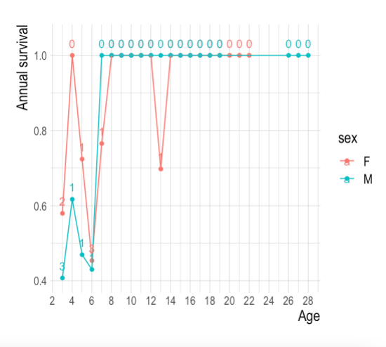

Figure 1. Annual survival for each age and sex estimated as (1-(deaths/years monitored)). The number of deaths observed for each sex and age shown as a number.

Overall, I do not think the results are accurately stated.  The tense of the statements (lines 411–417) and the projection in Figure 6C both confuse what you estimated, which was data from past years.  I would recommend something more like this: “The density of grizzly bears in the Elk Valley study area between 2016 and 2021 averaged 32.0 bears/1,000 km2 (90% CI: 28.9-35.0), or 103 individuals (90% CI: 92.7-112.0).  Calculating the difference in the population trajectories between the observed annual population growth rate of 1.01 and the intrinsic population growth rate of 0.94, we estimated that the resident population must have been supplemented by approximately 6.9% or ~7 immigrants per year.”

* We were explicit in stating what was estimated, but we agree that the tense here was confusing. The reviewers suggested phrasing is much better and we have incorporated it into the manuscript. Thanks!

Unreported mortality:  
I am not completely sure how the estimation of unreported mortality really contributes to this manuscript.  The unreported mortality topic accounts for about ~4.5 pages of the ~14.5 pages of methods/results, but it is not applied in any way to other analyses, and it is barely mentioned in the discussion.  Why did the authors choose to report it?

* The volume that this analysis takes up reflects the difficulty in estimating these parameters and thus our multiple approaches. We think the reason why we chose to investigate, estimate, and report it is as simple as the Peter Drucker quote, “If you can't measure it, you can't manage it.”
* Based on unaccounted differences between apparent survival vs mortality rates estimated in (Lamb et al. 2017) we identified that there must be a fair bit of unreported mortality or emigration going on. So a next step in this work was to identify if mortality was being chronically unreported and, if possible, break it out by source.
* Indeed, unreported mortality is a large source of uncertainty for managers who have to account for upwards of half the mortality not being reported. Updating and validating these estimates is important, as is assessing the rates in different places and by source (i.e., backcountry vs front country, or conflicts vs collisions). A number of folks have looked into these rates in the past and these rates are being used today, 20+ years later in some cases (McLellan et al. 1999, 2018, Cherry et al. 2002). In some cases these unreporting rates are built from fairly small samples (not unlike ours) so adding more data into the arena seems worthwhile. Our results are valid on their own and should one day be helpful in meta analyses.
* We would be remiss to not acknowledge the uncertainty and biases in the data and estimates, thus we applied multiple approaches to provide more robust inference.

Additionally, I have some comments about the three methods.  Although based on a small sample size, the collar fates method is a direct measurement of the variable of interest (i.e., how often human-caused mortalities were reported), unlike the other two methods.  But the authors seem to immediately discredit the method, arguing that the presence of a collar may artificially inflate the true reporting rate.  I simply cannot concur with this unexplained assumption and suggest a valid argument might also be made that the presence of a collar may discourage reporting, for example if a person assumes the mortality will be discovered anyway and would rather stay out of it (whether legal or illegal).  I also wonder how significant any collar effect might be, given the sources of mortality.  For example, we cannot even be sure that the collar is observable during vehicle or train collisions.  And we can assume that reporting of (illegal?) conflict-related kills is relatively low, irrespective of whether or not the bear was collared.  For these reasons, I think the collar method provides the most appropriate measure of reporting rate and I question the need for the other methods.

* It is partly for this reason that we lay out our assumptions and thoughts on possible bias, provide the raw data, and estimate the rates using multiple methods. It allows readers with different perspectives or who don’t agree with us to use the approach they believe is most reliable.

The other methods (CI or ear tag ratio) are, at best, indirect estimates of reporting rate.  And the key ratio used in both methods, namely the ratio of CO removals to other causes of HC mortality within the radio-marked sample, is not an unbiased metric.  First, the probability of being collared is not random or unbased relative to mortality, as bears are targeted for capture due to conflict situations and bears with conflict history generally have low survival.  Thus, this collared sample is a biased sample of the population. Second, the probability of CO-related mortality is unlikely to be independent from the presence of a collar or ear tags, which might signal previous conflict behavior to a CO. This lack of independence within the key ratio means it is a poor population-level metric.

* In general this could be true, but none of the bears captured first by the CO’s were killed while collared, suggesting the targeted captures did not significantly bias our sample.

Finally, I also question the lower reporting rate resulting from inclusion of the CI and eartag ratio methods.  For example, is it realistic to think that 2 out 3 road/rail mortalities of grizzly bears just go unnoticed by anyone (including drivers, transportation department, or wildlife agencies)?

* We think that 2 out of 3 road/rail mortalities going unreported is completely reasonable. The collar only method (the preferred method suggested by the reviewer) corroborates this ratio, with 4 out of 6 road/rail mortalities not being reported. In most cases the bear is not reported because it dies off the right of way. It isn’t necessarily malicious unreporting, just that a bear dies off the right of way and thus is not reported. As a simple example, see the photo below where a dead bear can be seen at the bottom of the photo just barely off the highway. This bear was not reported as a mortality and only known due to the collar.

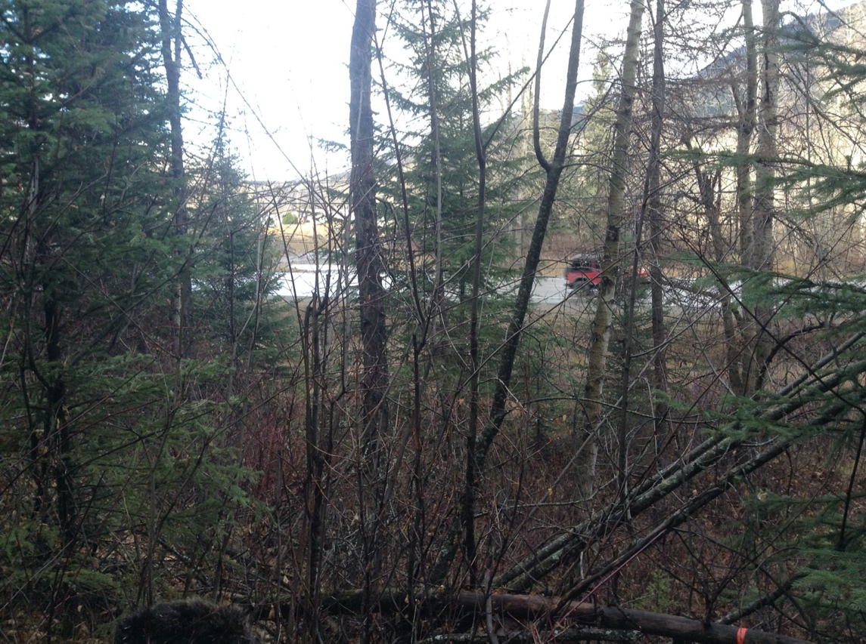

Figure 2. Unreported dead bear killed by collision shown at bottom of photo (dark fur) with highway 20 meters away. Only found due to collar.  
  
Other comments:  
Like stated above, I would encourage the authors to pay closer attention to their tense (sometimes past, sometimes present).  This study is retrospective, so most use of presence tense is inappropriate.   
  
If the Leslie matrix is based only on female rates, and male subadult survival is even lower than females’, then wouldn’t the number of immigrants needed actually be higher?

* Perhaps surprisingly, no. We ran the analysis with males and females through a population projection and got the same answer of ~7 immigrants. This seems to be due to some compensation between lower subadult male survival and higher adult male survival, compared to females. For the sake of simplicity and because the results were the same, we stuck with the female only model.

Line 98: “demographics of individual bears” seems like a contradiction in terms.  Demography involves populations.

* Agreed, this incorrect. We have changed the sentence to read as follows: “Here we sought to understand the demographics of the population by following individual grizzly bears in the Elk Valley, identify what was killing them, determine whether those mortalities were being reported, and estimate vital rates by age and sex”

Line 451: “Grizzly bears in the Elk Valley provide unique insights into how human-dominated landscapes shape grizzly bear behaviour and demography, and how grizzly bears in turn are slowly reshaping the behaviour of people who are adopting coexistence solutions.”  This sentence has very little relevance to this study!  With the exception of immigration, there is little in this manuscript about bear behavior.  And there is absolutely no information at all about human behavior.

* We contend that the inclusion of conflict reports provides behaviour data on bears. We also note contemporary initiatives such as bear aware programs, reducing roadkill carcass access, and highway mitigations that show incremental responses in human behaviour.

Lines 478–479: “The low intrinsic population growth rate suggested bear density in the lower Elk Valley would decrease by approximately 7% a year without immigration. Without being buoyed by immigration, the bears that spend time in the lower Elk valley bottom would decline rapidly.”  With 95–100% adult survival, I think it is an overstatement to suggest the population would rapidly decline.  Under these rates, many bears would live for >20 years (as seen from the oldest bears you captured), so there would continue to be at least an adult population in the Valley for a while, even if recruitment into that adult population is low.

* We removed rapid. It is irrefutable that the population would decline. At least initially it would be at about 6% (lambda=0.94) per year, and would eventually slow down and become mostly adults as the reviewer says…before eventually becoming extirpated or some level of density dependence kicked in.

Lines 531–533: “We thus expect conflicts in the Elk Valley could be reduced by ensuring high  
survival of resident adult female bears who know how to coexist and can continue teaching their  
offspring these habitats.”  You already have high survival of resident adults, so why are conflicts not already being reduced?  I would argue it is because it’s about people’s behavior, not about bear population dynamics or bear behavior.  As long as there are bears, and unsecured attractants, there are going to be conflicts.  I think I object to the implication that conflicts can be reduced by managing the bear population alone.  This manuscript provides very little background about the human environment and whether or not there are efforts to reduce human attractants in this Valley.  The authors pose questions about coexistence.  I must ask, is it coexistence if people can do whatever they want?

* We in no way think this would be managed through the bear population alone. I think our point is that above and beyond the benefits expected from reducing attractants and mortality, there could be added synergistic benefits as the population of bears becomes composed of fewer young naiive dispersers.

In actuality, this “population” in the Valley is not distinct, but one component of a larger population.  In some ways, I am concerned about studying it in isolation.  If this subpopulation is buoyed by immigration, and the Valley is an ecological trap (Lamb et al. 2017), can we assume the subpopulation has a greater proportion of subadult (dispersal-aged) bears, compared to surrounding areas?  Is the age structure, in fact, unnaturally skewed, and therefore not appropriately analyzed using traditional tools?  Are Valley bears supplementing their diet with anthropogenic foods?  Consequently, is the observed population size actually more bears than the Valley can actually support?

* These are great questions and we don’t have all the answers to them at this point, but there is clearly more to learn and monitor as we work to reduce mortality.

Figure 3 is unnecessary.  
  
Figure 4 (and accompanying text):  While I think it is helpful to report that the Elk valley is a hotspot for conflict and transportation kills, I think the geographic analysis, without information about bear presence/relative density and human density, is a bit too simplistic.  I do not think it adds much to the manuscript.  
  
Figure 5C: please include citations for the studies comparing vital rates.  
  
Figure 6C: I do not see the value of this graph.  First, for the 2016-2021 period it does not reflect the simple math that was used to calculate the “6.9% and ~7 immigrants” values, which I assume involved mean growth estimates.  Second, based on Leslie matrix with an assumption of a stable age distribution, the simple steady decline depicted is unlikely to represent how the population might change over time.  The stable age assumption is likely not met and it is likely that a standing adult population with high survival would persist for a while before disappearing when virtually no recruitment occurs.

* Figure concerns noted. We have added citations for the vital rates. The Fig 6C comments are fair and this is partly why we restricted the projection to +20 years only. Further, if the stable age assumption is not met, it is likely due to there being more subadults than adults in the population (as the reviewer suggests above). In this case, lambda would actually be lower than we estimate here (and thus the decline steeper) so our results are conservative in that respect. We put large error bars on the projections and acknowledge there is uncertainty in the counterfactual decline. It is mostly for display purposes and we think it is effective in that sense.

**References**

Cherry, S., M. Haroldson, J. Robinson-Cox, and C. Schwartz. 2002. Estimating total human-caused mortality from reported mortality using data from radio-instrumented grizzly bears. Ursus 13:175–184.

Eﬀord, M. 2022. openCR: Open population capture-recapture models.

Efford, M. G., and M. R. Schofield. 2020. A spatial open-population capture-recapture model. Biometrics 76:392–402.

Garshelis, D. L., M. L. Gibeau, and S. Herrero. 2005. Grizzly Bear Demographics in and around Banff National Park and Kananaskis Country, Alberta. The Journal of Wildlife Management 69:277–297.

Karamanlidis, A. A., A. Sanopoulos, L. Georgiadis, and A. Zedrosser. 2011. Structural and economic aspects of human–bear conflicts in Greece. Ursus 22:141–151.

Lamb, C. T., A. T. Ford, B. N. McLellan, M. F. Proctor, G. Mowat, L. Ciarniello, S. E. Nielsen, and S. Boutin. 2020. The ecology of human–carnivore coexistence. Proceedings of the National Academy of Sciences 117:17876–17883.

Lamb, C. T., G. Mowat, B. N. McLellan, S. E. Nielsen, and S. Boutin. 2017. Forbidden fruit: human settlement and abundant fruit create an ecological trap for an apex omnivore. Journal of Animal Ecology 86:55–65.

McLellan, B. N., F. W. Hovey, R. D. Mace, J. G. Woods, D. W. Carney, M. L. Gibeau, W. L. Wakkinen, and W. F. Kasworm. 1999. Rates and Causes of Grizzly Bear Mortality in the Interior Mountains of British Columbia, Alberta, Montana, Washington, and Idaho. The Journal of Wildlife Management 63:911.

McLellan, B. N., G. Mowat, and C. T. Lamb. 2018. Estimating unrecorded human-caused mortalities of grizzly bears in the Flathead Valley, British Columbia, Canada. PeerJ 6:e5781.

Morehouse, A. T., J. Tigner, and M. S. Boyce. 2018. Coexistence with Large Carnivores Supported by a Predator-Compensation Program. Environmental Management 61:719–731.

Nichols, J. D., and J. E. Hines. 2002. Approaches for the direct estimation of u , and demographic contributions to u , using capture-recapture data. Journal of Applied Statistics 29:539–568.

Pradel, R. 1996. Utilization of Capture-Mark-Recapture for the Study of Recruitment and Population Growth Rate. Biometrics 52:703.