Title: Assessing the Health-Fitness Dynamics of Endangered Mountain Caribou and the Influence of Maternal Penning

Running head: **KZ health paper #1**

Clayton T. Lamb1*, E. Dubman2, R.S. McNay2, L. Giguere2, Y. Majchrzak3, C. Thacker4, O. Slater5,6, B. MacBeth7, N. Owens-Beek8, B. Muir9, A.T. Ford1

**Affiliations**

1 University of British Columbia, Department of Biology, Kelowna, BC, Canada, V1V 1V7

2 Wildlife Infometrics, Mackenzie, BC, Canada, V0J 2C0

3 Department of Biological Sciences, University of Alberta, Edmonton, Alberta, Canada, T6G 2M9

4 Ministry of Forests, Lands, and Natural Resource Operations and Rural Development, Victoria, BC, Canada, V8W 9M1

5Faculty of Veterinary Medicine, University of Calgary, 3280 Hospital Dr. NW, Calgary, Alberta T2N 4Z6

6Canadian Wildlife Health Cooperative, University of Calgary, Clinical Skills Building, 11877 85th Street NW, Calgary, AB T3R 1J3

7Parks Canada Parks Canada, Banff National Park Resource Conservation, PO Box 900, Banff, AB, T1L 1K2, Canada

8Saulteau First Nations, Moberly Lake, BC, Canada, V0C 1X0

9West Moberly First Nations, Moberly Lake, BC, Canada, V0C 1X0

*Corresponding author: Clayton Lamb, ctlamb@ualberta.ca

**Abstract**

The health of wildlife plays a crucial role in population demography by connecting habitat and physiology. The southern mountain caribou, found in the western mountains of southern Canada, are currently facing significant threats. Among the southern mountain caribou population, the central group of caribou is considered endangered, necessitating an integrated approach to population and individual health. In this study, we evaluate the health of the Klinse-Za subpopulation within the central group, which is part of an Indigenous-led conservation initiative aimed at enhancing caribou population growth through seasonal maternal penning. We collected health metrics from 46 female Klinse-Za caribou between 2014–2021. The health metrics included trace mineral levels, cortisol levels, biomarkers for inflammation, and pathogen prevalence. We compared these health metrics between penned and non-penned animals, between reproductive and non-reproductive females, and between other subpopulations. We provide evidence linking trace nutrients and measures of stress to reproductive success but find no evidence for relationships between reproductive success and exposure to pathogens or biomarkers of inflammation. Based on the health metrics considered, Klinse-Za caribou were generally healthy relative to neighboring subpopulations and repeat capture and penning did not appear to create accumulated health issues. This work provides a baseline assessment of southern mountain caribou health that can inform future trends and provide guidance on maternal penning activities in support of caribou recovery.

**Keywords:** cortisol, disease, endangered species, fitness, one health, Rangifer tarandus, stress

# Introduction

Wildlife health is an expanding field of research with emerging interest from wildlife managers and practitioners. While traditionally wildlife health focused on detecting, preventing, or mitigating diseases and toxins in animal populations, current approaches are increasingly treating health as an integrative metric representing an animal’s collective interactions with its environment, humans, and resilience to change (Stephen 2014; Bondo et al. 2019). This integrated approach is often referred to as One Health, which acknowledges that wildlife, humans, and environmental health are intimately connected and creating positive outcomes for one supports the other (Zinsstag et al. 2011). Although a novel term, the One Health paradigm is not new. Indigenous peoples have long viewed the health of environments, wildlife, and humans as one (Jack et al. 2020), and actively stewarded landscapes as such (Kimmerer 2015; Knight et al. 2022).

One subspecies that has suffered from a recent lack of integrated approaches to health is woodland caribou (*Rangifer tarandus caribou*). Woodland caribou are distributed across the forested landscapes south of the arctic tundra in northern North America, and have been central to many northern Indigenous peoples’ cultural way of life millennia (Sharp and Sharp 2015; Parlee and Caine 2018). From the temporally limited perspective of western science, woodland caribou historically lived in areas with low primary productivity and low densities of other ungulate species, affording caribou refuge from high densities of predators such as wolves (*Canis lupus*), cougars (*Puma concolor*), and wolverine (*Gulo gulo*) (Serrouya et al. 2011). However, woodland caribou populations have declined precipitously in the last century due to human pressures such as intense habitat modification following colonization of the continent and climate change (Serrouya et al. 2021; Nagy-Reis et al. 2021). Industrial resource extraction and climate change have altered caribou habitat making it favourable for higher densities of moose (*Alces alces*), white-tailed deer (*Odocoileus virginianus)*, and elk (*Cervus canadensis*) in caribou habitat (Serrouya et al. 2011, 2021; Dawe and Boutin 2016; Fisher et al. 2020). Predator populations have increased in response to elevated prey densities, altering the predator-prey dynamic that caribou evolved under (Holt 1977; Serrouya et al. 2011; Dawe and Boutin 2016; Wallingford et al. 2020). Such changes have since caused caribou population declines and extirpations due to unsustainable predation rates (Wittmer et al. 2005). While the direct causes of caribou population declines are well understood, the influence of habitat loss and high predator densities on caribou health, and resulting population-level demographics, are unclear.

To date, most studies of caribou health in Canada and Europe have focused on pathogens and parasites (Ducrocq et al. 2008; Curry 2009). In recent years the perspective has broadened to include metrics like serum biochemistry (Johnson et al. 2010), body condition, and Traditional Ecological Knowledge (TEK, Brook et al. 2011), but this work mainly focused on barren-ground caribou. Integrated measures of health are becoming more common, as seen in northern British Columbia where Bondo et al. (2019) collected information on boreal caribou pathogens, physiological stress, serum biochemistry and trace minerals to assess overall health and emerging threats. While baseline health information about caribou is slowly accumulating, there is a paucity of data and no such studies have been conducted on mountain caribou. Health and population demography are rarely considered together, but in one study Tryland et al. (2019) linked a disease outbreak in semi-domesticated reindeer in Sweden to the increased stress, animal-to-animal contact, and compromised hygiene associated with corralling and feeding. Health considerations for mountain caribou in Canada are especially important in the southern portion of their distribution where populations are considered endangered or threatened due to recent declines (COSEWIC 2014; Environment Canada 2014; Boutin and Merrill 2016).

Southern mountain caribou are at the southernmost edge of the woodland caribou distribution. Unfortunately, such a distribution means that this globally unique population of caribou face extensive anthropogenic habitat disturbance, invading white-tailed deer, and greater winter variability compared to more northerly distributed caribou populations (Wallingford et al. 2020; Nagy-Reis et al. 2021). This threatened group of caribou is composed of 38 subpopulations, once distributed between southwestern Canada and the northwest contiguous USA (Environment Canada 2014). However, many subpopulations are in steep decline and over the last two decades, twelve subpopulations have been extirpated and the species is now extinct in the contiguous USA (Environment Canada 2014; Moskowitz 2019; Lamb et al. 2022). Adding to the concerns for this group of caribou, recent evidence suggests that woodland caribou may be nutritionally stressed (Heard and Zimmerman 2021; Cook et al. 2021; Denryter et al. 2022). The decline of southern mountain caribou has limited Indigenous peoples’ access to caribou and thus the practice of time-honored cultural activities. For example, on the advice of their Elders, members of West Moberly First Nations have voluntarily curtailed or completely stopped hunting caribou; an infringement of the rights to a subsistence livelihood promised by Canada in Treaty 8 and the *Constitution Act, 1982* (Muir and Booth 2012; Lamb et al. 2022).

An ambitious Indigenous-led effort, focused on recovering a subpopulation of southern mountain caribou to an abundance that could meaningfully contribute to their the cultural way of life and support a hunt in the future, provided a unique opportunity to assess caribou health from a western science perspective. To avert the extirpation of the once abundant Klinse-Za caribou subpopulation, West Moberly First Nations, Saulteau First Nations and partners began a collaborative recovery program that included wolf population reductions, habitat restoration, and maternal penning (McNay et al. 2013; Lamb et al. 2022). The goal of this program was to increase survival of adults and young, thereby allowing the subpopulation to begin recovering from a low of 38 animals in 2013 (McNay et al. 2022). The annual live capture of Klinse-Za caribou, and their subsequent stay in the maternal pen from March through July, gave us an opportunity to monitor health in a detailed manner that is rarely possible for wild animals. By bringing adult females into the maternal pen, a ~10 ha enclosure in the wild where they can safely birth and rear their young calves, we were able to connect results of health assays with reproductive and other demographic outcomes.

Given the intrusive nature of maternity penning, we sought to identify any effects this management effort might have on caribou health—either positive or negative—to guide future initiatives and asses the overall effectiveness of maternal penning as a conservation strategy. We assessed caribou health using a suite of heath metrics including trace mineral levels, cortisol levels, biomarkers for inflammation, and pathogen prevalence. These metrics were chosen based on an earlier study of caribou health in BC that identified priority health parameters to monitor in woodland caribou (Schwantje et al. 2014; Bondo et al. 2019) as well as wildlife veterinarian expert opinion. We compared these health metrics between penned and non-penned animals, between reproductive and non-reproductive females, and between other subpopulations. In this study we attempt to: 1) assess the potential impacts of maternal penning and repeat captures on caribou health, 2) characterize the current health of Klinse-Za caribou in relation to nearby subpopulations and published references ranges, and 3) evaluate associations between individual health and reproduction for Klinse-Za caribou. Overall, we assess the hypotheses that caribou health, as indexed by our health metrics, will 1) not be negatively impacted by maternal penning because although penning is invasive, the animals are fed and protected from predators and these aspects of the pen benefit caribou health more than the negative impacts from capture and temporary captivity, and 2) will positively correlate to more calves compared to less healthy caribou due to animals in better condition and health being able produce and support healthier calves that survive better.

# Methods

### Study area

For the purpose of this work, we use these subpopulations names and boundaries for the purpose of spatially identifying where caribou live and acknowledge that these boundaries are not always rigid, or indicative of distinct groups of caribou. We acknowledge that the delineation of a discrete range or subpopulation is a western concept and does not represent the way caribou used to live on the landscape as a continuous, not discrete, population. The ability to delineate caribou subpopulations at all is a direct result of the population declines, and even so there is still some movement of animals between these areas.

The study is focused on the Klinse-Za caribou subpopulation in north-eastern British Columbia, Canada (Figure 1). The current Klinse-Za range is in the western Peace region in British Columbia and characterized by both steep and rolling sections of the Rocky Mountains. Anthropogenic disturbance is concentrated towards the eastern side of the subpopulation range (though present at some level throughout), lower elevations, and includes both permanent infrastructure such as paved roads, electronic transmission lines and gas pipelines, as well as dynamic features like cutblocks, forest service roads, a large hydroelectric reservoir, and snowmobile trails. Additional details on the biogeoclimatic conditions within the area, history, and habitat protections are detailed in Lamb et al. (2022) and McNay et al. (2022).

## Maternal pen primer

Here we focus on two “groups” of caribou, those that were temporarily brought inside a maternal pen, and those outside the pen. We term the animals in the pen as “penned” and those outside the pen as “free-ranging”. Both groups of caribou are wild and mix when the animals are not separated during the penning season (March-August). Significant effort is made to allow for natural behaviour and to reduce human interaction in the pen. Elders from West Moberly consider the adult females in the pen “guests” indicating their intention for the stay to be temporary but welcoming.

We assessed health metrics during the 2014-2021 period of the Klinze-Za maternal pen (McNay et al. 2022). Each year, the pen operation was initiated in March by capturing 10 to 18 adult females just prior to their third trimester of pregnancy. The adult females were transported to a pen (7–14 ha), located in an alpine meadow within the caribou’s historic calving range, where they were marked, collared, and evaluated by a licensed veterinarian, and health samples collected. Female caribou in the pen were fed, monitored, and protected by Indigenous Caribou Guardians. Calves were typically born between early May and mid-June and were regularly monitored while in the pen. All females and calves were simultaneously released when the youngest calf was at least 6 weeks old and therefore past the highest-risk period for neonatal predation (Adams et al. 2019). Concurrently during the penning season, three aerial surveys of the free-ranging population were carried out via radio telemetry, collecting demographic data on population size and age-sex structure, as well as adult and calf survival and mortality.

## Sample collection

We primarily captured caribou in March of each year between 2014–2021, but also caught some animals (<5%) prior to March in December–February. Capture was conducted by aerial net gunning, as described in McNay et al. (2022). Adult female caribou were the target of most captures, but calves of both sexes were sometimes brought into the maternal pen with their mothers. We aimed to have approximately the same number of marked adult Klinse-Za females in the pen as were in the remaining free-ranging population. Initially most marked animals were brought into the pen, but as the overall population increased, the number of marked adult females in the free-ranging population increased. Captured adult females headed for the maternal pen were sedated with 10 mg of medetomidine (1mL of 10mg/mL) delivered intranasally using an atomizer attached to a 3 mL syringe. Fecal pellets were generally collected by hand from the rectum, but sometimes from the ground, prior to transport to the pen. Once in the maternal pen, we collected: 35 milliliters of blood from the jugular vein using 18-gauge 1.5" needles and 35mL syringes into 5mL BD brand vacutainers, 2) hair from the shoulder, and 3) three metrics of body condition: mass in kgs, a qualitative assessment of body condition based on palpation of the withers, ribs and hips (scoring between 1 to 5 on each and taking the sum as per Gerhart et al. (1996), and in some years a body fat percentage based on a rump fat ultrasound (in mm). If the female was captured and handled for the first time, we also took skin biopsy sample in the course of ear-tagging using a 6 mm biopsy punch. The blood collected at capture was centrifuged within 1-2 days of capture to collect serum (into a gold-top vacutainer), plasma, buffy coat (lavender-top EDTA vacutainer), and red cells (navy-top vacutainer). We used a LW Scientific USA E8 centrifuge, and spun the tubes for 12-15 minutes at 2500 rpm. Blood samples, and subsequently blood components, were refrigerated and kept on ice, respectively, until they were frozen at their permanent storage location. The body condition score (of up to 15 points from three points of palpation) was divided by three to get an average score between 1 and 5, then collapsed down to three classes: good (3.5 to 5), fair (2 to 3.5) and poor (under 2). Pregnancy of adult females was estimated based on blood parameters sampled at capture (positive pregnancy indicators: progesterone exceeding 1.2 mg/ml [2014–2017], and pregnancy-specific protein B levels exceeding 0.21 mg/ml [2018–2019]) (Russell et al. 1998; Sasser et al. 2009).

In addition to the data from the Klinse-Za animals, we also analyzed blood and hair samples collected from caribou that were captured in the winter or early spring between 1998­–2013 in nearby subpopulations as part of the Omineca Northern Caribou Project (ONCP) (Unpubl.Data, Wildlife Infometrics Inc., Mackenzie, British Columbia, Figure 1). Biological samples from six caribou subpopulations (Chase, Wolverine, Thutade, Akie/Ospika, Nonda, and Scott) were sent for laboratory analysis in tandem with the Klinse-Za samples to provide additional comparison groups. Ecologically and in Canada’s and BC’s classification system, all of these subpopulations are mountain caribou. The ranges of these ONCP subpopulations during the study years had a spatial extent of industrial impacts that was half or less than the Klinse-Za, providing a chance to contrast these animals’ health metrics with those of caribou exposed to lower levels of anthropogenic disturbance. Because at least some of the health metrics we evaluated in this study have established direct and indirect links with anthropogenic disturbance (e.g. nutrition and range displacement (van Beeck Calkoen et al. 2021)), human activity and physiological stress (Freeman 2008), we felt that having a comparison group sampled under lower levels of anthropogenic disturbance was important. Given that there are currently no established values for optimal parameter ranges for most caribou health metrics, we compared the health metrics of penned caribou to surrounding subpopulations, including the ONCP subpopulations as well as previously published data from boreal caribou in BC (Bondo et al. 2019).

### During the penning season

Between 2017–2019, we collected fecal pellets from both penned and free-ranging caribou three times throughout the penning season: once pre-calving (in April or May) and twice post-calving (in June and in July). Pen and free-ranging sampling sessions were carried out within 10 days of each other. In 2016, we carried out a one-time, two-day effort to collect fecal pellets in the pen (June 23 and 24, 2016), but were not able to follow up with free-ranging sampling that year. Initially, we attempted to collect pellets from known females in the pen through close observation. However, due to the close proximity of the females to one another, we could not assign individual identity to pellet samples so we collected as many high quality, fresh pellets as we could during the sessions to capture samples from as many animals as possible.

To collect samples from the free-ranging (i.e., non-penned) females, we used GPS data from collared individuals (ca. n=10 annually) to identify locations where caribou had been within the previous three days. We aimed to collect samples from every collared female’s location, however, depending on the sampling session, the number of locations and accessibility varied. We collected at 4 to 7 sites each session. Fecal pellets from calves were noticeably smaller than adult pellets and were not collected. Pellets were frozen within hours of collection. Identifying fecal samples to individual or sex was not possible in the field. Therefore, where collared females were traveling in mixed groups, we may have also collected samples from males and/or yearling calves. Upon completion of fecal sampling in 2019, we genotyped all samples to identify sex, as well as individual.

Procedures for capturing caribou, care while in the pen, and monitoring radio-collared caribou complied with guidelines established by the Canadian Council on Animal Care (2003, 2017), with standards for live animal capture and handling and monitoring established by BCMOELP (1998). All activities were approved under BC Wildlife Act Permits FJ14-93094, FJ18-421458, FJ21-623574, FJ22-682329 and FJ22-655188). Additional details are provided in Appendix A.

## Lab methods

The lab and analytical methods that we used for this study closely followed the protocol established for the Boreal Caribou Health Research Program (BCHRP;(Schwantje et al. 2014; Bondo et al. 2019)). We chose to address four priority ‘classes’ of caribou health: nutrition, inflammation, physiological stress, and pathogen exposure (Table 1, Appendix B), building on the classes of health evaluated under the BCHRP, but narrowed down to tests that were identified as high priority and which we had sufficient and appropriate sample sizes for. While there are numerous physiological metrics that could be evaluated under these umbrella classes, we selected the tests that, based on current best knowledge, could provide information related to individual animal survival and reproductive success, parameters which directly affect population persistence and recovery. Below we discuss these tests in more depth.

*Nutrition*

Trace minerals are inorganic micronutrients typically obtained from the diet that are necessary for the healthy physiological functioning of animals (Hidiroglou 1979). In domestic and some free-ranging ungulates, deficiencies in trace minerals such as selenium or iron have been associated with decreased health and reduced reproductive success (Flueck 1994; Bondo et al. 2019; Newby and DeCesare 2020). The BCHRP identified a suite of trace minerals that can be evaluated using blood serum, and we replicated those tests with blood samples from seven years of Klinse-Za adult female captures to establish baseline levels and identify potential deficiencies.

Many ungulates, and caribou specifically, depend on foraging in summer and early fall to attain the body condition that they need to survive the winter and for females, successfully conceive and carry a pregnancy to term (Parker et al. 2009). As such, we assessed levels of fecal nitrogen in pellets collected in the summer from both penned and free-ranging caribou as a measure of diet quality during this critical season for building body stores (Leslie Jr. et al. 2008). We also compared summer diet quality, as indexed by fecal N, between penned and free-ranging Klinse-Za caribou.

*Inflammation*

Haptoglobin is an acute phase protein produced in response to inflammation and infection in mammals (Quaye 2008). Several studies have identified the utility of using serum haptoglobin concentrations as a non-specific index of immune response in ungulates, including response to tuberculosis in red deer (*Cervus elaphus*) (Vicente et al. 2019), and injury in African elephants (*Loxodonta africana*) (Steyrer et al. 2023). As such, we tested for haptoglobin concentration in the serum of all captured adult females to screen for heightened immune response to health stressors.

*Stress*

Glucocorticoids, released in response to stressors through activation of the hypothalamic-pituitary-adrenal (HPA) axis, are frequently used to quantify physiological stress in animals and can be measured through various biological media (i.e., blood, saliva, feces, urine, hair) (Sheriff et al. 2011). Besides their use in helping researchers understand the conditions that elevate physiological stress in animals, elevated cortisol may play a role in population dynamics by negatively affecting reproductive success (Downs et al. 2018; Dulude-de Broin et al. 2020).

Fecal glucocorticoid metabolites can be used as an integrated measure of physiological stress over a relatively short period of time, usually hours or days (Millspaugh and Washburn 2004). We used fecal pellets collected throughout the penning season to compare the short-term stress experienced by penned versus free-ranging Klinse-Za caribou. Specifically, we compared fecal glucocorticoid metabolites (hereafter ‘FGM’) as a measure of physiological stress.

Measuring glucocorticoids in hair, hereafter ‘hair cortisol’, can provide a longer-term record (weeks to months) of cumulative physiological stress than other endocrine measures, as it is suspected to be incorporated into the hair shaft during periods of hair growth (Macbeth 2013; Spong et al. 2020).

For the genetic analysis of fecal pellets, we swabbed all spring and summer fecal pellet samples collected in the pen and from free-ranging caribou. The genetic analysis focused on individual identification of fecal samples (verified by reference skin and/or hair samples from known individuals), and sex identification.

*Pathogens*

In a recent study of caribou health in boreal BC subpopulations (Bondo et al. 2018), several pathogens have emerged as potential concerns. We focused on three priority pathogens: protozoan *Neospora caninum* (hereafter, ‘Neospora’), bacterium *Erysipelothrix rhusiopathiae* (hereafter, ‘Erysipelothrix’), and an alphaherpes virus – as yet unidentified in caribou but most likely Cervid Herpes virus 2, CvHV-2, identified using a test for Bovine Herpes virus 1, which causes Infectious Bovine Rhinotracheitis in cattle (hereafter, ‘Alphaherpesvirus’). We also tested for *Toxoplasma gondii* (hereafter ‘Toxoplasma’), a protozoan parasite that infects a wide range of mammalian species, including cervids (Dubey et al. 2007). All of these pathogens, under certain circumstances, have been associated with reduced reproductive success (reduced fertility and abortion) and in some cases, mortality (Dubey et al. 2007; Bondo et al. 2019). Seroprevalence signifies an exposure to the pathogen and the presence of a certain level of antibodies in the blood serum of the individual – it does not necessarily indicate active infection, disease, or pathology.

## Analytical methods

The primary health metrics we consider in this analysis are trace minerals, fecal nitrogen, haptoglobin, glucocorticoid concentration (hair and feces), and pathogen exposure. We focused on comparing, where possible, health metrics between penned and free-ranging Klinse-Za animals, between Klinse-Za and nearby caribou subpopulations, within the Klinse-Za subpopulation through time, and between successful and unsuccessful reproductive attempts. We only assessed connections between health metrics and reproductive success for penned females due to 1) the paucity of health samples from animals that were free-ranging following capture as a result of primarily capturing animals for the pen in early years, which expanded to capturing free-ranging animals as the population increased, and 2) uncertainty in calf outcomes for many free ranging animals, especially when calves are killed soon after birth but before our weekly flights.

Aside from the fecal pellets that we collected throughout the penning season, all other samples were taken capture in March. Therefore, it is important to note that while many of the samples are taken from females brought into the maternity pen, they do not necessarily reflect the effects of captivity, since the samples are collected prior to penning. For females that have been previously penned, a portion of the hair growth would have happened while in the maternal pen the previous summer. Therefore, we consider the animals location the year previous (penned or free-ranging) to investigate possible differences between penned and free-ranging animal hair cortisol or nutrition from blood serum (both collected at capture). We consider the animals current location (penned or free-ranging) for the nutrition and stress analyses based on fecal pellets collected during the penning season.

We conducted all analyses in program R (R Core Team 2021). All data and code to reproduce these results can be found at <https://github.com/ctlamb/KZ-Health>. We assessed statistical significance between groups using Kruskal-Wallis (2 groups) and Dunn (>2 groups) tests. For analyses requiring accounting for multiple variables we used generalized linear mixed models (glmm) and generalized linear models (glm). We determined whether a glmm was needed by comparing, via an analysis of variance, model fits between glmm and glm. The glmm was fit with a random intercept for year, capture location, or individual, when appropriate, while the glm was fit without either random term. When evidence suggested that the glmm was warranted we used the more complex glmm formulation, otherwise we used the simpler glm. To assess whether we could pool sexes for FGM analysis, we assessed FGM levels for animals of known sex from the free-ranging population and tested whether fecal nitrogen differed by sex, after controlling for day of year, location, their interaction, and a random intercept for year.

# Results

Over the course of the penning project from 2014–2021, 42 individual adult female caribou spent 1-6 calving seasons in the pen (mean=2.6, standard error [se]=0.25), for a cumulative 102 animal-years. We also captured females without translocation into the pen, and in some cases health samples were also taken from these animals (n=18 individuals, 22 animal-years).

We tested for correlations between the health metrics and found multiple instances where the metrics covaried, highlighting the integrated nature of health. We tested for correlations between haptoglobin and trace minerals following the results of Newby and DeCesare (2020). Haptoglobin was positively correlated with iron (r=0.63) and zinc (r=0.25), but not the other trace minerals considered. In addition, hair cortisol and haptoglobin levels were correlated (r=0.2) and higher rates of pathogens correlated with higher zinc (r=0.14—0.35) and lower hair cortisol (r=-0.13—-0.2). See Appendix C, Figure S1 for correlation matrix between all health metrics.

The health metrics were collected multiple times on some individuals due to being captured in more than one year. We assessed the sensitivity of our results to summarizing health metrics across all captures which would include multiple records for some individuals (pooled) or just using a single measure for each individual during their first capture. Overall, there was little qualitative, and no statistically significant, difference in the results from these two methods and we retain the results from the pooled dataset (Appendix D).

## Nutrition

Trace minerals levels were similar between animals that were penned or free-ranging the previous year, but penned animals had higher selenium and lower magnesium (Table 1). Klinse-Za animals had trace minerals levels that were generally on par with those of Omineca caribou, although copper, iron, manganese, and zinc appear to be lower for Klinse-Za (p<0.001, Figure 2). Compared to the BC boreal caribou from the northeastern part of the province, Klinse-Za caribou had lower zinc and manganese (p<0.001) and higher levels of selenium and molybdenum (p<0.001). Among the three minerals we had reference ranges for, Klinse-Za values fell at the lower end of the range for selenium and below the reference range for copper and zinc. Pregnant caribou (regardless of whether they delivered a live calf or not) had higher levels of zinc, iron, and cobalt in their blood serum collected in March of that year compared to those that were not pregnant (Figure 3A, zinc: H=8.74, p=0.003, iron: H=8.25, p=0.004, cobalt: H=4.79, p=0.029).

Of the caribou that were pregnant, those that produced a live calf had moderately higher levels of iron in their blood serum compared to caribou that did not produce a live calf (Figure 3A, iron: H=2.16, p=0.06).

Exploratory analyses suggested that some trace minerals may be either changing through time (Figure 3B), through successive penning, or both. To discriminate between annual trends and successive penning, we fit a model using only penned females for each trace nutrient and assessed nutrient level in response to annual changes through time, pen visit number, female age class, and reproductive outcome. While successive penning and time are clearly correlated for each individual (r=0.99), at the population level time and penning visits were less correlated (r=0.45), offering an opportunity to statistically decouple the two. Of the two temporal variables, year or times penned, year was more often related to changes in nutrients through time. There was evidence of declines through time for cobalt (β=-0.236, p=<0.001) and copper (β=-0.014, p=0.028), and for increases in iron (β=1.43, p=<0.01). Selenium is a nutrient given to females parenterally by intramuscular injection of Dystosel (3 mg/45 kg, Zoetis Canada Inc., Kirkland, QC) at capture and it also present in the pelleted diet (0.4 mg selenium/kg of feed) and was the only nutrient for which we detected evidence of change through successive penning and it was increasing (β=0.023, p=0.007). Compared to young animals, mature animals had lower cobalt (β=-0.373, p<0.01).

The average level of fecal nitrogen was higher for samples collected inside the pen versus outside the pen (Table 1). We found little evidence that sex influenced fecal nitrogen levels (sex(male): β=0.013 (se= 0.09), z=0.14), and the estimated effect was small (0.013), thus we pooled male and female samples together for analysis.

Free-ranging animals appeared to have lower levels of fecal nitrogen than penned animals in April, but by July the levels were similar between the two groups Figure 4. A glmm with year as a random intercept suggested that fecal nitrogen was higher in the pen (β=0.70, z=6.2), increased through the year (β=0.015 (se= 0.001), z=13.3), and increased slightly faster through the year for free-ranging animals (day of year*location(pen): β=-0.006 (se= 0.002), z=-4.16). In addition, a negative trend in the random effect for year was observed, so we included year in a post-hoc glm. The glm provided similar inferences and provided weak evidence for an annual decrease in fecal nitrogen overall (year β=-0.06 (se= 0.04), p=0.12), and was most notable for penned animals where fecal nitrogen levels were higher than in free ranging samples (β=1.4 (se= 0.21), p<0.001) but was slowly declining through time (year*pen: β=-0.18 (se= 0.05), p<0.001).

## *Inflammation*

Haptoglobin levels across 102 adult female serum samples had a mean of 0.25 g/L and were slightly lower for penned caribou but not significantly different (Table 1). These values were higher than those reported for 151 boreal caribou (0.14-0.19 g/L, Bondo et al. 2019). The maximum value in our data (1.36 g/L) is a likely an outlier since the next highest value is 0.65. This adult female was re-collared in the wild in March 2018 – she had a large, hairless, very bruised, and scabbed-over wound on her back (Appendix E, Figure S2), which might explain the high inflammation markers in her blood.

Haptoglobin levels were similar between females regardless of pregnancy status (H=1.71, p=0.18), and viability of their calves (H=1.06, p=0.29). Assessing haptoglobin changes through time for penned and free-ranging animals provided no statistical evidence for haptoglobin changes through time or for difference between animals that were penned or free ranging the previous year (year: β=0.005, p=0.47, pen: β=-0.05, p=0.12). Assessing haptoglobin levels for only penned animals with a model that included year and stays in pen provided evidence of decreases in this inflammation marker with increasing stays in pen (β=-0.016, p=0.05), but not through time (β=0.004 p=0.39).

## *Stress*

The hair cortisol concentration in our Klinse-Za samples consisted mostly of observations from animals that were free-ranging in the previous year, who had slightly lower cortisol levels on average than previously penned animals, but this difference was not statistically significant (Table 1). We excluded one potential outlier value of 213.4 pg/mg from a free-ranging female in 2019 because this value was >6 times larger than the next largest value (33.4 pg/mg) and the same individual had a hair cortisol level of 11.7 pg/mg when it was captured the following year.

Klinse-Za caribou hair cortisol concentrations were significantly higher than those measured in Omineca (Z=6.12, p<0.001) and boreal (Z=11.7, p<0.001) subpopulations (Figure 5A). We did not find evidence for cortisol relationships with caribou body mass (β = -0.05, p=0.23), body condition (β = -1.4, p=0.42), or body fat (β = -0.44, p=0.51). We compared levels of hair cortisol between pregnant and non-pregnant adult females in the pen but found no effect (H=0.004, p=0.95) (Figure 5D). We found a weak effect of hair cortisol on adult females that produced a live calf versus those that aborted or had a stillborn calf (Z=1.84, p=0.06). A moderate increase in average hair cortisol across all animals was detected through time (β­year = 0.66, p<0.01). There was no evidence that this related to the number of times an animal was penned (β­year = 0.03, p=0.94, Figure 5 E,F, Figure 6).

Across all the fecal samples (free-ranging n = 501 and penned n = 305) collected April to July, FGM levels ranged from 17.3 ng/g of dried feces, to 1273.3 ng/g. The mean across all samples was 92.8 ng/g and samples collected in the pen had lower FGM values than free-ranging samples (Table 1). The FGM results do not reflect the initial stress animals may have experienced because of capture, since we did not begin pellet collection until several weeks post-capture. We did not find evidence that sex influenced FGM levels (sex(male): β=9.9 (se= 11.9), p=0.83) after controlling for year, day of year, location, and the interaction between day of year and location, thus we pooled male and female samples for analysis.

Visually inspecting the data showed an increase in FGM levels between the spring (April) and the summer (June and July) sampling sessions, coinciding with the calving period (Figure 4). Of the 65 calves born in the Klinse-Za maternal pen between 2014-2020 (McNay et al. 2022), five live calves were born in June, one in July, and the rest were born in May. While penned and free-ranging animals had similar FGM values prior to early May, FGMs in free-ranging animals began to increase faster than in penned animals and remained higher through the duration of sampling, which ended in late July (Figure 4). A glmm with a random intercept for year confirmed this trend, where a significant interaction between day of year and location suggested that FGMs in free-ranging caribou rose faster through the year compared to penned animals (day of year: β=4.6 (se= 0.2), z=19.1, day of year*penned: β=-1.8 (se= 0.4), z=-4.4).

## *Pathogens*

There were no stastical differences between pathogen levels for animals that were either penned or free-ranging the previous year (Table 1). Erysipelothrix seroprevalence in the Klinse-Za across animals and years was 44% (95% CI: 35-54%, (48/107, Table 1). The bacterium appears to have been well-established in the subpopulation prior to the beginning of sampling (10 of 11 females captured in 2014 were seropositive). Among boreal caribou in 2012–2014, the seroprevalence was 14% (95% CI: 9-20%, Bondo et al. 2019), which is lower than the Klinse-Za. Erysipelothrix eroprevalence in nearby mountain subpopulations was similar to Klinse-Za at 52% (95% CI: 46-59%, 127/243 , Figure 7 A).

Alphaherpesvirus prevalence across all animals and years was 15% (95% CI: 8-22%, 16/105, Table 1) and was generally lower than boreal caribou 63% (95% CI: 55-70%, (Bondo et al. 2019). Nearby mountain subpopulations generally had higher prevalence 39% (95% CI: 16-62%, 7/11), but sample sizes were small (Figure 7 A and B). Alphaherpesvirus was detected in Klinse-Za animals every year except 2019, suggesting it was present in the population prior to the initiation of the penning project. Alphaherpesvirus seroprevalence appears long-lasting; each of the six females which tested positive for this virus had a positive test result for samples taken in subsequent years, except one individual (C311K), who had a negative result in 2019 after three positive results (in 2014, 2016 and 2017), and a positive result again in 2020.

Neospora did not show up in our results until 2016, and has only been detected in two individuals, accounting for the four positive samples: once in C348S (in 2016) and three times in C315S (in 2016, 2017 and 2020). Unlike Alphaherpesvirus, both animals had negative results following the initial positive result. Interestingly, C315S was sampled in both February and March of 2020 – the February sample was positive, while in March it was negative for Neospora. The level of Neospora seroprevalence in Klinze-Za (3%, 95% CI: 0-6%, 3/106, Table 1) was on par with the boreal caribou at 2% (95% CI: 0-6%, Bondo et al. 2019). Three nearby mountain subpopulations had no seroprevalence, while a fourth (Nonda) had 15% (4/26) prevalence for an overall prevalence across nearby mountain subpopulations of 6% (95% CI: 0-12%, 4/64).

Tests for Toxoplasma on 105 samples from 40 females across seven years all provided negative results, hence we did not further analyze these data (Table 1). This is consistent with boreal caribou results, which also did not identify any evidence of exposure to Toxoplasma in the boreal caribou subpopulations (Bondo et al. 2019).

We did not detect any effects of seropositivity on reproductive outcomes – i.e., on pregnancy status or successful delivery of a live calf. Kappa values measuring the balanced accuracy of the confusion matrices ranged from -0.01 to 0.06, confirming the lack of an effect (McHugh 2012, Figure 7 C). Neospora, which has the strongest established correlation with reproductive loss, was only associated with one adverse outcome; C315S was seropositive in 2016 and aborted her pregnancy at some point during the third trimester. Interestingly, even though she did not test positive in March of 2015, she delivered a stillborn calf at full term in May.

# Discussion

Southern mountain caribou are an endangered ecotype of woodland caribou whose recovery is at the nexus of ecological, legal, and economic issues (Hebblewhite 2017; Lamb et al. 2022). While the habitat, climate, and predation-related challenges to caribou recovery are well described (Wittmer et al. 2005; Serrouya et al. 2019; Laurent et al. 2021; Nagy-Reis et al. 2021; DeMars et al. 2021), health indicators can potentially help inform the recovery of caribou if health metrics can be linked to demographic effects with population-level implications. Here we provide baseline information on southern mountain caribou health metrics and leverage a unique opportunity, provided through short term recovery actions, to assess the impacts of maternal penning, and repeat captures for maternal penning, on caribou health.

Our results suggest that Klinse-Za caribou are generally healthy—based on the health metrics analyzed in this study—compared to nearby subpopulations that are less disturbed or live in different ecosystems, and relative to available reference values (Puls 1994). We did not detect any negative effects on the health metrics from maternal penning or repeat captures for maternal penning, a finding which accords with a study of Svalbard reindeer (Trondrud et al. 2022) that show no difference in behaviour or early calf survival for animals captured only once per winter, but do caution against multiple captures per year.

Data and theory on large ungulate ecology repeatedly affirm the fundamental role of nutrition in reproductive outcomes such as pregnancy, parturition, and calf survival (Cook et al. 2004; Parker et al. 2009). Here we assessed the influence of trace nutrients, haptoglobin, hair cortisol, and pathogens on reproductive outcomes for penned females. We assessed links between health metrics and reproductive outcomes which suggested increased zinc, iron, and cobalt levels were correlated with pregnancy, and provided weak evidence that calf viability (i.e., carried to term and not aborted/stillborn) increased with higher iron levels and lower hair cortisol. The iron result is consistent with a study of pregnancy in moose, where serum Fe was the strongest single predictor of pregnancy status (Newby and DeCesare 2020). Unlike Flueck (1994) who found increased reproduction following selenium supplementation, we did not find evidence that selenium was limiting Klinse-Za caribou reproduction. Disease and haptoglobin levels did not appear to influence reproductive outcomes. Finally, we showed that maternal penning and calving likely interact to influence short-term cortisol levels, whereby females in the pen had lower fecal cortisol metabolites post calving than free-ranging animals, despite having similar levels pre-calving; we posit that this is likely due to penned caribou having to be less vigilant of predators during this vulnerable period for calves (Bøving and Post 1997), but may also be related to increased food availability and quality in the pen. Collectively, we provide evidence that caribou health is an underused approach in western management systems, which can support caribou recovery through better understanding of how health influences demography at the population level.

Due to the invasive and possibly disruptive nature of the maternal pen operation, a key question raised at the beginning of the project was how the stress of capture and penning might be affecting female caribou. Recognizing that FGM values can index physiological stress but do not necessarily reflect all dimensions of animal well-being, our fecal cortisol results nonetheless suggest that penning did not cause significantly more physiological stress than would be naturally experienced by caribou in the free-ranging population. Rather, across and within years, the level of fecal cortisol metabolites in penned animals was lower than, or equal to, that observed in free-ranging individuals. An important methodological consideration is the potential for fecal sample collection method to affect the results, as the samples from penned caribou were collected within a day of defecation, whereas the free-ranging samples were collected from one to three days post-defecation. While laboratory studies of captive species (tigers (Parnell et al. 2015) and sheep (Scherpenhuizen et al. 2020)) showed a gradual decrease in FGMs with exposure to environmental conditions, a field study of in-situ FGMs in mountain-dwelling ungulates found that values declined over time and with exposure (Donini et al. 2022). As such, we take the higher FGMs observed in free-ranging Klinse-Za caribou pellets to represent a meaningful physiological difference between the two groups, rather than a sampling artefact (Parnell et al. 2015; Scherpenhuizen et al. 2020).

We also tested for the effects of repeat penning on 1) trace mineral levels that could be altered due to confinement and feeding, 2) haptoglobin, an index of ongoing immune response and inflammation, and 3) hair cortisol, a longer-term measure of stress than fecal cortisol (Ewacha et al. 2017). Repeat penning marginally increased selenium levels, a mineral supplementally given at capture, while other trace minerals were unaffected. There was weak evidence that repeated penning reduced haptoglobin levels, signalling reduced infection and inflammation, perhaps due to more balanced nutrition in the pen, less stress from predation, or consistent access to food. Hair cortisol levels did not increase with successive pen visits, suggesting that repeat captures and stays in the pen were not chronically stressing the animals, beyond the stress experienced at capture and shortly thereafter. Maternal penning has proved to be an effective part of the Klinse-Za’s comprehensive recovery program, which also includes the reduction of wolf density and habitat restoration (Lamb et al. 2022). While the pen has allowed calf survival to increase by nearly 50% and facilitated modest increases to adult female survival (McNay et al. 2022), the influence of repeat captures on caribou well-being has historically been of concern. Here we show that, based on the available data, females who were repeatedly captured and stayed in the maternal pen did not accrue negative health outcomes from a western science perspective.

Klinse-Za caribou health metric results generally fell within the ranges recorded in other subpopulations and reference values, with a few exceptions. Trace minerals levels were similar among mountain caribou subpopulations, but Klinse-Za was lower in zinc, manganese, iron, and copper than most subpopulations in the Omineca mountains. We do not yet know the exact cause of this difference but note that the Nonda subpopulation also had similarly low values to Klinse-Za, suggesting Klinse-Za was not a complete exception. The mountain subpopulations generally had higher levels of selenium and molybdenum than boreal subpopulations, perhaps due to differences in the nutrition, biogeochemistry, or industrial oil and gas exploration methods in mountain habitats in central BC versus the boreal habitats of northeast BC (Maundrell and Roe 2007; Denryter et al. 2022).

Hair cortisol, by its nature, is an indicator of long-term stress, since it incorporates circulating hormones over the course of its growth cycle (Macbeth 2013) – in our case, the growth cycle is from shedding the previous spring or early summer to the end of growth in the fall. Klinse-Za caribou had higher levels of hair cortisol compared to nearby subpopulations of mountain caribou. These subpopulations often occupied less disturbed landscapes which may explain this pattern, given that disturbance level has been linked to higher cortisol concentrations in other caribou subpopulations (Ewacha et al. 2017). Despite the higher hair cortisol concentrations in the Klinse-Za subpopulation, we did not find a relationship between hair cortisol concentration and body mass in March, body condition assessed during capture using palpation, or pregnancy. But we did detect a weak effect on calf viability, whereby females with lower stress levels were more likely to deliver a live calf, suggesting potential fitness links between stress and demography but more work is needed to confirm this. Within the Klinse-Za subpopulation, penned animals had similar hair cortisol levels to free-ranging individuals, suggesting no adverse effects of penning on their long-term stress levels.

Serum haptoglobin levels were, on average, lower in Klinse-Za caribou than in the BC boreal subpopulations, which was congruent with the lower seroprevalence of pathogens observed in the Klinse-Za subpopulation. Haptoglobin levels in BC boreal caribou ranged from 0.49–5.6 g/L for the five animals that were known from post-mortem examinations to have carried moderate to high levels of parasitic and infectious disease (Bondo and Schwantje 2018), a range of haptoglobin that was non-overlapping with the 98 levels measured in the Klinse-Za subpopulation, except for one measurement of 1.36 g/L in 2018. However, this assay is still not well-validated for caribou and so at this stage, establishing a baseline is the priority. Once this is developed, a quantitative, predictive model could help more precisely characterize the relationship between disease and serum haptoglobin.

Seropositive status for *Erysipelothrix rhusiopathiae*, the unspecific alphaherpes virus, and *Neospora caninum* was low across our samples, relative to the BC boreal caribou samples. All animals were seronegative for *Toxoplasma gondii*, the same as in boreal caribou (Bondo et al. 2019). Erysipelothrix had the highest seroprevalence in the first four years of penning, and it appears that immunity waned after an exposure at some point before 2014. From these data, exposure to pathogens in the Klinse-Za subpopulation does not seem to, independently, explain the reproductive failures (defined as not being pregnant or being pregnant but not delivering a live, healthy calf) that we have observed in penned Klinse-Za females. However, there may be covariates, such as age, trace nutrient status, comorbidity, habitat disturbance, or serum biochemistry (Bondo et al. 2018) which might collectively increase the explanatory power of infectious diseases for reproductive loss (Appendix C).

The levels of FGMs measured in samples collected from penned females and free-ranging Klinse-Za caribou in April are consistent with late winter FGM measurements in caribou elsewhere. For example, Joly et al. (2015) report mean FGM levels of 118.5 and 112.1 ng/g in pregnant and non-pregnant females in Alaska, respectively. While the utility and limitations of using FGMs as an indicator of physiological stress has been explored both in the husbandry and the caribou literature (Rehbinder and Hau 2005; Wasser et al. 2011), very few studies have carried out systematic field sampling over the course of the year, and so baseline values for free-ranging populations are lacking. As such, we cannot say if the high values observed during the June and July sessions, particularly for the free-ranging samples, fall within a normal range for caribou. Since we observe a marked increase in FGMs between the pre-calving sampling session (April) and post-calving (June and July), it is possible that the observed increase in the females’ FGM levels is linked to the transition from pregnancy to lactation and other maternal behaviors. However, because both male and female free-ranging caribou show parallel increases in FGMs during this time, it may be the compounded stressors of predator vigilance and avoidance as well as nutritional demands in a period when spring forage can be sparse. To decouple these effects, we suggest future investigations include thyroid hormone levels—measuring T3 (triiodothyronine) via blood samples or feces. T3 is a hormone which is associated with metabolism and is a marker for nutritional stress, and has been validated in several North American cervids (Martinez and Hewitt 1999; Goheen and Jesmer 2013).

Fecal nitrogen results from our samples are generally consistent with nitrogen levels from other *Rangifer* studies. Newton et al. (2015) recorded 2.7 – 3.7% fecal nitrogen content for their study area near Hudson Bay, with samples from inland subpopulations having significantly lower values (~2.8%) than coastal samples (~3.5%). A study of diet and behaviour in Svalbard reindeer documented fecal nitrogen content ranging from 2.5 – 3.6%, with most (40/47) samples having values ≤ 3.2% (Karbø 2019). Our samples showed more variation, ranging from 1.5 – 4.1%, but the mean was very similar to the inland Hudson Bay subpopulations. Compared to free-ranging caribou, we found that the penned females had significantly higher fecal nitrogen in April, but that difference became insignificant by June or July. We interpret this to indicate that in spring, free-ranging caribou have limited access to high quality forage as spring vegetation is only emerging. The penned animals, by contrast, have daily access to pelleted feed and supplementary lichen that could improve nutrition, as document in other penning efforts (Adams et al. 2019). By June and July, however, natural forage is abundant and thus the diet quality among penned and unpenned animals, at least as indicated by protein content, is expected to be very similar. One possible implication of this temporary improvement in diet quality for penned animals is the timing with respect to pregnancy. Pregnant females are in the pen during the third trimester of their pregnancy, which incurs the greatest energetic costs during gestation (Parker et al. 2009). Unsurprisingly, related studies have found higher reproductive success among penned caribou (Adams et al. 2019; McNay et al. 2022).

Collectively, these results provide insights into how maternal penning affect individual physiology, which in turn can influence population demographics. This study provides evidence that maternal penning and repeat captures for maternal penning were not negatively impacting the health of caribou based on the metrics collected in this study and provides baseline knowledge for mountain caribou health parameters. As penning-type measures continue to be considered in the suite of recovery actions for caribou (Boutin and Merrill 2016), our work highlights the importance of further investigation into the links between trace nutrients and reproductive outcomes, as well as the interplay between health metrics and their collective effects on demography. In future penning situations, it might be possible to identify limiting nutrients and provide these as supplements to test if removing this limitation increases pregnancy or calf viability. In addition to the health metrics considered, future investigations should consider monitoring for Chronic Wasting Disease, a fatal prion disease that is edging closer to caribou ranges and could have significant population-level impacts to caribou (Arifin et al. 2020).

# Acknowledgements

We thank editor Mark Brigham, reviewer Thomas Jung, and another anonymous reviewer for their helpful suggestions to improve the accuracy and clarity of this manuscript. This project is closely integrated with the Klinse-Za maternity pen project and therefore owes much to the people and organizations that support this large and complex endeavor. Since many of the samples used come from the capture session, we would like to acknowledge the support provided by the ~25 individuals (helicopter pilots, veterinarians, government biologists, First Nations Lands Office staff, contract biologists) during the capture and transport of adult females that occurs each March, from 2014 to present. This team performs the delicate job of handling each caribou in the most professional and humane manner possible. Especially, we thank the Nîkanêse Wah tzee Stewardship Society and its directors for their continued, unwavering support for the recovery of caribou in the traditional territories of Treaty 8 First Nations. For help with project conception, development, and technical guidance we are deeply grateful to Dr. Helen Schwantje. In carrying out the finicky work of organizing samples and data we would like to thank the staff members of Wildlife Infometrics Inc. and the BC Wildlife Health branch, especially Shari Willmott and Amelie Mathieu for making the long trek to get samples from Mackenzie, and to Shari and Meave for expert and patient management of databases and physical samples. We thank Kristin Bondo, Susan Kutz, and the BC Health Program for sharing the BC boreal caribou data with us. We are very grateful for the financial support of the Nîkanêse Wah tzee Stewardship Society, Habitat Conservation Trust Foundation, Canadian Mountain Network, Liber Ero Fellowship, Mitacs Canada, Fish and Wildlife Compensation Program, Yellowstone to Yukon Conservation Initiative, and Environment and Climate Change Canada. Your contributions have allowed us to finally launch something that has been years of questions and pen-side conversations in the making.

# Data availability statement

All data and analyses are available on github (<https://github.com/ctlamb/KZ-Health>)

**Tables**

Table 1. A summary of the health metrics considered for southern mountain caribou from the Klinse-Za subpopulation collected between 2014-2021. The samples were primarily collected at time of capture (March) and in this case we use the animals’ location (pen or free-ranging) from the previous year. Fecal samples were collected during the penning season (March-August) and we denoted the animals’ current location at the time of sampling (pen or free-ranging). Values are medians with 95% confident intervals shown in brackets. A population-level estimate is provided under the pooled column. Statistical significance between penned and free-ranging values were assessed using a Kruskal-Wallis test for all metrics, except for pathogens where we used a two-sample proportion test (* indicates p<0.05). Further information on the diagnostic tests used can be found in Appendix B.

|  |  |  |  |  |  |  |  |  |  |
| --- | --- | --- | --- | --- | --- | --- | --- | --- | --- |
| Class | Sample | Collection | Health metric | pooled | free-ranging n (years) | pen n (years) | free-ranging values | pen values | p value (pen vs. free-range) |
| Trace minerals | blood serum | at capture | Co (ng/mL) | 0.5 (0-1.73) | 71 (2014-2021) | 33 (2015-2021) | 0.53 (0-1.77) | 0.48 (0-1.7) | 0.15 |
| Trace minerals | blood serum | at capture | Cu (ug/mL) | 0.44 (0.26-0.63) | 71 (2014-2021) | 33 (2015-2021) | 0.44 (0.25-0.63) | 0.45 (0.29-0.61) | 0.953 |
| Trace minerals | blood serum | at capture | Fe (ug/mL) | 3.3 (0-14.42) | 71 (2014-2021) | 33 (2015-2021) | 3.4 (0-11.46) | 3.2 (0-19.09) | 0.384 |
| Trace minerals | blood serum | at capture | Mn (ng/mL) | 2.7 (0.63-4.77) | 71 (2014-2021) | 33 (2015-2021) | 2.8 (0.62-4.98) | 2.5 (0.75-4.25) | 0.047* |
| Trace minerals | blood serum | at capture | Mo (ng/mL) | 0.45 (0-14.16) | 71 (2014-2021) | 33 (2015-2021) | 0.45 (0-16.43) | 1.1 (0-7.12) | 0.578 |
| Trace minerals | blood serum | at capture | Se (ug/mL) | 0.06 (0-0.18) | 71 (2014-2021) | 33 (2015-2021) | 0.06 (0-0.12) | 0.07 (0-0.26) | 0.005* |
| Trace minerals | blood serum | at capture | Zn (ug/mL) | 0.64 (0.27-1) | 71 (2014-2021) | 33 (2015-2021) | 0.65 (0.25-1.05) | 0.6 (0.31-0.89) | 0.091 |
| Nutrition | fecal pellets | penning season | Fecal nitrogen (%) | 2.7 (1.44-3.96) | 210 (2017-2019) | 258 (2016-2019) | 2.4 (1.11-3.69) | 2.9 (1.77-4.03) | <0.001* |
| Inflammation | blood serum | at capture | Haptoglobin (g/L) | 0.25 (0-0.53) | 70 (2014-2021) | 32 (2015-2021) | 0.26 (0-0.57) | 0.24 (0.08-0.4) | 0.068 |
| Stress | hair | at capture | Hair cortisol (pg/mg) | 5.42 (0-46.38) | 73 (2014-2021) | 31 (2015-2021) | 4.97 (0-53.5) | 6.29 (0-15.68) | 0.352 |
| Stress | fecal pellets | penning season | FGM (ng/g) | 92.88 (0-476.44) | 501 (2017-2019) | 305 (2016-2019) | 102.43 (0-534.92) | 86.16 (0-347.41) | <0.001* |
| Pathogens | blood serum | at capture | Alphaherpesvirus | 0.15 (0.08-0.22) | 73 (2014-2021) | 33 (2015-2021) | 0.16 (0.08-0.25) | 0.12 (0.01-0.23) | 0.778 |
| Pathogens | blood serum | at capture | Erysipelothrix | 0.44 (0.35-0.54) | 74 (2014-2021) | 34 (2015-2021) | 0.47 (0.36-0.59) | 0.38 (0.22-0.55) | 0.502 |
| Pathogens | blood serum | at capture | Neospora | 0.03 (0-0.06) | 74 (2014-2021) | 32 (2015-2021) | 0.01 (0-0.04) | 0.06 (0-0.15) | 0.448 |
| Pathogens | blood serum | at capture | Toxoplasma | 0 (0-0) | 73 (2014-2021) | 32 (2015-2021) | 0 (0-0) | 0 (0-0) | - |

**Figures**

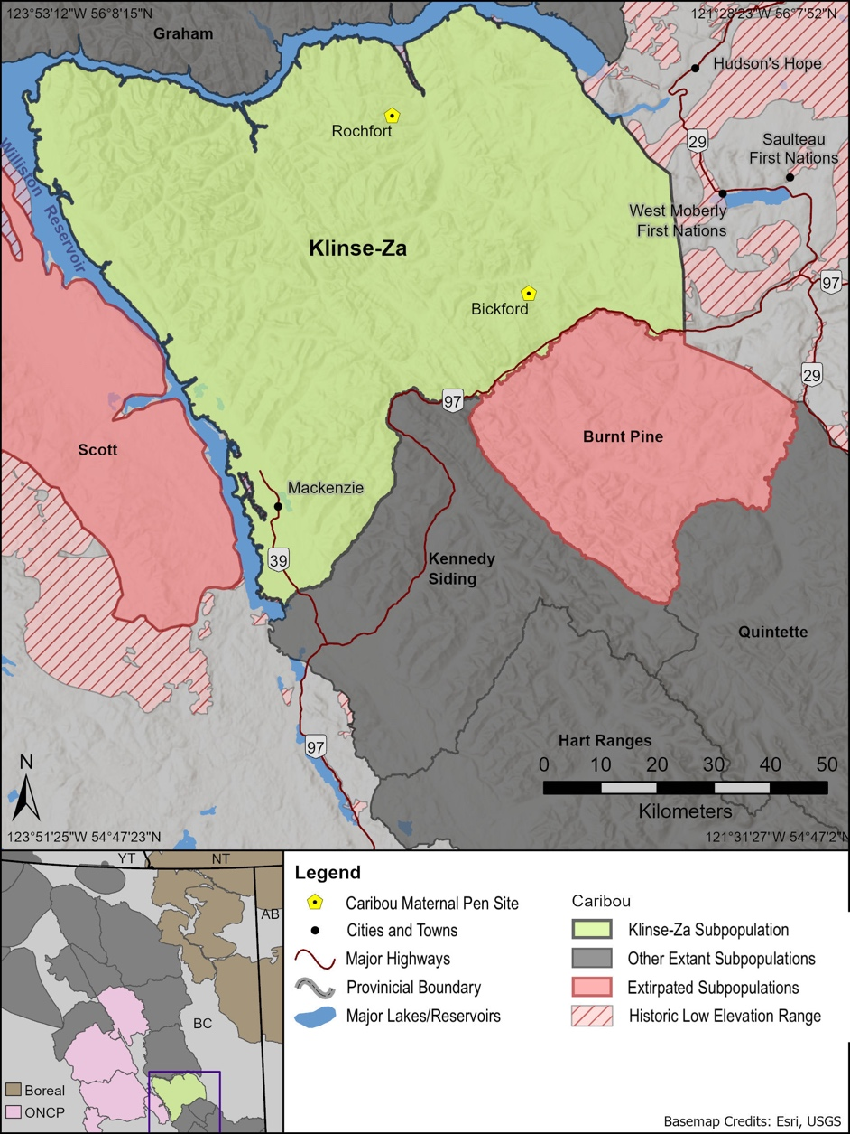

Figure 1. Location of the Klinse-Za caribou subpopulation range and two maternity pens in northern British Columbia.We used samples from caribou in the BC Boreal and Omineca Northern Caribou Project (ONCP) subpopulations as to compare our results to. The location of these subpopulations is shown in the inset. Currently unoccupied historic low elevation winter range shown with hatching (West Moberly First Nations 2014). Full historic range would likely have extended throughout the map extent and also included the now flooded habitat under Williston Reservoir. We use the subpopulations to denote the different areas caribou are currently using as distinct groups but acknowledge that caribou historically were not divisible into these discrete areas and even today there is movement between these areas, and these subpopulations will likely become less discrete as populations recover in abundance.

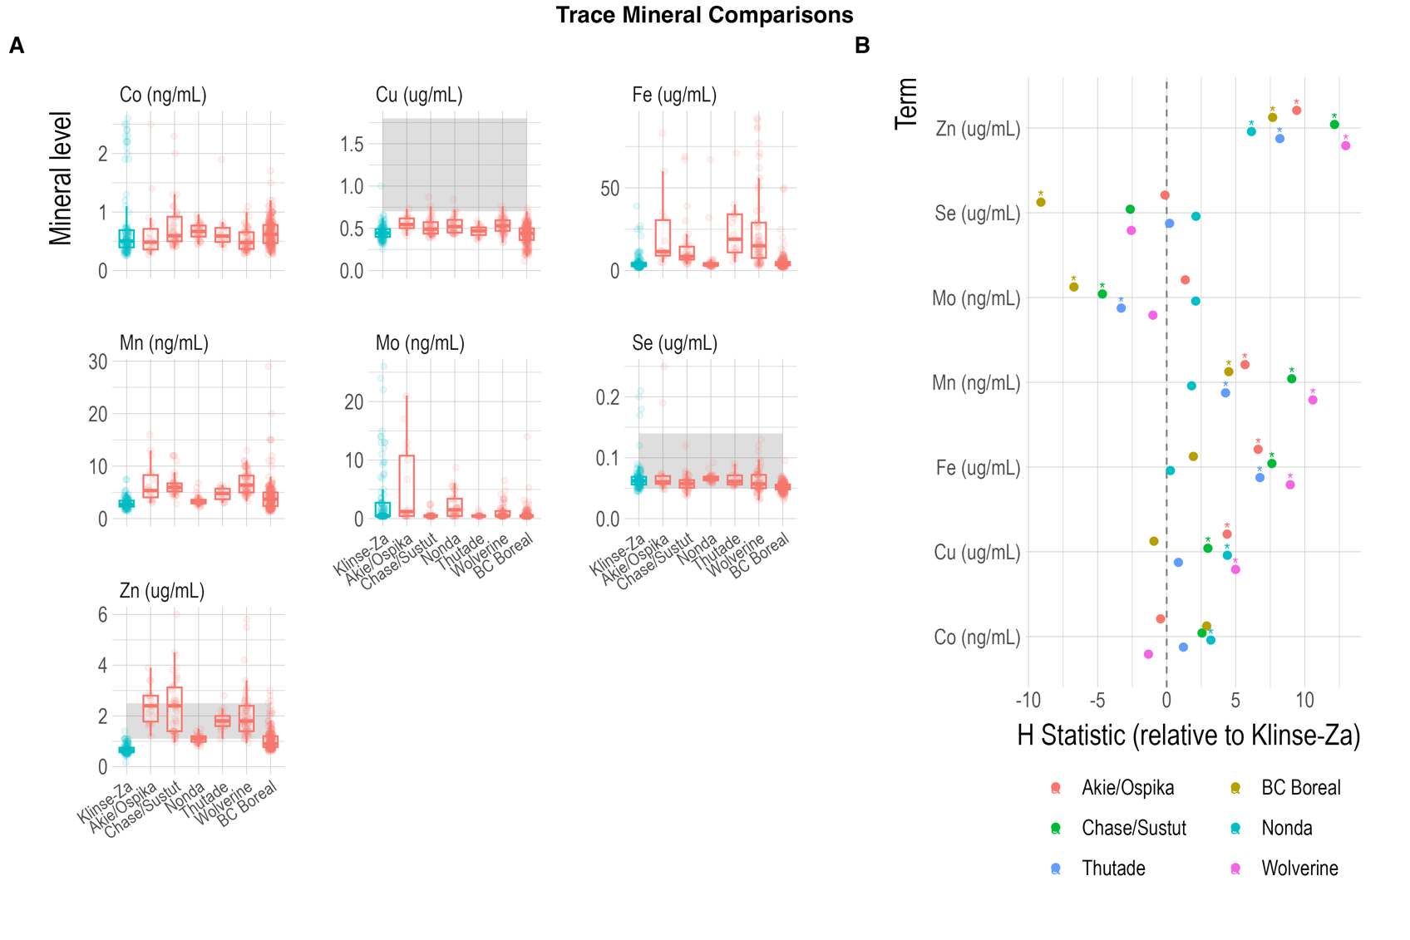

Figure . A) Serum trace mineral levels for Klinse-Za caribou (in blue) compared to nearby mountain caribou subpopulations and BC boreal caribou from (Bondo et al. 2019) (in pink). Shaded regions for Cu, Se, and Zu represent the reference ranges for 100 caribou and reindeer reported in (Puls 1994). B) estimated coefficients and 95% confidence intervals from a generalized linear model. All subpopulation values were modelled relative to Klinse-Za, thus values above 0 had higher levels than Klinse-za and below 0 had lower levels.

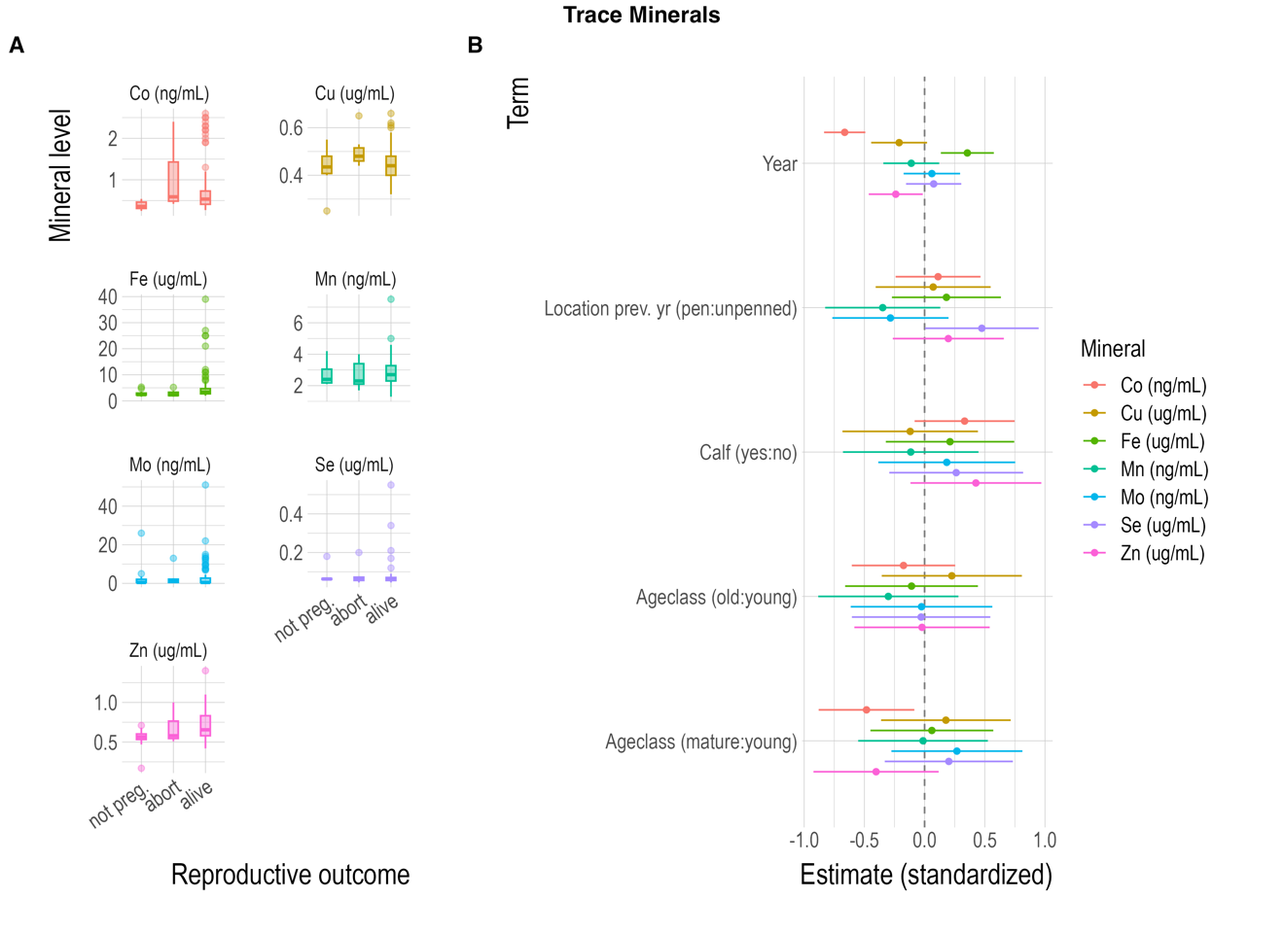

Figure . A) Spring reproductive outcomes and serum trace mineral levels measured in March for Klinse-Za caribou. B) Estimates and 95% confidence intervals for covariates fit to each trace mineral in a linear model.

Figure 4. Fecal glucocorticoid metabolites and nitrogen levels collected between April and July for penned and free-ranging Klinse-Za caribou between 2016–2019.

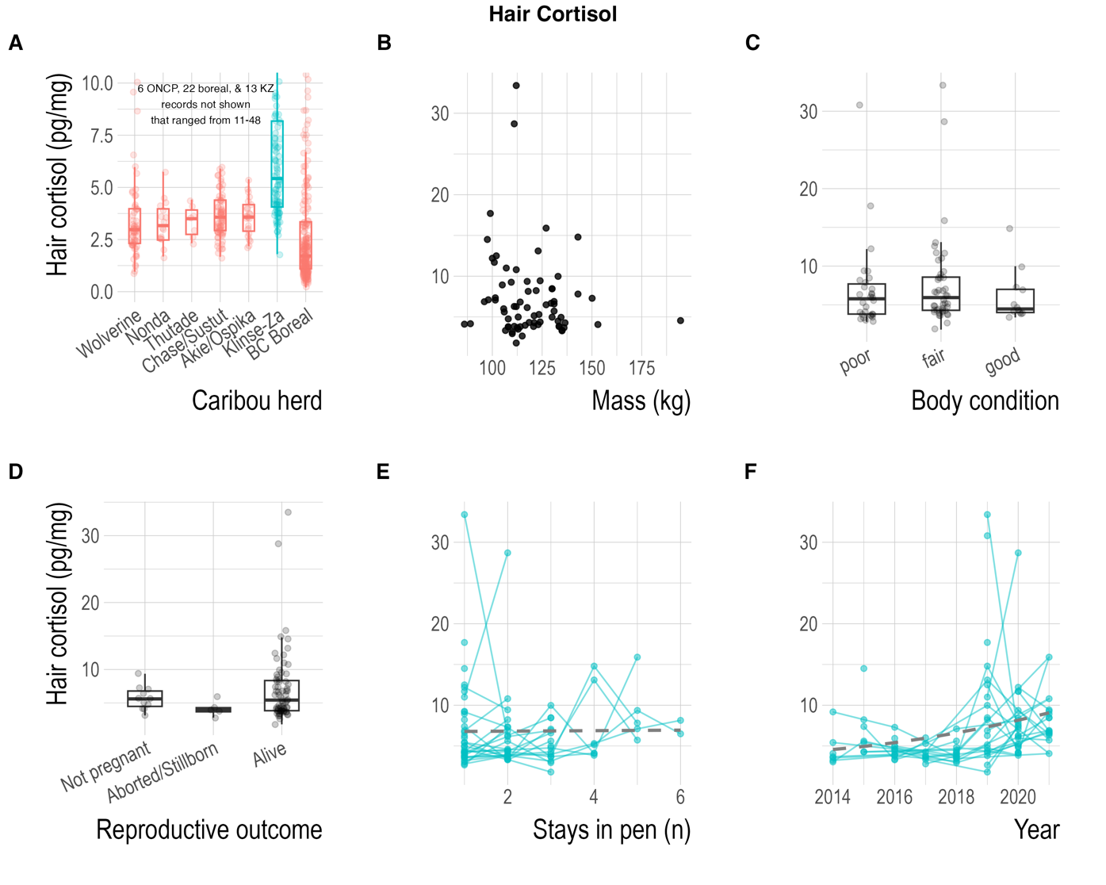

Figure 5. Hair cortisol relationships for Klinse-Za female caribou. Hair was sampled in March and generally reflects an averaged cortisol level from the entire period during hair growth (spring–fall). A) Hair cortisol levels for Klinse-Za female caribou compared to nearby mountain caribou subpopulations and BC boreal caribou from (Bondo et al. 2019). Hair cortisol was weakly related to two body condition metrics for: B) mass, and C) expert-based body condition score assessed via palpation. D) Spring reproductive outcomes and hair cortisol concentrations. E&F) hair cortisol concentration through time, either through repeated stays in the pen or by year.

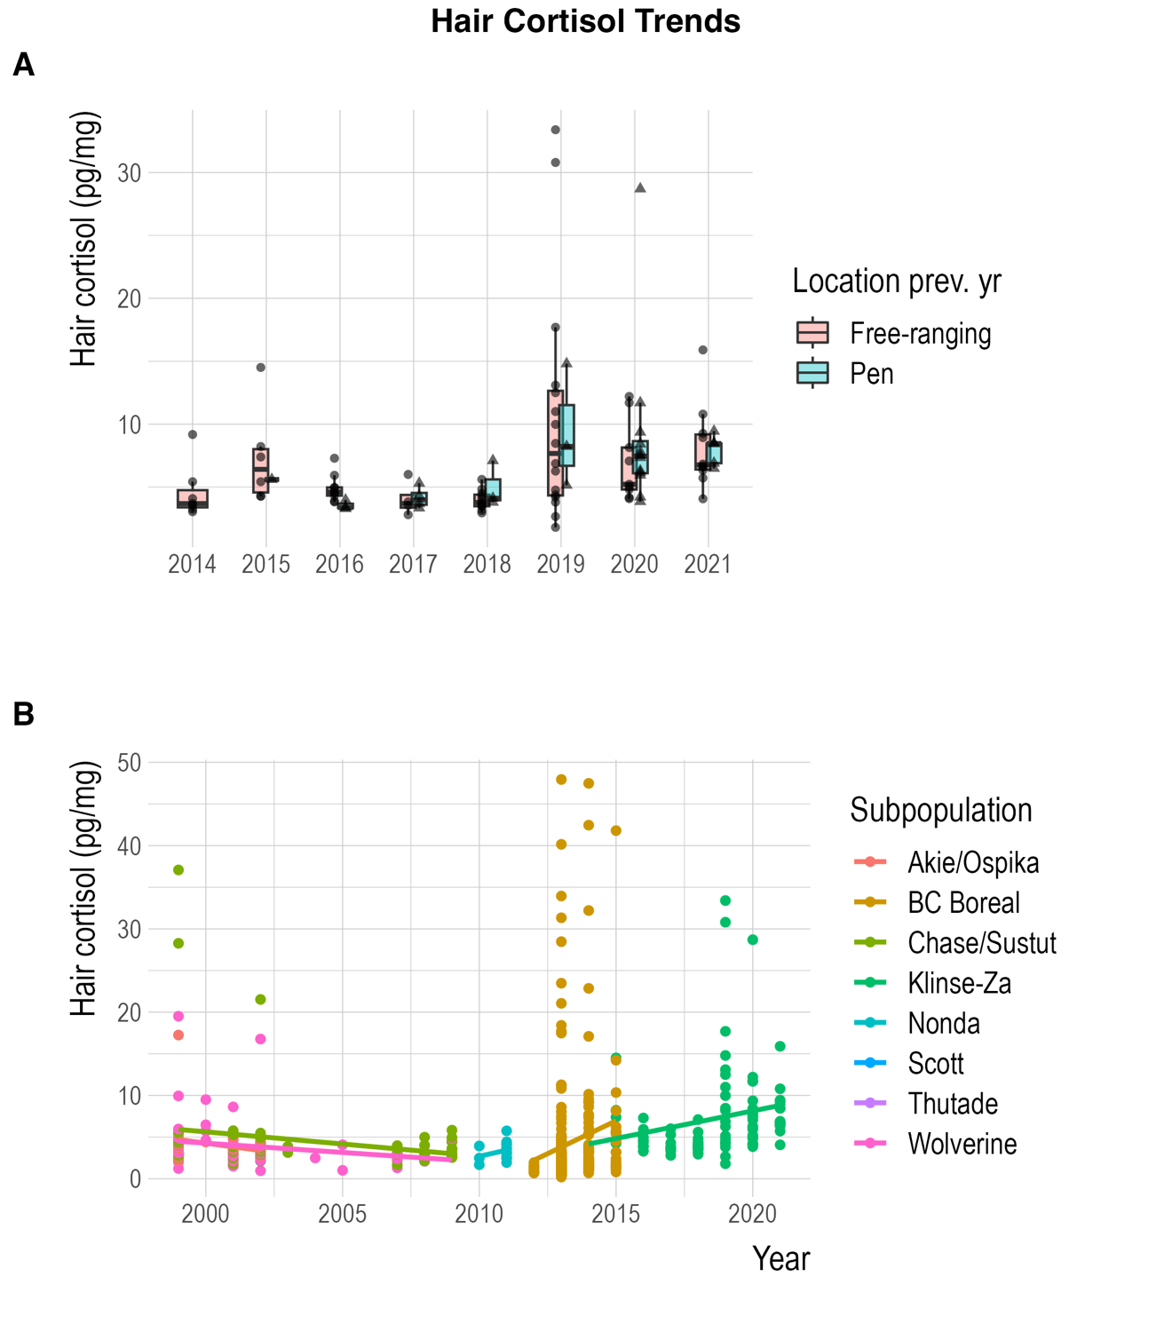

Figure 6. Hair cortisol trends through time for A) Klinse-Za female caribou inside vs outside maternal pen, and B) for Klinse-Za female caribou compared to nearby mountain caribou subpopulations and BC boreal caribou from (Bondo et al. 2019).

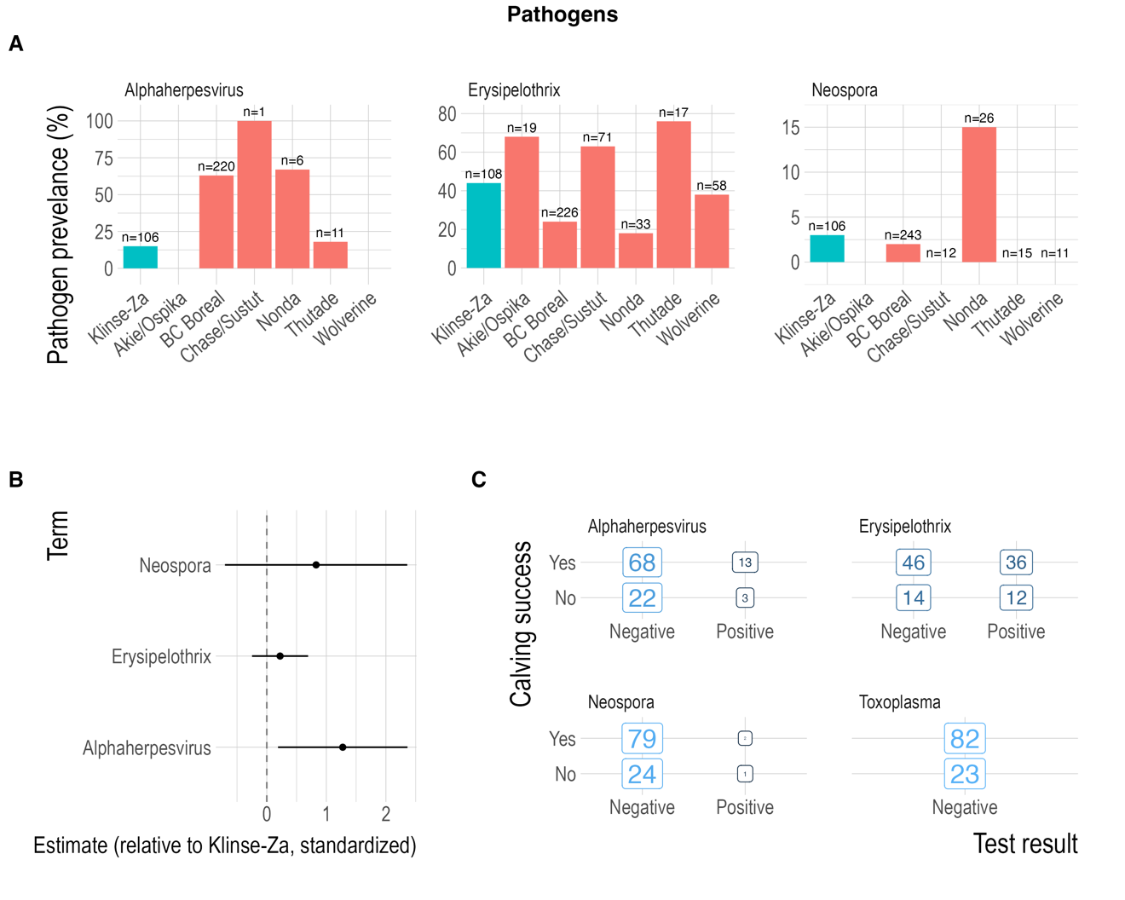

Figure 7. Pathogen seroprevalence for Klinse-Za female caribou compared to nearby mountain caribou subpopulations and BC boreal caribou from (Bondo et al. 2019) shown as A) bar chart, B) all other subpopulations pooled and compared to Klinse-Za seroprevalence in a linear model, 95% confidence intervals shown. C) confusion matrices for disease seroprevalence and calving success, all of which had little predictive power (kappa=-0.04 to 0.02).

# References