# Appendix A. Permits and Ethics Approval

Procedures for capturing caribou, care while in captivity, and monitoring radio-collared caribou complied with guidelines established by the Canadian Council on Animal Care (2003, 2017), with standards for live animal capture and handling and monitoring established by BCMOELP (1998). All activities were approved under BC Wildlife Act Permits FJ14-93094, FJ18-421458, FJ21-623574, FJ22-682329 and FJ22-655188).

Aerial wolf reductions were carried out by contractors to the Province of BC, as well as internal government staff, under the authority of the BC Wildlife Act between 2015-2021. The aerial wolf reduction considered here was permitted and received animal care approval through the Provincial Animal Care Review process for Scientific Permits (Wildlife Act Permit #’s: FJ15-169004, FJ15-165140, FJ-169006, FJ17-264123, FJ17-253645, FJ17-253804, FJ18-286980, FJ18-416476, FJ19-597709). The BC Animal Care Committee is chaired by the Provincial Wildlife Veterinarian and follows published animal care guidelines (CCAC 2003, 2017, BCMOELP 1998, Underwood and Anthony 2013). The aerial wolf reduction was exempt from the prohibitions in s.27 of the BC Wildlife Act against herding and hunting wildlife from an aircraft (exempt under s.3(1)(c)(ii) and 3(1)(c)(iii) of the Permit Regulation, B.C. Reg. 253/2000 from the prohibitions in s.27). Indigenous trapping and harvesting of predators, including wolves, was carried out between 2013-2021 under the authority enshrined in treaty rights on traditional territory. Maternity penning was permitted and underwent Provincial Animal Care Review (Wildlife Act Permit #’s: FJ14-93094, FJ18-421458, and FJ22-682329; and Special Use Permit #’s: S25789, S26697, S26316 and Free Use Permit #: 20767). Registered trapping by BC trappers was conducted under the authority of the Wildlife Act. No university personnel were involved in planning or conducting wolf reduction, operating maternity pens, or capturing caribou, thus obviating the need for university animal care review or approvals.

# Appendix B. Analytical laboratories and methods used for analysis of health samples

|  |  |  |  |  |
| --- | --- | --- | --- | --- |
| **Health Class** | **Health Metric** | **Sample Type** | **Method** | **Laboratory** |
| Pathogen | Alphaherpesvirus  [Bovine herpesvirus-1, Infectious Bovine Rhinotracheitis (IBR)] | serum | LSIVet Bovine IBR gB Blocking ELISA (Life Technologies Inc., Paris, France) | Animal Health Centre, Abbotsford, British Columbia, Canada |
| Pathogen | Toxoplasma gondii | serum | ID Screen Toxoplasmosis Indirect Multispecies ELISA Kit (Innovative Veterinary Diagnostics, Grabels, France) | Prairie Diagnostic Services Inc., SK |
| Pathogen | Neospora caninum | serum | Indirect ELISA with a posteriori western blot | Prairie Diagnostic Services Inc., SK |
| Pathogen | Erisypelothrix rhusiopathiae | serum | Indirect ELISA | University of Calgary, AB |
| Inflammation | Haptoglobin | serum | Photometric (+/- calculated) tests (Roche Diagnostics, Indianapolis, Indiana, USA) using bovine clinical diagnostic panel | University of Guelph, ON |
| Stress | Hair Cortisol Concentration | hair (200 guard hairs with bulbs removed) | ELISA  Oxford EA-65 Cortisol Competitive EIA kit (Oxford Biomedical, Lansing, Michigan, USA) | University of Saskatchewan, Toxicology Laboratory, Saskatoon, Saskatchewan, Canada |
| Stress | Fecal Glucocorticoid Metabolites (FGM) | feces (3-5 pellets) | ICP-MA (Bruker 820 S; Bruker Ltd. Milton, Ontario, Canada) | Toronto Zoo, ON |
| Nutrition | Serum Trace Mineral Levels  (Mn, Fe, Co, Cu, Zn, Se, Mo) | serum | Inductively coupled plasma mass spectrometry using Bruker 820 MS (Bruker Ltd., Milton, Ontario, Canada) | in-house at BC Wildlife Health Program Laboratory, Nanaimo, British Columbia, Canada |
| Nutrition | Fecal Nitrogen | feces | Elemental analyzer | Northern Analytical Laboratory Services (at UNBC) |
| Reproduction | Pregnancy | serum | ELISA test measuring pregnancy-specific protein B (BioPRYN wild test, BioTracking Inc., Moscow, Idaho, USA) |  |
| NA | Sex | fecal pellet ‘swab’ (epithelial cells) | Microsatellite analysis with a ZFX/ZFY sex marker, using QIAGEN DNeasy Blood and Tissue kits. | Wildlife Genetics International. Nelson, BC, Canada. |

# Appendix C. Correlations between health metrics



Figure S1. Correlation between health metrics from Klinse-Za caribou 2016-2021. Pairs with absolute correlation coefficients values >0.1 are shown.

# APPENDIX D. Photo of adult female with high haptoglobin reading

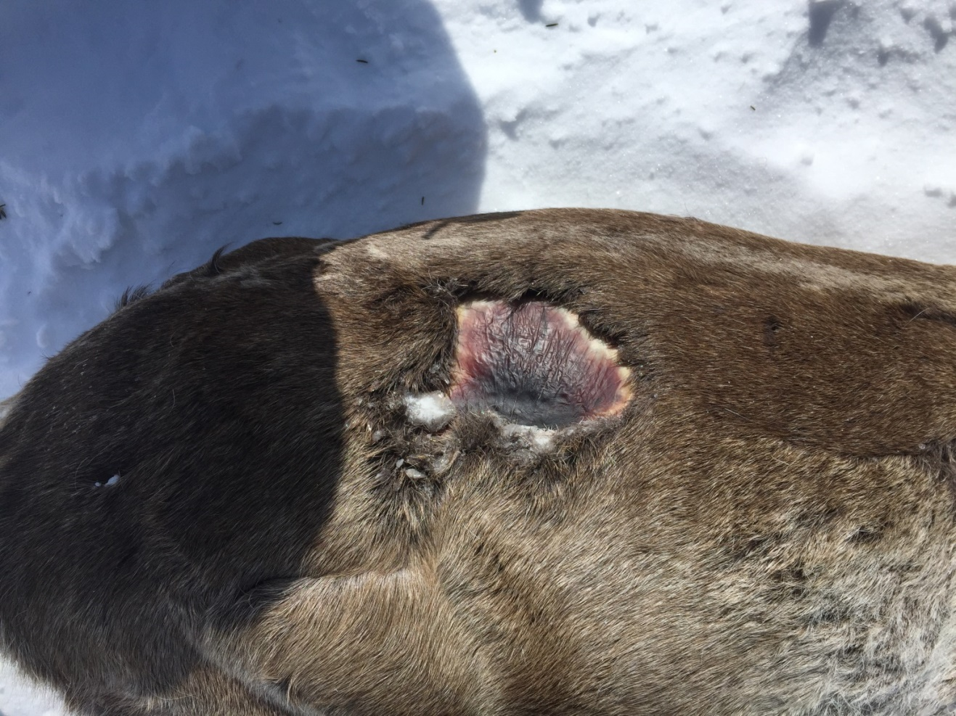

Figure S2. A photo of caribou cow C338K during capture in April 2018.