# Supplementary Materials

# A. Permits and Ethics Approval

Procedures for capturing caribou, care while in captivity, and monitoring radio-collared caribou complied with guidelines established by the Canadian Council on Animal Care (2003, 2017), with standards for live animal capture and handling and monitoring established by BCMOELP (1998). All activities were approved under BC Wildlife Act Permits FJ14-93094, FJ18-421458, FJ21-623574, FJ22-682329 and FJ22-655188).

Aerial wolf reductions were carried out by contractors to the Province of BC, as well as internal government staff, under the authority of the BC Wildlife Act between 2015-2021. The aerial wolf reduction considered here was permitted and received animal care approval through the Provincial Animal Care Review process for Scientific Permits (Wildlife Act Permit #’s: FJ15-169004, FJ15-165140, FJ-169006, FJ17-264123, FJ17-253645, FJ17-253804, FJ18-286980, FJ18-416476, FJ19-597709). The BC Animal Care Committee is chaired by the Provincial Wildlife Veterinarian and follows published animal care guidelines (CCAC 2003, 2017, BCMOELP 1998, Underwood and Anthony 2013). The aerial wolf reduction was exempt from the prohibitions in s.27 of the BC Wildlife Act against herding and hunting wildlife from an aircraft (exempt under s.3(1)(c)(ii) and 3(1)(c)(iii) of the Permit Regulation, B.C. Reg. 253/2000 from the prohibitions in s.27). Indigenous trapping and harvesting of predators, including wolves, was carried out between 2013-2021 under the authority enshrined in treaty rights on traditional territory. Maternity penning was permitted and underwent Provincial Animal Care Review (Wildlife Act Permit #’s: FJ14-93094, FJ18-421458, and FJ22-682329; and Special Use Permit #’s: S25789, S26697, S26316 and Free Use Permit #: 20767). Registered trapping by BC trappers was conducted under the authority of the Wildlife Act. No university personnel were involved in planning or conducting wolf reduction, operating maternity pens, or capturing caribou, thus obviating the need for university animal care review or approvals.

# B. Analytical laboratories and methods used for analysis of health samples

Table S1. Analytical laboratories and methods used for analysis of health samples.

|  |  |  |  |  |  |
| --- | --- | --- | --- | --- | --- |
| **Health Class** | **Health Metric** | **Sample Type** | **Method** | **Reference** | **Laboratory** |
| Pathogen | Alphaherpesvirus  [Bovine herpesvirus-1, Infectious Bovine Rhinotracheitis (IBR)] | serum | LSIVet Bovine IBR gB Blocking ELISA (Life Technologies Inc., Paris, France) | das Neves, C.G., Roth, S., Rimstad, E., Thiry, E. and Tryland, M., 2010. Cervid herpesvirus 2 infection in reindeer: a review. *Veterinary Microbiology*, *143*(1), pp.70-80. | Animal Health Centre (Abbotsford, BC, Canada) |
| Pathogen | Toxoplasma gondii | serum | ID Screen Toxoplasmosis Indirect Multispecies ELISA Kit (Innovative Veterinary Diagnostics, Grabels, France) | Bondo, K.J., Macbeth, B., Schwantje, H., Orsel, K., Culling, D., Culling, B., Tryland, M., Nymo, I.H. and Kutz, S., 2019. Health survey of boreal caribou (Rangifer tarandus caribou) in northeastern British Columbia, Canada. Journal of wildlife diseases, 55(3), pp.544-562. | Prairie Diagnostic Services Inc. (Saskatoon, SK, Canada) |
| Pathogen | Neospora caninum | serum | Indirect ELISA with a posteriori western blot | Gutiérrez-Expósito, D., Ortega-Mora, L.M., Gajadhar, A.A., García-Lunar, P., Dubey, J.P. and Álvarez-García, G., 2012. Serological evidence of Besnoitia spp. infection in Canadian wild ruminants and strong cross-reaction between Besnoitia besnoiti and Besnoitia tarandi. *Veterinary Parasitology*, *190*(1-2), pp.19-28. | Prairie Diagnostic Services Inc. (Saskatoon, SK, Canada) |
| Pathogen | Erisypelothrix rhusiopathiae | serum | Indirect ELISA | Bondo, K.J., Macbeth, B., Schwantje, H., Orsel, K., Culling, D., Culling, B., Tryland, M., Nymo, I.H. and Kutz, S., 2019. Health survey of boreal caribou (Rangifer tarandus caribou) in northeastern British Columbia, Canada. Journal of wildlife diseases, 55(3), pp.544-562. | University of Calgary (Calgary, AB, Canada) |
| Inflammation | Haptoglobin | serum | Photometric (+/- calculated) tests (Roche Diagnostics, Indianapolis, Indiana, USA) using bovine clinical diagnostic panel | Batchelor J, Fuller J, Woodman DD (1989). A simple method for the measurement of the haemoglobin binding capacity of canine haptoglobin | University of Guelph (Guelph, ON, Canada) |
| Stress | Hair Cortisol Concentration | hair (200 guard hairs with bulbs removed) | ELISA  Oxford EA-65 Cortisol Competitive EIA kit (Oxford Biomedical, Lansing, Michigan, USA) | Macbeth, B.J. 2013. An evaluation of hair cortisol concentration as a potential biomarker of long-term stress in free-ranging grizzly bears (Ursus arctos), polar bears (Ursus maritimus), and caribou (Rangifer tarandus sp.). Doctoral dissertation, University of Saskatchewan. | University of Saskatchewan, Toxicology Laboratory (Saskatoon, SK, Canada) |
| Stress | Fecal Glucocorticoid Metabolites (FGM) | feces (3-5 pellets) | ICP-MA (Bruker 820 S; Bruker Ltd. Milton, Ontario, Canada) | Di Francesco, J., Mastromonaco, G.F., Rowell, J.E., Blake, J., Checkley, S.L. and Kutz, S., 2021. Fecal glucocorticoid metabolites reflect hypothalamic–pituitary–adrenal axis activity in muskoxen (Ovibos moschatus). Plos one, 16(4), p.e0249281. | Toronto Zoo (Toronto, ON, Canada). |
| Nutrition | Serum Trace Mineral Levels  (Mn, Fe, Co, Cu, Zn, Se, Mo) | serum | Inductively coupled plasma mass spectrometry using Bruker 820 MS (Bruker Ltd., Milton, Ontario, Canada) | Jeffery, J., Frank, A.R., Hockridge, S., Stosnach, H. and Costelloe, S.J., 2019. Method for measurement of serum copper, zinc and selenium using total reflection X-ray fluorescence spectroscopy on the PICOFOX analyser: Validation and comparison with atomic absorption spectroscopy and inductively coupled plasma mass spectrometry. Annals of clinical biochemistry, 56(1), pp.170-178. | University of Guelph (Guelph, ON, Canada) |
| Nutrition | Fecal Nitrogen | feces | Costech 4010 Elemental analyzer | Morris, D.L., Tebbe, A.W., Weiss, W.P. and Lee, C., 2019. Effects of drying and analytical methods on nitrogen concentrations of feeds, feces, milk, and urine of dairy cows. Journal of dairy science, 102(6), pp.5212-5218. | Northern Analytical Laboratory Services at UNBC (Prince George, BC, Canada) |
| Reproduction | Pregnancy | serum | ELISA test measuring pregnancy-specific protein B (BioPRYN wild test, BioTracking Inc., Moscow, Idaho, USA) | Sasser, R.G. and Ruder, C.A., 1987. Detection of early pregnancy in domestic ruminants. J Reprod Fertil Suppl, 34, pp.261-71.  Russell, D.E., Gerhart, K.L., White, R.G. and Van De Wetering, D., 1998. Detection of early pregnancy in caribou: evidence for embryonic mortality. *The Journal of wildlife management*, pp.1066-1075. | Herd Health Diagnostics (Pullman, WA, United States) |
| NA | Sex | fecal pellet ‘swab’ (epithelial cells) | Microsatellite analysis with a ZFX/ZFY sex marker, using QIAGEN DNeasy Blood and Tissue kits. | Poole, K.G., Reynolds, D.M., Mowat, G. and Paetkau, D., 2011. Estimating mountain goat abundance using DNA from fecal pellets. The Journal of Wildlife Management, 75(6), pp.1527-1534.  Woods, J.G., Paetkau, D., Lewis, D., McLellan, B.N., Proctor, M. and Strobeck, C., 1999. Genetic tagging of free-ranging black and brown bears. Wildlife Society Bulletin, pp.616-627. | Wildlife Genetics International (Nelson, BC, Canada) |

# C. Correlations between health metrics



Figure S1. Correlation between health metrics from Klinse-Za caribou 2016-2021. Pairs

with absolute correlation coefficients values >0.1 are shown.

# D. Comparison between pooled and single datasets on summary statistics

Table S2. Comparison between pooled and single datasets on summary statistics.

|  |  |  |
| --- | --- | --- |
| Type | Pooled | Single |
| Co (ng/mL) | 0.5 (0-1.73) | 0.54 (0-1.65) |
| Cu (ug/mL) | 0.44 (0.26-0.63) | 0.45 (0.32-0.58) |
| Fe (ug/mL) | 3.3 (0-14.42) | 3.5 (0-8.74) |
| Mn (ng/mL) | 2.7 (0.63-4.77) | 2.6 (0.12-5.08) |
| Mo (ng/mL) | 0.45 (0-14.16) | 0.45 (0-13.19) |
| Se (ug/mL) | 0.06 (0-0.18) | 0.06 (0-0.12) |
| Zn (ug/mL) | 0.64 (0.27-1) | 0.66 (0.22-1.1) |
| Alphaherpesvirus | 0.15 (0.08-0.22) | 0.15 (0.04-0.26) |
| Erysipelothrix | 0.45 (0.35-0.54) | 0.55 (0.4-0.7) |
| Neospora | 0.03 (0-0.06) | 0.03 (0-0.07) |
| Toxoplasma | 0 (0-0) | 0 (0-0) |
| Hair cortisol (pg/mg) | 5.42 (0-46.38) | 4.97 (0-67.83) |
| Haptoglobin g/L | 0.25 (0-0.53) | 0.27 (0.09-0.45) |

# E. Photo of adult female with high haptoglobin reading

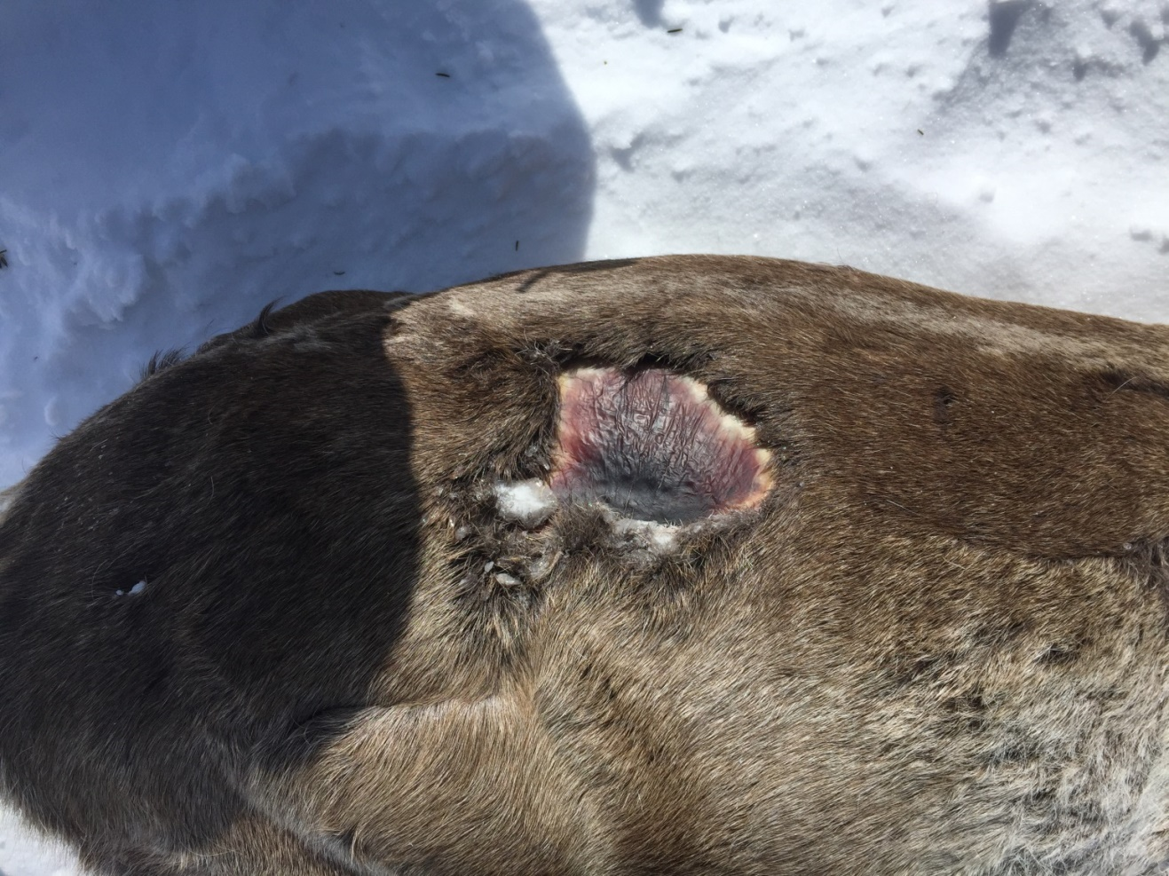

Figure S2. A photo of caribou cow C338K during capture in April 2018.