Documentation for GammaPA
Documentation Version 1.0
Corresponds to GammaPA version 2.6.5rel
April 20th, 2022

Carl T. Lira*
Aseel M. Bala
Renming Liu
William G. Killian
Lars Peereboom
Michigan State University

* corresponding author: lira@msu.edu

Overview
This document is a user manual for the implementation of the user Wertheim NRTL Plus Association Model (NRTL-PA) published in Bala, A. M.; Liu, R.; Peereboom, L.; Lira, C. T. Applications of an Association Activity Coefficient Model, NRTL-PA, to Alcohol-Containing Mixtures. Ind. Eng. Chem. Res. 2022, 61 (42), 15603–15619. https://doi.org/10.1021/acs.iecr.2c01415.
The code is adapted for use in the PGLWrapper project. The two primary computational differences are 1) use of corresponding states for calculating the species density rather than use of Aspen’s molar volume correlation; and 2) use of the ideal gas model rather than the Hayden-O’Connell Virial Coefficient Correlation. Due to these differences, the results will be approximately the same as the published results. The association constant implementation is adapted by assigning main groups and subgroup numbers to facilitate more robust implementation. The use of association constants differs from the implementation of the built-in Aspen method by C.C. Chen.
The model provides several options for combinatorial contributions, and the radial distribution function (rdf). The choice of rdf is coupled with the activity coefficient ($γ$) model, and the covolume parameters. Several levels of debugging are provided so that the user can print information to the history file to confirm that parameters are entered as intended.
Contributions due to the residual, combinatorial, combinatorial correction, and Wertheim models can be printed to .csv files for the activity coefficient and heat of mixing. Temperature-dependent molar volumes used in calculations can also be printed.

Option Codes
Option codes will defined as kop(i) where (i) indicates the column vector (i.e. kop(2) == 3 sets the second option code to a value of three).

Debug printing is provided to GammaPAdebug.txt. Examples of output can be seen later in this document.

NOTE: Selection of kop(1) == 3 will create output files gammas.csv, hxs.csv and vol.csv which will be appended each time the gammas are calculated. Because of this, it is advised to delete the generated files between runs when using kop(1) == 3. In addition, kop(3) should be used judiciously. For more information concerning debugging please reference section 5.

Debug Options (kop(1))
- kop(1) == 0: no debug printing
- kop(1) == 1: debug printing of gamma contributions and code version
- kop(1) == 2: includes printing of X, rho, deltas, in addition to the content above
- kop(1) == 3: includes printing of delta matrix indexes and gamma output to gammas.csv as well partial molar enthalpies to hxs.csv, in addition to the content above

Radial Distribution function (kop(2))
- kop(2) == 0: VdW
- kop(2) == 1: ESD
- kop(2) == 2: CPA (ESD with packing factor divided by four)
- kop(2) == 3: PC-SAFT
- kop(2) == 4: $g\left(σ\right)=1$

Pure Component Liquid Volume (kop(3))
- kop(3) == 0: standard liquid volume
- kop(3) == 1: temperature-dependent volume

Combinatorial Correction (kop(5)) * Ignored when kop(6) == 2
- kop(5) == 0: VdW
- kop(5) == 1: None
- kop(5) == 2: Staverman-Guggenheim
- kop(5) == 3: VdW with COVOL value – remove this option in code

Combinatorial Term (kop(6))
- kop(6) == 0: Flory
- kop(6) == 1: Flory with modified volume (V^{2/3})
- kop(6) == 2: None

Parameters
Parameters files are named according to the corresponding kop(2) – kop(6) flags. Each parameter filename corresponds to the method specified by the kop(x) value. For each parameter file, if values are missing or timestamps are inconsistent, the program will notify that it cannot continue.
Parameter files are tab-separated so that they may be readily loaded into Excel for editing and sorting. The parameter files include a timestamp in the form YYMMDDHHMM (hours in 24 format). The NRTL parameters must be the same or more recent than the RDF and Wertheim parameters.
The required input files are: GPA-IN (component list using TRC values, site ids), GPA-RDF-x, GPA-STDV, GPA-NRTL-xxxx. When a molecule may have more than one site configuration or PC-SAFT parameters, the option is provided by the extra field. The default option value is 0. For example, water may be modeled as a 2B or a 4C scheme, so the 2B may be option 0 and the 4C may be option 1.

RDF parameters
RDF parameters are stored in GPA-RDF where the value of x denotes the value of kop(2). Covolumes in (cm³/mol) are used for
kop(2) = 0, vdW (GPA-RDF-0) $g\left(σ\right)=1/(1-η_{p})$. Note that when kop(5) = 0 or 3, then parameters for GPA-RDF-0 are required, even when kop(2) = 4.
kop(2) = 1, ESD (GPA-RDF-1) $g\left(σ\right)=1/(1-{1.9η}_{p})$
kop(2) = 2, CPA (GPA-RDF-2) $g\left(σ\right)=1/(1-{1.9η}_{p}/4)$
kop(2) = 3, PC-SAFT (GPA-RDF-3) requires PC-SAFT parameters for all species. Note that various PC-SAFT parameters and SAFT variants are available in the literature and they are not interchangeable. Changing the PC-SAFT parameters requires refitting of the NRTL parameters. See Section 2.1.4.2 for the RDF expression.

Molar Volume
The standard volume, UNIQAUC parameters are in GPA-V. Each line has a timestamp.
When temperature-dependent molar volumes are specified in the option settings using kop(3) = 1, then the code uses molar volumes as calculated by the corresponding states method in PGLWrapper. The existing code does not extrapolate the molar volumes beyond the temperature limits specified in the parameters, but clamps the values at the temperature limits. Thus, above the upper temperature limit, the molar volume is calculated at the temperature limit and used in subsequent calculations. The lower limit is handled similarly. The temperature limits are entered in DNLDIP(6) and DNLDIP(7).

Wertheim Parameters
A library of Wertheim parameters is included in Wertheim.csv. The table can be loaded into Excel.
Wertheim Parameter are coupled with the RDF parameters and thus the parameter filenames are appended with the value of kop(2), i.e. GPA-Werth-0, GPA-Werth-1, etc.

VDW, ESD, CPA
GPA-Werth-0 (for VDW). GPA-Werth-1 (for ESD), or GPA-Werth-2 (for CPA). Parameters are in KAD is the CPA bonding volume, in cm³/mol. EPS is eps/k in Kelvin.
$$Δ_{ij}=g\left(σ\right)K_{ij}^{AD}(\exp\left(\frac{ϵ_{ij}^{AD}}{kT}\right)-1)$$

SAFT
GPA-Werth-3, KAD is the SAFT bonding volume parameter (dimensionless). UNIFAC group interaction, one element. EPS is $ϵ_{ij}^{AD}$/$k$ in Kelvin.
$$Δ_{ij}=g_{ij}\left(d\right){d_{ij}^{3}κ}_{ij}^{AD}(\exp\left(\frac{ϵ_{ij}^{AD}}{kT}\right)-1)$$
The diameter is temperature-dependent
$$d_{ij}\left(T\right)=σ_{ij}\left(1-0.12\exp\left(-\frac{3ϵ_{ij}}{kT}\right)\right)$$
where $ϵ$ is the physical energy and $σ_{ij}$ is the cross diameter using the combining rules
$σ_{ij}=(σ_{i}+σ_{j})/2$ and $ϵ_{ij}=\sqrt{ϵ_{i}ϵ_{j}}$
The radial distribution function is
$$g_{ij}^{hs}=\frac{1}{1-ζ_{3}}+\left(\frac{d_{i}d_{j}}{d_{i}+d_{j}}\right)\frac{3ζ_{2}}{{\left(1-ζ_{3}\right)}^{2}}+{\left(\frac{d_{i}d_{j}}{d_{i}+d_{j}}\right)}^{2}\frac{2ζ_{2}^{2}}{{\left(1-ζ_{3}\right)}^{3}}$$
where
$$ζ_{n}=\frac{π}{6}ρ\sum_{i}{x_{i}m_{i}d_{i}^{n}} n∈\left\{2,3\right\}$$

$g\left(σ\right)=1$
GPA-Werth-4. Parameters are in KAD is the CPA bonding volume, in cm³/mol. EPS is eps/k in Kelvin.
$$Δ_{ij}=K_{ij}^{AD}(\exp\left(\frac{ϵ_{ij}^{AD}}{kT}\right)-1)$$

Attractive (NRTL) Model Parameters
These are binary interaction parameters with the specified number of elements.
The elements correspond to NRTL parameters $τ_{ij}=a_{ij}+b_{ij}/T\left(K\right)$; third parameter is $α_{ij}$. The first species has the smaller TRC id and is component $i$. The order of parameters is: $a_{ij}, a_{ji}, b_{ij},b_{ji},α_{ij}=α_{ji}$.
The parameters depend upon the kop values. Not every combination is available in the distributed code. The filenames indicate the flags used for parameter regression.
GPA-NRTL3111.txt – RDF is PCSAFT, liquid volume is T-dependent, no combinatorial correction, and combinatorial uses Flory with a modified volume.
GPA-NRTL4111.txt – RDF is $g\left(σ\right)=1$, liquid volume is T-dependent, no combinatorial correction, and combinatorial uses Flory with a modified volume.

The codes in the filename are insufficient to assure that the NRTL parameters are unique, because the NRTL parameters depend on the values used for the RDF, the assigned sites, and association strengths. Each line includes the timestamp the NRTL parameters were fitted, the corresponding component ids, the latest timestamp from the RDF parameter file (if kop(2)$≠4$), and the latest timestamp from the Wertheim parameter file. If the timestamp of any of the RDF or association parameter is more recent than the NRTL parameter timestamp, then a warning is issued.

Example: Methanol + Cyclohexane (File Setup)
Now that the model has been created, the following steps will introduce the user to its application. An example binary system of methanol + cyclohexane will be used for illustrative purposes.
-------------------Resume here------------------------
Included with the distribution is an example file MEOH-HEP-CYC_SAFT.bkp for this case. When opening this example in a new version of Aspen, specify to keep databanks when performing benchmarking against results summarized herein.

Set Up Components and Association Sites
Note that n-heptane is not used in this example and can be omitted.
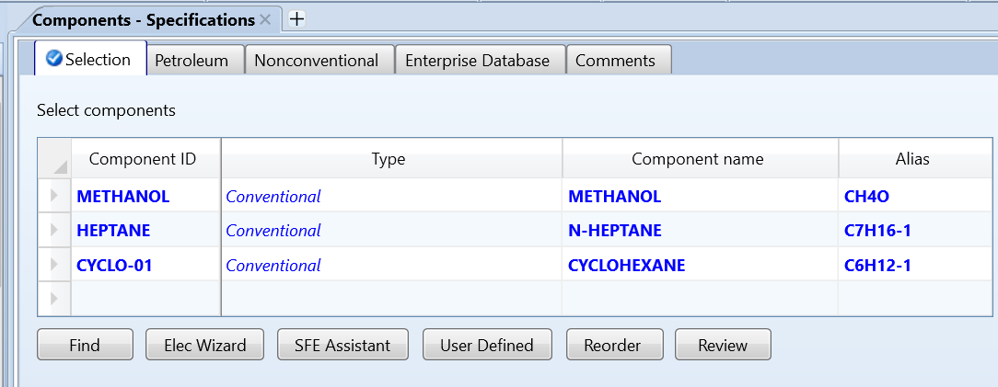

Define Association Sites
Wertheim sites are entered utilizing the Aspen framework for UNIFAC groups for Aspen 11. The user sites are stored in memory enabling the user UNIFAC groups to be utilized for the Wertheim sites. This is a customization to enter Wertheim sites into the Aspen framework. Files used in this way cannot be used for any UNIFAC calculations because the standard UNIFAC model will misinterpret the parameters.
Select Components > UNIFAC Groups in the browser menu. Define user Group ID and Group number. Group ID is a text string (8 char max) that provides easy recognition of the site. Here written to match the Group number for clarity. You may wish to name acceptors with an A, donors with a D and bivalent with a B. The Group ID is a user-specified text field.
The Group Number conventions are hard-coded into the calculations as follows:
- 4500-4749 are donors;
- 4750-4949 are acceptors;
- 4950-5000 are bivalent (carboxylic acids).
NOTE: These conventions MUST be followed because the Group Number is used within the code to decide bonding (e.g. acceptor with donor, but not donor with donor, etc.) Bivalent will bond to each other in 1:1 stoichiometry blocking further bonding for the sites, but they also will serve can serve as a donor and acceptor with other sites when those bonding parameter values are nonzero.

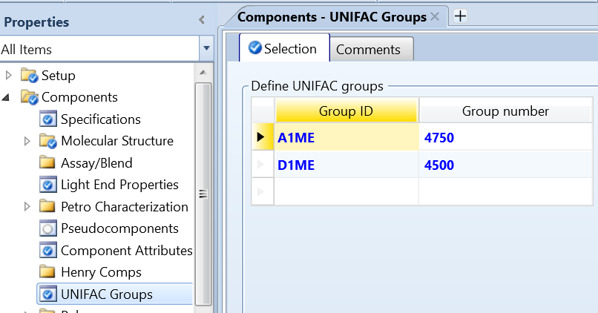

Designate Site Hosts
Assign sites to molecules using Components > Molecular Structure > Functional Group. Select UNIFAC as the functional group method. Do not assign any sites besides the sites to be used for Wertheim calculations.
Methanol has one acceptor and one donor, numbered 4500 and 4750.
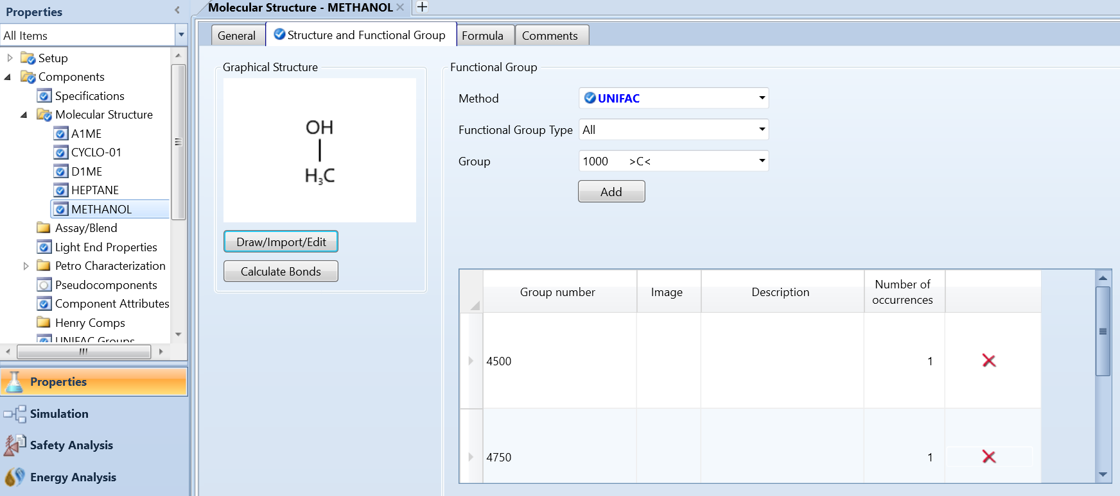
NOTE: Nothing is specified for molecules without Wertheim parameters. For instance, the built in UNIFAC group assignments for cyclohexane will be ignored in the Wertheim calculations. In addition, Wertheim sites will appear in the Molecular Structure folder of the data browser but require no additional input.

LLE systems and flash calculations
For systems with an LLE, it is important to perform flash calculations in the regression simulation. To do this navigate to Setup > Calculation Options > Flash Convergence and set the Max Iterations to 100.
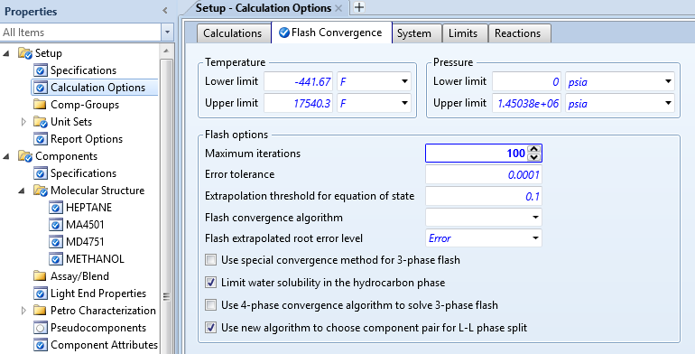

Enter parameter values
Now enter the parameter values for CPA COVOL in cm³/mol. To set the value, create an entry form using Methods>Parameters >Pure Component>Scalar (the default form name is OK). Then, in the Parameter dropdown menu, select the COVOL variable that you created earlier. (The value shown for heptane covolume is not needed for this example.) The user model does not use these values for PC-SAFT, but Aspen will set them to 1E35 when missing. A placeholder value can be entered if you are running PC-SAFT.

Association parameters
For SAFT association parameters, the following pure component parameters must be entered;
- PCSFTM – m, number of segments
- PCSFTU – $ϵ/k$ (in K), this is the physical energy parameter, not the association parameter.
- PCSFTV – $σ$ reference segment diameter (in Angstroms)
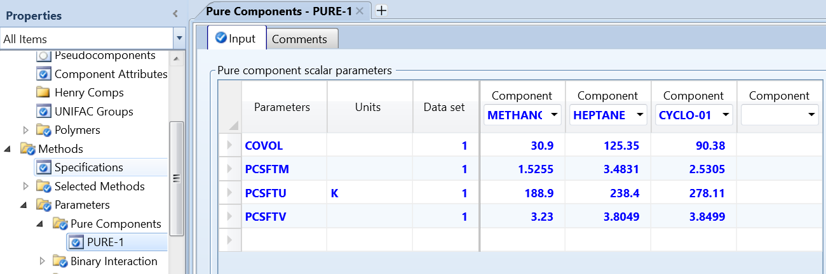
For Wertheim Parameters:
Under Methods > Parameters > UNIFAC Groups Binary, locate EPS-1 and KAD-1 for CPA or EPSPCS-1 and KADPCS-1 for PC-SAFT. Since Wertheim parameters are symmetrical the subroutine will fill the matrix according to the element provided.
The parameter EPS or EPSPCS is $ϵ_{ij}^{AD}/k$ in units of K
The parameter KAD is $K_{ij}^{AD}$ in units of cm³/mol, and KADPCS is $κ_{ij}^{AD}$, dimensionless.
NOTE: You do NOT need to provide both IJ and JI because if the values are different one of them will be overwritten. To minimize confusion, place the acceptors in the columns across the top and the donors along the rows, or vice-versa. The only exception to this will be bivalent molecules which much be in the column and the row.
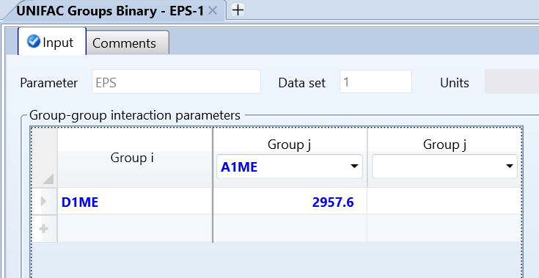
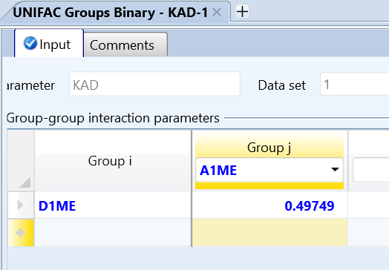
And for the PC-SAFT association parameters:
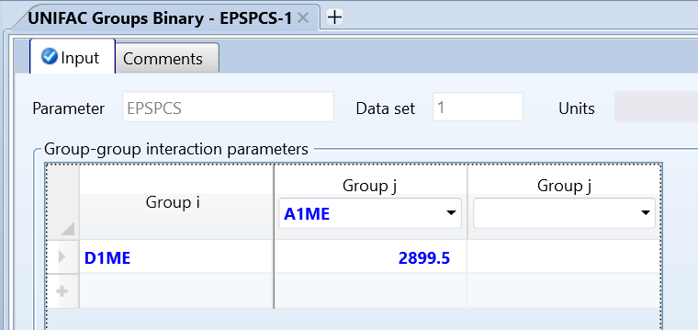
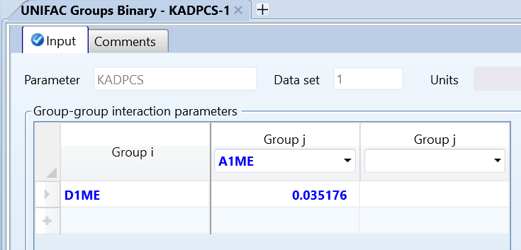

Set HOCETA
Set the Hayden-O’Connell (η) = 1.63 for methanol using Methods > Parameters > Binary Interaction > HOCETA

Residual Model Parameters
This example will use NRTL, so we will use the user parameters GMNRTL. When entered manually, the parameter source will be “USER”.
Under Methods > Parameters > Binary Interaction locate GMNRTL. To regenerate the solutions given for the example system in Section 4.1 (NRTL-PA with CPA parameters), set the parameters as shown in the following figure. The screen shot includes parameters not needed for the example, and unneeded parameters are masked with translucent blocks.
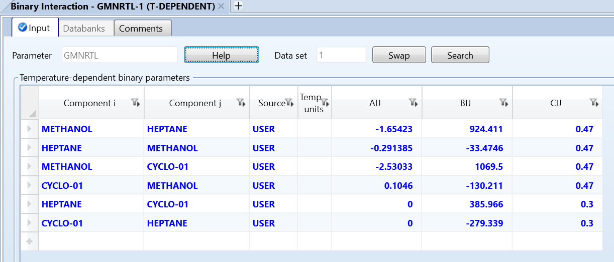
Set as follows for the example fit using the PC-SAFT association parameters (Section 4.2):
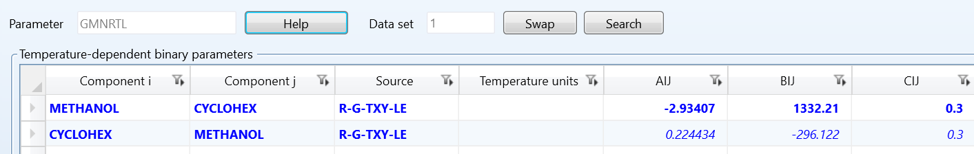

Example: Methanol + Cyclohexane (Running the file)

CPA
This example will use the CPA method with temperature-dependent pure-component volumes, the Flory combinatorial with the Staverman-Guggenheim correction.
Set the following option codes for this example
- kop(1) = 1; debug printing is set to level 1
- kop(2) = 2; rdf is set to CPA
- kop(3) = 1; temperature-dependent density.
- kop(5) = 2; combinatorial correction is set to Staverman-Guggenheim
- kop(6) = 0; Flory combinatorial term

Set the flags as follows for CPA benchmarking. Note that the kop(1) = 1 is optional but will provide minimal debugging to the history file.
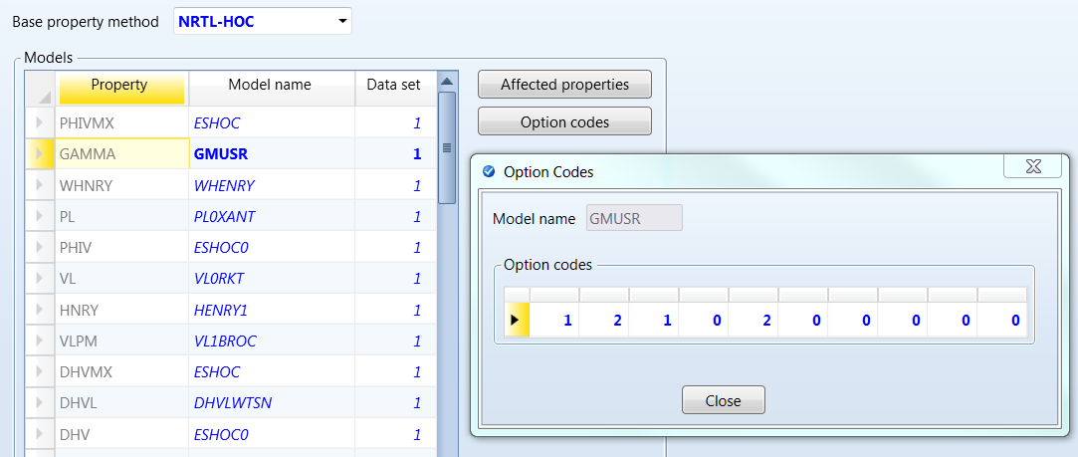
Results of using a variety of residual models are shown below and compared with CPA. The Scatchard-Hildebrand (SH), and Wilson methods are discussed by Bala[1] but not included in the public NRTL-PA distribution. Tabulated calculations follow the figure.
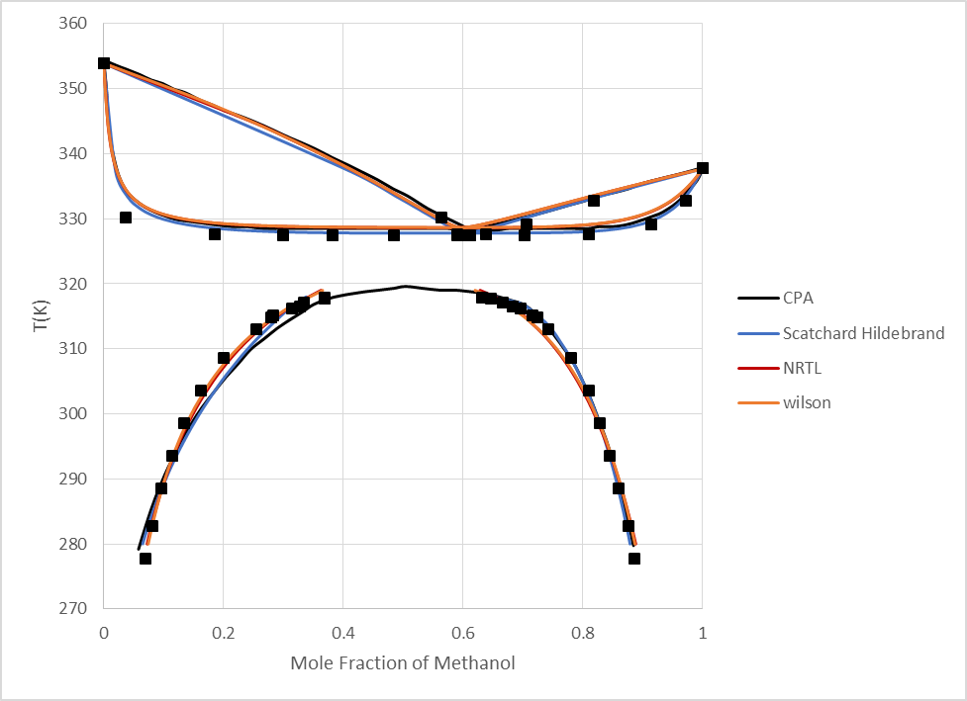
NOTE: NRTL and Wilson yield almost identical results and are therefore overlapped in this figure
Experimental Data plotted in the figure- VLE: Budantseva, L. S.; Lesteva, T. M.; Nemtsov, M. S. Zh. Fiz. Khim., 1975, 49, 260-1 Liquid-vapor equilibriums in methanol-C6 hydrocarbons of different classes. LLE: Katayama, H. Fluid Phase Equilib., 1999, 164, 83-95 Liquid-liquid equilibria of two ternary systems: methanol-cyclohexane including 1,3-dioxolane or 1,4-dioxane in the range of 277.79-308.64 K.
With these values, you can now run a binary analysis of methanol + cyclohexane and generate the following VLE and LLE data points with the model:
Experimental VLE Data |  |  |  | Experimental LLE Data
Temp  (K) | Pressure  (Pa) | X  Methanol | Y Methanol | Temp  (K) | Pressure  (Pa) | X1 | X2
353.82885 | 101320 | 0 | 0 | 277.79 | 101300 | 0.886 | 0.0705
334.33413 | 101320 | 0.05 | 0.492 | 282.8 | 101300 | 0.876 | 0.0816
329.3352 | 101320 | 0.1 | 0.566 | 288.54 | 101300 | 0.861 | 0.0964
327.53573 | 101320 | 0.2 | 0.598 | 293.61 | 101300 | 0.845 | 0.114
327.3358 | 101320 | 0.3 | 0.603 | 298.63 | 101300 | 0.828 | 0.134
327.3358 | 101320 | 0.4 | 0.603 | 303.63 | 101300 | 0.81 | 0.162
327.3358 | 101320 | 0.5 | 0.603 | 308.64 | 101300 | 0.781 | 0.2
327.3358 | 101320 | 0.6 | 0.603 | 313 | 101300 | 0.743 | 0.256
327.3358 | 101320 | 0.7 | 0.603 | 314.75 | 101300 | 0.724 | 0.28
327.53573 | 101320 | 0.8 | 0.605 | 315.14 | 101300 | 0.717 | 0.284
328.63541 | 101320 | 0.9 | 0.67 | 316.15 | 101300 | 0.696 | 0.314
330.83483 | 101320 | 0.95 | 0.764 | 316.48 | 101300 | 0.683 | 0.328
337.83343 | 101320 | 1 | 1 | 317.05 | 101300 | 0.667 | 0.335
 |  |  |  | 317.65 | 101300 | 0.647 | 0.369
 |  |  |  | 317.94 | 101300 | 0.632 | 0.37

The stable phase at 298.15 K will split into two liquid phases. The table below is a Gibbs Energy of Mixing Analysis calculated with the flash suppressed to provide validation of user calculations.
MOLEFRAC METHANOL | LIQUID DGMIX | LIQUID GAMMA METHANOL | LIQUID GAMMA CYCLO-01 | LIQUID HXS
 | kJ/kmol |  |  | kJ/kmol
0 | 0 |  | 1 | 0
0.02 | -41.6106 | 32.9999 | 1.01162 | 229.825
0.04 | -57.0513 | 19.336 | 1.02794 | 354.393
0.06 | -67.1492 | 13.8108 | 1.04609 | 451.761
0.08 | -74.499 | 10.7768 | 1.06568 | 534.609
0.1 | -80.1293 | 8.84619 | 1.08661 | 608.011
0.12 | -84.5793 | 7.50448 | 1.10888 | 674.6
0.14 | -88.1763 | 6.51541 | 1.1325 | 735.934
0.16 | -91.1396 | 5.75475 | 1.15755 | 793.018
0.18 | -93.6262 | 5.15079 | 1.18412 | 846.534
0.2 | -95.7546 | 4.65913 | 1.21229 | 896.961
0.22 | -97.6178 | 4.2508 | 1.24219 | 944.641
0.24 | -99.2914 | 3.90604 | 1.27396 | 989.819
0.26 | -100.839 | 3.61094 | 1.30775 | 1032.67
0.28 | -102.313 | 3.35539 | 1.34373 | 1073.32
0.3 | -103.763 | 3.13188 | 1.38209 | 1111.83
0.32 | -105.228 | 2.9347 | 1.42305 | 1148.27
0.34 | -106.746 | 2.75944 | 1.46687 | 1182.63
0.36 | -108.351 | 2.60264 | 1.5138 | 1214.9
0.38 | -110.074 | 2.46153 | 1.56418 | 1245.06
0.4 | -111.942 | 2.33389 | 1.61834 | 1273.04
0.42 | -113.982 | 2.21791 | 1.67668 | 1298.77
0.44 | -116.216 | 2.1121 | 1.73967 | 1322.16
0.46 | -118.666 | 2.01521 | 1.8078 | 1343.1
0.48 | -121.351 | 1.92622 | 1.88168 | 1361.45
0.5 | -124.288 | 1.84425 | 1.96196 | 1377.07
0.52 | -127.49 | 1.76856 | 2.04943 | 1389.8
0.54 | -130.97 | 1.69852 | 2.14498 | 1399.46
0.56 | -134.734 | 1.6336 | 2.24964 | 1405.84
0.58 | -138.786 | 1.57332 | 2.3646 | 1408.74
0.6 | -143.126 | 1.51729 | 2.49127 | 1407.89
0.62 | -147.746 | 1.46517 | 2.63128 | 1403.06
0.64 | -152.634 | 1.41666 | 2.78657 | 1393.95
0.66 | -157.767 | 1.3715 | 2.95941 | 1380.27
0.68 | -163.112 | 1.32946 | 3.15253 | 1361.67
0.7 | -168.623 | 1.29036 | 3.36916 | 1337.81
0.72 | -174.237 | 1.25403 | 3.6132 | 1308.29
0.74 | -179.872 | 1.22033 | 3.88938 | 1272.72
0.76 | -185.415 | 1.18916 | 4.20343 | 1230.63
0.78 | -190.721 | 1.16041 | 4.5624 | 1181.55
0.8 | -195.595 | 1.13402 | 4.97498 | 1124.96
0.82 | -199.78 | 1.10993 | 5.45198 | 1060.32
0.84 | -202.932 | 1.08812 | 6.00697 | 987.005
0.86 | -204.58 | 1.06857 | 6.65712 | 904.388
0.88 | -204.071 | 1.05131 | 7.42436 | 811.771
0.9 | -200.468 | 1.03636 | 8.33701 | 708.409
0.92 | -192.369 | 1.0238 | 9.43202 | 593.497
0.94 | -177.531 | 1.01372 | 10.7582 | 466.17
0.96 | -151.96 | 1.00627 | 12.3807 | 325.494
0.98 | -106.917 | 1.00161 | 14.3881 | 170.466
1 | 0 | 1 |  | 0

T-XY at 1.01325 bar.
MOLEFRAC METHANOL | TOTAL TEMP | LIQUID1 GAMMA METHANOL | LIQUID1 GAMMA CYCLO-01 | VAPOR MOLEFRAC METHANOL | VAPOR PHIMX METHANOL | VAPOR PHIMX CYCLO-01 | LIQUID HXS
 | C |  |  |  |  |  | kJ/kmol
0 | 80.78173 | 31.5451 | 1 | 0 |  | 0.962373 | 0
0.02 | 64.79257 | 20.19029 | 1.007354 | 0.399531 | 0.977662 | 0.964326 | 361.3668
0.04 | 60.91491 | 13.93458 | 1.020723 | 0.477669 | 0.970422 | 0.967155 | 570.564
0.06 | 59.13668 | 10.64938 | 1.036494 | 0.511936 | 0.967105 | 0.968807 | 732.05
0.08 | 58.09947 | 8.632651 | 1.053942 | 0.531803 | 0.965148 | 0.969902 | 868.1386
0.1 | 57.41826 | 7.265193 | 1.07283 | 0.544985 | 0.963844 | 0.970689 | 987.5474
0.12 | 56.93877 | 6.274535 | 1.093077 | 0.554455 | 0.96291 | 0.971286 | 1094.703
0.14 | 56.58615 | 5.52238 | 1.114671 | 0.56161 | 0.96221 | 0.971755 | 1192.193
0.16 | 56.31941 | 4.931009 | 1.137636 | 0.567209 | 0.961669 | 0.972134 | 1281.672
0.18 | 56.10618 | 4.453518 | 1.162033 | 0.571828 | 0.961228 | 0.972454 | 1364.12
0.2 | 55.95137 | 4.059184 | 1.187916 | 0.575343 | 0.960898 | 0.972702 | 1440.678
0.22 | 55.82101 | 3.72822 | 1.215392 | 0.57841 | 0.960614 | 0.972922 | 1511.494
0.24 | 55.71852 | 3.446211 | 1.244556 | 0.580961 | 0.960384 | 0.973107 | 1577.167
0.26 | 55.63448 | 3.203029 | 1.275531 | 0.583112 | 0.960191 | 0.973265 | 1637.915
0.28 | 55.57109 | 2.991061 | 1.308445 | 0.58491 | 0.960037 | 0.973399 | 1694.078
0.3 | 55.51782 | 2.804727 | 1.34346 | 0.586477 | 0.959904 | 0.973516 | 1745.65
0.32 | 55.47588 | 2.639614 | 1.380742 | 0.587781 | 0.959796 | 0.973614 | 1792.806
0.34 | 55.44252 | 2.492316 | 1.420485 | 0.588909 | 0.959705 | 0.9737 | 1835.587
0.36 | 55.4157 | 2.360129 | 1.462904 | 0.589884 | 0.959628 | 0.973774 | 1874.004
0.38 | 55.39471 | 2.240869 | 1.508239 | 0.590713 | 0.959565 | 0.973837 | 1908.067
0.4 | 55.37803 | 2.132773 | 1.556762 | 0.591436 | 0.959511 | 0.973893 | 1937.738
0.42 | 55.36461 | 2.034388 | 1.608777 | 0.59209 | 0.959463 | 0.973944 | 1962.962
0.44 | 55.35452 | 1.944505 | 1.664626 | 0.592629 | 0.959425 | 0.973985 | 1983.691
0.46 | 55.34625 | 1.862125 | 1.724696 | 0.593137 | 0.959391 | 0.974025 | 1999.82
0.48 | 55.33953 | 1.787431 | 1.788472 | 0.593616 | 0.959359 | 0.974062
0.5 | 55.33411 | 1.716612 | 1.859308 | 0.594075 | 0.95933 | 0.974098 | 2017.881
0.52 | 55.32963 | 1.652152 | 1.934911 | 0.594547 | 0.959301 | 0.974135 | 2019.575
0.54 | 55.32596 | 1.592497 | 2.016876 | 0.595049 | 0.95927 | 0.974174 | 2016.195
0.56 | 55.32311 | 1.537197 | 2.10594 | 0.59561 | 0.959238 | 0.974219 | 2007.593
0.58 | 55.32125 | 1.485864 | 2.202947 | 0.596258 | 0.959202 | 0.97427 | 1993.605
0.6 | 55.32071 | 1.438161 | 2.30887 | 0.597029 | 0.959161 | 0.974331 | 1974.06
0.62 | 55.32204 | 1.393798 | 2.424832 | 0.597962 | 0.959113 | 0.974405 | 1948.771
0.64 | 55.32609 | 1.352522 | 2.552133 | 0.599107 | 0.959057 | 0.974497 | 1917.543
0.66 | 55.33402 | 1.314112 | 2.692287 | 0.600521 | 0.95899 | 0.97461 | 1880.168
0.68 | 55.34742 | 1.278378 | 2.847057 | 0.602277 | 0.958911 | 0.974751 | 1836.424
0.7 | 55.36839 | 1.245158 | 3.018508 | 0.604459 | 0.958817 | 0.974927 | 1786.076
0.72 | 55.39972 | 1.214309 | 3.209064 | 0.607179 | 0.958706 | 0.975148 | 1728.876
0.74 | 55.44509 | 1.185715 | 3.421576 | 0.610573 | 0.958575 | 0.975424 | 1664.556
0.76 | 55.50927 | 1.159275 | 3.659407 | 0.614811 | 0.95842 | 0.975771 | 1592.831
0.78 | 55.59853 | 1.134911 | 3.926532 | 0.620117 | 0.95824 | 0.976208 | 1513.394
0.8 | 55.72109 | 1.11256 | 4.227647 | 0.626776 | 0.958029 | 0.97676 | 1425.912
0.82 | 55.88779 | 1.09218 | 4.568297 | 0.635167 | 0.957785 | 0.97746 | 1330.023
0.84 | 56.11294 | 1.073746 | 4.955001 | 0.645793 | 0.957505 | 0.978354 | 1225.326
0.86 | 56.41562 | 1.057251 | 5.39537 | 0.659336 | 0.95719 | 0.979503 | 1111.376
0.88 | 56.82134 | 1.042709 | 5.898167 | 0.676734 | 0.956842 | 0.980995 | 987.6712
0.9 | 57.36466 | 1.030155 | 6.473233 | 0.699316 | 0.956474 | 0.982955 | 853.6387
0.92 | 58.0924 | 1.019645 | 7.131171 | 0.728974 | 0.956118 | 0.985568 | 708.6121
0.94 | 59.06864 | 1.01126 | 7.882509 | 0.768485 | 0.95584 | 0.989112 | 551.8038
0.96 | 60.3811 | 1.005103 | 8.736 | 0.82201 | 0.955781 | 0.994026 | 382.2642
0.98 | 62.14953 | 1.001301 | 9.695511 | 0.895903 | 0.956227 | 1.001016 | 198.8225
1 | 64.53476 | 1 | 10.75497 | 1 | 0.957769 |  | 0

An LLE Flash results in the following coexisting mole fractions
TEMP  K | LIQUID1 GAMMA METHANOL | LIQUID1 GAMMA CYCLO-01 | LIQUID2 GAMMA METHANOL | LIQUID2 GAMMA CYCLO-01 | LIQUID1 MOLEFRAC METHANOL | LIQUID2 MOLEFRAC METHANOL
318 | 2.54836 | 1.44969 | 1.34096 | 2.75894 | 0.345161 | 0.655912
317 | 2.73811 | 1.40248 | 1.3106 | 2.9042 | 0.321881 | 0.672508
316 | 2.8839 | 1.3732 | 1.28187 | 3.06371 | 0.306317 | 0.689065
315 | 3.07582 | 1.33969 | 1.26095 | 3.20132 | 0.28773 | 0.701898
314 | 3.24253 | 1.3155 | 1.2416 | 3.34535 | 0.2735 | 0.714274
313 | 3.41088 | 1.29437 | 1.22395 | 3.49404 | 0.260531 | 0.72604
312 | 3.58891 | 1.27483 | 1.20939 | 3.63417 | 0.248084 | 0.736202
311 | 3.76626 | 1.25786 | 1.19577 | 3.77992 | 0.236861 | 0.746033
310 | 3.9502 | 1.24233 | 1.18393 | 3.92213 | 0.226256 | 0.754906
309 | 4.14037 | 1.22812 | 1.17349 | 4.06195 | 0.216257 | 0.763014
308 | 4.33557 | 1.21518 | 1.16401 | 4.20201 | 0.206889 | 0.770603
307 | 4.53021 | 1.20374 | 1.15465 | 4.35188 | 0.198362 | 0.778269
306 | 4.73485 | 1.19292 | 1.1466 | 4.49554 | 0.190119 | 0.785095
305 | 4.94413 | 1.18301 | 1.13906 | 4.6421 | 0.182385 | 0.791649
304 | 5.1612 | 1.17375 | 1.13224 | 4.78751 | 0.175006 | 0.797747
303 | 5.38292 | 1.16524 | 1.12579 | 4.93648 | 0.168076 | 0.803649
302 | 5.61274 | 1.15725 | 1.11995 | 5.08408 | 0.161454 | 0.809144
301 | 5.84869 | 1.14984 | 1.11444 | 5.23442 | 0.155187 | 0.81444
300 | 6.09242 | 1.14289 | 1.10934 | 5.38515 | 0.149211 | 0.819453
299 | 6.34343 | 1.13638 | 1.10457 | 5.53764 | 0.143525 | 0.824254
298 | 6.60201 | 1.13029 | 1.10008 | 5.69191 | 0.138112 | 0.828858
297 | 6.8684 | 1.12456 | 1.09587 | 5.84804 | 0.132951 | 0.833277
296 | 7.14286 | 1.11917 | 1.0919 | 6.00607 | 0.128029 | 0.837523
295 | 7.42565 | 1.1141 | 1.08815 | 6.16606 | 0.123329 | 0.841605
294 | 7.71702 | 1.10932 | 1.08462 | 6.32808 | 0.118839 | 0.845536
293 | 8.01722 | 1.1048 | 1.08128 | 6.49219 | 0.114548 | 0.849322
292 | 8.32652 | 1.10053 | 1.07811 | 6.65846 | 0.110443 | 0.852974
291 | 8.64516 | 1.09649 | 1.07512 | 6.82694 | 0.106514 | 0.856497
290 | 8.97339 | 1.09266 | 1.07227 | 6.99769 | 0.102753 | 0.8599
289 | 9.31147 | 1.08903 | 1.06957 | 7.1708 | 0.099151 | 0.863189
288 | 9.65966 | 1.08559 | 1.067 | 7.34631 | 0.095699 | 0.866369
287 | 10.0183 | 1.08232 | 1.06456 | 7.52424 | 0.092388 | 0.869446
286 | 10.3874 | 1.07921 | 1.06223 | 7.7048 | 0.089215 | 0.872427
285 | 10.7674 | 1.07626 | 1.06001 | 7.88798 | 0.086172 | 0.875315
284 | 11.1584 | 1.07344 | 1.0579 | 8.07384 | 0.083252 | 0.878116
283 | 11.5607 | 1.07077 | 1.05588 | 8.26246 | 0.080449 | 0.880832
282 | 11.9746 | 1.06822 | 1.05395 | 8.45391 | 0.077758 | 0.883468
281 | 12.4003 | 1.06578 | 1.0521 | 8.64827 | 0.075175 | 0.886028
280 | 12.8379 | 1.06347 | 1.05033 | 8.84562 | 0.072694 | 0.888515

PC-SAFT Association
Set options as follows for PC-SAFT benchmarking. Note that kop(1) = 1 is optional but will provide minimal debugging information to the history file.
- kop(1) = 1; debug printing is set to level 1
- kop(2) = 3; rdf is set to PC-SAFT
- kop(3) = 1; temperature-dependent density.
- kop(5) = 1; no combinatorial correction
- kop(6) = 1; modified Flory combinatorial term using V^{2/3}

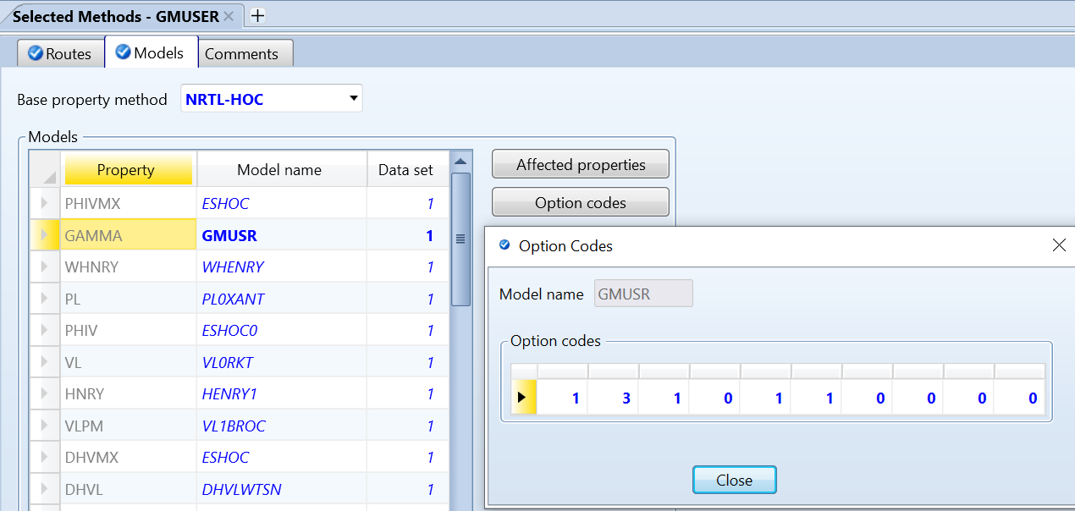

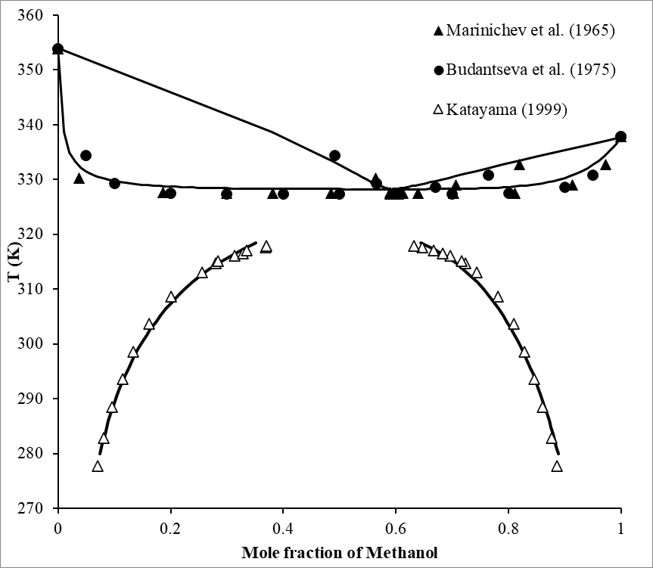
Experimental Data plotted in the figure:
VLE: Budantseva, L. S.; Lesteva, T. M.; Nemtsov, M. S. Zh. Fiz. Khim., 1975, 49, 260-1 Liquid-vapor equilibriums in methanol-C6 hydrocarbons of different classes
VLE: Marinichev, A. N.; Susarev, M. P. Zh. Prikl. Khim., 1965, 38, 1619
LLE: Katayama, H. Fluid Phase Equilib., 1999, 164, 83-95 Liquid-liquid equilibria of two ternary systems: methanol-cyclohexane including 1,3-dioxolane or 1,4-dioxane in the range of 277.79-308.64 K.
T-xy
MOLEFRAC METHANOL | TOTAL TEMP | LIQUID1 GAMMA METHANOL | LIQUID1 GAMMA CYCLO-01 | VAPOR MOLEFRAC METHANOL | VAPOR PHIMX METHANOL | VAPOR PHIMX CYCLO-01
 | K
0 | 353.9317 | 60.00196 | 1 | 0 |  | 0.962373
0.02 | 334.9717 | 25.68309 | 1.010375 | 0.455282 | 0.972399 | 0.96616
0.04 | 332.1696 | 15.93922 | 1.02618 | 0.508361 | 0.967233 | 0.968561
0.06 | 330.9378 | 11.64115 | 1.043887 | 0.531211 | 0.964939 | 0.969811
0.08 | 330.2221 | 9.200973 | 1.063014 | 0.544598 | 0.963584 | 0.970611
0.1 | 329.7507 | 7.620118 | 1.083418 | 0.553592 | 0.962676 | 0.97118
0.12 | 329.4167 | 6.509104 | 1.105069 | 0.560147 | 0.96202 | 0.97161
0.14 | 329.1637 | 5.683932 | 1.127987 | 0.565255 | 0.961514 | 0.971955
0.16 | 328.9779 | 5.045554 | 1.152209 | 0.569177 | 0.961131 | 0.972227
0.18 | 328.8285 | 4.536658 | 1.177809 | 0.572419 | 0.960819 | 0.972455
0.2 | 328.7122 | 4.120988 | 1.204866 | 0.575104 | 0.960566 | 0.972646
0.22 | 328.6194 | 3.775335 | 1.233433 | 0.577323 | 0.96036 | 0.972807
0.24 | 328.5416 | 3.482076 | 1.263755 | 0.579282 | 0.960183 | 0.97295
0.26 | 328.48 | 3.23101 | 1.295824 | 0.58092 | 0.960037 | 0.97307
0.28 | 328.43 | 3.013295 | 1.329826 | 0.582327 | 0.959914 | 0.973175
0.3 | 328.3896 | 2.822657 | 1.36592 | 0.583539 | 0.959811 | 0.973266
0.32 | 328.3569 | 2.654321 | 1.404285 | 0.584587 | 0.959724 | 0.973345
0.34 | 328.3307 | 2.504583 | 1.445118 | 0.585495 | 0.959651 | 0.973413
0.36 | 328.3096 | 2.370529 | 1.488643 | 0.586283 | 0.959589 | 0.973473
0.38 | 328.2927 | 2.249832 | 1.535108 | 0.586969 | 0.959536 | 0.973526
0.4 | 328.2793 | 2.140614 | 1.584794 | 0.58757 | 0.959491 | 0.973572
0.42 | 328.2686 | 2.04134 | 1.638016 | 0.588102 | 0.959453 | 0.973613
0.44 | 328.2601 | 1.950746 | 1.695126 | 0.588578 | 0.959419 | 0.973649
0.46 | 328.2533 | 1.867781 | 1.756527 | 0.589014 | 0.959389 | 0.973683
0.48 | 328.2478 | 1.791566 | 1.822671 | 0.589427 | 0.959362 | 0.973715
0.5 | 328.2432 | 1.721359 | 1.894072 | 0.589831 | 0.959336 | 0.973747
0.52 | 328.2395 | 1.656528 | 1.971316 | 0.590247 | 0.95931 | 0.973779
0.54 | 328.2365 | 1.596538 | 2.055071 | 0.590695 | 0.959283 | 0.973814
0.56 | 328.2342 | 1.540928 | 2.146103 | 0.591198 | 0.959254 | 0.973854
0.58 | 328.2329 | 1.489302 | 2.245289 | 0.591784 | 0.959221 | 0.9739
0.6 | 328.2327 | 1.441319 | 2.353643 | 0.592486 | 0.959183 | 0.973956
0.62 | 328.2344 | 1.396683 | 2.472335 | 0.593344 | 0.959139 | 0.974024
0.64 | 328.2386 | 1.355141 | 2.602723 | 0.594403 | 0.959086 | 0.974108
0.66 | 328.2466 | 1.31647 | 2.746386 | 0.595722 | 0.959023 | 0.974214
0.68 | 328.26 | 1.280481 | 2.905168 | 0.597371 | 0.958948 | 0.974346
0.7 | 328.2807 | 1.247011 | 3.081227 | 0.599435 | 0.958858 | 0.974512
0.72 | 328.3117 | 1.21592 | 3.277099 | 0.602024 | 0.958751 | 0.974721
0.74 | 328.3566 | 1.18709 | 3.495766 | 0.605277 | 0.958624 | 0.974986
0.76 | 328.4202 | 1.160426 | 3.74075 | 0.609365 | 0.958473 | 0.97532
0.78 | 328.5091 | 1.13585 | 4.016205 | 0.614513 | 0.958295 | 0.975742
0.8 | 328.6316 | 1.113302 | 4.327039 | 0.621015 | 0.958085 | 0.97628
0.82 | 328.7988 | 1.092742 | 4.679033 | 0.629255 | 0.957841 | 0.976965
0.84 | 329.0256 | 1.074148 | 5.078965 | 0.639749 | 0.957559 | 0.977845
0.86 | 329.3319 | 1.057516 | 5.534706 | 0.653197 | 0.957237 | 0.978983
0.88 | 329.744 | 1.042863 | 6.055243 | 0.670566 | 0.95688 | 0.980469
0.9 | 330.2982 | 1.030224 | 6.650538 | 0.693227 | 0.956499 | 0.98243
0.92 | 331.0433 | 1.019658 | 7.331065 | 0.723141 | 0.956124 | 0.985058
0.94 | 332.0461 | 1.011243 | 8.106734 | 0.763189 | 0.955825 | 0.988642
0.96 | 333.3981 | 1.005082 | 8.984778 | 0.817693 | 0.955746 | 0.993634
0.98 | 335.2229 | 1.001292 | 9.965999 | 0.893246 | 0.956189 | 1.000767
1 | 337.6848 | 1 | 11.03886 | 1 | 0.957769

LLE:
TEMP | LIQUID1 GAMMA METHANOL | LIQUID1 GAMMA CYCLO-01 | LIQUID2 GAMMA METHANOL | LIQUID2 GAMMA CYCLO-01 | LIQUID1 MOLEFRAC METHANOL | LIQUID2 MOLEFRAC METHANOL
K
315.578 | 2.97085 | 1.37577 | 1.27397 | 3.16654 | 0.298033 | 0.695019
315 | 3.07524 | 1.35785 | 1.26151 | 3.25069 | 0.28824 | 0.702692
314 | 3.24974 | 1.33157 | 1.243 | 3.39015 | 0.273304 | 0.714542
313 | 3.43555 | 1.30746 | 1.22592 | 3.5349 | 0.259004 | 0.725909
312 | 3.60184 | 1.28896 | 1.21 | 3.68624 | 0.247553 | 0.736904
311 | 3.78768 | 1.2706 | 1.19694 | 3.82752 | 0.235845 | 0.746334
310 | 3.97652 | 1.25424 | 1.18509 | 3.96997 | 0.225058 | 0.755182
309 | 4.17116 | 1.23933 | 1.17456 | 4.11068 | 0.214941 | 0.763316
308 | 4.3701 | 1.22583 | 1.16494 | 4.25233 | 0.205519 | 0.770974
307 | 4.57441 | 1.21348 | 1.15613 | 4.39497 | 0.19668 | 0.778198
306 | 4.78422 | 1.20216 | 1.14805 | 4.53824 | 0.188375 | 0.785004
305 | 4.99949 | 1.19174 | 1.14057 | 4.68314 | 0.180565 | 0.791478
304 | 5.22061 | 1.18212 | 1.1337 | 4.82832 | 0.173201 | 0.797577
303 | 5.44811 | 1.17319 | 1.12735 | 4.97451 | 0.166236 | 0.803366
302 | 5.68174 | 1.16491 | 1.12144 | 5.12204 | 0.159653 | 0.80888
301 | 5.92379 | 1.15713 | 1.11606 | 5.26804 | 0.153364 | 0.814019
300 | 6.16808 | 1.15002 | 1.11077 | 5.42132 | 0.147518 | 0.819163
299 | 6.41914 | 1.14337 | 1.10584 | 5.5759 | 0.141965 | 0.82407
298 | 6.68051 | 1.13704 | 1.10141 | 5.72741 | 0.136609 | 0.828597
297 | 6.94764 | 1.13115 | 1.09718 | 5.88213 | 0.131547 | 0.832995
296 | 7.2199 | 1.12565 | 1.09312 | 6.04086 | 0.126768 | 0.837292
295 | 7.49947 | 1.12049 | 1.08931 | 6.20077 | 0.122215 | 0.8414
294 | 7.78726 | 1.1156 | 1.08578 | 6.36088 | 0.11786 | 0.8453
293 | 8.08203 | 1.111 | 1.08243 | 6.52308 | 0.113715 | 0.84906
292 | 8.38379 | 1.10667 | 1.07926 | 6.68741 | 0.109768 | 0.852689
291 | 8.69253 | 1.10258 | 1.07625 | 6.85392 | 0.106008 | 0.856192
290 | 9.0082 | 1.09873 | 1.0734 | 7.02267 | 0.102425 | 0.859576
289 | 9.33076 | 1.09508 | 1.07068 | 7.1937 | 0.09901 | 0.862849
288 | 9.6601 | 1.09164 | 1.0681 | 7.36709 | 0.095754 | 0.866014
287 | 9.99612 | 1.08839 | 1.06564 | 7.54288 | 0.092648 | 0.869078
286 | 10.3386 | 1.08531 | 1.0633 | 7.72115 | 0.089687 | 0.872046
285 | 10.6875 | 1.0824 | 1.06107 | 7.90195 | 0.086863 | 0.874922
284 | 11.0424 | 1.07965 | 1.05893 | 8.08535 | 0.08417 | 0.87771
283 | 11.4032 | 1.07704 | 1.0569 | 8.27142 | 0.081601 | 0.880415
282 | 11.7694 | 1.07457 | 1.05495 | 8.46024 | 0.079151 | 0.883041
281 | 12.1408 | 1.07223 | 1.05309 | 8.65186 | 0.076816 | 0.885591
280 | 12.5168 | 1.07001 | 1.05131 | 8.84637 | 0.07459 | 0.888068

Excess Gibbs Energy and Excess Enthalpy at 323.15 K
MOLEFRAC METHANOL | LIQUID DGMIX | LIQUID GAMMA METHANOL | LIQUID GAMMA CYCLO-01 | LIQUID HXS
 | kJ/kmol |  |  | kJ/kmol
0 | 0 |  | 1 | 0
0.02 | -51.7844 | 29.2044 | 1.01158 | 263.783
0.04 | -75.0004 | 17.1619 | 1.0278 | 415.229
0.06 | -92.2718 | 12.2905 | 1.0458 | 537.054
0.08 | -106.416 | 9.61526 | 1.06518 | 642.702
0.1 | -118.546 | 7.91288 | 1.08583 | 737.54
0.12 | -129.245 | 6.72986 | 1.10773 | 824.343
0.14 | -138.864 | 5.85783 | 1.1309 | 904.747
0.16 | -147.636 | 5.18725 | 1.15539 | 979.801
0.18 | -155.726 | 4.65487 | 1.18128 | 1050.21
0.2 | -163.258 | 4.22152 | 1.20865 | 1116.46
0.22 | -170.327 | 3.86165 | 1.2376 | 1178.89
0.24 | -177.009 | 3.55784 | 1.26824 | 1237.75
0.26 | -183.367 | 3.29782 | 1.30072 | 1293.22
0.28 | -189.452 | 3.07268 | 1.33518 | 1345.39
0.3 | -195.307 | 2.87578 | 1.37178 | 1394.33
0.32 | -200.971 | 2.70209 | 1.41071 | 1440.08
0.34 | -206.477 | 2.54772 | 1.45217 | 1482.64
0.36 | -211.851 | 2.40962 | 1.4964 | 1521.98
0.38 | -217.12 | 2.28534 | 1.54366 | 1558.06
0.4 | -222.303 | 2.17294 | 1.59424 | 1590.8
0.42 | -227.419 | 2.07081 | 1.64848 | 1620.12
0.44 | -232.483 | 1.97763 | 1.70673 | 1645.91
0.46 | -237.508 | 1.89232 | 1.76943 | 1668.06
0.48 | -242.502 | 1.81396 | 1.83705 | 1686.43
0.5 | -247.471 | 1.74179 | 1.91013 | 1700.87
0.52 | -252.417 | 1.67514 | 1.98928 | 1711.22
0.54 | -257.339 | 1.61348 | 2.07523 | 1717.28
0.56 | -262.23 | 1.55632 | 2.16876 | 1718.88
0.58 | -267.079 | 1.50325 | 2.27083 | 1715.79
0.6 | -271.868 | 1.45393 | 2.38251 | 1707.8
0.62 | -276.572 | 1.40805 | 2.50505 | 1694.65
0.64 | -281.157 | 1.36535 | 2.63992 | 1676.09
0.66 | -285.58 | 1.32561 | 2.78882 | 1651.84
0.68 | -289.782 | 1.28862 | 2.95375 | 1621.61
0.7 | -293.691 | 1.25423 | 3.1371 | 1585.09
0.72 | -297.214 | 1.22229 | 3.34168 | 1541.94
0.74 | -300.234 | 1.19267 | 3.57084 | 1491.81
0.76 | -302.6 | 1.16528 | 3.82863 | 1434.33
0.78 | -304.124 | 1.14004 | 4.11991 | 1369.11
0.8 | -304.561 | 1.11689 | 4.45059 | 1295.71
0.82 | -303.596 | 1.09578 | 4.82792 | 1213.71
0.84 | -300.814 | 1.07668 | 5.26081 | 1122.62
0.86 | -295.663 | 1.05959 | 5.76031 | 1021.94
0.88 | -287.388 | 1.04452 | 6.34027 | 911.153
0.9 | -274.921 | 1.0315 | 7.01817 | 789.687
0.92 | -256.684 | 1.02058 | 7.81624 | 656.949
0.94 | -230.183 | 1.01184 | 8.76311 | 512.304
0.96 | -191.018 | 1.00539 | 9.89599 | 355.081
0.98 | -129.639 | 1.00139 | 11.2638 | 184.566
1 | 0 | 1 |  | 0

Understanding Debugging Information
Debug information which has been outputted to the history file (.his) is available to permit users to double-check the parameters being used in the calculations. If parameters are missing, Aspen sets the values to 1E35 or zero.
To generate the debug information, set kop(1) > 0 (section 2.6). After running the case, view the history file locate the icon on the Home ribbon and search for ‘GMU ver’. The output occurs each time an activity coefficient calculation occurs, so debugging should be used sparingly and disabled after confirming the parameters.
When matrices are outputted, they are generally listed by column because that is the default storage convention in FORTRAN.
Below is an example from the methanol + cyclohexane system at 323.15K using the PC-SAFT parameters above with debug level 2. With debug level 1, the table of gamma contributions is printed, but not the complete set of parameters.
------------------------------------------------------------------------------------------------------------------------
GMU - Print debug info. Start of func call. GMU version 2.6.5rel
GMUSR Option codes 2 3 1 0 1 1 0 0 0 0
KCALC, N, T, P = 1 2 323.150 0.101325E+06
*** Aspen Component Identifiers
1 METHANOL
3 CYCLO-01
Component id, m, sigma, epsok
1 1.5255 3.2300 188.90
3 2.5305 3.8499 278.11
Component id, volume and covolume
volume and covolume
1 41.890 30.900
3 112.18 90.380
*** GMNRTL Physical aij
0.0000 0.22443 -2.9341 0.0000
*** GMNRTL Physical bij
0.0000 -296.12 1332.2 0.0000
*** GMNRTL Physical alpha
0.0000 0.30000 0.30000 0.0000
*** GMNRTL Physical tau
0.0000 -0.69193 1.1885 0.0000
*** GMNRTL - User Site in Aspen Simulation (subset may be used)
1 A1ME 4750
2 D1ME 4500
Sites Present: site present in call, site in Aspen file, id, name, host, host x
1 1 4750 A1ME 1 0.50000
2 2 4500 D1ME 1 0.50000
Site1, Site2, index1, index2, Keps, eps, kad
A1ME A1ME 1 1 0.0000 0.0000 0.0000
D1ME A1ME 2 1 277.30 2899.5 0.35176E-01
A1ME D1ME 1 2 277.30 2899.5 0.35176E-01
D1ME D1ME 2 2 0.0000 0.0000 0.0000
Site hosts-----------------
1 1
Site name
A1ME D1ME
Site fractions, in order of sites
0.09076 0.09076
del matrix by row
0.0000 17006.
17006. 0.0000
Pure component-------------
Site name
D1ME A1ME
Site fractions, in order of sites
0.04877 0.04877
del matrix by row
0.0000 16755.
16755. 0.0000
*** Combinatorial Method: Flory using molar volume^(2/3)
*** GAMMA RESULTS
KCALC, N, T, P = 1 2 323.150 0.101325E+06
I NAME X lnGAMMAres lnGAMMAcomb lnGAMMAcombcorr lnGAMMAw lnGAMMA dlnGAMMA
1 METHANOL 0.500000 0.077267 -0.064281 0.000000 0.541924 0.554911 0.000000
3 CYCLO-01 0.500000 0.030408 -0.041654 0.000000 0.658415 0.647169 0.000000
End of function call
************************************************************************************************************************
When using kop(1) = 3, all of the user parameters and many of the intermediate calculations are printed to the history file. Additionally, the files gammas.csv, hxs.csv and vol.csv are created. The output provides contributions to the activity coefficients, the enthalpy of mixing and molar volumes. This option appends calculations every time that the gamma routine is called, so the file can grow very large if the case involves a lot of gamma calculations. The program runs slowly when kop(1) = 3. We recommend using this level of debugging only for isothermal property calculations such as binary excess Gibbs energy. Then turn down/off the debugging information for normal runs.

Reading gammas.csv
The columns in gammas.csv are as follows: T(K), P(Pa), Aspen component index for the order entered in components list, component name, ln(gamma_res), ln(gamma_comb), ln(gamma_comb_correction), ln(gamma_wertheim), ln(gamma), d(ln(gamma))/dT where T is in K.
The columns for components are repeated for each component in the function call. Aspen will sometimes change the order of components in the function call, which results in a change in order of the component columns. To see temperature derivatives, perform a calculation such an excess enthalpy calculation and view the hxs.csv file.

Reading hxs.csv
The columns in hxs.csv give the contributions to the partial molar excess enthalpy and are as follows: T(K), P(Pa), Aspen component index for the order entered in components list, component name,
-RTd(ln(gamma_res))/dT, -RTd(ln(gamma_comb))/dT, -RTd(ln(gamma_comb_correction))/dT,
-RTd(ln(gamma_wertheim))/dT, -RTd(ln(gamma))/dT, d(ln(gamma))/dT where R is in J/mol-K, and T is in K for all rows.
The columns for components are repeated for each component in the function call. Aspen will sometimes change the order of components in the function call, which results in a change in order of the component columns.

Reading vol.csv
The columns in vol.csv are as follows:
T(K), ideal solution mixture molar volume (cm³/mol), then for each component: id, name, component molar volume (cm³/mol)

Appendix A – Model details
The NRTL residual model uses:
$$G_{ij}=\exp\left({-α}_{ij}τ_{ij}\right)$$
$τ_{ij}=a_{ij}+b_{ij}/T$ ; $α_{ij}=α_{ji}=c_{ij}$. GMNRTL parameters are $a_{ij}, b_{ij}, c_{ij}$

Appendix B – Conversion of CPA values

Pure Compound Parameters for the CPA Equations of State
This appendix summarizes CPA parameters from literature and conversion to units used with the user model.
For components that self-associate:
$$KAD=β_{CPA}^{AD}*b_{CPA}\left(\frac{cm3}{mol}\right)$$
$$EPS= ε^{AD}/k(K)$$
For cross-association, the user enters the desired values of the cross interactions directly, so any custom value can be used. For cross-interactions of similar compounds, such as two alcohols, Elliott’s combining rules (ECR) can be used:
$$Δ^{A_{i}D_{j}}=\sqrt{Δ^{A_{i}D_{i}}Δ^{A_{j}D_{j}}}$$
We suggest a modification relative to CPA. The original combining rule includes the radial distribution function of the pure components i and j and calculates their geometric means. However, this removes the compositional dependence of the association strength term. Therefore, we suggest the rule as follows:
$$Δ^{A_{i}D_{j}}=g(σ)\sqrt{\frac{Δ^{A_{i}D_{i}}}{{g(σ}_{i})}\frac{Δ^{A_{j}D_{j}}}{{g(σ}_{j})}}$$
To accomplish this, we suggest the following parameters for cross-association when the associating sites are the same type (e.g. hydroxyls), and assume that $\exp\left(\frac{ε^{AD}}{RT}\right)-1 ≅\exp\left(\frac{ε^{AD}}{RT}\right)$:
$$KAD=KA_{i}D_{j}=\sqrt{KA_{i}D_{i}*KA_{j}D_{j}}$$
$$EPS=EPS_{ij}=\frac{ε^{A_{i}D_{i}}+ε^{A_{j}D_{j}}}{2k}$$

References
[1] A.M. Bala Ahmed, Fundamental Studies and Engineering Modeling of Hydrogen Bonding, Ph.D. Thesis, Michigan State University, 2018.
[2] G.M. Kontogeorgis, G.K. Folas, Chapter 9, Appendix A, in: Thermodynamic Models for Industrial Applications: From Classical and Advanced Mixing Rules to Association Theories, John Wiley & Sons, 2009. https://www.wiley.com/go/kontogeorgis.
[3] I.G. Economou, G.D. Ikonomou, P. Vimalchand, M.D. Donohue, Thermodynamics of Lewis acid-base mixtures, AIChE Journal. 36 (1990) 1851–1864. https://doi.org/10.1002/aic.690361209.

