Documentation for Wertheim Gamma Model
Documentation Version 5.1
Corresponds to gmu.dll version 2.6.3
Oct 30, 2020

Carl T. Lira
Aseel M. Bala
William G. Killian
Lars Peereboom
Michigan State University

Overview
This is the MSU set of documentation intended for internal use. This holds only the parts of the documentation that are not included in the release version.

Debug Options (kop(1))
kop(1) == 0: no debug printing
kop(1) == 1: debug printing of gamma contributions and .dll version
kop(1) == 2: includes printing of X, rho, deltas, in addition to the content above
kop(1) == 3: includes printing of delta matrix indexes and gamma output to gammas.csv as well partial molar enthalpies to hxs.csv, in addition to the content above

Radial Distribution function (kop(2))
kop(2) == 0: VdW
kop(2) == 1: ESD
kop(2) == 2: CPA (ESD with packing factor divided by four)
kop(2) == 3: SAFT

Pure Component Liquid Volume (kop(3))
kop(3) == 0: standard liquid volume
kop(3) == 1: temperature-dependent volume

Residual Model (kop(4))
kop(4) == 0: NRTL, parameters should be entered as GMNRTL
kop(4) == 1: Wilson, parameters should be entered as GMUW
kop(4) == 2: Scatchard-Hildebrand, parameters should be entered as GMUSH
kop(4) == 3: Nagata, parameters should be entered as GMUNAG

Combinatorial Correction (kop(5))
* Ignored when kop(4) == 1 or when kop(6) == 2
kop(5) == 0: VdW with standard covolumes (calculated by UNIQUACR*15.17)
kop(5) == 1: None
kop(5) == 2: Staverman-Guggenheim
kop(5) == 3: VdW with COVOL value

Combinatorial Term (kop(6))
* Ignored when kop(4) == 1
kop(6) == 0: Flory
kop(6) == 1: Flory with modified volume (V^{2/3})
kop(6) == 2: None

Create User Parameters
Locate the Customize folder on the left hand side and enter the four variables as follows; please note that these variable names MUST be used.

Covolume
COVOL, molecular CPA covolume (cm³/mol) or the VdW covolume (cm³/mol). The parameter usage is controlled by GMUSR option codes kop(2) and kop(5). Pure component, one element.
For VdW, $g\left(σ\right)=1/(1-η_{p})$. For ESD, $g\left(σ\right)=1/(1-{1.9η}_{p})$, for CPA $g\left(σ\right)=1/(1-{1.9η}_{p}/4)$. The correct covolume is important.
The covolume parameters are not used for $g(σ)$ for the SAFT method, but can still be used for combinatorial correction.

Physical Model Parameters
Parameters are needed only for the model which has been specified using GMUSR option code kop(4). Each of these are binary interaction parameters with the specified number of elements.
NOTE: The parameters are required ONLY for the residual model that will be used as determined by the GMUSR option codes.
- GMNRTL: specify three elements; The elements correspond to NRTL parameters $τ_{ij}=a_{ij}+b_{ij}/T\left(K\right)$; third parameter is $α_{ij}$
- GMUSH: specify two elements; The elements correspond to Scatchard-Hildebrand parameters, $A_{ij}\left(T\right)=a_{ij}T+b_{ij}$
- GMUW: specify two elements; The elements correspond to Wilson parameters, $\ln{Λ_{ij}}=a_{ij}+b_{ij}/T$
- GMUNAG: specify two elements; The elements correspond to Nagata1 parameters, $τ_{ij}=\exp{(a_{ij}+b_{ij}/T)}$

Wertheim Parameters

CPA
KAD is the CPA bonding volume, in cm³/mol. UNIFAC group interaction, one element.
EPS is the CPA enthalpy of bonding, eps/k in Kelvin. UNIFAC group interaction, one element.
$$Δ_{ij}=g\left(σ\right)K_{ij}^{AD}(\exp\left(\frac{ϵ_{ij}^{AD}}{kT}\right)-1)$$

SAFT
KADPCS is the SAFT bonding volume parameter (dimensionless). UNIFAC group interaction, one element.
EPSPCS is the SAFT enthalpy of bonding, eps/k in Kelvin. UNIFAC interaction, one element.
$$Δ_{ij}=g_{ij}\left(d\right){d_{ij}^{3}κ}_{ij}^{AD}(\exp\left(\frac{ϵ_{ij}^{AD}}{kT}\right)-1)$$
The diameter is temperature-dependent
$$d_{ij}\left(T\right)=σ_{ij}\left(1-0.12\exp\left(-\frac{3ϵ_{ij}}{kT}\right)\right)$$
where $ϵ$ is the physical energy and $σ_{ij}$ is the cross diameter using the combining rules
$σ_{ij}=(σ_{i}+σ_{j})/2$ and $ϵ_{ij}=\sqrt{ϵ_{i}ϵ_{j}}$
The radial distribution function is
$$g_{ij}^{hs}=\frac{1}{1-ζ_{3}}+\left(\frac{d_{i}d_{j}}{d_{i}+d_{j}}\right)\frac{3ζ_{2}}{{\left(1-ζ_{3}\right)}^{2}}+{\left(\frac{d_{i}d_{j}}{d_{i}+d_{j}}\right)}^{2}\frac{2ζ_{2}^{2}}{{\left(1-ζ_{3}\right)}^{3}}$$
where
$$ζ_{n}=\frac{π}{6}ρ\sum_{i}{x_{i}m_{i}d_{i}^{n}} n∈\left\{2,3\right\}$$
the component columns.

Appendix A – Model details
The NRTL residual model uses:
$$G_{ij}=\exp\left({-α}_{ij}τ_{ij}\right)$$
$τ_{ij}=a_{ij}+b_{ij}/T$ ; $α_{ij}=α_{ji}=c_{ij}$. GMNRTL parameters are $a_{ij}, b_{ij}, c_{ij}$
The Wilson residual model uses:
$$\ln{Λ_{ij}}=a_{ij}+b_{ij}/T$$
GMUW parameters are $a_{ij}, b_{ij}$.
Note that the Wilson equation already includes Flory, so no other choice for combinatorial term is permitted.
The Scatchard-Hildebrand is simplified to evaluate the functional form.
$$G^{E,res}≈U^{E,res}=\left(U-U^{ig}\right)-{(U-U^{ig})}^{is}=V\sum_{i=1}^{n-1}{\sum_{j=i+1}^{n}{φ_{i}φ_{j}A_{ij}}}$$
$$A_{ij}={(δ_{i}-δ_{j})}^{2}+2δ_{i}δ_{j}k_{ij}$$
which we simplify as

$$A_{ij}\left(T\right)=a_{ij}T+b_{ij}$$
The residual gamma is
$$RT\ln{γ_{k}^{res}} =V_{k}(\sum_{i=1}^{n}{φ_{i}A_{ik}-\frac{1}{2}\sum_{i=1}^{n}{\sum_{j=1}^{n}{φ_{i}φ_{j}A_{ij}}})}$$
Note that $A_{ij}/\left(RT\right)=a_{ij}/R+b_{ij}/T$. GMUSH parameters are $a_{ij}, b_{ij}$.
The model that we call Nagata1 is implemented in a similar form as Nagata, et al. [1]. One difference is that Nagata, et al. use $K_{ϕ'}$ rather than $K_{c}$. In their work, the volume fraction is modified to use the Lyngby form of the combinatorial entropy (using $r^{2/3}$). Our code provides an option to use $V^{2/3}$ for the combinatorial term.
The Nagata1 residual model is a variation of Wilson. The Wilson equation can be written as
$$G^{E,wilson}=-\sum_{i}{x_{i}\ln{(\sum_{j}{ϕ_{j}τ_{ij})}}}+\sum_{i}{x_{i}\ln{(ϕ_{i}/x_{i})}}$$
Where $τ_{ij}=\exp{(a_{ij}+b_{ij}/T)}$, and the second sum over i is Flory’s term. We have proven that Wertheim + Flory results in Kc (our 2016 paper). Nagata wrote
$$G^{E,nagata1}=-\sum_{i}{x_{i}\ln{(\sum_{j}{ϕ_{j}τ_{ij})}}}$$
and then used $K_{ϕ}^{'}=Π{\left(ϕ_{i}^{'}\right)}^{ν_{i}}$, where $ϕ_{i}^{'}=r_{i}^{2/3}/\sum_{k}{r_{k}^{2/3}}.$ Further, we have proven that using the Lyngby-modified Flory results in the same form of the activity coefficient equation as Nagata except for the chemical term (unpublished). Use of the Modified Flory results in the same form as Flory’s equation for the combinatorial term but replacing the volume with $V^{2/3}.$ We therefore provide the Lyngby version of the modified combinatorial term. The form of Natata1 results in
$$\ln{γ_{k}^{res}}=-\ln\left(\sum_{j}{ϕ_{j}τ_{jk}}\right)+\frac{ϕ_{k}}{x_{k}}-\sum_{i}{\frac{ϕ_{k}τ_{ki}\left(x_{i}/x_{k}\right)}{\sum_{j}{ϕ_{j}τ_{ji}}}}=-\ln\left(\sum_{j}{ϕ_{j}τ_{jk}}\right)+\frac{V_{k}}{V}\left(1-\sum_{i}{\frac{{x_{i}τ}_{ki}}{\sum_{j}{ϕ_{j}τ_{ji}}}}\right)$$
$τ_{ij}=a_{ij}+b_{ij}/T$ . GMUT parameters are $a_{ij}, b_{ij}.$

Additional Examples for Methanol + Cyclohexane
Binary case: Methanol-Cyclohexane (VLE, LLE), MEOH-HEP-CYC.bkp
This section summarizes details for additional models. Parameter values are used from sections 3.1.1-3.3.2. The cases us database PURE35, HOCETA for MeOH = 1.63.
We show results for three models:
    - Wilson + Staverman-Guggenheim + Wertheim
    - Scatchard Hildebrand (modified) +Flory + Staverman-Guggenheim + Wertheim
    - Nagata1 + Modified Flory + Wertheim

Wilson (+ Flory) + Staverman-Guggenheim + Wertheim
Note that the Wilson equation already includes Flory, so no other choice for combinatorial term is permitted.
To use Wilson for the residual term,
- Set the gamma model option kop(4) ==1 (see section 2.6):
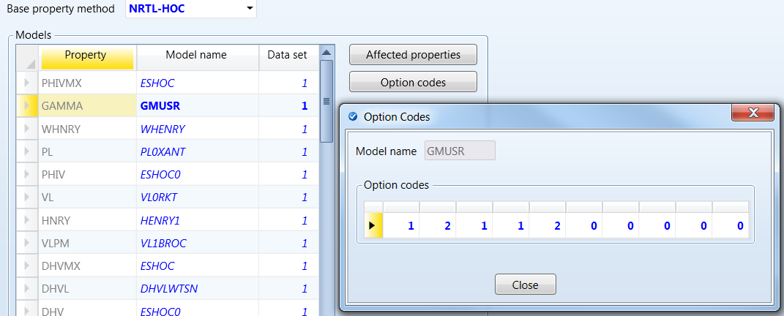
- Create the parameter ‘GMUW’ (see section 2.8) as a two-element parameter and set with the following values:
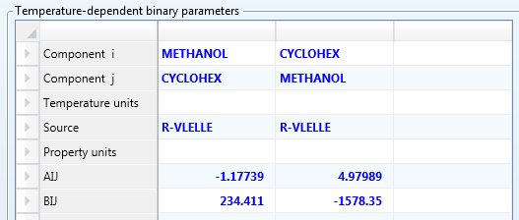
Results at 298.15K, no flash
MOLEFRAC METHANOL | LIQUID HXS | LIQUID GAMMA METHANOL | LIQUID GAMMA CYCLO | LIQUID DGMIX
 | kJ/kmol |  |  | kJ/kmol
0 | 0 |  | 1 | 0
0.02 | 229.171 | 33.4445 | 1.01164 | -40.9091
0.04 | 352.593 | 19.5682 | 1.028 | -55.7244
0.06 | 448.351 | 13.958 | 1.04622 | -65.2688
0.08 | 529.156 | 10.8783 | 1.06592 | -72.1327
0.1 | 600.115 | 8.91946 | 1.08698 | -77.3405
0.12 | 663.892 | 7.55894 | 1.10939 | -81.4267
0.14 | 722.085 | 6.5567 | 1.13318 | -84.7144
0.16 | 775.735 | 5.78652 | 1.15841 | -87.4181
0.18 | 825.566 | 5.17552 | 1.18517 | -89.6902
0.2 | 872.097 | 4.67861 | 1.21354 | -91.6443
0.22 | 915.715 | 4.26632 | 1.24365 | -93.3687
0.24 | 956.713 | 3.91859 | 1.27562 | -94.9341
0.26 | 995.315 | 3.62127 | 1.3096 | -96.3987
0.28 | 1031.69 | 3.36409 | 1.34576 | -97.8115
0.3 | 1065.98 | 3.13941 | 1.38429 | -99.2143
0.32 | 1098.27 | 2.94142 | 1.42539 | -100.644
0.34 | 1128.63 | 2.76564 | 1.46931 | -102.132
0.36 | 1157.12 | 2.60854 | 1.51631 | -103.708
0.38 | 1183.76 | 2.46731 | 1.56669 | -105.398
0.4 | 1208.56 | 2.33969 | 1.62079 | -107.224
0.42 | 1231.5 | 2.22383 | 1.67901 | -109.208
0.44 | 1252.57 | 2.11822 | 1.74179 | -111.37
0.46 | 1271.71 | 2.02158 | 1.80962 | -113.725
0.48 | 1288.86 | 1.93287 | 1.88308 | -116.29
0.5 | 1303.95 | 1.8512 | 1.96283 | -119.078
0.52 | 1316.87 | 1.77581 | 2.04964 | -122.1
0.54 | 1327.51 | 1.70605 | 2.14439 | -125.364
0.56 | 1335.72 | 1.64138 | 2.2481 | -128.877
0.58 | 1341.35 | 1.58133 | 2.36198 | -132.641
0.6 | 1344.2 | 1.52548 | 2.48742 | -136.656
0.62 | 1344.05 | 1.47349 | 2.62607 | -140.915
0.64 | 1340.64 | 1.42504 | 2.77991 | -145.407
0.66 | 1333.7 | 1.37988 | 2.95127 | -150.114
0.68 | 1322.87 | 1.33778 | 3.14295 | -155.009
0.7 | 1307.78 | 1.29854 | 3.35832 | -160.052
0.72 | 1287.99 | 1.26199 | 3.6015 | -165.192
0.74 | 1262.98 | 1.228 | 3.87749 | -170.357
0.76 | 1232.18 | 1.19645 | 4.19248 | -175.452
0.78 | 1194.91 | 1.16725 | 4.55417 | -180.349
0.8 | 1150.39 | 1.14032 | 4.97219 | -184.879
0.82 | 1097.72 | 1.11563 | 5.45875 | -188.814
0.84 | 1035.83 | 1.09315 | 6.02944 | -191.843
0.86 | 963.489 | 1.07288 | 6.70447 | -193.541
0.88 | 879.244 | 1.05485 | 7.51026 | -193.305
0.9 | 781.376 | 1.03912 | 8.48188 | -190.259
0.92 | 667.844 | 1.02579 | 9.66653 | -183.074
0.94 | 536.207 | 1.01498 | 11.1288 | -169.597
0.96 | 383.528 | 1.0069 | 12.9584 | -145.939
0.98 | 206.244 | 1.00179 | 15.2829 | -103.489
1 | 0 | 1 |  | 0

With these values, you can now run a binary analysis of methanol+cyclohexane and generate the following VLE and LLE data points with the model:
y_MeOH | x_MeOH | K
0 | 0 | 353.932
0.39731 | 0.02 | 338.053
0.476593 | 0.04 | 334.124
0.511269 | 0.06 | 332.325
0.5313 | 0.08 | 331.278
0.544627 | 0.1 | 330.589
0.554027 | 0.12 | 330.112
0.561132 | 0.139981 | 329.761
0.566742 | 0.16 | 329.492
0.571205 | 0.18 | 329.286
0.574835 | 0.2 | 329.125
0.577856 | 0.22 | 328.997
0.580319 | 0.24 | 328.895
0.582463 | 0.26 | 328.815
0.584303 | 0.28 | 328.748
0.585848 | 0.3 | 328.695
0.586886 | 0.32 | 328.664
0.588285 | 0.34 | 328.62
0.589323 | 0.36 | 328.59
0.590114 | 0.38 | 328.571
0.590859 | 0.4 | 328.554
0.59153 | 0.42 | 328.54
0.592113 | 0.44 | 328.529
0.592934 | 0.46 | 328.516
0.593179 | 0.48 | 328.513
0.593688 | 0.5 | 328.507
0.594127 | 0.52 | 328.503
0.594768 | 0.54 | 328.498
0.595415 | 0.56 | 328.494
0.596091 | 0.58 | 328.493
0.596921 | 0.6 | 328.492
0.597918 | 0.62 | 328.493
0.599118 | 0.64 | 328.498
0.600591 | 0.66 | 328.506
0.602362 | 0.68 | 328.519
0.604633 | 0.7 | 328.542
0.607437 | 0.72 | 328.574
0.61076 | 0.740006 | 328.618
0.615161 | 0.76 | 328.685
0.620526 | 0.78 | 328.776
0.62728 | 0.8 | 328.9
0.635729 | 0.82 | 329.07
0.646466 | 0.84 | 329.299
0.660158 | 0.86 | 329.609
0.677802 | 0.88 | 330.018
0.700622 | 0.9 | 330.569
0.730644 | 0.92 | 331.306
0.770573 | 0.94 | 332.292
0.824418 | 0.96 | 333.609
0.898053 | 0.98 | 335.363
1 | 1 | 337.685

LLE at 3 bar
K | x_Mea | x_Meb
280 | 0.074453 | 0.887216
281 | 0.076742 | 0.884928
282 | 0.07913 | 0.882564
283 | 0.08162 | 0.880119
284 | 0.084218 | 0.87759
285 | 0.08693 | 0.874973
286 | 0.089761 | 0.872264
287 | 0.092718 | 0.869457
288 | 0.095807 | 0.866548
289 | 0.099035 | 0.863531
290 | 0.102411 | 0.860401
291 | 0.105944 | 0.85715
292 | 0.109643 | 0.853773
293 | 0.113516 | 0.850261
294 | 0.117576 | 0.846606
295 | 0.121834 | 0.8428
296 | 0.126305 | 0.838832
297 | 0.131002 | 0.834692
298 | 0.135941 | 0.830367
298.15 | 0.136704 | 0.829701
299 | 0.141141 | 0.825844
300 | 0.14662 | 0.821109
301 | 0.152398 | 0.816143
302 | 0.158496 | 0.810925
303 | 0.164902 | 0.805399
304 | 0.17174 | 0.799617
305 | 0.179002 | 0.793517
306 | 0.186718 | 0.78706
307 | 0.194898 | 0.780185
308 | 0.203539 | 0.772791
309 | 0.212839 | 0.764943
310 | 0.222865 | 0.756559
311 | 0.233503 | 0.747421
312 | 0.24494 | 0.737485
313 | 0.257372 | 0.726286
314 | 0.270849 | 0.714159
315 | 0.28656 | 0.701409
316 | 0.302871 | 0.686001
317 | 0.322615 | 0.669649
318 | 0.344936 | 0.650487
319 | 0.365479 | 0.620584

Scatchard Hildebrand + Flory + Staverman-Guggenheim + Wertheim
To use Scatchard Hildebrand for the residual term,
- Set the gamma model option kop(4) ==2 (see section 2.6):
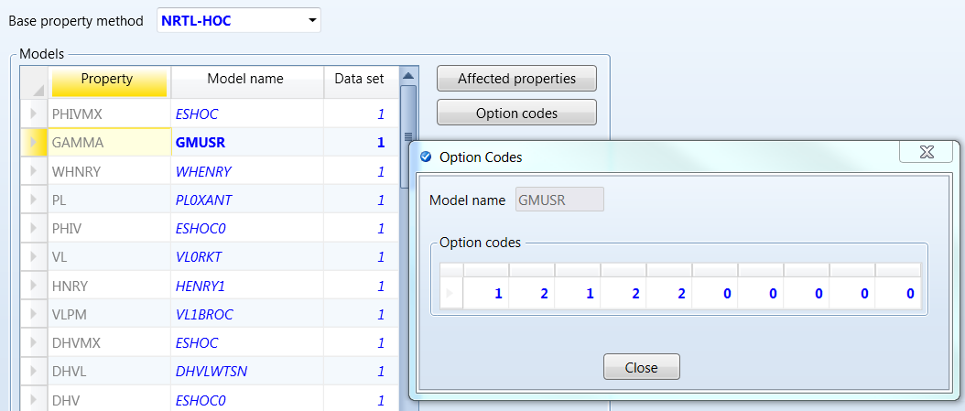
- Create the parameter ‘GMUSH’ and as a two-element parameter (section 2.8) with the following values:
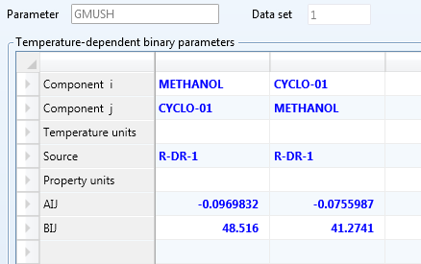
Results at 298.15K, no flash
MOLEFRAC METHANOL | LIQUID HXS | LIQUID GAMMA METHANOL | LIQUID GAMMA CYCLO | LIQUID DGMIX
 | kJ/kmol |  |  | kJ/kmol
0 | 0 |  | 1 | 0
0.02 | 227.281 | 33.3142 | 1.01148 | -41.481
0.04 | 348.262 | 19.5144 | 1.02765 | -56.8068
0.06 | 441.023 | 13.9354 | 1.04564 | -66.7999
0.08 | 518.27 | 10.8729 | 1.06507 | -74.05
0.1 | 585.103 | 8.92483 | 1.08581 | -79.581
0.12 | 644.183 | 7.57168 | 1.10786 | -83.9271
0.14 | 697.103 | 6.57471 | 1.13124 | -87.4107
0.16 | 744.902 | 5.80844 | 1.156 | -90.2463
0.18 | 788.3 | 5.2004 | 1.18223 | -92.5859
0.2 | 827.817 | 4.70573 | 1.21002 | -94.543
0.22 | 863.839 | 4.29516 | 1.23947 | -96.2058
0.24 | 896.66 | 3.94874 | 1.27071 | -97.6453
0.26 | 926.506 | 3.6524 | 1.30388 | -98.9197
0.28 | 953.554 | 3.39593 | 1.33914 | -100.078
0.3 | 977.941 | 3.17173 | 1.37668 | -101.164
0.32 | 999.776 | 2.97403 | 1.4167 | -102.214
0.34 | 1019.14 | 2.79837 | 1.45942 | -103.261
0.36 | 1036.09 | 2.64124 | 1.50512 | -104.335
0.38 | 1050.68 | 2.49986 | 1.55409 | -105.464
0.4 | 1062.94 | 2.37197 | 1.60665 | -106.673
0.42 | 1072.88 | 2.25574 | 1.6632 | -107.985
0.44 | 1080.5 | 2.14965 | 1.72416 | -109.422
0.46 | 1085.79 | 2.05245 | 1.79004 | -111.004
0.48 | 1088.75 | 1.9631 | 1.8614 | -112.75
0.5 | 1089.34 | 1.8807 | 1.93891 | -114.677
0.52 | 1087.53 | 1.80451 | 2.02333 | -116.8
0.54 | 1083.26 | 1.73389 | 2.11555 | -119.135
0.56 | 1076.48 | 1.6683 | 2.2166 | -121.694
0.58 | 1067.13 | 1.60725 | 2.3277 | -124.485
0.6 | 1055.13 | 1.55035 | 2.45029 | -127.517
0.62 | 1040.38 | 1.49725 | 2.58606 | -130.793
0.64 | 1022.79 | 1.44764 | 2.73706 | -134.313
0.66 | 1002.25 | 1.40127 | 2.9057 | -138.07
0.68 | 978.627 | 1.3579 | 3.09494 | -142.05
0.7 | 951.788 | 1.31736 | 3.30834 | -146.231
0.72 | 921.575 | 1.27947 | 3.5503 | -150.578
0.74 | 887.816 | 1.2441 | 3.8262 | -155.039
0.76 | 850.318 | 1.21115 | 4.14279 | -159.543
0.78 | 808.869 | 1.18052 | 4.50852 | -163.989
0.8 | 763.233 | 1.15215 | 4.93411 | -168.236
0.82 | 713.145 | 1.126 | 5.4333 | -172.09
0.84 | 658.313 | 1.10208 | 6.02391 | -175.279
0.86 | 598.411 | 1.08038 | 6.72932 | -177.42
0.88 | 533.072 | 1.06095 | 7.58061 | -177.959
0.9 | 461.887 | 1.04388 | 8.61971 | -176.077
0.92 | 384.399 | 1.02928 | 9.90407 | -170.509
0.94 | 300.09 | 1.01732 | 11.5138 | -159.171
0.96 | 208.376 | 1.00824 | 13.5627 | -138.257
0.98 | 108.597 | 1.00233 | 16.216 | -99.2479
1 | 0 | 1 |  | 0

With these values, you can now run a binary analysis of methanol+cyclohexane and generate the following VLE and LLE data points with the model:

MOLEFRAC METHANOL | TEMP(K) | VAPOR MOLEFRAC METHANOL | LIQUID1 MOLEFRAC METHANOL
0 | 353.932 | 0 | 0
0.02 | 337.26 | 0.413078 | 0.02
0.04 | 333.403 | 0.48949 | 0.04
0.06 | 331.641 | 0.522888 | 0.06
0.08 | 330.611 | 0.542301 | 0.08
0.1 | 329.932 | 0.555246 | 0.1
0.12 | 329.452 | 0.5646 | 0.12
0.14 | 329.094 | 0.571759 | 0.14
0.16 | 328.825 | 0.577332 | 0.16
0.18 | 328.613 | 0.581876 | 0.18
0.2 | 328.448 | 0.585569 | 0.2
0.22 | 328.311 | 0.588765 | 0.22
0.24 | 328.203 | 0.591418 | 0.24
0.26 | 328.116 | 0.593678 | 0.26
0.28 | 328.045 | 0.595612 | 0.28
0.3 | 327.988 | 0.597275 | 0.3
0.32 | 327.943 | 0.598704 | 0.32
0.34 | 327.906 | 0.599932 | 0.34
0.36 | 327.868 | 0.601314 | 0.359906
0.38 | 327.855 | 0.601881 | 0.38
0.4 | 327.838 | 0.602643 | 0.4
0.42 | 327.826 | 0.603283 | 0.42
0.44 | 327.817 | 0.603816 | 0.44
0.46 | 327.81 | 0.604254 | 0.46
0.48 | 327.807 | 0.60461 | 0.48
0.5 | 327.804 | 0.604896 | 0.5
0.52 | 327.803 | 0.605123 | 0.52
0.54 | 327.803 | 0.605307 | 0.54
0.56 | 327.804 | 0.605461 | 0.56
0.58 | 327.805 | 0.605603 | 0.58
0.6 | 327.806 | 0.605754 | 0.6
0.62 | 327.808 | 0.60594 | 0.62
0.64 | 327.81 | 0.606189 | 0.64
0.66 | 327.813 | 0.606542 | 0.66
0.68 | 327.818 | 0.607046 | 0.68
0.7 | 327.827 | 0.607764 | 0.7
0.72 | 327.839 | 0.608775 | 0.72
0.74 | 327.86 | 0.610183 | 0.74
0.76 | 327.89 | 0.612127 | 0.76
0.78 | 327.937 | 0.614789 | 0.78
0.8 | 328.007 | 0.618418 | 0.8
0.82 | 328.109 | 0.623356 | 0.82
0.84 | 328.258 | 0.630079 | 0.84
0.86 | 328.474 | 0.639269 | 0.86
0.88 | 328.788 | 0.651918 | 0.88
0.9 | 329.241 | 0.669528 | 0.9
0.92 | 329.9 | 0.694428 | 0.92
0.94 | 330.863 | 0.730395 | 0.94
0.96 | 332.287 | 0.783856 | 0.96
0.98 | 334.423 | 0.866368 | 0.98
1 | 337.685 | 1 | 1
LLE at 3 bar
K
280 | 0.06513 | 0.879183
281 | 0.068357 | 0.877076
282 | 0.071715 | 0.874913
283 | 0.075209 | 0.872693
284 | 0.078844 | 0.870412
285 | 0.082622 | 0.868067
286 | 0.08655 | 0.865656
287 | 0.090631 | 0.863175
288 | 0.094868 | 0.860618
289 | 0.099271 | 0.857987
290 | 0.103843 | 0.855274
291 | 0.10859 | 0.852476
292 | 0.113517 | 0.849588
293 | 0.118629 | 0.846604
294 | 0.123934 | 0.843519
295 | 0.129438 | 0.840327
296 | 0.135146 | 0.83702
297 | 0.141064 | 0.833589
298 | 0.147196 | 0.830022
298.15 | 0.148135 | 0.829474
299 | 0.153522 | 0.826281
300 | 0.160118 | 0.82242
301 | 0.166958 | 0.818395
302 | 0.174046 | 0.814188
303 | 0.181383 | 0.809774
304 | 0.18896 | 0.805117
305 | 0.196832 | 0.800221
306 | 0.20493 | 0.795009
307 | 0.213486 | 0.789618
308 | 0.222193 | 0.78361
309 | 0.231222 | 0.777071
310 | 0.240786 | 0.770585
311 | 0.250589 | 0.763384
312 | 0.261055 | 0.756261
313 | 0.272261 | 0.748622
314 | 0.283588 | 0.738891
315 | 0.295059 | 0.727103
316 | 0.307417 | 0.713655
317 | 0.321174 | 0.696257
318 | 0.338101 | 0.652499

Nagata1 + Modified Flory + Wertheim

The model should be combined with the Lyngby version of the combinatorial contribution, without any combinatorial correction. We implemented the Lynby version using $V^{2/3}$ rather than $r^{2/3}$

Appendix B – Conversion of CPA values

Pure Compound Parameters for the CPA Equations of State
This appendix summarizes CPA parameters from literature and conversion to units used with the user model.
For components that self-associate:
$$KAD=β_{CPA}^{AD}*b_{CPA}\left(\frac{cm3}{mol}\right)$$
$$EPS= ε^{AD}/k(K)$$
For cross-association, the user enters the desired values of the cross interactions directly, so any custom value can be used. For cross-interactions of similar compounds, such as two alcohols, Elliott’s combining rules (ECR) can be used:
$$Δ^{A_{i}D_{j}}=\sqrt{Δ^{A_{i}D_{i}}Δ^{A_{j}D_{j}}}$$
We suggest a modification relative to CPA. The original combining rule includes the radial distribution function of the pure components i and j and calculates their geometric means. However, this removes the compositional dependence of the association strength term. Therefore, we suggest the rule as follows:
$$Δ^{A_{i}D_{j}}=g(σ)\sqrt{\frac{Δ^{A_{i}D_{i}}}{{g(σ}_{i})}\frac{Δ^{A_{j}D_{j}}}{{g(σ}_{j})}}$$
To accomplish this, we suggest the following parameters for cross-association when the associating sites are the same type (e.g. hydroxyls), and assume that $\exp\left(\frac{ε^{AD}}{RT}\right)-1 ≅\exp\left(\frac{ε^{AD}}{RT}\right)$:
$$KAD=KA_{i}D_{j}=\sqrt{KA_{i}D_{i}*KA_{j}D_{j}}$$
$$EPS=EPS_{ij}=\frac{ε^{A_{i}D_{i}}+ε^{A_{j}D_{j}}}{2k}$$

The CPA parameters below are those found in Appendix A of “Thermodynamic Models for Industrial Applications” by G.M. Kontogeorgis and G. K. Folas. However, the methanol parameters were updated and provided from:
Kontogeorgis, G.M., Michelsen, M.L., Folas, G.K., Derawi, S., von Solms, N. and Stenby, E.H.; “Ten Years with the CPA (Cubic-Plus-Association) Equation of State. Pat 1. Pure Compounds and Self-Associating Systems”, Ind. Eng. Chem. Res.,2006,45,4855-4868
To convert these parameters for Aspen input, carry out the following operations:
$$COVOL\left(\frac{cm^{3}}{mol}\right)=b\left(\frac{L}{mol}\right)1000$$
$$KAD\left(\frac{cm^{3}}{mol}\right)=b\left(\frac{L}{mol}\right)\left(β^{AB}*{10}^{3}\right)$$
$$EPS(K)=ε^{AB}\left(\frac{barL}{mol}\right)*\frac{100}{8.3145}$$

Table B.1 CPA pure component parameters for associating compounds.[2] All alcohols are modeled as 2B molecules, water and glycols as 4C molecules, amines as 2B molecules and acids as 1A molecules. For glycoethers either the 2B or the 3B scheme shall be used, while for alkanolamines the 4C scheme is used. The last three columns are converted to units used in the user model.
Compound | T_{c} (K) | b (l/mol) | a₀  (bar  l² mol⁻²) | c₁ | (bar  l mol⁻¹) | *10³ | COVOL  (cm³  mol⁻¹) | $$ϵ^{AD}/k$$(K) | K^{AD}  (cm³  mol)
water | 647.29 | 0.014515 | 1.2277 | 0.67359 | 166.55 | 69.2 | 14.515 | 2003.2 | 1.00444
methanol | 512.64 | 0.0309 | 4.0531 | 0.431 | 245.91 | 16.1 | 30.9 | 2957.8 |  | 0.49749
ethanol | 513.92 | 0.049110 | 8.6716 | 0.73690 | 215.32 | 8.00 | 49.11 | 2589.8 |  | 0.39288
propanol | 536.78 | 0.064110 | 11.9102 | 0.91709 | 210.00 | 8.10 | 64.11 | 2525.9 |  | 0.51929
iso-propanol | 508.30 | 0.064110 | 10.6019 | 0.94680 | 210.00 | 9.10 | 64.11 | 2525.9 |  | 0.58340
1-butanol | 563.05 | 0.079700 | 15.6949 | 0.97840 | 210.00 | 8.20 | 79.7 | 2525.9 |  | 0.65354
1-pentanol | 469.70 | 0.097455 | 22.7576 | 0.93580 | 210.00 | 3.60 | 97.455 | 2525.9 |  | 0.35084
1-heptanol | 631.9 | 0.13133 | 35.73857 | 1.01096 | 262.72 | 0.3 | 131.33 | 3160.0 |  | 0.03940
1-octanol | 652.50 | 0.148500 | 41.5822 | 1.14860 | 267.59 | 0.14 | 148.5 | 3218.5 |  | 0.02079
1-dodecanol | 719.40 | 0.22137 | 71.756 | 0.9650 | 337.91 | 0.12 | 221.37 | 4064.3 |  | 0.026564
2-butanol | 536.05 | 0.0811 | 17.31578 | 0.88935 | 210.01 | 2.2 | 81.1 | 2526.0 |  | 0.17842
isobutanol | 547.78 | 0.08105 | 18.31373 | 0.90354 | 228.62 | 1.0 | 81.05 | 2749.8 |  | 0.08105
formic acid | 588 | 0.03 | 5.6336 | 0.3338 | 419.17 | 15.5 | 30 | 5041.7 |  | 0.46500
acetic acid | 591.95 | 0.0468 | 9.1196 | 0.4644 | 403.23 | 4.5 | 46.8 | 4850.0 |  | 0.21060
propionic acid | 600.81 | 0.0641 | 13.2676 | 0.6891 | 399.75 | 2.1 | 64.1 | 4808.2 |  | 0.13461
formic acid | 588 | 0.03 | 5.6336 | 0.3338 | 419.17 | 15.5 | 30 | 5041.7 |  | 0.46500
acetic acid | 591.95 | 0.0468 | 9.1196 | 0.4644 | 403.23 | 4.5 | 46.8 | 4850.0 |  | 0.21060
propionic acid | 600.81 | 0.0641 | 13.2676 | 0.6891 | 399.75 | 2.1 | 64.1 | 4808.2 |  | 0.13461
MEG | 720 | 0.0514 | 10.819 | 0.6744 | 197.52 | 14.1 | 51.4 | 2375.8 |  | 0.72474
DEG | 744.6 | 0.0921 | 26.408 | 0.7991 | 196.84 | 6.4 | 92.1 | 2367.6 |  | 0.58944
TEG | 769.5 | 0.1321 | 39.126 | 1.1692 | 143.37 | 18.8 | 132.1 | 1724.4 |  | 2.48348
Tetra – EG | 795 | 0.1812 | 48.634 | 1.994 | 4.79 | 3790 | 181.2 | 57.614 |  | 686.75
1,2 – PG | 626 | 0.0675 | 13.836 | 0.9372 | 174.42 | 19 | 67.5 | 2097.9 |  | 1.28250
Methylamine | 430.05 | 0.0361 | 5.4886 | 0.6044 | 114.66 | 33.7 | 36.1 | 1379.1 |  | 1.21657
Ethylamine | 456.15 | 0.0531 | 9.0567 | 0.7382 | 93.175 | 43 | 53.1 | 1120.7 |  | 2.28330
Diethylamine | 496.6 | 0.0857 | 17.246 | 0.8838 | 37.008 | 110.8 | 85.7 | 445.13 |  | 9.49556
Isobutyl – acetate (2B) | 561.8 | 0.11172 | 17.52187 | 0.86195 | 184.10 | 49.41 | 111.72 | 2214.3 |  | 5.52009
n-butyl acetate (2B) | 563.8 | 0.11889 | 29.27857 | 0.97798 | 94.45 | 5.9 | 118.89 | 1136.0 |  | 0.70145
Acetone (2B) | 508.2 | 0.0592 | 7.8643 | 0.99510 | 111.73 | 289 | 59.2 | 1343.9 |  | 17.10880
C₁E₁ (2B) | 564.0 | 0.0693 | 10.0780 | 1.4025 | 153.043 | 215.4 | 69.3 | 1840.8 |  | 14.92722
C₁E₁(3B) | 564.0 | 0.0693 | 9.21579 | 1.4637 | 152.657 | 91.5 | 69.3 | 1836.1 |  | 6.34095
C₂E₁ (2B) | 569.0 | 0.0878 | 14.5994 | 1.3675 | 146.061 | 145.3 | 87.8 | 1756.8 |  | 12.75734
C₂E₁ (3B) | 569.0 | 0.0878 | 13.6843 | 1.3257 | 155.673 | 54 | 87.8 | 1872.4 |  | 4.74120
C₄E₁ (2B) | 600.0 | 0.1246 | 32.1728 | 1.2431 | 19.1517 | 732.9 | 124.6 | 230.35 |  | 91.31934
C₄E₁ (3B) | 600.0 | 0.1246 | 32.0230 | 1.2451 | 15.3105 | 473.5 | 124.6 | 184.15 |  | 58.99810
MEA |  | 0.05656 | 14.112 | 0.7012 | 181.77 | 5.35 | 56.56 | 2186.3 |  | 0.30260
DEA |  | 0.09435 | 20.942 | 1.5743 | 161.59 | 33.2 | 94.35 | 1943.6 |  | 3.13242
MDEA |  | 0.11145 | 21.659 | 1.3371 | 161.59 | 33.2 | 111.45 | 1943.6 |  | 3.70014

Table B.1 CPA pure component parameters for non-associating compounds[3]. The last column provides the values for the units used in the user model.
Compound | T_{c} (K) | b (l/mol) | a₀ (bar  l² mol⁻²) | c₁ | COVOL  (cm³  mol⁻¹)
propane | 369.83 | 0.057834 | 9.11875 | 0.6307 | 57.834
n-butane | 425.18 | 0.072081 | 13.14274 | 0.70771 | 72.081
iso-butane | 408.14 | 0.0747 | 12.9094 | 0.7021 | 74.7
n-pentane | 469.7 | 0.091008 | 18.198 | 0.79858 | 91.008
n-hexane | 507.6 | 0.10789 | 23.681 | 0.8313 | 107.89
cyclohexane | 553.58 | 0.09038 | 21.257 | 0.74265 | 90.38
n-heptane | 540.2 | 0.12535 | 29.178 | 0.9137 | 125.35
n-octane | 568.7 | 0.14244 | 34.875 | 0.99415 | 142.44
iso-octane | 543.96 | 0.13875 | 32.141 | 0.86993 | 138.75
n-nonane | 594.60 | 0.16035 | 41.25061 | 1.04628 | 160.35
n-decane | 617.7 | 0.17865 | 47.389 | 1.13243 | 178.65
n-undecane | 639 | 0.197909 | 55.2201 | 1.1437 | 197.909
n-dodecane | 658 | 0.21624 | 62.403 | 1.19531 | 216.24
n-tetradecane | 693 | 0.25053 | 76.618 | 1.29057 | 250.53
n-hexadecane | 723 | 0.2961 | 94.914 | 1.3728 | 296.1
n-octadecane | 747 | 0.333685 | 110.81 | 1.46978 | 333.685
n-nonadecane | 758 | 0.353889 | 119.724 | 1.50837 | 353.889
n-eicosane | 768 | 0.374384 | 129.53 | 1.53669 | 374.384
ethylbenzene | 617.20 | 0.10872 | 28.860 | 0.8539 | 108.72
propylbenzene | 638.38 | 0.12685 | 34.821 | 0.9117 | 126.85
butylbenzene | 660.55 | 0.14440 | 41.294 | 0.9618 | 144.4
pentylbenzene | 679.90 | 0.16167 | 48.415 | 0.9795 | 161.67
hexylbenzene | 698.00 | 0.18022 | 55.3223 | 1.0436 | 180.22
m-xylene | 617.05 | 0.10872 | 29.086 | 0.8681 | 108.72
p-xylene | 616.23 | 0.1098 | 29.31663 | 0.86256 | 109.8
1-hexene | 504.03 | 0.10200 | 21.983 | 0.8430 | 102
1-octene | 566.60 | 0.13780 | 33.630 | 0.9700 | 137.8
1-decene | 616.40 | 0.17333 | 46.579 | 1.0642 | 173.33
2-methylpentane | 497.50 | 0.107757 | 22.8205 | 0.83732 | 107.757
2-methylhexane | 530.37 | 0.124720 | 28.327 | 0.89910 | 124.72
2-methylheptane | 559.64 | 0.141885 | 34.1842 | 0.96008 | 141.885
2,4-dimethylhexane | 553.50 | 0.141199 | 33.3033 | 0.92763 | 141.199
2,2,4-trimethylpentane | 543.96 | 0.139164 | 32.2332 | 0.86803 | 139.164
Ethylcyclohexane | 609.15 | 0.124584 | 32.3264 | 0.82473 | 124.584
Acetone | 508.2 | 0.0619 | 13.996 | 0.80023 | 61.9
Chloroform | 536.4 | 0.0665 | 15.119 | 0.74544 | 66.5
Dimethyl ether | 400.1 | 0.0496 | 8.4354 | 0.72125 | 49.6
Dipropyl ether | 530.6 | 0.11578 | 26.38364 | 0.92963 | 115.78
Diisopropyl ether | 500.05 | 0.11578 | 24.33523 | 0.94902 | 115.78
Ethyl propyl ether | 500.23 | 0.10034 | 21.76524 | 0.84978 | 100.34
Methyl formate | 487.2 | 0.05006 | 10.52239 | 0.79622 | 50.06
Methyl acetate | 506.55 | 0.06625 | 14.59349 | 0.87185 | 66.25
Ethyl acetate | 523.3 | 0.08338 | 18.88000 | 0.94265 | 83.38
Isobutyl acetate | 560.8 | 0.11631 | 28.07736 | 1.03889 | 116.31
n-butyl acetate | 563.8 | 0.11788 | 29.23732 | 1.02499 | 117.88
Acetic anhydride | 606.00 | 0.08728 | 23.31410 | 1.03323 | 87.28
C6F6 |  | 0.0978 | 21.8 | 0.99 | 97.8
C7F8 |  | 0.124 | 29 | 1.04 | 124
C6F14 |  | 0.159 | 29.9 | 1.2 | 159
C7F16 |  | 0.189 | 38.2 | 1.21 | 189
C8F18 |  | 0.206 | 43.7 | 1.32 | 206
C9F20 |  | 0.242 | 52.3 | 1.42 | 242
C7F14 |  | 0.1629 | 35 | 0.96 | 162.9
C10F18 |  | 0.429 | 86.4 | 1.38 | 429
1-Br-C8F17 |  | 0.235 | 55.2 | 1.29 | 235
1-H-C8F17 |  | 0.2064 | 50.2 | 1.07 | 206.4
1,8-H-C8F16 |  | 0.2002 | 56.8 | 1.01 | 200.2

Appendix C –Supplementary Examples for Debugging
These test cases provide users an opportunity for additional debugging to confirm that calculations work as expected. The examples were used in development and debugging of the code and checked with hand calculations and excel spreadsheets, so those results are also included here.
The examples in this appendix DO NOT USE REALISTIC PARAMETER VALUES. The parameters are set to dummy values solely for the purposes of debugging. If you suspect an issue with the code, you may reproduce one of these examples using dummy values.
To test the cases below, we simulate a flash drum with an inlet stream containing components that associate in a variety of ways. The case study files are distributed with the code.
CaseStudy1: The Aspen V9.0 file is CaseStudy1.bkp. Ternary test case of Methanol + Ethanol + Cyclohexane. Parameters are entered above as debugging (not realistic) values.
CaseStudy2: The Aspen V9.0 file is CaseStudy2.bkp. Multicomponent case of 1,4-Dioxane + Chloroform + Methanol + Acetic Acid + Heptane + Ethylene Glycol + Water. CPA Parameters are manipulated and entered above. For this case the ESD $g(σ)$ is used.

CaseStudy1: Methanol-Ethanol-Cyclohexane
This case uses PURE32 with dummy parameter values.
For this case the vdw $g(σ)$ is used, and standard liquid volume. GMUSER option codes for NRTL-PA, kop(5)=1, kop(6) = 2, and uses any value for kop(1). All other kop values are zero.
STD liquid volumes are: methanol, 40.3346; ethanol, 58.1727; cyclohexane, 107.687
Hayden-O’Connell is used
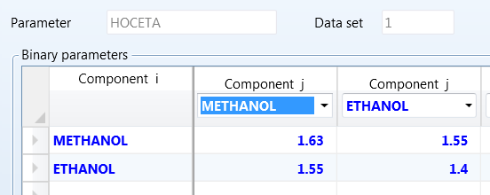
Groups are assigned
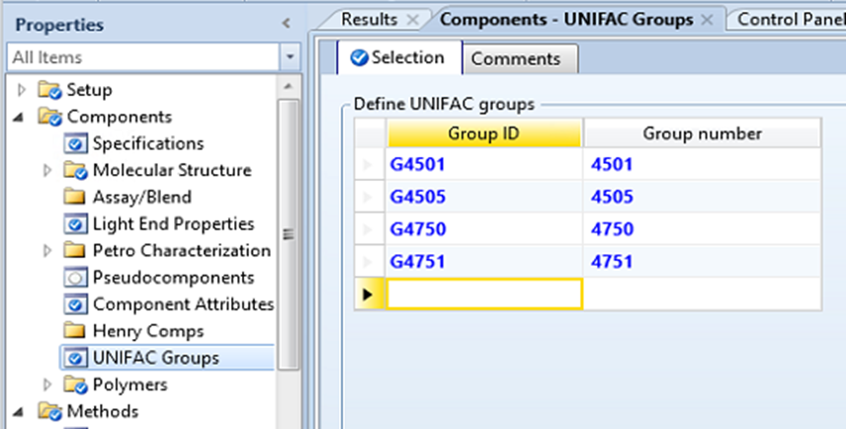
Ethanol has one donor and one acceptor
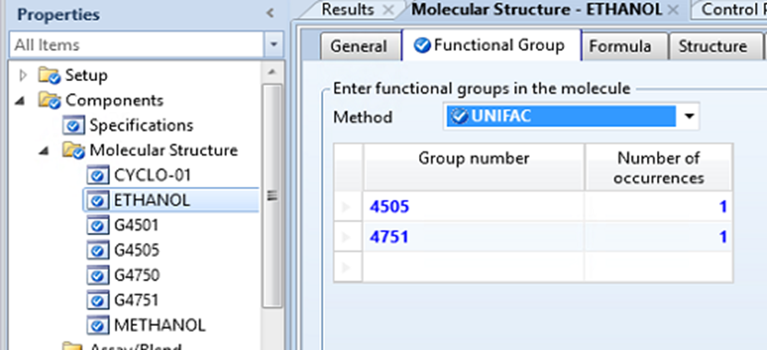
Methanol has one donor and one acceptor
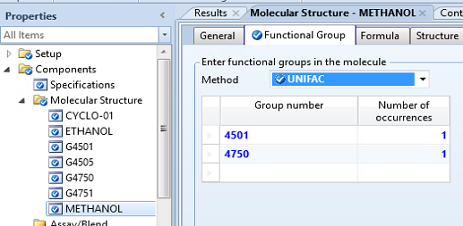
Dummy values for the Wertheim parameters:
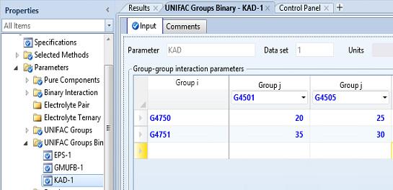
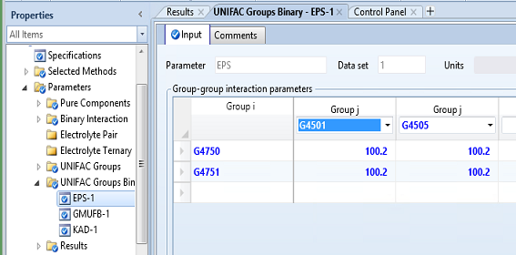
Now enter the parameter values for COVOL. (Covolume values below are vdw volumes for CaseStudy1.bkp, because vdw g(sigma) is used in this example). Vdw values can be obtained from the UNIQUAC values if you have properly reference UNIQUAC (section 2.4) and customized the reference to the dll (section 2.2) you should be able to Home>Retrieve parameters and find GMUQR if you need to set the covolume based on UNIQUAC parameters. The vdw volumes in cm3/mol are calculated using 15.17*GMUQR.
Under Methods > Parameters> Pure Components, click New then choose scalar and find COVOL in the first drop-down menu. Add pure component covolumes.
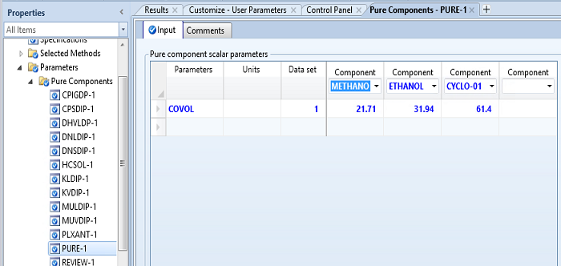
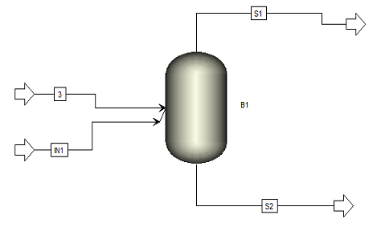
Inlets set Flash Options to liquid only. 1 kmol/h each.
P = 1 bar
Vapor fraction = 0

GMNRTL parameters are set to zero except c_{ij} = 0.3 for all pairs. GMUSR options (star is wildcard) *,0,0,0,1,2.
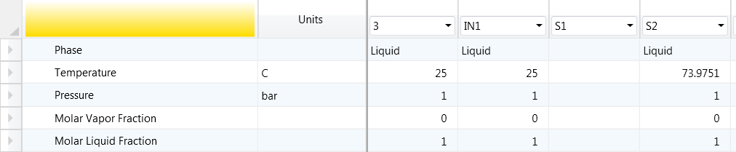
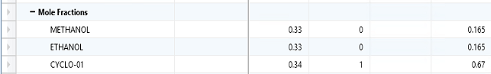

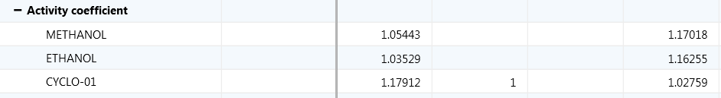
Output from Aspen history file with debug print enabled. The highlighted values show a comparison of Aspen and Spreadsheet or Matlab calculations.
Stream S2
------------------------------------------------------------------------------------------------------------------------
GMU - Print debug info. Start of func call. GMU version 2.5
GMUSR Option codes 1 0 0 0 1 2 0 0 0 0
KCALC, N, T, P = 1 3 347.125 0.100000E+06
*** Aspen Component Identifiers
1 METHANOL
2 ETHANOL
3 CYCLO-01
*** GAMMA RESULTS
KCALC, N, T, P = 1 3 347.125 0.100000E+06
I NAME X lnGAMMAres lnGAMMAcomb lnGAMMAcombcorr lnGAMMAw lnGAMMA dlnGAMMA
1 METHANOL 0.165000 0.000000 0.000000 0.000000 0.157158 0.157158 0.000000
2 ETHANOL 0.165000 0.000000 0.000000 0.000000 0.150617 0.150617 0.000000
3 CYCLO-01 0.670000 0.000000 0.000000 0.000000 0.027217 0.027217 0.000000
End of function call
************************************************************************************************************************
Spreadsheet check
 |  |  |  | ln(g) | gamma
ln(g1) | 0.365332744 | 0.010951494 | -0.21912 | 0.157164492 | 1.170188
ln(g2) | 0.363234814 | 0.01542515 | -0.22805 | 0.150611245 | 1.162545
ln(g3) |  | 0.027217325 |  | 0.027217325 | 1.027591

Stream 3:
------------------------------------------------------------------------------------------------------------------------
GMU - Print debug info. Start of func call. GMU version 2.1
KCALC, N, T, P = 1 3 298.150 0.100000E+06
*** Component Identifiers
1 METHANOL
2 ETHANOL
3 CYCLO-01
*** GAMMA RESULTS
KCALC, N, T, P = 1 3 298.150 0.100000E+06
I NAME X GAMMAres GAMMAcomb GAMMAcombcorr GAMMAw GAMMA dlnGAMMA
1 METHANOL 0.330000 1.000000 1.000000 1.000000 1.054434 1.054434 0.000000
2 ETHANOL 0.330000 1.000000 1.000000 1.000000 1.035295 1.035295 0.000000
3 CYCLO-01 0.340000 1.000000 1.000000 1.000000 1.179116 1.179116 0.000000
End of function call
************************************************************************************************************************
Spreadsheet check
 |  |  |  | ln(g) | gamma
ln(g1) | 0.231407743 | 0.066297184 | -0.2447 | 0.053004915 | 1.054435
ln(g2) | 0.195437443 | 0.093379409 | -0.25413 | 0.034686644 | 1.035295
ln(g3) |  | 0.164765835 |  | 0.164765835 | 1.179117

Enthalpy for ethanol + cyclohexane at 298.15 and 1.013 bar:
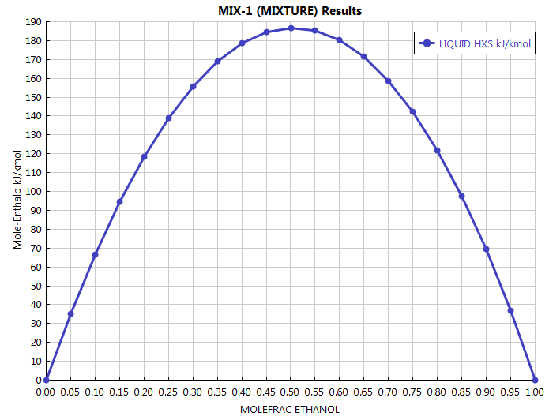
MOLEFRAC ETHANOL | LIQUID HXS | LIQUID CPMX
 | kJ/kmol | kJ/kmol-K
0 | 0 | 156.155
0.1 | 66.6764 | 152.248
0.2 | 118.548 | 148.348
0.3 | 155.813 | 144.449
0.4 | 178.552 | 140.543
0.5 | 186.737 | 136.625
0.6 | 180.227 | 132.689
0.7 | 158.761 | 128.729
0.8 | 121.952 | 124.74
0.9 | 69.2653 | 120.716
1 | 0 | 116.652

Enthalpy for methanol + cyclohexane at 298.15K and 1.013 bar:
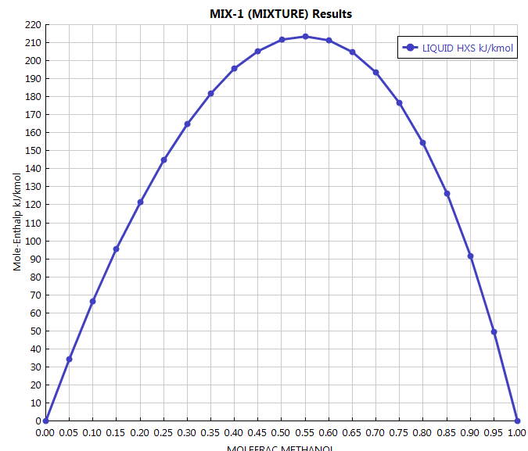
MOLEFRAC METHANOL | LIQUID HXS | LIQUID CPMX
 | kJ/kmol | kJ/kmol-K
0 | 0 | 156.155
0.1 | 66.2523 | 148.688
0.2 | 121.594 | 141.229
0.3 | 165.058 | 133.773
0.4 | 195.499 | 126.317
0.5 | 211.544 | 118.853
0.6 | 211.526 | 111.376
0.7 | 193.381 | 103.877
0.8 | 154.507 | 96.3459
0.9 | 91.5411 | 88.7678
1 | 0 | 81.1245

Keep the Wertheim parameters, but set the following dummy (arbitrary) GMNRTL parameters.
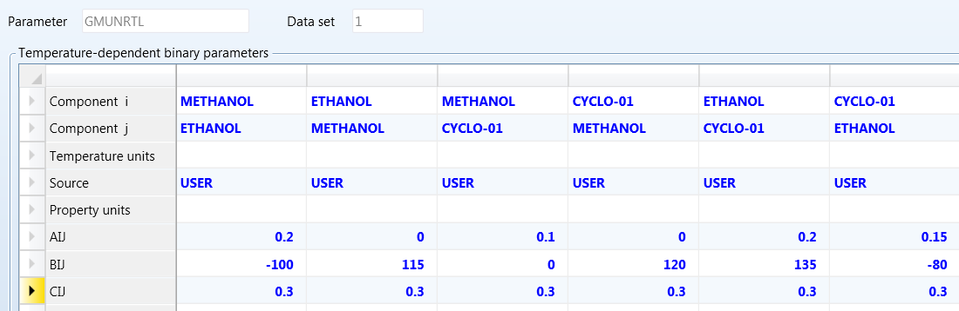
The following residual gammas are below:

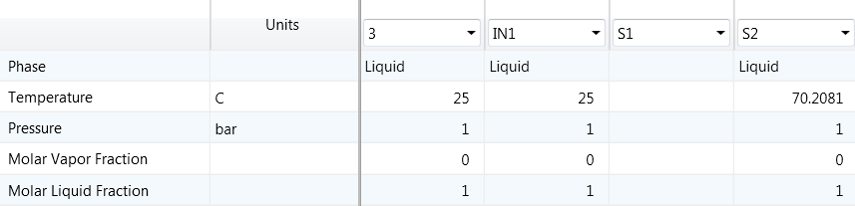
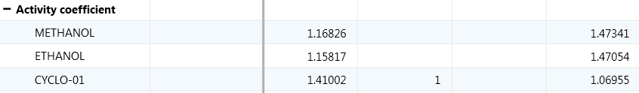
Now the residual contribution to these gammas is checked against independent calculations using the NRTL parameters.
Stream 3
------------------------------------------------------------------------------------------------------------------------
GMU - Print debug info. Start of func call. GMU version 2.1
KCALC, N, T, P = 1 3 298.150 0.100000E+06
*** Component Identifiers
1 METHANOL
2 ETHANOL
3 CYCLO-01
*** GAMMA RESULTS
KCALC, N, T, P = 1 3 298.150 0.100000E+06
I NAME X GAMMAres GAMMAcomb GAMMAcombcorr GAMMAw GAMMA dlnGAMMA
1 METHANOL 0.330000 1.107946 1.000000 1.000000 1.054434 1.168256 0.000000
2 ETHANOL 0.330000 1.118687 1.000000 1.000000 1.035295 1.158171 0.000000
3 CYCLO-01 0.340000 1.195831 1.000000 1.000000 1.179116 1.410023 0.000000
End of function call
************************************************************************************************************************
Matlab using textbook software [4]
>> aij = [0, 0.2, 0.1; 0, 0, 0.2; 0, 0.15, 0];
>> bij = [0, -100, 0; 115, 0, 135; 120, -80, 0];
>> alpha = [0.3, 0.3, 0.3; 0.3, 0.3, 0.3; 0.3, 0.3, 0.3];
>> tau = aij + bij/298.15
tau =
0 -0.1354 0.1000
0.3857 0 0.6528
0.4025 -0.1183 0
>> gamma=nrtl([0.33, 0.33, 0.34], tau, alpha)
gamma = 1.1079 1.1187 1.1958
Stream S2
------------------------------------------------------------------------------------------------------------------------
GMU - Print debug info. Start of func call. GMU version 2.1
KCALC, N, T, P = 1 3 343.358 0.100000E+06
*** Component Identifiers
1 METHANOL
2 ETHANOL
3 CYCLO-01
*** GAMMA RESULTS
KCALC, N, T, P = 1 3 343.358 0.100000E+06
I NAME X GAMMAres GAMMAcomb GAMMAcombcorr GAMMAw GAMMA dlnGAMMA
1 METHANOL 0.165000 1.257362 1.000000 1.000000 1.171828 1.473412 0.000000
2 ETHANOL 0.165000 1.263289 1.000000 1.000000 1.164054 1.470536 0.000000
3 CYCLO-01 0.670000 1.040521 1.000000 1.000000 1.027899 1.069550 0.000000
End of function call
************************************************************************************************************************

Matlab using textbook software [4]
>> aij = [0, 0.2, 0.1; 0, 0, 0.2; 0, 0.15, 0];
>> bij = [0, -100, 0; 115, 0, 135; 120, -80, 0];
>> alpha = [0.3, 0.3, 0.3; 0.3, 0.3, 0.3; 0.3, 0.3, 0.3];
>> tau = aij + bij/343.3581
tau =
0 -0.091241 0.1
0.33493 0 0.59318
0.34949 -0.082993 0
>> gamma=nrtl([0.165, 0.165, 0.67], tau, alpha)
gamma = 1.2574 1.2633 1.0405

CaseStudy2i.bkp, CaseStudy2vi.bkp - Multicomponent case: 1,4-Dioxane + Chloroform + Methanol + Acetic Acid + Heptane + Ethylene Glycol + Water
The temperature and pressure for all the following cases are set to 298.15 and 1 bar. These cases use PURE32.
This test case deletes components, rearranges components and sites to assure that the code works correctly with different permutations of changes such as those below.
    - All components
    - Missing single-site component
    - Missing multiple-site component
    - Multiple missing components
    - Scrambled components, unscrambled sites
    - Scrambled components, scrambled sites
Note: there is a slight difference between the ln (gamma) values calculated with excel and aspen. This is because the excel method requires many iterations to converge to a certain value of site fraction (X) for that component. With enough iterations, it does converge to the Aspen value but we didn’t think it was necessary to add more iterations (and increase the size of the excel sheet) to get more agreement for one component. It’s clear the Aspen code is calculating terms correctly. Aspen uses a more sophisticated iteration scheme.
Note: When the concentration of a component is zero, the infinite dilution value in the remaining mixture is calculated by Excel subject to the convergence issues mentioned above.
********************CPA OPTION*************************************
GMU option codes: *,2,0,0,1,2
All GMNRTL aij =0, bij = 0, cij = 0.3
There is no combinatorial correction in these test cases.

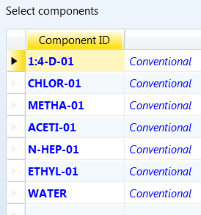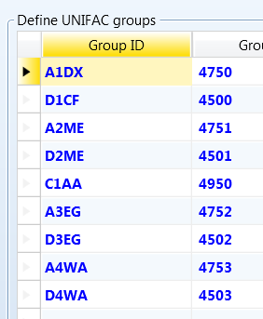
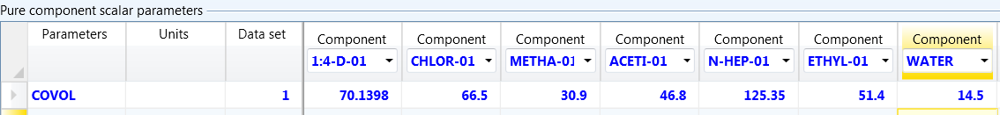
Assignments and std liquid volume:
1,4-Dioxane (1) 4750, 85.6635
Chloroform (1) 4500, 80.5048
Methanol (1) 4751, (1) 4501, 40.3346
Acetic (1) 4950, 57.63
Ethylene Glycol (2) 4752, (2) 4502, 55.908
Water (2) 4753, (2) 4503, 18.05
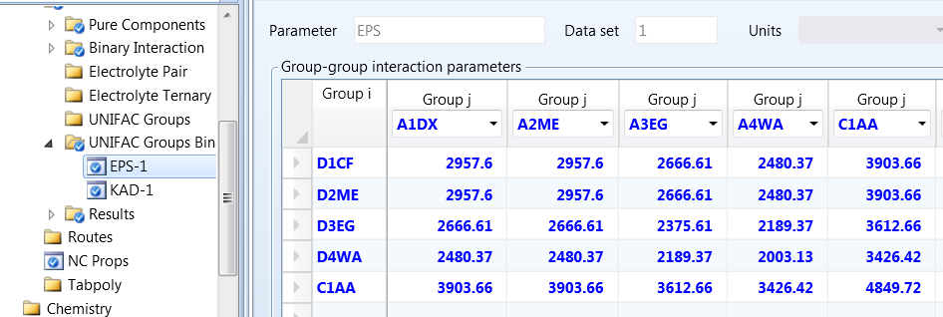
NOTE: in version 2.6.5, a value of 2 was removed for symmetry from C1AA+C1AA, so the value below must be multiplied by 2 when using ver >= 2.6.5. Use 0.2106.
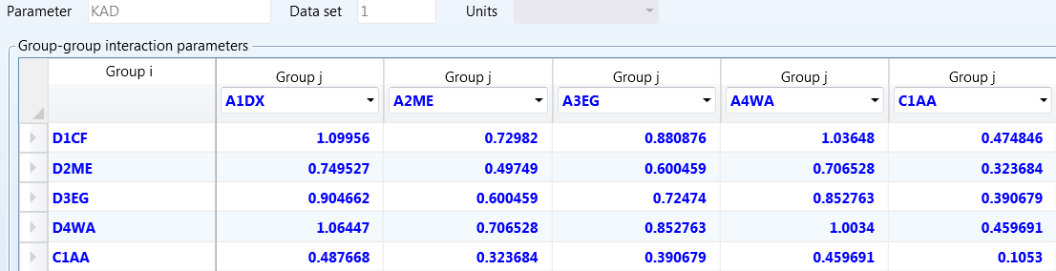
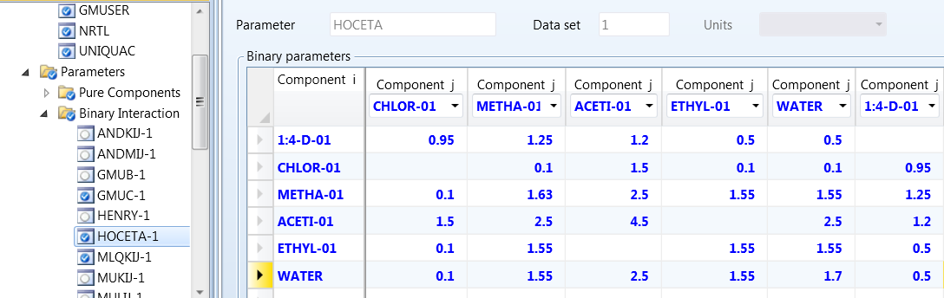
*********SAFT OPTION********************
SAFT case study was done on aspen 11 ver 37.0
GMU option codes: *,3,0,0,1,2
All GMNRTL aij =0, bij = 0, cij = 0.3
There is no combinatorial correction in these test cases.
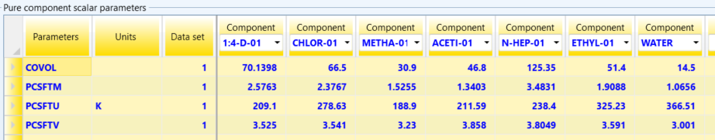
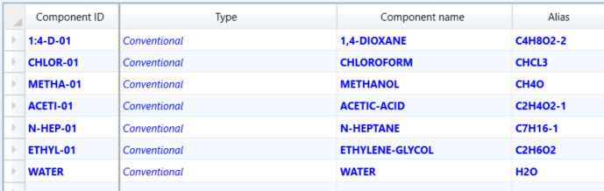
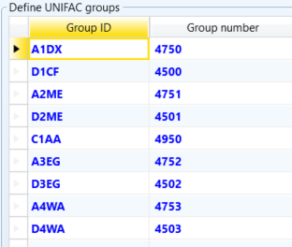
Assignments:
1,4-Dioxane (1) 4750
Chloroform (1) 4500
Methanol (1) 4751, (1) 4501
Acetic (1) 4950
Ethylene Glycol (2) 4752, (2) 4502
Water (2) 4753, (2) 4503

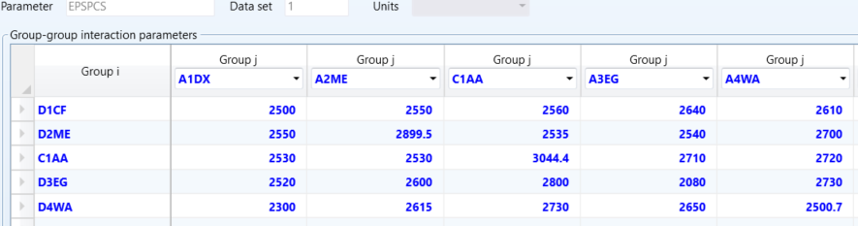

NOTE: in version 2.6.5, a value of 2 was removed for symmetry from C1AA+C1AA, so the value below must be multiplied by 2 when using ver >= 2.6.5. Use 0.1511.
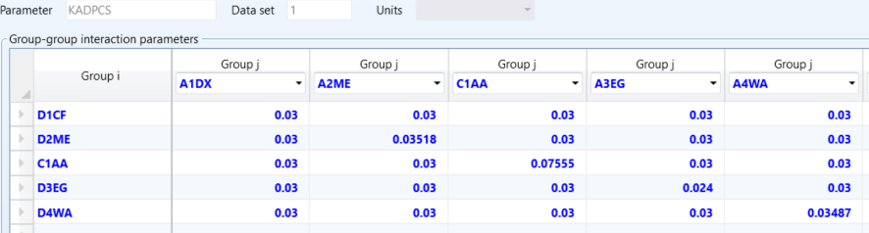

All components (CaseStudy2i.bkp, stream IN), 298.15K, 1 bar
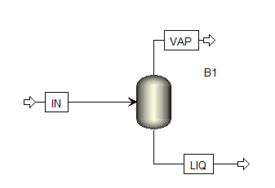
*********CPA OPTION***********
GMUSR Option codes 1 2 0 0 1 2 0 0 0 0
Trial 1 - All components |  |  | Excel | Aspen
Component | Chemical | x | ln(gamma) | lnGAMMAw
1 | 1,4-Dioxane | 0.05 | -1.892691956 | -1.892614
2 | Chloroform | 0.075 | -1.846619828 | -1.846696
3 | Methanol | 0.3 | 0.032767206 | 0.032755
4 | Acetic Acid | 0.2 | -0.154859214 | -0.154084
5 | Heptane | 0.1 | 2.355188524 | 2.355191
6 | Ethylene glycol | 0.01 | 0.379775235 | 0.379768
7 | Water | 0.265 | 1.616192957 | 1.616188

**********SAFT OPTION********
------------------------------------------------------------------------------------------------------------------------
GMU - Print debug info. Start of func call. GMU version 2.6.3
GMUSR Option codes 1 3 0 0 1 2 0 0 0 0
KCALC, N, T, P = 1 7 298.150 0.100000E+06
*** Aspen Component Identifiers
1 1:4-D-01
2 CHLOR-01
3 METHA-01
4 ACETI-01
5 N-HEP-01
6 ETHYL-01
7 WATER
*** GAMMA RESULTS
KCALC, N, T, P = 1 7 298.150 0.100000E+06
I NAME X lnGAMMAres lnGAMMAcomb lnGAMMAcombcorr lnGAMMAw lnGAMMA dlnGAMMA
1 1:4-D-01 0.050000 0.000000 0.000000 0.000000 -0.772867 -0.772867 0.000000
2 CHLOR-01 0.075000 0.000000 0.000000 0.000000 -1.331286 -1.331286 0.000000
3 METHA-01 0.300000 0.000000 0.000000 0.000000 0.384532 0.384532 0.000000
4 ACETI-01 0.200000 0.000000 0.000000 0.000000 0.805428 0.805428 0.000000
5 N-HEP-01 0.100000 0.000000 0.000000 0.000000 2.757269 2.757269 0.000000
6 ETHYL-01 0.010000 0.000000 0.000000 0.000000 -3.511860 -3.511860 0.000000
7 WATER 0.265000 0.000000 0.000000 0.000000 2.753566 2.753566 0.000000
End of function call
************************************************************************************************************************

UOS BLOCK B1 MODEL: FLASH2 TIME = 0.25
------------------------------------------------------------------------------------------------------------------------
GMU - Print debug info. Start of func call. GMU version 2.6.3
GMUSR Option codes 1 3 0 0 1 2 0 0 0 0
KCALC, N, T, P = 3 7 344.452 0.800000E+05
*** Aspen Component Identifiers
1 1:4-D-01
2 CHLOR-01
3 METHA-01
4 ACETI-01
5 N-HEP-01
6 ETHYL-01
7 WATER
*** GAMMA RESULTS
KCALC, N, T, P = 3 7 344.452 0.800000E+05
I NAME X lnGAMMAres lnGAMMAcomb lnGAMMAcombcorr lnGAMMAw lnGAMMA dlnGAMMA
1 1:4-D-01 0.050000 0.000000 0.000000 0.000000 -0.360518 -0.360518 0.007120
2 CHLOR-01 0.075000 0.000000 0.000000 0.000000 -0.849820 -0.849820 0.008524
3 METHA-01 0.300000 0.000000 0.000000 0.000000 0.350448 0.350448 -0.000698
4 ACETI-01 0.200000 0.000000 0.000000 0.000000 0.747092 0.747092 -0.001310
5 N-HEP-01 0.100000 0.000000 0.000000 0.000000 2.620746 2.620746 -0.003288
6 ETHYL-01 0.010000 0.000000 0.000000 0.000000 -2.799254 -2.799254 0.013466
7 WATER 0.265000 0.000000 0.000000 0.000000 2.686837 2.686837 -0.001673
I NAME X dlnGAMMAres dlnGAMMAcomb dlnGAMMAcombcorr dlnGAMMAw lnGAMMA dlnGAMMA
1 1:4-D-01 0.050000 0.000000 0.000000 0.000000 0.007120 -0.360518 0.007120
2 CHLOR-01 0.075000 0.000000 0.000000 0.000000 0.008524 -0.849820 0.008524
3 METHA-01 0.300000 0.000000 0.000000 0.000000 -0.000698 0.350448 -0.000698
4 ACETI-01 0.200000 0.000000 0.000000 0.000000 -0.001310 0.747092 -0.001310
5 N-HEP-01 0.100000 0.000000 0.000000 0.000000 -0.003288 2.620746 -0.003288
6 ETHYL-01 0.010000 0.000000 0.000000 0.000000 0.013466 -2.799254 0.013466
7 WATER 0.265000 0.000000 0.000000 0.000000 -0.001673 2.686837 -0.001673
End of function call
Verified in Wertheim.xls (sheet “multicomponentSAFT”)
$term1=$ $\sum_{i∈k}{N_{d,i}\ln{X_{i}}}$
$$term2=\frac{ρ}{2}\sum_{i}{\sum_{j}{x_{i}x_{j}N_{d,i}N_{d,j}X_{i}X_{J}Δ_{ij}\left(\frac{{\overline{V}}_{k}}{V}\left(1+\left(\frac{ρ}{g_{ij}}\frac{∂g_{ij}}{∂ρ}\right)\right)-\left(\frac{n}{g_{ij}}\frac{∂g_{ij}}{∂n_{k}}\right)\right)}}$$

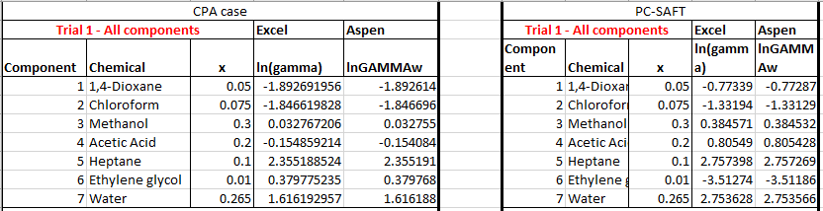

Missing single-site component (change composition stream IN from CaseStudy2i.bkp)
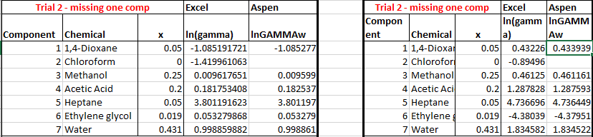

Missing multiple-site component (change composition stream IN from CaseStudy2i.bkp)
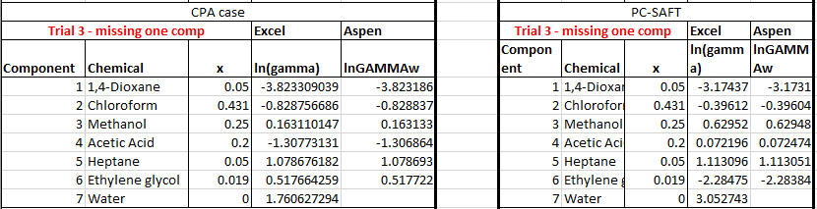

Multiple missing components (change composition stream IN from CaseStudy2i.bkp)
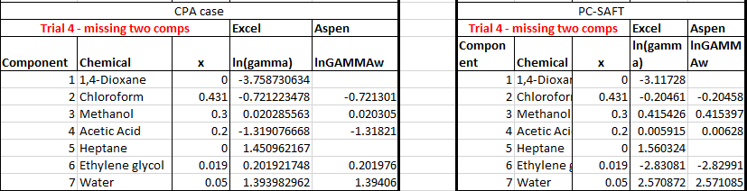

Scrambled components, unscrambled sites (CaseStudy2i.bkp, stream IN), 298.15K, 1 bar (Using Specifications>Components select to rearrange.)
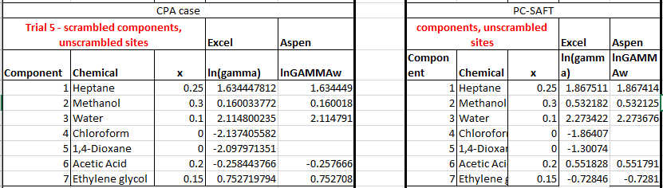

Scrambled components, scrambled sites (CaseStudy2vi.bkp, stream IN), 298.15K, 1 bar. Same parameters as previous cases, but sites are rearranged and reassigned.

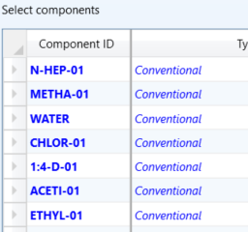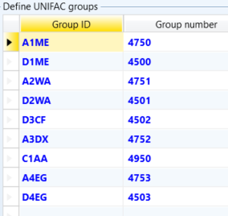
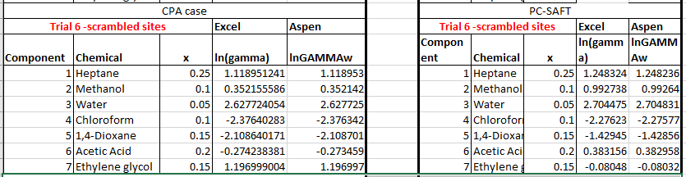

Site in mixture has nothing to associate with (change stream IN from CaseStudy2vi.bkp), 298.15 K, 1 bar.
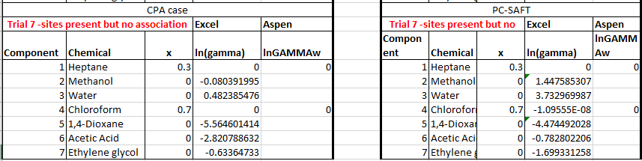

References
[1] I. Nagata, K. Tamura, K. Gotoh, Association model of fluids. Phase equilibria and excess enthalpies in mixtures containing alcohol and acetonitrile, Z. Phys. Chemie-Int. J. Res. Phys. Chem. Chem. Phys., Frankfort. 199 (1997) 1–23.
[2] G.M. Kontogeorgis, G.K. Folas, Chapter 9, Appendix A, in: Thermodynamic Models for Industrial Applications: From Classical and Advanced Mixing Rules to Association Theories, John Wiley & Sons, 2009. https://www.wiley.com/go/kontogeorgis.
[3] I.G. Economou, G.D. Ikonomou, P. Vimalchand, M.D. Donohue, Thermodynamics of Lewis acid-base mixtures, AIChE Journal. 36 (1990) 1851–1864. doi:10.1002/aic.690361209.
[4] J.R. Elliott, C.T. Lira, Introductory Chemical Engineering Thermodynamics, International Edition, 2nd ed., Pearson Education, Upper Saddle River, NJ, 2012.

