**Project Eyetracking:**

*For improved car safety and safety of the community*

Daniel Bean, Clayton Musall, Zach Rohn, & Matthew Stagg

Rev. D – 4/6/16

**Executive Summary:**

**Background and Purpose:**

Driving and traffic regulations are common use for day-to-day individuals who drive to work, drive on vacation, and drive there kids to school. Safety is always a concern for parents and even companies who supply vehicles and other forms of transportation to the consumer. When parents drive there kids to school or even allow there kids to be dropped off at school by a bus or walk the safety is there number one concern. Today's technologies serve an amazing purpose – we are able to call freely of landlines, text or email messages, and even video conference with people from all over the globe, but there is a downfall.

Driving distractions and technology go hand-in-hand when it comes to accidents, injuries, or even death with driving related instances. Not only does technology take away from a drivers focus and cause injury to others, but the driver is also in danger themselves with probable cause of felonies and/or manslaughter charges ruining lives, careers, and even families.

Companies do try to prevent unattributed technological distractions like AT&T with there “Stop Texting and Driving” campaign, but instances of texting and driving still occur and increase.

**Our Solution:**

Eyetracking's goal is to prevent and inform companies and consumers of there driving habits by supplying information to companies/consumers about looking away from the road. As humans, we are always interested in visible and physical data and information and the Eyetracking project's goal is to capture that interest.

With Eyetracking the user will always be the focus and interactivity will be key. Combining an eyetracking capability with a built-in web camera to track eye movement, a mobile-phone application, and a website where users will be able to tell how well they are driving the focus will change from what is on there phone and shift to the ability to drive well.

**The Competition:**

Other eyetracking suites and safety programs goals have attempted to dissolve the problem of distracted driving, but they were unable to encapsulate interactivity with information. Our solution provides a suite where the user holds the information, can compare themselves to other drivers around the world, and challenge themselves to improve driving habits.

**Our Goal:**

To provide and enhance the user’s car safety and intelligent driving techniques by alerting driver when driver faces distraction, provide information concerning distractions and driving habits, and reinforce safe driving techniques.

**Table of Contents:**

Executive Summary...................................................................................................................................2

**Part 1 – Planning:**

System Request..........................................................................................................................................4

Feasibility Analysis....................................................................................................................................5

Budget........................................................................................................................................................8

Project Plan..............................................................................................................................................11

**Part 2 – Analysis:**

System Requirements...............................................................................................................................13

Use Cases.................................................................................................................................................15

Logical DFD............................................................................................................................................20

Logical ERD............................................................................................................................................21

**Part 3 – Design:**

Alternative Matrix....................................................................................................................................22

Architecture Report..................................................................................................................................23

Hardware & Software Specification........................................................................................................24

Interface Design.......................................................................................................................................25

Data Dictionary........................................................................................................................................29

**Part 4 – Appendix:**

Team Contract..........................................................................................................................................30

Team Information.....................................................................................................................................32

**System Request:**

*Project Name:*

Eye-Tracking for Car Safety

*Project Sponsor:*

**Name:** Dr. Gongjun Yan

**Department:** Department of Computer Science

**Organization:** University of Southern Indiana

**Phone:** (812) 228-5073 **E-mail:** [gyan@usi.edu](mailto:gyan@usi.edu)

*Business Need:*

Enhance the user’s car safety and intelligent driving techniques by alerting driver when driver faces distraction, provide information concerning distractions and driving habits, and reinforce safe driving techniques.

*Functionality:*

The device sits on the car dashboard and faces the driver of the car with a camera. The camera tracks eye movement and pupil location and sends data to the device concerning the pupil’s location and visibility. If the pupil becomes invisible to the camera or disappears from camera line-of-sight for any amount of time the device sends an audible alert.

For future functionality and usability we would expect the device to still track and alert eye movement, but with added features. Instead of the alert being instantaneous there will be a short delay and the alert will not be constant, but a short burst of sound. As far as being able to track user behavior and analytics the device will send information to a cloud server and be visible through a web- and application-front-end that will display statistics from the device such as drive time, speed, average time looking away from camera, etc.

*Expected Value:*

Having a device that can alert and keep track of driving statistics and provide alert functionality will help deter from unsafe texting and driving while providing an analytical solution. Researchers and other users can track data and work to improve driving style/technique as well as increase own personal safety and the safety of others.

*Tangible:*

A safer road where drivers will take more caution while driving their vehicles. Less injuries from accidents and other text- or call-related injuries while driving should decrease.

*Intangible:*

Teaching people not to text and drive and giving them an alert while the driver is texting provides a safer environment increasing security and well-being.

*Special Issues or Constraints:*

Implementation into different types of vehicles with the current hardware design could uncover difficulty. The mount will need to fit into most vehicles.

**Feasibility Analysis:**

A feasibility analysis will allow our team to determine if creating and managing an Eyetracking Project to Improve Driver safety. The analysis will identify any risks involved and help minimize risks before implementation. The analysis will contain an Economic, Organizational, and Technical feasibility report.

**Economic Feasibility:**

Our initial step was to determine the initial cost of development and production and determining if the cost was within budget

*Development Costs:*

All developers within the project are from the CS483 senior capstone class and will work entirely on this project for grading purpose. In a commercial environment we would incur a development cost of:

**Table 1-1: Development Costs**

| Project Length: | January 26, 2016 – April 28, 2016 (16-17 weeks) |
| --- | --- |
| Hours per Week: | 8 |
| Team Members: | 4 |
| Total Hours: | 434.45 |
| Hourly Rate: | $30.00 |
| **Total Development Cost:** | $13033.50 |

*Operating Costs:*

Operating Costs within our project are reoccurring costs the organization or group choosing to use this project would be per year and initial hardware cost.

**Table 1-2: Operating Costs**

|  |  |
| --- | --- |
| Web Storage & Hosting | $500.00 |
| Custom Domain Cost | Included in above cost |
| Google Developer Account | $25.00 |
| Raspberry Pi w/Camera & Casing | $35.00 |
| **Total Operating Cost:** | $560.00 |

*Other Costs:*

Training and documentation will provided to the users through interactive directions on website, application, and through initial users upon the total completion of the project. Any sort of service will be billed as determined by issue, technical and hardware support will be charged dependent on cost applied and customer service or support will be free. The hourly billed rate for technical/hardware support will be at $15.00/hr.

*Risk:*

Resources for operating costs and development are denoted above in Table 1-1 & 1-2. In terms of Economic risk that the project will face any sort of over development costs for finished times or any sort of low rate for development. Any maintenance costs that be over denoted are a predicted loss.

*Benefit:*

Drivers and companies will discover driving habits that they have a chance to improve giving both the ability to increase driving skills and safety of their community.

**Organizational Feasibility:**

Studying the organizational feasibility of the project determines if the eyetracking software/system is built will users actually use it? We conducted a stakeholder analysis by evaluating potential users of the system and willingness to learn the system.

*Project Champion:*

Our target audience and company would be places or people who are actively driving or employ those who actively drive. A company example would be an automobile manufacturer such as Ford or GM and a trucking company such as First Class Services Inc. Ford and GM both manufacture cars, trucks, and SUV's that consumers use on a day-to-day basis and both compete for safety regulations and best-in-class driving. With the ever growing age of technology, smart and electric cars are becoming closer to a staple within todays society. Implementation of a system such as eyetracking and driving statistics into regular driving use will give companies such as Ford and GM information about driving habits regular consumers have and what safety regulations can be implemented to prevent those issues.

Another type of company such as First Class Solutions Inc. could use the software/hardware solution to gather information about there drivers and a way to improve driving safety. Truck drivers are constantly driving long hours and extending concentration on the road. Proper rest and safety of truck drivers are a benefit to the business and the community.

*Users:*

The eyetracking project solution is to provide the user of the software and comapanies who use the software a way to participate in safer driving and information about driving habits. Most of todays technologies are connected and a way for us to implement data comparison and analytics will ever increase a connected society. Our solution takes advantage of web technologies and smart phone technologies allowing different users to use a mobile and web application. Each user will have there own profile where data is visible and accessible to them to compare to other users, track there alerts compared to others, and how they can improve driving habits. With cooperation from users and companies the web site will grow and later improvements can be added.

*Strategic Alignment:*

In terms of total solution for eyetracking and data solutions there is currently no system implemented or being developed. In terms of separate programs, open-source eyetracking software solutions exist and web data analytics exist that provide separate services. The goal of the Eyetracking project is to combine the interactivity and usability of web and application services with the hardware of a Raspberry Pi to improve car safety and driving safety. Having a mobile and web interface has benefits that provide combined capabilities and serve multiple purposes when implementing a software system.

**Technical Feasibility:**

The technical feasibility will determine if we can physically build the system. The feasibility of the hardware is okay in terms of purchase cost, but in terms of risks:

*Risks:*

Risk related to familiarity with the mobile application and the web interface is lower for our target audience.

1. The target audience are most modern companies and day-to-day consumers. Many people own smart devices and familiarity with smart systems exist. Usability of the application and website supplied will try to improve on simplicity.
2. The development team has a mix of experience in concepts. Learning in terms of the Web Framework being used and some implementations of Hardware I/O will require time and could delay future progressions of the project. Risk is moderate, but in terms of learning capabilities of the team we are consistent.

The project size is considered a medium risk

1. The projects team will consist of 4 people
2. The project sponsor investment is moderate in terms of ideas for implementation and cooperation. Mentoring and guidance is what is needed.
3. The project's estimated implementation date and in terms of finalization we are looking for completion date of April 16, 2016.

**Budget:**

In our budget study we included a detailed development breakdown for the project development plan for the first year in terms of ongoing costs and maintenance costs. The initial project costs are going to be at no cost or charge to prototyping, but a budget is included for reference. Any graphic design was donated by art students at University of Southern Indiana.

In terms of ongoing costs the maintenance costs assume that labor in terms of hardware or technical maintenance, but in terms of reference we are estimating around 100 hours a year at $15.00/hr to manage updates, application modifications and hardware modifications. Any sort of other costs are related to operational costs of the web hosting and webserver space being rented and maintained for the website and application. Any renewal and data hosting services must be renewed in one year after initial creation in 2017.

**Table 1-3: 5 Year Budget Plan**

|  |  |  |  |  |  |  |
| --- | --- | --- | --- | --- | --- | --- |
| **Project Budget** | **2016** | **2017** | **2018** | **2019** | **2020** | **Total** |
| **Development Costs:** | $15360.00 | $-.-- | $-.-- | $-.-- | $-.-- | $15360.00 |
| **Hosting Costs:** | $500.00 | $500.00 | $500.00 | $500.00 | $500.00 | $25000.00 |
| **Maintenance Costs:** | $-.-- | $1500.00 | $1500.00 | $1500.00 | $1500.00 | $1500.00 |
| **Total:** | $15860.00 | $2000.00 | $2000.00 | $2000.00 | $2000.00 | $41860.00 |

**Table 1-4: Development Budget Plan**

| **Task Name** | **Time** | **Total Cost** |
| --- | --- | --- |
| ***Planning*** | **32.30** | **$969.00** |
| Create Team Contract | 1.00 | $30.00 |
| Create System Request | 2.25 | $67.50 |
| Gather Requirements | 11.00 | $330.00 |
| Create Feasibility Analysis | 5.25 | $157.50 |
| Create Project Charter | 1.00 | $30.00 |
| Develop Project Plan | 9.30 | $279.00 |
| Research Technology for Project | 2.50 | $75.00 |
| ***Analysis*** | **31.85** | **$955.50** |
| System Requirements | 3.00 | $90.00 |
| Logical DFD | 6.25 | $187.50 |
| Logical ERD | 5.25 | $157.50 |
| Alternative Matrix | 2.35 | $70.50 |
| Use Cases | 15.00 | $450.00 |
| ***Design*** | **95.30** | **$2859.00** |
| Interface Design | 6.00 | $180.00 |
| Hardware and Software Specification | 5.00 | $150.00 |
| Architecture Design | 3.25 | $97.50 |
| Use Scenarios | 9.50 | $285.00 |
| Program Design | 46.75 | $1402.50 |
| Physical DFD | 9.55 | $286.50 |
| Data Dictionary | 4.50 | $135.00 |
| Physical ERD | 6.50 | $195.00 |
| CRUD Matrix | 4.25 | $127.50 |
| ***Implementation*** | **145.00** | **$4350.00** |
| Web Based Interface | 40.00 | $1200.00 |
| Data Submission | 25.00 | $750.00 |
| Application Based Interface | 35.00 | $1050.00 |
| Hardware Implementation | 45.00 | $1350.00 |
| ***Testing*** | **120.00** | **$3600.00** |
| Prototype Testing | 100.00 | $3000.00 |
| Final Testing | 20.00 | $600.00 |
| ***Presentation*** | **10.00** | **$300.00** |
| Finalize Documentation | 10.00 | $300.00 |
| ***Other Costs*** |  |  |
| Publishing on Google Play | N/A | $25.00 |
| Raspberry Pi w/Camera & Casing |  | $35.00 |
| ***Total Cost:*** | **434.45** | **$****13033.50** |

**Project Plan:**

The Eyetracking project plan details all of the tasks that were needed to be completed in the order they were needed to be completed in and the approximate date that each task was completed. We chose to use an agile development method with prototyping of each interface or section we were working with because of the short development time, learning of the programming tools/languages, the amount of work needed for each section, and ease of understanding in terms of basic concept.

The deadlines for the project were project development completed before April 11, 2016 and the final IT Alliance presentation on April 27, 2016.

**Table 1-5: Gantt Chart**

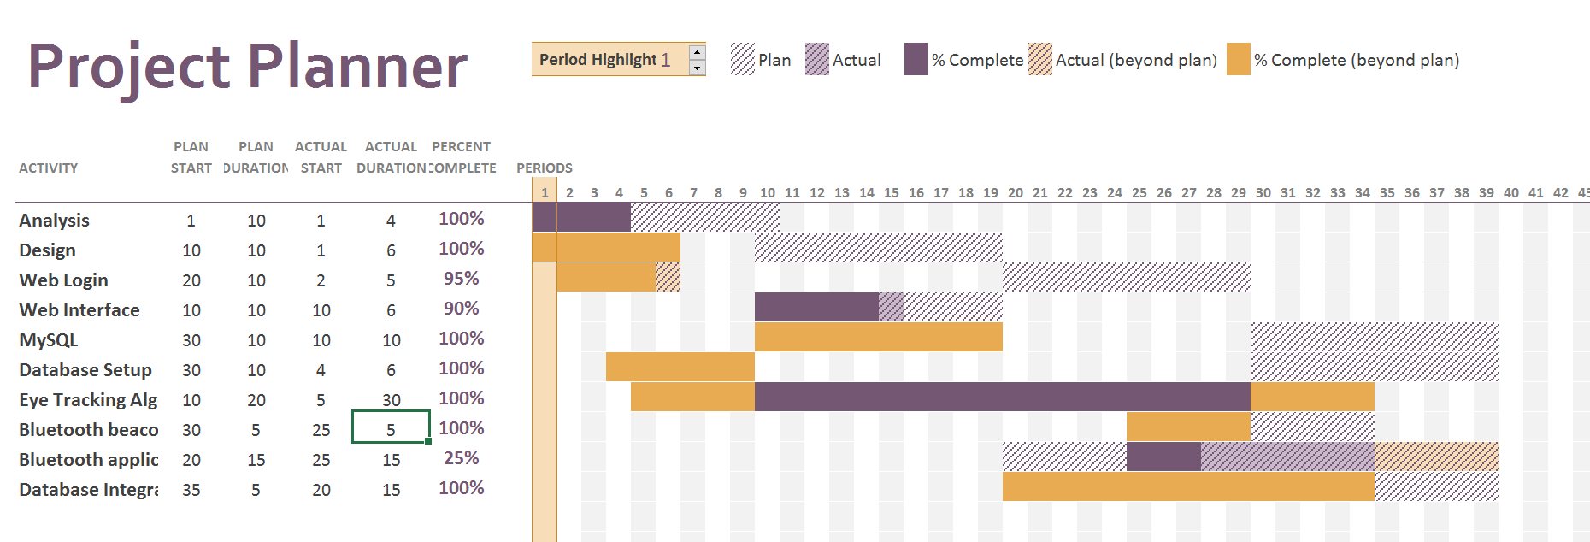

**System Requirements:**

**1. Functional Requirements:**

***1.1. The system should have a web-based interface***

1.1.1. The system should contain a home page with direction on how to set-up eyetracking system.

1.1.2. The system should contain an about page with information on content creators and purpose of the project.

1.1.3. The system should have a user registration page

1.1.3.1. The system should contain information for the user to create a username, password, etc.

1.1.4. The system should contain a user page displaying user information, data captured, and data analytics

1.1.4.1. Users can edit information about there user page such as first and last name, email address, etc.

1.1.5. The web based system should be able to receive requests from the application and store information inside a database

***1.2. The system should have an application based interface***

1.2.1. The system should interface with Bluetooth LE beacon advertisements to receive:

1.2.1.1. Eye Gaze position

1.2.1.2. Any loss of eye detection

1.2.2. The system should push the following information to the server:

1.2.2.1 Location

1.2.2.2 Speed

1.2.2.3 All other information gathered from eye tracker

***1.3. The system should contain hardware with eyetracking software***

1.3.1. The system should track user eye movements and relay the current gaze position to the application.

1.3.2 The system should constantly be broadcasting all relevant information to the application.

1.3.3 The system will also send notifications if no eyes are detected for a long period of time (2s).

**2. Nonfunctional Requirements**

***2.1. Cultural***

2.1.1. The system is going to be written in English

2.1.2. The system is going to be targeted to consumers who drive or companies who employ drivers

***2.2. Other***

2.2.1. The system will be easy to use for new users

2.2.2. The system will help increase driving safety and awareness of safety while driving

***2.3. Performance***

2.3.1. The system will respond quickly to all requests

2.3.2. The system will collect data accurately

***2.4. Operational***

2.4.1. The system should run on mobile phones, desktops, and laptops

**Use Cases:**

**Use Case Name:**

View Home Page

**UC ID:**

eyetracking_HomePage

**Actor:**

User

**Priority:**

High

**Description:**

When the user loads Eyetracking home page, home page will be displayed.

**Trigger:**

The URL for home page is loaded

**Trigger Type:**

Internal

**Preconditions:**

1.) The user navigates to the eyetracking home page ex. “ctmusall.pythonanywhere.com”

2.) The user clicks the link to “Home” at the top of any page

**Normal Course:**

1.0) User loads into Django home page

1.1) IF the user is logged in, display home page with link to user page at top

1.2) IF the user is not logged in, display home page without the link to user page

**Alternative Course:**

User clicks the 'home' page link at the top of any other page.

**Post Conditions:**

Home text with name at the top if logged in will be displayed at the top of the page and if not logged in the basic home page will be displayed

**Exceptions:**

E1.) The back button is clicked

1.) Goes back to the previous screen

**Use Case Name:**

View About Page

**UC ID:**

eyetracking_AboutPage

**Actor:**

User

**Priority:**

High

**Description:**

When the user loads Eyetracking about page, about page will be displayed.

**Trigger:**

The URL for about page is loaded

**Trigger Type:**

Internal

**Preconditions:**

1.) The user navigates to the eyetracking about page ex. “ctmusall.pythonanywhere.com/about”

2.) The user clicks the link to “About” at the top of any page

**Normal Course:**

1.0) User loads into Django About page

**Alternative Course:**

User clicks the 'about' page link at the top of any other page.

**Post Conditions:**

-

**Exceptions:**

E1.) The back button is clicked

1.) Goes back to the previous screen

**Use Case Name:**

View Register Here Page

**UC ID:**

eyetracking_RegisterPage

**Actor:**

User

**Priority:**

High

**Description:**

When the user loads Eyetracking register page, register page will be displayed.

**Trigger:**

The URL for register page is loaded

**Trigger Type:**

Internal

**Preconditions:**

1.) The user navigates to the eyetracking register page ex. “ctmusall.pythonanywhere.com/register”

2.) The user clicks the link to “register here” at the top of any page

**Normal Course:**

1.0) User loads into Django register page

**Alternative Course:**

User tries to load into a page where a login is required

**Post Conditions:**

1) The user page is shown for the user as a redirect

**Exceptions:**

E1.) The back button is clicked

1.) Goes back to the previous screen

**Use Case Name:**

View Login Page

**UC ID:**

eyetracking_LoginPage

**Actor:**

User

**Priority:**

High

**Description:**

When the user loads Eyetracking login page, login page will be displayed.

**Trigger:**

The URL for login page is loaded

**Trigger Type:**

Internal

**Preconditions:**

1.) The user navigates to the eyetracking login page ex. “ctmusall.pythonanywhere.com/login”

2.) The user clicks the link to “login” at the top of any page

**Normal Course:**

1.0) User loads into Django login page

**Alternative Course:**

User tries to load into a page where a login is required

**Post Conditions:**

1) The user page is shown for the user as a redirect

**Exceptions:**

E1.) The back button is clicked

1.) Goes back to the previous screen

**Use Case Name:**

View User Page

**UC ID:**

eyetracking_UserPage

**Actor:**

User

**Priority:**

High

**Description:**

When the user loads Eyetracking user page, user page will be displayed.

**Trigger:**

The URL for user page is loaded

**Trigger Type:**

Internal

**Preconditions:**

1.) The user navigates to the eyetracking user page ex. “ctmusall.pythonanywhere.com/user”

2.) The user clicks the link to “user” at the top of any page

**Normal Course:**

1.0) User loads into Django user page after login

2.0) User loads into Django user page after register

**Alternative Course:**

User tries to load into a page where a login is required

**Post Conditions:**

1) Data, Graphs, and User Information is shown for the user

**Exceptions:**

E1.) The back button is clicked

1.) Goes back to the previous screen

**Logical DFD:**

*Web Application –*

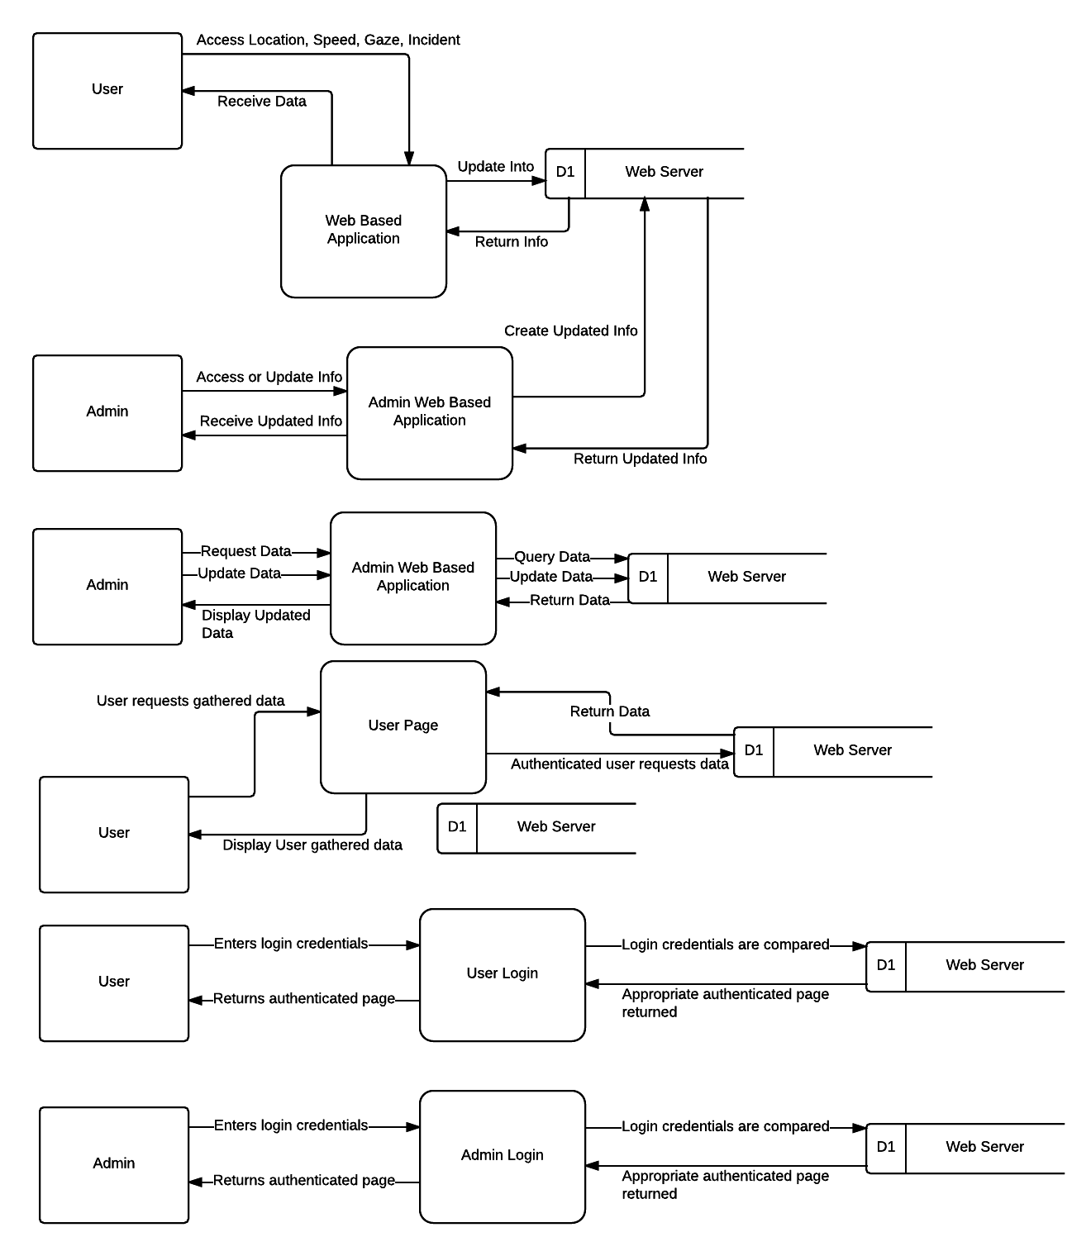

**Logical ERD:**

*Web Application –*

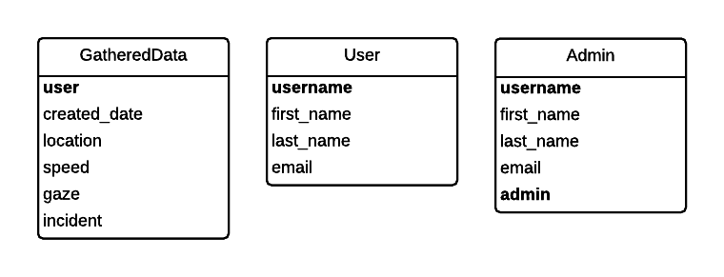

**Alternative Matrix:**

**Table 1-5: Alternative Matrix for Web Application**

|  |  |  |  |  |  |  |  |
| --- | --- | --- | --- | --- | --- | --- | --- |
| **Criteria** | **Weight** | **Django** | **Score(1-5)** | **W.S.** | **Custom** | **Score** | **W.S.** |
| **Tech:** |  |  |  |  |  |  |  |
| Updating Ease | 10 | Django- Python  Updates | 5 | 50 | Manual updates | 1 | 10 |
| Expertise of Development Team | 10 | Team has knowledge in Python/Django | 5 | 50 | Team developed – expert | 5 | 50 |
| Hosting Maintenance | 10 | Hosting mainained locally | 4 | 40 | Locally Hosted | 1 | 10 |
| **Econ:** |  |  |  |  |  |  |  |
| Hosting Cost | 25 | $500 one time | 3 | 75 | More expensive over time | 2 | 50 |
| **Org:** |  |  |  |  |  |  |  |
| Number of Users | 20 | Gain own users | 3 | 60 | Gain own users | 3 | 60 |
| Ease of Access to User | 25 | Django and python apps included | 5 | 125 | User interface and experience would be custom | 5 | 125 |
| **Total:** | 100 |  | 25 | 400 |  | 17 | 305 |

The alternative matrix we used was based on two seperate entities: Django Application Web Framework and building a stand-alone web based framework. Using pre-constructed web based technologies is cheaper in terms of development and was chosen because of its longer testing time and usability. Knowledge for systems and training time is lower because of this choice, but the most important thing is keeping cost low. We want to maximize the amount of capabilities we have with the technologies available.

**Architecture Report:**

**Table 1-6: Architecture Report**

|  |  |  |
| --- | --- | --- |
| **Requirements** | **Web Server Based** | **Client Based** |
| **Operational Requirements:** |  |  |
| Technical Environment | X | X |
| System Integration | X | X |
| Portability |  | X |
| Maintainability | X |  |
| **Performance Requirements:** |  |  |
| Speed |  | X |
| Capacity | X |  |
| Availability & Requirements | X | X |
| **Security Requirements** |  |  |
| System Value Estimates |  |  |
| Access Control | X |  |
| Encryption & Authentication | X |  |
| Virus Control | X |  |
| **Cultural & Political Requirements** |  |  |
| Multilingual |  |  |
| Customizations | X |  |
| Making Unstated Norms |  |  |
| Legal Requirements |  |  |

**Hardware and Software Specifications:**

There is multiple hardware and software devices needed for the project. A web server and device need, at the minimum, the following:

**Table 1-7: Hardware and Software**

|  |  |
| --- | --- |
| **Web Server** | **Client Device** |
| MySQL | Web Browser |
| Bluetooth/Wireless Data | Android OS |

Hosting for a custom url and data storage would need to be purchased described above.

**Interface Design:**

*Eyetracking – Home Page*

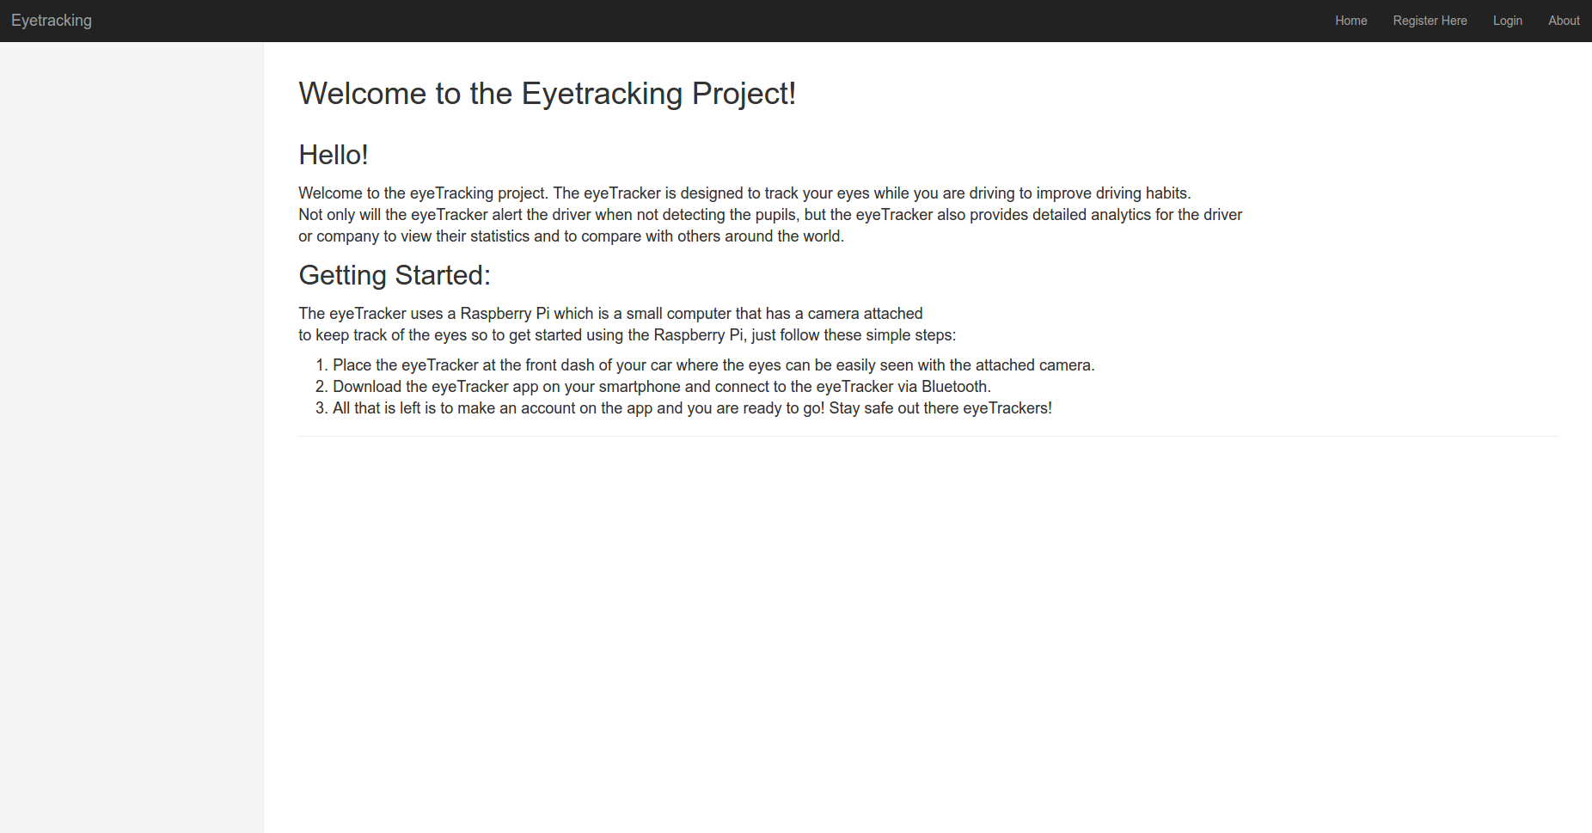

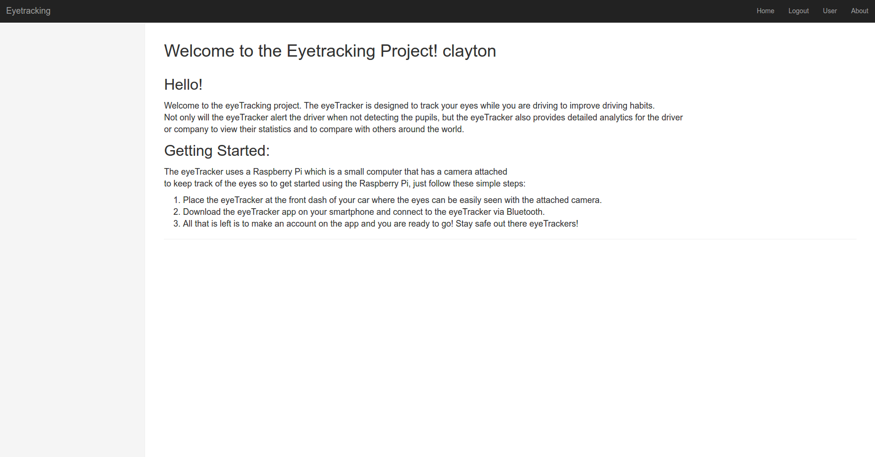

*Eyetracking – About Page*

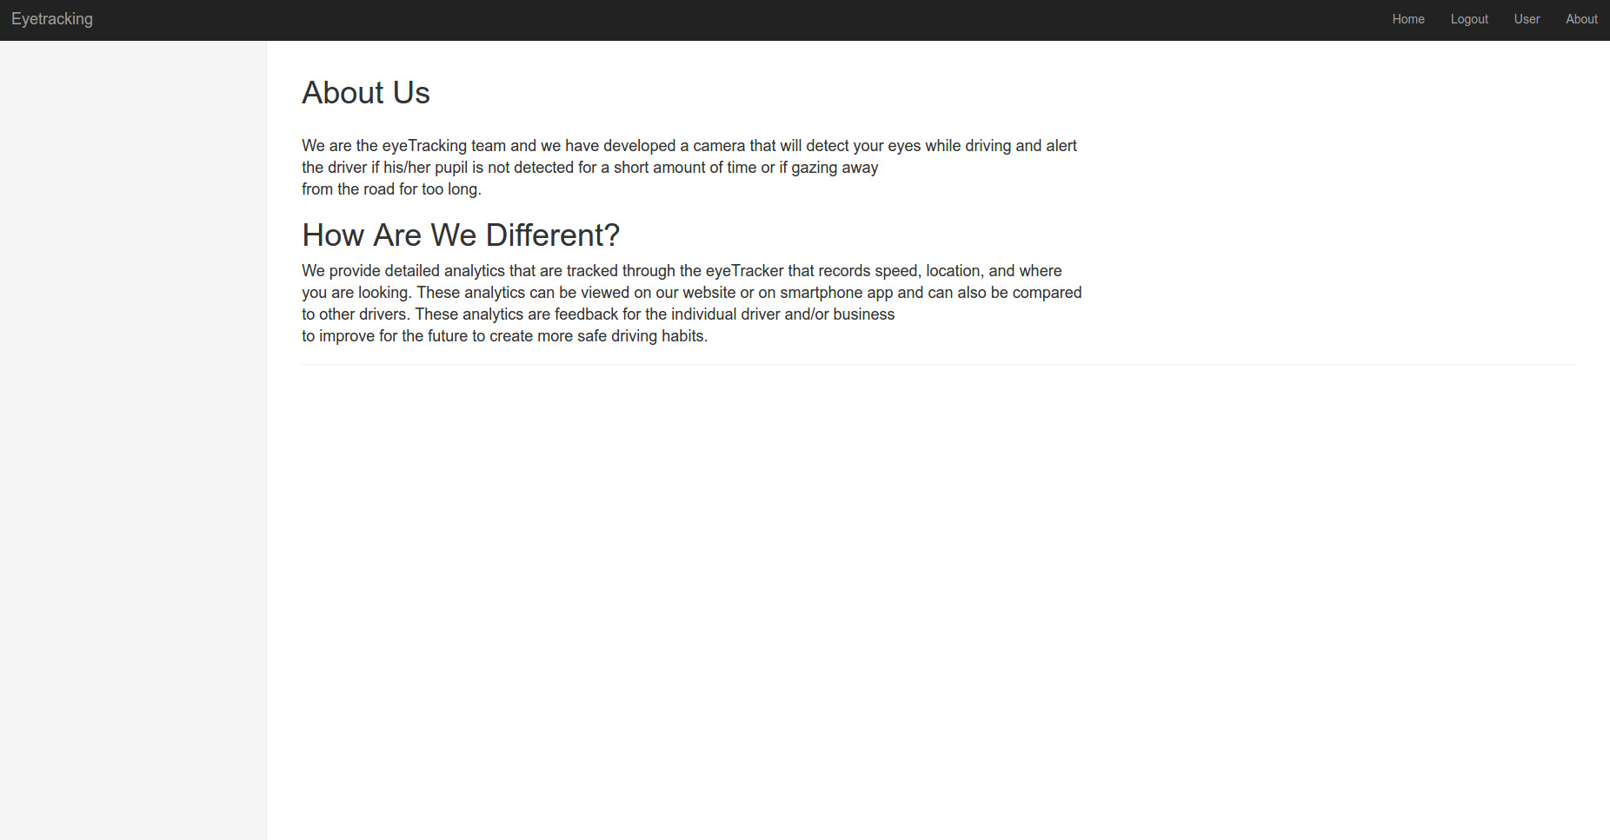

*Eyetracking – Register Page*

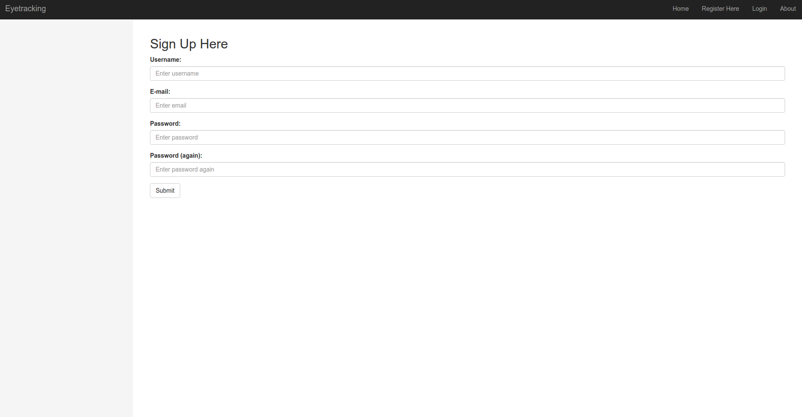

*Eyetracking – Login Page*

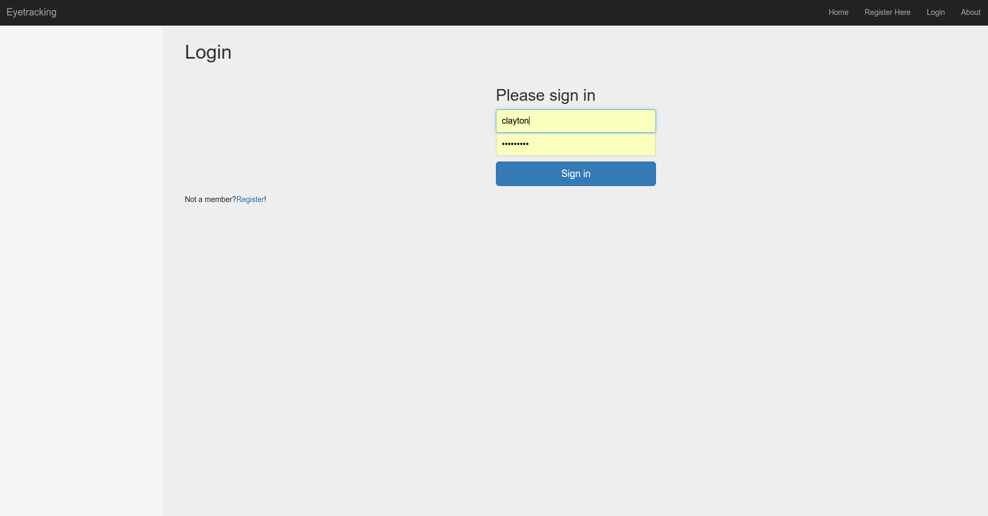

*Eyetracking – User Page*

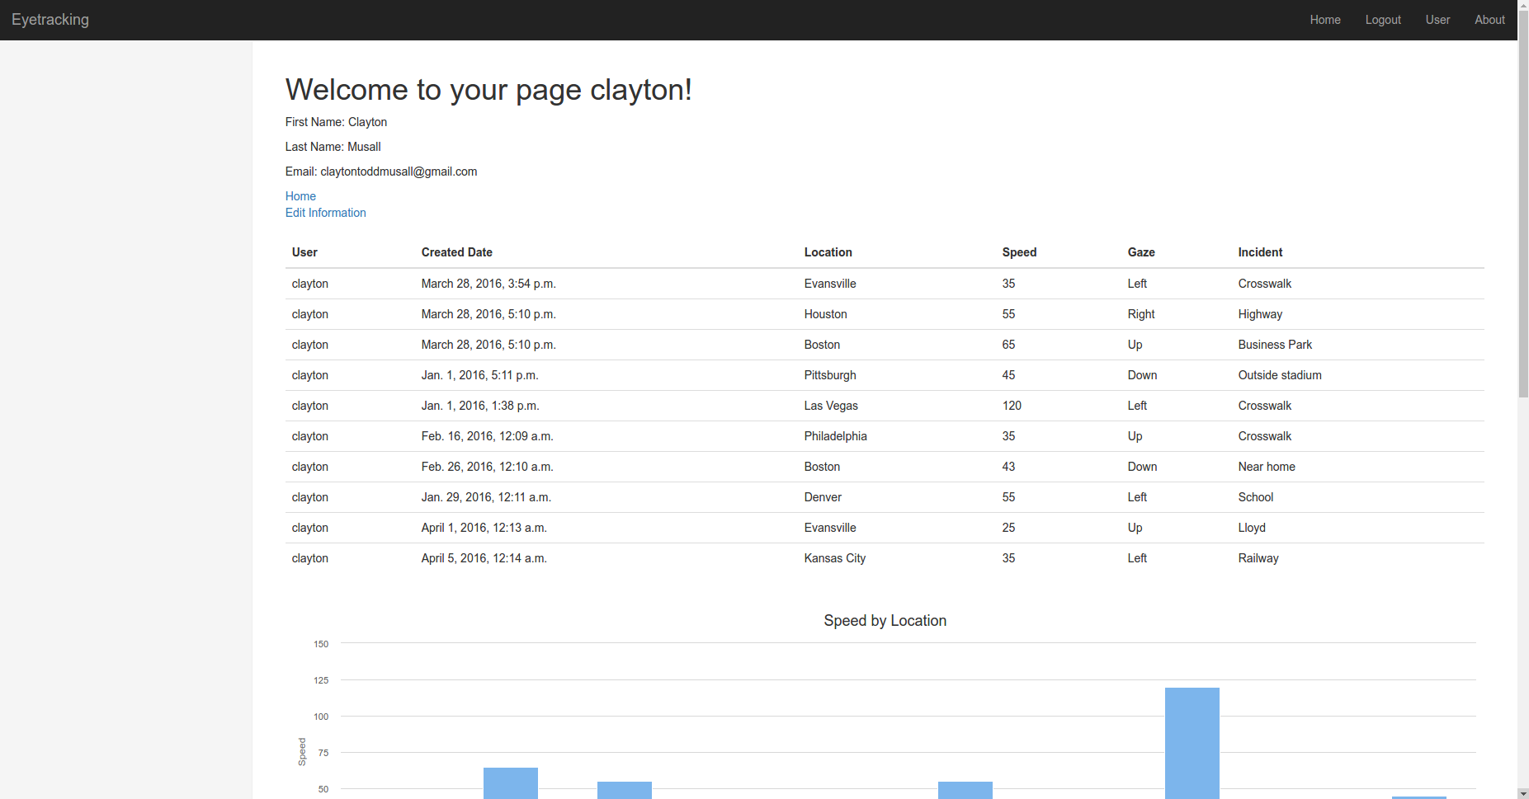

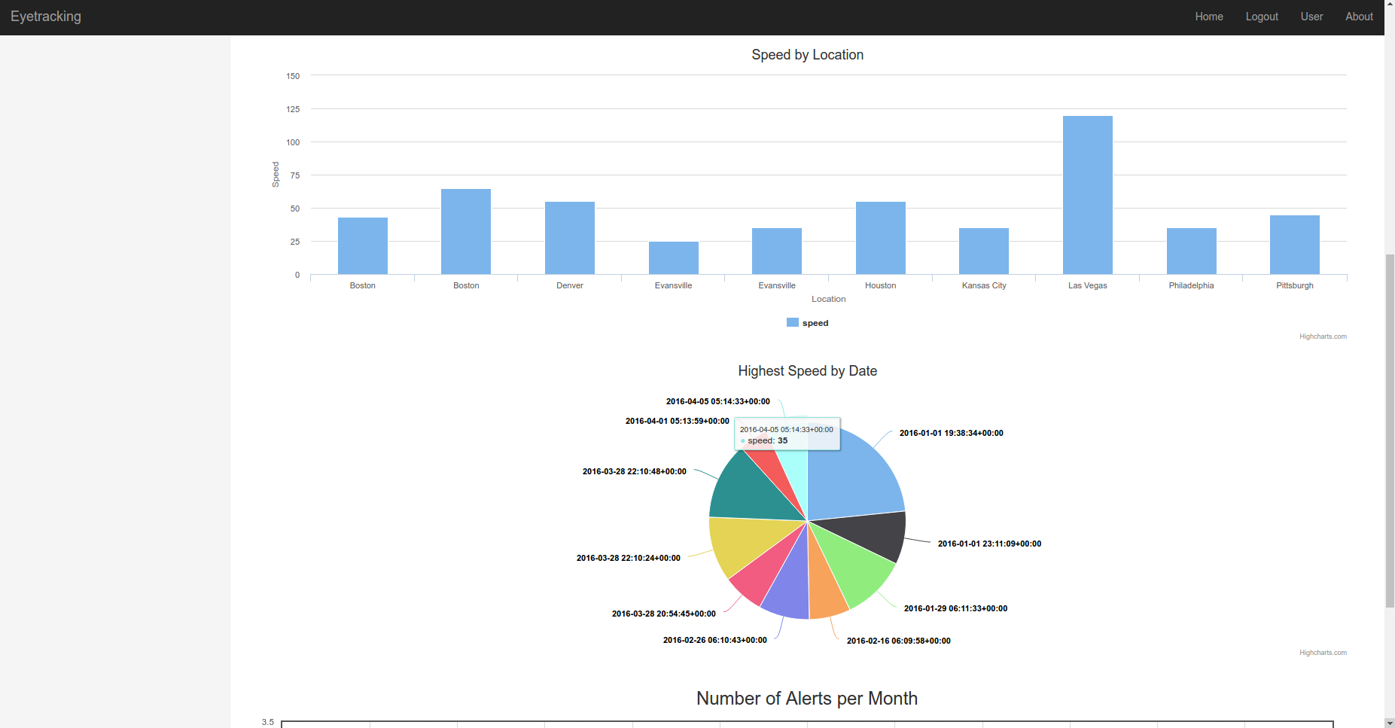

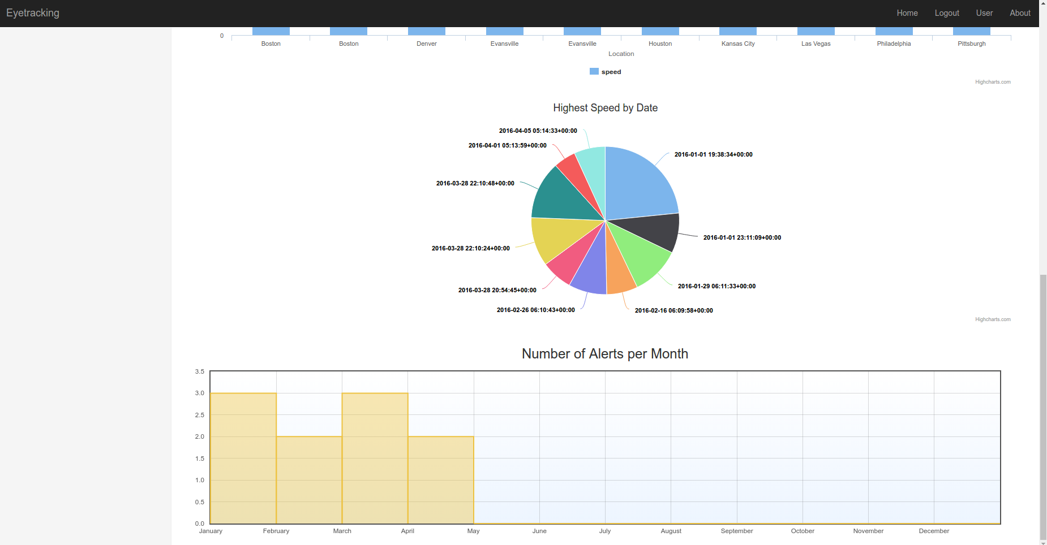

**Data Dictionary:**

**Table 1-7: Data Dictionary for Web Framework**

|  |  |  |  |
| --- | --- | --- | --- |
| **Module Name** | **Field Name** | **Data Type** | **Data Description** |
| Gathered Data | user | UserObject | Unique user id |
|  | created_date | DataTime | Date in which alert is gathered |
|  | location | CharField | Location of the alert |
|  | speed | Integer | Speed on how fast the user is driving |
|  | gaze | CharField | Direction of the gaze |
|  | incident | CharField | Incident location |
| User | username | CharField | Unique username |
|  | first_name | CharField | First name of the user |
|  | last_name | CharField | Last name of the user |
|  | email | CharField | Email address of the user |

**Team Contract:**

Student-Instructor Contract for Senior Project

This contract outlines some of the responsibilities and tights expected from all students and the instructor for this course. By signing it, you acknowledge that you take responsibility for your own education and have the right to be given the opportunity to acquire that knowledge. The purpose of this contract is to make you aware of what is expected by participating in this course.

1. I accept that everything I need to know will not be taught in class and I must actively seek to educate myself. I am responsible for learning material outside of the regular class meeting times and will endeavor to educate myself on anything I need to learn to accomplish the projects.

2 The instructor is responsible for making learning resources available through print; verbal, and/or electronic means.

3. I acknowledge that this class uses a team-based format and promise to treat my team members with professionalism, respect; and honest I acknowledge that everyone has different strengths and will help to teach any team members who need assistance as I expect that will also assist me.

4. I promise to evaluate my team members fairly based on the work they perform and not let personal prejudices affect my evaluations.

5. I have read and understand the syllabus and the information it contains.

6. I am expected to consult the instructor, other students, and designed persons at my project business/agency for help, but I will not take credit for any work L have not done or represent others’ work as my own.

7. I understand that the instructor, consultants, and mentors at roy project business/agency are available for consultation on questions relating to this course. However, they cannot guarantee all answers will be correct in all regards. I am responsible for asking any questions about my project assignment and deciding whether the answers I receive are correct.

8. The instructor is responsible for making the material understandable, pertinent, and timely as possible, and I promise to provide constructive feedback if I am dissatisfied with the material or presentation.

9. I understand that this course will be treated as seriously as a classroom course and a professional experience.

10. I understand that there is no remuneration for the worked performed for this course.

11. I understand that transportation is my responsibility.

12. I understand that attendance at class meetings, all team meetings, arid meetings arranged with the project business/agency arc mandatory.

13. I understand that professional behavior (e.g. punctuality, attendance, positive attitude) twist be shown.

14. All concerns are to be brought to the attention of the instructor who will consult with the appropriate person.

15. I will adhere to the project business/agency chain of command.

16. Both the instructor and l are responsible for maintaining a scholarly environment based upon mutual trust and respect.

17. My team will present a final written report and I will participate in a presentation of the project.

I have read, understand, and t conditions of this contract

**Clayton Musall, Matthew Stagg, Dan Bean, Zach Rohn** **1/11/16**

Student(s) Date

**Gonjun Yan** **1/11/16**

Instructor Date

**Team Information:**

