Christian Todhunter

05/18/2020

IT FDN 100 A

Assignment05

DICTIONARies!!!!

# Introduction to Module 05

Module 5 introduced us to further functions of a list and added dictionaries to our knowledge base. The other items added were the use of some error handling techniques, Github repositories, programming patterns, and script templates!!!

## The Assignment Requirements

The follow figure outlines the task at hand from R. Roots “Assignment05” document: 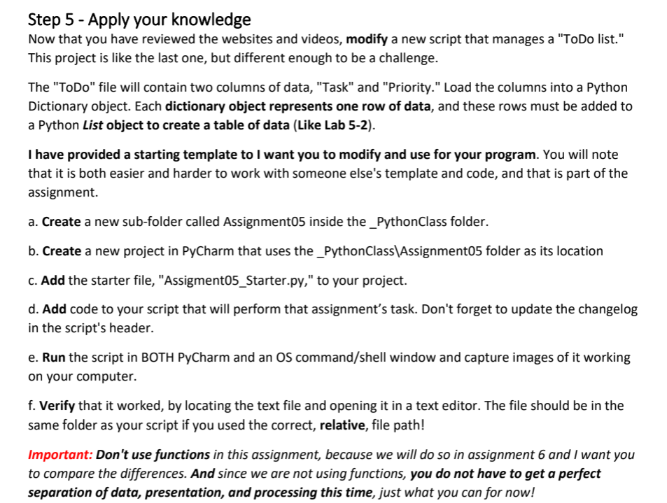

Figure 1: Screenshot from *Assignment05* by R. Root

In addition to the above, we were also tasked with uploading THIS DOCUMENT to GitHub, along with the corresponding python file.

## My Approach

This week I made sure to read the chapter from our text very thoroughly, as last week I felt ill prepared for the assignment. However unfortunately I wasn’t able to attend the Tuesday review session this week and I think doing so would have helped, so I will make sure to attend the upcoming session for module six. After reading the text, I watched the video for Module 05 and visited the external sites as usual. I ended up re-reading parts of the chapter and re-watching some parts of the videos to solve some issues I was having.

Most of my time for this assignment was spent figuring out how to properly populate a dictionary. I kept having issues with printing the dictionary and seeing only the last row in the text file that was supposed to be loaded. At first I though this was due to the strip() and split() function not working properly, or more accurately, as intended. Only after a good amount of time did I catch some text printed in bold in the assignment that served as a clue to what was going wrong, see Figure 2 below:

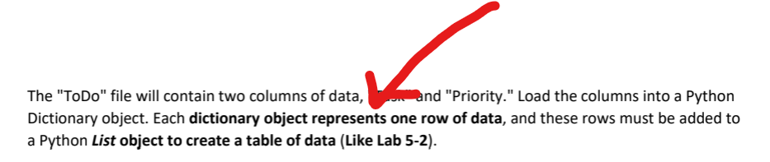

Figure 2: Screenshot from Assignment05 in PyCharm

Figure 3 shows a screenshot of the loop that fixed the issue. The trick was recalling that the dicRow variable gets rewritten every time the loop steps through a row in the data file. Specifically, I was missing line 40. I needed to append the dicRow to each row being created in the lstTable via the loop. Other than this, I had a little bit of trouble figuring out how to find a string within the list, but the Module 05 forum helped me with that:

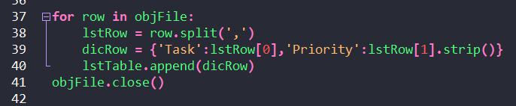

Figure 3: For loop example from Assignment05 in Notepad ++.

# The Solution Arrives!

As previously stated, eventually I got it working! Below is a screenshot of the output .txt file (Figure 4), followed by the code running via command-line and PyCharm (Figures 5 and 6):

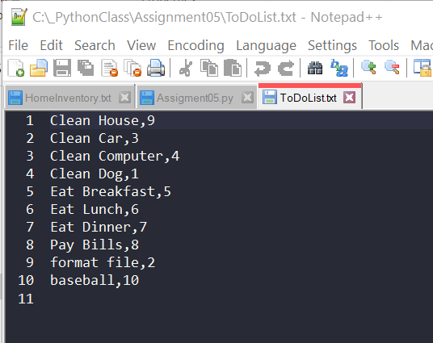

Figure 4: Assignment05.py output .txt file via Notepad++

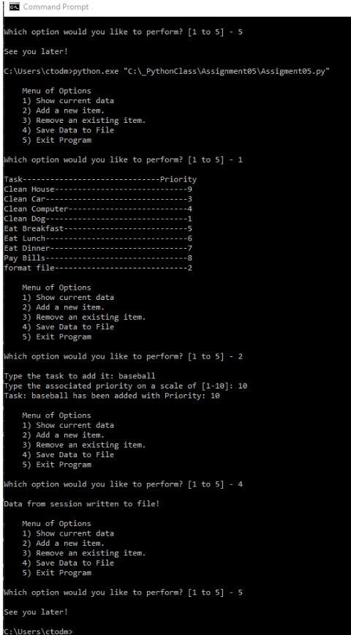

Figure 5: Command-line running Assignment05.py *(larger image available in submission)*

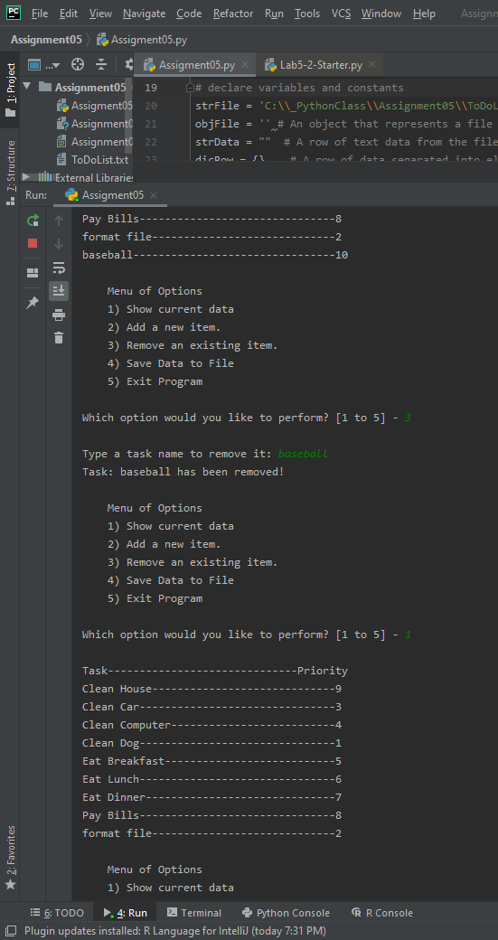

Figure 6: PyCharm running Assignment05.py

## Summary

Once again I was a pretty stumped on this one. Lucky for my I figured it out eventually. There are things I would have liked to incorporate in this code, such as sorting the list table by priority, detecting if a priority had already been assigned and prompting the user to choose an empty one, and detecting if a task item is duplicate or not. Some of these questions I plan to post to the forum and see if I can get some feedback. Otherwise, looking forward to Module 06!