Foremen
Renovation Project Management Platform
Business Analysis Document
Expanded Edition — Feature-by-Feature Specification
Result of the Business Analysis Phase
Version 2.0 (Expanded)
Confidential — Internal

How to Read This Document
This is the expanded edition of the Foremen business analysis. It is organized in two parts. Part I sets the shared context that applies to the whole platform: the business problem, the stakeholders, the project lifecycle, the overall architecture, and the cross-cutting rules for security and internationalization. Part II is a feature-by-feature catalog: every module of the platform (tracked internally as specifications FOR-01 through FOR-12) is described in its own chapter of at least two pages.
Each feature chapter follows the same template so it can be read on its own:
- Purpose and business value — why the feature exists and the value it delivers.
- Actors and roles — who uses it and in what role.
- Functional capabilities — what the feature lets users do.
- Domain and data — the entities and key data behind it.
- Process — the main end-to-end flow.
- Business rules — the invariants and constraints that must hold.
- Access control — who may read or change what.
- Non-functional notes — quality attributes, dependencies, and delivery status.
Terminology mixes English with the Polish terms used on site (for example kosztorys for the estimate and aneks for an amendment), because the platform is bilingual and the Polish terms are what the crews actually use. The glossary at the end collects them.

Part I — Platform Context
Part I describes the platform as a whole: the problem it solves, who it serves, how a project flows through it, and the architecture and cross-cutting rules that every feature in Part II builds on.

1. The Business Problem
A renovation company coordinates many people around a single apartment or house. A manager owns the commercial relationship with the client, an estimator prices the work, a foreman runs the site, workers execute tasks, and the client approves and pays. Today all of this is coordinated through one shared Excel workbook passed around by email. A single sheet of that workbook holds the entire project: the list of works grouped by category, the quantity of each work in each room, a bill of materials with consumption norms, three commercial packages, planned versus actual margins, change orders, and week-by-week worker progress.
That spreadsheet is remarkably complete, which is why it is the source of truth for the domain model. But as a working tool it has hard limits: there is no access control, so anyone with the file can see and change everything; there is no reliable history of who changed what; there is no clean, client-safe view of the offer; and there is no separation between the design stage (before the contract is signed) and the execution stage (after it). Foremen keeps the spreadsheet's "everything in one place" strength and removes its weaknesses by turning it into a structured, multi-user, role-aware, audited web application.
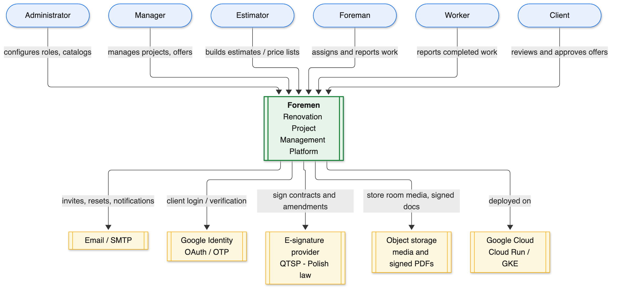
Figure 1. System context — the actors and external systems around the platform.

2. Stakeholders and Roles
Foremen distinguishes two kinds of role. A system role is the user's global role in the application. A project role is assigned per project through project membership, so the same person can be a manager on one project and only an observer on another. Access to any piece of data is decided by the combination of the system role, the permission matrix, and project membership. There are no separate per-role screens: the interface adapts automatically to the user's permissions, and the current role name is shown in the top bar for clarity.
System role | Primary responsibility in the platform
Administrator | Full access to every entity and operation; configures roles, permissions, and catalogs.
Manager | Owns projects commercially: creates projects, builds offers, runs procurement.
Estimator | Prices work and maintains the work catalog and price list.
Foreman | Runs the site: assigns tasks, approves worker reports, tracks progress.
Worker | Executes assigned tasks and reports completed work.
Financier | Handles primary documents, cost allocation, and payroll inputs.
Client | Reviews progress, approves offers, chooses a commercial package.

Project roles assigned through membership are MANAGER, FOREMAN, WORKER, CLIENT, and FINANCIER. A project may have more than one CLIENT member (for example co-owners or a spouse), and client membership can be added at any point in the lifecycle, not only when the project is created.

3. The Project Lifecycle
A project moves through a small number of stages, and the dividing line between them is the signing of the contract. Before signing, the project is in the design stage (status DRAFT): the team enriches rooms, composes the works, builds the estimate and bill of materials, prepares the offer, selects the crew, drafts the planning schedule, and watches a readiness tracker that answers the single question "what still blocks us from signing?". Signing the contract flips the same project workspace into the execution stage (status ACTIVE), where the tabs change to amendments, worker reporting, plan-versus-fact scheduling, and procurement. When all work is completed and accepted, the project closes.
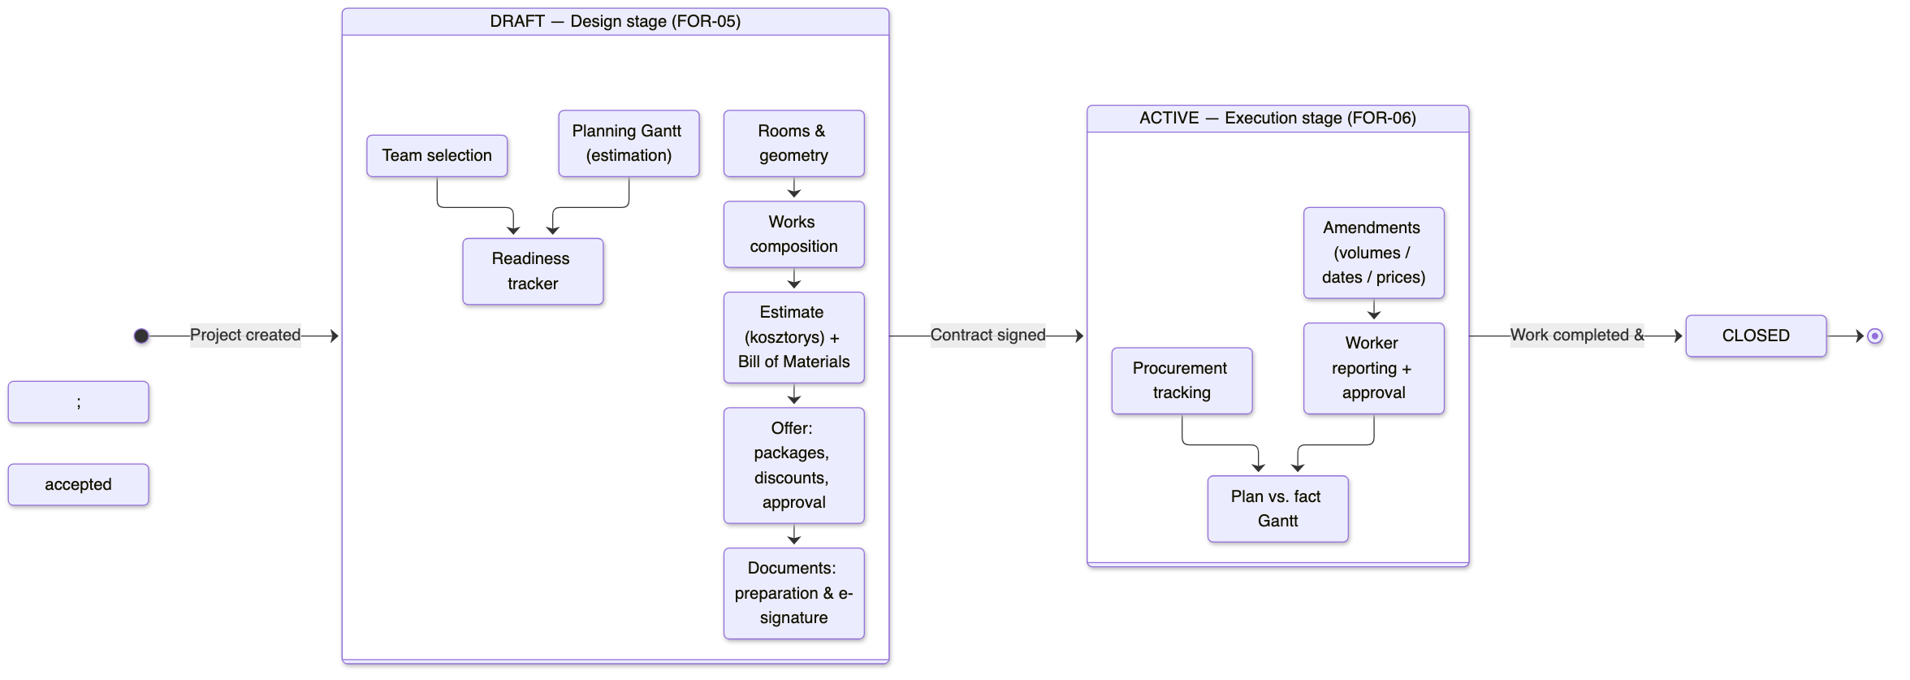
Figure 2. Project lifecycle — design and execution stages separated by contract signing.
A principle that runs through the whole platform is that the estimate is derived, not duplicated. Works reference the catalog and the price valid for the relevant package; the bill of materials is derived from per-work consumption norms; totals, package values, and margins are computed. Nothing that can be derived is typed by hand, which is what keeps the numbers internally consistent as the project changes.

4. Solution Architecture
Foremen is a web application with a React front end and a Java backend, backed by PostgreSQL and object storage, and deployed on Google Cloud. The backend is built on a custom generic CRUD framework: common create, read, update, and delete behavior lives in generic interfaces, and each managed entity is exposed as a thin controller / service / data-access triple that inherits that behavior. Cross-cutting concerns — authorization, internationalization, auditing, and caching — are applied uniformly to every entity rather than re-implemented per feature.
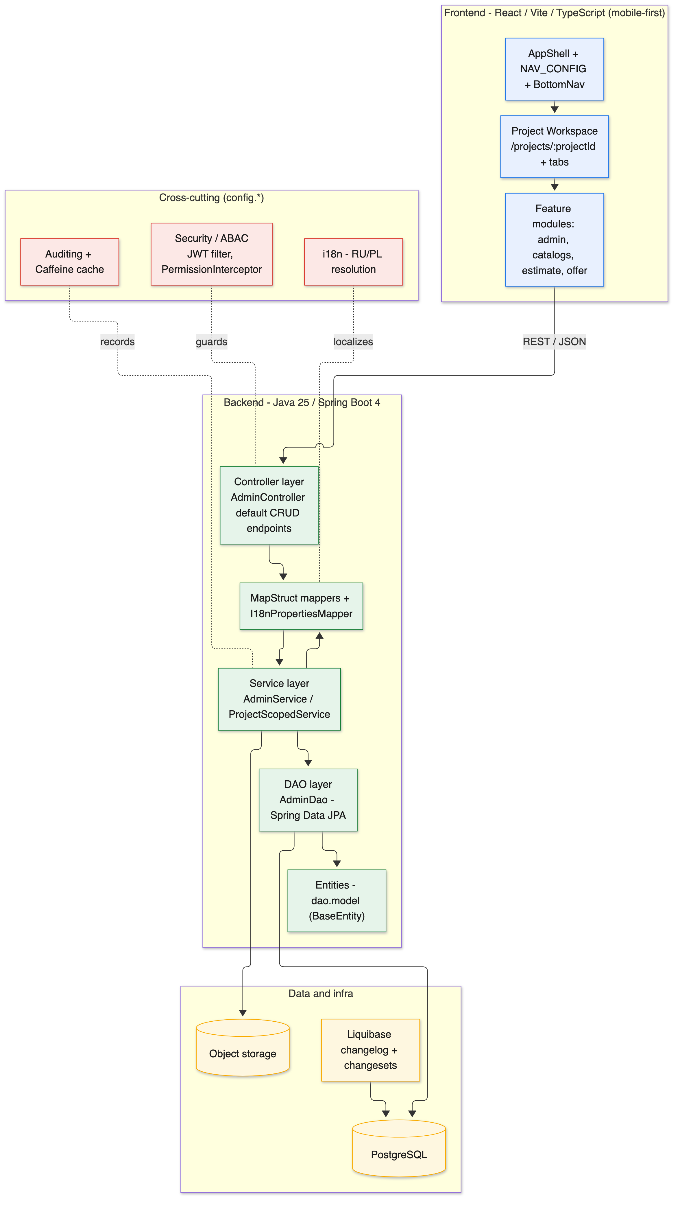
Figure 3. Layered solution architecture.
Layer | Technology
Frontend | React, Vite, TypeScript; mobile-first, iOS-like design.
Backend | Java 25, Spring Boot 4, Gradle.
Persistence | Spring Data JPA with MapStruct mapping; PostgreSQL.
Migrations | Liquibase changelog with per-feature changesets, applied before the backend starts.
Authorization | Attribute-based access control (ABAC) plus project-level membership scoping.
Infrastructure | Google Cloud (Cloud Run / GKE); Docker Compose for local development.

5. Cross-Cutting Rules

5.1 Security and access control
Authorization is attribute-based. The permission matrix is expressed as roles, resources, operations, and the grants that connect them. Each protected endpoint declares the resource it belongs to and the operation it performs. On every request an interceptor resolves the required resource-and-operation pair and checks it against the caller's role. The Administrator role bypasses the matrix; every other decision is an exact membership check that denies by default. A startup validator refuses to launch if any endpoint is only half-annotated, so a protected endpoint can never silently become unguarded. Project scoping is a second, orthogonal layer: it restricts the rows a caller can see or change to the projects they belong to, and reports an out-of-scope record as "not found" so its existence is not revealed.
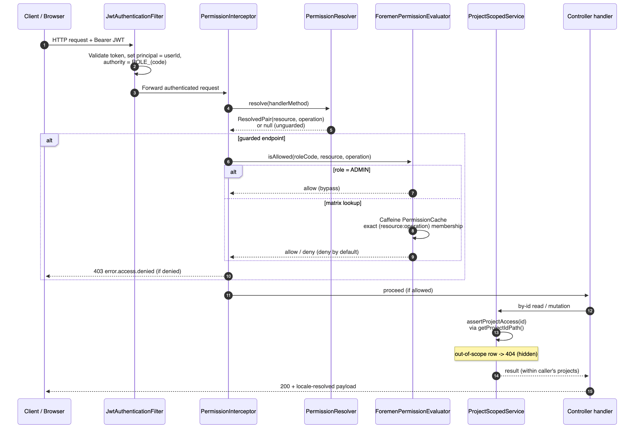
Figure 4. Request authorization and project-scoping flow.

5.2 Internationalization
Localizable text is stored in parallel columns per language (Russian and Polish). During mapping, the value for the current locale is resolved automatically, defaulting to Polish when the locale is not Russian. List views carry a single resolved value, while detail/edit views carry all locales. This single, consistent strategy applies to every entity in the system, from dictionaries to work items.

Part II — Features
Part II describes each module in its own chapter. The map below shows the modules and their build order; the chapters that follow expand each one.
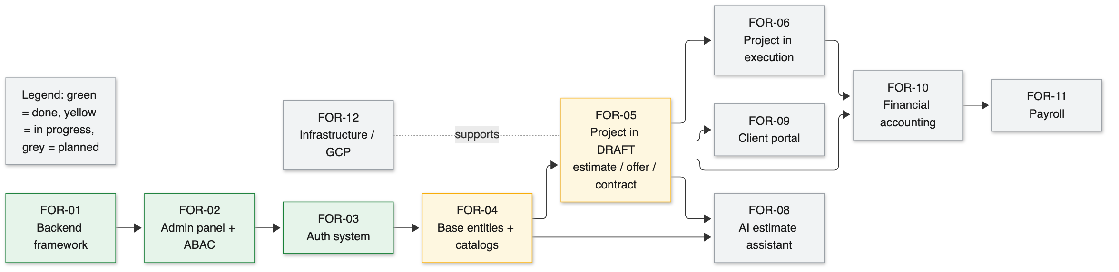
Figure 5. Module map and build order (green = done, yellow = in progress, grey = planned).

6. FOR-01 — Backend Framework
Status: Done
The foundation every other backend feature is built on: a generic CRUD framework that turns a new business entity into a complete REST resource with little repetitive code.

6.1 Purpose and Business Value
Foremen manages a large number of similar entities — dictionaries, catalog items, project sub-entities, and more. Writing create / read / update / delete logic, pagination, filtering, auditing, and localization by hand for each one would be slow and error-prone, and every small inconsistency between entities would eventually surface as a bug or a confusing screen. FOR-01 removes that cost by providing a single, well-tested framework that all entities inherit.
The business value is leverage and consistency. A new managed entity becomes a thin set of classes that plug into the framework and immediately gain the full set of endpoints, the same pagination and filtering behavior, automatic audit logging, and the same bilingual handling. That means new features ship faster, behave predictably, and are cheaper to maintain. It also makes the system easier to reason about: once a developer understands one entity, they understand them all.

6.2 Actors and Roles
The feature serves the following actors; who may actually see or change each piece of data is ultimately decided by the permission matrix and project membership described in Part I.
- Developers — the primary consumers; they add entities by implementing the framework interfaces.
- All end users — benefit indirectly through consistent, reliable behavior across every screen.

6.3 Representative User Stories
The capabilities below are driven by concrete needs. The following user stories capture the intent in the users' own terms:
- As a developer, I want a new entity to gain standard list, detail, create, update, and delete endpoints without re-writing boilerplate, so that I can focus on the business rules that are actually unique.
- As a developer, I want pagination, filtering, and sorting to work the same way on every table, so that the front end can treat all resources uniformly.
- As an administrator, I want every change to a record to be recorded automatically, so that I never depend on a developer remembering to add audit logging.
- As a user, I want all screens to behave consistently, so that learning one screen teaches me the others.

6.4 Functional Capabilities
- A generic controller that provides the full REST surface as inherited default behavior: create, bulk create, update, bulk update, paginated read, read-by-id, count, audit history, delete, set-field-to-null, localization discovery, and metadata.
- A generic service layer that adds transactions, validation hooks, query building from a filter string, and automatic audit logging of changes.
- A generic data-access layer built on Spring Data, with specification-based filtering and sorting.
- A shared base entity that gives every record an identity and audit stamps (created and updated, by whom and when).
- Object mapping between request/response objects, service models, and database entities, including automatic resolution of localized fields.

6.5 Domain and Data
The framework is layered. A request flows from the controller to the service, then to the data-access layer and the entity, with object mappers translating between the shapes used at each layer. The table summarizes the building blocks.
Building block | Responsibility
Generic controller | Declares all REST endpoints as inherited behavior; a concrete controller only wires in its service and mappers.
Generic service | Transactions, validation, query building, and audit logging.
Generic data access | Spring Data repository with filtering, sorting, and pagination.
Base entity | Identity plus created/updated audit fields shared by every entity.
Object mappers | Two-hop mapping (request to service to entity) with locale resolution.

6.6 Process
Adding a new managed entity follows the same repeatable recipe, which is what keeps the codebase uniform:
- Define the entity extending the shared base entity, with its localized fields in the parallel-column convention.
- Create the data-access interface for the entity.
- Create the service that wires in the data access, the mappers, and the entity class.
- Create the controller that exposes the service, declaring its permission resource.
- Add a database migration that creates the table and seeds the entity into the permission matrix.

6.7 Worked Example
Suppose the team needs to add a "delivery status" dictionary. The developer defines the entity with its bilingual name, creates the data-access interface, the service, and the controller, and adds a migration that creates the table and registers the resource in the permission matrix.
Without writing any endpoint code, the new dictionary immediately exposes paginated listing with filtering and sorting, create and bulk-create, update and bulk-update, delete, audit history, and localized names that resolve to the caller's language. The front end can render it with the same data-table component used everywhere else. What would otherwise be a day of repetitive work becomes a short, predictable task.

6.8 Business Rules
- Every entity carries audit stamps; who created and last changed a record, and when, is always recorded.
- Localized text always uses the parallel-column convention so the localization layer can resolve it uniformly.
- Read endpoints are paginated and filterable by default; large result sets are never returned unbounded.

6.9 Risks and Assumptions
- A generic framework concentrates risk: a defect in shared behavior affects every entity, so the shared layer must be well tested.
- Highly unusual entities may need to override framework defaults; the design keeps those overrides local rather than forcing changes to the shared layer.

6.10 Non-Functional Notes and Dependencies
Quality attributes:
- Maintainability: one framework, many entities; changes to shared behavior apply everywhere at once.
- Consistency: identical pagination, filtering, auditing, and localization across all resources.
- Testability: generic behavior is tested once and relied on by every entity.
- Performance: paginated, specification-based queries keep large tables responsive.
Dependencies:
- None upstream; FOR-01 is the base that FOR-02 through FOR-12 build on.

6.11 Signals of Done
The feature can be considered complete when the following observable signals hold:
- A new entity can be added with only its entity, data-access, service, and controller classes plus a migration.
- All inherited endpoints work for the new entity without additional code.
- Changes to any entity appear in the audit log with before/after snapshots.

7. FOR-02 — Admin Panel and Access-Control Model
Status: Done
The administrative web application and the data model behind access control: roles, resources, operations, and the grants that connect them, plus full audit history.

7.1 Purpose and Business Value
Before any project work can be managed safely, the company needs to decide who is allowed to do what. FOR-02 delivers both the model that expresses those decisions and the admin screens that let an administrator manage them. It also establishes the audit trail that records every change to important data, which is essential once multiple people share the system.
The business value is control and accountability. Administrators can define exactly which roles may perform which operations on which resources, and they can review a complete history of changes. This replaces the spreadsheet world, where everyone with the file had full access and no change was ever recorded, with a governed, auditable environment.

7.2 Actors and Roles
The feature serves the following actors; who may actually see or change each piece of data is ultimately decided by the permission matrix and project membership described in Part I.
- Administrator — configures roles and their grants, manages users, and reviews audit history.
- All employees — are assigned a role whose grants determine what they can see and do.

7.3 Representative User Stories
The capabilities below are driven by concrete needs. The following user stories capture the intent in the users' own terms:
- As an administrator, I want to define exactly which operations each role may perform on each resource, so that staff only have the access their job requires.
- As an administrator, I want to invite, activate, and deactivate users, so that I control who can sign in.
- As an auditor, I want to see what changed between two versions of a record and who made the change, so that I can investigate issues after the fact.
- As any employee, I want screens to behave the same across the admin area, so that I do not relearn the interface per section.

7.4 Functional Capabilities
- Management of the permission matrix: roles, the resources they can act on, and the operations allowed on each resource.
- Role management screens with the ability to grant or revoke create/read/update/delete on each resource.
- User management: inviting, activating, deactivating, and assigning roles to users.
- A reusable data-table component with server-side filtering, sorting, and pagination used across the whole admin area.
- A full audit log with before/after snapshots, and a comparison view that highlights what changed between two versions of a record.
- Theme and appearance settings for the admin application.

7.5 Domain and Data
The access-control model is a classic matrix expressed as four tables plus their join rows. This model is consumed at runtime by the authorization layer (FOR-03).
Entity | Purpose
Role | A named role such as Administrator, Manager, or Client.
Resource | A protected area of the system, such as users, projects, or the work catalog.
Operation | An action: create, read, update, or delete.
Role-resource grant | Which resources a role may act on, and which operations it is allowed on each.
Audit log | A record of each change with who, when, and before/after snapshots.

7.6 Process
A typical administration flow:
- The administrator opens the role management screen and selects a role.
- They grant the role access to a resource and tick the operations allowed on it.
- The change is saved and takes effect for every user holding that role.
- Any later change to a governed record is captured in the audit log with a before/after snapshot.
- An auditor opens the comparison view to see exactly what changed between two versions.

7.7 Worked Example
An administrator onboards a new estimator. They create (or invite) the user, assign the Estimator role, and confirm from the role screen that Estimator has read access to projects and create/read/update on the work catalog and prices, but no access to user management.
A week later a price is changed unexpectedly. The administrator opens the audit log for the price, finds the change, and uses the comparison view to see the exact before and after values and who made the change — turning a potential dispute into a two-minute lookup.

7.8 Business Rules
- The permission matrix is the single source of truth for what a role may do.
- Deny by default: a role has no access to a resource unless it has been explicitly granted.
- Every create, update, and delete of a governed entity is recorded in the audit log.

7.9 Access Control
The matrix uses a small, fixed vocabulary of operations, applied to a growing set of resources. The four operations are deliberately coarse so that grants stay easy to reason about and audit:
Operation | Meaning in the matrix
Create | Add a new record to a resource (for example, create a user or a catalog item).
Read | List and view records of a resource, subject to any project scoping.
Update | Modify existing records of a resource.
Delete | Remove records of a resource (often restricted to Administrator).

7.10 Risks and Assumptions
- An over-broad grant can expose data unintentionally; deny-by-default and periodic review mitigate this.
- Audit volume grows over time; snapshots are stored per change and should be retained according to policy.

7.11 Non-Functional Notes and Dependencies
Quality attributes:
- Auditability: a complete, queryable change history with snapshots.
- Usability: one consistent data-table experience across all admin screens.
- Security: the model is designed for deny-by-default enforcement in FOR-03.
Dependencies:
- FOR-01 for the CRUD framework the admin resources are built on.

7.12 Signals of Done
The feature can be considered complete when the following observable signals hold:
- An administrator can grant or revoke each operation per resource per role and see it take effect.
- Every governed change produces an audit entry with before/after snapshots.
- The comparison view clearly highlights what changed between two versions.

8. FOR-03 — Authentication and Authorization
Status: Done
How users prove who they are and how the platform decides, on every request, whether they may perform the action they are attempting.

8.1 Purpose and Business Value
FOR-03 turns the access-control model from FOR-02 into enforced behavior and adds the sign-in flows for the different kinds of user. Employees sign in with email and password; clients can sign in without a password using a one-time code; new users are invited by email and set their own password through a secure link. Every request is then checked against the permission matrix and, where relevant, against the user's project membership.
The business value is trust and safety. Clients and employees get sign-in methods that fit how they actually work, while the company gets confidence that data is only visible to the people entitled to see it. The authorization checks are enforced centrally, so a developer cannot accidentally ship an endpoint that forgets to check permissions — the application refuses to start if an endpoint is misconfigured.
Figure 6. Authentication, matrix authorization, and project scoping on each request.

8.2 Actors and Roles
The feature serves the following actors; who may actually see or change each piece of data is ultimately decided by the permission matrix and project membership described in Part I.
- Employees — sign in with email and password and receive time-limited sessions.
- Clients — sign in passwordless with a one-time code, or through Google.
- Administrators — invite users and manage their activation and deactivation.

8.3 Representative User Stories
The capabilities below are driven by concrete needs. The following user stories capture the intent in the users' own terms:
- As an employee, I want to sign in with my email and password and stay signed in for a reasonable time, so that I am not constantly re-authenticating.
- As a client, I want to sign in with a one-time code sent to my email, so that I do not have to manage yet another password.
- As a newly invited user, I want to set my own password through a secure link, so that activation is simple and safe.
- As a security owner, I want the system to refuse to start if any endpoint forgets its permission check, so that a mistake cannot reach production unnoticed.
- As a manager, I want to only see the projects I am a member of, so that other teams' data is never exposed to me.

8.4 Functional Capabilities
- Email-and-password sign-in for employees, issuing a short-lived access token and a refresh token.
- Refresh-token rotation: each refresh token is single-use and replaced on every refresh.
- Passwordless one-time-code sign-in for clients, with client-specific session lifetimes.
- Email invitations: a new user sets a password through a single-use link, which activates and signs them in.
- Google sign-in and a password-reset flow via a single-use, time-limited link.
- Central authorization on every request against the permission matrix, with the Administrator role bypassing the matrix.
- Project-level scoping so users only see and change data for the projects they belong to.
- Menu and action visibility driven by the same permissions, so users only see what they can use.

8.5 Domain and Data
Authorization has two orthogonal layers that are checked in order on every request. The sequence below shows how a request is authenticated, authorized against the matrix, and then scoped to the caller's projects.

8.6 Process
End-to-end, a protected request is handled like this:
- The request arrives with a bearer token; the authentication filter validates it and sets the caller's identity and role.
- An interceptor resolves which resource and operation the target endpoint requires.
- The authorization layer checks the caller's role against the matrix: Administrator is always allowed; any other role is an exact match that denies by default.
- For project-scoped data, the service further restricts results to the caller's projects, hiding out-of-scope records as "not found".
- If every check passes, the handler runs and the response is localized to the caller's language.

8.7 Worked Example
A foreman opens the app and requests the list of their projects. The access token identifies them and their role; the authorization layer confirms the Foreman role may read projects; the service then filters the list to the projects where the foreman is a member. A project belonging to another crew is simply absent from the results.
If the foreman tries to open a specific project they do not belong to, the system responds as if the project does not exist, rather than revealing that it exists but is forbidden. Meanwhile, their access token quietly expires and is renewed using a single-use refresh token, so the session continues without interrupting their work.

8.8 Business Rules
- Deny by default: no grant means no access.
- The Administrator role bypasses the matrix by exact role match.
- A protected endpoint that is only half-configured prevents the application from starting.
- Out-of-scope project data is reported as not found, never as forbidden, so its existence is not revealed.
- Sign-in is hardened against user-enumeration and timing attacks.

8.9 Risks and Assumptions
- Token theft is mitigated by short access-token lifetimes and single-use refresh tokens, but client devices remain a trust boundary.
- Hiding forbidden records as not-found trades a small amount of clarity for a meaningful reduction in information leakage.

8.10 Non-Functional Notes and Dependencies
Quality attributes:
- Security: central, deny-by-default enforcement; hardened sign-in; single-use tokens.
- Robustness: misconfiguration is caught at startup, not in production.
- Fit for users: distinct sign-in methods for employees and clients.
Dependencies:
- FOR-01 for the framework; FOR-02 for the permission matrix it enforces.

8.11 Signals of Done
The feature can be considered complete when the following observable signals hold:
- Employees, clients, and invited users can each sign in through their intended flow.
- A guarded endpoint rejects a caller without the required grant, and the Administrator role bypasses the matrix.
- A misconfigured (half-annotated) endpoint prevents application startup.
- A user never sees project data outside their membership.

9. FOR-04 — Base Entities and Catalogs
Status: In progress
The domain foundation: the reference dictionaries, the work catalog and its prices, the material catalogs, and the core project and room entities that every later feature builds on.

9.1 Purpose and Business Value
The estimate, the schedule, procurement, and every commercial calculation all draw on a shared set of reference data: units of measure, currencies, VAT rates, room types, work and material categories, delivery categories and statuses, and the commercial packages. FOR-04 delivers all of these as managed dictionaries, seeded with the real values the company already uses. On top of the dictionaries it delivers the work catalog with its package-based prices, the two material catalogs, the per-work material consumption norms, and the Project and Room entities that anchor the whole project domain.
The business value is a single, governed source of truth for pricing and classification. Because the catalog and prices are centralized and seeded from the company's existing price list, every estimate starts from consistent, up-to-date numbers rather than a copy-pasted spreadsheet. The material consumption norms, researched against Polish construction standards, let the platform derive a bill of materials automatically instead of estimating materials by hand.

9.2 Actors and Roles
The feature serves the following actors; who may actually see or change each piece of data is ultimately decided by the permission matrix and project membership described in Part I.
- Administrator — maintains the dictionaries and can change any catalog or price.
- Manager / Estimator — extend and adjust the work catalog, prices, and material catalogs.
- Other employees — read catalogs and dictionaries to choose values in forms.

9.3 Representative User Stories
The capabilities below are driven by concrete needs. The following user stories capture the intent in the users' own terms:
- As an estimator, I want a central work catalog with per-package prices, so that every estimate starts from the same up-to-date numbers.
- As a manager, I want the price list shown as one column per package, so that I can compare START, COMFORT, and PRESTIGE pricing at a glance.
- As an estimator, I want each work to know which materials it consumes and how much, so that the bill of materials is produced automatically rather than guessed.
- As an administrator, I want to maintain all reference values in one place in both languages, so that forms everywhere show consistent, localized options.

9.4 Functional Capabilities
- A full set of reference dictionaries (units, currencies, VAT rates, room types, work categories, delivery categories and statuses, material categories, offer packages, material types, producers, and materials), each with bilingual names and seeded with real values.
- A work catalog of priced work items organized by category.
- Package-based prices: one price per (work item, package, currency), with a documented fallback when a package has no explicit price.
- A price-list screen that pivots prices into one column per package (for example, price for START, COMFORT, PRESTIGE), filterable and sortable per package.
- Two separate material catalogs — construction materials and finishing materials — each with its own fields, managed on separate screens.
- Per-work material consumption norms linking each work to the materials it consumes and how much, researched against Polish construction standards.
- The Project entity (the anchor of the project domain) and the Room entity (with dimensions and auto-calculated geometry).
- A reference-filter improvement applied as the default behavior for every table in the admin area.

9.5 Domain and Data
FOR-04 is split into the global catalogs (shared across all projects) and the project-scoped anchor entities. The highlights:
Entity / catalog | Key points
Dictionaries | Bilingual, global, administrator-maintained, seeded via migrations. Values such as units (m2, mb, szt), currencies (PLN/EUR/USD), and VAT rates (23/8/5/0).
Work categories | Thirteen ordered categories, from preliminary works and demolition through finishing and extras.
Work catalog + prices | Priced work items; prices are per commercial package (START/COMFORT/PRESTIGE), seeded from the company's price list.
Construction materials | Name, packages, unit, purchase price, and retail prices.
Finishing materials | Richer: category, material, type, producer, model, SKU, features, prices, link, and photo; seeded from a catalog file.
Consumption norms | Per-work material usage with justification, enabling an automatic bill of materials.
Project | The project anchor; owns rooms, estimate, members, and offers; carries lifecycle status.
Room | Dimensions and auto-calculated geometry; project-scoped.

9.6 Worked Example
An estimator adds a tiling work to a project. Because the catalog already holds the work with its unit (square meters) and a price for each package, the estimate line is priced immediately for START, COMFORT, and PRESTIGE. If one package lacks an explicit price, the system falls back to the highest price among the other packages, so there is never a gap.
The same work carries material consumption norms — for example, adhesive and grout per square meter — researched against Polish construction standards. When the estimator sets the quantity, the bill of materials for that line is derived automatically, with a justification recorded for each norm.

9.7 Business Rules
- All reference text is bilingual with Polish as the fallback language.
- Dictionaries are global, administrator-maintained, and seeded by migrations so production starts with real data.
- A work price is set per package; if a package has no explicit price, the highest price among the other packages is used.
- Materials are split into two fixed branches — construction and finishing — managed as separate resources with different fields.
- Projects and rooms are project-scoped: access is filtered by project membership.

9.8 Access Control
The access matrix below summarizes who may do what. C/R/U/D are create, read, update, and delete; "own" means limited to the user's projects by membership; a dash means no access.
Resource | Admin | Manager | Foreman | Worker | Financier | Client
Dictionaries | CRUD | R | R | R | R | —
Work catalog & prices | CRUD | CRU | R | R | R | —
Material catalogs | CRUD | CRU | R | R | R | —
Projects | CRUD | CRU (own) | R (own) | R (own) | R (own) | R (own)
Rooms | CRUD | CRUD (own) | R (own) | — | — | —

9.9 Risks and Assumptions
- Seed data must match the company's real price list; a research artifact and idempotent seeds reduce the risk of drift or double-loading.
- The construction-material catalog is initially thinner than the finishing catalog; it is seeded from the research artifact and extended over time.

9.10 Non-Functional Notes and Dependencies
Quality attributes:
- Data integrity: a single governed source for classification and pricing.
- Idempotent, re-runnable seeds so production data loads safely.
- Backwards-compatible table improvements that apply across the admin area.
Dependencies:
- FOR-01 for the framework; FOR-02/03 for the permission matrix and project scoping.

9.11 Signals of Done
The feature can be considered complete when the following observable signals hold:
- All dictionaries are present, bilingual, and seeded with the real values.
- The work catalog is priced per package and the price list pivots correctly, with working per-package filtering and sorting.
- A work's consumption norms produce a derived bill of materials when quantities are set.
- Projects and rooms exist as project-scoped entities with working geometry calculations.

10. FOR-05 — Project in Design (Estimate, Offer, Contract)
Status: In progress
The heart of the platform: the single project workspace and everything that happens before the contract is signed — the estimate, the bill of materials, the commercial offer, document signing, team selection, and the readiness tracker.

10.1 Purpose and Business Value
FOR-05 is where the company earns the job. It reproduces the richest part of the client's spreadsheet — the priced estimate, the per-room quantities, the derived bill of materials, and the three commercial packages — inside a single project workspace. From one place the team prices the work, assembles the offer with discounts, prepares and signs the contract, picks the crew, and tracks how close the project is to being ready to sign.
The business value is a faster, cleaner, and more trustworthy path from first measurement to signed contract. Prices come from the governed catalog, materials are derived from consumption norms, and package values and margins are computed, so the offer is internally consistent and quick to produce. Freezing prices when the offer is approved means a signed offer never silently changes if the catalog is later edited. Online signing, compatible with Polish law, removes the paper round-trip.
The workspace is deliberately organized as one project context with tabs grouped into phases, rather than scattering the stages across ten menu items. On a phone the tabs collapse into a segmented control with an overflow menu, and dense tables fall back to cards; detail such as the per-room matrix, the bill of materials, and margins is revealed progressively so the primary task stays in focus.
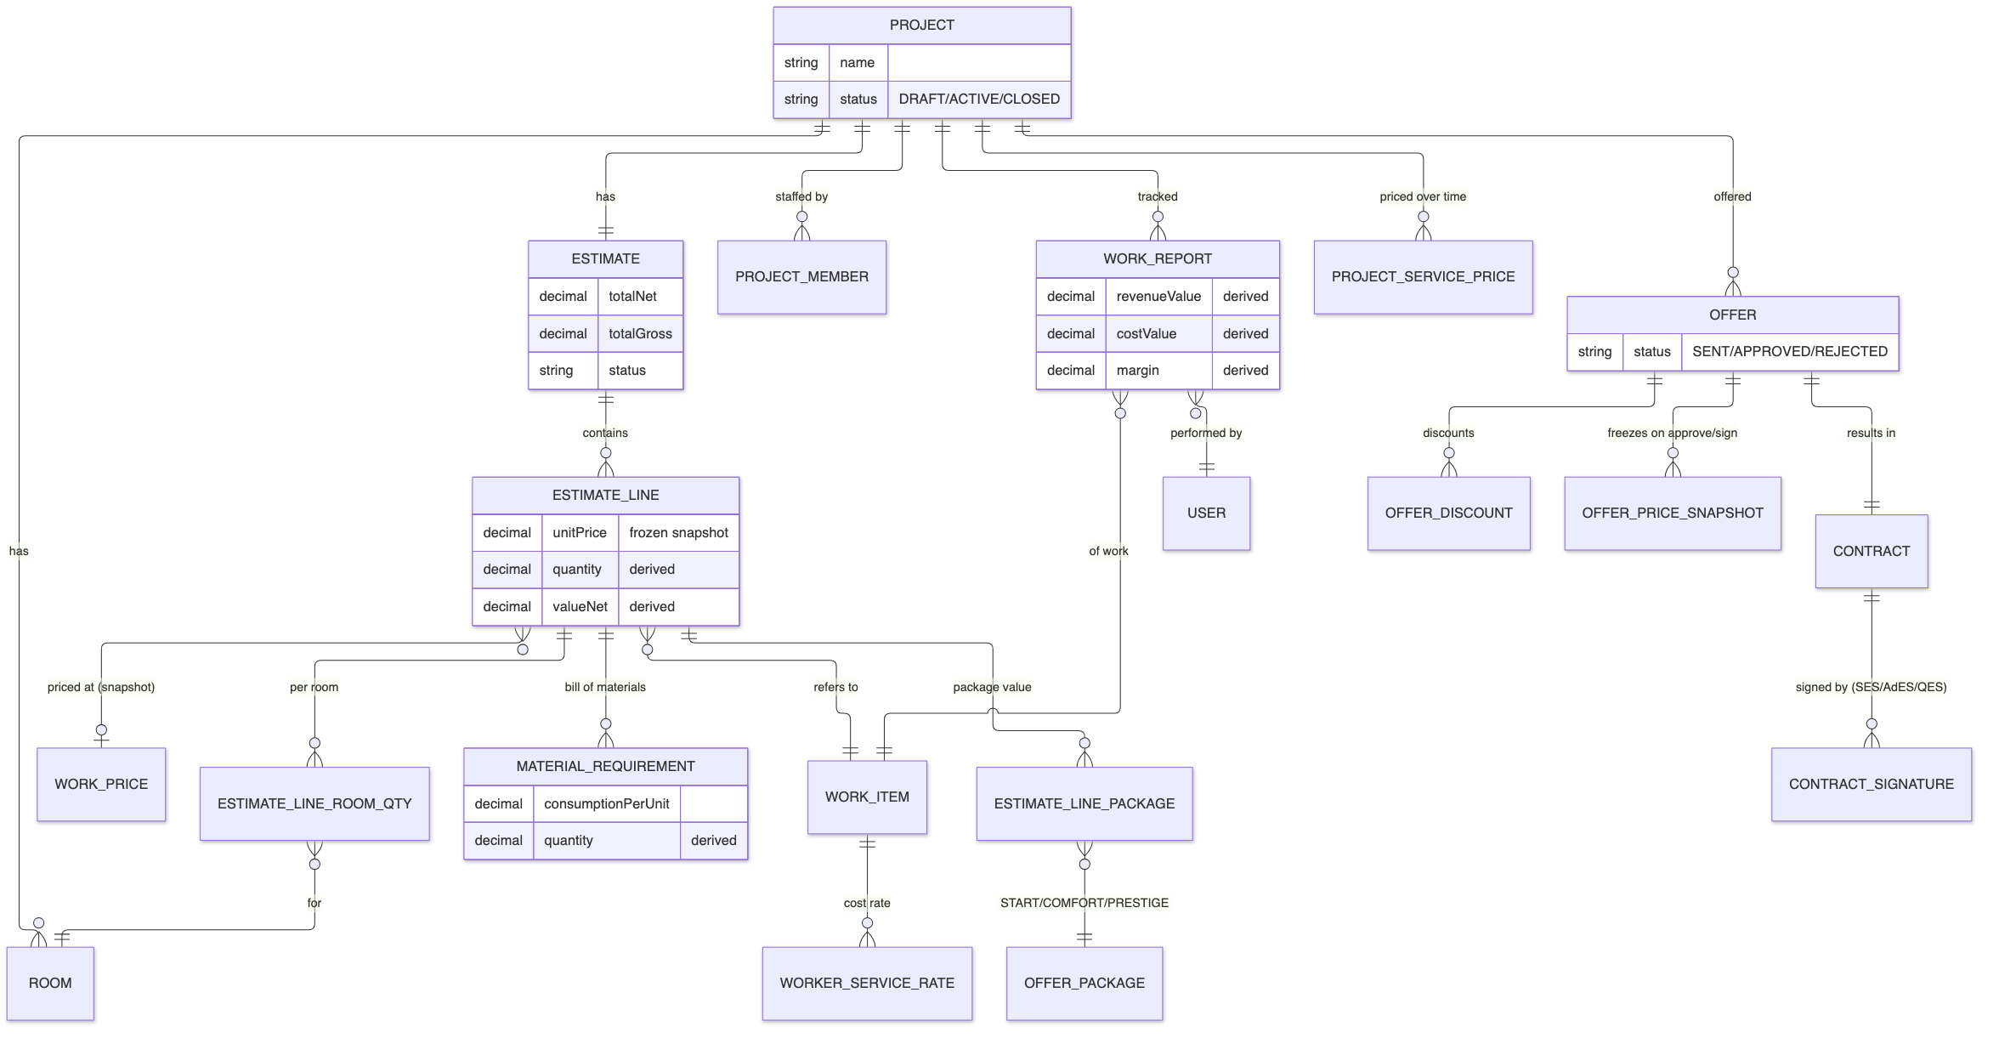
Figure 7. Core domain model behind the estimate, offer, and contract.

10.2 Actors and Roles
The feature serves the following actors; who may actually see or change each piece of data is ultimately decided by the permission matrix and project membership described in Part I.
- Manager — builds the estimate and offer, applies discounts, and drives the project toward signing.
- Estimator — prices works and tunes quantities and materials.
- Client — reviews the offer, chooses a package, and approves or rejects.
- Foreman — is assigned during team selection and prepares for execution.

10.3 Functional Capabilities
- A single project workspace at one route, with phase-grouped tabs and a persistent readiness widget in the header.
- Room enrichment: dimensions, geometry, and room media.
- Works composition: add works one by one, in bulk, or from a reusable template, with the ability to exclude unwanted items.
- The estimate (kosztorys): priced works split per room, with line totals derived from the per-room quantities.
- A derived bill of materials computed from per-work consumption norms, plus a materials-by-room projection.
- Three commercial packages (START / COMFORT / PRESTIGE) with per-line and total values for comparison.
- Cost and margin analysis: offer price versus service cost and material cost, with minimum, average, and maximum margins.
- The offer: discounts and rebates (global, per category, or per line), submission, and client approval or rejection.
- Price freezing: when an offer is approved or signed, its prices are snapshotted so later catalog edits do not change it.
- A temporal project price schedule, so the price used always matches the relevant date.
- Document preparation and electronic signing of the contract, compatible with Polish law.
- Team selection: assigning managers, foremen, workers, and clients to the project.
- A planning Gantt (an estimate of timing before work starts) and a price-history view for transparency.
- A readiness tracker that shows each stage as done, partial, or blocked, with an overall readiness percentage.

10.4 Domain and Data
The domain model is a direct decomposition of the client's spreadsheet. A project owns rooms and one estimate; the estimate owns lines; each line references a catalog work item and a frozen price and splits its quantity across rooms; the bill of materials and package values are derived from the lines.
Entity | Purpose
Estimate / Estimate line | The priced list of works; each line references a work item and a frozen unit price.
Estimate line room quantity | The quantity of a line's work in a specific room; the line total is the sum across rooms.
Material requirement | A derived bill-of-materials row: material and quantity from consumption norms.
Estimate line package | Per-line value for each commercial package.
Offer / Offer discount | The commercial offer and the discounts applied to it.
Offer price snapshot | Frozen prices captured when an offer is approved or signed.
Contract / signature | The signed agreement and its electronic signatures (simple, advanced, or qualified).
Project member | A user's role on the project; more than one client is allowed.
Project service price | The temporal client price schedule for the project.

10.5 Process
The design stage flows from measurement to a signed contract:
- Rooms are entered with their dimensions and geometry.
- Works are composed from the catalog and quantities are set per room.
- The estimate prices the works; the bill of materials and package values are derived automatically.
- The offer is assembled with discounts and sent to the client.
- The client reviews, chooses a package, and approves; prices are frozen into a snapshot.
- The contract is prepared and signed electronically; the project moves to the execution stage.

10.6 Business Rules
- Everything derivable is derived: line totals, the bill of materials, package values, and margins are computed, not typed.
- A catalog price is frozen onto the estimate line; later catalog edits do not change an existing line.
- On approval or signing, the offer's prices are snapshotted and the signed offer never changes from catalog edits.
- A project may have more than one client member, addable at any point in the lifecycle.
- What a user sees in the workspace is driven entirely by their role, permissions, and project membership.

10.7 10.9 Notifications
This feature is expected to emit user-facing notifications (for example, offer sent to the client, offer approved or rejected, contract ready to sign). The exact set, recipients, and message text are to be confirmed per child specification and should be emitted through the platform's generic notification service rather than re-implemented. This document records the expectation; the specific notification set is finalized during requirements for each child feature.

10.8 Non-Functional Notes and Dependencies
Quality attributes:
- Usability: one project context, progressive disclosure, mobile-first tables that fall back to cards.
- Data integrity: derived values and price freezing keep a signed offer stable.
- Legal compliance: electronic signatures compatible with Polish law.
Dependencies:
- FOR-04 for the project, rooms, catalog, prices, packages, and material norms; FOR-01/02/03 for the framework, matrix, and scoping.

11. FOR-06 — Project in Execution
Status: Planned
Everything that happens after the contract is signed: change orders (amendments), worker reporting, plan-versus-fact scheduling, and procurement tracking.

11.1 Purpose and Business Value
Once a project is signed it enters execution, and the same workspace flips to a different set of tabs. FOR-06 covers the realities of a running site: scope changes negotiated as amendments, workers reporting what they completed, the schedule being updated against the plan, and materials being ordered and received. It does not re-create the estimate — it reads the signed estimate and prices from FOR-05 and layers execution changes and actuals on top.
The business value is control during delivery. Amendments keep the commercial agreement accurate when scope changes, worker reports capture both what the client is billed and what the worker is paid (and therefore the margin), the schedule reflects real progress, and procurement is tracked from need to delivery. Together these turn the execution stage from an offline, spreadsheet-and-memory process into a tracked, auditable one.
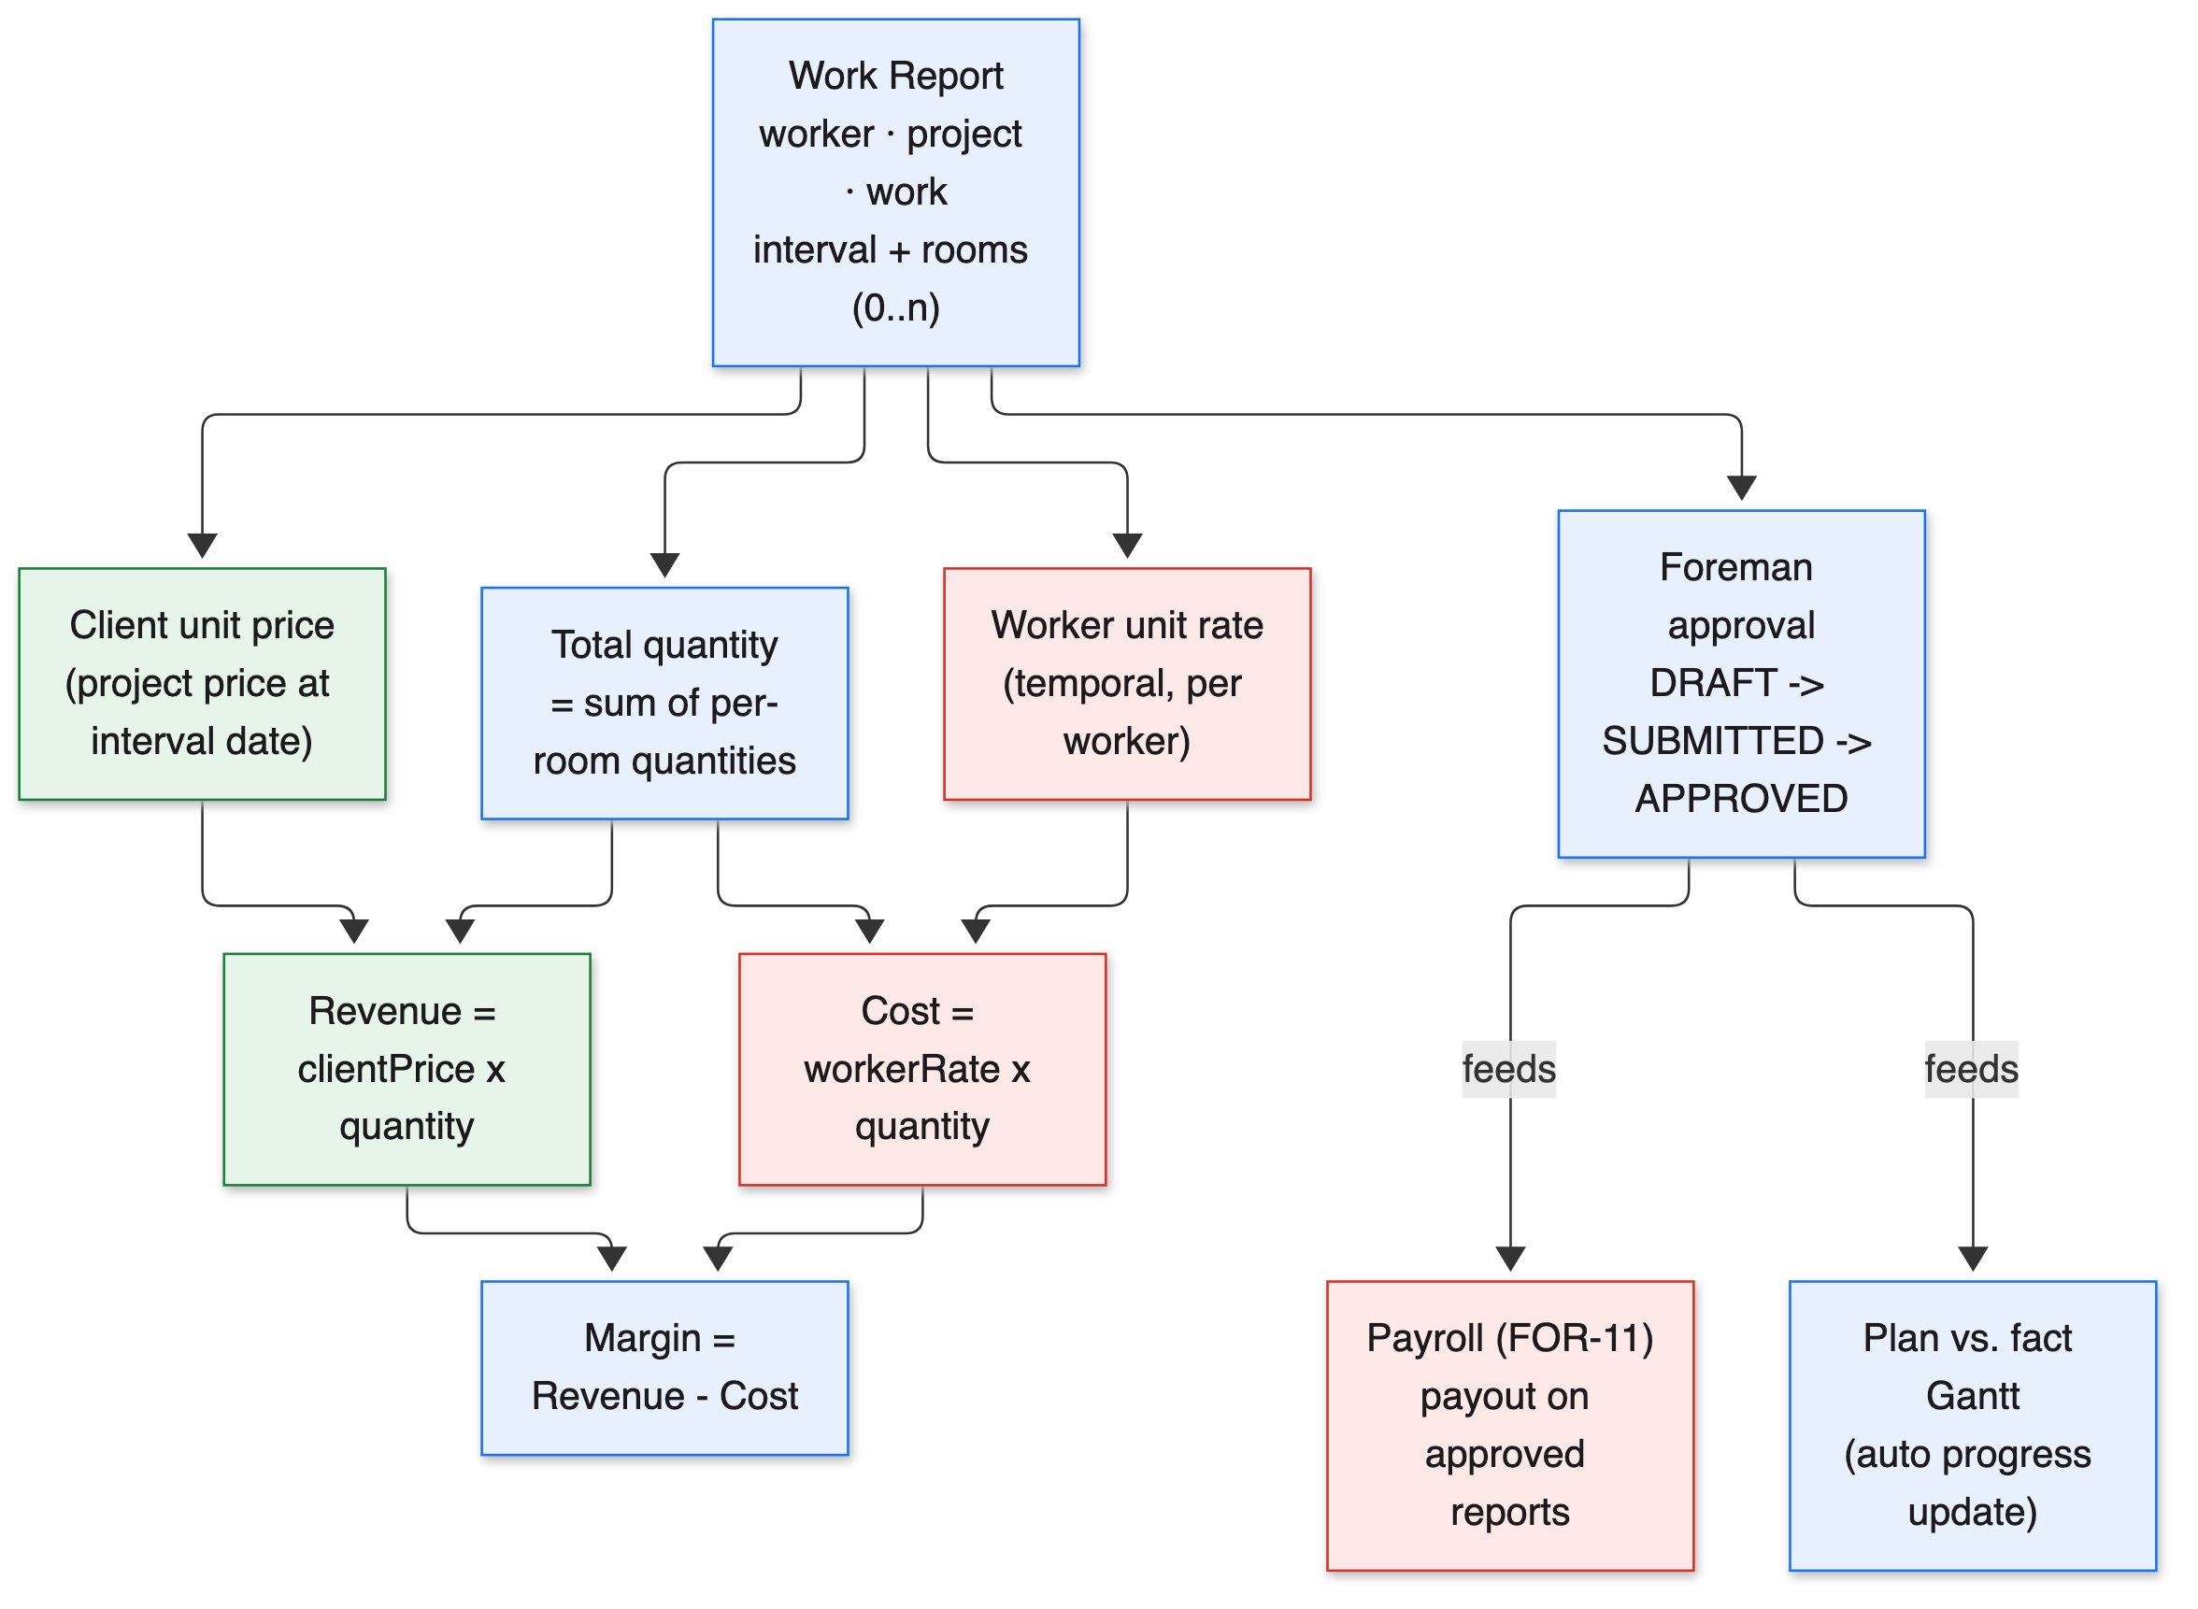
Figure 8. Work report — revenue, cost, and the derived margin feeding payroll and the schedule.

11.2 Actors and Roles
The feature serves the following actors; who may actually see or change each piece of data is ultimately decided by the permission matrix and project membership described in Part I.
- Manager — prepares amendments and oversees commercial changes.
- Foreman — approves worker reports and keeps the schedule current.
- Worker — reports completed work by work item, interval, and room.
- Financier — consumes approved reports and received goods for accounting and payroll.

11.3 Representative User Stories
The capabilities below are driven by concrete needs. The following user stories capture the intent in the users' own terms:
- As a manager, I want to raise an amendment when the client changes scope, so that the agreement and prices stay accurate.
- As a worker, I want to report what I completed by work, period, and room, so that my output is recorded and I am paid correctly.
- As a foreman, I want to approve or reject each worker report, so that only genuine progress drives the schedule and payroll.
- As a manager, I want the schedule to reflect real progress automatically, so that plan-versus-fact is always current without manual bookkeeping.
- As a financier, I want procurement tracked from need to delivery, so that costs can be allocated as goods arrive.

11.4 Functional Capabilities
- Amendments: changes to volumes, dates, or prices relative to the signed estimate, with price overrides written to the project price schedule.
- Amendment signing through the same electronic-signature engine used for the contract.
- Worker reporting: a report per worker, project, and work item, over an interval, split across rooms, with foreman approval.
- Both the revenue side (what the client pays) and the cost side (what the worker is paid), yielding the margin on each report.
- A plan-versus-fact Gantt that updates automatically from approved reports and manually from amendments, with percent-complete.
- Procurement tracking: turning the bill of materials into orders, following their status, and recording receipt.
- Integration tabs that embed primary-document capture (finance) and payroll into the project workspace.

11.5 Domain and Data
FOR-06 adds execution entities on top of the FOR-05 domain. The work report is the centerpiece: it carries both price sides and derives the margin.
Entity | Purpose
Amendment / amendment line | A change order and its per-line deltas of quantity, date, or price.
Work report | A worker's completed work over an interval, with revenue, cost, and margin.
Work report room | The per-room split of the reported quantity.
Delivery / status | A procurement order and its lifecycle status from new to delivered.

11.6 Process
A worker report flows from the site to payroll and the schedule:
- A worker reports completed work for a work item over an interval, split across rooms.
- The report resolves the client price (revenue) and the worker rate (cost) at the interval date.
- Revenue, cost, and margin are derived from the quantity and the two prices.
- The foreman reviews and approves the report.
- Approved reports feed the plan-versus-fact schedule and the payroll calculation.

11.7 Worked Example
A client decides mid-project to upgrade bathroom tiling. The manager raises an amendment that adds quantity and sets a new unit price effective from the agreed date; the amendment is signed through the same engine used for the contract. From that date forward, the project price for that work reflects the override.
The worker who does the tiling reports the completed area for the week, split by room. The report resolves the client price (revenue) and the worker's rate (cost) at the work date and derives the margin. The foreman approves it; the plan-versus-fact Gantt advances the tiling task's percent-complete, and the approved report becomes an input to that period's payroll.

11.8 Business Rules
- Execution reads the signed estimate and prices from the design stage; it does not duplicate them.
- Amendment price changes are written as dated overrides, so the correct price applies from the correct date.
- A work report carries both the revenue and cost sides; the margin is always the difference.
- A report affects the schedule and payroll only after a foreman approves it.

11.9 11.9 Notifications
Execution is notification-heavy (for example, report submitted for approval, report approved or rejected, amendment ready to sign, delivery received). The precise set and recipients are to be confirmed per child specification and emitted through the generic notification service. This document records the expectation only.

11.10 Risks and Assumptions
- Execution depends on FOR-05 being complete, since it reads the signed estimate, prices, and signing engine.
- Automatic schedule updates must handle rejected or revised reports gracefully to avoid double-counting progress.

11.11 Non-Functional Notes and Dependencies
Quality attributes:
- Continuity: the same workspace serves design and execution; tabs switch by project status.
- Traceability: amendments and reports are auditable; the margin is always reconstructable.
Dependencies:
- FOR-05 for the signed estimate, prices, signing engine, and planning Gantt; FOR-10/11 for the worker cost rate and payout.

11.12 Signals of Done
The feature can be considered complete when the following observable signals hold:
- An amendment can change volumes, dates, or prices and be signed, with price overrides applied from the correct date.
- A worker report captures revenue, cost, and margin and requires foreman approval to take effect.
- Approved reports advance the plan-versus-fact schedule and feed payroll.
- Procurement items move through their statuses from need to receipt.

12. FOR-08 — AI Estimate Assistant
Status: Planned
An AI assistant that helps build the estimate conversationally, with a chat kept per project.

12.1 Purpose and Business Value
Building an estimate from scratch is detailed, repetitive work: finding the right catalog items, setting quantities per room, and choosing materials. FOR-08 introduces an AI assistant that works alongside the estimator inside the project, suggesting works, drafting quantities, and answering questions, while the estimator stays in control of every change.
The business value is speed and accessibility. An assistant that can propose a first draft of the estimate from a short description, or fill in obvious items, shortens the time to a sendable offer and lowers the skill barrier for less experienced staff. Because the chat is kept per project, the assistant has the project's context and the conversation is preserved for later reference.

12.2 Actors and Roles
The feature serves the following actors; who may actually see or change each piece of data is ultimately decided by the permission matrix and project membership described in Part I.
- Manager / Estimator — converse with the assistant to draft and refine the estimate.
- The assistant — proposes works, quantities, and materials, acting only through controlled tools.

12.3 Representative User Stories
The capabilities below are driven by concrete needs. The following user stories capture the intent in the users' own terms:
- As an estimator, I want to describe a renovation in a sentence or two and get a first-draft estimate, so that I start from a working baseline instead of a blank sheet.
- As an estimator, I want to ask the assistant to add the usual works for a bathroom of a given size, so that I do not hunt through the catalog for routine items.
- As a manager, I want the assistant's suggestions presented as proposals I can accept or reject, so that I stay in control of what the client is offered.
- As a returning user, I want the conversation to be there when I reopen the project, so that I can continue where I left off.

12.4 Functional Capabilities
The assistant is a productivity layer over the existing estimate, not a replacement for it. Its capabilities are deliberately scoped so a human always confirms the outcome:
- A per-project chat that preserves the conversation and the project context.
- An orchestrator that interprets requests and calls a defined set of tools to read catalog data and propose estimate changes.
- Tool-based actions so the assistant proposes changes that the user reviews, rather than acting unchecked.
- Assistance surfaced inside the works and estimate tabs where it is most useful.

12.5 Domain and Data
FOR-08 adds a conversational layer over the existing estimate domain. Its own data is primarily the per-project chat session and message history; it reads and proposes changes to the FOR-05 estimate entities through tools.
Element | Role
Chat session | A per-project conversation that preserves context and history.
Orchestrator | Interprets the user's request and decides which tools to call.
Read tools | Inspect the catalog and the current estimate to ground suggestions.
Proposal | A reviewable set of suggested works, quantities, or package choices.

12.6 Process
A typical assisted-estimate interaction:
- The user describes the project or asks for specific additions in the per-project chat.
- The orchestrator interprets the request and calls read tools to inspect the catalog and the current estimate.
- The assistant proposes concrete changes (works, quantities, package) as reviewable suggestions.
- The user accepts, edits, or rejects each suggestion.
- Accepted changes are applied through the normal estimate path, with full validation and permissions.

12.7 Worked Example
An estimator opens a new project for a two-room apartment and types a short description of the scope. The assistant proposes a set of catalog works with suggested quantities per room and a package choice, presented as a draft the estimator can review line by line.
The estimator accepts most lines, edits a few quantities, and removes one work that does not apply. Each accepted change flows through the normal estimate logic — the same validation, pricing, and derived bill of materials as a manually entered line — so the assistant speeds up the work without creating a parallel, untrusted path.

12.8 Business Rules
- The assistant acts only through defined tools; it does not bypass the normal validation and permission checks.
- Proposed changes are reviewed by the user before they take effect.
- Chat history is scoped to the project and subject to the same access control as the project.

12.9 Risks and Assumptions
- AI suggestions can be wrong; the review-before-apply rule keeps a human accountable for every change.
- The assistant must respect the same permissions and project scoping as the user it acts for.
- Quality depends on the catalog and norms being accurate (FOR-04), so the assistant is only as good as its underlying data.

12.10 Non-Functional Notes and Dependencies
Quality attributes:
- Safety: controlled tool use keeps the assistant within the permission model.
- Context retention: per-project chat preserves continuity.
- Transparency: proposed changes are visible and reversible before they are applied.
Dependencies:
- FOR-04 and FOR-05 for the catalog and estimate the assistant works with.

12.11 Signals of Done
The feature can be considered complete when the following observable signals hold:
- A per-project chat persists across sessions and carries project context.
- The assistant can propose works, quantities, and a package based on a described scope.
- Every proposed change is reviewed by the user before it is applied, and applied changes go through normal validation.

13. FOR-09 — Client Portal
Status: Planned
The client's own view of the project: read-only estimates, schedules, and lists, plus the communication needed to approve the offer and coordinate purchases.

13.1 Purpose and Business Value
Clients need visibility and a way to make decisions, but they must not see internal costs or be able to change project data. FOR-09 gives clients a safe, read-only window onto their project — the offer, the schedule, and the purchase lists — together with the specific interactions they are entitled to: approving the offer, choosing a package, agreeing discounts, and coordinating purchasing choices.
The business value is a professional client experience and faster decisions. Instead of emailing spreadsheet exports, the company gives the client a clean, controlled portal. Clients can approve offers and respond to purchasing questions in one place, which shortens approval cycles and reduces miscommunication, while the role and permission model guarantees they only ever see what is meant for them.

13.2 Actors and Roles
The feature serves the following actors; who may actually see or change each piece of data is ultimately decided by the permission matrix and project membership described in Part I.
- Client — views their project read-only and performs the approvals and choices allowed to them.
- Manager / Foreman — respond to client requests and approve purchasing coordination.

13.3 Representative User Stories
The capabilities below are driven by concrete needs. The following user stories capture the intent in the users' own terms:
- As a client, I want to see a clear version of my offer with the package options, so that I understand what I am paying for.
- As a client, I want to approve or reject the offer online, so that I do not need to print, sign, and scan documents.
- As a client, I want to follow the schedule and the purchase lists, so that I know what is happening and what decisions are pending.
- As a client with a co-owner, I want both of us to have access, so that either of us can review and respond.
- As a manager, I want client purchasing requests to come to me for approval, so that choices are coordinated rather than ad hoc.

13.4 Functional Capabilities
The portal exposes only what a client is entitled to see and do. Internal figures such as costs and margins are never part of a client projection:
- Read-only client views of the estimate or offer, the schedule, and the purchase lists.
- Offer approval: reviewing packages and discounts and approving or rejecting the offer.
- Package and special-price selection where the client is given options.
- Communication around purchasing: a client request, a manager or foreman approval, price agreement, and choice between purchasing variants.
- Client sign-in by one-time code or Google, with client-appropriate session lifetimes.

13.5 Domain and Data
FOR-09 is mostly a controlled projection of existing project data for client consumption, plus the communication threads around approvals and purchasing. It introduces little new core data; it reuses the offer, estimate, schedule, and procurement entities read-only and layers client-facing interactions on top.
Surface | What the client sees or does
Offer view | A clean, read-only presentation of packages and agreed discounts.
Approval action | Approve or reject the offer; choose a package where offered.
Schedule view | A read-only view of the project timeline.
Purchase lists | Read-only lists of planned and ordered items.
Purchasing thread | A request/approval conversation routed to a manager or foreman.

13.6 Process
A typical client interaction with the portal:
- The client signs in with a one-time code or Google.
- They review the offer, including packages and agreed discounts.
- They approve or reject, or raise a question about purchasing.
- Client requests route to a manager or foreman for approval.
- Approved decisions flow back into the offer or procurement, visible to the client as read-only.

13.7 Worked Example
A client receives a notification that their offer is ready. They sign in with a one-time code sent to their email and see a clean presentation of the three packages over the same scope, with the discounts that were agreed. They choose COMFORT and approve the offer; internally this freezes the offer prices and moves the project toward contract signing.
Later, during execution, the client is asked to choose between two tile options for a bathroom. They review the options in the portal and submit a choice; the request goes to the manager for approval before it affects procurement. At no point does the client see internal costs or margins — only the information meant for them.

13.8 Business Rules
- Clients have read-only access to project data and never see internal cost or margin information.
- Clients can only perform the specific actions granted to them, such as approving an offer.
- All client access is governed by the same permission model and project membership as the rest of the platform.

13.9 13.9 Notifications
The portal is a natural place for client-facing notifications (for example, offer ready to review, purchase decision requested). The exact set and delivery channels are to be confirmed during the feature's requirements and emitted through the generic notification service.

13.10 Risks and Assumptions
- The read-only boundary must be airtight; any projection that leaks internal cost data would be a serious issue, so projections are built deliberately and minimally.
- Clients vary widely in technical comfort, which is why the portal is decision-oriented and mobile-first.

13.11 Non-Functional Notes and Dependencies
Quality attributes:
- Security: strict read-only projection; no exposure of internal figures.
- Usability: a clean, decision-oriented client experience.
- Responsiveness: mobile-first, since clients are most likely to review on a phone.
Dependencies:
- FOR-05 for the offer and estimate; FOR-06 for schedule and procurement; FOR-03 for client sign-in and scoping.

13.12 Signals of Done
The feature can be considered complete when the following observable signals hold:
- Clients can view the offer, schedule, and purchase lists but cannot change project data.
- Clients can approve or reject an offer and choose a package where offered.
- Client purchasing requests route to a manager or foreman for approval.
- No client projection exposes internal cost or margin figures.

14. FOR-10 — Financial Accounting
Status: Planned
The money side of a project: capturing primary documents, importing bank transactions, and allocating costs to projects and cost categories.

14.1 Purpose and Business Value
A renovation project generates invoices, receipts, and bank movements that must be tied back to the right project and cost category to know whether the project is actually profitable. FOR-10 captures these primary documents, imports bank transactions, and allocates both to projects and categories, giving the company a real cost picture rather than an estimate.
The business value is financial truth. By connecting actual spending to each project and comparing it against the estimated and billed amounts, the company can see real margins, catch overruns early, and base future estimates on evidence. FOR-10 also owns the internal worker cost rates that the margin calculations and payroll depend on, keeping a single source of truth for what work costs the company.
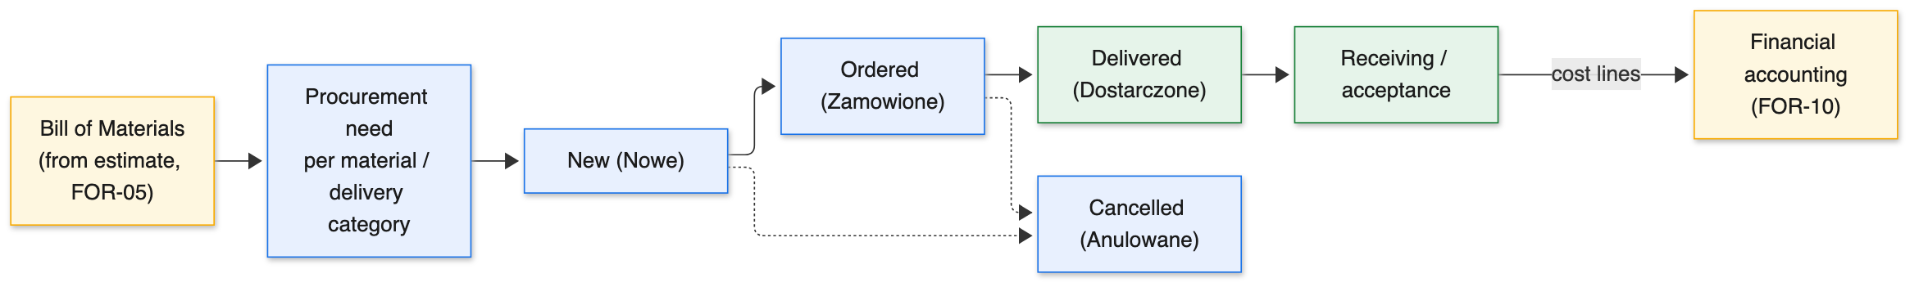
Figure 9. Procurement flows from the bill of materials to receiving and into financial accounting.

14.2 Actors and Roles
The feature serves the following actors; who may actually see or change each piece of data is ultimately decided by the permission matrix and project membership described in Part I.
- Financier — captures primary documents, imports and allocates transactions, and maintains cost rates.
- Manager — reviews project financials and margins.

14.3 Representative User Stories
The capabilities below are driven by concrete needs. The following user stories capture the intent in the users' own terms:
- As a financier, I want to attach each invoice and receipt to a project and cost category, so that I can see where money actually went.
- As a financier, I want to import bank transactions and allocate them to projects, so that reconciliation is quick and accurate.
- As a manager, I want to compare actual costs against the estimate for a project, so that I can catch overruns early.
- As a payroll owner, I want worker cost rates maintained in one place, so that margins and payouts use the same, correct numbers.

14.4 Functional Capabilities
Financial accounting closes the loop between what was estimated, what was billed, and what was actually spent:
- Capture of primary documents (invoices and receipts) attached to projects and cost categories.
- Import of bank transactions and their allocation to projects and cost categories.
- Cost allocation that connects actual spending to the estimate and the billed amounts.
- Ownership of the internal worker cost rates used for margins and payroll.

14.5 Domain and Data
FOR-10 introduces financial records and the worker cost-rate schedule. It reads the procurement and estimate data from other modules to allocate costs; receipt capture may be assisted by document recognition and messaging-based capture explored in sibling tools.
Entity | Purpose
Primary document | An invoice or receipt attached to a project and cost category.
Bank transaction | An imported movement allocated to a project and category.
Worker service rate | The temporal, per-worker cost rate used by margins and payroll.

14.6 Process
A cost flows from document to allocation like this:
- A primary document (invoice or receipt) is captured and attached to a project and cost category.
- Bank transactions are imported.
- Each transaction is allocated to the relevant project and cost category.
- Actual costs are compared against the estimated and billed amounts for the project.
- Worker cost rates are maintained here and read by margin calculations and payroll.

14.7 Worked Example
After a delivery of tiles is received, the financier attaches the supplier invoice to the project and the appropriate cost category. When the matching bank payment is imported, it is allocated to the same project and category, so the spend is both documented and reconciled.
At the end of the month, the manager compares the project's actual material and labor costs against the estimated and billed amounts. Because labor cost comes from the governed worker rates and the approved work reports, the margin shown is grounded in real figures rather than the original estimate — and any divergence is visible while there is still time to react.

14.8 Business Rules
- Every captured cost is allocated to a project and a cost category.
- Worker cost rates are owned here and read by other modules; they are temporal and per worker.
- Financial data follows the same access control and project scoping as the rest of the platform.

14.9 Risks and Assumptions
- Receipt and invoice capture can be labor-intensive; document recognition and messaging-based capture explored in sibling tools can reduce the manual load.
- Allocation accuracy depends on discipline; clear categories and links to primary documents help keep it reliable.

14.10 Non-Functional Notes and Dependencies
Quality attributes:
- Accuracy: actual costs reconciled against estimated and billed amounts.
- Single source of truth for worker cost rates.
- Traceability: each cost is linked to its primary document and the project it belongs to.
Dependencies:
- FOR-05 and FOR-06 for the estimate, procurement, and work reports it allocates against.

14.11 Signals of Done
The feature can be considered complete when the following observable signals hold:
- Primary documents can be attached to a project and cost category.
- Bank transactions can be imported and allocated.
- Actual project costs can be compared against estimated and billed amounts.
- Worker cost rates are maintained here and consumed by margins and payroll.

15. FOR-11 — Payroll
Status: Planned
Calculating what each worker is paid, based on the work they reported and the cost rates that apply to them.

15.1 Purpose and Business Value
Workers are paid for the work they complete, at rates that can differ by worker and change over time. FOR-11 turns approved worker reports into payouts by applying the right cost rate to the reported quantities for each worker and period. It builds directly on the reporting from FOR-06 and the cost rates owned by FOR-10.
The business value is accurate, defensible payroll with far less manual effort. Because payouts are computed from approved reports and governed rates, there is a clear, auditable line from the work a worker did to the amount they are paid, which reduces disputes and the time spent reconciling pay by hand.
Payroll in renovation work is awkward precisely because pay is piece-based and rates are not uniform: the same task can be worth different amounts to different workers, and a worker's rate may change between the start and end of a long project. Doing this in a spreadsheet means copying numbers between the progress sheet and a pay sheet by hand, which is slow and easy to get wrong. By computing directly from the data already captured during execution, FOR-11 removes that duplication entirely: there is no separate pay sheet to maintain, only a calculation over records that already exist and have already been approved.

15.2 Actors and Roles
The feature serves the following actors; who may actually see or change each piece of data is ultimately decided by the permission matrix and project membership described in Part I.
- Financier — runs and reviews the payroll calculation.
- Foreman — upstream, approves the reports that payroll is based on.
- Worker — sees the volume and earnings attributable to them.

15.3 Representative User Stories
The capabilities below are driven by concrete needs. The following user stories capture the intent in the users' own terms:
- As a financier, I want payouts computed automatically from approved reports, so that I do not reconcile pay by hand.
- As a worker, I want to see the volume and earnings attributed to me for a period, so that I can check my pay is correct.
- As a foreman, I want only the reports I approved to count toward pay, so that unapproved or disputed work is excluded.
- As an auditor, I want each payout to trace back to specific reports and rates, so that disputes can be resolved with evidence.

15.4 Functional Capabilities
Payroll is a calculation layer: it does not capture new site data but turns approved reports into money owed, using governed rates:
- Computation of worker payouts from approved work reports and the applicable cost rates.
- Attribution of volume and earnings to each worker over a period.
- A payroll settlement surface embedded in the project workspace.

15.5 Domain and Data
FOR-11 computes over existing data rather than introducing a large new domain: it reads approved work reports (FOR-06) and worker cost rates (FOR-10) and produces payout figures per worker and period.
Input / output | Source or meaning
Approved work report | Input from FOR-06: the quantities a worker completed, per work and interval.
Worker cost rate | Input from FOR-10: the temporal, per-worker rate for a work.
Period | The pay window over which reports are gathered.
Payout | Output: the amount owed to a worker, traceable to the reports and rates used.

15.6 Process
- Approved work reports for the period are gathered per worker.
- The applicable worker cost rate is resolved for each reported work and interval.
- The payout is computed from the reported quantities and the rates.
- The result is reviewed and settled.

15.7 Worked Example
At period end, the financier runs the payroll calculation. For each worker, the system gathers their approved reports, resolves the worker's cost rate as it applied on each work's date, and multiplies by the reported quantities to produce the payout.
A worker questions their amount. Because every payout line traces back to a specific approved report (with its work item, interval, rooms, and quantities) and the rate that applied at the time, the financier can walk through the calculation line by line and resolve the question quickly, without re-deriving anything by hand.

15.8 Business Rules
- Only approved reports are eligible for payout.
- Rates are resolved as they applied at the time the work was done.
- Payroll figures are reconstructable from the underlying reports and rates.

15.9 Risks and Assumptions
- Payroll correctness depends on upstream approval discipline and accurate rates; both are owned elsewhere (FOR-06 and FOR-10) and read here.
- Rate changes over time must be applied as of the work date, not the pay date, to avoid over- or under-paying.

15.10 Non-Functional Notes and Dependencies
Quality attributes:
- Auditability: a clear line from reported work to payout.
- Accuracy: temporal, per-worker rates applied correctly.
- Transparency: workers can see the volume and earnings attributed to them.
Dependencies:
- FOR-06 for approved work reports; FOR-10 for worker cost rates.

15.11 Signals of Done
The feature can be considered complete when the following observable signals hold:
- Payouts are computed only from approved reports.
- Each payout traces back to the underlying reports and the rates applied.
- Workers can see their attributed volume and earnings for a period.

16. FOR-12 — Infrastructure
Status: Planned
How the platform is deployed, operated, and connected to the external services it relies on.

16.1 Purpose and Business Value
A working application still needs somewhere to run, a way to be deployed and updated safely, and connections to the external services it depends on — email, electronic signing, object storage for media and signed documents, and client authentication. FOR-12 covers deploying Foremen to Google Cloud and wiring up those integrations.
The business value is a reliable, operable product. Containerized services, database migrations applied automatically before the application starts, and a managed cloud platform mean the system can be deployed and upgraded predictably. Centralizing the external integrations here keeps the rest of the platform clean and makes it straightforward to configure providers per environment.
This module is intentionally added incrementally, as the rest of the platform matures. Early development runs the whole stack locally with container orchestration — a database, the migration step, the backend, and the frontend — which keeps the local environment close to production and avoids surprises at deployment time. As features that depend on external providers come online (signing, media storage, client sign-in), the corresponding integrations are configured and hardened. Treating infrastructure as its own module, rather than an afterthought, means operational concerns such as secrets handling, environment separation, and safe migration ordering are designed deliberately instead of improvised under release pressure.

16.2 Actors and Roles
The feature serves the following actors; who may actually see or change each piece of data is ultimately decided by the permission matrix and project membership described in Part I.
- Operations / Administrators — deploy, configure, and operate the platform.
- The platform itself — consumes the configured external services at runtime.

16.3 Representative User Stories
The capabilities below are driven by concrete needs. The following user stories capture the intent in the users' own terms:
- As an operator, I want to deploy a new version with a predictable, repeatable process, so that releases are low-risk.
- As an operator, I want schema changes applied automatically before the application serves traffic, so that the code and database never fall out of step.
- As an administrator, I want external providers configured per environment, so that staging and production can differ without code changes.
- As a security owner, I want media and signed documents stored in object storage rather than the database, so that storage scales and secrets stay out of the database.

16.4 Functional Capabilities
Infrastructure is where the product becomes something that can be run, upgraded, and connected to the outside world safely:
- Deployment to Google Cloud, with containerized backend and frontend services.
- Database schema managed by migrations that run before the backend starts.
- Integration with email, electronic-signature providers, object storage, and client authentication.
- Environment-specific configuration of providers and secrets.

16.5 Domain and Data
FOR-12 is an operational module rather than a business-domain one. It provides the runtime environment and the connections to external systems shown in the system context (Figure 1): email, signing, object storage, authentication, and the cloud platform.
External system | Why the platform needs it
Email / SMTP | Invitations, password resets, and notifications.
E-signature provider | Signing contracts and amendments under Polish law.
Object storage | Storing room/project media and signed documents outside the database.
Client authentication | One-time-code and Google sign-in for clients.
Cloud platform | Running and scaling the containerized services.

16.6 Process
A deployment proceeds in a fixed order so the system is always consistent:
- Build the containerized backend and frontend images.
- Run database migrations as a dedicated step.
- Start the backend only after migrations succeed.
- Start the frontend and wire it to the backend.
- Resolve external providers (email, signing, storage, authentication) from per-environment configuration.

16.7 Worked Example
A new release is deployed to the cloud. The database migrations run first as a dedicated step; only once they succeed does the backend start, which guarantees the running code always matches the schema it expects. The frontend and backend run as separate containerized services behind the platform's networking.
When a contract is signed, the signed document and any supporting media are written to object storage, and the e-signature provider is called through configuration that differs between staging and production. Switching a provider or rotating a secret is a configuration change, not a code change.

16.8 Business Rules
- Schema changes are applied through migrations before the application serves traffic.
- External providers are configured per environment rather than hard-coded.
- Media and signed documents are stored in object storage, not in the database.

16.9 Risks and Assumptions
- Misordered deployments can cause schema/code mismatches; running migrations as a gating step before the backend starts prevents this.
- External providers are third-party dependencies; per-environment configuration and clear separation keep the platform adaptable.

16.10 Non-Functional Notes and Dependencies
Quality attributes:
- Reliability and repeatable deployments.
- Portability through containerization and managed migrations.
- Operability: clear separation of per-environment configuration and secrets.
Dependencies:
- Underpins all modules at runtime; required in production by the signing, media, and notification features.

16.11 Signals of Done
The feature can be considered complete when the following observable signals hold:
- The platform deploys to the cloud as containerized services.
- Migrations run and must succeed before the backend starts.
- External providers are configured per environment, not hard-coded.
- Media and signed documents are stored in object storage.

17. Glossary
Term | Meaning
Estimate (kosztorys) | The priced list of works for a project, split per room.
Bill of materials | The materials required by the works, derived from consumption norms.
Offer | The commercial proposal to the client, with packages and discounts.
Package | A commercial tier over the same scope: START, COMFORT, or PRESTIGE.
Amendment (aneks) | A change order altering volumes, dates, or prices after signing.
Work report | A worker's completed work over an interval, carrying revenue, cost, and margin.
Readiness tracker | The widget showing how close a project is to being ready to sign.
Access control (ABAC) | The role / resource / operation permission matrix.
Project scoping | Limiting data access to the projects a user is a member of.
Electronic signature | Simple, advanced, or qualified e-signature levels under EU/Polish law.

End of document.

