Foremen
Renovation Project Management Platform
Business Analysis Document
Result of the Business Analysis Phase — Project Specification
Version 1.0
Confidential — Internal

1. Executive Summary
Foremen is a full-featured platform for managing renovation (remont) projects. It covers the complete project lifecycle: planning, estimating, procurement, task assignment, progress control, and a client portal. The platform digitizes a workflow that construction companies today run inside a single, overloaded Excel workbook, and turns it into a structured, multi-user, role-aware web application.
The source of truth for the domain model is the client's existing spreadsheet ("Matrix Foremen v3.0"). A single sheet in that workbook holds an entire project: the list of works grouped by category, per-room quantities, a bill of materials with consumption norms, three commercial packages (START / COMFORT / PRESTIGE), planned and actual margins, change orders (amendments), and week-by-week worker progress. Foremen preserves this "everything in one place" mental model while adding access control, auditability, internationalization, and legally compatible electronic signatures.
This document is the result of the business analysis phase. It consolidates the business context, stakeholders, scope, domain model, process flows, and the solution architecture into a single reference that both business and engineering stakeholders can navigate.

1.1 Business Goals
- Digitize the workflow — replace the fragile single-spreadsheet workflow with a structured, auditable system.
- Unify the project view — one project, one context — all lifecycle stages reachable without losing orientation.
- Automate pricing — estimate, bill of materials, packages, discounts, and margins computed, not hand-typed.
- Support two languages — Russian and Polish throughout the UI and the data, with Polish as the default fallback.
- Enforce access control — role plus a fine-grained permission matrix decide what every user can see and do.
- Enable e-signature — contracts and amendments signed online, compatible with Polish law.

2. Business Context
A renovation company coordinates many parties around a single apartment or house: a manager who owns the commercial relationship, an estimator who prices the work, a foreman who runs the site, workers who execute tasks, and the client who approves and pays. Today these parties exchange one Excel file by email. There is no access control, no history of who changed what, no reliable way to show the client a clean offer, and no separation between the design stage (before the contract is signed) and the execution stage (after signing).
Foremen sits at the center of this collaboration. It integrates with external services for email, client authentication, electronic signatures, object storage for media and signed documents, and the cloud platform it runs on. The system context below shows the actors and the external systems the platform depends on.
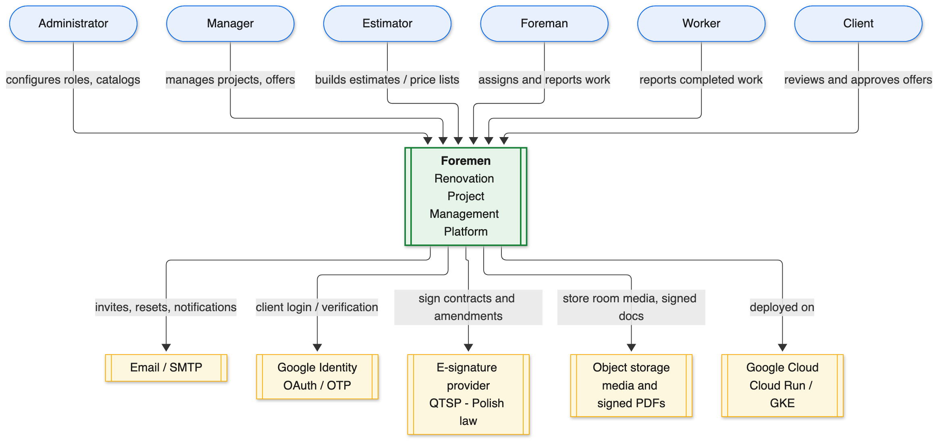
Figure 1. System context — actors and external systems.

2.1 Stakeholders and Roles
Foremen distinguishes two kinds of role. A system role is the user's global role in the application. A project role is assigned per project through project membership, so the same person can be a manager on one project and merely an observer on another. Access to any piece of data is decided by the combination of system role, the permission matrix, and project membership. There are no separate per-role workspaces: the interface adapts automatically based on the user's permissions.
System role | Responsibility
Administrator | Full access to all entities and operations; configures roles and catalogs.
Manager | Manages projects, estimates, offers, and procurement.
Foreman | Runs work on site, assigns tasks, approves worker reports.
Worker | Executes tasks and reports completed work.
Estimator | Works with estimates and the price list (catalog).
Client | Reviews project progress, approves offers, chooses packages.

Project roles (assigned via project membership) are MANAGER, FOREMAN, WORKER, CLIENT, and FINANCIER. A project may have more than one CLIENT member — for example co-owners or a spouse — and client membership can be added at any point in the lifecycle, not only at project creation.

3. Scope and Delivery Roadmap
The platform is delivered as a sequence of modules (internally tracked as specifications, FOR-01 through FOR-12). The foundation modules — the backend framework, the admin panel, and the authentication system — are complete. The base-entities catalog is largely complete, and the project design stage is in active development. The remaining modules build on this core.
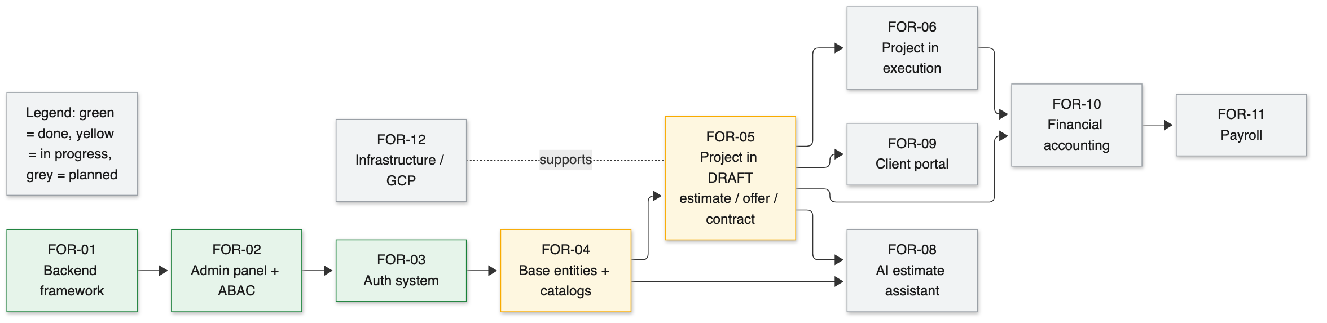
Figure 2. Module map and build order (green = done, yellow = in progress, grey = planned).
Module | Scope | Status
FOR-01 Backend framework | Custom generic CRUD framework and base architecture. | Done
FOR-02 Admin panel | Admin web app, ABAC entities, role management, audit. | Done
FOR-03 Auth system | Login, roles, menu visibility, access validation. | Done
FOR-04 Base entities | Projects, rooms, units, currencies, VAT, catalogs, work prices. | In progress
FOR-05 Project in design (DRAFT) | Estimate, bill of materials, offer, margins, contracts, team, readiness. | In progress
FOR-06 Project in execution | Amendments, worker reporting, Gantt update, procurement tracking. | Planned
FOR-08 AI estimate assistant | AI-assisted estimate creation with per-project chat. | Planned
FOR-09 Client portal | Read-only views plus client-side communication and approval. | Planned
FOR-10 Financial accounting | Primary documents, bank transactions, cost allocation. | Planned
FOR-11 Payroll | Worker payout computation. | Planned
FOR-12 Infrastructure | Deployment to Google Cloud. | Planned

3.1 In Scope / Out of Scope
In scope for the current phase:
- The project design stage (status DRAFT): offer preparation, estimate and bill of materials, document preparation and signing, team selection, planning Gantt, and the readiness tracker.
- The reference catalogs (units, currencies, VAT rates, room types, work and material categories, offer packages, the work catalog and its price history).
- Authentication, authorization, auditing, and internationalization as cross-cutting capabilities.
Deferred to later modules:
- The execution stage (status ACTIVE): amendments, worker reporting, plan-versus-fact Gantt, and procurement tracking (FOR-06).
- AI-assisted estimating (FOR-08), the client portal (FOR-09), financial accounting (FOR-10), and payroll (FOR-11).

4. Project Lifecycle
A project moves through a small set of stages. The dividing line is the signing of the contract. Before signing, the project is in the design stage (DRAFT): the team prepares the offer, builds the estimate, selects the crew, and tracks how close the project is to being ready to sign. Signing the contract moves the project into the execution stage (ACTIVE), where the same workspace flips to tracking amendments, worker reports, schedule progress, and procurement. When all work is completed and accepted, the project is closed.
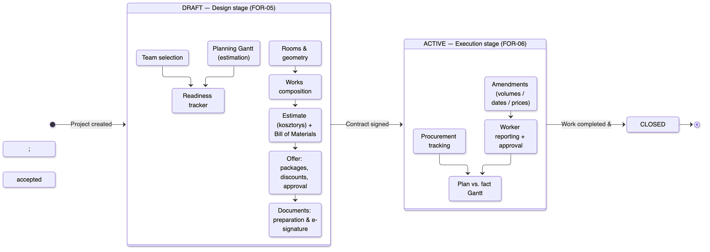
Figure 3. Project lifecycle — design stage, execution stage, and the contract-signing boundary.
A key design principle is that the estimate is derived, not duplicated. Works reference the catalog and the price valid at a given date; the bill of materials is derived from per-work consumption norms; totals, package values, and margins are computed. Nothing that can be derived is entered by hand, which keeps the numbers internally consistent.

5. Domain Model
The domain model is a direct decomposition of the client's spreadsheet. A project owns rooms and exactly one estimate. The estimate contains lines; each line references a catalog work item and the price it was quoted at, and splits its quantity across rooms. From each line the system derives a bill of materials (via consumption norms) and per-package values for the three commercial packages. An offer applies discounts on top of the estimate and, once approved or signed, freezes its prices into a snapshot so later catalog edits never change a signed offer. The offer results in a contract, which is signed electronically.
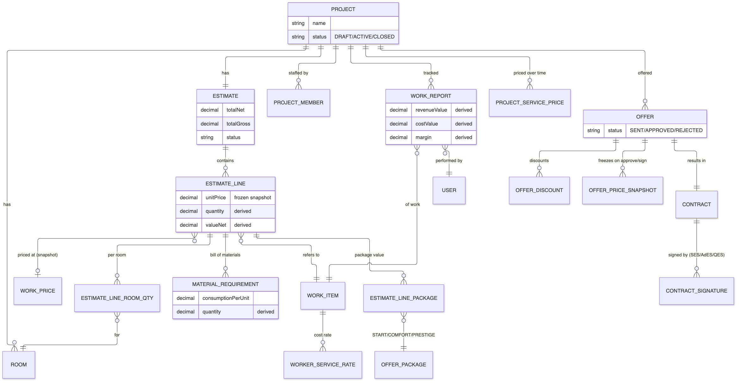
Figure 4. Core domain model (estimate, offer, contract, and work reporting).

5.1 Key Entities
Entity | Purpose
Project | The anchor entity; owns rooms, the estimate, members, and offers. Carries lifecycle status.
Room | A room with geometry; estimate quantities and the bill of materials are split per room.
Estimate / EstimateLine | The priced list of works. A line references a work item and a frozen unit price.
EstimateLineRoomQty | The quantity of a line's work in a specific room; the line total is the sum across rooms.
MaterialRequirement | A derived bill-of-materials row: material and quantity computed from consumption norms.
EstimateLinePackage | Per-line value for each commercial package (START / COMFORT / PRESTIGE).
Offer / OfferDiscount | The commercial offer and the negotiated discounts applied to it.
OfferPriceSnapshot | Frozen prices captured when an offer is approved or signed.
Contract / ContractSignature | The signed agreement and its electronic signatures (SES / AdES / QES).
WorkReport | A worker's completed work over an interval, carrying both revenue and cost sides and the derived margin.

5.2 Pricing and Margins
- Price freeze — A catalog work price is frozen onto the estimate line as a snapshot; the catalog reference is kept only for provenance.
- Temporal prices — Project-specific prices are kept over time with effective-from / effective-to intervals, so the price used always matches the relevant date.
- Revenue vs. cost — Each work report resolves a client price (revenue) and a worker rate (cost); the margin is the difference. Worker rates are owned by the finance and payroll modules.
- Commercial packages — Three packages (START / COMFORT / PRESTIGE) give the client comparable commercial options over the same scope of work.

6. Solution Architecture
Foremen is a web application with a React front end and a Java backend, backed by PostgreSQL and object storage, and deployed on Google Cloud. The backend is built on a custom generic CRUD framework: common create / read / update / delete behavior lives in generic interfaces, and each managed entity is exposed as a thin controller / service / data-access triple that inherits that behavior. Cross-cutting concerns — security and authorization, internationalization, auditing, and caching — are applied uniformly across every entity.
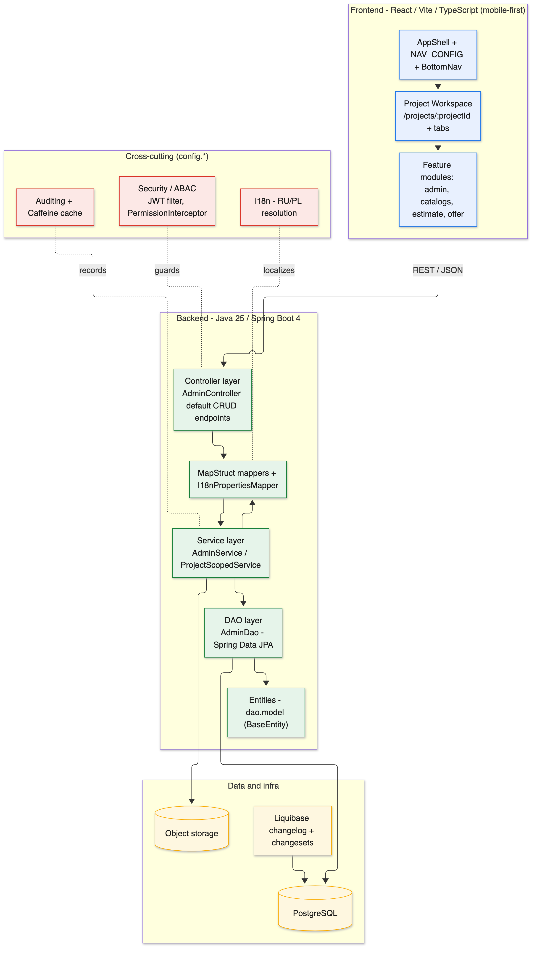
Figure 5. Layered solution architecture.

6.1 Technology Stack
Layer | Technology
Frontend | React, Vite, TypeScript; mobile-first, iOS-like design.
Backend | Java 25, Spring Boot 4, Gradle.
Persistence | Spring Data JPA with MapStruct mapping; PostgreSQL.
Database migrations | Liquibase (changelog with per-feature changesets).
Authorization | Attribute-based access control (ABAC) plus project-level membership.
Infrastructure | Google Cloud (Cloud Run / GKE); Docker Compose for local development.

6.2 Backend CRUD Framework
Each managed entity is a small set of classes layered as controller, service, data access, and entity. The generic controller interface declares the full set of REST endpoints (create, bulk create, update, bulk update, paginated read, read by id, count, audit, delete, and metadata) as default methods, so a concrete controller only wires in its mappers and service. The service layer adds transactions, validation, automatic audit logging, and query building. MapStruct maps between request/response DTOs, service models, and entities in two hops. Every entity inherits a common base with identity and auditing fields (created / updated, by whom and when).

6.3 Internationalization
Localizable text is stored in parallel columns per language (Russian and Polish). During mapping, the system resolves the value for the current locale, defaulting to Polish when the locale is not Russian. The detailed, all-locales form is used for editing, while list and summary views carry a single resolved value. This keeps a single, consistent internationalization strategy across every entity in the system.

7. Security and Access Control
Authorization is attribute-based. The permission matrix is expressed as roles, resources, operations, and the grants that connect them. Each protected API endpoint declares the resource it belongs to and the operation it performs. On every request, an interceptor resolves the required resource-and-operation pair and checks it against the caller's role. The Administrator role bypasses the matrix; every other decision is an exact membership check that denies by default. A startup validator refuses to launch the application if any endpoint is only half-annotated, so a protected endpoint can never silently become unguarded.
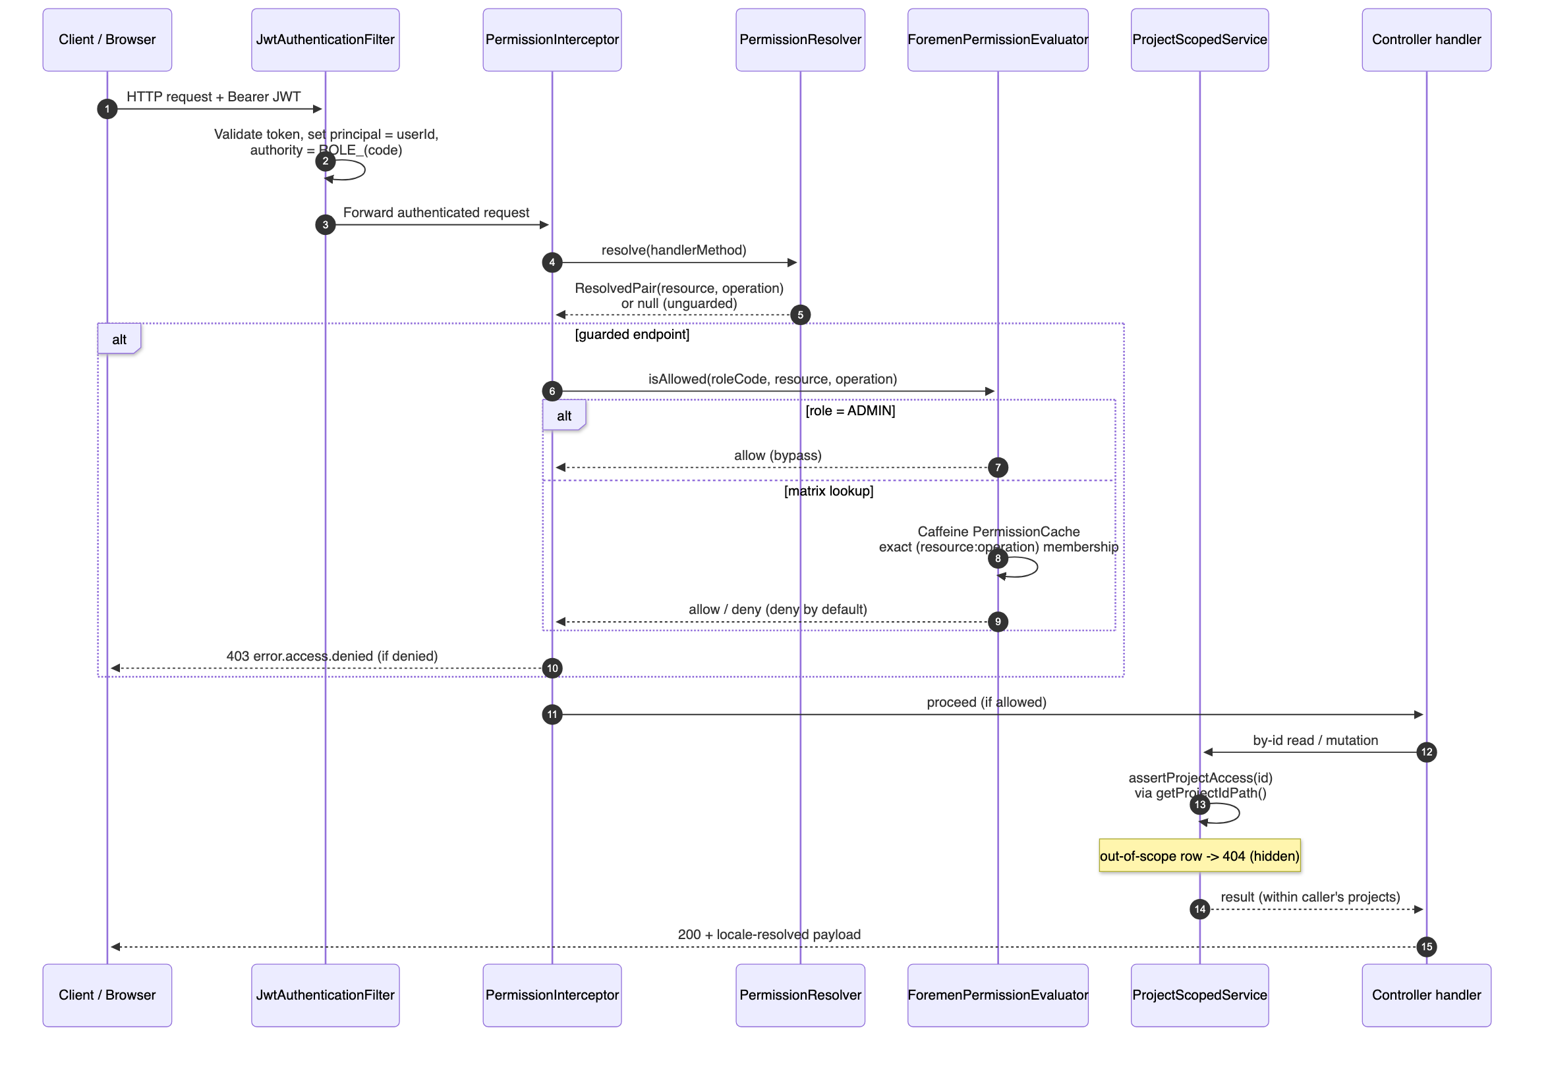
Figure 6. Request authorization and project scoping flow.
Authorization has two orthogonal layers. The permission matrix decides whether a role may perform an operation on a resource at all. Project scoping then restricts the rows a caller may see or change to the projects they are a member of; list queries are filtered to the caller's projects, and an out-of-scope record is reported as "not found" rather than "forbidden" so its existence is not revealed.

7.1 Authentication
- JWT sessions — Employees sign in with email and password and receive a short-lived access token plus a refresh token. Refresh tokens are single-use and rotated on each refresh.
- Client OTP — Clients can sign in passwordless with a one-time code sent to their email, receiving tokens with client-specific lifetimes.
- Invitations — New users are invited by email; they set a password through a single-use invite link, which activates the account and logs them in.
- Google and reset — Clients may also authenticate through Google; password reset is available via a single-use, time-limited link.
The login path is hardened against user-enumeration and timing attacks: unknown accounts take the same time to reject as wrong passwords, and account-status errors are distinct from credential errors only where it is safe to be.

8. Non-Functional Requirements
Attribute | Approach
Security | ABAC with deny-by-default; project-level data isolation; hardened authentication.
Auditability | Automatic audit logging of create/update/delete with before/after snapshots.
Internationalization | Russian and Polish across UI and data, with Polish fallback.
Usability | Mobile-first design; single project workspace with progressive disclosure.
Maintainability | Generic CRUD framework; each new entity added through a consistent, validated pattern.
Data integrity | Derived values computed, not hand-entered; prices frozen on approval.
Legal compliance | Electronic signatures compatible with Polish law (SES / AdES / QES).
Portability | Containerized services; Liquibase-managed schema; cloud deployment.

9. Glossary
Term | Meaning
Estimate (kosztorys) | The priced list of works for a project, split per room.
Bill of materials (BoM) | The materials required by the works, derived from consumption norms.
Offer | The commercial proposal to the client, with packages and discounts.
Package | A commercial tier of the same scope: START, COMFORT, or PRESTIGE.
Amendment | A change order altering volumes, dates, or prices after signing.
ABAC | Attribute-based access control — the role/resource/operation permission matrix.
ProjectScopedService | Backend mechanism that limits data access to the caller's projects.
SES / AdES / QES | Simple, advanced, and qualified electronic signature levels (EU/Polish law).

End of document.

