* Things Working
  + Character creation/deletion/selection
    - Username database check
  + Player Movement
  + Data structure for accounts and characters (firebase)
  + Client login -> gateway -> server -> auth (firebase)
    - Server -> client
    - Client hash256 encryption to gateway
  + Server database calls
  + Populate map (baselevel) from worldstate
    - Spawns/despawn other chars
    - Character attack animations
    - Server-side damage/kill/exp/hp server calculations
  + Spawn monsters
    - Hp/spawn/take damage/do damage server calculations
  + Client disconnects to login when server disconnects
  + Server-side movement and collision
  + Server-side calculations and monster spawn
  + Account/character information saves in firebase database on disconnect/logout
* Things in the process
  + After server reconnects, client issues connecting to auth
    - Probably something with the same hash key
  + Multi-maps
  + Potential multi-channel instances of maps
* Questionable code:
  + Client
    - server.gd
      * update_account_data
      * fetch_characters
      * return_player_stats
    - global.gd
      * references monster_scene in baselevel
        + can only spawn green guys in blaselevel

will cause issues with adding new monsters to baselevel2

* + - Issue with entering map with spawn monsters
      * Cannot find monster node
        + Maybe wipe world state while entering maps
        + Probably solution

If node not exist -> create

* + - RegisteredScreen.gd not updated
  + Server
    - Player_verification
      * Fill_player_container
        + Uses temp data from serverdata.gd
    - Player_container
      * Player death does not work yet
    - When player kills monster server doesn’t remove monter right away causing multiple world states with monster state dead
    - Experience not gained on kill

Notes:

* 28JUN2023
  + Added to github
  + Fixed server crash relog in freeze
  + Implemented singular account login
  + Fixed changing maps
    - Fixed spawn location on top of portals vs logging in
  + Removing comments and dead code
  + Standardizing function and variable names
* 12APR2023
  + Objective
    - Work on exp system and dying
    - Dying -> respawn decrease xp
    - Level -> lvl + 1 exp table
    - Should add if player in character selection not  to update
      * Queue free player container
      * No character save
  + Worked on:
    - EXP-Level
      * Exp table in serverdata.gd
      * Level up script in player container
      * Level up script in client global.update player stat
    - Altered greenguy exp rate for testing
    - Brained stormed portal and map change
      * Added portal function to global
      * Have to consider how it works:
        + Call to server to verify pressing up on portal
        + Moving server player container
        + Return call to client to load new map
        + Client send to server new world state
        + Updating player location in all dictionaries
        + Load new map etc’
      * Added:
        + Print for each function below (everything works so far)
        + Client

Server

Portal function

Remote return portal

Portal

If player press up on portal

Call client server portal function

* + - * + Server

Remote portal function

Finds and calls portal node.overLappingBodies

Return calls client return portal

Portal

overLappingBodies

Confirms if player is actually on the portal

* + - Changed client player to exist on layer 7 portal and 10 teleporter
      * Portal and teleporter can collide and detect player
* 11APR2023
  + Added script for exp calculation in server mob
    - Calls player container function if player is still in map when mob dies
      * Calls server update character info
  + Added client character script to print out xp gain and add xp
  + Altered Firebase code on line 43 for accounts with no characters
  + Updated create character & check character function in server
  + Player location is saved by path to map node
  + Server now sends player ign through worldstate [“U]
    - Allows clients to populate other players template with character name
  + Firebase updates correctly when character logsoff/disconnects
  + ServerData.username_list now works

* Updated client spawnnewplayer
  + Line 572
    - Player_id is now a dictionary
    - Not comparing network id anymore
      * Comparing displaynames
* 31MAR2023
  + Update
    - Added display of hp in client
      * Above character head
      * Changes when takes damage
    - Updated all dictionaries in client and server when taking damage
    - Firebase saving info seems like to work properly when logout/dc
    - Server.serverdata
      * Player template & player info
        + added :

Maxhp

Maxmana

Avoidibility

Accuracy

Weapondefense

Magicdefense

* + - Removed all characters on firebase besides two characters
      * Edited data to reflect stats above
  + Things to do
    - Periodically update all characters in firebase
    - Look at iframes
      * It seems like not working in client
    - Take damage print is storing the damage variable
      * Takes 6
      * Takes 12
      * Takes 18 dmg ….etc
* 30MAR2023
  + Implemented simple monster touch damage formula and communication in server
    - Characters have i frames
    - Need to update character hp stats and send to client for update
  + Added server and client functions to communicate damage and update damage player takes from touch damage
    - Needs to work on server player container and global functions to update player node characters dictionary and current character dictionary with new hp values ( Player container line 53).
* 29MAR2023
  + Despawn:
    - Despawn and respawning works now
      * Edited client: monster and global world state process
        + Global checks world state for hp <= 0

Sends monster death function

Changed so that open_location array does not get edited

Caused spawning issues when erasing

* + - * + If not

Update hp and location

* + - * Synced with server via state == dead and time-out = 0
  + Removed client global files: Firebase, chrisndubs
  + Commented out lots of print statements in server and client
* 28MAR2023
  + Notes
    - Client:
      * Monster location, damage = null
      * State doesnt change to dead
    - Server:
      * Monster location, damage = null
  + Depsawn:
    - Respawned monster respawn in “dead” color (black)
    - On client queue free runs often(need to change to only once)
  + Changed monster id in dictionary to be based off of values in open location and not monster_id_counter
    - Monster_id_counter should be -> monster counter
  + Added queue free in client: global.gd line 542
    - 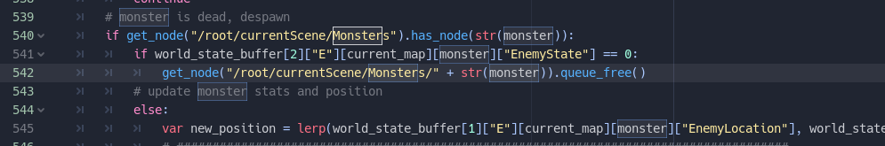
* 27MAR2023
  + Added npc hit to green guy
  + Added function in overlapping body to find closest body in attack box
  + Call greenguy.npchit(dmg)
  + Monster turns black when hp <= 0
    - Added despawn (havent tested)
      * Possible issue with sending state (monster state & position)
      * Greenguy npc hit
      * Map processdelta
  + Need to do:
    - Communicate to server if character is climbing or not
    - Implement knockback to mobs
    - Monster despawn when current hp <= 0
* 21MAR2023
  + Set player damage box layer to 6 and mask to 6
    - Set monster take damage from mask 6 to layer 6
  + Change map layer monster and player
  + Disabled knockback functions
  + flip attack area2d when facing left
  + Attack area2d detects monster hitbox area2d on both client and server (synced)
    - Function get area 2d runs at the end of animation
  + Need to add:
    - Monster doing damage to player
    - Server damage calculation
      * Update enemy hp/dmg etc
      * Display damage on client screen
      * Add knockback collision detection
* 20MAR2023
  + Start implementing server attack collision
    - Attack animation
      * Area 2d -> get ,monster bodies overlap
        + Sort, top most
        + Attack calculation should consider how many monsters can attack
        + Currently disabled stab animation collisionshape2d
      * Rpc send attack -> server runs animation -> overlap = damage calculation
    - When monster is hit:
      * Change movement pattern to aggro move towards character
    - Should turn of physical collision with monsters
      * Only overlap and knockback
  + Completed
    - Added attack animation for client player and other players
    - Added script for player and playertemplate
    - Added Server.gd rpc call to send attack
    - Added RecievedAttack rpc call
      * Added filtering for player attack and other player in map attack
    - Server scripts for:
      * Receiving rpc attack calls
    - Successfully display attacks of other players in map
  + Need to add
    - Server scripts for:
      * Run server side attack animation
      * Calculation collision/overlap
      * Determine monster knockback
      * Determine damage
      * Send Damage
      * Send attack information to client

* 17MAR2023
  + Moveplayercontainer in server.gd
    - spawnlocation(x,y) + maplocation(x,y)
  + Tried to implement client key stroke -> server character movement -> client movement
    - Too complicated and will introduce to much lag
    - Client side movement
    - Client - server side collision (environment)
    - Monster collision probably only server calculated
      * Damage, etc
    - Client attack -> sends message to server
      * Server calculates damage
      * Applies damage and other calculations
    - Server sends damage data to client to display
* 16MAR2023
  + Made server tick to 60 and added conditional to send world state every 20 fps
  + Current error when player DC:
    - Server
      * Server.gd (Line 41)
        + Issue was in server.gd(line 251)

‘Ysort” instead of “YSort”

* + - * Teleporter.gd (line 19)
        + Old script from client
        + Changed up to default ui_up
  + Added movable/jump camera on server
    - 1 = baselevel
    - 2 = baselevel2
  + Try to do:
    - Change so client send player input instead of position in player state
      * server .gd (server) -> recievedplayerstate → playercontainer.validate(player_state[“P”] (input) -> calculate position function etc -> edit “P” to player position -> client update position
      * If no input (character is idle) P=current global position
      * If character not on floor, is jumping, is climbing etc
      * Add groups to player container (climbing, player)
* 15MAR2023
  + Added camera so baselevel is seen in server
  + Green monster motion works on server
    - Actual rng movement script works on server and sends coordinates to client via world state
    - World state shows movement on client
  + Currently player movement is not updated in server
    - The collision body stays at spawn
  + Added Baselevel2 to server
    - Currently got to figure out how to transport actual characters from map to map (currently both maps are on the same plane without walls)
    - No scripts for this scene
  + Removed all character models not in default to cut down size
    - 20MB —>  Less than 2 MB
  + Remove all server scenes in client folder
  + Still no combat
* 14MAR2023
  + Changed Dictionary { f = X, d= X}
  + Created server baselevel1 and greenguy
    - Set monsters to spawn in ysort/monsters
    - Have to change server script to move character to map/ysort/players
      * Edited in server.gd move player container, player verification (character select link)
  + Character now spawns in hypothetical server map with collision at spawn point
    - Currently input does not move character
    - Cannot see server map
* 13MAR2023
  + Added animation dictionary to player state in client side
    - Dictionary { “floor” = X, direction = X}
      * Should change to “f” and “d” to cut down on transferred bits
    - Other client use this dictionary to correctly interpret player direction and is_on_floor
    - This fixed the issue of walking into walls causing change in direction
* 08MAR2023
  + I think i fixed the walking issue
  + Possible existing issue of character facing right when walking left into wall
* 07MAR2023
  + Stopped at #16 5:29
  + Debugged server spawn data -> client spawn
    - Corrected index in server baselevel.tscn
      * Was spawning two monsters on top of each other instead of using the second spawn coordinates
      * Monster movement still needs to be added
      * **Currently monsters are idle at spawn location**
  + Removed all movement and client spawn functions
    - Spawn based off of world state
    - Added hp, move health bar update functions to client monster.gd
      * Hp
        + Not in use yet
      * Movement
        + Need to add movement algo to server
        + Other player template animations sort of working

Need to use new server position data to flip and move sprite

**Add direction to each players’ worldstate**

**Instead of using new.x ><= position.x**

**Use direction bool to control model flip**

* + - * + Client registers other players move based on world state

Walking animation conditional isnt working (always jumping)

Idle animation conditional works

Jumping resets player to face right

Walking left flips model but sometimes resets to right once stopped

* + - * No working combat yet from server
        + Monsters cannot die
* 06MAR2023
  + Worked On:
    - Converting client side to server side for map/monster management
    - Got monsters to spawn from server world state data
    - Removed all enemy scripts from baselevel.tscn
      * Dynamically loads green guy scene through global physics process -> create a node and add to current scene/monsters
      * Load/update the monsters stats through the world state data
    - Did not implement the location from world state
      * Still uses the rng script from the green guy scene
  + Should do next time:
    - Finish the video
    - Convert the movement script to the server.
      * Same rng but update the coordinates for location
      * Client: algorithm to determine left right movement.
        + If x2 < x1 then left
        + If x2 > x1 then right
        + Else standing still
  + Notes:
    - **Stopped at #15 @17:58**
    - **Working on client on how to read world state to populate enemies**
    - Still no combat scripts or death scripts
    - Consider creating a dictionary on monsters in the map
      * For multiple monsters
      * Add monster name and unique id
        + Allows client to filter out which monster to spawn
* 03MAR2023
  + Worked on
    - Added conditionals in _physics_process client global.gd
      * If server.serstatus
    - Removed conditionals in above
      * If “T”, “E”
    - Added serverstatus in server.gd
      * Controlled by connection successful and disconnection
    - On server disconnect, global.world_state_buffer cleared
    - Still in the middle of using world state to spawn/move monsters on baselevel
    - **Stopped at #15 @9:46**
    - **Working on client on how to read world state to populate enemies**
  + Notes
    - **Server crash != client crash anymore**
      * **Possible solution:**
        + **Server uptime global variable conditional**
        + **If server crash -> true**
        + **Put in physics_process if true pass**
        + **Also add in conditional if player id is in P: dictionary.key()**
      * **Server crashes on same user login after server restart**
      * **Server, playerVerification.gd, line 47**

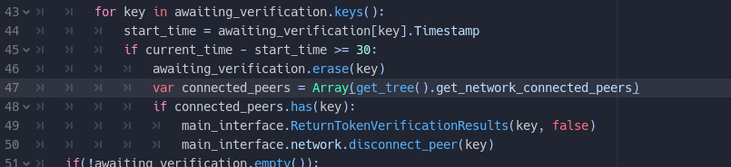

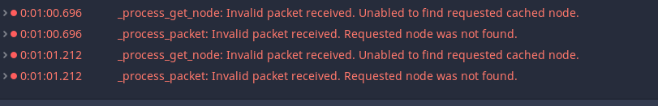

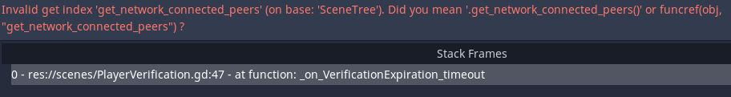

* Need to add signal connection failed to Client server.gd
  + Allow login button to be clickable
* When server disconnects then reconnects, relogging in causes rpc issues with server get_network_connected_peers
  + Server then crashes and client reloads main menu
* 01MAR2023
  + Worked on:
    - Organized client singleton scripts
      * Comments
      * Pair rpc and return rpcs next in tandem
    - Disconnected firebase connection from client
      * Moving towards:
        + client - server - database model
      * Removed client firebase calls and http requests from global
  + Notes
    - Changed world state structure
    - Changed client/server interaction with world state
      * No if -> pass
    - **Server crash = client crash**
      * **Returns to  main menu but crashes because global process data (world_states) still runs in the background**
    - **Stopped at #15 @9:46**
    - **Working on client on how to read world state to populate enemies**
* 28FEB2023
  + Worked on:
    - Server side enemy
    - Added timer spawn for mobs in baselevel
    - Add enemies dictionary of lists to world state
  + Notes:
  + <https://www.youtube.com/watch?v=tj24IrCy1hs>
  + @10 minutes
  + Client: global.gd
    - Working on using world state enemies to filter out monsters for current map and updating spawn/position etc
* 27FEB2023
  + Worked on:
    - Extrapolation (untested)
      * Lost packets
    - Server and Client clock synchronization
  + NoteS:
    - Need move client side to server side
      * Monster, maps, characters
      * Client side send inputs to server
        + Server sends visual to client
    - Client does not communicate map changes to server
      * Player always stays on initial map logged into
        + Player gets removed when dc or log off
      * Possibly when server-side map integration
      * Player press up on portal, server sends map change to client
        + Client changes map for player.
* 13JAN2023
  + Worked on
    - Interpolation
    - Edited the update world state
    - Added process(Delta) to world state management
      * Spawning and despawning works so far
  + Notes:
    - Had to add rpc call on peer disconnect To despawn characters on clients.
    - 3 seconds after peer disconnect to prevent instant node creation due to previous/current world state during disconnect
* 12JAN2023
  + Worked on
    - Spawning and despawning characters
    - Portal works
  + Notes
    - Turned off player damage
    - Spawning and despawning works
* 11JAN2023
  + Worked on
    - Added spawn character(server, client.global)
    - Movecharacternode(server: working)
    - When another character enters the map, character model spawn
    - Added client to server player state
      * Should change so its T,P, and map name
    - Added server to client world sate
      * Currently does not have map name because above. Dont know which user is actually in your map
  + Current Notes
    - Edit string concatenations for storing and generating node paths
    - Map paths
    - Edit damage list references
    - 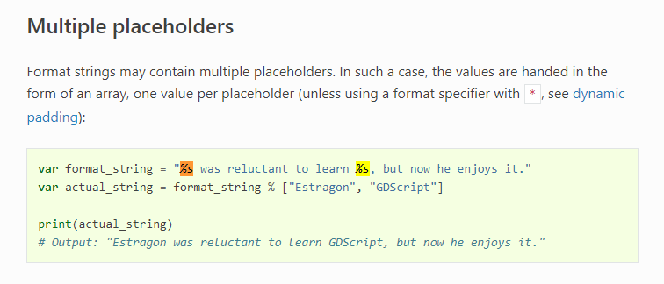
* 10JAN2023
  + Server
    - Moveplayercontainer
    - spawn character
  + Client
    - Added global.spawnnewplayer
      * Takes player id and map string
      * If map == client map spawn instance in other players
    - Added global.despawnplayer
    - Created player template
  + Current issues
    - No characters still have one character widget open
    - selecting/spawning characters do not move them to map node in server
* 06JAN2023
  + Debugged
    - Adding char
    - Deleting char
    - Username check
    - All server and client related functions rpc calls firebase calls in relation to the three tasks listed above.
  + Need to work on:
    - Character spawn
    - Spawning other players
    - Syncing other players
    - Teeter, exploration/interpolation
    - Client-server clock syncing
    - CLEAN UP SCRIPTS
    - CLEAN UP FUNCTION AND VARIABLE NAMES
* 05JAN2023
  + Create character option
    - Client and server/database validation of string username
  + Need to work on:
    - Change to username check available button
    - Create character function in server
      * Add character to server global
      * Sync with database/client
        + Updates users/fb_id/ characters
        + Update characters/
        + Send update to client
      * Reload character contents on client character screen
* 04JAN2023
  + Created server backend functions
    - Update document/Get document/ delete document
      * Forks for /users and /characters
    - Peer Disconnect
      * Removes player id from serverdata.player_location
      * Updates account’s firestore /user, /characters
      * Removes player node from server
      * Prints disconnect message
    - Firebase json -> godot dictionary
      * Database data to server data
      * Sends array to client
    - Godot dictionary -> firebase json
      * Converts server data to database data
  + Need to work on:
    - User node timer to update database with current server data
      * Similar to peer disconnect
      * Need to consider if account needs to fully disconnect before changing characters
        + Or if player can return to character select
    - Server-client rpc functions to sync data
  + Test to be done
    - Delete a character in /user before disconnecting to see if it updates
    - Delete character in /character before disconnecting to see updates