FE535 Introduction to Financial Risk Management
Project 1 – Final Report
Team members: Christopher Torello, Jinhong Chen, Riccardo Baccelliere
Date: November 2026

Data
We use daily adjusted closing prices (Yahoo Finance, auto-adjusted) for the 19 Fidelity Select mutual funds (FSPTX, FSELX, FSCSX, FSPHX, FBIOX, FSMEX, FPHAX, FIDSX, FSRBX, FSPCX, FSENX, FSDAX, FSRFX, FSCPX, FSAVX, FSRPX, FDFAX, FSTCX, FWRLX), the SPY ETF (market portfolio) and the XLK ETF (alternative benchmark), from January 2015 to September 2026. Daily log returns are computed as r_t = ln(P_t / P_{t-1}), giving 2,952 daily observations for each of the 21 tickers. The risk-free rate is assumed to be zero. All computations were conducted in Python (source file: project1.ipynb). Problem 2 uses monthly adjusted closes of FSPTX, FIDSX and FSCPX over the same window, and Problem 3 uses monthly SPY adjusted closes from January 1994 to September 2026 (393 prices, 392 log returns).

Problem 1: Performance Summary
Annualization uses 252 trading days: mean μ = 252·mean(r), volatility σ = √252·sd(r), SR = μ/σ. Relative measures against a benchmark M: β = Cov(r_i, r_M)/Var(r_M); Jensen's α = 252·[mean(r_i) − β·mean(r_M)]; Treynor ratio TR = μ_i/β; tracking error ω = √252·sd(r_i − r_M); information ratio IR = (μ_i − μ_M)/ω.

1.1 Absolute performance summary
Table 1.1 – Summary of annual absolute performance across the 19 funds (6 × 3)
 | Mean | Volatility | SR
Min | 0.0562 | 0.1482 | 0.2480
Q1 | 0.0826 | 0.1941 | 0.3823
Mean | 0.1119 | 0.2263 | 0.4927
Median | 0.0995 | 0.2181 | 0.4868
Q3 | 0.1158 | 0.2441 | 0.5612
Max | 0.2653 | 0.3431 | 0.8405

Answer 1.1. The median fund earns an annual mean return of 9.95% with 21.8% volatility and a Sharpe ratio of 0.49; mean returns range from 5.6% to 26.5%, volatilities from 14.8% to 34.3%, and Sharpe ratios from 0.25 to 0.84.

1.2 Mean return vs. volatility
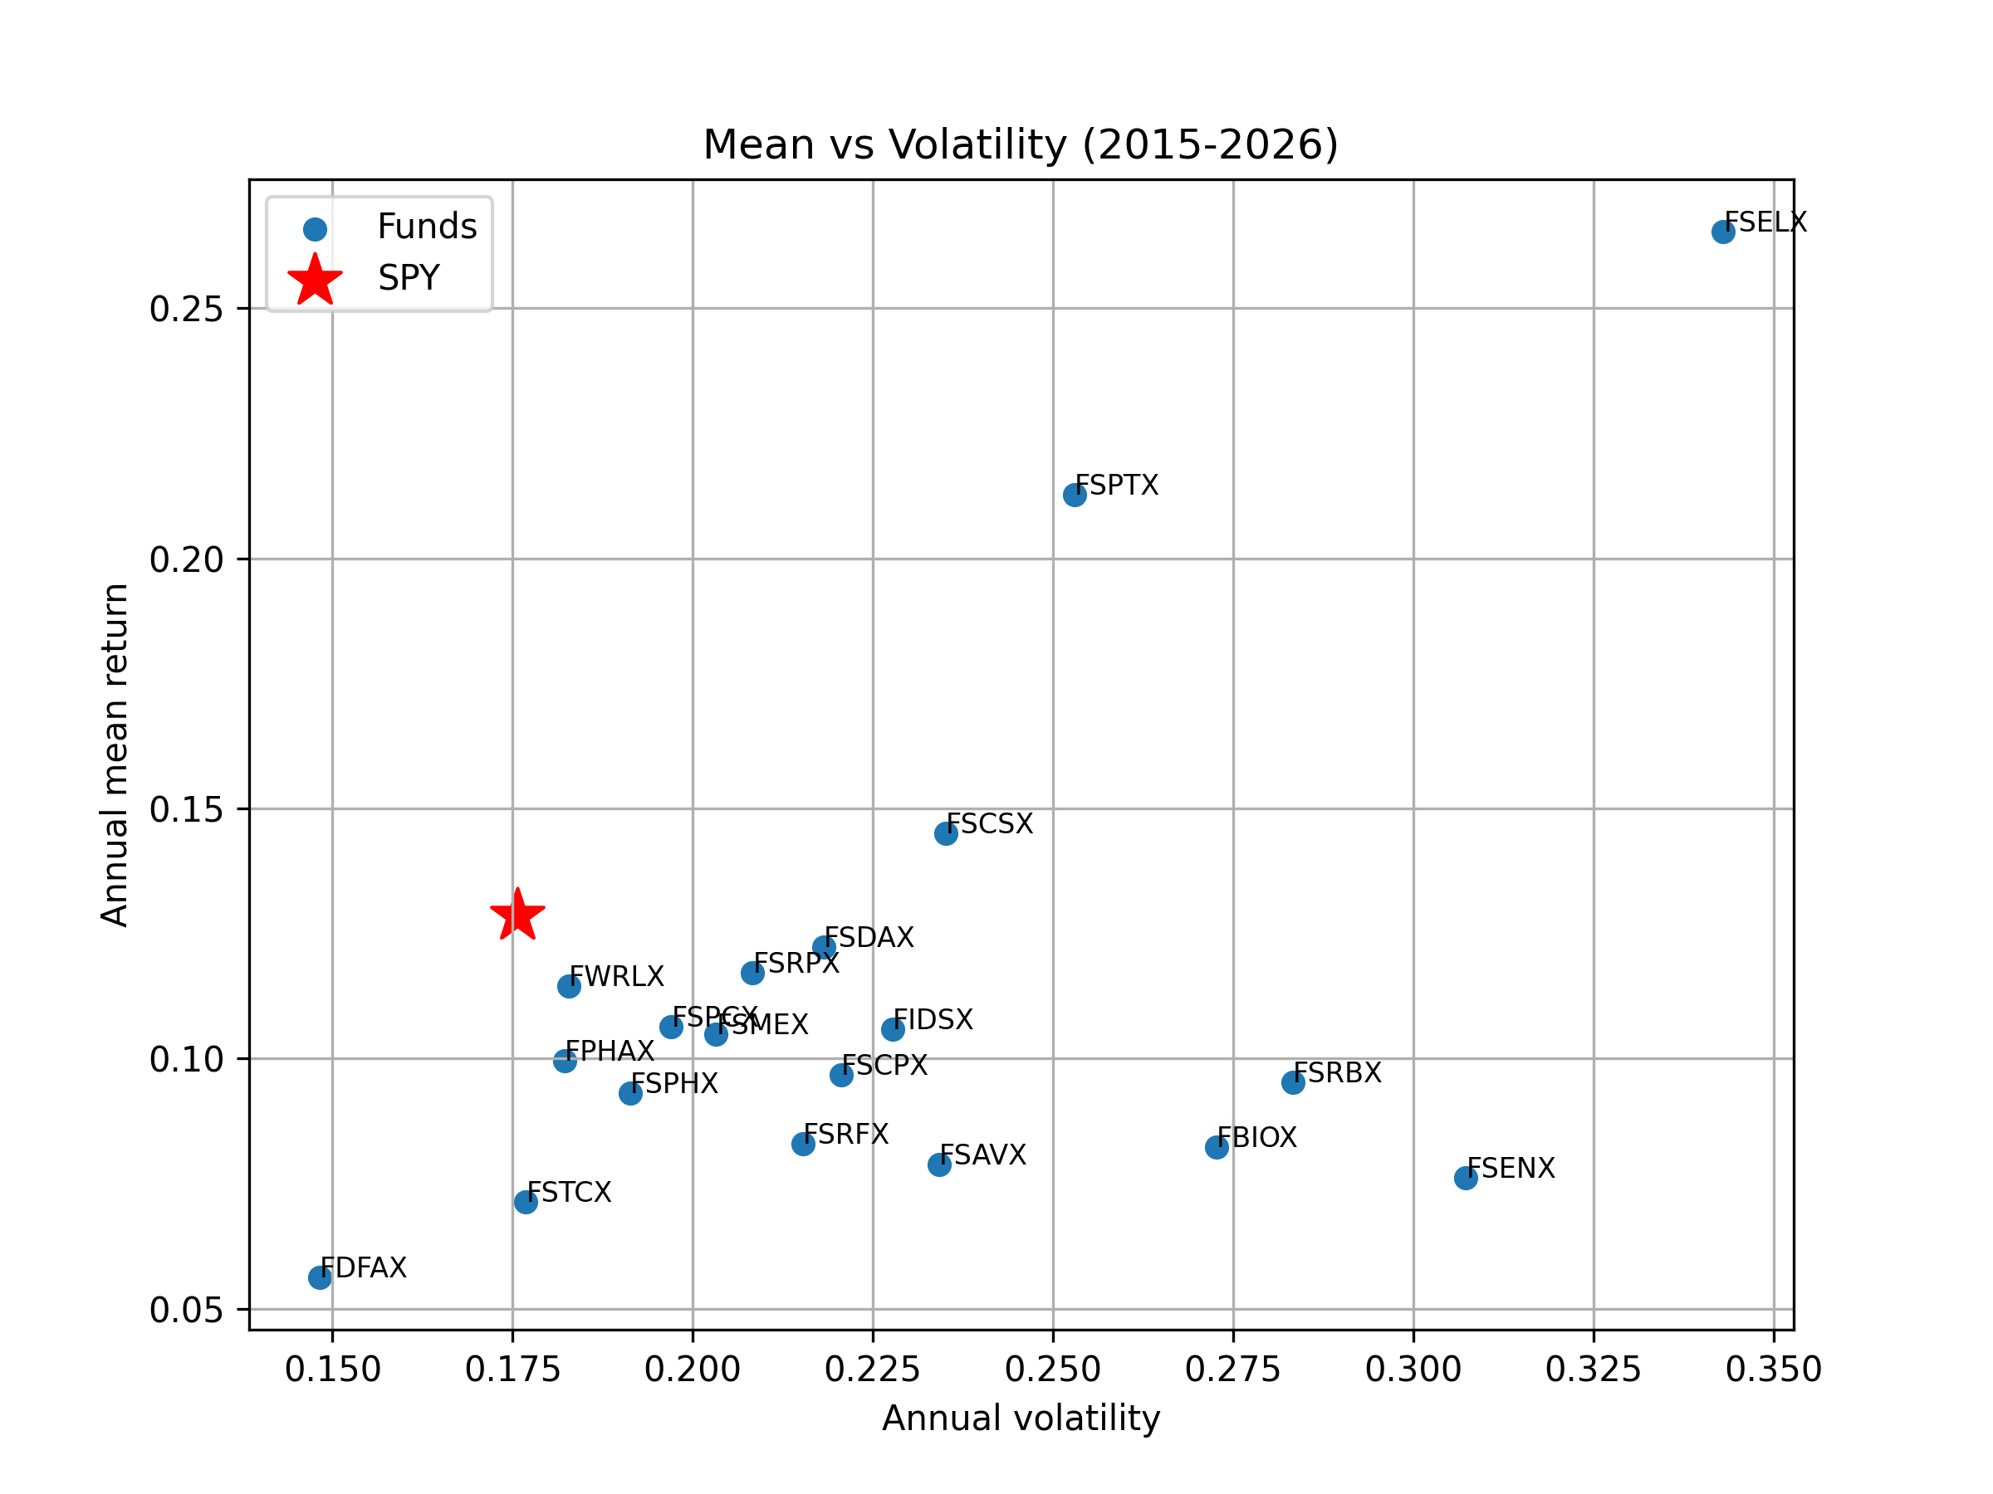
Figure 1.2 – Annual mean return vs. annual volatility of the 19 funds; SPY highlighted (red star)
Table 1.2 – Funds with a higher mean return than SPY (SPY: mean 0.1285, volatility 0.1757)
Ticker | Mean | Volatility
FSPTX | 0.2127 | 0.2530
FSELX | 0.2653 | 0.3431
FSCSX | 0.1450 | 0.2351

Answer 1.2. Only three funds outperform SPY in mean return (FSELX 26.5%, FSPTX 21.3%, FSCSX 14.5% vs. 12.9% for SPY), and all of them carry higher volatility than the market (34.3%, 25.3%, 23.5% vs. 17.6%), so their extra return comes with extra risk.

1.3 Relative performance (benchmark: SPY)

1.3(a) Summary table
Table 1.3a – Summary of relative performance measures vs. SPY (6 × 5)
 | Alpha | Beta | TR | TE (ω) | IR
Min | -0.0623 | 0.5950 | 0.0717 | 0.0824 | -0.5698
Q1 | -0.0458 | 0.8783 | 0.0849 | 0.1237 | -0.2986
Mean | -0.0162 | 0.9970 | 0.1104 | 0.1446 | -0.1347
Median | -0.0160 | 1.0015 | 0.1097 | 0.1322 | -0.1866
Q3 | -0.0014 | 1.1074 | 0.1269 | 0.1421 | -0.1361
Max | 0.0643 | 1.5644 | 0.1696 | 0.2483 | 0.6821

Answer 1.3(a). The median fund has β ≈ 1.00, α ≈ −1.6%, TR 0.11, tracking error 13.2% and IR −0.19, so most funds underperform SPY on a risk-adjusted basis.

1.3(b) Top-5 funds by Jensen's α
Table 1.3b – Absolute and relative performance of the five funds with the highest α (vs. SPY)
Ticker | Mean | Vol | SR | Alpha | Beta | TR | TE | IR
FSELX | 0.2653 | 0.3431 | 0.7733 | 0.0643 | 1.5644 | 0.1696 | 0.2280 | 0.6000
FSPTX | 0.2127 | 0.2530 | 0.8405 | 0.0469 | 1.2903 | 0.1648 | 0.1234 | 0.6821
FPHAX | 0.0995 | 0.1822 | 0.5459 | 0.0096 | 0.6996 | 0.1422 | 0.1445 | -0.2009
FSDAX | 0.1223 | 0.2181 | 0.5605 | -0.0004 | 0.9546 | 0.1281 | 0.1397 | -0.0447
FSCSX | 0.1450 | 0.2351 | 0.6165 | -0.0008 | 1.1342 | 0.1278 | 0.1270 | 0.1297

Answer 1.3(b). The five funds with the highest Jensen's α are FSELX (Semiconductors, 6.4%), FSPTX (Technology, 4.7%), FPHAX (Pharmaceuticals, 1.0%), FSDAX (Defense & Aerospace, −0.04%) and FSCSX (Software, −0.08%), mostly technology-related sector funds. Only the two tech funds stand out in both absolute and relative terms: they have the highest mean returns and Sharpe ratios (0.77 and 0.84) and a positive IR (0.60 and 0.68), although with β above 1. FPHAX earns a positive α thanks to its low β (0.70), despite a mean return below SPY and a negative IR, while FSDAX and FSCSX have α close to zero, so their relative performance is essentially in line with the market.

1.4 Expense ratios

1.4(a) Mean return and α vs. expense ratio
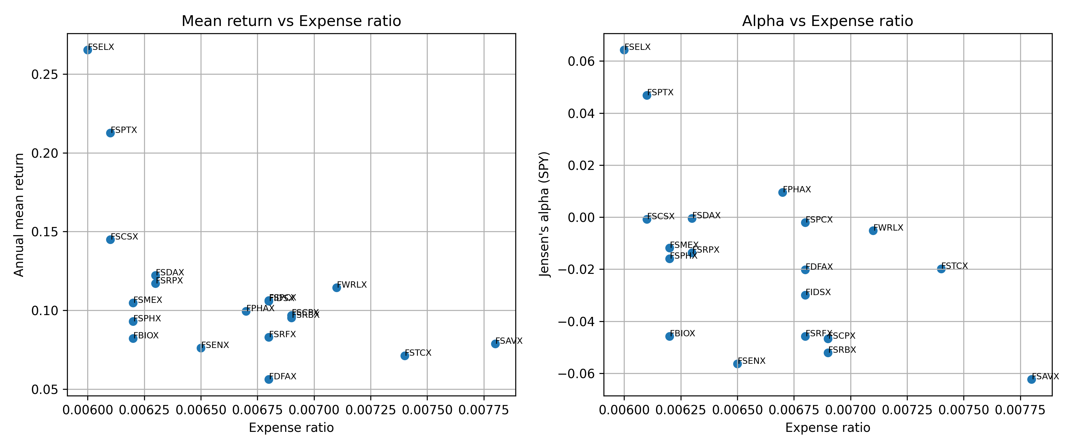
Figure 1.4 – (i) Annual mean return and (ii) Jensen's α (vs. SPY) against the expense ratio

1.4(b) Evidence
Answer 1.4(b). No: both the mean return and Jensen's α are negatively related to the expense ratio (correlations of −0.55 and −0.54), with the cheapest funds (FSELX, FSPTX) delivering the highest mean and α and the most expensive (FSAVX) the lowest α, because higher fees are a direct cost that lowers net returns and is not compensated by superior managerial skill.

1.5 Alternative benchmark: XLK

1.5(a) Summary table
Table 1.5a – Summary of relative performance measures vs. XLK (6 × 5)
 | Alpha | Beta | TR | TE (ω) | IR
Min | -0.0647 | 0.3177 | 0.1117 | 0.0596 | -0.7486
Q1 | -0.0329 | 0.5456 | 0.1466 | 0.1627 | -0.6535
Mean | -0.0194 | 0.6449 | 0.1736 | 0.1845 | -0.4806
Median | -0.0168 | 0.6089 | 0.1731 | 0.1838 | -0.5125
Q3 | -0.0020 | 0.6858 | 0.1934 | 0.2063 | -0.4414
Max | 0.0166 | 1.2688 | 0.2411 | 0.2976 | 0.3633

Answer 1.5(a). Against XLK the median fund has β 0.61, α −1.7%, tracking error 18.4% and IR −0.51.

1.5(b) Effect of the benchmark
Table 1.5b – Jensen's α and its rank under SPY and XLK benchmarks
Ticker | Alpha (SPY) | Rank (SPY) | Alpha (XLK) | Rank (XLK)
FSELX | 0.0643 | 1 | 0.0071 | 3
FSPTX | 0.0469 | 2 | 0.0044 | 5
FPHAX | 0.0096 | 3 | 0.0134 | 2
FSDAX | -0.0004 | 4 | 0.0061 | 4
FSCSX | -0.0008 | 5 | -0.0292 | 13
FSPCX | -0.0020 | 6 | 0.0166 | 1
FWRLX | -0.0051 | 7 | -0.0201 | 12
FSMEX | -0.0118 | 8 | -0.0162 | 9
FSRPX | -0.0136 | 9 | -0.0186 | 11
FSPHX | -0.0160 | 10 | -0.0168 | 10
FSTCX | -0.0198 | 11 | -0.0128 | 7
FDFAX | -0.0202 | 12 | -0.0084 | 6
FIDSX | -0.0300 | 13 | -0.0145 | 8
FBIOX | -0.0458 | 14 | -0.0519 | 17
FSRFX | -0.0458 | 15 | -0.0410 | 16
FSCPX | -0.0467 | 16 | -0.0549 | 18
FSRBX | -0.0521 | 17 | -0.0299 | 14
FSENX | -0.0563 | 18 | -0.0359 | 15
FSAVX | -0.0623 | 19 | -0.0647 | 19

Answer 1.5(b). The choice of benchmark materially changes the assessment: relative to XLK, the technology funds lose most of their outperformance (FSELX's α falls from 6.4% to 0.7%, FSPTX's from 4.7% to 0.4%, and FSCSX drops from 5th to 13th with α of −2.9%), because their high α against SPY largely reflected exposure to the tech sector rather than managerial skill, which XLK already captures; conversely, non-tech funds such as FSPCX (Insurance) and FPHAX (Pharmaceuticals) now rank highest, while the lower betas and more negative IRs show that XLK is a poor benchmark for most non-tech funds, so α is only meaningful when the benchmark matches the fund's investment style.

Problem 2: Mean-Variance Frontier
We use monthly log returns of FSPTX, FIDSX and FSCPX. The efficient set is computed in closed form with matrix algebra only: w₀ = Σ⁻¹1 / (1ᵀΣ⁻¹1) is the global minimum variance (GMV) portfolio, w₁ = Bμ = Σ⁻¹μ − (1ᵀΣ⁻¹μ)·w₀ is the aggressive fund, and the optimal portfolio for risk aversion A is w(A) = w₀ + (1/A)·w₁ for A = 1, …, 100. The Sharpe (tangency) portfolio is w(A_T) with A_T = 1ᵀΣ⁻¹μ. Frontier plots are annualized (mean × 12, volatility × √12).

2.1 Monthly data and sample split
Answer 2.1. The 140 monthly returns are split evenly. Period 1 covers February 2015 to November 2020 (70 months) and period 2 covers December 2020 to September 2026 (70 months).

2.2 Mean vectors
Table 2.2 – Mean monthly log return vectors μ₁ and μ₂ (annualized in brackets)
Ticker | μ₁ (Period 1) | μ₂ (Period 2)
FSPTX | 0.0193 (0.231) | 0.0165 (0.198)
FIDSX | 0.0063 (0.075) | 0.0124 (0.149)
FSCPX | 0.0115 (0.138) | 0.0050 (0.061)

Answer 2.2. FSPTX has the highest mean in both periods. FIDSX doubles its mean in period 2, while FSCPX falls by more than half.

2.3 Covariance matrices
Table 2.3 – Monthly covariance matrices Σ₁ (left) and Σ₂ (right)
 | FSPTX | FIDSX | FSCPX | FSPTX | FIDSX | FSCPX
FSPTX | 0.00312 | 0.00237 | 0.00248 | 0.00474 | 0.00156 | 0.00330
FIDSX | 0.00237 | 0.00371 | 0.00258 | 0.00156 | 0.00316 | 0.00218
FSCPX | 0.00248 | 0.00258 | 0.00269 | 0.00330 | 0.00218 | 0.00373

Answer 2.3. FSPTX and FSCPX become more volatile in period 2, while FIDSX becomes less volatile. The covariance of FSPTX with FIDSX falls from 0.00237 to 0.00156, while its covariance with FSCPX rises from 0.00248 to 0.00330.

2.4 The two funds
Table 2.4 – GMV portfolio w₀ and aggressive fund w₁ for each period
Ticker | w₀ (P1) | w₁ (P1) | w₀ (P2) | w₁ (P2)
FSPTX | 0.2486 | 9.1561 | 0.2941 | 6.4493
FIDSX | 0.0895 | −4.2081 | 0.6348 | 3.3634
FSCPX | 0.6618 | −4.9480 | 0.0711 | −9.8128

Answer 2.4. Each w₀ sums to one and each w₁ sums to zero, as required. The two periods give very different allocations. The GMV portfolio is long-only in both periods, but its largest holding switches from FSCPX (66%) to FIDSX (63%). In w₁, FSPTX is held long in both periods, FIDSX flips from −4.21 to +3.36, and the short position in FSCPX doubles from −4.95 to −9.81. Because monthly variances are small, Σ⁻¹ and therefore w₁ are large, so the weights are highly sensitive to changes in the estimated μ and Σ.

2.5 Utopian MV efficient frontier
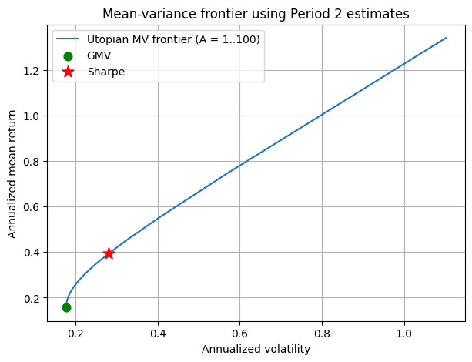
Figure 2.5 – Utopian frontier built and evaluated with (μ₂, Σ₂), with the GMV and Sharpe portfolios
Table 2.5 – GMV and Sharpe portfolios of period 2 (annualized)
 | w FSPTX | w FIDSX | w FSCPX | Mean | Vol | Sharpe | A
GMV | 0.2941 | 0.6348 | 0.0711 | 0.1568 | 0.1773 | 0.8845 | ∞
Sharpe | 1.5870 | 1.3091 | −1.8961 | 0.3941 | 0.2811 | 1.4020 | 4.99

Answer 2.5. The frontier starts at the GMV portfolio (17.7% volatility) and rises as A falls toward 1. The Sharpe portfolio lies on the frontier at A_T ≈ 4.99 with a Sharpe ratio of 1.40, achieved by shorting FSCPX by about 190%. These returns are unrealistically high because the portfolios are built and evaluated with the same period-2 data.

2.6 Realistic out-of-sample evaluation
Answer 2.6. Portfolios are built with (μ₁, Σ₁) for the same grid of A and evaluated with (μ₂, Σ₂). The resulting out-of-sample frontier (orange) is plotted on the same figure as the utopian frontier in Figure 2.8.

2.7 In-sample vs. out-of-sample
Answer 2.7. No. The out-of-sample curve lies entirely below and to the right of the utopian frontier, so the portfolios chosen with period-1 estimates are not mean-variance efficient in period 2. The period-1 Sharpe portfolio achieves an out-of-sample Sharpe ratio of only 0.67 versus 1.40 for the true tangency portfolio, and the period-1 GMV portfolio carries 20.1% volatility versus the true minimum of 17.7%. The gap widens as A falls, because the most aggressive portfolios rely most heavily on the noisy estimate of μ.

2.8 Shrinkage: diagonal Σ₁
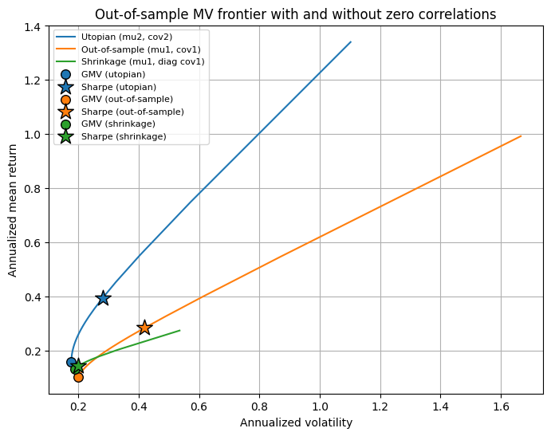
Figure 2.8 – Utopian, out-of-sample and shrinkage (diagonal Σ₁) frontiers, all evaluated with period-2 data
Table 2.8 – GMV and Sharpe portfolios of each case, evaluated in period 2 (annualized)
Portfolio | Mean | Vol | Sharpe
GMV (utopian) | 0.1568 | 0.1773 | 0.8845
Sharpe (utopian) | 0.3941 | 0.2811 | 1.4020
GMV (out-of-sample) | 0.1026 | 0.2010 | 0.5104
Sharpe (out-of-sample) | 0.2833 | 0.4198 | 0.6749
GMV (shrinkage) | 0.1311 | 0.1880 | 0.6971
Sharpe (shrinkage) | 0.1428 | 0.2010 | 0.7104

Answer 2.8. Setting correlations to zero removes the large hedged long-short positions, so the shrinkage portfolios are far less extreme and the green curve is much shorter. At low risk it beats the unrestricted out-of-sample portfolios: its GMV is closer to the true one (18.8% vs. 20.1% volatility, Sharpe 0.70 vs. 0.51), and its Sharpe portfolio does slightly better (0.71 vs. 0.67). At higher risk the two curves cross and the unrestricted portfolios earn more, because ignoring correlations also discards real information. Shrinkage therefore trades some upside for stability, as the bias-variance trade-off predicts.

2.9 Lesson
Answer 2.9. Mean-variance portfolios that are optimal in-sample can perform much worse out-of-sample because the weights are highly sensitive to estimation error in μ and Σ, and imposing a simpler covariance structure can make them more robust.

Problem 3: Risk Modeling
SPY is modelled as a geometric Brownian motion. With Δt = 1/12, the parameters are calibrated as σ̂ = sd(r)/√Δt and μ̂ = mean(r)/Δt + σ̂²/2. VaR at 99% is defined, following the handout, as the mean minus the 1st percentile.

3.1 GBM calibration
Table 3.1 – Calibrated GBM parameters (392 monthly log returns, Jan 1994 – Sep 2026)
Parameter | Estimate (annual)
μ | 0.1134
σ | 0.1499

3.2 Monte Carlo simulation
Table 3.2 – Simulated vs. true conditional moments of S_T (1,000 paths, 392 months, S₀ = $27.06)
 | Simulated | True (GBM)
E[S_T | S₀] | 1,064.27 | 1,100.55
Var[S_T | S₀] | 1,110,612 | 1,311,200

Answer 3.2. The simulated mean is within about 3% of the true value E[S_T] = S₀e^{μT}, which confirms the simulation. The variance is further off (about 15%) because S_T is lognormal with a very long right tail over T ≈ 32.7 years, and 1,000 paths cannot pin it down precisely.

3.3 Closest simulated path
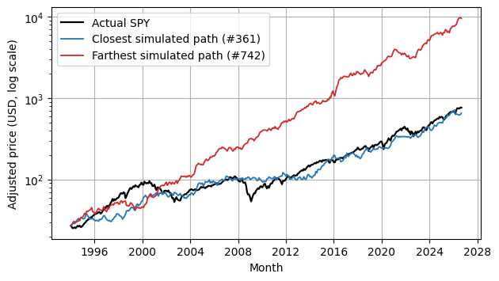
Figure 3.3 – Actual SPY path vs. the closest (#361) and farthest (#742) simulated paths by L2 distance (log scale)
Answer 3.3. Path #361 has the smallest L2 distance (677) from the actual price path, against a median distance of 2,829. It follows SPY's overall upward trend but not its actual crashes, because GBM shocks are independent and normal.

3.4 99% VaR of the PNL
Table 3.4 – PNL of 100 SPY shares held from Jan 1994 to Sep 2026 (simulated)
 | Value ($)
Mean PNL | 103,721
1st percentile PNL | 7,583
99% VaR (mean − 1st percentile) | 96,138

Answer 3.4. The 99% VaR is about $96,100. Even the 1st-percentile path ends with a gain of about $7,600, so over 32 years the risk is of falling far short of the expected gain rather than of an outright loss.

3.5 VaR as a function of σ

3.5(a) Plot
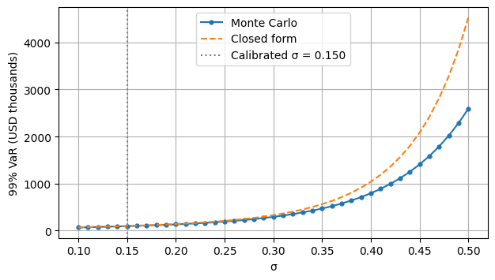
Figure 3.5 – 99% VaR (USD thousands) vs. σ, Monte Carlo and closed form, with μ recalibrated for each σ
Table 3.5 – 99% VaR at selected values of σ ($)
σ | 0.10 | 0.20 | 0.30 | 0.40 | 0.50
Monte Carlo | 67,885 | 134,031 | 293,368 | 795,333 | 2,590,365
Closed form | 69,617 | 141,234 | 330,273 | 1,040,193 | 4,525,573

3.5(b) Model risk
Answer 3.5(b). VaR is very sensitive to σ. It grows from about $68K at σ = 0.10 to about $2.6M at σ = 0.50. A small error in σ, or using the wrong model, changes the risk number enormously, so calibration is a major source of model risk. The effect gets stronger as σ increases: each 0.01 step adds more to VaR than the one before, so errors in σ are amplified most when volatility is high.

3.5(c) Shape of the function
Answer 3.5(c). The curve is nonlinear and convex. Under GBM, S_T is lognormal, so VaR = 100·S₀·e^{mT}(e^{σ²T/2} − e^{zσ√T}), where z = −2.326 is the 1% normal quantile and m = μ − σ²/2 is held at its calibrated value. The σ² term inside the exponential grows explosively over T ≈ 32.7 years, which bends the curve upward. For an IID Gaussian process, independent monthly shocks add up, so variances add and the total change is N(mT, σ²T). Its VaR is mT − (mT + zσ√T) = |z|·σ·√T: the drift cancels, and VaR is linear in σ. Both models start from the same Gaussian log return, but GBM turns it into a price with e^x, and that exponential step is what makes the curve convex. At high σ the Monte Carlo estimate also falls below the closed form, because 1,000 paths miss the extreme right tail.

3.6 Historical vs. parametric monthly VaR
Table 3.6 – Monthly 99% VaR and return moments: historical vs. simulated GBM
 | Historical | Simulated GBM
99% VaR (a, b) | 0.1195 | 0.1004
1st percentile | −0.1110 | −0.0920
Minimum | −0.1805 | −0.2171
Skewness | −0.7230 | −0.0010
Excess kurtosis | 1.2740 | −0.0104

Answer 3.6(a)–(b). The historical 99% VaR is 0.1195 and the parametric (Monte Carlo) 99% VaR is 0.1004.
Answer 3.6(c). Historical VaR (0.120) is about 19% larger than parametric VaR (0.100). The parametric figure is almost identical to a normal-distribution VaR (0.101), so GBM is effectively assuming normal returns and understates the left tail and the kurtosis.
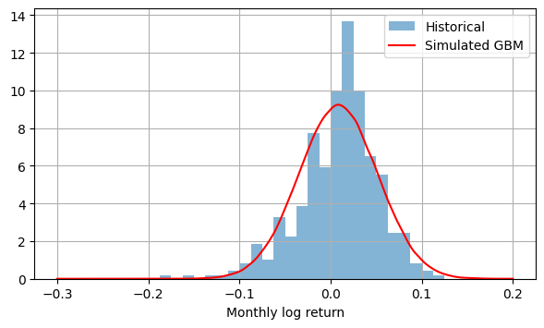
Figure 3.6 – Density of historical vs. simulated GBM monthly log returns
Answer 3.6(d). Historical returns are negatively skewed (−0.72) with fat tails (excess kurtosis 1.27), and include crash months as bad as −18%. The simulated returns are symmetric and normal (skew ≈ 0, kurtosis ≈ 0). The historical density is more peaked in the middle and has a heavier left tail. Because skewness cubes each deviation, a few extreme months dominate it: October 2008 is the largest single contributor, but the sample also contains crash months in 1998 (Russia/LTCM), 2002 (dot-com bust), 2008–09 (financial crisis), 2020 (COVID) and 2022. These repeated crashes, with no matching large up-months, create the heavy left tail that GBM's normal returns cannot reproduce.
Answer 3.6(e). GBM only matches the first two moments of the data, the mean and the volatility, and implicitly assumes zero skew and zero excess kurtosis. VaR depends on the tail, which is driven by those higher moments, so GBM underestimates downside risk exactly where VaR matters. Model choice is therefore itself a risk, alongside parameter estimates. Matching more features of the data, including the observed skew and kurtosis, would give a more realistic tail, although these higher moments are noisy to estimate because they depend on only a few extreme months. Comparing VaR across several approaches, as we did with historical and parametric VaR, further reduces reliance on any single model's assumptions.

Problem 4: Dynamic Games via Monte Carlo
Each stage draws X_t ~ U(0, 10). We simulate 1,000,000 games and work backward from the forced final stop. At each earlier stage the continuation value is estimated by least squares on the basis [1, x, x²], and the player stops if X_t exceeds it (Longstaff-Schwartz LSMC). The fitted rules are re-evaluated on 4,000,000 fresh paths to remove in-sample bias, and compared with the analytical recursion U_{k+1} = U_k²/20 + 5 with U₁ = 5.

4.1 Two-stage problem
Table 4.1 – Estimated continuation value C_t(x) = a + bx + cx² and stopping thresholds (t = 0, 1, 2)
t | a | b | c | LSMC threshold | Exact threshold
0 | 6.2489 | 0.0001 | −0.0000 | 6.2489 | 6.25
1 | 4.9876 | 0.0055 | −0.0005 | 5.0013 | 5.00

Answer 4.1. The stopping rule is to stop at t = 1 if X₁ > 5.00, and at t = 0 if X₀ > 6.25. At t = 2 you must stop. The LSMC value is 6.9524 in-sample and 6.9526 out-of-sample, versus the analytical 6.9531 (= 5 + 6.25²/20). Thresholds and values match the analytical solution to within about 0.001.

4.2 Ten-stage problem
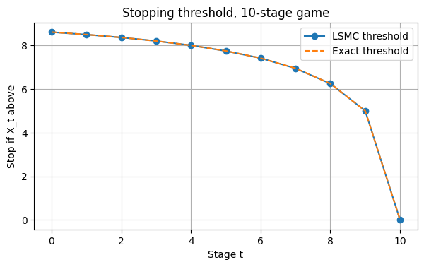
Figure 4.2 – Estimated and exact stopping threshold, 10-stage game
Answer 4.2. The thresholds fall over time: 8.61 at t = 0, then 7.75 at t = 5, 6.25 at t = 8 and 5.00 at t = 9, matching the exact values to within 0.006. The maximum expected payoff is 8.7078, versus 8.7075 analytically.

4.3 One-hundred-stage problem
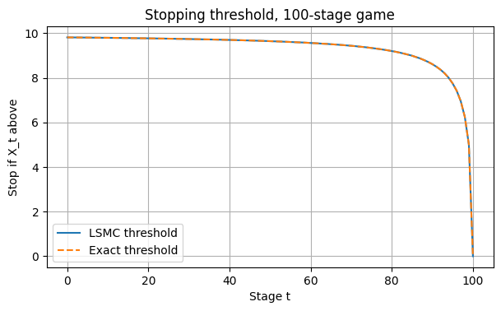
Figure 4.3 – Estimated and exact stopping threshold, 100-stage game
Table 4.3 – Game value and initial threshold for 2, 10 and 100 stages
Game | LSMC (in-sample) | LSMC (out-of-sample) | Analytical | Threshold at t = 0
2-stage | 6.9524 | 6.9526 | 6.9531 | 6.25
10-stage | 8.7074 | 8.7078 | 8.7075 | 8.61
100-stage | 9.8139 | 9.8139 | 9.8139 | 9.81

Answer 4.3. The value is 9.8139 and matches the analytical value. The threshold starts at 9.81 and stays above 9 until about t = 85, then drops steeply to 5 at t = 99. Compared with 2 and 10 stages, more stages raise both the value (6.95 → 8.71 → 9.81) and the early thresholds, approaching the maximum of 10.

4.4 Option to wait
Answer 4.4. The option to wait is worth V₀ − 5: 1.95, 3.71 and 4.81 for 2, 10 and 100 stages. It grows with the horizon but at a diminishing rate, since each extra stage adds (10 − U_n)²/20, and the value approaches the upper bound of 10 (roughly 10 − 20/n for n draws). The optimal threshold equals the continuation value of the remaining draws. With many stages left it is close to 10, so you are very selective. As the final stage approaches, it falls more and more steeply: 6.25 with two draws remaining, then 5 with one, then 0 at the forced stop. The time value of waiting decays to zero, like an American option's exercise boundary near expiry, where theta rapidly erodes the option's extrinsic value. In practice, optimal exercise rules can be built the same way, using realistic return distributions (including volatility skew), option Greeks, and historical backtests from both the buyer's and the seller's perspective.

