FE535 Introduction to Financial Risk Management
Project 1 – Final Report
Team members: ______________________
Date: November 2026

Data
We use daily adjusted closing prices (Yahoo Finance, auto-adjusted) for the 19 Fidelity Select mutual funds (FSPTX, FSELX, FSCSX, FSPHX, FBIOX, FSMEX, FPHAX, FIDSX, FSRBX, FSPCX, FSENX, FSDAX, FSRFX, FSCPX, FSAVX, FSRPX, FDFAX, FSTCX, FWRLX), the SPY ETF (market portfolio) and the XLK ETF (alternative benchmark), from January 2015 to September 2026. Daily log returns are computed as r_t = ln(P_t / P_{t-1}), giving 2,952 daily observations for each of the 21 tickers. The risk-free rate is assumed to be zero. All computations were conducted in Python (source file: Project 1.py).

Problem 1: Performance Summary
Annualization uses 252 trading days: mean μ = 252·mean(r), volatility σ = √252·sd(r), SR = μ/σ. Relative measures against a benchmark M: β = Cov(r_i, r_M)/Var(r_M); Jensen's α = 252·[mean(r_i) − β·mean(r_M)]; Treynor ratio TR = μ_i/β; tracking error ω = √252·sd(r_i − r_M); information ratio IR = (μ_i − μ_M)/ω.

1.1 Absolute performance summary
Table 1.1 – Summary of annual absolute performance across the 19 funds (6 × 3)
 | Mean | Volatility | SR
Min | 0.0562 | 0.1482 | 0.2480
Q1 | 0.0826 | 0.1941 | 0.3823
Mean | 0.1119 | 0.2263 | 0.4927
Median | 0.0995 | 0.2181 | 0.4868
Q3 | 0.1158 | 0.2441 | 0.5612
Max | 0.2653 | 0.3431 | 0.8405

Answer 1.1. The median fund earns an annual mean return of 9.95% with 21.8% volatility and a Sharpe ratio of 0.49; mean returns range from 5.6% to 26.5%, volatilities from 14.8% to 34.3%, and Sharpe ratios from 0.25 to 0.84.

1.2 Mean return vs. volatility
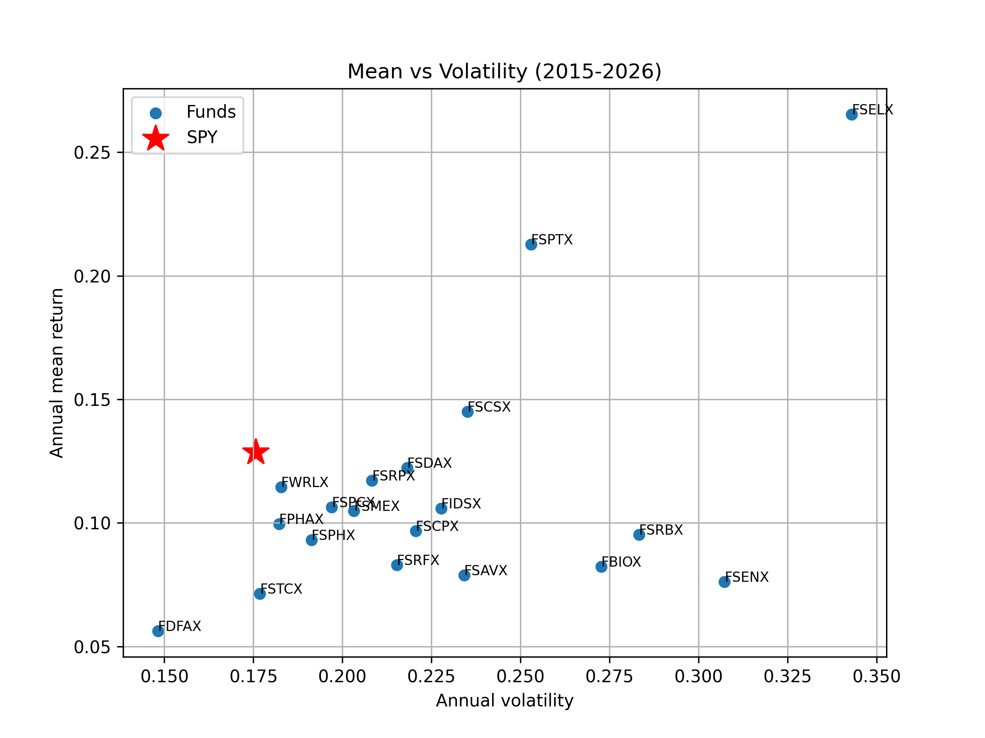
Figure 1.2 – Annual mean return vs. annual volatility of the 19 funds; SPY highlighted (red star)
Table 1.2 – Funds with a higher mean return than SPY (SPY: mean 0.1285, volatility 0.1757)
Ticker | Mean | Volatility
FSPTX | 0.2127 | 0.2530
FSELX | 0.2653 | 0.3431
FSCSX | 0.1450 | 0.2351

Answer 1.2. Only three funds outperform SPY in mean return (FSELX 26.5%, FSPTX 21.3%, FSCSX 14.5% vs. 12.9% for SPY), and all of them carry higher volatility than the market (34.3%, 25.3%, 23.5% vs. 17.6%), so their extra return comes with extra risk.

1.3 Relative performance (benchmark: SPY)

1.3(a) Summary table
Table 1.3a – Summary of relative performance measures vs. SPY (6 × 5)
 | Alpha | Beta | TR | TE (ω) | IR
Min | -0.0623 | 0.5950 | 0.0717 | 0.0824 | -0.5698
Q1 | -0.0458 | 0.8783 | 0.0849 | 0.1237 | -0.2986
Mean | -0.0162 | 0.9970 | 0.1104 | 0.1446 | -0.1347
Median | -0.0160 | 1.0015 | 0.1097 | 0.1322 | -0.1866
Q3 | -0.0014 | 1.1074 | 0.1269 | 0.1421 | -0.1361
Max | 0.0643 | 1.5644 | 0.1696 | 0.2483 | 0.6821

Answer 1.3(a). The median fund has β ≈ 1.00, α ≈ −1.6%, TR 0.11, tracking error 13.2% and IR −0.19, so most funds underperform SPY on a risk-adjusted basis.

1.3(b) Top-5 funds by Jensen's α
Table 1.3b – Absolute and relative performance of the five funds with the highest α (vs. SPY)
Ticker | Mean | Vol | SR | Alpha | Beta | TR | TE | IR
FSELX | 0.2653 | 0.3431 | 0.7733 | 0.0643 | 1.5644 | 0.1696 | 0.2280 | 0.6000
FSPTX | 0.2127 | 0.2530 | 0.8405 | 0.0469 | 1.2903 | 0.1648 | 0.1234 | 0.6821
FPHAX | 0.0995 | 0.1822 | 0.5459 | 0.0096 | 0.6996 | 0.1422 | 0.1445 | -0.2009
FSDAX | 0.1223 | 0.2181 | 0.5605 | -0.0004 | 0.9546 | 0.1281 | 0.1397 | -0.0447
FSCSX | 0.1450 | 0.2351 | 0.6165 | -0.0008 | 1.1342 | 0.1278 | 0.1270 | 0.1297

Answer 1.3(b). The five funds with the highest Jensen's α are FSELX (Semiconductors, 6.4%), FSPTX (Technology, 4.7%), FPHAX (Pharmaceuticals, 1.0%), FSDAX (Defense & Aerospace, −0.04%) and FSCSX (Software, −0.08%), mostly technology-related sector funds. Only the two tech funds stand out in both absolute and relative terms: they have the highest mean returns and Sharpe ratios (0.77 and 0.84) and a positive IR (0.60 and 0.68), although with β above 1. FPHAX earns a positive α thanks to its low β (0.70), despite a mean return below SPY and a negative IR, while FSDAX and FSCSX have α close to zero, so their relative performance is essentially in line with the market.

1.4 Expense ratios

1.4(a) Mean return and α vs. expense ratio
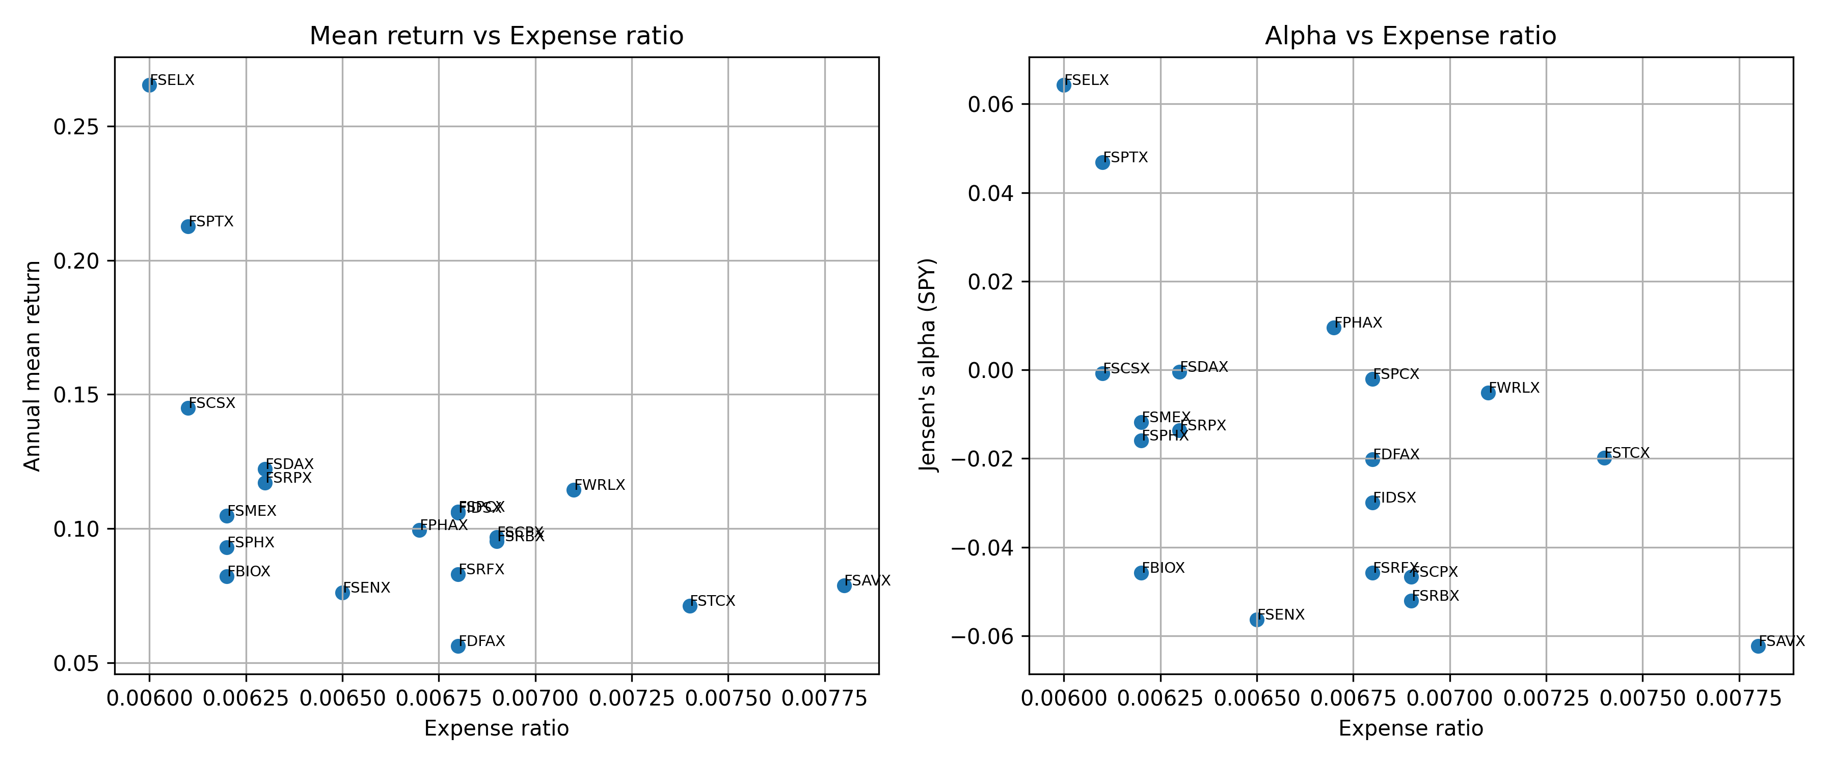
Figure 1.4 – (i) Annual mean return and (ii) Jensen's α (vs. SPY) against the expense ratio

1.4(b) Evidence
Answer 1.4(b). No: both the mean return and Jensen's α are negatively related to the expense ratio (correlations of −0.55 and −0.54), with the cheapest funds (FSELX, FSPTX) delivering the highest mean and α and the most expensive (FSAVX) the lowest α, because higher fees are a direct cost that lowers net returns and is not compensated by superior managerial skill.

1.5 Alternative benchmark: XLK

1.5(a) Summary table
Table 1.5a – Summary of relative performance measures vs. XLK (6 × 5)
 | Alpha | Beta | TR | TE (ω) | IR
Min | -0.0647 | 0.3177 | 0.1117 | 0.0596 | -0.7486
Q1 | -0.0329 | 0.5456 | 0.1466 | 0.1627 | -0.6535
Mean | -0.0194 | 0.6449 | 0.1736 | 0.1845 | -0.4806
Median | -0.0168 | 0.6089 | 0.1731 | 0.1838 | -0.5125
Q3 | -0.0020 | 0.6858 | 0.1934 | 0.2063 | -0.4414
Max | 0.0166 | 1.2688 | 0.2411 | 0.2976 | 0.3633

Answer 1.5(a). Against XLK the median fund has β 0.61, α −1.7%, tracking error 18.4% and IR −0.51.

1.5(b) Effect of the benchmark
Table 1.5b – Jensen's α and its rank under SPY and XLK benchmarks
Ticker | Alpha (SPY) | Rank (SPY) | Alpha (XLK) | Rank (XLK)
FSELX | 0.0643 | 1 | 0.0071 | 3
FSPTX | 0.0469 | 2 | 0.0044 | 5
FPHAX | 0.0096 | 3 | 0.0134 | 2
FSDAX | -0.0004 | 4 | 0.0061 | 4
FSCSX | -0.0008 | 5 | -0.0292 | 13
FSPCX | -0.0020 | 6 | 0.0166 | 1
FWRLX | -0.0051 | 7 | -0.0201 | 12
FSMEX | -0.0118 | 8 | -0.0162 | 9
FSRPX | -0.0136 | 9 | -0.0186 | 11
FSPHX | -0.0160 | 10 | -0.0168 | 10
FSTCX | -0.0198 | 11 | -0.0128 | 7
FDFAX | -0.0202 | 12 | -0.0084 | 6
FIDSX | -0.0300 | 13 | -0.0145 | 8
FBIOX | -0.0458 | 14 | -0.0519 | 17
FSRFX | -0.0458 | 15 | -0.0410 | 16
FSCPX | -0.0467 | 16 | -0.0549 | 18
FSRBX | -0.0521 | 17 | -0.0299 | 14
FSENX | -0.0563 | 18 | -0.0359 | 15
FSAVX | -0.0623 | 19 | -0.0647 | 19

Answer 1.5(b). The choice of benchmark materially changes the assessment: relative to XLK, the technology funds lose most of their outperformance (FSELX's α falls from 6.4% to 0.7%, FSPTX's from 4.7% to 0.4%, and FSCSX drops from 5th to 13th with α of −2.9%), because their high α against SPY largely reflected exposure to the tech sector rather than managerial skill, which XLK already captures; conversely, non-tech funds such as FSPCX (Insurance) and FPHAX (Pharmaceuticals) now rank highest, while the lower betas and more negative IRs show that XLK is a poor benchmark for most non-tech funds, so α is only meaningful when the benchmark matches the fund's investment style.

Problem 2: Mean-Variance Frontier
[To be completed]

Problem 3: Risk Modeling
[To be completed]

Problem 4: Dynamic Games via Monte Carlo
[To be completed]

