Effort and Delay Discounting in a Foraging Environment 2

Claudio Toro-Serey & Joseph T. McGuire

## 

## Research Questions

#### 3.1. Main question: Are decisions affected differently by equivalent time periods of pure delay, cognitive effort, and physical effort? Crucially, is this pattern different when individuals chose among all forms of effort?

## Hypotheses

#### 4.1. Single-option, accept/reject decisions will be influenced by within-subject manipulations of reward magnitude in line with a theoretical reward-maximizing strategy.

**4.1.1.** Participants will more frequently accept high-reward prospects than low-reward prospects. **4.1.2.** The pattern of acceptances will match that of groups that previously experienced each effort separately for an equivalent delay.

#### 4.2. Prospect acceptance rates will differ across three within-subject conditions, in which the delays associated with rewards (a) are unfilled, (b) include a cognitive effort requirement, or (c) include a physical effort requirement. Each effort type will be paired with unfilled delay trials in a blocked manner.

**4.2.1.** Acceptance rates for unfilled-delayed trials will be higher than those for both physical and cognitive effort trials.

**4.2.2.** Acceptance rates for physical effort trials will be lower than those for cognitive effort trials.

**4.3.3.** Acceptance rates for unfilled-delay trials will not differ based on their pairing with each effort condition.

#### 4.3. Choices will be well fit by a computational model in which the subjective opportunity cost of time is free to vary across the four between-subject conditions.

**4.3.1.** Participants will display stable preferences, meaning that the reward amounts they accept in a given timing condition will be similar throughout the experiment.

**4.3.2.** Subject-specific opportunity cost (OC) estimates will vary inversely with acceptance rates. Thus, the unfilled-delay condition will produce higher OC estimates than both effort conditions, which in turn will show no differences between them.

## Analyses

#### 16.1. Tests of whether decision makers integrate delay and reward information.

**16.1.1.** *To address hypothesis 4.1., A logistic regression will be fit for each participant in order to predict trial-wise acceptances, using handling time and reward amount as predictors. The resulting beta coefficients for handling time and reward will be pooled across all participants, and we will perform a one-sample rank-sum test on each set of coefficients to examine whether the they are significantly positive or negative (compared to 0). If the group coefficients are significantly positive, it would mean that a predictor reliably increases the likelihood of acceptance. This will allow us to determine whether increments in handling time and reward amounts increased and decreased the likelihood of acceptance for each participant, respectively.*

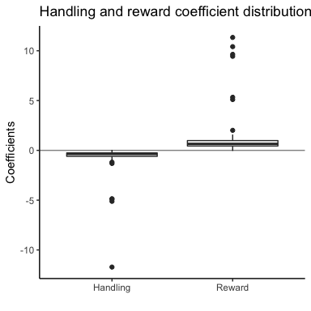

The plot shows the pooled coefficients across subjects for the effect of each predictor. The results show the expected discounting effect of increasing the handling time, as well as the increase in acceptance likelihood as a function of reward increments. We found that these coefficients were significantly different from zero for both handling (V = 30, < 0.001) and reward (V = 3556, p = 2.879146510^{-15}) regardless of cost condition.

**16.1.2.** *We will perform an extension of the logistic regression from 16.1.1., this time adding an autoregressive covariate containing the number of consecutive quits prior to a given trial. In this way, we will examine the possibility that participant choices were governed by recent quitting history rather than the experimental parameters (see 11.1.3.). Coefficients not significantly different from 0 will denote that a participant did not rely on recent quitting history.*

To measure the significance of each subject's autoregressive coefficient, we computed its CI and checked how many contained zero. By this measure, around 11 percent of our participants seemed to have been influenced by recent quitting. However, the autoregressive predictor did not preclude the effect of the remaininig experimental parameters.

**16.1.3.** *A general linear model with constant, linear, and quadratic terms will be used to estimate the correspondence between proportion accepted (independent variable) and total earnings (dependent variable). No other covariates will be used, as this analysis is to confirm that over and under accepting are detrimental to total earnings. The quadratic term will be defined as the squared deviation from the optimal overall acceptance rate.*

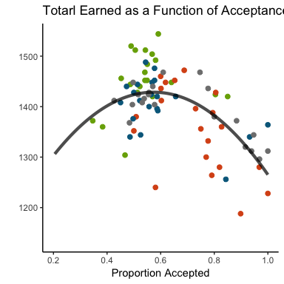

The figure shows that participants that over and unceraccepted earned less money overall, as predicted. This is supported by a significant quadratic term from the linear model (F = 25.65, Beta = -899.2109282, SE = 242.25, R-squared = 0.39; black line shows the fit). The following table shows all the results from the model.

Fitting linear model: Earnings ~ propComplete + propAllsq

|  |  |  |  |  |
| --- | --- | --- | --- | --- |
|  | Estimate | Std. Error | t value | Pr(> |
| **(Intercept)** | 1133 | 114 | 9.9 | 1.3e-15 |
| **propComplete** | 1032 | 342 | 3 | 0.0034 |
| **propAllsq** | -899 | 242 | -3.7 | 0.00038 |

**16.1.4.** *To determine the optimality of each group’s decisions, we will perform two-sided one-sample (*one-sample? wouldn't it be paired vs optimal?*) t-tests to see if the proportion of acceptances for each time/reward combination was significantly different from the optimal rate (see 11.2.). This will result in 36 independent tests (3 rewards amounts, 3 handling/travel time combinations, and 4 groups), so we will correct for multiple comparisons using False Discovery Rate (FDR).*

Of the 36 tests, around 0.5 were significantly deviant from optimality. Most of these were from effortful groups, as the wait group just showed deviations for 2 seconds handling/4 cent, and 10 seconds handling/8 cent offers.

#### 16.2. Comparisons among the four delay and effort conditions.

**16.2.1.** *To compare preferences (hypothesis 4.2.), we will first perform a one-way ANOVA on the proportion of trials accepted using group as a factor. In addition, we will do pairwise comparisons on the proportion completed among all 4 groups using non-parametric permutation contrasts (6 tests). The same approach will be used for total earnings. This will give us an initial glimpse on the potential differences in cost among conditions.*

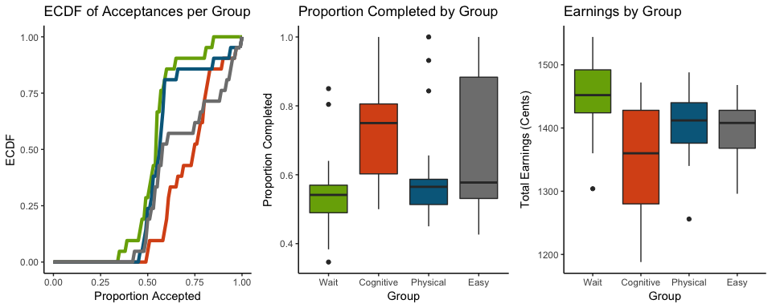

The plots show that subjects in the wait condition accepted the least and earned the most, suggesting a more optimal pattern of choices. Participants in the cognitive effort and easy conditions had higher more variable acceptance patterns, which are reflected in the comparatively low earnings. The reason why the easy condition does not show variable earnings like the cognitive effort group is probably due to the quadratic relationship between earnings and acceptances shown before.

**16.2.2.** *In order to further look at the effect of delay, work, and rewards, we will perform a repeated measures ANOVA on the proportion completed for each combination of factors. Reward and handling time will be within-subject factors, and condition a between-subjects factor. In support of hypotheses 4.1. and 4.2., we anticipate significant main effects of handling time, reward, and cost condition, but no interactions.*

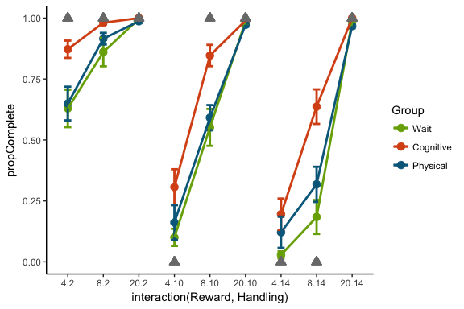

Analysis of Variance Model

|  |  |  |  |  |  |
| --- | --- | --- | --- | --- | --- |
|  | Df | Sum Sq | Mean Sq | F value | Pr(>F) |
| **factor(Group)** | 3 | 2.7 | 0.91 | 15 | 2e-09 |
| **Handling** | 1 | 5.8 | 5.8 | 94 | 5.3e-21 |
| **Reward** | 1 | 15 | 15 | 246 | 5.1e-48 |
| **factor(Group):Handling** | 3 | 0.095 | 0.032 | 0.51 | 0.67 |
| **factor(Group):Reward** | 3 | 0.92 | 0.31 | 5 | 0.0019 |
| **Handling:Reward** | 1 | 2.8 | 2.8 | 45 | 3.2e-11 |
| **factor(Group):Handling:Reward** | 3 | 0.0051 | 0.0017 | 0.028 | 0.99 |
| **Residuals** | 736 | 45 | 0.061 | NA | NA |

**16.2.3.** *We will compute the probability of accepting a trial with a mixed-effects logistic regression. Based on the task structure and our main question, our a priori model of interest will include cost condition, handling time, and reward amount as fixed main effects, and subject ID as a random effect. Cost condition will be modeled with three categorical terms, with the fourth condition as the reference condition. We will run three versions of the model with different reference conditions, in order to test all pairwise differences among the four cost conditions. As with 16.2.2., we anticipate significant main effects (coefficients different than zero) of handling time, reward, and cost condition. We hypothesize that the differences among cost conditions will follow the pattern described in 4.2.*

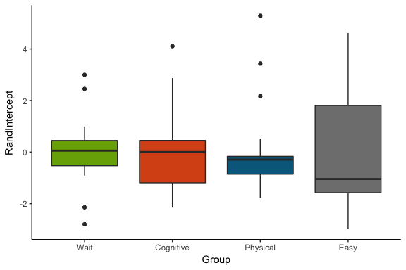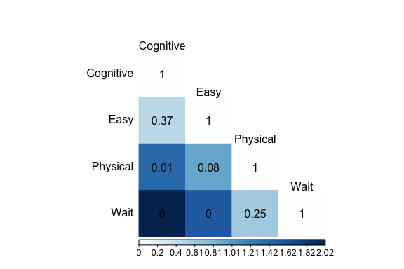

**16.2.4.** *Next, we will examine whether the a priori model from 16.2.3. outperforms both simpler and more complex models. Unlike the individual logistic regression fits in 16.1.1., a mixed-effects approach gives us a better goodness of fit measure for model comparisons. We will determine the best model (combination of predictors) using Akaike’s Information Criterion (AIC) to determine the model that minimizes the negative log-likelihood while penalizing the addition of parameters. The regression with each combination of predictors will be fitted in the following order: 1) intercept only; 2) condition only; 3) handling time only; 4) reward only; 5) condition, handling, and reward main effects (from 16.2.3.); 6) adding a handling-by-reward interaction; and 7) adding all three possible two-way interactions. We predict that model 5 will have the lowest AIC.*

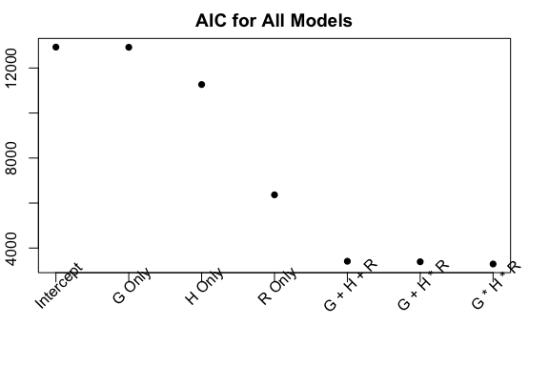

#### 16.3. Modeling the subjective opportunity cost in each condition.

**16.3.1.** *Response times (RT) for quit responses will be presented in a descriptive manner in order to examine whether participants tended to quit early or late within individual trials. Each cost group’s response time distribution will contain the pooled RT across its corresponding participants, and we will display the empirical cumulative distribution functions for each condition. Short RT would suggest confident and stable decisions (in support of 4.3.1.).*

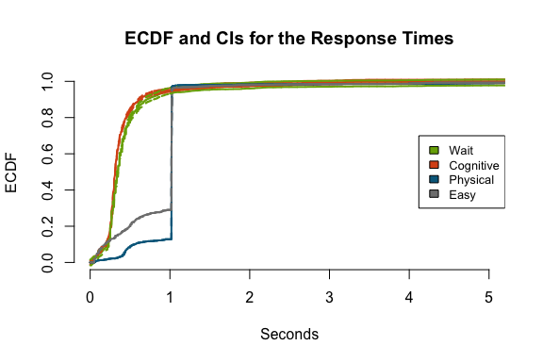

ECDFs of pooled response times from each group. Responses were overall quick, with the wait group being slightly slower.

**16.3.2.** *In order to further examine choice stability (hypothesis 4.3.1.), we will compute each participant’s total proportion of acceptances pre- and post-midpoint. For each cost condition separately, we will fit a linear model that predicts post-midpoint acceptance from before-midpoint rates. We will report the slopes and 95% confidence intervals (CI) for each cost group. CIs containing 1 will denote that participants in that group produced consistent choices.*

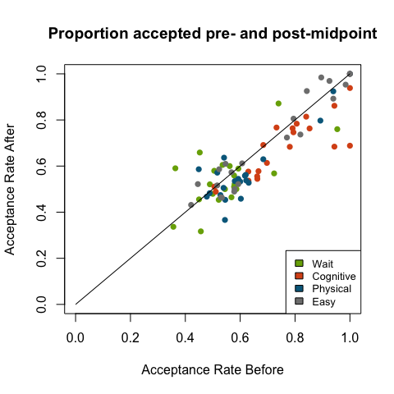

Pre-post acceptances for each subject in each condition

The following table shows the coefficients and CI for each linear model, and show that pre-post acceptance rates were very similar for each condition.

Predicting Post-mid acceptance from pre-mid choices: Coefficients and CI.

|  |  |  |  |
| --- | --- | --- | --- |
| Condition | Beta | CI-Low | CI-High |
| Wait | $$0.6745405$$ | $$0.2825207$$ | $$1.0665603$$ |
| Cognitive | $$0.9028712$$ | $$0.6254282$$ | $$1.1803143$$ |
| Physical | $$0.8491954$$ | $$0.6334089$$ | $$1.0649819$$ |
| Easy | $$0.8985949$$ | $$0.7655853$$ | $$1.0316046$$ |

**16.3.3.** *To estimate the subjective opportunity cost (hypothesis 4.3.2.), we will use a logistic function to model each participant’s probability of completing a trial based on the difference between the delayed reward’s magnitude and the estimated opportunity cost (OC) for each cost type. OC will be computed as the product of a free parameter (gamma) and the handling time. Both gamma and the temperature parameter of the logistic function will be estimated at the subject level, independently for each subject.*

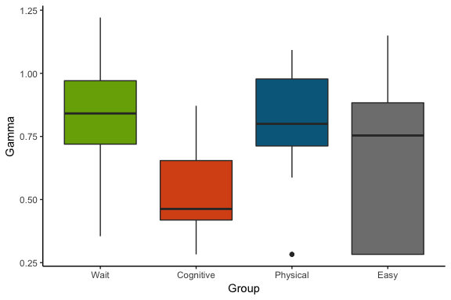

**16.3.4.** *We will cross-validate each subject’s OC value using the pre-midpoint data for estimation, and post-midpoint choices for testing. The estimates will be used to predict acceptances in the testing sample, and the mean percent correctly predicted will be reported for each group. This will also provide information on the stability of each participant’s choices (4.3.1.).*

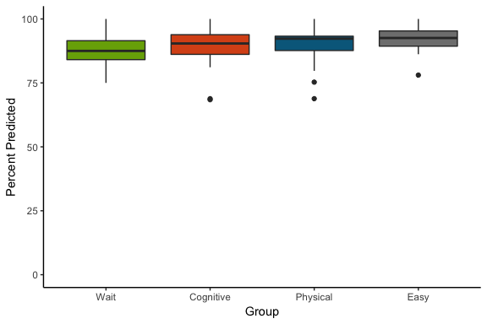

**16.3.5.** *The OC estimates for each group will be compared using an ANOVA with condition as a factor. This will let us determine which cost type produced the highest discounting.*

