Requirements:

1. Access to Docker and Postman

Steps to run the program:

1. Clone the repo at:
2. On your command line, go to the directory where you cloned the repo
3. Build the docker image by entering this in the command line: **docker build -t fetch-receipt-processor-image .**
4. Open your Docker application and verify that your image is listed under images
5. Ensure port 8080 is available on your local. Terminate any processes running on this port.
6. On your command line, enter: **docker-compose up**
7. On Docker, verify the container is now running
8. Head over to PostMan, you will need the following requests set up:
   1. POST: <http://localhost:8080/receipts/process>
   2. GET: [http://localhost:8080/receipts/{id}/points?id=](http://localhost:8080/receipts/%7Bid%7D/points?id=)
9. For the POST request, enter information similar to the image below. You should expect an id returned with your request. 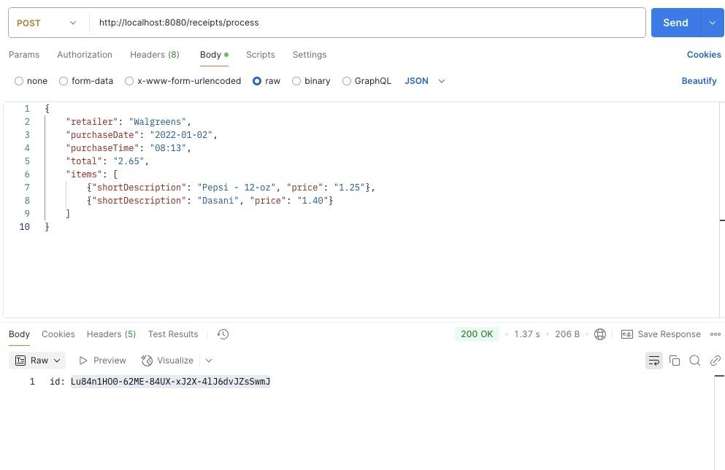
10. For the GET request, use the ID received from the POST to get the points calculated for a receipt.