Department of Chemical Engineering and Biotechnology, University of Cambridge,1 National Physical Laboratory, 2 *craig.russell@npl.co.uk
Abstract
We present a tomographic reconstruction algorithm, which is applied to Optical Projection Tomography (OPT) [1] images, that is robust to mechanical jitter and systematic angular and spatial drift. OPT relies on precise mechanical rotation and is less mechanically stable than large scale CT scanning systems, leading to reconstruction artefacts. The algorithm uses multiple (5+) tracked fiducial beads to recover the sample pose and the image rays are then back-projected at each orientation. The quality of the image reconstruction using the proposed algorithm shows an improvement when compared to the Radon transform. When adding a systematic spatial and angular mechanical drift, the reconstruction using the proposed algorithm shows a significant improvement over the Radon transform.
Sharpe et.al proposed OPT [Error: Reference source not found] using visible light to image transparent or translucent mesoscopic samples, with micrometer resolution. OPT addresses the scale gap between photographic techniques (for samples typically larger than 10), and light microscopy techniques (samples smaller than 1) to image biological samples in the 110 regime.
OPT is based on computerised tomography techniques [Error: Reference source not found] in which a set of projections of a specimen are imaged as the specimen travels through a full rotation. Typically a Radon transform used to then transform this set of images into a 3D image stack in Cartesian (X,Y,Z). The Radon transform relies heavily on the assumption of circular motion with constant angular steps about a vertical axis. This work presents an improved reconstruction algorithm that is robust to spatial and angular mechanical drifts during acquisitions, as well as inconsistent angular steps.
The proposed algorithm works by triangulating points between images pairs to extract camera pose using the theoretical framework used in stereoscopic imaging.

1 Stereoscopic imaging

[Sorry. Ignored \begin{subfigure} ... \end{subfigure}]

[Sorry. Ignored \begin{subfigure} ... \end{subfigure}]
Figure 1: X\s\do5(c) = is the camera-centered coordinate point in 3D space. X = (X,Y,Z) is the world coordinate point in 3D space. p = (x,y,f) is the ray vector to point of image plane. x = (x,y) is the image plane coordinates. w = (u,v) is the pixel coordinates (not shown) corresponding to the point x. The optical axis travels along the axis through the image plane.

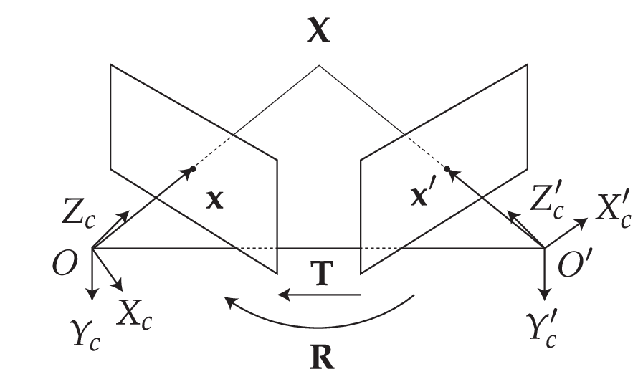
Figure 2: Epi-polar geometry described for two adjacent views (or cameras of a scene). Coordinates as expressed in 1 with prime notation (') denoting the additional right camera view. Transforming from right to left camera-centered coordinates (X\s\do5(c)’ to X\s\do5(c)) requires a rotation (R) and a translation (T). 1
The stereoscopic imaging scenes allows for the triangulation of individual features in three dimensional space (know as world points) when the features or fiducial markers in one detector are uniquely identifiable, see Figure 2 for the coordinate system which descibes this geometry. Triangulation requires that each feature is detected in both images of a stereo imaging system, and for these detections to be correctly associated with one another, this is known as the correspondence problem. Many methods exist to ensure that features are detected from image data and accurately associated between two cameras or views. Properties of scale independent features and their surrounding pixel environment in one image can be matched to a similar feature in the second image.
Coordinates in two adjaceent views with a common epi-pole (see Figure 2) are related by the Essential matrix (Essential) for uncalibrated cameras and the Fundamental matrix (F) for calibrated cameras. Their properties can described by:
[Sorry. Ignored \begin{gather} ... \end{gather}]
Where K is a matrix which converts image plane coordinates to camera pixel coordinates and where p refers to a point in the image plane.

2 The proposed algorithm
The shift of a camera around a scene separated by a transformation matrix (
[Sorry. Ignored \begin{bmatrix} ... \end{bmatrix}]
) is analogous to transforming the sample in the fixed view of an imaging detector, as in an OPT acquisition. During an ideal OPT acquisition, a marker will appear to follow an elliptical path in the xy image plane. During the following volume reconstruction there is a fitting step to recover the path of the fiducial marker, which is used to apply as a correction before using the inverse Radon transform. This type of reconstruction not only ignores any mechanical jitter of the sample but also any affine, systematic, mechanical drift (in X,Y,Z,Θ,φ,ψ). Using two adjacent images of a scene, separated by some rotation and translation, world points in 3D space may be triangulated within the scene given the rotational and translational matrices of the respective camera views.Once a sufficient amount of fiducial markers are reliably tracked from the first to the second image, either of the fundamental matrixfundamental or essential matrixessential matrices can be computed. Using the factorisation one of these matrixes, between each adjacent view of a rotating scene, the translation and rotational matrices can be recovered.To reconstruct we compute F for the current image and the first image using 5 or more fiducial markers; having additional beads helps to remove ambiguity and increase confidence in F. Once F is calculated F is then decomposed into and between each view n and n+1. The image at view n+1 is then back projected along the virtual optical axis within a virtual volume where the sample will be reconstructed. The size of this back projection and virtual volume is chosen to be suitably large (so that important data is not lost). The transformation matrices that are recovered are then inverted to realign the back projection of the image rays in the volume to their respective source positions.
[Sorry. Ignored \begin{subfigure} ... \end{subfigure}]

[Sorry. Ignored \begin{subfigure} ... \end{subfigure}]
Figure 3: This figure illustrates the simulation of OPT data incorporating rotational and translational offsets, and the proposed reconstruction algorithm. (fig:flopt\s\do5(a)lgorithm\s\do5(f)orward): The n projections of the object (Σ), at rotation ( to ) and translation ( to ), produces n frames of image data. During the OPT measurement, n projections of the object Σ are observed with rotations to and corresponding translations to where the translations account for imperfect alignment. (fig:flopt\s\do5(a)lgorithm\s\do5(i)nverse): In the reconstruction algorithm, the rotational and translational matrices are recovered ( to and to ) from triangulation of the fiducial markers. These transformation matrices are then used to obtain a contribution to the volumetric reconstruction from each observed frame and the summated reconstruction is assembled from the n frames. The now realigned back projections are summed to produce an unfiltered back projection. The transformation matrices are shown in augmented form using homogenous coordinates.
In both cases a decomposed F matrix will produce four possible transformation pairs (R,T; R,-T; -R,T; -R,-T). Once the transformation matrix between the current view (n) and the first view is calculated the proceeding transformation matrices are then easily chosen by similarity to the previous collected matrix and general direction of motion. An example of this type of selection would be:

[Sorry. Ignored \begin{bmatrix} ... \end{bmatrix}]
-
[Sorry. Ignored \begin{bmatrix} ... \end{bmatrix}]
)\s\up14(2)) (1)
The first two views are more difficult to choose the correct decomposition for, but it is possible if a suitable ideal matrix is given as a comparison. Such an ideal matrix is composed using a priori knowledge of the likely angle of rotation of the system’s imaging properties.

3 Verification of the proposed algorithm
To verify that the proposed algorithm successfully reconstructs the specimen, it was applied to a volume of simulated data. The image of Lena with an orthogonal image of cameraman is used here as a testcard volume to verify the validity of the reconstruction. Superimposed on the testcard volume are fiducial beads to track the rotation of the image, see 17. The reference image was then rotated through 128 angles over 2π radians and projected along the Y axis and a slice in (X,Y) was taken to create a single line projection, shown three dimensionally in 5. This is repeated for each angle with each line projection stacked to create a sinogram, see Error: Reference source not found.

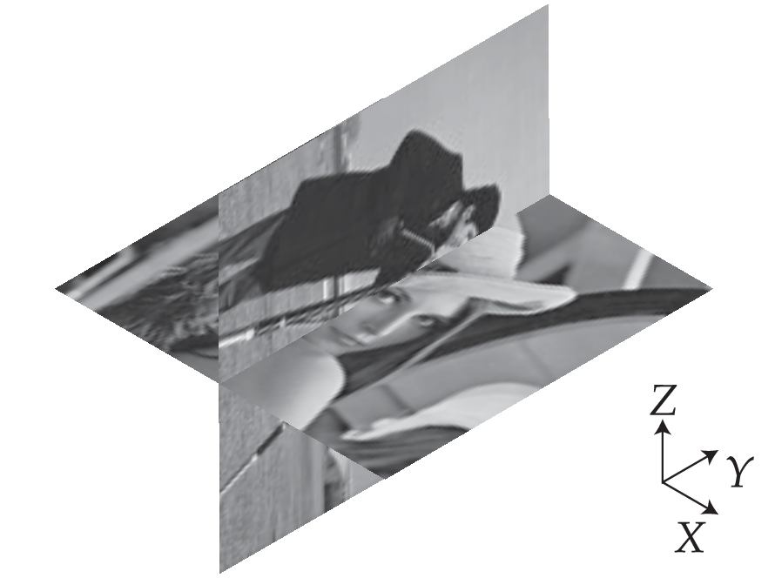
Figure 4: Ground truth 3D object for reconstruction, based on the Cameraman and Lena testcard images.

[Sorry. Ignored \begin{subfigure} ... \end{subfigure}]

[Sorry. Ignored \begin{subfigure} ... \end{subfigure}]

[Sorry. Ignored \begin{subfigure} ... \end{subfigure}]

[Sorry. Ignored \begin{subfigure} ... \end{subfigure}]
[Sorry. Ignored \begin{subfigure} ... \end{subfigure}]

[Sorry. Ignored \begin{subfigure} ... \end{subfigure}]

[Sorry. Ignored \begin{subfigure} ... \end{subfigure}]

[Sorry. Ignored \begin{subfigure} ... \end{subfigure}]
[Sorry. Ignored \begin{subfigure} ... \end{subfigure}]

[Sorry. Ignored \begin{subfigure} ... \end{subfigure}]

[Sorry. Ignored \begin{subfigure} ... \end{subfigure}]

[Sorry. Ignored \begin{subfigure} ... \end{subfigure}]
[Sorry. Ignored \begin{subfigure} ... \end{subfigure}]

[Sorry. Ignored \begin{subfigure} ... \end{subfigure}]

[Sorry. Ignored \begin{subfigure} ... \end{subfigure}]

[Sorry. Ignored \begin{subfigure} ... \end{subfigure}]
Figure 5: A 3D test-volume of two orthogonal and different testcard images, from 4, was used to verify the reconstructive capabilities of the proposed algorithm. The projected image data (b), (h), (j) and (d), (h), (l), were used to iteratively generate reconstructions where the reconstruction incorporates all the information from observation 0 to n. The results are unfiltered for clarity of demonstrating the iterative reconstruction, which is applied in 15. 415
In the standard approach for OPT reconstruction, the sinogram undergoes the inverse Radon transform, as shown in 12 and then post-filtering, see Error: Reference source not found. This step is substituted for the proposed algorithm; in 6 the two techniques are compared for ideal conditions of smooth, predictable rotation. The proposed algorithm produces a faithful reconstruction on the original image, as shown in 15 Both techniques lose some of the original contrast of the object due to under-sampling of rotations. When taking the histogram of the absolute pixel-wise difference between the original source image to the images produced by the new algorithm and the Radon transform, see Error: Reference source not found. The mean square errors (MSE, see Equation (3)) of the new algorithm and the Radon transform are 15.01 and 14.84 respectively, see Error: Reference source not found for a histogram of a pixel-wise comparison. This suggests that the new algorithm is producing an accurate reconstruction of the object, similar to the standard Radon transform.
()

[Sorry. Ignored \begin{subfigure} ... \end{subfigure}]
[Sorry. Ignored \begin{subfigure} ... \end{subfigure}]

[Sorry. Ignored \begin{subfigure} ... \end{subfigure}]
Figure 6: (fig:flopt\s\do5(c)omparison\s\do5(l)ine\s\do5(p)rofile), Line profile comparison of the reconstruction of a reference image computationally rotated, projected and reconstructed using the standard Radon transform and the new proposed algorithm. (fig:flopt\s\do5(h)istogram), Histogram of of pixel values compared between reconstructions using flOPT and the Radon transform. The shift of the histogram to towards overall lower deviance from the source image suggests the flOPT algorithm out performs the Radon transform (fig:helical\s\do5(c)omparison): Comparison of standard and proposed OPT reconstruction algorithms for acquisitions with drift. 2D image correlation of the ground truth and the reconstruction shows that the proposed flOPT algorithm does not degrade with systematic drift, whereas reconstruction using the standard Radon transform is severely degraded.
The more challenging case of a sample drifting, with a constant velocity and systematically along the X axis was then considered; this produced a helical path of a single fiducial within the sample, see Error: Reference source not found. In Error: Reference source not found, the Radon transform entirely fails to produce a recognisable reproduction of the test image with the addition of a slight helicity to the rotation. The proposed algorithm produces an equivalent result to that of a sample rotating without any systematic drift, see Error: Reference source not found. In Error: Reference source not found the respective images from each algorithm were compared, as before, while the helical shift was incremented. See Error: Reference source not found for a sinogram of a sample whereby a helical shift has been induced. When using correlation as a metric of reproduction quality, at zero helicity, the new algorithm fairs slightly worse at 94 correlation compared to the Radon transform at 96. As expected, the Radon transform rapidly deteriorates once a systematic drift is applied; whereas the new algorithm maintains the quality of the reconstruction, see Error: Reference source not found.

[Sorry. Ignored \begin{subfigure} ... \end{subfigure}]

[Sorry. Ignored \begin{subfigure} ... \end{subfigure}]

[Sorry. Ignored \begin{subfigure} ... \end{subfigure}]

[Sorry. Ignored \begin{subfigure} ... \end{subfigure}]
Figure 7: Comparison of the two reconstructions under sample imaging with a systematic drift, in 3D though represented here in 2D.

3.1 Recovery of R and T using matrix decomposition
To quantitatively verify that the matrix decomposition technique was valid and robust, the accuracy of the reproduction of R and T was tested directly. The original R and T matrices were computed and compared to R and T generated from matrix decomposition, this absolute difference was computed element-wise in each matrix and then an average for each matrix was taken. Overall, the worst case scenario produced a percentage error of 2 (see Error: Reference source not found for full statistics). The accuracy of the calculated R and T did deteriorate when adding in additional degrees of combined movement, but with no correlation between the degree of helicity and the error produced. Consistently the translational matrix (T) was more accurately reproduced, this is likely due to there being fewer of degrees of freedom for errors to spread over.

[Sorry. Ignored \begin{subfigure} ... \end{subfigure}]

[Sorry. Ignored \begin{subfigure} ... \end{subfigure}]
[Sorry. Ignored \begin{subfigure} ... \end{subfigure}]

[Sorry. Ignored \begin{subfigure} ... \end{subfigure}]
[Sorry. Ignored \begin{subfigure} ... \end{subfigure}]

[Sorry. Ignored \begin{subfigure} ... \end{subfigure}]
Figure 8: Box plots demonstrating that the rotational and translations matrices can be recovered accurately from fiducial marker positions. Panels (fig:pc\s\do5(s)um\s\do5(r)ot\s\do5(a)lpha) and (fig:pc\s\do5(s)um\s\do5(t)rans\s\do5(a)lpha) introduce an angular drift during rotation, to an observer at the detector this would appear as a tip of the sample towards them, causing precession. Panels (fig:pc\s\do5(s)um\s\do5(r)ot\s\do5(t)x) and (fig:pc\s\do5(s)um\s\do5(t)rans\s\do5(t)x) introduce a lateral drift in X causing a helical path to be drawn out. Panels (fig:pc\s\do5(s)um\s\do5(r)ot\s\do5(b)oth) and (fig:pc\s\do5(s)um\s\do5(t)rans\s\do5(b)oth) combine the two effects. In all cases the percentage error introduced by the the addition of undesirable additional movements was on the order of <2.

4 Discussion
A new algorithm for reconstructing OPT data has been demonstrated. The new algorithm uses multiple fiducial markers to recover the matrix which describes the rotation and translation of the sample. The quality of the reconstructions when compared to the standard Radon transform shows a slight improvement, with a great effect when a systematic drift is introduced. The accuracy of the decomposition of F into R and T were compared to the ground truth matrices. The element-wise absolute difference of each matrix was averaged across the matrix for R and T. In the worst case scenario a maximum of 2 average absolute difference was found between ground truth and recovered matrices, suggesting the technique is robust to various forms of drift and general instability. Such an algorithm could be used to help in minimising ghosting effects seen in real samples; particularly in samples where slipping is likely to occur such as in gels or in cheaper OPT systems which tend to be more mechanically unstable and imprecise.

5 Future work
The theory backing the proposed algorithm relies on triangulation between two view points. However, it is possible to use three separate views to reconstruct a scene, one such approach being quaternion tensors. Working with tensors is more complex, but a future iteration of the algorithm presented here may benefit from using three views to provide a more accurate transformation matrix. Beyond three views there currently is no mathematical framework at present for four or more views. If such tools did exist, it may be possible to have the algorithm described above be a non-iterative and essentially a single shot reconstruction from pixels to voxels.
Fiducial markers could also be extracted from the image texture alone, circumventing the need for for the additional beads embedded in the sample. To find such a correspondences, points with similar local texture are found and matched in between each image using standard algorithms such as SIFT and RANSAC. This was attempted however the errors introduced into the transformation matrices appear to make the approach currently untenable.

6 Introduction
Adherence to the specifications listed in this template is essential for efficient review and publication of submissions. Proper reference format is especially important (see Section 11).

7 Multiple corresponding authors
There are two options for indicating multiple corresponding authorship, and they are formatted quite differently. The first format would be as follows and uses an asterisk to denote one of the authors:

\author{Author One\authormark{1,3} and Author Two\authormark{2,4,*}}

\address{\authormark{1}Peer Review, Publications Department,
Optical Society of America, 2010 Massachusetts Avenue NW,
Washington, DC 20036, USA\\
\authormark{2}Publications Department, Optical Society of America,
2010 Massachusetts Avenue NW, Washington, DC 20036, USA\\
\authormark{3}xyz@osa.org}

\email{\authormark{*}opex@osa.org}

This format will generate the following appearance:
1Peer Review, Publications Department, Optical Society of America, 2010 Massachusetts Avenue NW, Washington, DC 20036, USA
2Publications Department, Optical Society of America, 2010 Massachusetts Avenue NW, Washington, DC 20036, USA
3xyz@osa.org
*opex@osa.org
The second format forgoes the asterisk and sets all email addresses equally within the affiliations. Please note that this format does not use the \email{} field at all.

\author{Author One\authormark{1,3} and Author Two\authormark{2,4}}

\address{\authormark{1}Peer Review, Publications Department,
Optical Society of America, 2010 Massachusetts Avenue NW,
Washington, DC 20036, USA\\
\authormark{2}Publications Department, Optical Society of America,
2010 Massachusetts Avenue NW, Washington, DC 20036, USA\\
\authormark{3}xyz@osa.org\\
\authormark{4}opex@osa.org}

This format will generate the following appearance:
1Peer Review, Publications Department, Optical Society of America, 2010 Massachusetts Avenue NW, Washington, DC 20036, USA
2Publications Department, Optical Society of America, 2010 Massachusetts Avenue NW, Washington, DC 20036, USA
3xyz@osa.org
4opex@osa.org
These are the preferred formats for multiple corresponding authorship, and either may be used.
The abstract should be limited to approximately 100 words. If the work of another author is cited in the abstract, that citation should be written out without a number, (e.g., journal, volume, first page, and year in square brackets [Opt. Express 22, 1234 (2014)]), and a separate citation should be included in the body of the text. The first reference cited in the main text must be [1]. Do not include numbers, bullets, or lists inside the abstract.

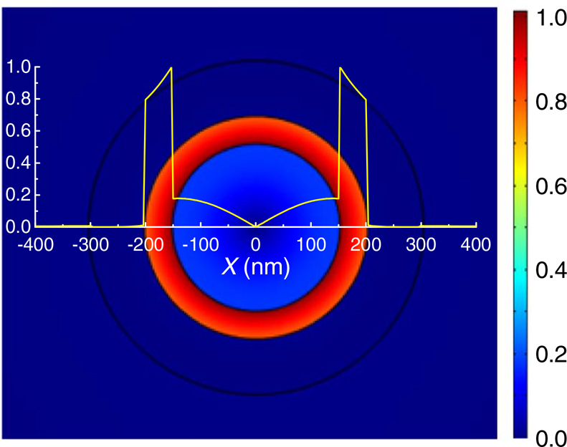
Figure 9: Sample caption (Fig. 2, []).

8 Assessing final manuscript length
OSA’s Universal Manuscript Template is based on the OSA Express layout and will provide an accurate length estimate for Optics Express, Biomedical Optics Express, Optical Materials Express, and OSA’s newest title OSA Continuum. Applied Optics, JOSAA, JOSAB, Optics Letters, Optica, and Photonics Research publish articles in a two-column layout. To estimate the final page count in a two-column layout, multiply the manuscript page count (in increments of 1/4 page) by 60%. For example, 11.5 pages in the OSA Universal Manuscript Template are roughly equivalent to 7 composed two-column pages. Note that the estimate is only an approximation, as treatment of figure sizing, equation display, and other aspects can vary greatly across manuscripts. Authors of Letters may use the legacy template for a more accurate length estimate.

9 Figures, tables, and supplemental materials

9.1 Figures and tables
OSA encourages authors to submit color figures with their manuscripts. Figures and tables should be placed in the body of the manuscript. Standard LATEX environments should be used to place tables and figures:

\begin{figure}[htbp]
\centering\includegraphics[width=7cm]{osafig1}
\caption{Sample caption (Fig. 2, \cite{Yelin:03}).}
\end{figure}

9.2 Supplementary materials in OSA journals
OSA journals allow authors to include supplementary materials as integral parts of a manuscript. Such materials are subject to peer-review procedures along with the rest of the paper and should be uploaded and described using OSA’s Prism manuscript system. Please see the http://www.osapublishing.org/submit/style/multimedia.cfmAuthor Guidelines for Supplementary Materials in OSA Journals for further information.
Supplementary materials must be associated with a figure, table, or equation, OR be referenced in the results section of the manuscript. Please note that to create text color for supplementary materials links, use of the command
\textcolor{urlblue}{Visualization 1} is preferred to using the command
\url{Visualization 1}.

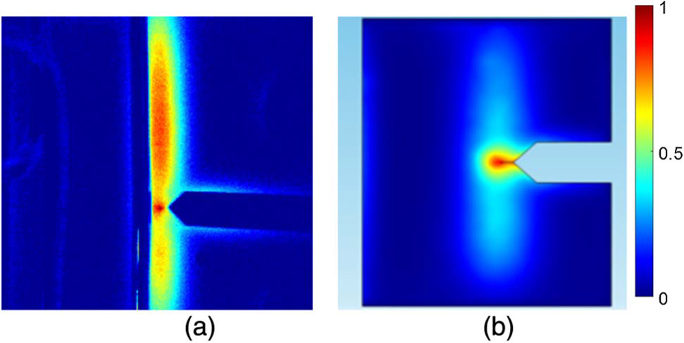
Figure 10: (a) Three traps create three rings of magnetic nanoparticles. (b) The rings interact with one another (see Visualization 1, []).

\begin{figure}[hbt!]
\centering\includegraphics{opexfig2}
\caption{Normalized modulus distributions of transverse electrical
field components of the TM01 mode in PWs with (a) SiO_2 core
and (b) Si core}{Visualization 1}), \cite{Masajada:13}).}
\end{figure}

10 Mathematical and scientific notation

10.1 Displayed equations
Displayed equations should be centered. Equation numbers should appear at the right-hand margin, in parentheses:
(3)
All equations should be numbered in the order in which they appear and should be referenced from within the main text as Eq. (1), Eq. (2), and so on [or as inequality (1), etc., as appropriate].

Funding
Please identify all appropriate funding sources by name and contract number. Funding information should be listed in a separate block preceding any acknowledgments. List only the funding agencies and any associated grants or project numbers, as shown in the example below:

National Science Foundation (NSF) (1253236, 0868895, 1222301); Program 973 (2014AA014402); Natural National Science Foundation (NSFC) (123456).

OSA participates in https://www.crossref.org/fundingdata/Crossref’s Funding Data, a service that provides a standard way to report funding sources for published scholarly research. To ensure consistency, please enter any funding agencies and contract numbers from the Funding section in Prism during submission or revisions.

Acknowledgments
Acknowledgments, if included, should appear at the end of the document. The section title should not be numbered.

Disclosures
For Biomedical Optics Express submissions only, disclosures should be listed in a separate nonnumbered section at the end of the manuscript. List the Disclosures codes identified on OSA’s http://www.osapublishing.org/submit/review/conflicts-interest-policy.cfmConflict of Interest policy page, as shown in the examples below:

ABC: 123 Corporation (I,E,P), DEF: 456 Corporation (R,S). GHI: 789 Corporation (C).

If there are no disclosures, then list “The authors declare that there are no conflicts of interest related to this article.”

11 References
Proper formatting of references is extremely important, not only for consistent appearance but also for accurate electronic tagging. Please follow the guidelines provided below on formatting, callouts, and use of BibTEX.

11.1 Formatting reference items
Each source must have its own reference number. Footnotes (notes at the bottom of text pages) are not used in OSA journals. References require all author names, full titles, and inclusive pagination. Examples of common reference types can be found on the http://www.osapublishing.org/submit/style/style\s\do5(t)raditional\s\do5(j)ournals.cfm Author and Reviewer Resource Center.
The commands \begin{thebibliography}{} and \end{thebibliography} format the section according to standard style, showing the title References. Use the \bibitem{label} command to start each reference.

11.2 Formatting reference citations
References should be numbered consecutively in the order in which they are referenced in the body of the paper. Set reference callouts with standard \cite{} command or set manually inside square brackets [1].
To reference multiple articles at once, simply use a comma to separate the reference labels, e.g. \cite{Yelin:03,Masajada:13,Zhang:14}, produces [, , ].

11.3 BibTEX
BibTEX may be used to create a file containing the references, whose contents (i.e., contents of .bbl file) can then be pasted into the bibliography section of the .tex file. A BibTEX style file, osajnl.bst, is provided.

12 Conclusion
After proofreading the manuscript, compress your .tex manuscript file and all figures (which should be in EPS or PDF format) in a ZIP, TAR or TAR-GZIP package. All files must be referenced at the root level (e.g., file figure-1.eps, not /myfigs/figure-1.eps). If there are supplementary materials, the associated files should not be included in your manuscript archive but be uploaded separately through the Prism interface.
Add references with BibTeX or manually. [, , , ]
References
[] D. Yelin, D. Oron, S. Thiberge, E. Moses, and Y. Silberberg, “Multiphoton plasmon-resonance microscopy,” Opt. Express 11, 1385–1391 (2003).
[] J. Masajada, M. Bacia, and S. Drobczyński, “Cluster formation in ferrofluids induced by holographic optical tweezers,” Opt. Lett. 38, 3910–3913 (2013).
[] Y. Zhang, S. Qiao, L. Sun, Q. W. Shi, W. Huang, L. Li, and Z. Yang, “Photoinduced active terahertz metamaterials with nanostructured vanadium dioxide film deposited by sol-gel method,” Optics Express 22, 11070–11078 (2014).
[] Optical Society, “OSA Publishing,” https://www.osapublishing.org.
[] P. Forster, V. Ramaswamy, P. Artaxo, T. Bernsten, R. Betts, D. Fahey, J. Haywood, J. Lean, D. Lowe, G. Myhre, J. Nganga, R. Prinn, G. Raga, M. Schulz, and R. V. Dorland, “Changes in atmospheric consituents and in radiative forcing,” in Climate Change 2007: The Physical Science Basis. Contribution of Working Group 1 to the Fourth assesment report of Intergovernmental Panel on Climate Change, S. Solomon, D. Qin, M. Manning, Z. Chen, M. Marquis, K. B. Averyt, M. Tignor, and H. L. Miler, eds. (Cambridge University Press, 2007).
[] B. H. Dean, D. L. Aronstein, S. J. Smith, R. Shiri, and S. D. Acton, “Phase retrieval algorithm for JWST flight and testbed telescope,” in Space Telescopes and Instrumentation I: Optical, Infrared, and Millimeter, vol. 6265 (2006), p. 17.

13 Supplemental

13.1 Reconstruction
As the sample is rotated each detector pixel collects an intensity at discrete (n) angles through a full rotation of the sample; where is the unattenuated radiation intensity from the source to the detector, k is the attenuation caused by the sample along a detected ray an I(n) is the measured intensity, see Error: Reference source not found. Rays from the sample to the detector approximate straight lines, and so the the rays reaching the detector with a line integrals. A projection is then the resulting intensity profile at the detector for a rotation angle, and the integral transform that results in is the Radon transform.
(4)
(5)
Where is the Radon transform of f(X,Y) which represents the contrast image of 2D slice of the specimen. The Radon transform of an image produces a sinugram as in Error: Reference source not found
An inverse Radon transform is used to recover the original object from the projection data; which is achieved by taking the Fourier transform of each projection measurement, then reordering the information from the sample into the respective position in Fourier space. This is valid due to the Fourier Slice theorem [Error: Reference source not found] (see Appendix Error: Reference source not found for a derivation), which states that the Fourier transform of a parallel projection is equivalent to a 2D slice of the Fourier transform of the original sample.
(6)
Where is the filtered projection data, and is the back-projected image. A spatial filtering step is applied during back-projection to avoid spatial frequency oversampling during the objectâ€™s rotation (see Error: Reference source not found) a high pass filter is commonly used to compensate for the perceived blurring. The blurring arises as is back-projected (smeared) across the image plane for each angle of reconstruction; which means that not only does the back-projection contribute at the line it is intended to (along line C in 1), but all other points along the back-projecting ray.
Now, suppose we know the relative positions of the two cameras and their respective intrinsic parameters, such as magnification and pixel offset. For a single camera and given the camera parameters, we can translate pixel coordinates, w=(u,v), into the coplanar image plane coordinates x=(x,y):
(7)
(8)
Knowing the focal length (f) of the imaging system, image plane coordinates may be projected into a ray in 3D. The ray can be defined by using the point p in camera-centred coordinates, where it crosses the image plane.
p=
[Sorry. Ignored \begin{bmatrix} ... \end{bmatrix}]
(9)
From the definition of a world point, as observed through an image, we can construct a dual-view model of world points in space as in 2. Using a model of a system with two views allows for the triangulation of rays based on image correspondences, this is an important part of stereo-vision. The most important matching constraint which can be used the epipolar constraint, and follows directly from the fact that the rays must intersect in 3D space. Epipolar constraints facilitate the search for correspondences, they constrain the search to a 1D line in each image. To derive general epipolar constraints, one should consider the epipolar geometry of two cameras as seen in 2
The baseline is defined as the line joining the optical centres. An epipole is the point of intersection of the baseline with the image plan and there are two epipoles per feature, one for each camera. An epipolar line is a line of intersection of the epipolar plane with an image plane. It is the image in one camera of the ray from the other cameraâ€™s optical centre to the world point (X). For different world points, the epipolar plane rotates about the baseline. All epipolar lines intersect the epipole.
The epipolar line constrains the search for correspondence from a region to a line. If a point feature is observed at x in one image frame, then its location x’ in the other image frame must lie on the epipolar line. We can derive an expression for the epipolar line. The two camera-centered coordinate systems X\s\do5(c)’ and X\s\do5(c) are related by a rotation, R and translation, T (see in 2) as follows:
(10)

Figure : Epi-polar geometry described for two adjacent views (or cameras of a scene). Coordinates as expressed in 1 with prime notation (') denoting the additional right camera view. Transforming from right to left camera-centered coordinates (X\s\do5(c)’ to X\s\do5(c)) requires a rotation (R) and a translation (T). 1

The Essential matrix
Taking the scalar product of (Error: Reference source not found) with , we obtain:
(11)

[Sorry. Ignored \begin{bmatrix} ... \end{bmatrix}]
(12)
So equation (Error: Reference source not found) can be rewritten as:
(13)
(14)
(15)
Essential is a 3×3 matrix known as the essential matrix. The constraint also holds for rays p, which are parallel to the camera-centered position vectors X\s\do5(c):
()
This is the epipolar constraint. If a point p is observed in one image, then its position p’ in the other image must lie on the line defined by Equation (1). The essential matrix can convert from pixels on the detector to rays p in the world, assuming a calibrated camera (intrinsic properties are known), and pixel coordinates can then be converted to image plane coordinates using:

[Sorry. Ignored \begin{bmatrix} ... \end{bmatrix}]
=
[Sorry. Ignored \begin{bmatrix} ... \end{bmatrix}]
[Sorry. Ignored \begin{bmatrix} ... \end{bmatrix}]
We can modify this to derive a relationship between pixel coordinates and rays:
[Sorry. Ignored \begin{bmatrix} ... \end{bmatrix}]
=
[Sorry. Ignored \begin{bmatrix} ... \end{bmatrix}]
[Sorry. Ignored \begin{bmatrix} ... \end{bmatrix}]
K is defined as follows: K =
[Sorry. Ignored \begin{bmatrix} ... \end{bmatrix}]
then we can write pixel coordinates in homogenous coordinates: w = K p (17)

13.3 The Fundamental matrix
1 (18)
(19)
The (3×3) matrix F, is the called the fundamental matrix. With intrinsically calibrated cameras, structure can be recovered by triangulation. First, the two projection matrices are obtained via a SVD of the essential matrix. The SVD of the essential matrix is given by:
(20)

[Sorry. Ignored \begin{bmatrix} ... \end{bmatrix}]
U\s\up5(T) and R = U
[Sorry. Ignored \begin{bmatrix} ... \end{bmatrix}]
V\s\up5(T)Then, aligning the left camera and world coordinate systems gives the projection matrices: P = K
[Sorry. Ignored \begin{bmatrix} ... \end{bmatrix}]
and P’ = K’
[Sorry. Ignored \begin{bmatrix} ... \end{bmatrix}]
(21)
Where
[Sorry. Ignored \begin{bmatrix} ... \end{bmatrix}]
is the identity matrix augmented column-wise with a zero matrix, and the two projection matrices (P and P') project from camera pixel coordinates to world coordinates. Given these projection matrices, scene structure can be recovered (only up to scale, since only the magnitude of T (—T—) is unknown) using least squares fitting. Ambiguities in T and R are resolved by ensuring that visible points lie in front of the two cameras. As with the essential matrix, the fundamental matrix can be factorised into a skew-symmetric matrix corresponding to translation and a 3×3 non-singular matrix corresponding to rotation.
[Sorry. Ignored \begin{subfigure} ... \end{subfigure}]

[Sorry. Ignored \begin{subfigure} ... \end{subfigure}]
Figure 12: The result of a tomographic reconstruction (using equally spaced angular steps and no translation between frames) requires Fourier filtering to normalise spatial contrast.
The second approach is less prone to compound errors but relies on precise identification and tracking of fiducial markers. distinction and tracking fiducials. Instead of calculating F between neighbouring images, F is calculated between the current projection and the very first projection. F is then decomposed and the transformation matrix is inverted and applied to the back projected volume. The reoriented back projected volumes are summed and finally filtered to remove the additional spatial frequencies imparted from rotating the sample.

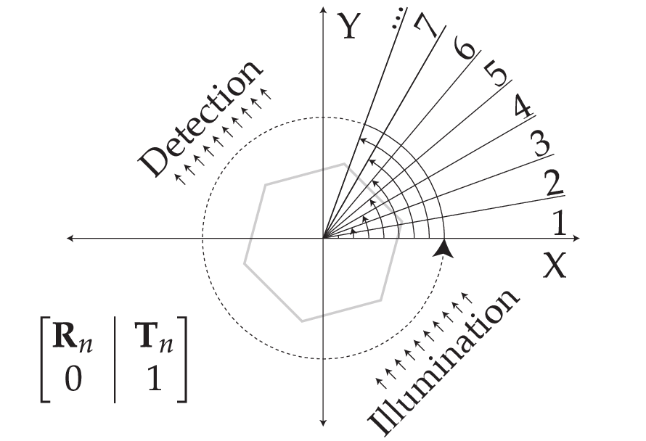
Figure 13: Principles of the proposed algorithm. Each successive frame of OPT image data will have an associated R and T (shown here in augmented form using homogenous coordinates), these matrices can be recovered from comparing the fiducial marker positions in each frame (n) and its successor (n+1).

[Sorry. Ignored \begin{subfigure} ... \end{subfigure}]

[Sorry. Ignored \begin{subfigure} ... \end{subfigure}]
Figure : The result of a tomographic reconstruction (using equally spaced angular steps and no translation between frames) requires Fourier filtering to normalise spatial contrast.

[Sorry. Ignored \begin{subfigure} ... \end{subfigure}]

[Sorry. Ignored \begin{subfigure} ... \end{subfigure}]
Figure 15: Filtered reconstruction of the ground truth reference image from 5 using the new proposed algorithm. 5

[Sorry. Ignored \begin{subfigure} ... \end{subfigure}]

[Sorry. Ignored \begin{subfigure} ... \end{subfigure}]
Figure : Comparison of the two reconstructions under sample imaging with a systematic drift, in 3D though represented here in 2D.

[Sorry. Ignored \begin{subfigure} ... \end{subfigure}]

[Sorry. Ignored \begin{subfigure} ... \end{subfigure}]
Figure 17: Reference images for OPT reconstruction.

