**Data base access:**

1. While I was preparing my Sunday school lesson, I did a google search for something and saw the following link in the search results:

[LDS Church Membership Statistics Analysis - Fuller Consideration](http://www.fullerconsideration.com/membership.php)

www.fullerconsideration.com/membership.php

Definition: **Total membership** refers to the **total** number of individuals on the records of the **LDS church** as **members** at the end of each given year. This includes ...

You've visited this page 2 times. Last visit: 9/7/18

2. I clicked on the link.

3. I clicked on “Raw data and Calculations”

4. I clicked on “File” “Save As” “csv”

Variables:

End.of.Year Total.Membership Children.of.Record

1 1830 6 0

Baptisms.of.Children.of.Record Convert.Baptisms Total.Baptisms

1 0 6 6

Convert.Children.of.Record Births.to.Active.Members Mormon.Birth.Rate

1 0 0 57.6

Mormon.Death.Rate Mormon.Life.Expectancy Birth.Rate..Fractional.

1 50 39.5 1.0576

**Data Structure**

Headings are text. Data in the first 8 columns contains some characters, all other data are numeric. Please note that it was necessary to change the format of the Excel data cells to ‘general’ format to remove commas that were seen as ‘character’.

|  |
| --- |
| data.frame': 191 obs. of 12 variables:  $ End.of.Year : int 1830 1830 1831 1832 1833 1834 1835 1836 1837 1838 ...  $ Total.Membership : int 6 280 680 2661 3140 4372 8835 13293 16282 17881 ...  $ Children.of.Record : chr "0" "40" "74" "330" ...  $ Baptisms.of.Children.of.Record: chr "0" "0" "13" "22" ...  $ Convert.Baptisms : int 6 274 398 1974 455 1198 4404 4342 2802 1350 ...  $ Total.Baptisms : int 6 274 411 1996 519 1257 4473 4461 2956 1573 ...  $ Convert.Children.of.Record : int 0 32 46 231 53 140 515 508 328 158 ...  $ Births.to.Active.Members : int 0 8 28 99 174 228 407 690 935 1093 ...  $ Mormon.Birth.Rate : num 57.6 57.6 58.4 59.2 60 60.8 61.6 62.4 63.2 64 ...  $ Mormon.Death.Rate : num 50 50 50 50 50 50 50 50 50 50 ...  $ Mormon.Life.Expectancy : num 39.5 39.5 39.5 39.5 39.5 39.5 39.5 39.5 39.5 39.5 ...  $ Birth.Rate..Fractional. : num 1.06 1.04 1.04 1.04 1.04 ... |
|  |

**Mean of 5 variables:**

Total Membership: [1] 2821583

Convert Baptisms: [1] 69300.34

Mormon Birth Rate (per 1000 population): [1] 40.79921

Mormon Death Rate (per 1000 members): [1] 16.97921

Mormon Life Expectancy: [1] 58.39162

**Median of 5 variables:**

Total Membership: [1] 597861

Convert Baptisms: [1] 6373

Mormon Birth Rate (per 1000 population): [1] 37.7

Mormon Death Rate (per 1000 members): [1] 7.8

Mormon Life Expectancy: [1] 57.3

**Mode of 5 variables:**

Total Membership: no mode, single occurrence values

Convert Baptisms: [1] "2802"

Mormon Birth Rate(per 1000 population): [1] "21.1"

Mormon Death Rate(per 1000 members): [1] "50"

Mormon Life Expectancy: [1] "39.5"

|  |
| --- |
|  |
| |  | | --- | |  | |

**Standard deviation of Mormon Birth Rate** (per 1000 population):

[1] 15.88073

**Range of Mormon Birth Rate** (per 1000 population):

[1] 16.2 65.6 (min/max)

[1] 49.4 (range)

**Variance of Mormon Birth Rate** (per 1000 population):

[1] 252.1977

**Histogram of Mormon Life Expectancy**

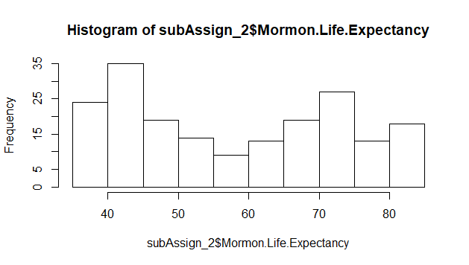

**Stem-leaf plot of Mormon Life Expectancy**

38 | 455555555555555555555559

40 | 3570114689

42 | 04448902367889

44 | 1233467799025

46 | 28990011223378

48 | 891

50 | 16226

52 | 02777

54 | 1478

56 | 8033

58 | 61789

60 | 269339

62 | 304468

64 | 028

66 | 3913

68 | 04570688889

70 | 00133333669235

72 | 1704579

74 | 156777991355777

76 | 1575

78 | 43

80 | 21

82 | 0012345678900012