Choose three variables of interest and complete the following tasks:

o Describe the central tendency of the variables

Total Membership

Mean: 2,821,583

Median: 597,861

Mode:

[1] "6" "280" "680" "2661" "3140" "4372" "8835" "13293"

[9] "16282" "16460" "16865" "17881" "19856" "23564" "25980" "26146"

[17] "30332" "33993" "34694" "40477" "48160" "51839" "52165" "52640"

[25] "55236" "55755" "57038" "61082" "63881" "63974" "64154" "66211"

[33] "68429" "68780" "71770" "74348" "76771" "77884" "81124" "84622"

[41] "88432" "90130" "95596" "98152" "101538" "103916" "107167" "111111"

[49] "115065" "125046" "128386" "133628" "140733" "145604" "151593" "158242"

[57] "164130" "166653" "173029" "180294" "183144" "188263" "195445" "200961"

[65] "214534" "222369" "231116" "241427" "255736" "267251" "271681" "283765"

[73] "292931" "299105" "304901" "324289" "332048" "345014" "357913" "371472"

[81] "377279" "398478" "407291" "417555" "431607" "454718" "466238" "477321"

[89] "488038" "495962" "507961" "525987" "548803" "566358" "575896" "597861"

[97] "613572" "623909" "644745" "655686" "663652" "670017" "688435" "703949"

[105] "717619" "730738" "746384" "760690" "767752" "784764" "803528" "862664"

[113] "892080" "917715" "937050" "954004" "979454" "996505" "1016170" "1041970"

[121] "1078671" "1111314" "1147157" "1189053" "1246362" "1302240" "1357274" "1416731"

[129] "1488314" "1555799" "1616088" "1693180" "1823661" "1965786" "2117451" "2234916"

[137] "2395932" "2480899" "2614340" "2684073" "2807456" "2930810" "3090953" "3227790"

[145] "3321556" "3385909" "3572202" "3742749" "3969220" "4166854" "4404121" "4639822"

[153] "4920449" "5162619" "5351724" "5641054" "5919483" "6166974" "6394314" "6721210"

[161] "7308444" "7761207" "8089848" "8404087" "8689168" "9024368" "9338397" "9692441"

[169] "10071783" "10404448" "10752984" "11068861" "11394518" "11721548" "11985254" "12275822"

[177] "12560869" "12868606" "13193999" "13508509" "13824854" "14131467" "14441346" "14782473"

[185] "15082028" "15372337" "15634199" "15882417" "16118169" "16367030" "16610582"

Range: 16,610,576

Total Baptisms

Mean: 98,642

Median: 20,971

Mode:

[1] "6" "274" "411" "519" "965" "1027" "1257" "1573" "1996"

[10] "2956" "3049" "3101" "3271" "3882" "3927" "4250" "4276" "4360"

[19] "4371" "4396" "4458" "4461" "4473" "4498" "4499" "4743" "4780"

[28] "4895" "4898" "5035" "5095" "5107" "5109" "5118" "5249" "5259"

[37] "5469" "5643" "5653" "5742" "5785" "5873" "5959" "6205" "6457"

[46] "6476" "6711" "6744" "7045" "7382" "7689" "7970" "8251" "8613"

[55] "8684" "8982" "9532" "10075" "10510" "10739" "10947" "11153" "11396"

[64] "11669" "11779" "11921" "12197" "12383" "12494" "12804" "13034" "13219"

[73] "13729" "14295" "14709" "14761" "14830" "14860" "14871" "14909" "14942"

[82] "15178" "15325" "15532" "15902" "15953" "16656" "16749" "17101" "17457"

[91] "17572" "18796" "20512" "20763" "20816" "20971" "21063" "21113" "21115"

[100] "21257" "21603" "21687" "21784" "21953" "21979" "22004" "22071" "22160"

[109] "22289" "22517" "22696" "22879" "23108" "23144" "23369" "23508" "23872"

[118] "26022" "28735" "30455" "36795" "37508" "40380" "42207" "42709" "45796"

[127] "54476" "58715" "63374" "69465" "72261" "90775" "115871" "116252" "117116"

[136] "117503" "124616" "128181" "131868" "134336" "135172" "137038" "142577" "145675"

[145] "149580" "154850" "162741" "186240" "215000" "229939" "258419" "260000" "261983"

[154] "267640" "274000" "286000" "288210" "293000" "302284" "319761" "328880" "329515"

[163] "335382" "336258" "337920" "339978" "342380" "346700" "351857" "355423" "358742"

[172] "362134" "363278" "364270" "364862" "366851" "372704" "372770" "372811" "372916"

[181] "373268" "373343" "375469" "375963" "381120" "386652" "390289" "393012" "393940"

[190] "402402" "408877"

Range: 408,871

Births to Active Members

Mean: 33,150

Median: 18,516

Mode: [1] "1093"

Range: 102,767

o Describe the variables through variation

Total Membership: [1] 2.029032e+13

Total Baptisms: [1] 18733257023

Births to Active Members: [1] 1043986336

o Discuss normality. Are your variables approximating normality? What are ways that you can show that they are or are not?

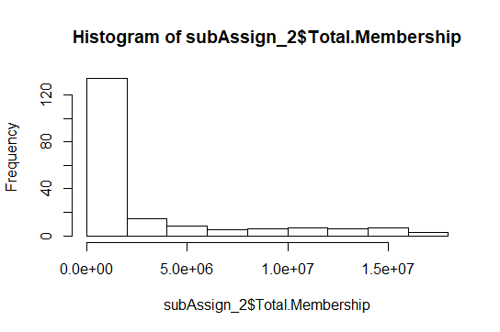

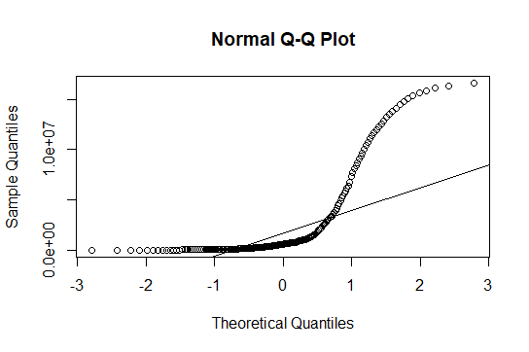

Both the Histogram and Q-Q Plot show that the data for the variable Total Membership do not approximate normality.

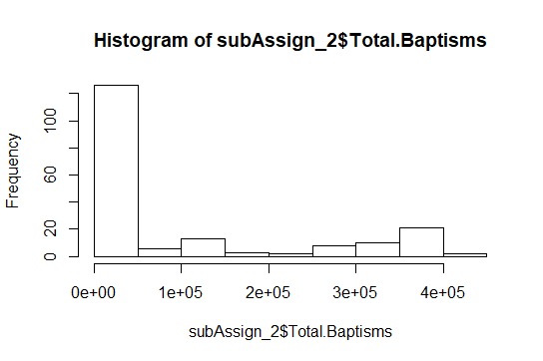

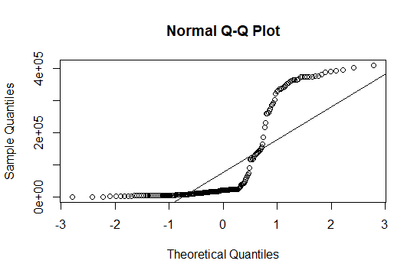

Both the Histogram and Q-Q Plot show that the data for the variable Total Baptisms do not approximate normality.

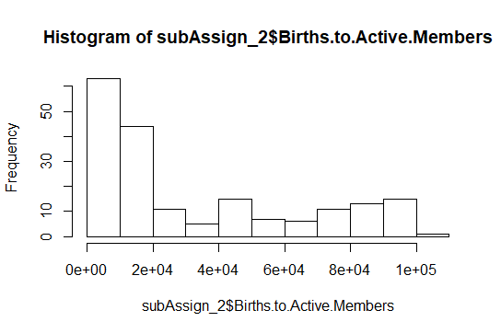

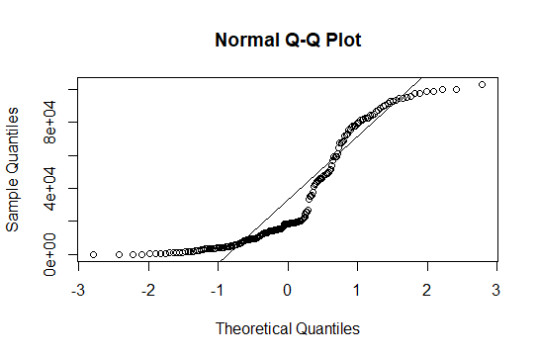

Both the Histogram and Q-Q Plot show that the data for the variable Births to Active Members do not approximate normality. However, the Q-Q Plot indicates data for this variable are closer to a normal curve than the other two variables as the points are more evenly distributed along the line than the previous two variables.