Bean Summary
Here’s a summary of all of the beans we haven’t previously mentioned:
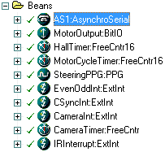
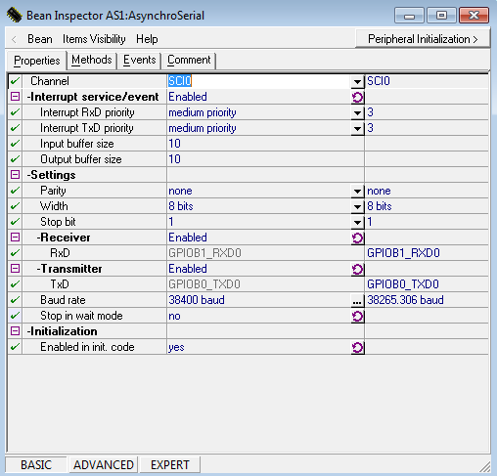
This is the interrupt we set up for wireless serial on the car; it goes at roughly 38250 baud and has methods for sending and receiving bytes through the module. This bean was essential for debugging.
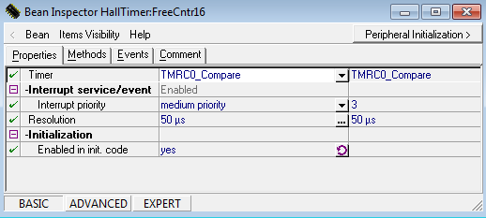
This was the timer used to tell the time between hall pulses to help estimate the speed of the car. The timer was in microseconds but could only return word precision, so we came up with a scheme that can get it to double word precision by adding our own 1/20th second timer in code and incrementing that every time this timer reached 50,000 microseconds.
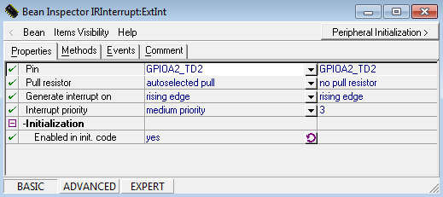
This is the interrupt for obstacle detection. On the rising edge of the IR sensor, the software breaks into a routine away from line steering that manually turns around an object to the left.
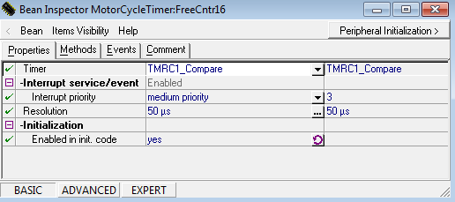
This is a timer we used to set up PWM control to control the motor output using PID.
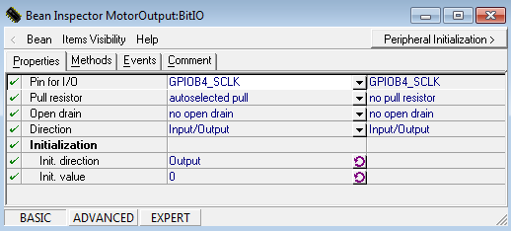
Used in conjunction with MotorCycleTimer, this MotorOutput bit turns on and off the signal to the motor, that gets buffered by a comparator to drive the motor at the chosen duty cycle based on PID information.

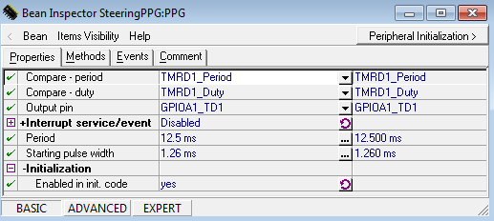
This bean is hooked directly to steering

